Genereren van uml-diagram in intellij

# Hoe kan ik met behulp van intelliJ automatisch een uml-diagram genereren op basis van bestaande code?

IntelliJ Ultimate edition laat ons toe om in het programma zelf uml-diagrammen te genereren, zonder hiervoor extra plug-ins te moeten installeren. In dit document bespreken we kort hoe dit in zijn werk gaat.

1. Selecteer een package waarvan je een UML-diagram wilt laten genereren.

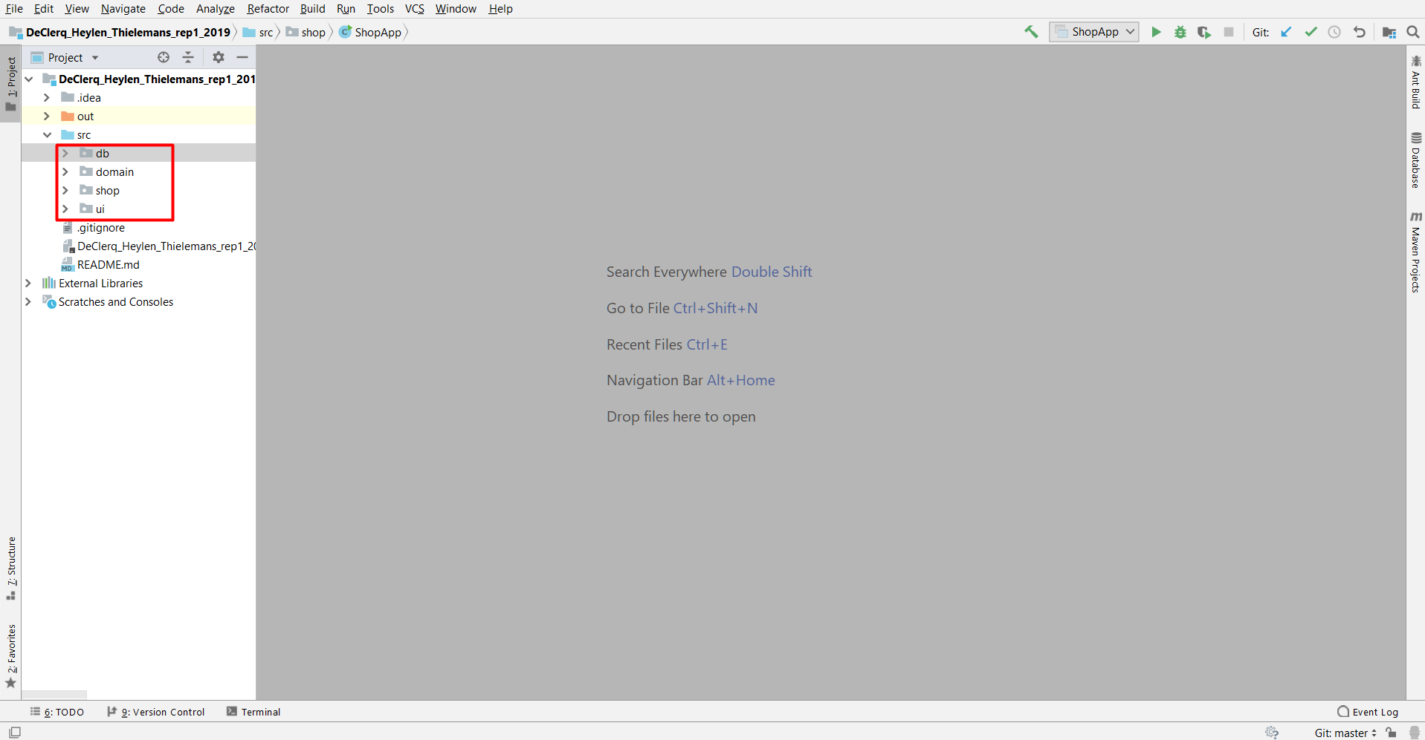

1. Rechtsklik, en kies *‘Diagrams’* -> ‘*show diagram…’*. Als alternatief kan u ook  Ctrl+Alt+Shift+U indrukken:

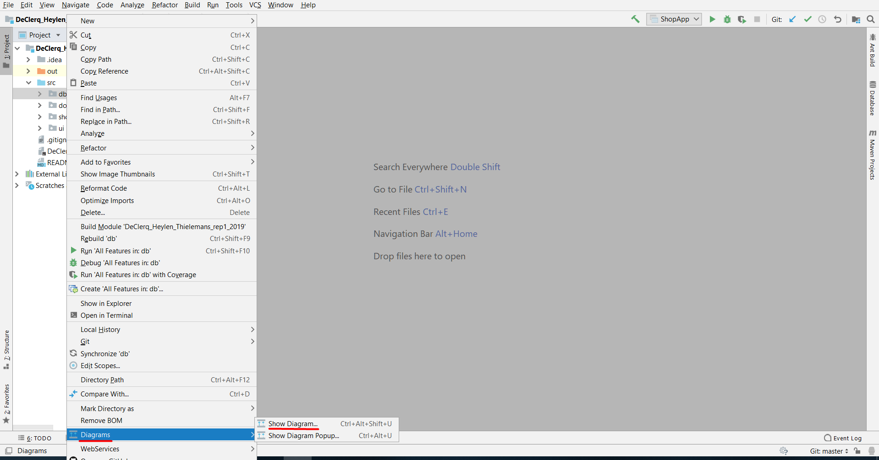

1. Selecteer vervolgens ‘*Java Class Diagrams’*:

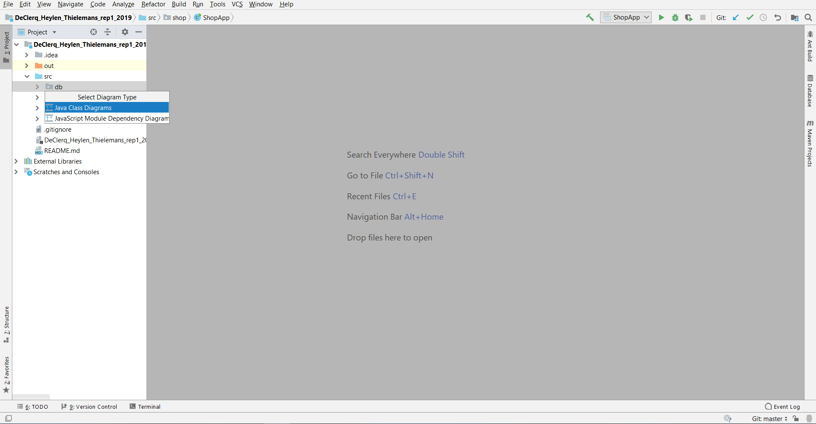

1. U krijgt nu de klassen gezien die in de package zaten. U kunt extra packages toevoegen door ze in het venster te slepen :

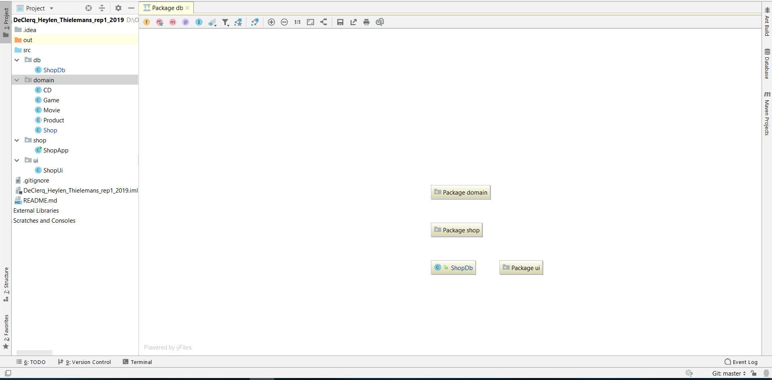

1. Via de icoontjes bovenaan kan u de relaties tussen de klassen weergeven, hun instantievariabelen tonen, de methodes laten tonen,… :

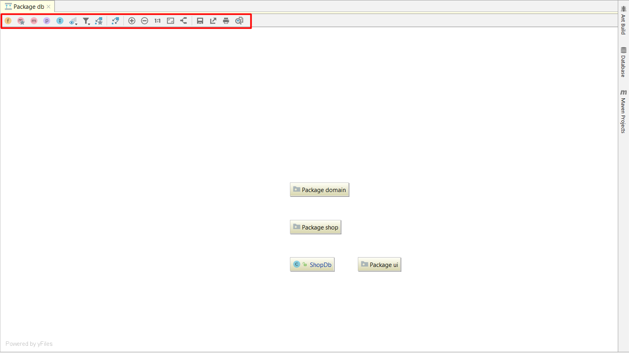

Hieronder volgt een kort overzicht van al de iconen en hun beschrijving:

| Toolbar **Item** | **Description** |
| --- | --- |
| Methods | Click this button to show methods in the class nodes. |
| Fields | Click this button to show fields in the class nodes. |
| JavaScriptLanguage icons members constructor | Click this button to show constructors in the class nodes. |
| property | Click this button to show properties in the class nodes. |
| innerClass | Click this button to show inner classes in the class nodes. |
| filterVisibilityLevel | Click this button to reveal the combo box, and select visibility level of the elements to be displayed in diagram. |
| filter arrow down | Click this button to reveal the combo box, and select the desired scope of elements to be displayed in diagram, for example, project or non-project files. The elements out of the selected scope will be hidden. |
| the Edge Creation mode button | Click this button to enable creating **extends** or **implements** links between node elements. If this button is not pressed, links cannot be drawn. |
| showDependencies | Click this button to show dependencies of the selected class or package. |
| Zoom In | Click this button to increase the scale of the diagram, or press NumPad+. |
| Zoom Out | Click this button to decrease the scale of the diagram, or press NumPad-. |
| Actual Size | Click this button to restore the actual size of the diagram. |
| Fit Content | Click this button to make the contents fit into the current diagram size. |
| Apply Current Layout | Click this button to apply the current layout, selected on the context menu of the diagram, or press F5. |
| Save diagram | Click this button to save the current diagram as a UML file. |
| Export to file | Click this button to save the diagram in an image file. |
| Print Graph | Click this button to print the diagram. |
| Print Preview | Click this button to open the diagram preview in a separate frame, where you can configure the page layout, scale, and headings information. |

| **Item** | **Shortcut** | **Description** |
| --- | --- | --- |
| Add class to diagram | Space | Choose this command to [add existing class](https://www.jetbrains.com/help/idea/class-diagram.html#add_class) to the diagram background. |
| Collapse nodes | C | Choose this command to show the containing package of the selected node. |
| Expand nodes | E | Choose this command to show class diagram of the selected package. |
| New | Alt+Insert | Choose this command to create a new node element or member. |
| Refactor |  | Point to this node to select one of the refactoring commands available in this context. |
| Analyze |  | Point to this node to select one of the code analysis commands available in this context. |

1. Afbeelding met kaart, binnen

   Automatisch gegenereerde beschrijvingEn volledig opengeklapt uml-diagram ziet er dan uit als volgt:

Bronnen:

<https://www.jetbrains.com/help/idea/class-diagram.html>

<https://www.jetbrains.com/help/idea/class-diagram-toolbar-and-context-menu.html>