Subject Name: **Source Code Management**

Subject Code: **24CSE0106**

Session: **2024-25**

Department: **CSE**



|  |  |  |
| --- | --- | --- |
| **Submitted By:**  Itishjot Singh  2410990366  G5 |  | **Submitted To:**  Dr. Chetna Sharma |

**List of Programs**

|  |  |  |
| --- | --- | --- |
| **S. No** | **Program Title** | **Page No.** |
| 1 | To install and configure Git Client on your local system | 3-5 |
| 2 | Setting up GitHub account ad adding collaborators on GitHub Repository | 6-7 |
| 3 | To merge two branches with a Git repository | 8-9 |
| 4 | To demonstrate push and pull operations in Git | 10 |

|  |  |  |
| --- | --- | --- |
|  |  |  |

**Task 1.1**

**Practical 1**

**Aim:** To install and configure Git Client on your local system.

**Theory:**

Git is a distributed version control system used to track changes in source code. This practical focuses on setting up Git on your local system for effective version control.

**Procedure:**

○ Download Git from git-scm.com.  
○ Install Git by following the setup wizard.  
○ Open Git Bash and verify installation using the command: git --version.  
○ Configure user details using the commands:  
git config --global user.name "Your Name"  
git config --global user.email "Your Email"

**Snapshots of download:**

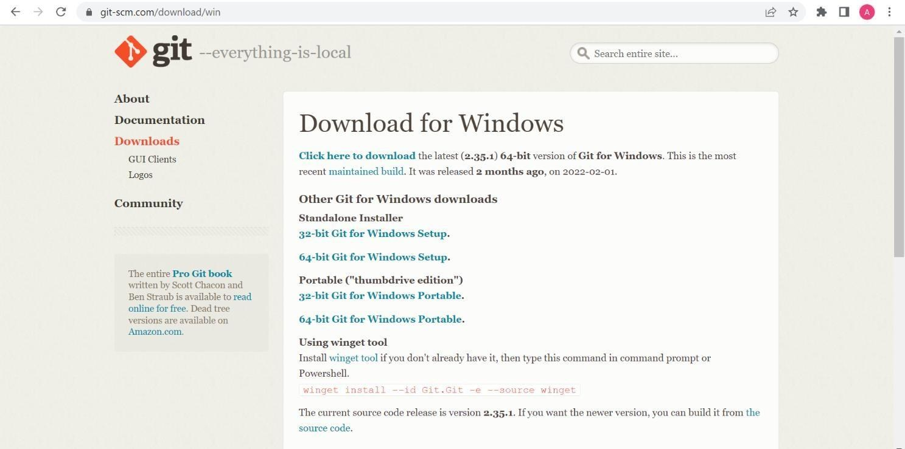

Opted for “64-bit Git for Windows Setup”

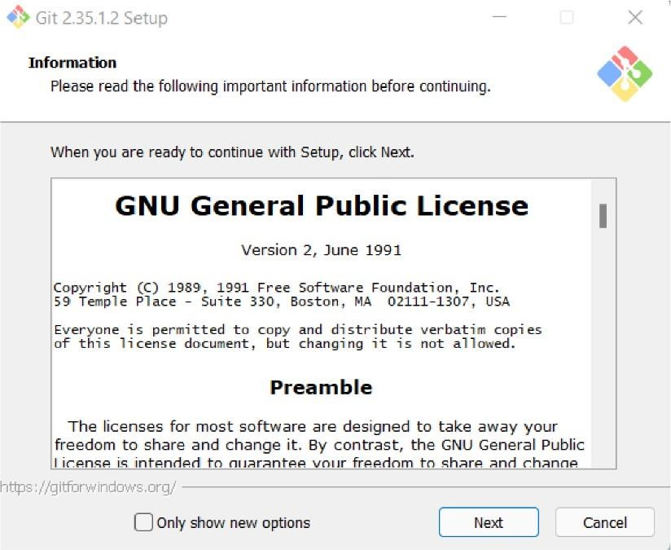

Git Setup

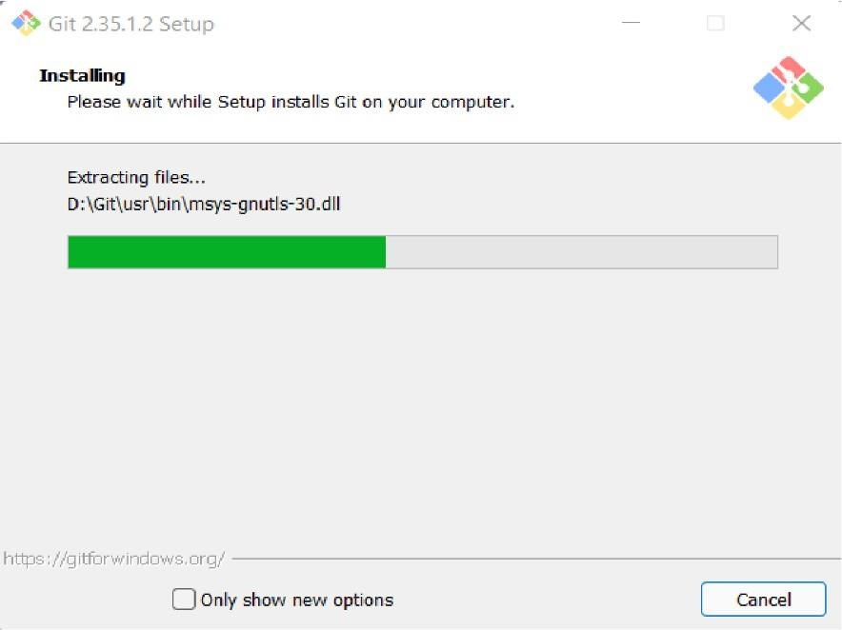

Git Installation

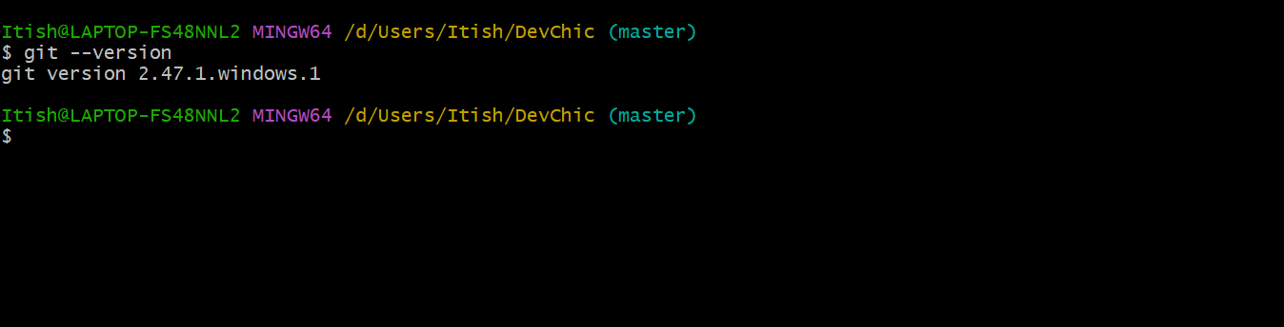

Git Bash version

**Practical 2**

**Aim:** Setting up GitHub Account

**Theory:**

GitHub: GitHub is a website and cloud-based service (client) that helps an individual or developers to store and manage their code. We can also track as well as control changes to our or public code.

Advantages of GitHub: GitHub has a user-friendly interface and is easy to use. We can connect the git-hub and git but using some commands shown below in figure 001. Without GitHub we cannot use Git because it generally requires a host and if we are working for a project, we need to share it will our team members, which can only be done by making a repository. Additionally, anyone can sign up and host a public code repository for free, which makes GitHub especially popular with open-source projects.

**Procedure:**

To make an account on GitHub, we search for GitHub on our browser or visit <https://github.com/signup>. Then, we will enter our mail ID and create a username and password for a GitHub account.

**Snapshots:**

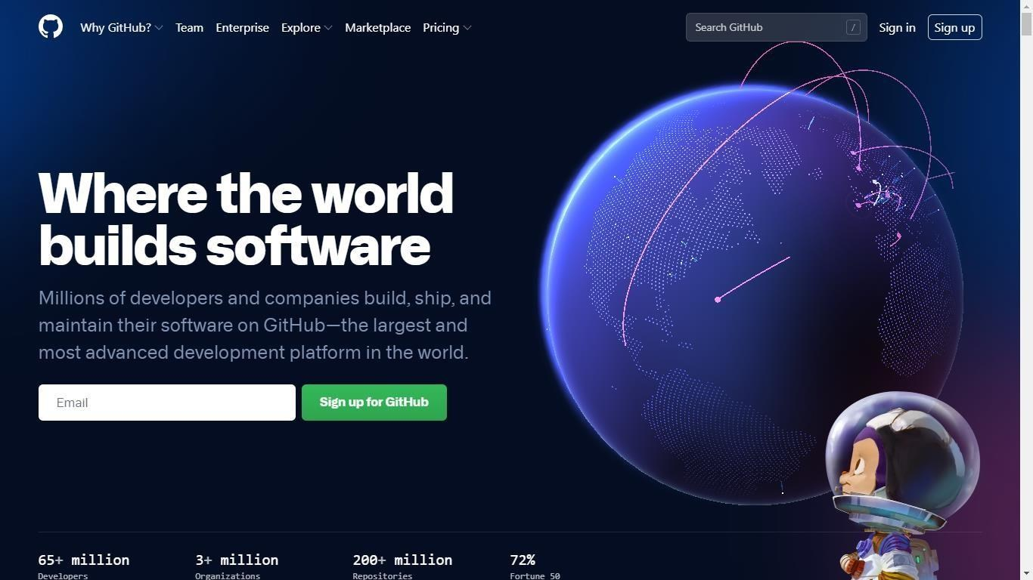

After visiting the link this type of interface will appear, if you already have an account, you can sign in and if not, you can create.

**GitHub Login:**

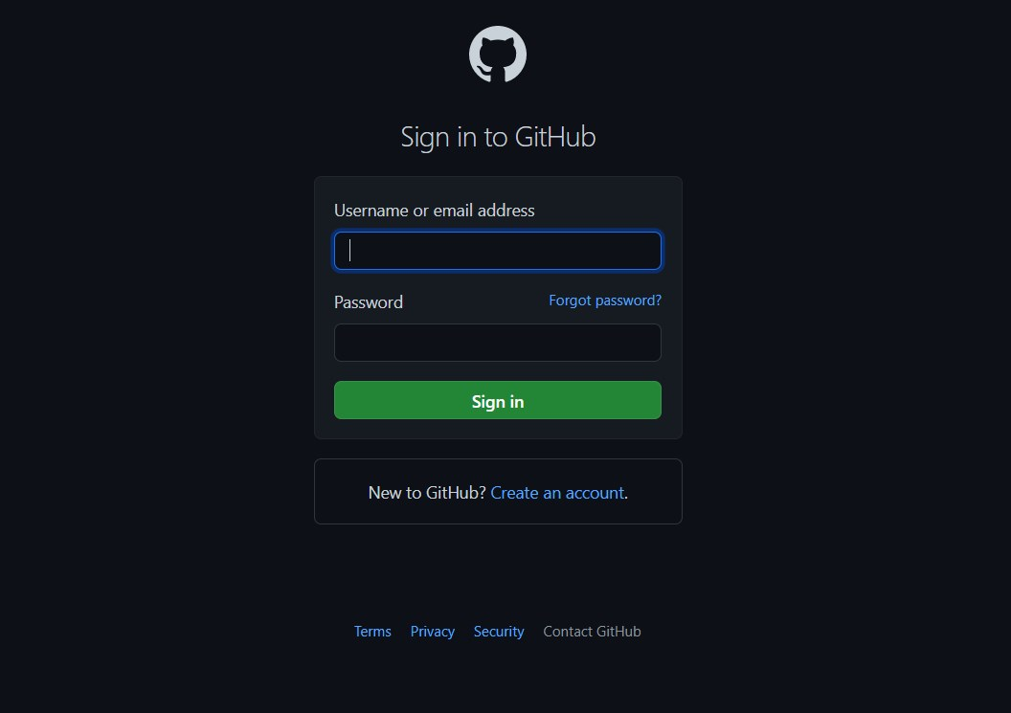

**Adding Collaborators:**

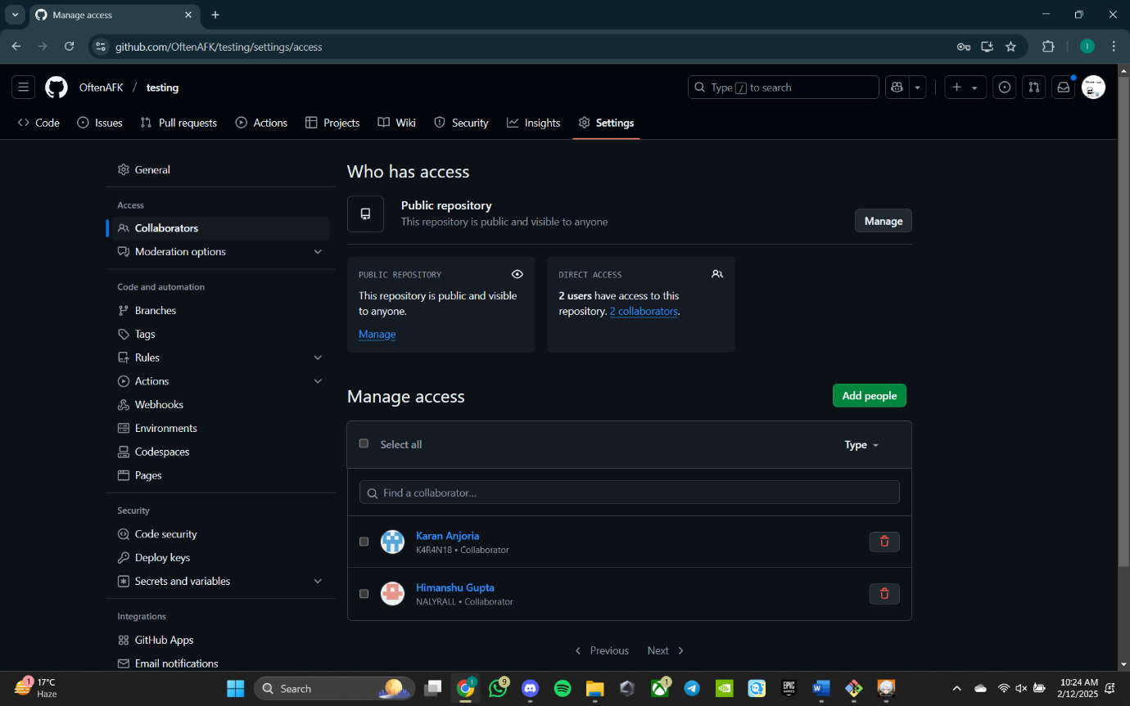

**Practical 3**

**Aim:**To merge two branches within a Git repository**.**

**Theory:**

 Merging branches in Git allows you to combine changes from one branch into another. It is a fundamental process in collaborative workflows, ensuring all contributions are integrated into a single codebase.

**Procedure:**1. Create a new branch and switch to it:  
git checkout -b new-branch

2. Make changes to a file in the new branch and commit them:  
echo "New content" > file.txt  
git add file.txt  
git commit -m "Add changes in new branch"

3. Switch back to the main branch:  
git checkout main

4. Modify another file in the main branch and commit the changes:  
echo "Main branch changes" > another-file.txt  
git add another-file.txt  
git commit -m "Modify file in main branch"

5. Merge the new branch into the main branch:

Git merge new-branch

git merge new-branch

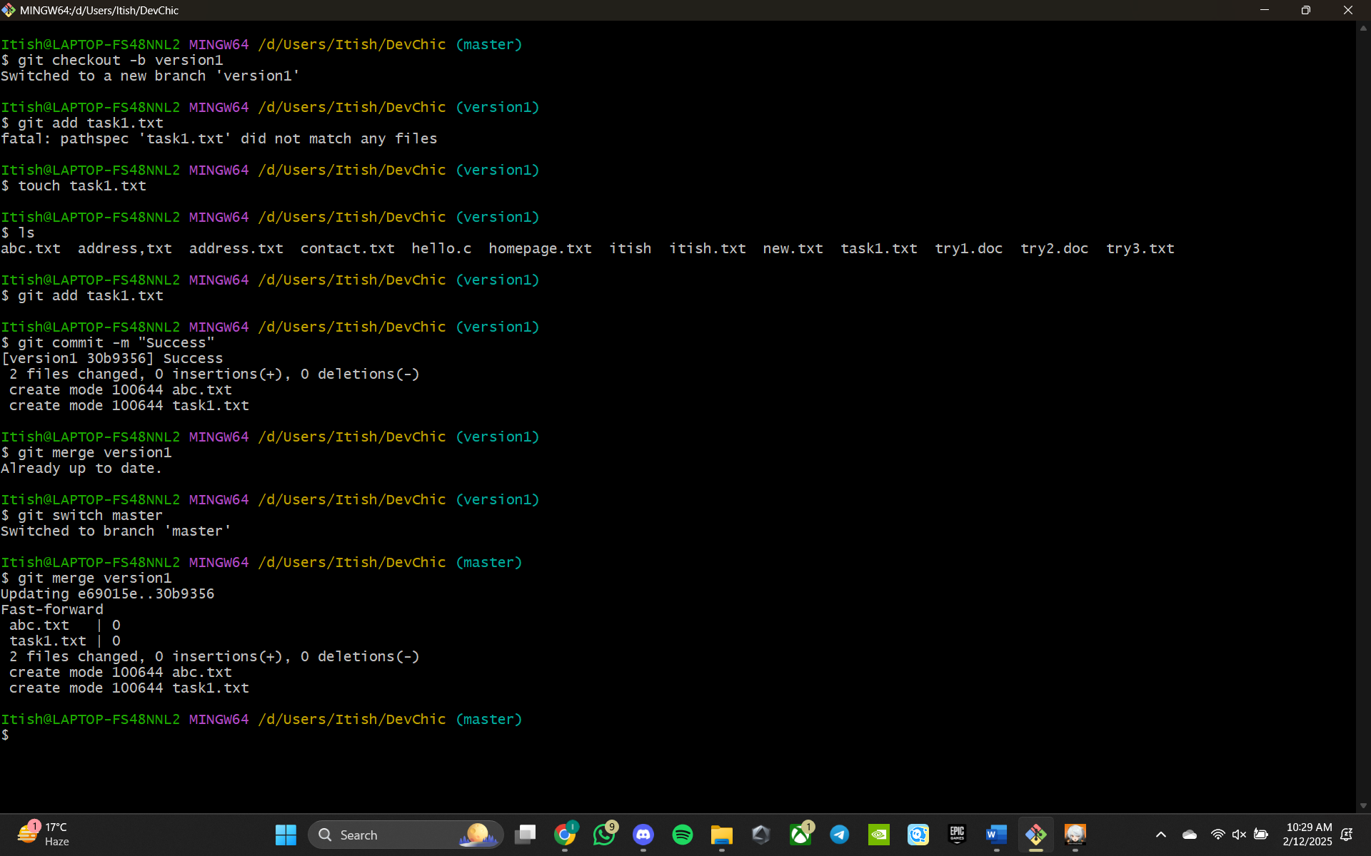**Snapshots:**

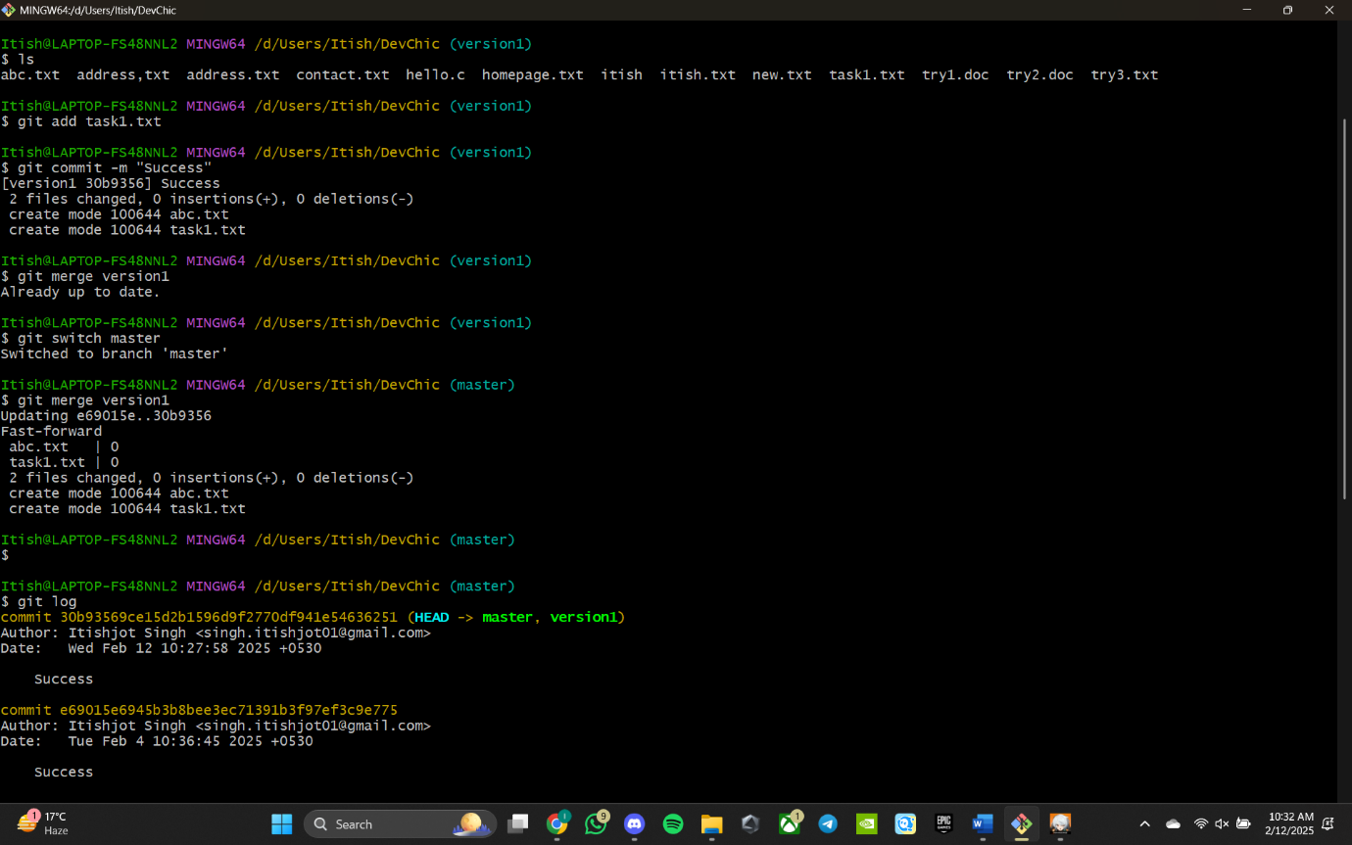

**Practical 4**

**Aim:**

To demonstrate push and pull operations in Git.

**Theory:**

Push transfers committed changes from the local repository to the remote repository, while pull retrieves updates from the remote repository.

**Procedure:**  
○ Make changes in the local repository and commit them.  
○ Push the changes to the remote repository using git push.  
○ Make changes directly on the remote repository (e.g., via GitHub interface).  
○ Pull the changes to the local repository using git pull.

**Tasks:**  
Provide screenshots of the push and pull operations.  
Include the updated commit log.

**Screenshots**

