NATIONAL UNIVERSITY OF COMPUTER AND EMERGING SCIENCES
Computer Networks — Laboratory 07
Socket Programming Part II — TCP & UDP Client-Server Communication

Student ID | 23F-3043
Course | Computer Networks (CN)
Lab Session | Lab 07 — Socket Programming Part II
Date | Spring 2025

01 Objective

The objective of this laboratory session is to implement and demonstrate bi-directional client-server communication using both TCP (Transmission Control Protocol) and UDP (User Datagram Protocol) socket APIs in C++. Students will gain hands-on experience with the POSIX socket interface, understand the differences between connection-oriented and connectionless communication paradigms, and observe real-time message exchange between networked processes.
02 Part A — TCP Socket Programming

TCP provides a reliable, connection-oriented byte stream between the client and server. The server creates a listening socket, binds it to port 8080, and waits for incoming connections. The client connects, sends a greeting, and receives a response.
2.1 TCP Client (tcp_client.cpp)
#include <iostream>
#include <unistd.h>
#include <arpa/inet.h>
#include <cstring>

using namespace std;

int main() {
int sock;
struct sockaddr_in serv_addr;
char buffer[1024] = {0};

// 1. Create socket
sock = socket(AF_INET, SOCK_STREAM, 0);

serv_addr.sin_family = AF_INET;
serv_addr.sin_port = htons(8080);

// Convert IP address
inet_pton(AF_INET, "127.0.0.1", &serv_addr.sin_addr);

// 2. Connect to server
connect(sock, (struct sockaddr *)&serv_addr, sizeof(serv_addr));

// 3. Send request
char message[] = "Hello Server";
send(sock, message, strlen(message), 0);

// 4. Receive response
read(sock, buffer, 1024);
cout << "Server reply: " << buffer << endl;

close(sock);

return 0;
}

2.2 TCP Server (tcp_server.cpp)
#include <iostream>
#include <unistd.h>
#include <arpa/inet.h>
#include <cstring>

using namespace std;

int main() {
int server_fd, client_socket;
struct sockaddr_in address;
int addrlen = sizeof(address);
char buffer[1024] = {0};

// 1. Create socket
server_fd = socket(AF_INET, SOCK_STREAM, 0);

if (server_fd == 0) {
cout << "Socket failed\n";
return 1;
}

// 2. Define server address
address.sin_family = AF_INET;
address.sin_addr.s_addr = INADDR_ANY;
address.sin_port = htons(8080);

// 3. Bind socket
bind(server_fd, (struct sockaddr *)&address, sizeof(address));

// 4. Listen
listen(server_fd, 3);
cout << "Server waiting for connection...\n";

// 5. Accept client
client_socket = accept(server_fd, (struct sockaddr *)&address,
(socklen_t*)&addrlen);

// 6. Receive request
read(client_socket, buffer, 1024);
cout << "Client says: " << buffer << endl;

// 7. Send response
char response[] = "Hello from Server";
send(client_socket, response, strlen(response), 0);

close(client_socket);
close(server_fd);

return 0;
}

2.3 TCP Output
Terminal output demonstrating successful TCP client-server message exchange:
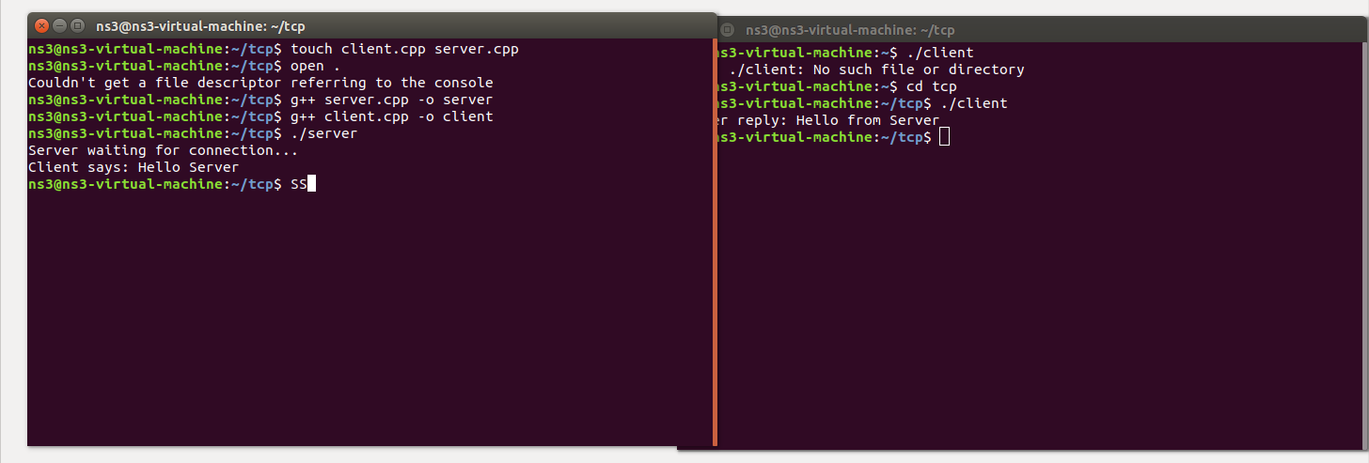

03 Part B — UDP Socket Programming

UDP provides a connectionless, best-effort datagram delivery service. Unlike TCP, there is no handshake or persistent connection. The server binds to port 8080 and waits for incoming datagrams. The client sends a message directly using sendto() and receives the server reply via recvfrom().
3.1 UDP Client (udp_client.cpp)
#include <iostream>
#include <arpa/inet.h>
#include <unistd.h>
#include <cstring>

using namespace std;

int main() {

int sockfd;
char buffer[1024];
struct sockaddr_in serverAddr;

// 1. Create UDP socket
sockfd = socket(AF_INET, SOCK_DGRAM, 0);

serverAddr.sin_family = AF_INET;
serverAddr.sin_port = htons(8080);

inet_pton(AF_INET, "127.0.0.1", &serverAddr.sin_addr);

// 2. Send request
char message[] = "Hello UDP Server";

sendto(sockfd, message, strlen(message), 0,
(struct sockaddr*)&serverAddr, sizeof(serverAddr));

// 3. Receive response
socklen_t len = sizeof(serverAddr);

recvfrom(sockfd, buffer, sizeof(buffer), 0,
(struct sockaddr*)&serverAddr, &len);

cout << "Server reply: " << buffer << endl;

close(sockfd);

return 0;
}

3.2 UDP Server (udp_server.cpp)
#include <iostream>
#include <arpa/inet.h>
#include <unistd.h>
#include <cstring>

using namespace std;

int main() {

int sockfd;
char buffer[1024];
struct sockaddr_in serverAddr, clientAddr;
socklen_t len = sizeof(clientAddr);

// 1. Create UDP socket
sockfd = socket(AF_INET, SOCK_DGRAM, 0);

if (sockfd < 0) {
cout << "Socket creation failed\n";
return 1;
}

// 2. Setup server address
serverAddr.sin_family = AF_INET;
serverAddr.sin_port = htons(8080);
serverAddr.sin_addr.s_addr = INADDR_ANY;

// 3. Bind socket
bind(sockfd, (struct sockaddr*)&serverAddr, sizeof(serverAddr));

cout << "UDP Server running on port 8080...\n";

// 4. Receive message from client
recvfrom(sockfd, buffer, sizeof(buffer), 0,
(struct sockaddr*)&clientAddr, &len);

cout << "Client says: " << buffer << endl;

// 5. Send response
char response[] = "Hello from UDP Server";
sendto(sockfd, response, strlen(response), 0,
(struct sockaddr*)&clientAddr, len);

close(sockfd);

return 0;
}

3.3 UDP Output
Terminal output demonstrating successful UDP client-server datagram exchange:
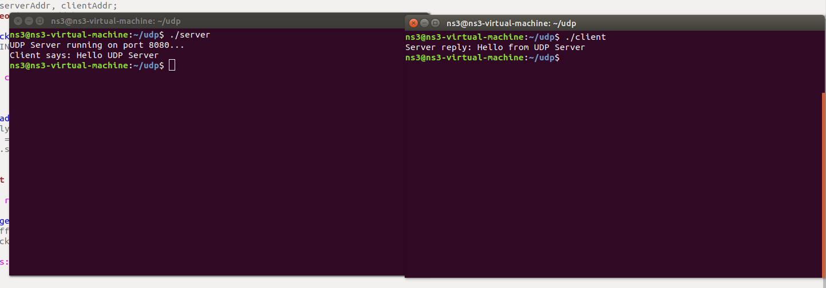

04 TCP vs UDP — Key Differences

Feature | TCP | UDP
Connection | Connection-oriented (3-way handshake) | Connectionless (no handshake)
Reliability | Guaranteed delivery with ACKs | Best-effort, no delivery guarantee
Ordering | Maintains packet order | No ordering guarantee
Socket Type | SOCK_STREAM | SOCK_DGRAM
Key Functions | connect(), accept(), send(), read() | sendto(), recvfrom()
Use Case | Web, email, file transfer | DNS, streaming, gaming

05 Conclusion

This laboratory successfully demonstrated the implementation of both TCP and UDP client-server architectures using POSIX socket APIs in C++. The TCP implementation showcased the complete lifecycle of a connection-oriented communication — from socket creation, binding, and listening on the server side, to connection establishment and bidirectional message exchange. The UDP implementation illustrated the simplicity of connectionless communication using sendto() and recvfrom(), eliminating the overhead of connection management while trading off reliability guarantees.
Both protocols were tested on localhost (127.0.0.1) over port 8080, and the terminal outputs confirm successful bidirectional message delivery. This exercise reinforces the fundamental understanding of transport-layer socket programming that underpins all modern networked applications.

23F-3043 • Computer Networks Lab 07 • FAST NUCES

