CL3001
Computer Networks - Lab
Lab 12 & Week-12
IP Addressing
Objectives:
- To design and implement IP addressing schemes, subnetting, and VLSM in Cisco Packet Tracer.

For the given IPs fill the following table for first 2 subnets.
- IP = 100.0.0.0 for 3000 subnets
Subnet no. | Subnet ID | Subnet Mask | 1st usable IP address | 2nd usable IP address | Last usable IP address | Broadcast address
1 | 100.0.0.0 | 255.255.240.0 | 100.0.0.1 | 100.0.0.2 | 100.0.15.254 | 100.0.15.255
2 | 100.0.16.0 | 255.255.240.0 | 100.0.16.1 | 100.0.16.2 | 100.0.31.254 | 100.0.31.255

- IP = 150.89.0.0 for 1800 subnets
Subnet no. | Subnet ID | Subnet Mask | 1st usable | 2nd usable | Last usable | Broadcast
1 | 150.89.0.0 | 255.255.255.224 | 150.89.0.1 | 150.89.0.2 | 150.89.0.30 | 150.89.0.31
2 | 150.89.0.32 | 255.255.255.224 | 150.89.0.33 | 150.89.0.34 | 150.89.0.62 | 150.89.0.63

- IP = 203.45.67.0 for 10 subnets
Subnet no. | Subnet ID | Subnet Mask | 1st usable | 2nd usable | Last usable | Broadcast
1 | 203.45.67.0 | 255.255.255.240 | 203.45.67.1 | 203.45.67.2 | 203.45.67.14 | 203.45.67.15
2 | 203.45.67.16 | 255.255.255.240 | 203.45.67.17 | 203.45.67.18 | 203.45.67.30 | 203.45.67.31

For the following IPs do the subnetting as per the no. of hosts given and fill the following table.
Subnetting
- IP = 87.0.0.0 for 20000, 124000 , 90000 , 80000 hosts
Subnet no. | Subnet ID | Subnet Mask | 1st usable IP address | 2nd usable IP address | Last usable IP address | Broadcast address | No. of hosts
124000 | 87.0.0.0 | 255.254.0.0 | 87.0.0.1 | 87.0.0.2 | 87.1.255.254 | 87.1.255.255 | 131070
90000 | 87.2.0.0 | 255.254.0.0 | 87.2.0.1 | 87.2.0.2 | 87.3.255.254 | 87.3.255.255 | 131070
80000 | 87.4.0.0 | 255.254.0.0 | 87.4.0.1 | 87.4.0.2 | 87.5.255.254 | 87.5.255.255 | 131070
20000 | 87.6.0.0 | 255.255.128.0 | 87.6.0.1 | 87.6.0.2 | 87.6.127.254 | 87.6.127.255 | 32766

- IP = 156.78.0.0 for 20000 , 8000 , 16000 , 500 hosts
Subnet no. | Subnet ID | Subnet Mask | 1st usable IP address | 2nd usable IP address | Last usable IP address | Broadcast address | No. of hosts
16000 | 156.78.0.0 | 255.255.128.0  (/17) | 156.78.0.1 | 156.78.0.2 | 156.78.127.254 | 156.78.127.255 | 20000
20000 | 156.78.128.0 | 255.255.192.0  (/18) | 156.78.128.1 | 156.78.128.2 | 156.78.191.254 | 156.78.191.255 | 16000
8000 | 156.78.192.0 | 255.255.224.0  (/19) | 156.78.192.1 | 156.78.192.2 | 156.78.223.254 | 156.78.223.255 | 8000
500 | 156.78.224.0 | 255.255.254.0  (/23) | 156.78.224.1 | 156.78.224.2 | 156.78.225.254 | 156.78.225.255 | 500

- IP = 192.168.1.0 for 50 , 12, 30 , 19 hosts
Subnet no. | Subnet ID | Subnet Mask | 1st usable IP address | 2nd usable IP address | Last usable IP address | Broadcast address | No. of hosts
50 | 192.168.1.0 | 255.255.255.192 (/26) | 192.168.1.1 | 192.168.1.2 | 192.168.1.62 | 192.168.1.63 | 50
30 | 192.168.1.64 | 255.255.255.224 (/27) | 192.168.1.65 | 192.168.1.66 | 192.168.1.94 | 192.168.1.95 | 30
19 | 192.168.1.96 | 255.255.255.224 (/27) | 192.168.1.97 | 192.168.1.98 | 192.168.1.126 | 192.168.1.127 | 19
12 | 192.168.1.128 | 255.255.255.240 (/28) | 192.168.1.129 | 192.168.1.130 | 192.168.1.142 | 192.168.1.143 | 12

Task 1:
You have learned IP Addressing classes, CIDR and their fix length subnet mask (FLSM) and variable length subnet mask VLSM. Also, you have practice of static routing between networks in previous labs. Now you are required to configure the given topology using the above-mentioned concepts. For this topology is given. IP: 196.10.0.0 & subnet mask: 255.255.255.0. You are required to create 5 subnetworks using FLSM technique of the given IP address of class C.
Clearly perform each step from scratch to generate the required subnets and their IP address, now configure topology using these Ips and subnets and perform topology static routing testing. Each step has marks, so be careful.
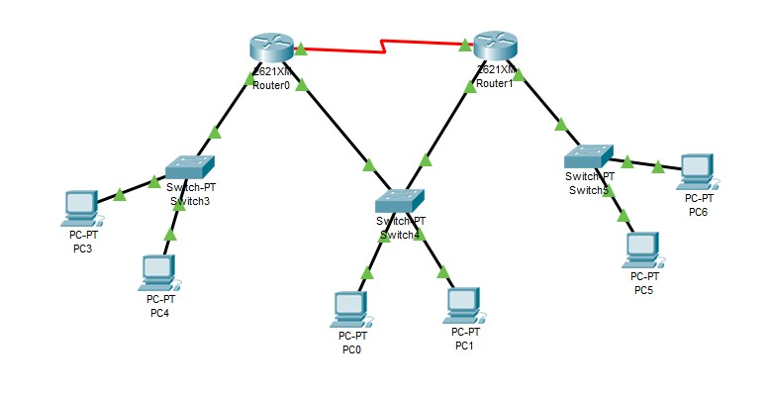

Subnet Table:
Subnet | Network ID | Subnet Mask | 1st Usable IP | 2nd Usable IP | Last Usable IP | Broadcast
1 | 196.10.0.0 | 255.255.255.224 | 196.10.0.1 | 196.10.0.2 | 196.10.0.30 | 196.10.0.31
2 | 196.10.0.32 | 255.255.255.224 | 196.10.0.33 | 196.10.0.34 | 196.10.0.62 | 196.10.0.63
3 | 196.10.0.64 | 255.255.255.224 | 196.10.0.65 | 196.10.0.66 | 196.10.0.94 | 196.10.0.95
4 | 196.10.0.96 | 255.255.255.224 | 196.10.0.97 | 196.10.0.98 | 196.10.0.126 | 196.10.0.127
5 | 196.10.0.128 | 255.255.255.224 | 196.10.0.129 | 196.10.0.130 | 196.10.0.158 | 196.10.0.159

Topology:
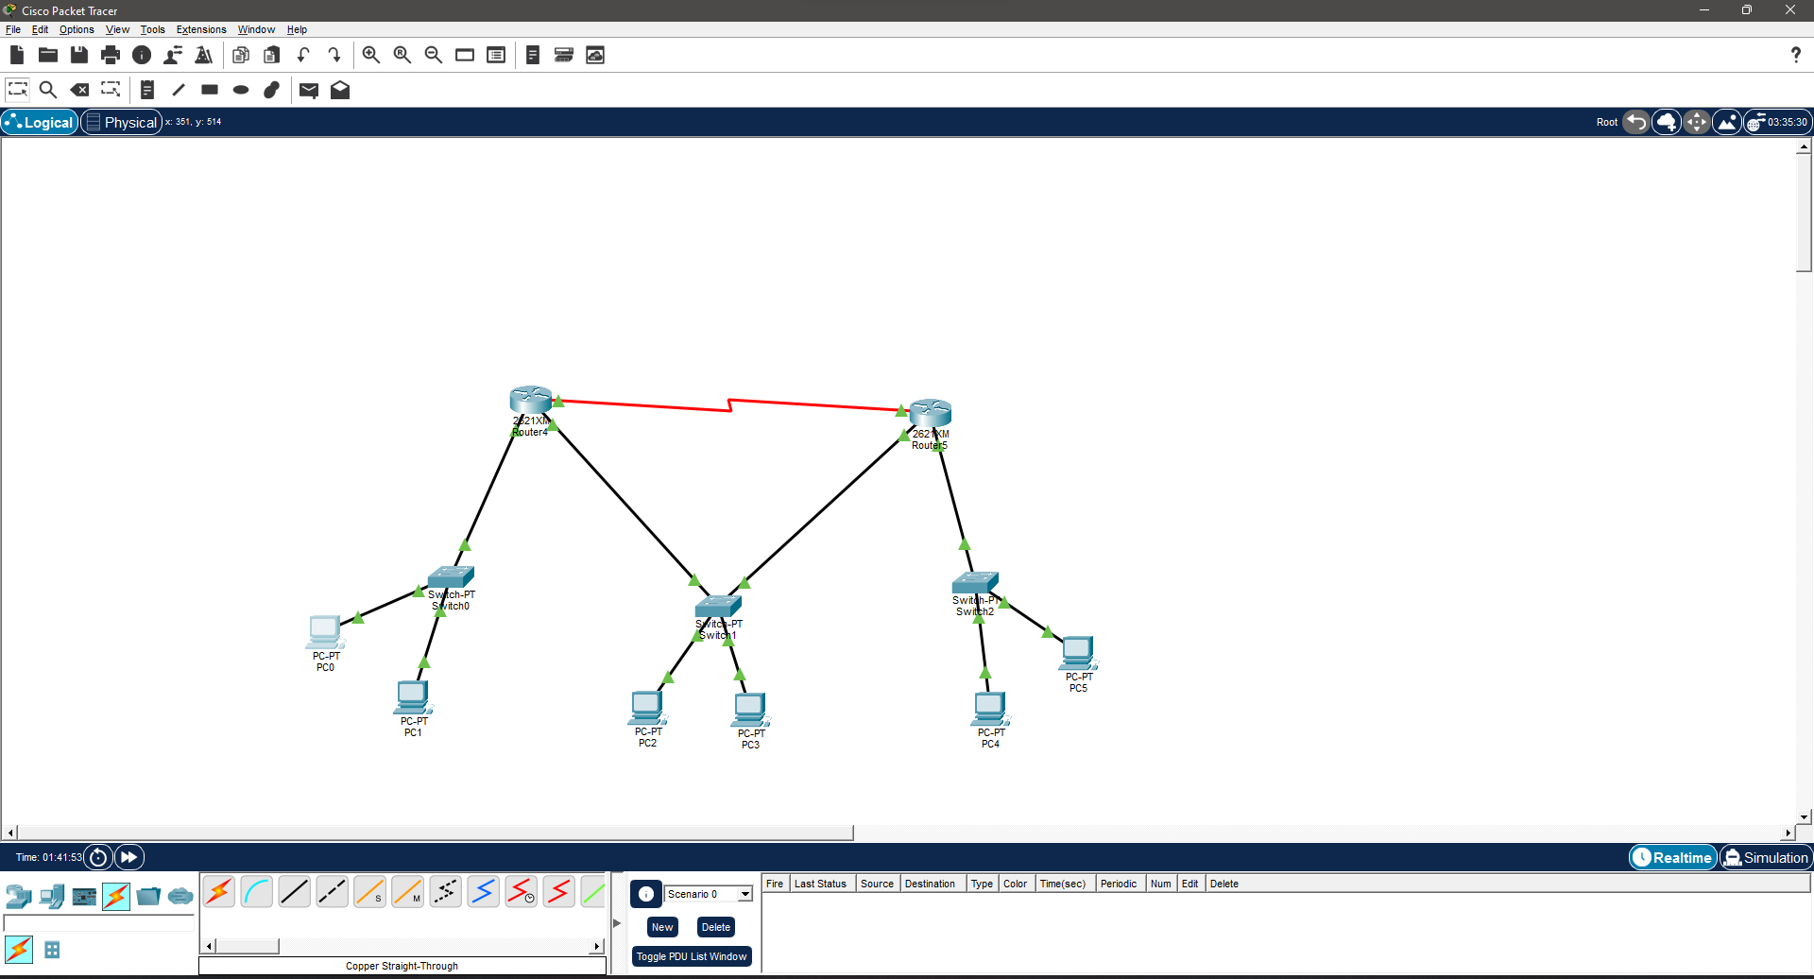
Ip configuration at router 1(named as router 4 in packet tracer):
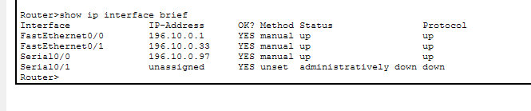
Ip configuration at router 2(named as router 5 in packet tracer):
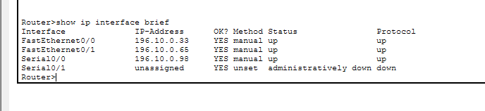
PC0 configuration:
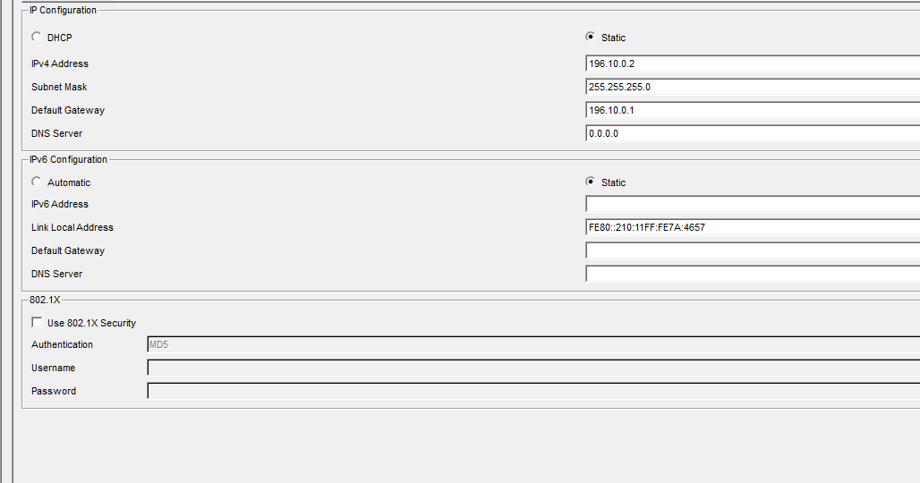
PC2 configuration:
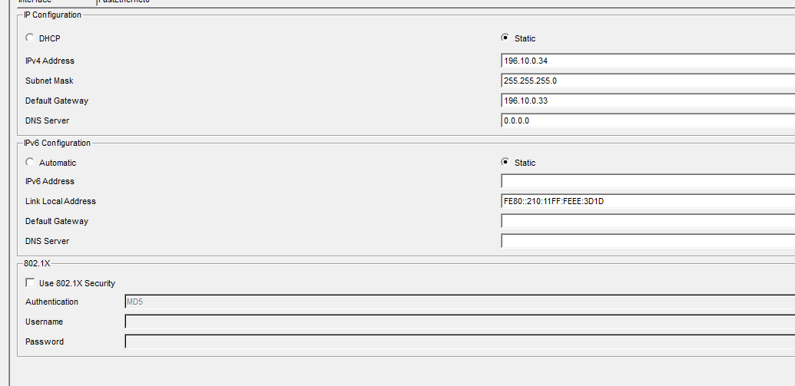

Pinging from PC0 to PC2
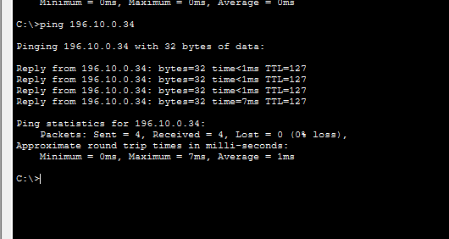
Task 2:
You have learned IP Addressing classes, CIDR and their fix length subnet mask (FLSM) and variable length subnet mask VLSM. Also, you have practice of static routing between networks in previous labs. Now you are required to configure the given topology using the above-mentioned concepts. For this topology is given. IP: 10.0.0.0 & subnet mask: 255.0.0.0. You are required to create subnetworks but with different number of required Host IDs using VLSM technique of the given IP address of class A.
Clearly perform each step from scratch to generate the required subnets and their IP address, now configure topology using these Ips and subnets and perform topology static routing testing. Each step has marks, so be careful.
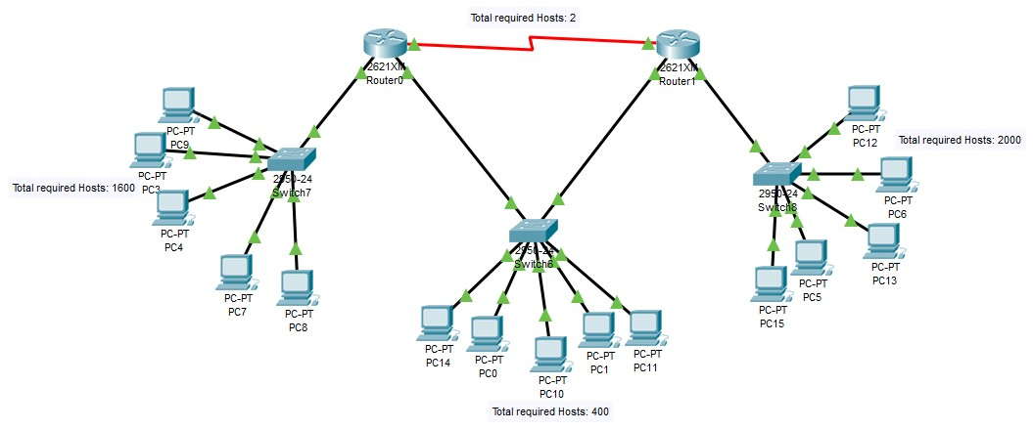

VLSM RULE:
LAN | Hosts Needed
LAN 1 | 2000
LAN 2 | 1000
LAN 3 | 400
WAN (Serial) | 2

FINAL SUBNET TABLE:

LAN (2000 Hosts):
Field | Value
Subnet ID | 10.0.0.0
Subnet Mask | 255.255.248.0 (/21)
First Usable IP | 10.0.0.1
Last Usable IP | 10.0.7.254
Broadcast | 10.0.7.255
Total Hosts | 2046

LAN (1000 Hosts):
Field | Value
Subnet ID | 10.0.8.0
Subnet Mask | 255.255.252.0 (/22)
First Usable IP | 10.0.8.1
Last Usable IP | 10.0.11.254
Broadcast | 10.0.11.255
Total Hosts | 1022

LAN (400 Hosts):
Field | Value
Subnet ID | 10.0.12.0
Subnet Mask | 255.255.254.0 (/23)
First Usable IP | 10.0.12.1
Last Usable IP | 10.0.13.254
Broadcast | 10.0.13.255
Total Hosts | 510

WAN / SERIAL LINK:
Field | Value
Subnet ID | 10.0.14.0
Subnet Mask | 255.255.255.252 (/30)
First Usable IP | 10.0.14.1
Last Usable IP | 10.0.14.2
Broadcast | 10.0.14.3
Total Hosts | 2

SUMMARY TABLE:
Network | Purpose | Subnet
10.0.0.0/21 | Right LAN (2000 hosts) | Router → Switch
10.0.8.0/22 | Left LAN (1000 hosts) | Router → Switch
10.0.12.0/23 | Middle LAN (400 hosts) | Switch shared
10.0.14.0/30 | WAN link | Router ↔ Router

Topology:
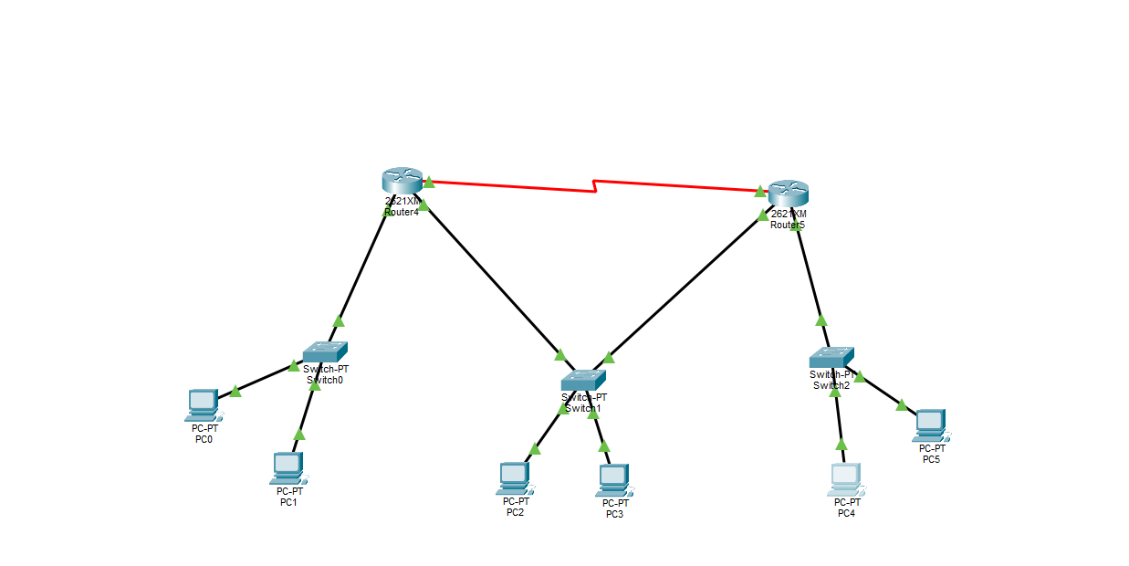

Ip configuration router 1(named as router 4 in packet tracer):
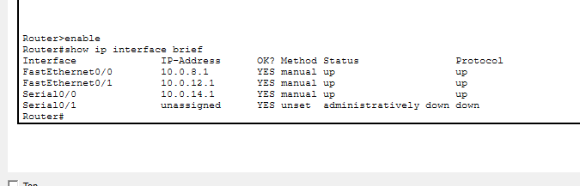
Ip configuration router 2(named as router 5 in packet tracer):
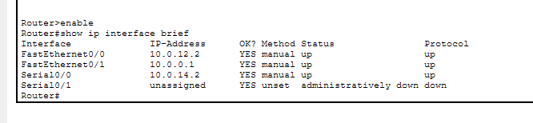

PC0 configuration:
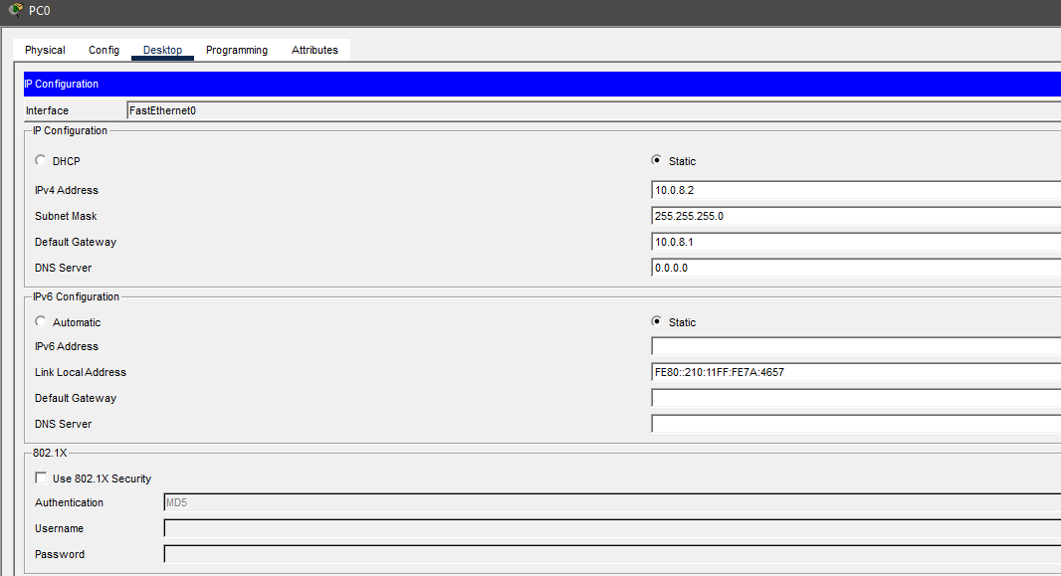

PC4 configuration:
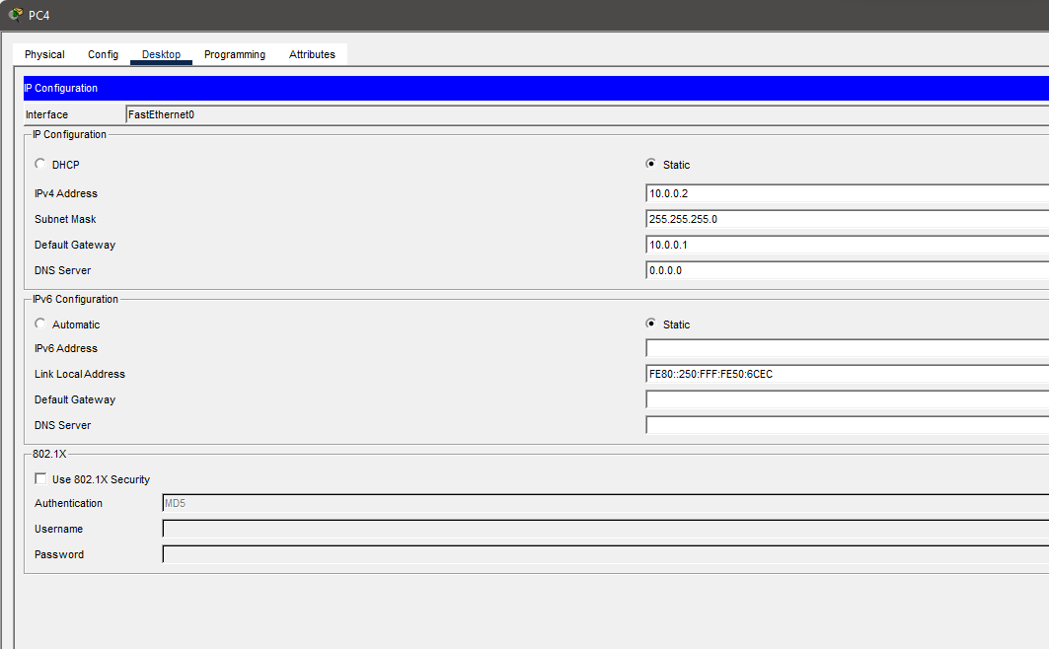Pinging From PC0 to PC4:
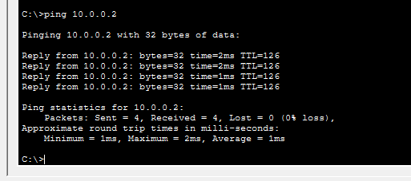

Pinging From PC4 to PC0:
