Digital Sustainability
Mannonov Og’abek

Unit 41: Digital Sustainability
Lecturer: Konstantin Drygin
Group:23-316
Student ID: 231105
Submission date: 24.01.2026

BTEC LEARNER ASSESSMENT SUBMISSION AND DECLARATION

When submitting evidence for assessment, each learner must sign a declaration confirming that the work is their own.

Learner(Student) ID | 231105
Assessor name: | Konstantin Drygin
BTEC Programme Title: | Pearson BTEC Higher Nationals in Digital Technologies
Unit or Component Number and Title: | UNIT 41: Digital Sustainability
Assignment Title:
Date Assignment Submitted: | 24.01.2026

Please list the evidence submitted for each task. Indicate the page numbers where the evidence can be found or describe the nature of the evidence (e.g. video, illustration).

Assignment task reference | Evidence submitted

Learner declaration

I certify that the work submitted for this assignment is my own. I have clearly referenced any sources used in the work. I understand that false declaration is a form of malpractice.



Learner declaration: Date: 24.01.2026

Table of Contents:

Introduction 5
Task 1 - International Frameworks and Agreements for Sustainability 6
Task 2 - Local Problem: Global Connection 9
Task 3 - IT Solution (Software Developer) 10
Task 4 - Energy Consumption and Carbon Footprint Calculation 12
Task 5 - Multidiscipline Cooperation (Option A) 14
Conclusion 15
Reference List 16

Introduction

Sustainability has become a key global concern as climate change, rising energy consumption, and carbon emissions increasingly affect societies and economies. Digital technologies play an important role in addressing these challenges by enabling more efficient use of resources through monitoring, optimisation, and automation. At the same time, digital systems must be designed responsibly to minimise their own environmental impact. This assignment examines digital sustainability by linking global frameworks, national policies, and local challenges. It explores the Paris Agreement as an international sustainability framework and connects it to energy inefficiency in public buildings in Uzbekistan. The work then proposes a digital energy management system as a practical IT solution, evaluates its carbon footprint, and highlights the importance of multidisciplinary cooperation in achieving sustainable outcomes.

Task 1 - International Frameworks and Agreements for Sustainability

The Paris Agreement

Background
The Paris Agreement is an international climate agreement adopted in 2015 at the 21st Conference of the Parties (COP21) in Paris, France. It was developed under the umbrella of the United Nations Framework Convention on Climate Change (UNFCCC) and officially entered into force in November 2016. The agreement was supported by almost all countries worldwide, including both developed and developing nations, in response to the growing threat of global climate change.(UNFCCC, 2023)
The main motivation for creating the Paris Agreement was the increasing scientific evidence that human activities, particularly the burning of fossil fuels, are driving global warming. Earlier frameworks such as the Kyoto Protocol had limited success because they placed binding obligations mainly on developed countries. In contrast, the Paris Agreement introduced a more inclusive and flexible approach, allowing all countries to contribute according to their national capabilities and circumstances.

Main Idea
The core objective of the Paris Agreement is to limit the rise in global average temperature to well below 2°C above pre-industrial levels, while making efforts to restrict it to 1.5°C. This goal highlights the close relationship between environmental protection and economic development. Climate change is not only an environmental issue but also a social and economic challenge that affects public health, food security, infrastructure, and technological progress.
The agreement promotes global responsibility by requiring participation from all countries while recognising different levels of development. It supports sustainable economic growth by encouraging low-carbon development pathways, clean energy adoption, and technological innovation. (United Nations, 2023)

How It Was Made
The Paris Agreement was developed through long-term international negotiations within the UNFCCC framework. Governments, climate scientists, non-governmental organisations, and private sector stakeholders were involved in the discussions. Annual Conferences of the Parties (COP) played a key role in shaping and refining the agreement.
A major innovation of the Paris Agreement is its bottom-up structure. Instead of imposing uniform targets, countries submit Nationally Determined Contributions (NDCs), which describe how they plan to reduce greenhouse gas emissions and adapt to climate impacts. This approach increased political acceptance and encouraged broad global participation.(UNFCCC, 2023)

Key Topics
The Paris Agreement addresses several important areas:
- Reduction of greenhouse gas emissions
- Transition to renewable and clean energy sources
- Climate adaptation and resilience
- Climate finance for developing countries
- Technology transfer and capacity building
- Sustainable cities, transport systems, and industrial development
Digital technologies are increasingly important across these areas, particularly in emissions monitoring, energy management, and smart infrastructure development.

Implementation and Monitoring
Implementation of the Paris Agreement relies on national climate plans (NDCs), which are reviewed and updated every five years. Countries are expected to increase their level of ambition over time. A transparency framework requires countries to report emissions data, policy actions, and progress using common reporting standards.
Global review mechanisms such as the Global Stocktake assess collective progress towards long-term climate goals. Although the agreement does not include strict penalties, transparency and international accountability encourage countries to comply with their commitments.

Results and Impact
The Paris Agreement has had a strong influence on global climate policy. It has stimulated investment in renewable energy, low-carbon technologies, and sustainable innovation. Many countries have introduced national climate strategies and long-term carbon neutrality targets.
Despite these achievements, current national commitments remain insufficient to fully meet the 1.5°C target, and progress differs between regions. Nevertheless, the agreement is effective as a global coordination framework rather than a strict enforcement mechanism. Its main strength lies in providing a shared direction for climate action and accelerating the transition towards low-carbon technologies. Without reliable data, transparent reporting, and digital monitoring systems, the agreement would risk remaining symbolic rather than operational.(Climate Action Tracker, 2024)

Criticism
Critics argue that the Paris Agreement relies too heavily on voluntary commitments and lacks strong enforcement mechanisms. Some countries may set unambitious targets or fail to meet their pledges. In addition, financial support for developing countries has not always met expectations, which can limit effective implementation.

Connection to Digital Sustainability
Digital sustainability is a critical enabler of the Paris Agreement. Modern climate action depends on digital technologies such as smart grids, IoT sensors, cloud platforms, and data analytics systems. These tools enable accurate measurement of emissions, optimisation of energy consumption, and real-time evaluation of policy effectiveness.
For example, digital carbon accounting platforms support countries in tracking progress against their NDCs, while energy-efficient software and low-power data centres reduce the environmental impact of digital infrastructure itself. Without sustainable digital technologies, achieving the transparency, scalability, and efficiency required by the Paris Agreement would be extremely difficult. Therefore, digital sustainability is essential to the long-term success of this global framework.

Connection to Uzbekistan Local Acts
Uzbekistan is a signatory to the Paris Agreement and has adopted national strategies aligned with its objectives, including renewable energy development programs and climate adaptation policies. These initiatives support energy efficiency, digital monitoring systems, and sustainable technological solutions at the national and local levels.

Task 2 - Local Problem: Global Connection

Energy Inefficiency in Public Buildings in Uzbekistan
One significant sustainability problem in Uzbekistan is the inefficient use of energy in public buildings such as schools, universities, hospitals, and government offices. Many of these buildings rely on outdated heating, cooling, and lighting systems, which leads to excessive electricity and gas consumption. As a result, energy waste increases operational costs and contributes to higher carbon dioxide emissions.(Uzbekistan Ministry of Energy, 2023)
This issue is recognised at the national level through Uzbekistan’s energy efficiency and green economy development strategies, which aim to reduce energy losses, modernise public infrastructure, and promote the use of digital energy management systems. National programs supporting building renovation, smart metering, and efficient energy use directly address this problem by encouraging more sustainable management of public facilities.(Uzbekistan Ministry of Ecology, 2023)
At the global level, energy inefficiency in buildings is closely connected to the Paris Agreement, which focuses on reducing greenhouse gas emissions and supporting low-carbon development. Buildings represent a major source of energy-related emissions worldwide. By improving energy efficiency in public buildings, Uzbekistan aligns its national policies with the goals of the Paris Agreement, demonstrating how global sustainability frameworks guide practical local actions that reduce emissions and support climate objectives.(UNFCCC, 2023)

Task 3 - IT Solution (Software Developer)

Digital Energy Management System for Public Buildings

Purpose of the System
The purpose of this IT solution is to reduce energy waste in public buildings such as schools, universities, hospitals, and government offices in Uzbekistan. The system aims to monitor, control, and optimize electricity and heating usage through digital automation and data-driven decision-making. By improving energy efficiency, the solution supports national sustainability goals and contributes to reduced carbon emissions.

Main Functions of the System
The proposed system includes the following key functions:
Energy Monitoring: The system collects real-time energy consumption data from smart meters installed in public buildings. This allows facility managers to see how much electricity and heating energy is being used.
Energy Optimisation and Scheduling: Based on usage patterns, the system automatically adjusts heating, cooling, and lighting schedules. For example, energy use is reduced during non-working hours, weekends, or holidays.
Reporting and Alerts:The system provides dashboards and reports showing daily, monthly, and annual energy usage. Alerts are generated when abnormal or excessive energy consumption is detected.

System Architecture (Simple Description)
The IT solution uses a client–server architecture:
- Smart Meters / Sensors collect energy consumption data
- Backend Server (API) processes and stores data
- Database stores historical energy data
- Web Dashboard / Mobile App allows managers to view reports and control settings

Contribution to Local Sustainability
This software solution directly helps local sustainability by reducing unnecessary energy consumption in public buildings. Lower energy use leads to reduced operational costs and decreased greenhouse gas emissions.(Carbon Trust, 2023) By improving efficiency rather than only monitoring, the system creates real environmental and economic benefits.

Sustainable Techniques Used
The IT solution applies the following sustainable techniques:
Low-Power and Efficient Software Design :The system minimises background processing and data transfer, reducing server workload and electricity consumption.
Efficient Data Collection and Storage: Data is collected at optimised intervals instead of continuously, reducing network traffic and storage energy use.
Lifecycle Extension of Existing Infrastructure :The system works with existing buildings and energy systems, extending their useful life and reducing the need for new hardware production. These techniques reduce the environmental impact of the digital solution itself while supporting a low-carbon energy strategy.

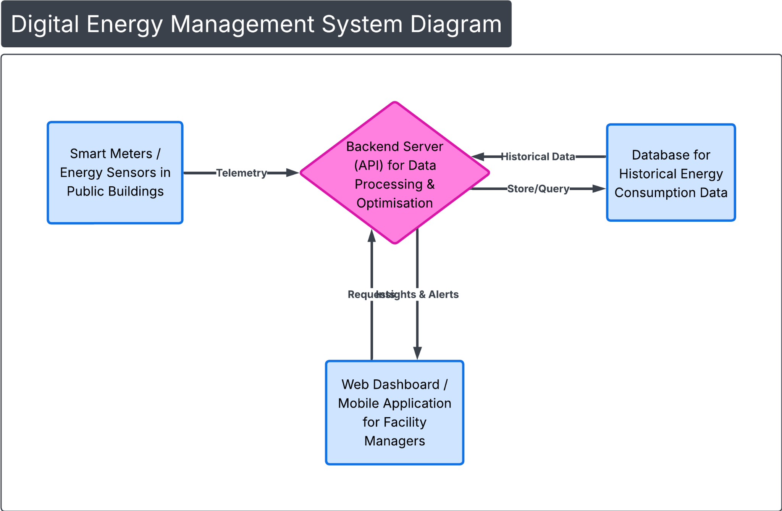

Task 4 - Energy Consumption and Carbon Footprint Calculation

Chosen Parameters
Electricity emission factor: Uzbekistan uses a mixed electricity grid with a high share of fossil fuels. Therefore, a realistic emission factor of 0.58 kg CO₂ per kWh is used.(Carbon Trust, 2023)
Power Usage Effectiveness (PUE): A PUE of 1.3 is selected, representing a reasonably efficient cloud data centre. Energy use is reduced through virtualisation, shared infrastructure, and efficient resource management.
Device | Power (W) | Daily usage (h) | Quantity | PUE | Daily energy (kWh) | Annual energy (kWh) | CO₂ (kg/year
Backend server (cloud VM) | 120 | 24 | 1 | 1.3 | 3.74 | 1366.6 | 792.6
Database storage (cloud) | 80 | 24 | 1 | 1.3 | 2.50 | 911.0 | 528.4
Network gateway/router | 10 | 24 | 1 | 1.0 | 0.24 | 87.6 | 50.8
Smart energy sensors | 2 | 24 | 20 | 1.0 | 0.96 | 350.4 | 203.2
Facility manager laptops | 50 | 4 | 2 | 1.0 | 0.40 | 146.0 | 84.7
Total daily energy: 7.84 kWh/day
Total annual energy: 2861.6 kWh/year
Total carbon footprint: 1659.7 kg CO₂/year (≈ 1.66 tCO₂/year)

The proposed digital energy management system consumes approximately 2861.6 kWh of electricity per year, resulting in an estimated 1.66 tonnes of CO₂ emissions annually based on Uzbekistan’s electricity grid emission factor. The backend server and database account for the largest share of energy consumption because they operate continuously and are affected by data centre overheads represented by the PUE value of 1.3. Energy use and emissions can be further reduced by implementing autoscaling and serverless services, which minimise idle computing time. Additional improvements include optimised data collection intervals, efficient data storage policies, and selecting cloud providers with higher renewable energy usage. These measures ensure that the digital solution itself remains energy-efficient while supporting wider sustainability and low-carbon objectives.(Berners-Lee, 2019)

Task 5 - Multidiscipline Cooperation (Option A)

Collaboration Between Disciplines in a Digital Sustainability Project
The digital energy management system for public buildings requires cooperation between specialists from multiple disciplines to ensure its effectiveness and sustainability.
Software Developers are responsible for designing and implementing the digital system. Their tasks include developing the backend server, database structure, optimisation logic, and user dashboards. They also ensure that the software is energy-efficient and scalable.
Energy Engineers provide expertise on building energy systems, heating, cooling, and electricity usage. They help define realistic optimisation rules and ensure that digital controls align with physical energy infrastructure.
Environmental Specialists analyse carbon emissions and sustainability impacts. They support the calculation of carbon footprint, validate emission reduction results, and ensure alignment with national and international climate goals.
Public Sector Facility Managers contribute operational knowledge of public buildings. They define user requirements, working schedules, and practical constraints, ensuring that the system can be applied in real-life conditions.
This multidisciplinary cooperation improves decision-making, reduces implementation risks, and ensures that the digital solution delivers measurable energy savings and environmental benefits.(Hazas and Nathan, 2019)
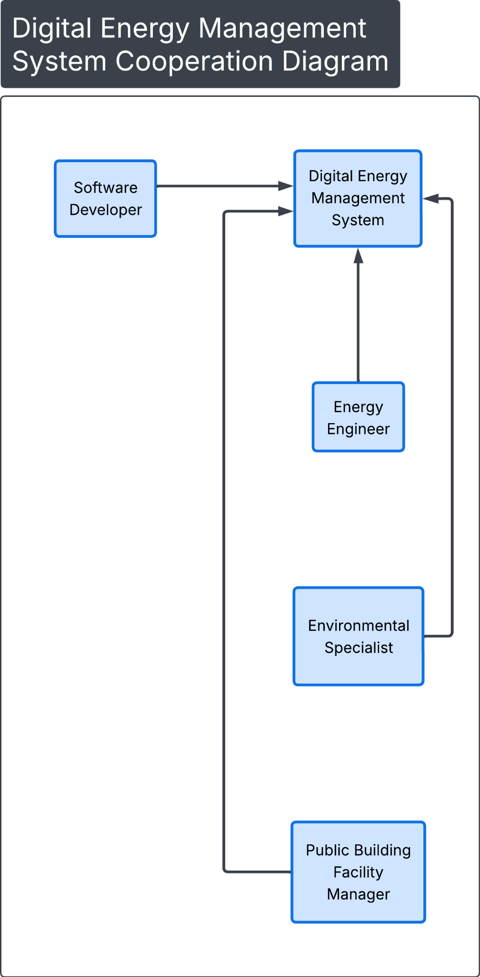

Conclusion
This assignment has demonstrated how digital technologies can play a significant role in supporting sustainability at global, national, and local levels. By analysing the Paris Agreement, the work highlighted the importance of international frameworks in guiding climate action and promoting low-carbon development. The study then connected these global objectives to a real local challenge in Uzbekistan, namely energy inefficiency in public buildings. A digital energy management system was proposed as a practical IT solution to address this issue by monitoring, optimising, and reducing energy consumption. The energy and carbon footprint calculations showed that while digital systems consume resources, their impact can be managed and reduced through efficient design, cloud optimisation, and sustainable techniques. Finally, the assignment emphasised the importance of multidisciplinary cooperation, showing that effective digital sustainability projects require collaboration between technical, environmental, and public-sector stakeholders. Overall, this work illustrates how well-designed digital solutions can contribute meaningfully to sustainable development and climate goals.

Reference List
Berners-Lee, M. (2010) How Bad Are Bananas? The Carbon Footprint of Everything. London: Profile Books.
Berners-Lee, M. (2019) There Is No Planet B: A Handbook for the Make or Break Years. Cambridge: Cambridge University Press.
Boyle, G. (2012) Energy Systems and Sustainability: Power for a Sustainable Future. Oxford: Oxford University Press.
Carbon Trust (2023) Introduction to Carbon Footprinting. Available at: https://www.carbontrust.com (Accessed: 2026).
Climate Action Tracker (2024) Global Climate Targets and Progress. Available at: https://climateactiontracker.org (Accessed: 2026).
Fenner, A. and Ainger, C. (2013) Sustainable Infrastructures: Principles into Practice. London: ICE Publishing.
Hazas, M. and Nathan, L. (2019) Digital Technology and Sustainability: Engaging the Paradox. London: Routledge.
United Nations (2023) Climate Action and Sustainable Development. Available at: https://www.un.org/en/climatechange (Accessed: 2026).
United Nations Framework Convention on Climate Change (UNFCCC) (2023) The Paris Agreement. Available at: https://unfccc.int (Accessed: 2026).
Uzbekistan Ministry of Energy (2023) Energy Efficiency and Renewable Energy Policies. Available through official government publications.
Uzbekistan Ministry of Ecology (2023) Environmental Protection and Green Economy Strategy. Available through official government publications.

