Risk Analysis and Systems Testing
Mannonov Og’abek

Unit 28: Risk Analysis and Systems Testing
Lecturer: Muhammadaziz Xoliqberdiyev
Group:23-316
Student ID: 231105
Submission date: 25.01.2026

BTEC LEARNER ASSESSMENT SUBMISSION AND DECLARATION

When submitting evidence for assessment, each learner must sign a declaration confirming that the work is their own.

Learner(Student) ID | 231105
Assessor name: | Muhammadaziz Xoliqberdiyev
BTEC Programme Title: | Pearson BTEC Higher Nationals in Digital Technologies
Unit or Component Number and Title: | UNIT 28: Risk Analysis and Systems Testing
Assignment Title:
Date Assignment Submitted: | 25.01.2026

Please list the evidence submitted for each task. Indicate the page numbers where the evidence can be found or describe the nature of the evidence (e.g. video, illustration).

Assignment task reference | Evidence submitted

Learner declaration

I certify that the work submitted for this assignment is my own. I have clearly referenced any sources used in the work. I understand that false declaration is a form of malpractice.



Learner declaration: Date: 25.01.2026

Table of Contents:

Introduction 4
Task 1 5
Task 2 7
Task 3 10
Conclusion 19
Reference List 20

Introduction
Software quality assurance is a critical aspect of modern software development, as even small defects can lead to serious functional, financial, and reputational consequences. With the increasing complexity of web applications and APIs, it is no longer practical to test every possible scenario within limited time and resources. For this reason, risk-based testing has become an important approach in identifying and prioritising the most critical areas of a system.
This assignment focuses on risk analysis and systematic testing techniques applied to a real-world web application. It aims to identify high-risk functionalities, evaluate their impact and probability, and design appropriate testing strategies to reduce potential failures. The work also covers manual test case design using positive and negative scenarios, including Boundary Value Analysis and Error Guessing techniques. In addition, the assignment demonstrates automated API testing using Postman to support early detection of integration-level defects. Overall, this assignment highlights the importance of structured testing, risk prioritisation, and automation in ensuring reliable, high-quality software systems.

Task 1
Website under test: https://www.automationexercise.com

1. Risk Determination
One of the most significant risks identified on the AutomationExercise website is the failure or incorrect operation of the Login and Signup functionality. Authentication is a core entry point to the system, enabling users to access their accounts and interact with essential features such as product browsing, cart management, and API-based services. If users are unable to log in or register successfully, they are effectively blocked from using the application.
This risk is critical because authentication issues directly affect system accessibility and usability. Any defect in this area can lead to user frustration, reduced trust in the application, and a negative overall user experience. As a result, login and signup defects represent a high-priority risk that must be addressed early in the testing process.

2. Impact Assessment
Impact: 80%
A failure in the login or signup process would prevent users from accessing the system entirely. This would make other dependent functionalities unavailable and significantly reduce the value of the application. From both a technical and business perspective, such a failure would have serious consequences, including loss of users and reduced system credibility. Therefore, the impact of this risk is assessed as high.

3. Probability Assessment
Probability: 60%
Login and signup functionalities are among the most frequently used components of a web application. They involve multiple elements such as input validation, database interaction, authentication logic, and session management. Due to their complexity and high usage frequency, there is a moderate to high likelihood of defects occurring, particularly when changes are introduced or when the system is tested with a wide range of inputs.

4. Risk Exposure Calculation
Formula:
Risk Exposure = Impact × Probability

Calculation:
0.8 × 0.6 = 0.48 (48%)

Risk Level:
48% – Medium to High Risk
This result indicates that the login and signup functionality should be prioritised during testing activities.

5. Systematic Testing Process
To identify and reduce this risk, a structured testing approach should be applied:
- Functional Testing to verify correct login and registration behaviour
- Boundary Value Analysis to test limits such as minimum and maximum input lengths
- Error Guessing to identify common user mistakes, including empty or invalid inputs
- Regression Testing to ensure updates do not introduce new authentication defects
- Automation Testing to repeatedly validate login behaviour efficiently

6. Preventive Measures
The following preventive measures can help minimise this risk:
- Implementing clear and consistent input validation rules for authentication fields
- Displaying meaningful and user-friendly error messages
- Applying backend validation alongside frontend checks
- Integrating automated authentication tests into the continuous testing process
These measures support early defect detection and improve the stability and reliability of the authentication functionality.

Risk ID | Risk Description | Impact (%) | Probability (%) | Risk Exposure | Risk Level | Priority
R1 | Failure or incorrect operation of Login and Signup functionality | 80% | 60% | 48% | Medium–High | High

Task 2
2.1 Login / Signup Test Cases
Test Case ID | Test Title | Preconditions | Test Steps | Expected Result | Status
TC-01 | Login with valid credentials | User registered | 1. Open login page  2. Enter valid email  3. Enter valid password  4. Click Login | User logs in successfully | Pass
TC-02 | Login with invalid password (Error Guessing) | User registered | 1. Enter valid email  2. Enter wrong password  3. Click Login | Error message displayed | Pass
TC-03 | Login with empty fields (Error Guessing) | None | 1. Leave fields empty  2. Click Login | Validation error shown | Pass
TC-04 | Signup with short password (BVA) | None | 1. Enter valid email  2. Enter password less than min length  3. Click Signup | Password validation error | Pass
2.2 Products Test Cases
Test Case ID | Test Title | Preconditions | Test Steps | Expected Result | Status
TC-05 | View product list | Website accessible | 1. Navigate to Products page | Product list is displayed | Pass
TC-06 | Search for existing product | Products available | 1. Enter valid product name  2. Click Search | Matching products displayed | Pass
TC-07 | Search with empty input (Error Guessing) | None | 1. Leave search field empty  2. Click Search | No results or validation message shown | Pass

2.3 Cart Test Cases
Test Case ID | Test Title | Preconditions | Test Steps | Expected Result | Status
TC-08 | Add product to cart | Product available | 1. Select product  2. Click Add to Cart | Product added to cart | Pass
TC-09 | Add multiple products to cart | Products available | 1. Add first product  2. Add second product | All products appear in cart | Pass
TC-10 | Add product quantity beyond limit (BVA) | Product available | 1. Increase quantity beyond allowed limit  2. Add to cart | Quantity validation error | Pass

Test Case ID | Test Title | Preconditions | Test Steps | Expected Result | Status
TC-11 | Login with invalid email format (Error Guessing) | None | 1,Open login page  2.Enter email: abc@ (invalid format)  3.Enter any password  4.Click Login | Validation message shown for invalid email format | Pass
TC-12 | Signup with empty email field (Error Guessing) | None | 1.Open signup page  2.Leave email field empty  3.Enter valid password  4.Click Signup | Validation error shown (email required) | Pass
TC-13 | Search for non-existing product (Negative) | Products available | 1.Go to Products page  2.Enter a random name: zzzz_non_existing_item_123  3.Click Search | No products found message OR empty results shown | Pass
TC-14 | Remove product from cart | At least one product added to cart | 1.Open Cart page  2.Click “X” / Remove on an item  3.Refresh cart if needed | Selected product removed and cart updated correctly | Pass
TC-15 | Update product quantity to 0 (BVA – lower boundary) | Product in cart | 1.Open Cart page  2.Set quantity to 0 (or decrease below 1 if possible)  3.Update cart / click outside input | System prevents 0 quantity OR automatically removes item / shows validation error | Pass

Bug Report Section
Bug ID | Title | Steps to Reproduce | Expected Result | Severity
BR-01 | Login error message unclear | Enter valid email + wrong password | Clear error message | Medium

Task 3

3.1 Overview of Automated API Testing
This task focuses on automating integration testing for REST APIs using Postman. Automated API testing was selected to ensure consistent validation of system behaviour, reduce manual testing effort, and detect defects early in the development lifecycle. A risk-based testing approach was applied, prioritising APIs related to authentication, data access, and core business functionality.
Ten APIs were selected from the AutomationExercise API list and tested using Postman post-response scripts written in JavaScript. Both positive and negative scenarios were included to validate expected behaviour under normal and erroneous conditions.

3.2 Selected APIs for Testing
The following APIs were selected for integration testing:
- GET /api/productsList
- POST /api/productsList (unsupported method)
- GET /api/brandsList
- PUT /api/brandsList (unsupported method)
- POST /api/searchProduct
- POST /api/searchProduct (missing parameter)
- POST /api/verifyLogin (valid details)
- POST /api/verifyLogin (missing parameters)
- DELETE /api/verifyLogin (unsupported method)
- POST /api/verifyLogin (invalid credentials)
Authentication-related APIs were prioritised due to their higher security risk, while product and search APIs were prioritised due to their importance to core system functionality.

3.3 Test Environment and Setup
Testing was performed using the Postman desktop application on a local machine, simulating a build execution environment. All requests were organised into a Postman collection. For POST requests, parameters were sent using x-www-form-urlencoded format as required by the API specification.
Automated assertions were added in the Post-response (Tests) section of each request using JavaScript.

3.4 Automated Test Scripts (Examples)
The following JavaScript test scripts were implemented in the Post-response section of Postman.

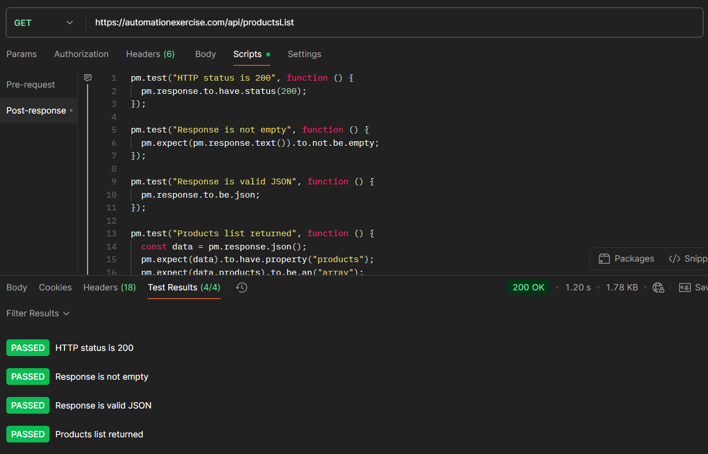
Get All Products List
Example 1: GET Products List
pm.test("HTTP status is 200", function () {
pm.response.to.have.status(200);
});
pm.test("Products list is returned", function () {
const data = pm.response.json();
pm.expect(data.products).to.be.an("array").that.is.not.empty;
});
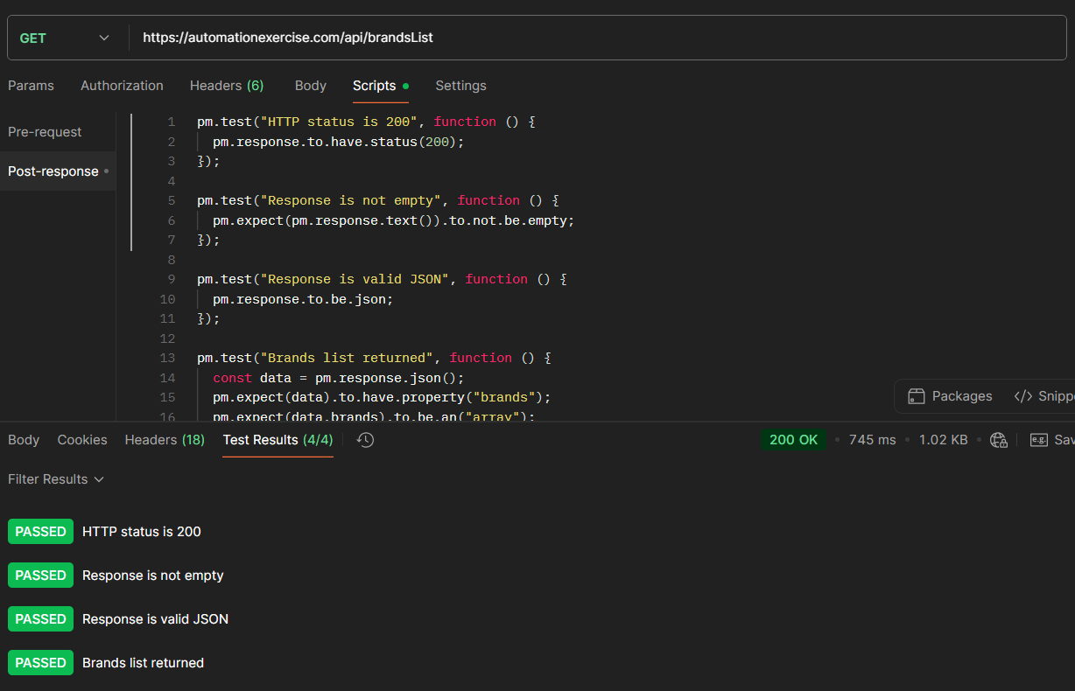
Get All Brands List

Example 2: Verify Login – Invalid Credentials
pm.test("Response is valid JSON", function () {
pm.response.to.be.json;
});

pm.test("Invalid login returns appropriate message", function () {
const data = pm.response.json();
pm.expect(data.message.toLowerCase()).to.satisfy(msg =>
msg.includes("invalid") ||
msg.includes("not found") ||
msg.includes("user exists")
);
});
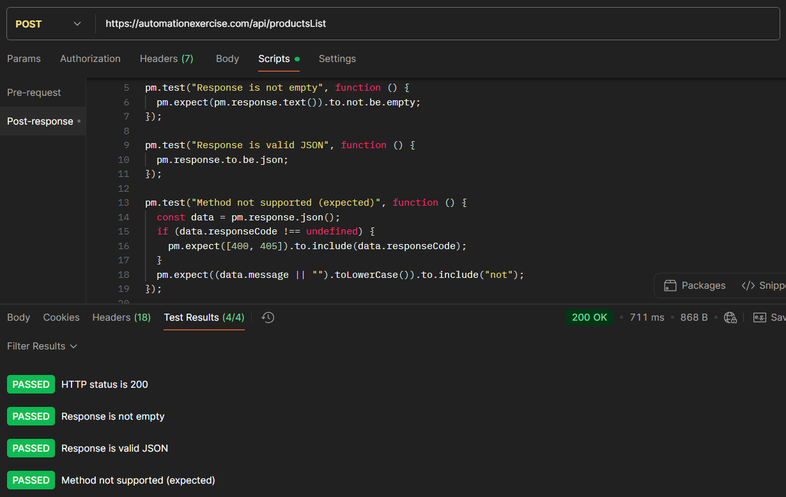
Post To All Products List
Api Endpoint api/productList
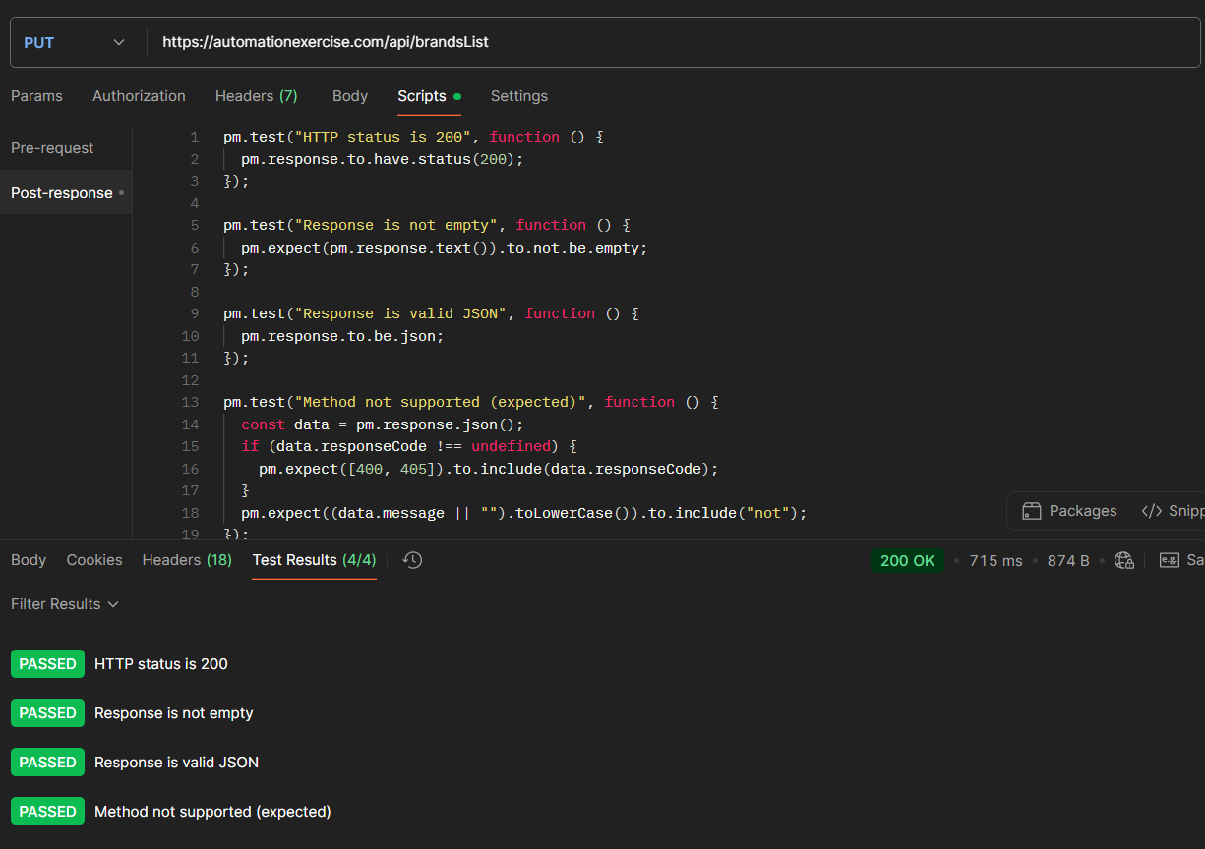
Put To All Brands List
Api Endpoint api/brandsList
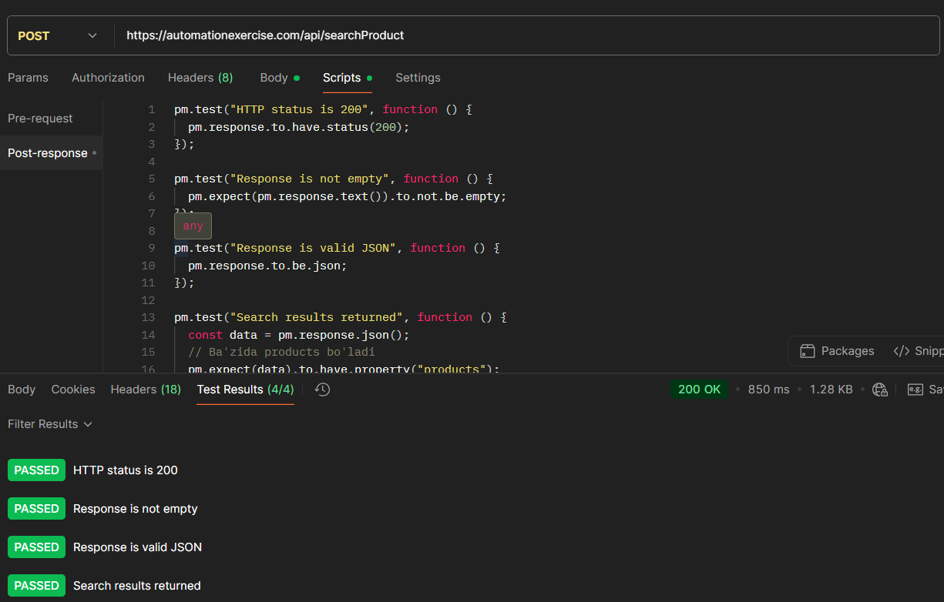
Post To Search Product
Api Endpoint api/searchProduct
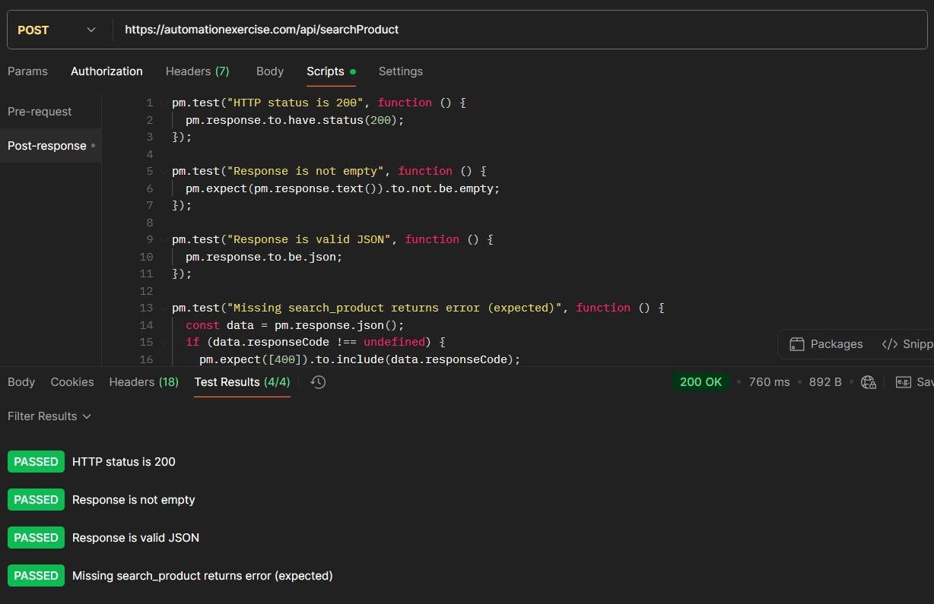
POST To Search Product without search_product parameter
Api Endpoint api/searchProduct
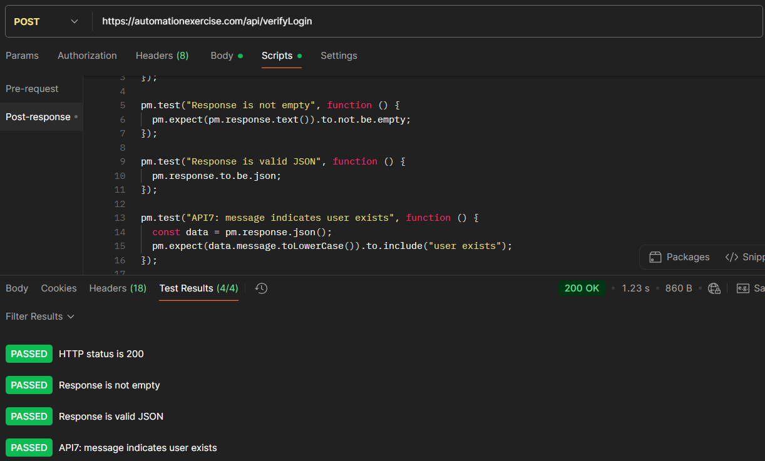
POST To Verify Login with valid details
Api Endpoint api/verifyLogin
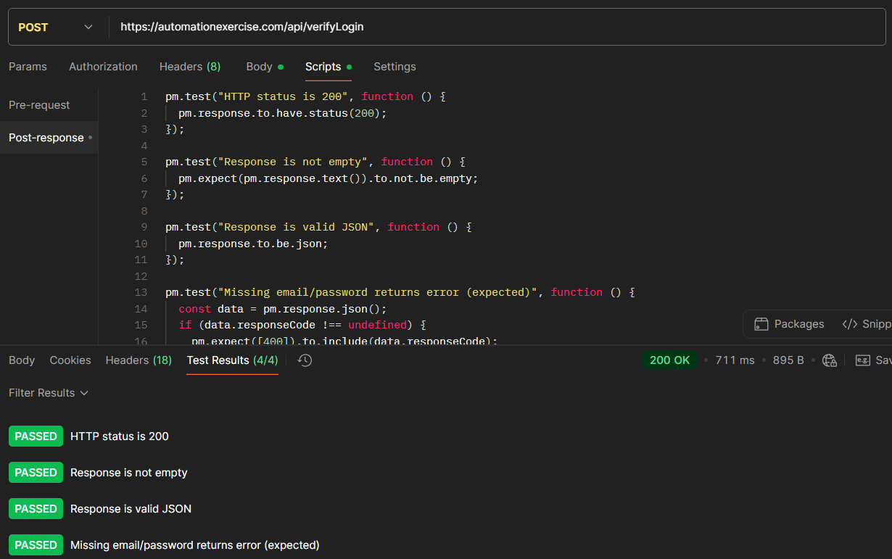
POST To Verify Login without email parameter
Api Endpoint api/verifyLogin

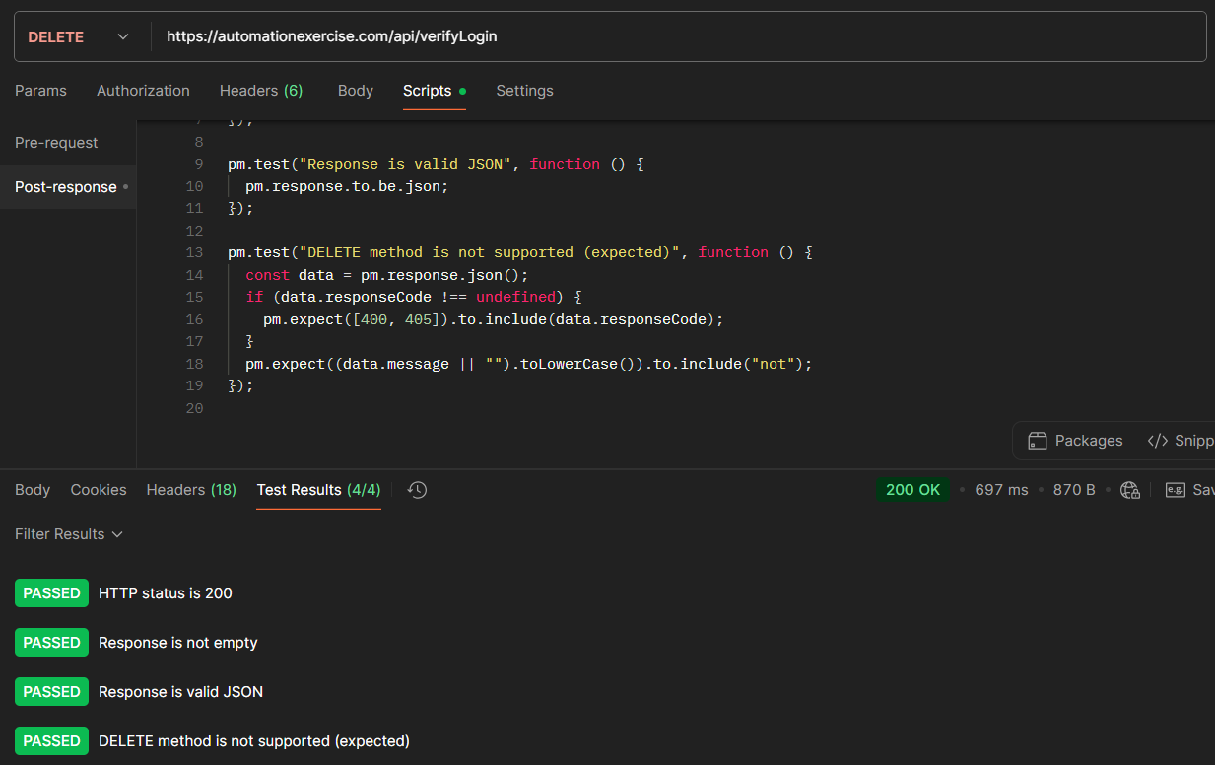
DELETE To Verify Login
Api Endpoint api/verifyLogin
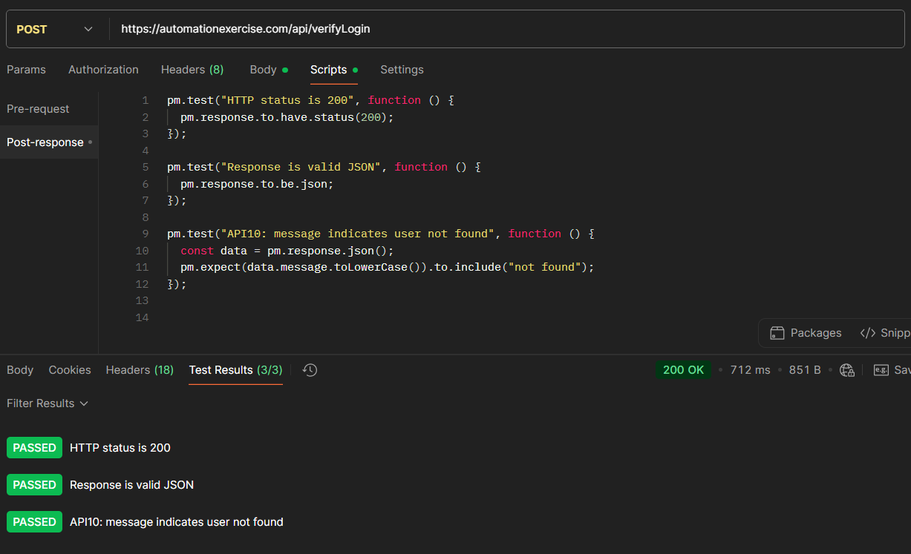
POST To Verify Login with invalid details
Api Endpoint api/verify/Login
Similar scripts were implemented for the remaining APIs to validate HTTP status codes, response structure, error handling, and business logic messages.

3.5 Test Execution and Results Log
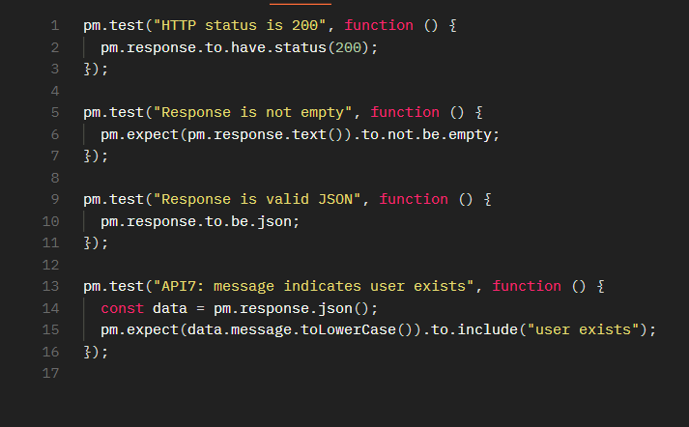
Figure 1 below demonstrates successful execution of automated Postman tests with all assertions passed.
All automated tests were executed successfully within the Postman environment. Initial failures occurred due to incorrect parameters and reused email addresses during account creation. These issues were resolved by correcting field names and using unique test data.
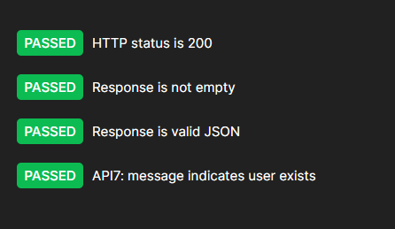
Summary of results:
- Products and brands APIs returned valid lists – Pass
- Unsupported HTTP methods returned appropriate error messages – Pass
- Search API returned results when parameters were provided and errors when missing – Pass
- Authentication APIs returned expected messages for valid, invalid, and missing credentials – Pass

3.6 Modifications and Justification
Modifications were applied during testing to ensure accurate validation and risk isolation. Unique email addresses were used for account creation to avoid duplicate user conflicts. Parameter mismatches were corrected to align with API specifications. These changes ensured reliable test execution and reduced false failures.

3.7 Build Environment and Risk-Based Prioritisation
Postman supports automated execution of API tests and can be extended to CI/CD pipelines using Newman. Risk-based prioritisation was applied by testing authentication and account-related APIs first due to their higher impact on security and data integrity. This approach improves defect detection efficiency and reduces the likelihood of critical failures reaching production.

Conclusion
This assignment has demonstrated the application of risk-based testing and automated integration testing to improve software quality and reliability. Through Task 1 and Task 2, key risks within the AutomationExercise application were identified and addressed using structured manual test cases, including both positive and negative scenarios. These activities highlighted the importance of early risk identification and systematic testing in reducing defects.
Task 3 further strengthened the testing process by implementing automated API testing using Postman. Automated post-response scripts validated HTTP responses, data structures, and business logic for critical endpoints, particularly authentication-related APIs with higher security risks. The use of automation improved consistency, efficiency, and repeatability of testing activities.
Overall, the combination of manual and automated testing techniques, supported by a risk-based approach, ensured comprehensive test coverage and early defect detection. This approach aligns with industry best practices and demonstrates how structured testing contributes to delivering reliable and high-quality software systems.

Reference List
AutomationExercise (2025) Automation Exercise – API List. Available at: https://www.automationexercise.com/api_list (Accessed: 24 January 2026).
AutomationExercise (2025) Automation Exercise – Web Application. Available at: https://www.automationexercise.com (Accessed: 24 January 2026).
ISTQB (2024) Certified Tester Foundation Level Syllabus v4.0.1. International Software Testing Qualifications Board. Available at:
https://istqb.org/wp-content/uploads/2024/11/ISTQB_CTFL_Syllabus_v4.0.1.pdf (Accessed: 24 January 2026).
Postman (2025) Postman Documentation – Automated Testing. Available at: https://learning.postman.com/docs/writing-scripts/test-scripts/ (Accessed: 24 January 2026).
Myers, G.J., Sandler, C. and Badgett, T. (2011) The Art of Software Testing. 3rd edn. Hoboken: John Wiley & Sons.
Pressman, R.S. and Maxim, B.R. (2020) Software Engineering: A Practitioner’s Approach. 9th edn. New York: McGraw-Hill Education.

