**Faults in ICT Tools**

* ICT tools develop hardware and software faults.
* You can troubleshoot faults and find quick solutions.
* Some faults require the help of a trained ICT technician to fix them.
* When using tools, make sure you use the correct tool and you handle the tool correctly.
* When fixing ICT faults, ICT tools from a Professional tools kit are used.
* In a professional tools kit, you find the following tools;

1. **Electrostatic discharge tools**, commonly known as **ESD tools**.

* ESD tools have antistatic wrist and mat to prevent static electricity from accumulating on hardware or on the technician.

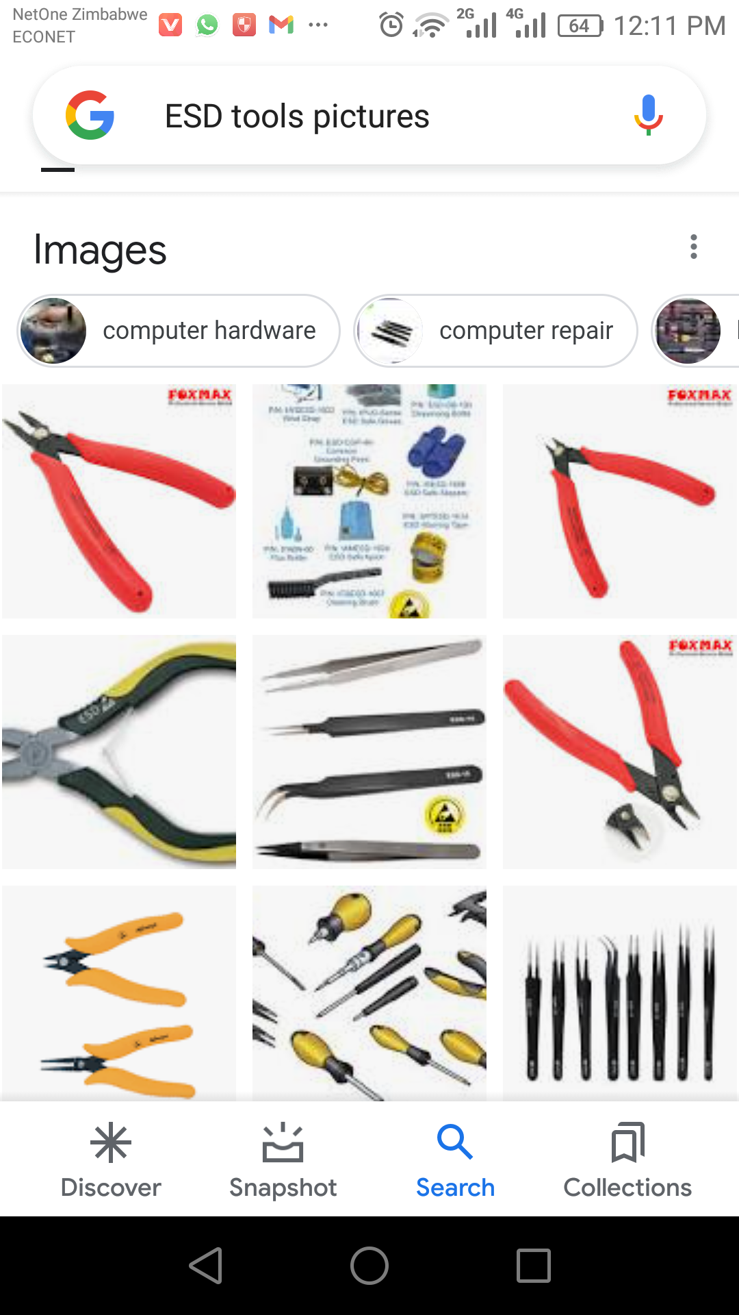

* Static electricity damage hardware.
* ESD tools prevent electric shocks when fixing ICT tools.

1. **Hand tools**

* Examples of hand tools are pliers, wire cutter, wire stripper, crimper and flash light.

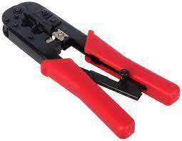

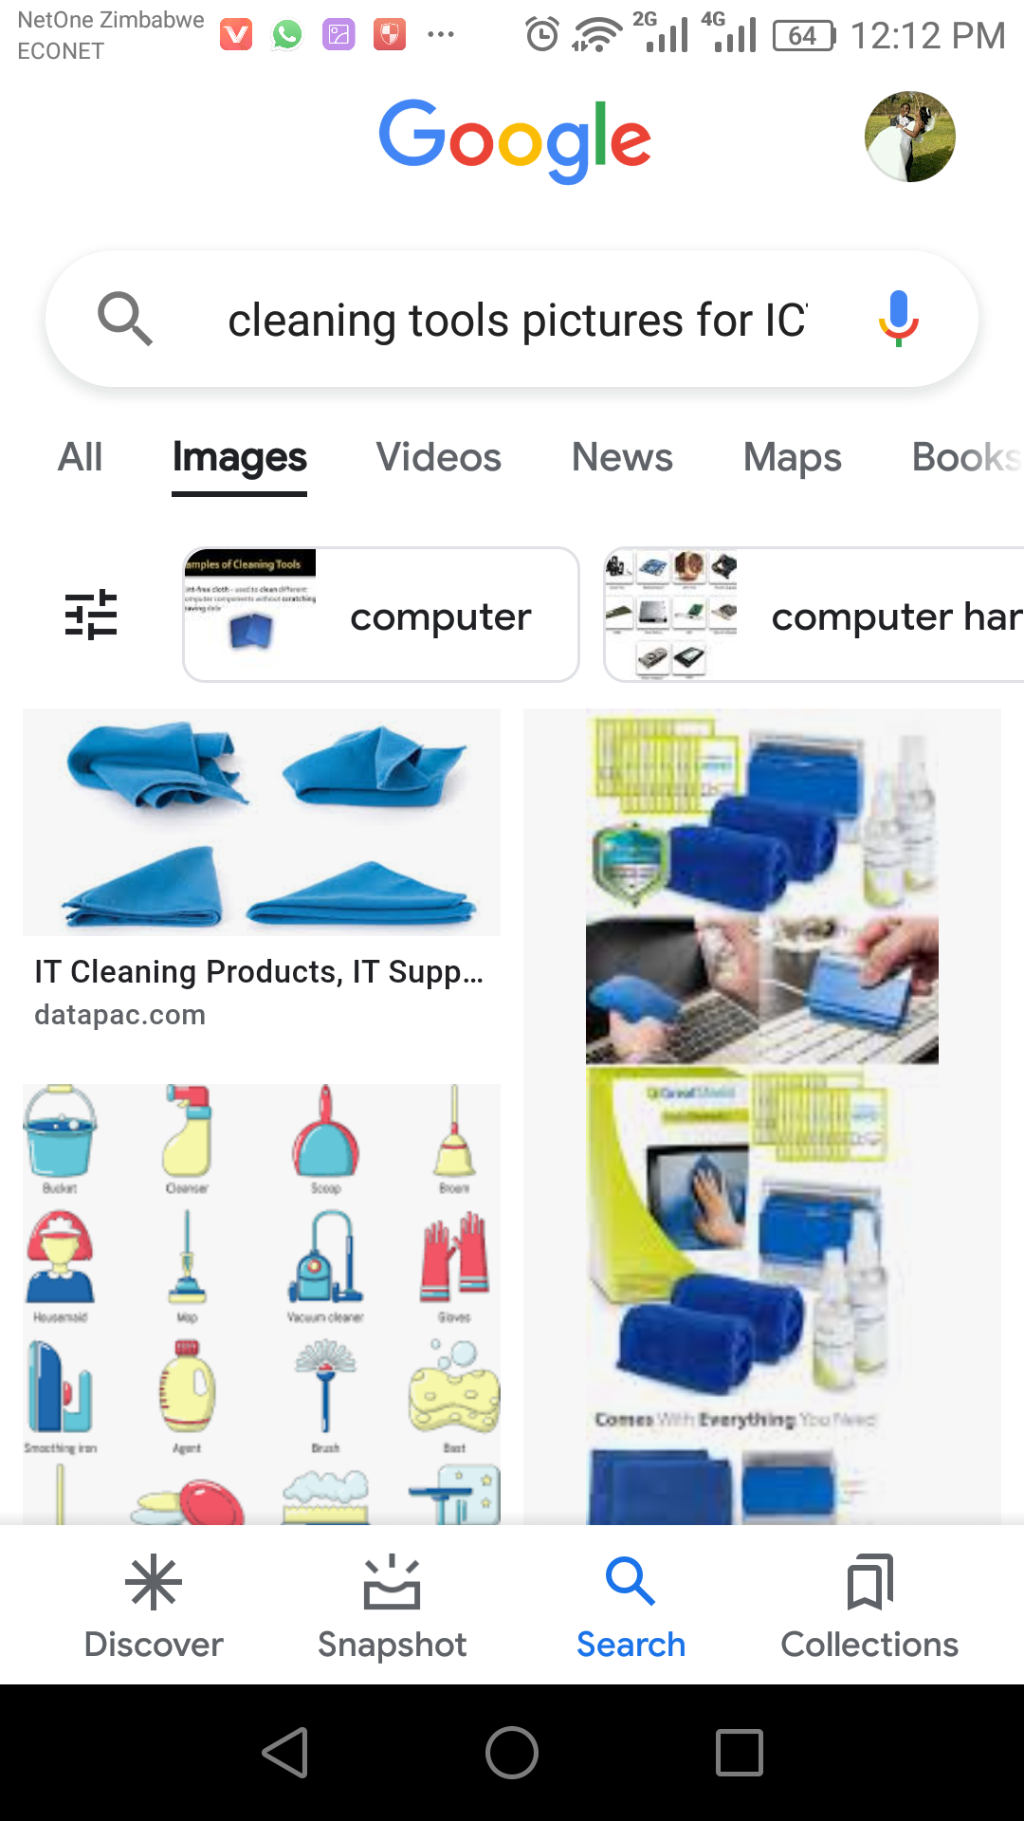

1. **Cleaning tools.**

Examples of cleaning tools are soft cloth, air blower.

1. **Diagnostic tools.**

Examples of diagnostic tools are;

1. A digital multi-meter used to take many types of measurements.
2. A loop back adapter used to test the functionality of computer ports.

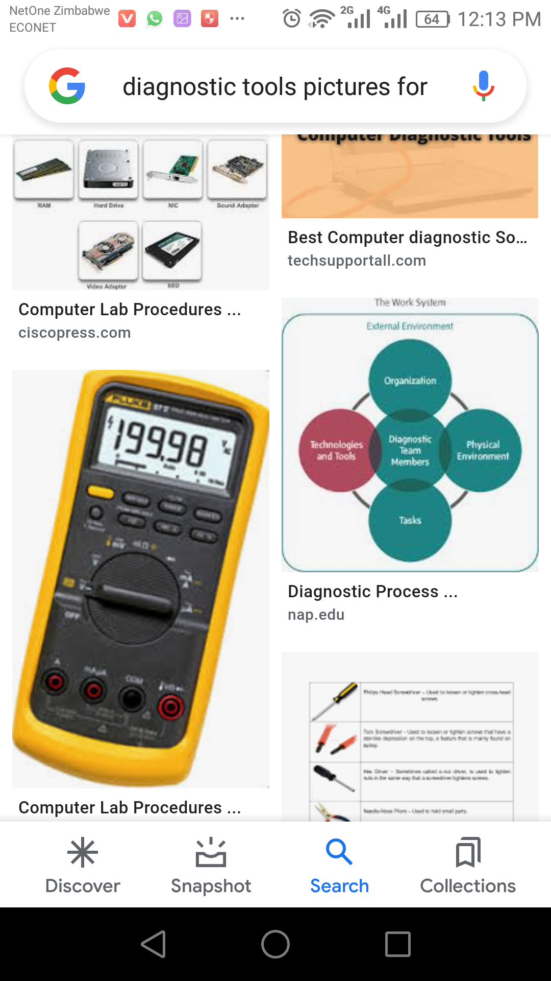

1. **Software tools**

Software tools come together with the OS, for example disk management tools such as:

1. Scan disk
2. Disk clean up.

**Exercise**

1. _______________________ is not part of the professional ICT tools kit. [watering/cleaning]
2. A crimping tool is part of ___________________________tools. [ESD/hand]
3. A common problem in printers is _____________________________ [paper jam/audio problems]
4. A multi-meter is used to ________________________________________ [scan/take measurements]
5. A book of instructions on how to operate and maintain a tool is called a _____________ [manual/chassis]
6. ESD tools are important because ___________________________________________________________________________________________________________________
7. Give one safety precaution when using tools ____________________________________________________________________________________________________________________
8. Name the tool you would use to remove dust in a printer ____________________________________________________________________________________________________________________
9. Name the tool you would use to wipe dust from the keyboard. ____________________________________________________________________________________________________________________
10. What name is given to the frame of a computer? ____________________________________________________________________________________________________________________
11. Which tools come as a package with the Operating system

____________________________________________________________________________________________________________________

1. Mr Mupandira is fixing computers in a computer lab and keeps getting shocks of static electricity. What advice can you give to Mr Mupandira?

____________________________________________________________________________________________________________________

**Faults in I.C.T Tools**

**Disassembling The System Unit.**

* A system unit is the case that contains all hardware parts responsible for processing done by the computer.
* A system unit can be disassembled for the following reasons;

1. To clean it
2. To replace damaged parts.

**Stages on disassembling the System Unit.**

1. Unplug the system unit
2. Unscrew the screws on the outer casing.

**Computer Parts inside the System Unit.**

1. Power supply, having wires running to the motherboard, internal hard drive etc.
2. CD/DVD Drive
3. System fan
4. Central processing unit fan
5. Hard drive
6. RAM- an information storage in a computer used to store running programs and data for the programs. The more RAM you have the faster your computer runs.
7. C.P.U
8. Motherboard

**Practical**

* **Disassemble a system unit with your facilitator.**

**Exercise**

1. To ___________________________ is to put together an ICT tool.
2. To __________________________ is to remove parts that are placed together.
3. What is the first step when disassembling a system unit?
4. All the components in the system unit are held together by the ______________________________
5. There are __________________________ fans in the system unit.
6. The __________________________ unit supplies power to all components in the system unit.
7. Why must you exercise caution when handling the hard drive?
8. What is the most delicate component in the system unit?
9. Which two components can be connected to a system unit from the outside?

**Topic: ICT Tools**

**Term One - Week Four, Grade 7**

* Hardware is categorized into four that is internal hardware, external hardware, network hardware and auxiliary hardware.
* Computer auxiliary hardware is hardware that a computer can function without.

**Exercise.**

1. Three examples of internal hardware are;
2. __________________________________
3. __________________________________
4. __________________________________
5. Three examples of external hardware are;

a)__________________________________

b)__________________________________

c)__________________________________

1. Three examples of network hardware are;

a)__________________________________

b)__________________________________

c)__________________________________

1. Three examples of auxiliary hardware are;

a)__________________________________

b)__________________________________

c)__________________________________

**Topic: ICT Tools**

**Term One - Week Five, Grade 7**

Types of computers.

* There are four main types of computers, these are micro, mini, mainframe and super computers.
* Personal computers are designed for a single user.

Computer peripherals

* Computer peripherals are hardware attached to the system unit.
* Peripheral devices are grouped into three that is input, output and storage.

**Exercise Two**

1. Three examples of personal computers are;
2. ______________________________________
3. ______________________________________
4. ______________________________________
5. The largest computer is known as the _______________________ computer.
6. Two examples of Palmtops are;
7. _______________________________
8. _______________________________
9. Three examples of peripheral devices are;
10. ________________________________
11. ________________________________
12. ________________________________
13. Three examples of output devices are;
14. ________________________________
15. ________________________________
16. ________________________________
17. Three examples of input devices are ________________, __________________ and ___________________
18. Three examples of storage devices are _________________, ___________________ and __________________

**Topic: ICT Tools**

**Term One - Week 6, Grade 7 p**orts on the System Unit

1. USB Ports

* For USB devices connection, examples being scanners, printers, digital cameras, memory sticks etc.
* These are more than any ports on the system unit.

1. Serial socket

* Allows for connections of devices such as projectors.

1. A parallel port

* Allows connections of devices like printers

1. Network port

* Allows internet connections.

**Exercise**

1. S.U is short of ______________________________________________________________________________
2. C.P.U is short of _____________________________________________________________________________
3. USB is short of ______________________________________________________________________________
4. PDF is short of ______________________________________________________________________________
5. CD is short of _______________________________________________________________________________
6. DVD is short of ______________________________________________________________________________
7. A _____________________port allows us to connect to the internet.
8. Why are keyboards referred to as QWERTY? ___________________________________________________________________________________________
9. Why are letters of the alphabet not in order on the keyboard. ___________________________________________________________________________________________
10. Four components of a keyboard are letters, numeric keypad, function keys and special keys. Three examples of special keys are;
11. _______________________________________________
12. _______________________________________________
13. _______________________________________________

**Revision**

**Term One - Week Seven, Grade Seven**

1. Pointing devices are used to move objects around, select options and drag; three examples are;
2. _______________________________________
3. _______________________________________
4. _______________________________________
5. Three contents of a mouse are _____________________, ______________________ and __________________
6. Which part on a smart phone acts as both input and output? __________________________________________
7. Where can you find a web camera? ______________________________________________________________
8. Two uses of web cameras are;
9. _________________________________________________________
10. _________________________________________________________
11. A ________________________ assist in having a hard copy from a soft copy.
12. Another name for a monitor is __________________________________________________________________
13. What does a computer internal hard drive store?
14. _____________________________________________________
15. ______________________________________________________
16. A hard drive of a computer spins in order to process data, the speed in which it spins is measured as Revolution per minute RPM or RPS. What does RPS stands for? ________________________________________________
17. Four examples of secondary storage devices are;
18. _____________________________________
19. _____________________________________
20. _____________________________________
21. _____________________________________
22. A kilobyte is equal to 1 000bytes, a Megabyte to 1 million bytes, a Gigabyte to _______________bytes and a terabyte to _______________________bytes
23. Why is it important to back up data?

___________________________________________________________________________________________

**Topic: ICT Faults**

**Term One Week Eight, Grade Seven.**

* A fault is an error or failure or malfunctioning of the system causing the ICT tool to behave in an abnormal way.
* Faults emanates from hardware and software.
* Computer users must be logical in addressing faults hence the need to do the following before fixing faults;

1. Check for power connectivity
2. Check whether the device’s battery has power.
3. Check whether the device is switched on
4. Are all connected devices well secured and connected.

**Exercise.**

1. Six computer faults are;
2. __________________________________________________
3. __________________________________________________
4. __________________________________________________
5. __________________________________________________
6. __________________________________________________
7. ___________________________________________________
8. If the printer is not printing, I can check on;
9. ____________________________________________________
10. ____________________________________________________
11. _____________________________________________________
12. Define the following terms.
13. Peripheral device _________________________________________________________________________
14. Hardware _______________________________________________________________________________
15. Software ________________________________________________________________________________

**Topic: Maintenance**

**Term One, Week Nine – Grade 7**

* Hardware and software has to be maintained.
* There are basically four types of computer hardware and software maintenance.

1. Predictive maintenance

* Involves the use of diagnostic tools installed within your computer
* Involves troubleshooting, this is cheap – no need to buy anything but rather to follow prompts hence it is a Do It Yourself {DIY}

1. Preventive maintenance

* Focuses on preventing possible failures.
* Involves the use of antivirus software and periodic scans.

1. Corrective maintenance

* This takes effect when the first two cannot work, it means there is a fault.
* Attend to the fault or hire a technician.

1. Evolutionary maintenance

* This is when you keep on upgrading your system as technology is a continuous process.
* When new software and hardware evolves, make use them.

**Exercise.**

1. Which type of maintenance is costs free?

______________________________________________________

1. Four examples of preventive maintenance are;
2. ___________________________________________________
3. ___________________________________________________
4. ___________________________________________________
5. ___________________________________________________
6. How can you get knowledge on how to fix some faults in the event that you have called a technician?
7. ____________________________________________________
8. ____________________________________________________

**Topic: Creating and publishing**

**Term One, Week Ten – Grade Seven.**

* Creating and publishing has more to do with general publications and graphics such as newsletters, IDs, magazines, business cards, small booklets and fliers.
* Using Creating and publishing tools information can be presented using charts and graphs.
* One can use Microsoft publisher to publish a variety.

**Exercise.**

1. Four examples of publications in Microsoft publisher are;
2. __________________________________________
3. __________________________________________
4. __________________________________________
5. ___________________________________________
6. Three types of graphs are;
7. ___________________________________________
8. ___________________________________________
9. ___________________________________________

This is a ____________ graph.

Three characteristics of a good graph are;

1. ____________________________________________
2. ____________________________________________
3. ____________________________________________

**Topic: Computer Software**

**Term One – Week Eleven; Grade Seven**

* Software is a program that enables hardware to perform its work.
* There are two types of software that is system and application software.
* **System software** is the instruction that makes the computer work.
* System software comes in with the computer when you buy it.
* **Application software** is a computer program designed with the user in mind.

**Types of software are;**

1. Browsers for __________________________________________________________
2. Database _____________________________________________________________
3. Games _______________________________________________________________
4. Mail and calendar ______________________________________________________
5. Maps ________________________________________________________________
6. Messaging ____________________________________________________________
7. Movies and TV _________________________________________________________
8. Music player for ________________________________________________________
9. Paint for ______________________________________________________________
10. Photos or pictures for ___________________________________________________
11. Presentation for ________________________________________________________
12. Publisher for ___________________________________________________________
13. Spreadsheets for _______________________________________________________
14. Voice recorder for ______________________________________________________
15. Word processor for _____________________________________________________

**Topic: Safety and Security**

**Term One – Week Twelve; Grade Seven**

* Safety is a way of keeping one’s information safe from reaching wrong destination.
* There are various forms of security, these are;

1. Passwords – unique, personal identity key that the claimant has to remember & the verifier is set to recognise
2. Patterns
3. Facelock
4. Fingerprint
5. Pin

* Computers must be kept safe from virus.
* Virus is an undesirable program that copies itself to another program so that it can cause damage.
* Virus aims into infecting the computer, gain entry and steals data.

**Effects of computer virus**

1. alters programs and applications in your P.C
2. leads to slowness of the P.C
3. causes a P.C to fail booting/starting
4. delete files or data.
5. Affect drivers of other hardware such as printers leading to malfunctioning.

**How computer virus spread**

1. by connecting to the source
2. by downloading applications, some come attached to a virus
3. from email messages

**The presence of computer virus can be detected through;**

1. slower system performance
2. Pop-ups bombarding the screen
3. Programs running on their own
4. Files multiplying or duplicating on their own.
5. New files or programs in the computer files.
6. Folders getting deleted

**Topic: Safety and security**

**Term One – Week Thirteen; Grade Seven**

**Cyber wellness: Ethical and Legal Use**

* *Cyber wellness refers to the positive well-being of internet users.*

**Dangers of using the internet.**

1. **Cyber bullying**

* *It involves sending of insulting and hateful messages on social networks by cyber bullies*.

1. **Online predators**

* *It involves sexual harassment or abuse by older people on minors.*

1. **Theft of personal information**.

* *Hackers can hack your social account and gain access to all your social/personal details and use them to harass you.*

1. **Pornography/Inappropriate content**

* *One can find links to adult websites on social media, an accidental click can lead you into these adult platforms hence you can get psychological abuse.*

1. **Phishing**

* *This is tricking people into clicking malicious and dangerous links, by so doing personal information can be stolen and used in illegal deals or one can be blackmailed. Hackers, can as well demand money from their prey.*

1. **Inappropriate content**

* *When one opens a browser, some adverts can pop out, these might not be of one’s age and they can mislead.*

**Preventing Cyber abuse**

1. *Do not accept or like information you see on internet which has nothing to do with your business.*
2. *Do not talk to strangers.*
3. *Avoid clicking links which you find on social media platforms.*
4. *Observe internet etiquette in communication. This means use good language whenever you post anything.*

**Displaying Internet Etiquette**

1. ***Do not shout:*** *Avoid using capital letters throughout your text, it appears rude.*
2. ***Use discretion:*** *Make sure whatever you post can not embarrass you later because what you post on internet can live forever to be seen by your parents, children and grand children.*
3. ***Protect personal information:*** *Do not share your personal details with the public.*
4. ***Obey copyright laws:*** *Never copy someone else’s work and paste it as yours because that is considered as stealing,*
5. ***Proofread your work:*** *Re-read anything you type before clicking the send button*

**Exercise**

1. *Define cyber wellness. [1]*

*___________________________________________________________________________________________________________________________*

1. *Four dangers of using the internet are;*
2. *______________________________________*
3. *______________________________________*
4. *______________________________________*
5. *______________________________________ [4]*
6. *State any two things that cyberbullies can do. [2]*
7. *______________________________________________________________________________________________________________________*
8. *_____________________________________________________________________________________________________________________*
9. *People who sexually harass minors {Children} on internet are known as Online______________________________ [1]*
10. *Tricking people into clicking malicious and dangerous links is known as ______________________________________[1]*
11. *Four advices that can be given to a Grade Five learner who need to practice internet etiquette are;*
12. *Proof read your work before posting it.*
13. *_______________________________________________________________________________*
14. *_______________________________________________________________________________*
15. *________________________________________________________________________________ [3]*

***End of Term Examination***

1. *Three contents of a professional tools kit are;*
2. *__________________________________________*
3. *__________________________________________*
4. *__________________________________________*
5. *Explain the use of the following hardware;*
6. *Printer ______________________________________________________________________________________________________________*
7. *Projector ___________________________________________________________________________________________________________*
8. *Define the following terms:*
9. *Disassembling ______________________________________________________________________________________________________*
10. *Assembling _________________________________________________________________________________________________________*
11. *Two internal parts of a computer are _______________________________________________ and _____________________________*
12. *Distinquish between a laptop and a desktop computer.*

*___________________________________________________________________________________________________________________________*

1. *Two examples of network hardware are;*
2. *__________________________________________*
3. *___________________________________________*
4. *Define auxiliary hardware and give one example.*

*___________________________________________________________________________________________________________________________*

1. *Which special keys do the following;*
2. *Spacing evenly __________________________________________________________*
3. *Opting for secondary keys ___________________________________________________*
4. *What does a computer internal hard drive store?*
5. *________________________________________________*
6. *________________________________________________*
7. *A visual displays unit can also be called a ____________________________________________________________________________*
8. *State any two computer faults and suggest how they can be fixed?*
9. *_______________________________________________________________________________________________________________________*
10. *_______________________________________________________________________________________________________________________*
11. *When we hire a technician to attend to a fault, the maintenance is known as ______________________________________*
12. *Define troubleshooting. _________________________________________________________________________________________________________________________*
13. *Which type of maintenance is costs free? _________________________________________________________________________*
14. *Two dangers of using the internet are;*
15. *_______________________________________________________________*
16. *_________________________________________________________________*
17. *How can you know that your computer has virus?*
18. *_______________________________________________________________*
19. *________________________________________________________________*
20. *Define phishing.*

*___________________________________________________________________________________________________________________________*

1. *What name is given to people who sexually abuse or harras minors on internet. __________________________________*
2. *Definer cyber wellness.*

*___________________________________________________________________________________________________________________________*

1. *________________________________________ allows us to have a hardcopy from a soft copy.*