**CHAPTER 5**

**RESULTS AND DISCUSSIONS**

**5.1 Introduction**

The input is sensed by the sensor and they send the information to the microcontroller, where the microcontroller responds and gives command to the particular component with predefined algorithm. The timing condition for the railway gate control system must be set based on the speed and length of the train into the background algorithm which can be easily changed and modified using microcontroller. The servo motor is controlled by the microcontroller for rotations by calculating the code of proper delay into the microcontroller. This system is a scaled down model of the real time railway gate control. This can be implemented in real time with the higher horse power motors, controlled by Programmable Logic Controllers and through several Distributed Control Systems (DCS). Applying the automatic railway gate control system at the level crossing may offer several advantages for public. Since, the operation is automatic; error due to manual operation is prevented. It is also less time consuming, no human resource is required. It provides safety and quality services and it avoids accident automatically.

**5.2 Section**

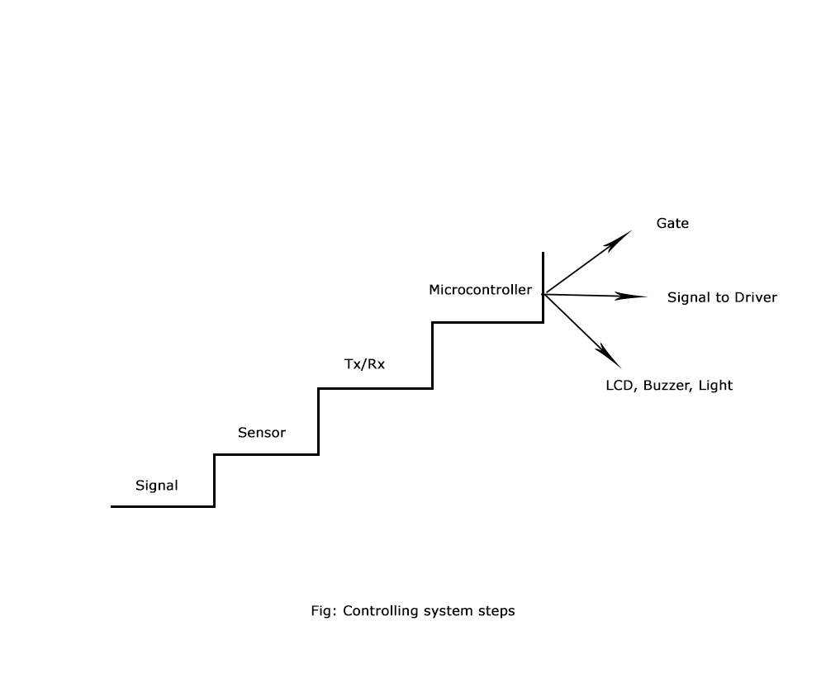

Fig : Controlling system steps

The figure above shows the steps how to controlling system works and it has already been discussed in the previous section.

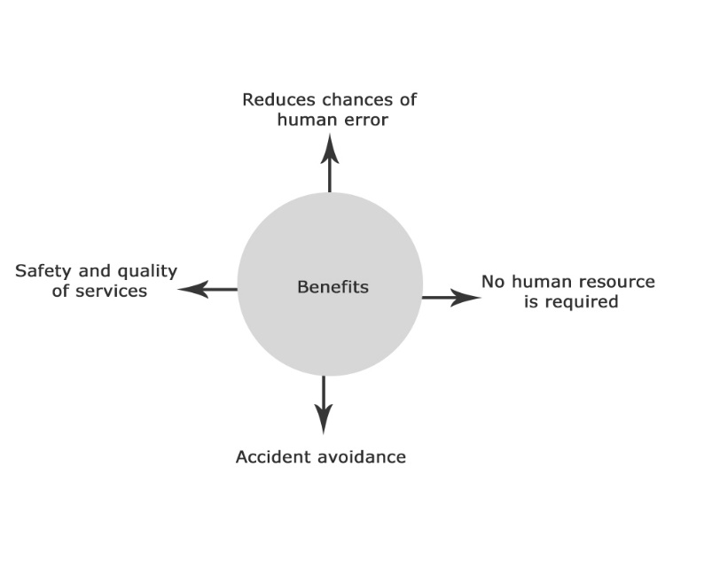

Fig: Benefits of the automatic railway traffic control system

**5.3 Summary**

Automatic Railway Gate Control System with High Speed Alerting System is an innovative circuit which automatically controls the operation of railway gates detecting the arrival and departure of trains at the gate. It has a lot of benefits too as we have discussed above.