Student Record and Academic Management System
By: Sarvesh Ugale

- Problem Statement:
As we know now, maintaining students record in a school/college is an important as well as a complex task. And when it comes to maintaining the record of 100s of students at the same time that too in a traditional ‘Paper based Records’ is unreliable, time consuming as well as a stressful job to do. So, a Digital System, that manages all these tasks is needed, so the student’s records are reliable, convenient, and easy to access.

- Functional Requirements:
- Add student information
- Display student records
- Search student details
- Calculate average marks
- Display grades
- Exit application

- Non-Functional Requirements:
- Simplicity
- Ease of use
- Accuracy
- Reliability

- Algorithms:
- Adding student records:
- Start.
- Ask the user to input the student's name, PRN, department, semester, and attendance.
- Ask the user to input the marks for 5 subjects.
- Calculate the average by calling the Average Calculation algorithm.
- Calculate the grade by calling the Grade Calculation algorithm.
- Save all this data as a single student record.
- Add this new record to the main student list.
- End.
- Searching Records:
- Start.
- Check if the student list is empty. If yes, display "No records available" and End.
- Ask the user to input the PRN they want to search for.
- Go through the student list one by one.
- If a student's PRN matches the input, display their full details and stop searching.
- If the end of the list is reached and no match is found, display "Student not found".
- End.
- Grade Calculation:
- Start.
- Take the student's average marks as input.
- If average is 90 or above, the grade is "A+".
- If average is 80 to 89, the grade is "A".
- If average is 70 to 79, the grade is "B+".
- If average is 60 to 69, the grade is "B".
- If average is 50 to 59, the grade is "C".
- If average is 40 to 49, the grade is "D".
- If average is below 40, the grade is "F".
- Return the final grade.
- End.
- Average Calculation:
- Start.
- Take the marks of the 5 subjects as input.
- Add all 5 marks together to find the total sum.
- Divide the total sum by 5 to find the average.
- Return the average.
- End.
- Displaying Records:
- Start.
- Check if the main student list is empty.
- If it is empty, display "No student records available" and End.
- If it is not empty, look at the first student record.
- Print that student's name, PRN, department, semester, marks, attendance, average, and grade.
- Move to the next student and repeat step 5 until all students have been displayed.
- End.

- Flowcharts:
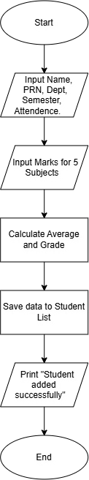
- Add Student:
- Search Student:
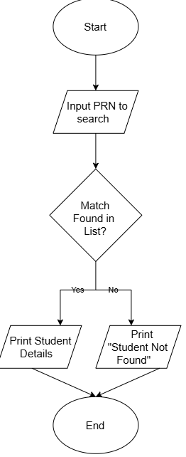
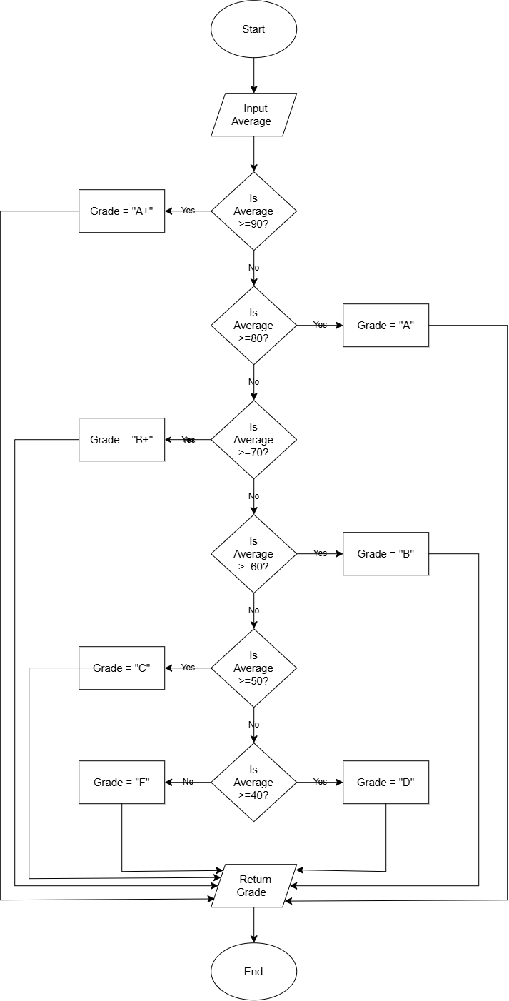
- Grade Calculation:

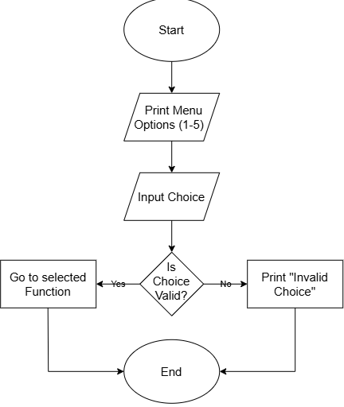
- Display Menu:

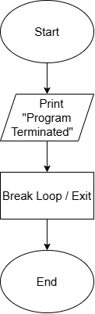
- Exit System

- Pseudocode
- Pseudocode for Adding a Student:

PROCEDURE Add_Student
PRINT "Enter student details (name, roll no, department, semester)"
INPUT name, roll_no, department, semester

INIT marks as empty list
FOR i = 1 TO 5
INPUT mark
APPEND mark TO marks
END FOR

INPUT attendance

average = CALL Calculate_Average(marks)
grade = CALL Calculate_Grade(average)

CREATE student record with all details
ADD student to students list
PRINT "Student record added successfully!"
END PROCEDURE

- Pseudocode for Searching a Student:

PROCEDURE Search_Student
IF students list is empty THEN
PRINT "No student records available."
RETURN
END IF

INPUT search_roll_no
SET found = FALSE

FOR EACH student IN students list
IF student.roll_no EQUALS search_roll_no THEN
PRINT student details
SET found = TRUE
BREAK
END IF
END FOR

IF found EQUALS FALSE THEN
PRINT "Student not found."
END IF
END PROCEDURE

- Pseudocode for Grade Calculation:

FUNCTION Calculate_Grade(average)
IF average >= 90 THEN
RETURN "A+"
ELSE IF average >= 80 THEN
RETURN "A"
ELSE IF average >= 70 THEN
RETURN "B+"
ELSE IF average >= 60 THEN
RETURN "B"
ELSE IF average >= 50 THEN
RETURN "C"
ELSE IF average >= 40 THEN
RETURN "D"
ELSE
RETURN "F"
END IF
END FUNCTION

- Pseudocode for Average Calculation:

FUNCTION Calculate_Average(marks)
total = SUM(marks)
average = total / LENGTH(marks)
RETURN average
END FUNCTION
- Pseudocode for the Main Display Menu:

PROCEDURE Main_Menu
WHILE TRUE
PRINT "1. Add Student"
PRINT "2. Display Records"
PRINT "3. Search Student"
PRINT "4. Calculate Average/Grade"
PRINT "5. Exit"

INPUT choice

IF choice == "1" THEN
CALL Add_Student
ELSE IF choice == "2" THEN
CALL Display_Students
ELSE IF choice == "3" THEN
CALL Search_Student
ELSE IF choice == "4" THEN
CALL Display_Grade
ELSE IF choice == "5" THEN
PRINT "Program terminated."
BREAK
ELSE
PRINT "Invalid choice."
END IF
END WHILE
END PROCEDURE

- Source Code:
students = []

def calculate_average(marks):
total = sum(marks)
average = total / len(marks)
return average

def calculate_grade(average):
if average >= 90:
return "A+"
elif average >= 80:
return "A"
elif average >= 70:
return "B+"
elif average >= 60:
return "B"
elif average >= 50:
return "C"
elif average >= 40:
return "D"
else:
return "F"

def add_student():
print("\n--- Add Student ---")

name = input("Enter student name: ")
prn = input("Enter PRN: ")
department = input("Enter department: ")
semester = int(input("Enter semester: "))

marks = []

print("\nEnter marks for 5 subjects:")

for i in range(5):
mark = float(input("Enter marks for Subject " + str(i + 1) + ": "))
marks.append(mark)

attendance = float(input("\nEnter attendance percentage: "))

average = calculate_average(marks)
grade = calculate_grade(average)

student = {
"name": name,
"prn": prn,
"department": department,
"semester": semester,
"marks": marks,
"attendance": attendance,
"average": average,
"grade": grade
}

students.append(student)

print("\nStudent record added successfully!")

def display_students():
print("\n--- Student Records ---")

if len(students) == 0:
print("No student records available.")
return

for student in students:
print("Name :", student["name"])
print("PRN :", student["prn"])
print("Department :", student["department"])
print("Semester :", student["semester"])

print("Subject Marks:")
for i in range(5):
print(" Subject", i + 1, ":", student["marks"][i])

print("Attendance :", student["attendance"], "%")
print("Average :", round(student["average"], 2))
print("Grade :", student["grade"])

def search_student():
print("\n Search Student")

if len(students) == 0:
print("No student records available.")
return

prn = input("Enter PRN to search: ")

found = False

for student in students:
if student["prn"] == prn:
print("\nStudent Found!")
print("Name :", student["name"])
print("PRN:", student["prn"])
print("Department :", student["department"])
print("Semester :", student["semester"])
print("Marks :", student["marks"])
print("Attendance :", student["attendance"], "%")
print("Average :", round(student["average"], 2))
print("Grade :", student["grade"])

found = True
break

if found == False:
print("Student with PRN", prn, "not found.")

def display_grade():
print("\n Average Marks and Grade")

if len(students) == 0:
print("No student records available.")
return

prn = input("Enter PRN: ")

found = False

for student in students:
if student["prn"] == prn:

average = calculate_average(student["marks"])
grade = calculate_grade(average)

print("\nStudent Name :", student["name"])
print("Average Marks:", round(average, 2))
print("Grade :", grade)

found = True
break

if found == False:
print("Student not found.")

while True:

print(" STUDENT RECORD AND ACADEMIC SYSTEM")

print("1. Add Student")
print("2. Display Student Records")
print("3. Search Student")
print("4. Calculate Average and Grade")
print("5. Exit")

choice = input("\nEnter your choice: ")

if choice == "1":
add_student()

elif choice == "2":
display_students()

elif choice == "3":
search_student()

elif choice == "4":
display_grade()

elif choice == "5":
print("\nThank you for using the Student Record System.")
print("Program terminated.")
break

else:
print("\nInvalid choice. Please enter a number from 1 to 5.")

- Testing and Screenshots:
- Test Case 1 (Add Student):
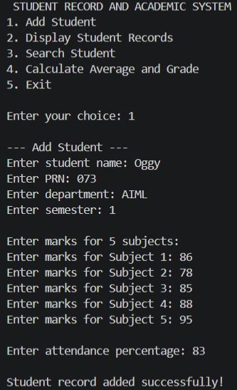

- Test Case 2 (Boundary Testing):
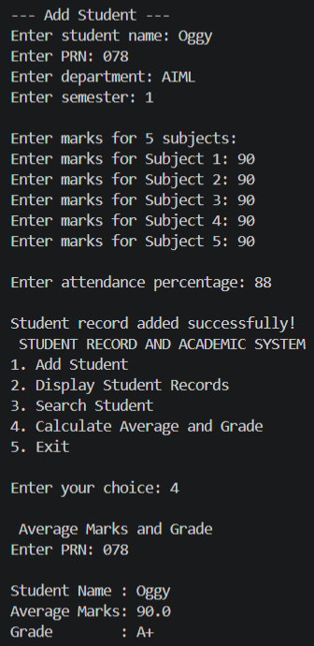
- Test For A+ grade:

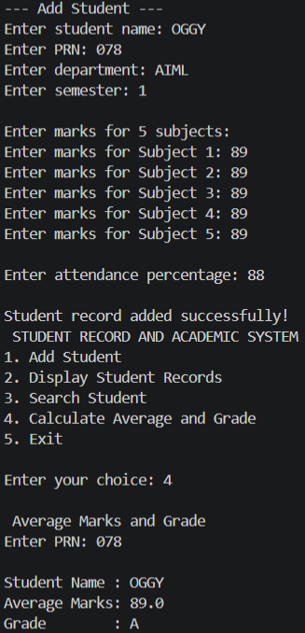
- Test for A grade:

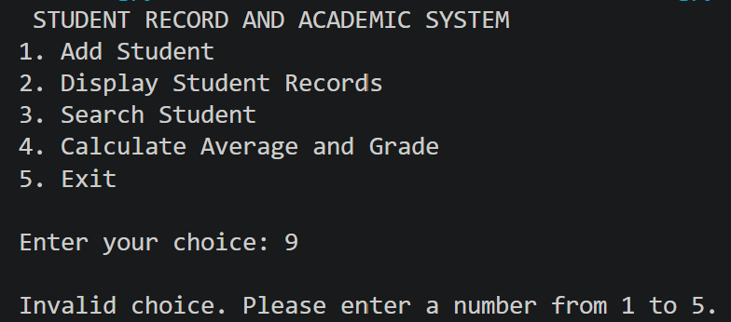
- Test Case 3 (Error/Logical Testing):

- Unit Reflection Report:
Throughout this project, I learned that effective software development requires careful planning before any code is written. By breaking down the problem and creating algorithms, flowcharts, and pseudocode first, I significantly improved my computational thinking and logical reasoning skills. This structured methodology made the actual Python implementation much easier and less prone to errors. Additionally, I gained valuable hands-on experience using loops, conditionals, and dictionaries in Python, as well as learning how to systematically test my program for boundary and logical errors.

