DESIGN AND IMPLEMENTATION OF A WEB BASED RESULT COMPUTATION SYSTEM

(CASE STUDY OF MICHAEL AND CECILIA IBRU UNIVERSITY)

BY

OBANYEDO MARVELLOUS OGHENERUNOR

NS/CS/19/0508

A PROJECT SUBMITTED TO THE

DEPARTMENT OF MATHEMATICS AND COMPUTER SCIENCE

FACULTY OF NATURAL AND APPLIED SCIENCE

MICHAEL AND CECILIA IBRU UNIVERSITY, AGBARHA-OTOR, NIGERIA

IN PARTIAL FULFILLMENT OF THE REQUIREMENT FOR THE AWARD OF BACHELOR

OF SCIENCE

JULY, 2023

CERTIFICATION
This is to certify that this project work, “Design and Implementation of a Web Based Result Computation System”, was written by MARVELLOUS OGHENERUNOR OBANYEDO with Matriculation number NS/CS/19/0508 and has been read and approved for the award of Bachelor of Science(b.sc.) in the department of Mathematics and Computer science, Faculty of Computing, Michael and Cecilia Ibru University, Agbarah-Otor.

……………………………………………… …………………………...
MR. CLEMENT OGEH OMAMODE DATE
(PROJECT SUPERVISOR)

……………………………………………… …………………………...
PROFESSOR OBE OLUMIDE OLAYINKA DATE
(EXTERNAL PROJECT SUPERVISOR)

……………………………………………… …………………………...
DR. O.E AGBOJE DATE

(HEAD OF DEPARTMENT)

i
DECLARATION

This work is being submitted in partial fulfillment of the requirement for the degree of Bachelor in Computer Science and has not previously been accepted in substance for any degree and is not being concurrently submitted in candidature for any degree.

……………………………………………... …………………………...
OBANYEDO MARVELLOUS OGHENERUNOR DATE

ii
DEDICATION
I express my heartfelt gratitude to God for His enabling grace, as this work is dedicated to Him. I am immensely thankful to my remarkable family, whose unwavering support and boundless love have continuously fueled my motivation. I extend my sincere appreciation to my esteemed lecturers for their invaluable guidance and imparted knowledge. Additionally, I am grateful to my fellow students for their collaborative spirit and camaraderie, which have made this journey truly unforgettable.

iii
ACKNOWLEDGMENT
I am deeply indebted to my Supervisor, Mr. Clement Ogeh Omamode, the Head of the Department, Dr. O.E Agboje, and the Lecturers in the Department of Computer Science. Their unwavering moral support played a pivotal role in the successful completion of my undergraduate program. I am grateful to God Almighty and my parents for their invaluable financial support throughout my career. To each and every one of you, I express my heartfelt appreciation for everything. Thank you all very much.

iv
ABSTRACT

The web-based result computation system abstracts the complexities of calculating and generating academic results in a university or educational institution. It provides a user-friendly interface that simplifies data management, computation algorithms, result generation, security, access control, and integration with other systems. By abstracting these components, the system streamlines the result computation process and ensures accuracy, reliability, and timeliness. It simplifies data storage, retrieval, and organization, automates grade calculations and performance indicators, and generates result sheets and reports in customizable formats. The system also abstracts security measures, ensuring authorized access to student results, and integrates with other institutional systems for seamless data synchronization. This abstraction allows users, such as faculty, staff, and administrators, to focus on result analysis, interpretation, and decision-making, rather than getting overwhelmed by technical details. The web-based nature of the system enables easy access from anywhere with an internet connection, enhancing accessibility and convenience. Overall, the result computation system's abstraction simplifies and automates result processing, improves efficiency, reduces errors, and provides standardized and reliable frameworks for handling academic outcomes. It empowers users with accurate and timely student results, facilitating informed decision-making and enhancing the overall academic experience within the institution.

v
TABLE OF CONTENT

Certification…………………………………………………………………………………………....i
Declaration…………………………………………..…………...…………………………………....ii
Dedication…………………………………………..…………...…………………………………….iii
Acknowledgment……………...……………………………………………..………………………..iv Abstract…………..…………………………………………………………….………………….…..v
Table of Contents………………………………………………………………………...………..….vi
CHAPTER ONE: INTRODUCTION
1.0 Background of the Study……………………………………………………...……………………..1
1.1 Statements of the Problem…………………………………………………………………………...2
1.2 Aim and Objectives………………………………………………………………………………….3
1.3 Significance of the Study………………………………………………………………………...…..4
1.4 Scope and Limitations of the Study………………………………………………………………….4
1.5 The Research Layout………………………………………………………………………………...5
1.6 Definition of Terms…………………………………………………………………………………..6
CHAPTER TWO: LITERATURE REVIEW
2.0 Result Computation………...………………………………………………………………………..8
2.1 Result Computation Techniques……………………………………………………………………..8
2.2 Review of Literature…………………………………………………………...………………..….10
2.3 Review of the Existing System……………………………………………………………………..12
2.4 Benefits of the Result Computation System………………………………………………………..13
2.5 Summary……………………………………………………………………………………………14

vi

CHAPTER THREE: METHODOLOGY
3.0 System Architecture………………………………………………………………………………...15
3.1 System Components………………………………………………………………………………...15
3.2 Methodology Used...………………………………………………………………………………..16
3.3 System Functionality………………………………………………………………………………..18
3.4.1 Flowchart of The Developed System..…………………………………………………………...20
3.4.2 Methods of Data Collection……………………………………………………………………....21
3.4.3 The Action Diagram………………………………………………………………………………23
3.4.4 The Entity Relationship Diagram of the System………………………………………………….24
3.5 The Database Design……………………………………………………………………………….25
3.6 Summary……………………………………………………………………………………………29
CHAPTER FOUR: IMPLEMENTATION
4.0 Features, Languages and Technologies Used………………………………………………………31
4.1 Design Specification……………………………..………………………………………………...33
4.1.1 Home Page Design……………………………………………………………………………….33
4.1.2 The Login Design………………………………………………………………………………...34
4.1.3 Sign Up Page Design……………………………………………………………………………..36
4.1.4 The Admin Dashboard Page……………………………………………………………………...38
4.2 System Requirements……………………………………………………………………………....44
4.3 Summary……………………………………………………………………………………………45

vii

CHAPTER FIVE: SUMMARY, CONCLUSION AND RECOMMENDATION
5.0 Summary………………………………………………………………………………………….46
5.1 Conclusion………………………………………………………………………………………...46
5.2 Recommendation………………………………………………………………………………….47
REFERENCES………………………………………………………………………………………..48
APPENDIX…………………………………………………………………………………………...51

viii
LIST OF FIGURES
Figure 1: Agile Methodology Circle…………………………………………………………….18
Figure 2: Flowchart Diagram of the System………….………………………………………...20
Figure 3: Use case diagram for the system……………………………………………………...22

Figure 4 The Action Diagram of the System…………………………………………...……….23

Figure 5: The Entity Relationship Diagram of the System………………………………………24

Figure 6: The Home page………………………………………………………………………..34
Figure 7: The Login Page………………………………………………………………………..35
Figure 8: Password Reset…………………………………………………………………….….36
Figure 9: The Sign Up Page……………………………………………………………………..37
Figure 10: The admin dashboard………………………………………………………………..38
Figure 11: The admin add course interface……………………………………………………..39
Figure 12: The result interface………………………………………………………………….40
Figure 13: The compute result interface………………………………………………………...41
Figure 14: The compute result interface for a student………………………………………….42
Figure 15: The input field interface…………………………………………………………….43
Figure 16: The result page for a student………………………………………………………..44

ix

CHAPTER ONE
INTRODUCTION
1.0 BACKGROUND OF THE STUDY.
The computation of results is a critical aspect of academic assessment, as it provides students with feedback on their academic progress and serves as a basis for determining their academic standing. The traditional method of manually computing results is time-consuming and prone to errors, especially in universities with large numbers of students and multiple courses In recent years, there has been a growing interest in developing automated result computation systems for universities. These systems aim to streamline the process of computing results and reduce the workload on academic staff, while improving the accuracy and efficiency of the process. Automated result computation systems typically use software programs and algorithms to analyze student performance data and compute results. These systems can handle large amounts of data and perform complex computations, such as grading schemes and curve-fitting, with greater accuracy and consistency than traditional manual methods. One of the main advantages of an automated result computer system is that it can provide real-time feedback to students, allowing them to monitor their academic progress and make informed decisions about their coursework. Additionally, it can help academic staff to identify areas where students are struggling and provide targeted interventions to improve student performance.In summary, the development of an automated result computation system for a university has the potential to improve the accuracy, efficiency, and effectiveness of academic assessment. By leveraging advanced software
programs and algorithms, universities can streamline the computation of results, reduce the workload on academic staff, and provide students with real-time feedback on their academic progress.
Assessment of Higher Education Learning Outcomes (AHELO Consortium, 2019)
1.1 STATEMENTS OF THE PROBLEM
The traditional manual method of computing academic results in universities is time-consuming and error-prone, especially in large institutions with a high volume of students and courses. This can result in delays in the release of results and inconsistencies in grading, leading to dissatisfaction among students and academic staff. In addition, the manual method of computing results is resource-intensive and places a significant workload on academic staff. This can lead to burnout and fatigue among staff, as well as errors in computation due to the sheer volume of data that needs to be processed.
Therefore, there is a need to develop an automated result computation system that can overcome the limitations of the traditional manual method. The automated system should be able to handle large volumes of data, compute results accurately and efficiently, and provide real-time feedback and analytics to students and academic staff. Furthermore, the automated system should be user-friendly and easy to use for both students and academic staff. It should be able to integrate seamlessly with existing university systems and provide a high degree of security to protect student data.
1.2 AIM AND OBJECTIVES
The main aim of this project work is to develop a web based result computation portal for Michael and Cecilia Ibru University. The objectives are listed below:
- To develop a web based result computation system portal that can accuracy and efficiently compute results for all courses offered by the university.
- To provide academic staff with a user-friendly utilizing web technologies like CSS(Cascading Style Sheet) and Bootstrap 5(A CSS framework), and easy-to-use system that can reduce their workload and improve the accuracy and consistency of grading using.
- To ensure the security and privacy of student result data by implementing appropriate security measures and protocols such as password integration.
- To improve the efficiency of the academic assessment process, resulting in a faster release of results and a more streamlined process for students and academic staff.
- To provide a scalable system that can accommodate the growing number of students and courses offered by the university.

1.3 SIGNIFICANCE OF THE STUDY
The development of a result computation portal for the university has significant implications for academic assessment, student experience, and the overall reputation of the institution. By improving the accuracy, efficiency, and effectiveness of the academic assessment process, an automated result computation system can contribute to the improvement of academic standards and the success of students and academic staff.

1.4 SCOPE AND LIMITATIONS OF THE STUDY
The scope of a study refers to the boundaries within which the research is conducted, while the limitations refer to factors that may affect the results and interpretations of the study.
In the context of the design and implementation of a university result computation portal, the scope of the study would include:
- The development of a web-based portal for computing and publishing results of an educational institution.
- The implementation of the portal for use by course advisors.
- The integration of necessary features such as exam results input, grading system, and report generation.
The limitations of the study include:
- Limited access to the necessary resources for the development of the portal.
- Limited time frame for the development and implementation of the portal.
- Limited resources for testing and debugging the portal.
- Limited availability of data for testing and validation purposes.
- Limited user acceptance of the portal due to factors such as user preferences, technical skills, and resistance to change.
1.5 THE RESEARCH LAYOUT
The organization of this research work and brief outline of the chapters are as follows:

Chapter One - Introduction to the research work/study which entails laying a background for the research.

Chapter Two – Literature review which involves the review of various methods and ways that has been used to solve the issue of result computation.

Chapter Three – This entails on the methodology and dataset used in the study.

Chapter four – This part focuses on the setup, implementation, experimental results and performance criteria of the methods used in the research work.

Chapter Five – This is the final stage of the research work. It also entails recommendations for future work.
1.7 DEFINITION OF TERMS
Software: Software is a set of instructions or programs that are designed to perform specific tasks on a computer system. It includes both the programs and associated documentation, as well as data and configuration files required to operate the programs. In contrast, a program, on the other hand, is a specific set of instructions that are written in a programming language to perform a particular task or set of tasks on a computer system. Programs are one component of software, along with documentation, data files, and configuration files.
Web Application: A web application is a software application that is accessed through a web browser over a network, such as the internet or an intranet. It is a client-server application, where the client (usually a web browser) sends requests to the server, and the server processes those requests and returns the appropriate response.
Internet: The internet is a global network of interconnected computer systems and devices that communicate with each other using standard communication protocols. It is a massive network that spans the globe, connecting millions of devices, servers, and computers to each other.
Technology: Technology refers to the application of scientific knowledge, tools, and techniques to create practical solutions to problems or to improve existing products, services, or processes. It involves the development, production, and use of tools, machines, systems, and techniques to solve problems or achieve specific goals.
Portal: In software development, a portal refers to a web-based platform that provides users with a single point of access to a variety of resources, services, and applications.
Https: In computing, HTTPS stands for Hypertext Transfer Protocol Secure. It is an extension of the HTTP protocol used for secure communication over the internet. HTTPS is a combination of the HTTP protocol and the SSL/TLS cryptographic protocol.

CHAPTER TWO
LITERATURE REVIEW

2.0 RESULT COMPUTATION
Result computation is the process of calculating and generating academic results for students based on their performance in a course or program. It involves taking into account various factors, such as assignments, tests, projects, and final exams, and assigning grades or marks to students based on their performance in each of these areas.
Result computation typically involves the use of software applications and databases that are specifically designed to manage and process academic results. The process may be automated or semi-automated, depending on the complexity of the grading system and the number of students involved.
The accuracy and timeliness of result computation are critical to the academic success of students, as well as the overall efficiency of the academic institution. Result computation must be carried out in a transparent and fair manner, taking into account all relevant factors and following established grading policies and procedures.
2.1 RESULT COMPUTATION TECHNIQUES
Result computation involves key techniques. These includes;
- Weighted Average: The technique of using weighted averages to compute grades has been around for a long time and is a common approach used in many educational institutions. The use of weighted averages is often attributed to the work of Adolphe Quetelet, a Belgian statistician who developed the concept of the average in the 19th century.
- Absolute Grading: Absolute grading systems have been used in educational institutions for many years, with different grading scales and criteria used by different institutions. In the United States, the commonly used grading scale of A to F was established in the early 20th century.
- Relative Grading: The technique of relative grading was first introduced by educational psychologist Edward Thorndike in the early 20th century. Thorndike proposed that grades should be assigned based on the distribution of scores among students, rather than an absolute standard.
- Norm-Referenced Grading: Norm-referenced grading has been used in educational institutions for many years, with the practice originating from the work of educational psychologist Lee Cronbach in the mid-20th century. Norm-referenced grading is often used to compare the performance of students against a larger group of test-takers or a normative sample.
- Criterion-Referenced Grading: The technique of criterion-referenced grading was first introduced by educational psychologist Robert Glaser in the 1960s. Glaser proposed that grades should be based on the achievement of specific learning outcomes, rather than a comparison with other students.

2.2 REVIEW OF LITERATURE
Eludire's research in 2011 made commendable progress in developing a software system for student registration and matriculation number generation, providing an organized and efficient approach to manage student information. The system's ability to generate both pre-defined and customized reports enhanced administrative decision-making processes. However, challenges related to networked deployment and limitations on the number of records and file sizes called for further attention and improvement.
This research serves as a valuable contribution to the field of student registration and matriculation systems, shedding light on both achievements and areas for refinement. As technology continues to advance, future studies may build upon Eludire's work to create even more robust and scalable systems, ultimately benefiting educational institutions in streamlining administrative tasks and improving overall efficiency.
In 2022, Raphael conducted research to develop a web-based Result Management System aimed at computing and managing student results. The system allowed both students and administrators to register and use its functionalities. The term "admin" in this context refers to individuals such as the Head of Department (H.O.D), Dean of Faculty, or Course Advisor, providing flexibility in its usage.
The Result Management System successfully addressed the challenge of effectively storing student results. However, it had certain limitations. One significant limitation was that the system did not offer an automated way of computing results. Instead, results still needed to be calculated manually. While the system included a GPA calculator, it was not fully automated, which may have affected its overall efficiency and effectiveness.
In 2008, Ekpenyong conducted research to develop an Intelligent Knowledge-Based System (IKBS) using the Microsoft Excel spreadsheet program. The system leveraged the programming facilities offered by Excel, allowing for efficient monitoring of student performance through cell referencing. This tracking included total scores, grades, cumulative points, and other relevant information, enhancing the process of result computation.
The IKBS proved to be a valuable tool in improving result computation. However, it also exhibited some drawbacks. The major limitation of Ekpenyong's work was that the programming was hard-coded into the cells. This approach limited the system's flexibility, making it challenging to adapt for different scenarios or modify without substantial programming expertise. As a result, customization and modifications required a high level of technical skill, potentially making it less user-friendly for individuals without extensive programming knowledge.
In 2014, Choji, Emmanuel, and Ezenma undertook research to develop a software system utilizing the PHP programming language and MySQL database management system. The software aimed to streamline administrative tasks by allowing staff members to register and log in using default usernames and passwords. Once logged in, staff could enter students' raw scores for the subjects they taught, view submitted results, and change their passwords as needed.
The system's structure designated the principal as the system administrator, granting them access to view staff, students, course registrations, and any student's results irrespective of their class. To ensure user-friendliness, the software employed a graphical user interface (GUI), making it accessible and easy to use. The utilization of a relational database system further ensured data integrity and organization.
Notably, this software stood out from other available systems as it combined both registration and result computation functionalities. While many systems focused on either one of these aspects, this software encompassed both, providing a comprehensive solution for administrative tasks in an educational setting.
However, the provided dataset did not offer specific details on additional limitations of the system beyond the mentioned functionalities. Further research may be required to explore any potential drawbacks or limitations not covered in the available information.
2.3 REVIEW OF THE EXISTING SYSTEM
This system is a collaborative project with my co-researchers focused on developing a result computation system that works in conjunction with a course registration system utilizing the same database. The result computation system is specifically designed for course advisors, enabling them to add courses that students can subsequently register for through the course registration system. Once students have registered, course advisors can proceed to compute the results for those courses using the result computation system.
In response to the limitations associated with the manual management of student results, we propose a solution in the form of a web-based application that automates the result processing. The development of this web application utilized the PHP scripting language, known as Hypertext Preprocessor, while the underlying database management system employed is MySQL, a reliable relational database management system.
2.4 BENEFITS OF THE RESULT COMPUTATION SYSTEM
The benefits of implementing a web-based result computation system for a university are significant and cannot be underestimated. Some of the key advantages include:
- Streamlined Result Processing: The system automates the result computation process, reducing manual errors and saving valuable time for faculty and staff.
- Increased Efficiency: By automating tasks such as grade calculation and GPA computation, the system improves efficiency and reduces the workload on faculty members and administrative staff.
- Enhanced Accuracy and Data Integrity: The digital system eliminates the risks of human errors and inconsistencies associated with manual result computation, ensuring accurate and reliable results.
- Timely Result Publication: The automated system expedites the result computation process, allowing for timely publication of results to students, reducing anxieties and providing a better overall experience.
- Customized Reporting: The system offers customizable reports, allowing faculty members and administrators to generate specific result reports based on their requirements, making data analysis more effective and tailored to their needs.
- Integration with Existing Systems: The system can integrate with existing student information systems, providing a seamless flow of data and reducing the need for duplicate data entry.
- Long-term Cost Savings: While initial implementation costs are involved, the long-term benefits and savings from reduced manual efforts, improved efficiency, and minimized errors outweigh the investment made in the system.
2.5 SUMMARY
The manual method of computing student results involves the use of mechanical appliances which are not automatic. Due to the correlative increased in the number of students and advancement in technology, the need for an automated system becomes very necessary. Various literatures has been examined and hence the need for building a system that can adapt to the current trend in technology. In order to build a system that handles all the shortcomings of the existing system, Hypertext Markup Language is used to design the client side coupled with JavaScript which makes the application interactive Hypertext Pre-processor (PHP).

CHAPTER THREE

METHODOLOGY

3.0 SYSTEM ARCHITECTURE

Our web-based result computation system has a client-server architecture. The client is the user interface that the course advisors interact with, while the server is responsible for processing user requests and generating results.
The server is hosted on a shared hosting platform to ensure that it is always available and scalable. I have chosen to use Hostinger free hosting service, 000webhost. The server is implemented using PHP, a back-end programming language, and it interacts with a MySQL database to store and retrieve data.
On the client-side, i have developed a web application using HTML, CSS, JavaScript, BootStrap 5, a popular CSS framework for building user interfaces. The web application communicates with the server using RESTful API methods or operations such as HTTP methods to send user requests and receive responses.
3.2 SYSTEM COMPONENTS
The web-based result computation system has the following components:
- User Interface: This is the front-end component that the user interacts with. It provides a user-friendly interface for course advisors to input data and view results.
- RESTful API: This component handles communication between the client and server. It receives requests from the client and sends responses back.
- Server: This component processes user requests and generates results. It interacts with the database to store and retrieve data.
- Database: This component stores all the data required by the system. It includes student and teacher data, course data, and result data.
3.3 METHODOLOGY USED
The methodology used in the project is the Agile Methodology. Agile methodology is an iterative and incremental approach to software development that emphasizes flexibility, collaboration, and continuous improvement. It aims to deliver working software in short iterations called sprints, typically lasting from one to four weeks. The Agile methodology is based on a set of values and principles outlined in the Agile Manifesto.
Here are some key aspects of Agile methodology:
- Iterative and Incremental Development: Agile projects are divided into small iterations or sprints, with each iteration resulting in a working increment of the software. This allows for regular feedback and enables the project to adapt and evolve based on changing requirements.
- Adaptive Planning: Agile projects embrace changing requirements throughout the development process. Instead of extensive upfront planning, Agile teams focus on high-level planning initially and adapt plans as they gain more insights and feedback during the project.
- Cross-functional Teams: Agile promotes collaboration among team members from different disciplines (developers, testers, designers, etc.). These cross-functional teams work together closely throughout the project, fostering effective communication and collective ownership of the software's quality and success.
- Customer Collaboration: Agile methodologies encourage frequent interaction and collaboration with the customer or product owner. The customer provides feedback, clarifies requirements, and participates in regular reviews to ensure that the software meets their needs.
- Continuous Delivery and Feedback: Agile projects emphasize delivering working software at regular intervals. This allows stakeholders to provide feedback early on, ensuring that the project stays on track and aligns with customer expectations.
- Continuous Improvement: Agile teams continuously reflect on their work and seek ways to improve efficiency and quality. They regularly hold retrospectives to identify areas for improvement and implement changes in subsequent iterations.

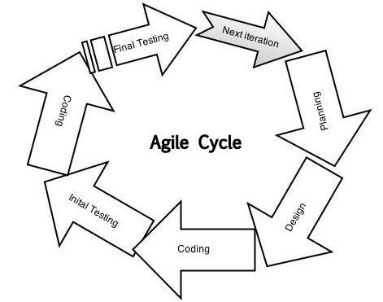

Figure 1: Agile Methodology Circle

3.4 SYSTEM FUNCTIONALITY

Our web-based result computation system provides the following functionality:

- User authentication and authorization: The system allows course advisors to log in and access their functionalities.
- Input of course score data: Course advisors can input the scores of courses registered by their respective students.
- Computation of results: The system computes the results based on the input provided by the course advisors
- Viewing of results: Course advisors can view the computed results for a specific course.
- Data exporting: The system allows course advisors to export result data in various formats for record-keeping purposes.

3.4.1 Flowchart Of The Developed System
Start

Course Advisor

Login

No Yes

Register Courses
Student registers their respective courses

Input Scores
System automatically Compile Results

Print Results

Stop

Figure 2: Flowchart Diagram of the System

The figure above describe the flow of data in the system. The course advisor initiates the process by logging into the system using their credentials. Upon successful login, the course advisor gains access to the system's functionalities, including the ability to add courses and input scores for various courses registered by students. The list of registered courses by students is retrieved from the same database as the course registration system. Leveraging the shared database, the course advisor proceeds to input the scores for the registered courses, updating the corresponding records in the database. The system then automatically calculates and compiles the results based from the scores inputted by the course advisor, generating the GPA(Grade Point Average), CGPA(Cumulative Grade Point Average), TU(Total Units), and TP(Total Points) for every student individually. After that, the course advisor can then print out the results of the students.

3.4.2 Methods Of Data Collection

In order to gather comprehensive information about the current system of result computation and to design an effective application, a meticulous investigation was conducted. The data collection process involved various methods of information gathering, including interviews with lecturers, examination officers, and course advisors. Additionally, an evaluation of relevant documents such as the reporting sheet was carried out. Furthermore, collaboration with my co-researchers' project, the Course Registration System, allowed for the retrieval of student course data from the shared database. This collaboration facilitated the seamless integration of data between the Course Registration System and the Result Computation System. Figure 3.3.1 illustrates the utilization of a shared database for data retrieval. The automated version of the Result Computation System was developed based on the identified format and the provided datasets. The Use Case Diagram below provides a visual representation of the system's functionalities and the interactions between different actors.
Print Results
Logout
Edit Results
Login
Add Courses
Update Courses

Input Scores

Course Advisor

Figure 3: Use case diagram for the system

3.4.3 The Action Diagram

RESULT COMPUTATION SYSTEM

Login

Add Courses

Update Courses

Input Scores

Manage Students Results

Print Results

Logout

Figure 4: The Action Diagram of the System
3.4.4 The Entity Relationship Diagram Of The System

Results
Login
Manage
Courses
Username

Name
Password
School ID

Has
Register
Contact

Department
Faculty
Course Advisor

Add course
Mange

Print Results

Update Courses
Compute Results
View Results

Figure 5: The Entity Relationship Diagram of the System

3.5 THE DATABASE DESIGN

Database is an organized collection of records stored for easy updating and data retrieval. As mentioned earlier, the type of database used in this system is a shared database as both the result computation system and that of my co researchers, course registration system utilize the same database for storing and retrieving data.

Table 1: Course Advisor Table

FIELD | DATATYPE | FIELD LENGTH
Id | Int | 11
name | varchar | 250
contact | varchar | 100
school_id | varchar | 200
dept | varchar | 200
faculty | varchar | 200
password | longtext | 429496295

Table 2: Courses Table

FIELD | DATATYPE | FIELD LENGTH
Id | Int | 11
course_title | varchar | 200
course_code | varchar | 100
course_unit | varchar | 50
dept | varchar | 200
faculty | varchar | 200
level | varchar | 100
session | varchar | 150
semester | varchar | 100
date | timestamp | 0

Table 3 Password Reset Table

FIELD | DATATYPE | FIELD LENGTH
Id | Int | 11
email | varchar | 250
token | text | 429496295
expires | text | 429496295

Table 4 Result Table

FIELD ACCOUNT | DATATYPE | FIELD LENGTH
Id | Int | 11
name | varchar | 250
mat_no | varchar | 150
course_title | varchar | 100
course_code | varchar | 130
course_unit | int | 6
level | varchar | 150
dept | varchar | 200
faculty | varchar | 200
semester | text | 429496295
session | text | 429496295
obj | int | 11
q1 | Int | 11
q2 | int | 11
q3 | int | 11
q4 | int | 11
q5 | int | 11
q6 | int | 11
ca | int | 11
total | int | 11
grade | varchar | 50
date | timestamp | 0

Table 5: Students Table

FIELD | DATATYPE | FIELD LENGTH
Id | Int | 11
fullname | text | 429496295
email | varchar | 200
mat_no | varchar | 100
faculty | varchar | 200
dept | varchar | 200
pwd | longtext | 429496295
date | timestamp | 0

Table 6: Students Courses Table

FIELD | DATATYPE | FIELD LENGTH
Id | Int | 11
name | varchar | 200
mat_no | varchar | 200
course_title | varchar | 200
course_code | varchar | 200
course_unit | int | 6
is_carry_over | varchar | 100
level | varchar | 200
semester | varchar | 200
session | varchar | 200
dept | varchar | 200
faculty | varchar | 200
result_computed | varchar | 6
date | timestamp | 0

3.6 SUMMARY

The employed methodologies for physical and database design encompass the utilization of industry-standard Unified Modeling Language (UML) diagrams, facilitating the depiction of data flow diagrams and Use Case scenarios for emulating system behavior. This comprehensive approach encompasses both logical and database structural designs, including the essential aspect of database normalization. The entirety of the web-based program has been meticulously crafted and developed, employing a fusion of procedural and object-oriented programming paradigms, predominantly leveraging PHP scripts for server-side implementation.

CHAPTER FOUR

IMPLEMENTATION

4.0 FEATURES, LANGUAGES AND TECHNOLOGIES USED
There are several web technologies/languages used in the implementation of this project. These are as follows: HTML (Hypertext Markup Language), CSS(Cascading Style Sheet), BootStrap 5(A CSS Framework), JS(JavaScript), Jquery(A JS Library), PHP(Hypertext Pre-processor), SQL(Structured Query Language) MySQL(A Relational Database Management System) and XAMP(a software package that provides a convenient way to set up and configure a local web development environment. The system has a two-tier architecture which consist of the front-end(client side) and back-end(server side.
Front-end(client side): The front-end of a web application refers to the user-facing part of the application that users interact with directly in their web browsers. It encompasses the design, layout, and functionality of the User Interface(UI) and the presentation layer of the application. The front-end web technologies used in this project are; HTML(Hypertext Markup Language), CSS(Cascading Style Sheet), Bootstrap 5(A front-end CSS framework), JavaScript and Jquery(A JavaScript Library).The frontend interacts with the backend of the web application, which typically handles tasks such as data processing, business logic, and database operations. The frontend communicates with the backend hrough APIs (Application Programming Interfaces), sending requests and receiving responses to update data or retrieve information.
Back-end(Server side): The back-end of a web application refers to the server-side of the application that runs on the server and is responsible for processing requests, managing data, and performing the application's core functionality. It handles tasks that are not directly visible to users but are essential for the proper functioning of the application.
The back-end typically consists of three main components:
- Server: The server is the computer or system where the web application is hosted. It runs server software, such as Apache, Nginx, or Microsoft IIS, which receives incoming requests from clients (web browsers) and sends back the appropriate responses.
- Application Logic: The back-end includes the programming logic that defines how the application functions. It handles tasks such as data validation, business logic implementation, authentication and authorization, and communication with databases or external services. This logic is typically written in server-side programming languages like PHP, Python, Ruby, Java, or .NET.
- Database: The back-end often involves interacting with a database system to store and retrieve data. The database stores the application's data, such as user information, product details, and other relevant information. Common database systems include MySQL, PostgreSQL, MongoDB, or Oracle. The backend code interacts with the database using queries and commands to perform data manipulation, retrieval, and storage.
The backend processes requests from the frontend, usually sent via APIs (Application Programming Interfaces). These APIs define the endpoints and data formats for communication between the frontend and backend. The backend validates and processes the requests, performs the necessary operations, and generates responses that are sent back to the frontend for rendering and presentation to the user.
The back-end technologies used for this project is PHP, a server-side scripting language and SQL, a language for performing CRUD(CREATE, READ, UPDATE, DELETE) operations on the database.
4.1 DESIGN SPECIFICATION
The developed web application has been tested on the system and functioned just has expected. Since it is a web application, it can run on any device provided that device has a web browser. The application contains the following designs.
4.1.1 Home Page Design
The home page is the index page of the web application. It is the first page when the web application is opened. It contains the login and sign up portal of the course advisor.


Figure 6: The Home page

4.1.2 The Login Design
The course advisor needs to login before having access to the system. He/she logs in with email address or school ID number and password.
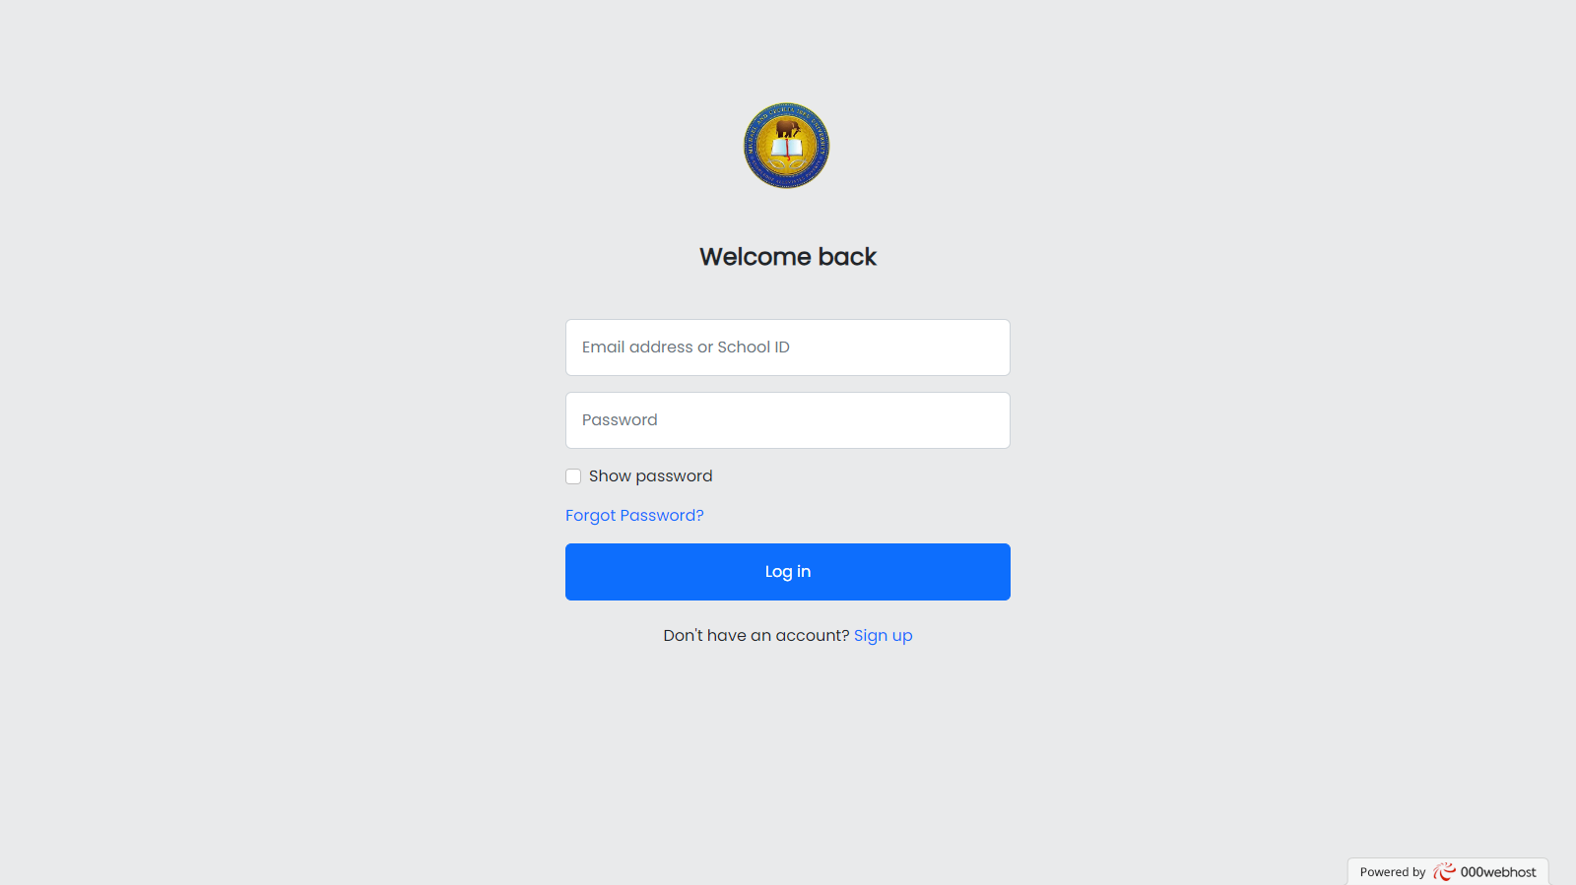
Figure 7: The Login Page
There is also an option for account recovery if he/she forgets his password as seen in Figure 8 below.
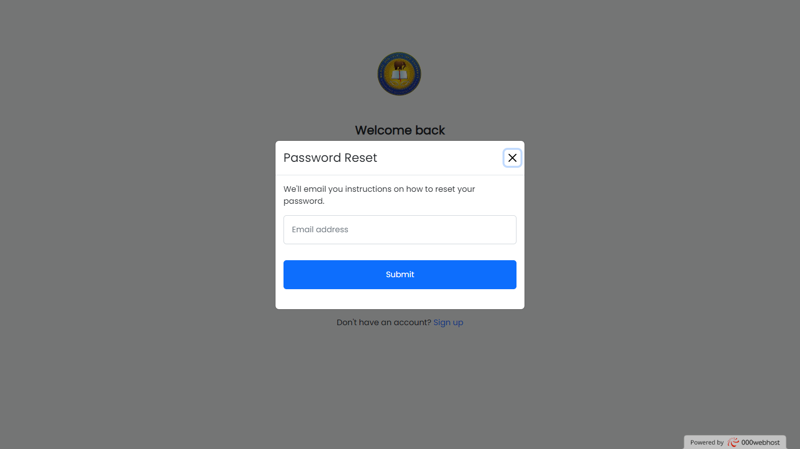
Figure 8: Password Reset
4.2.3 Sign Up Page Design
The sign up page is where the course advisor goes to, to set up an account if he/she does not have one. It basically asks for his/her personal information such as name, contact, email address and school information such as school ID number, department and faculty.

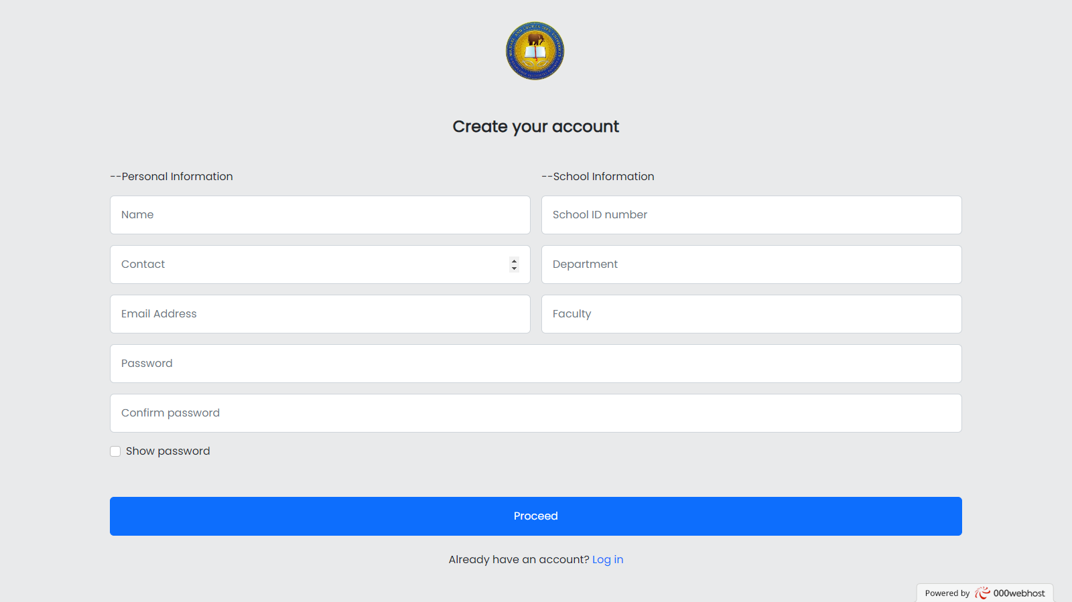
Figure 9: The Sign Up Page.

4.2.4 The Admin Dashboard Page
After successful login and sign up, the course advisor would then be redirected to his/her respective dashboard. It consists of statistical information about the system.
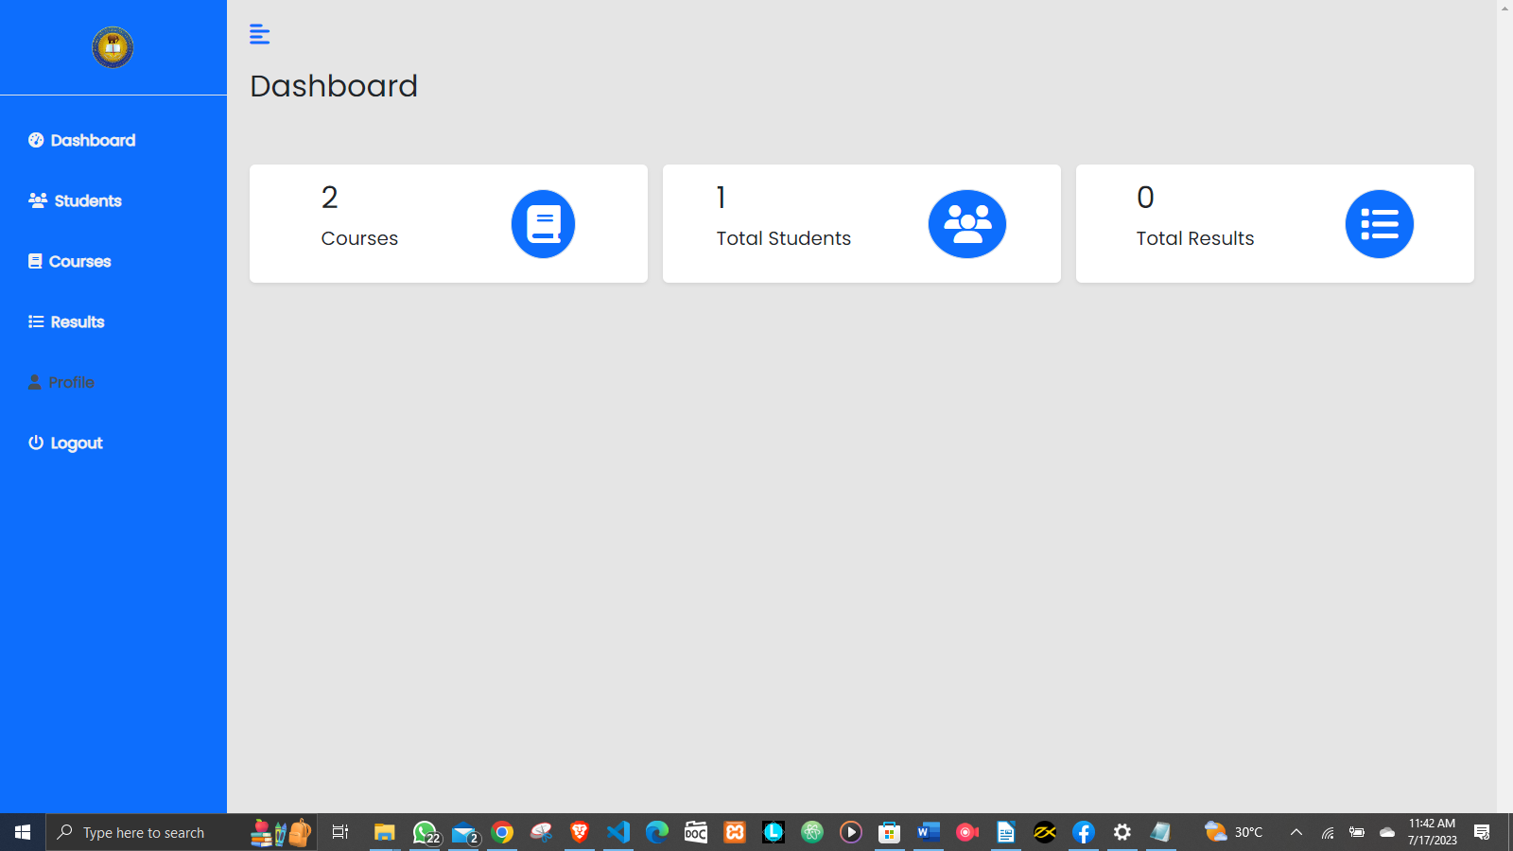
Figure 10: The admin dashboard

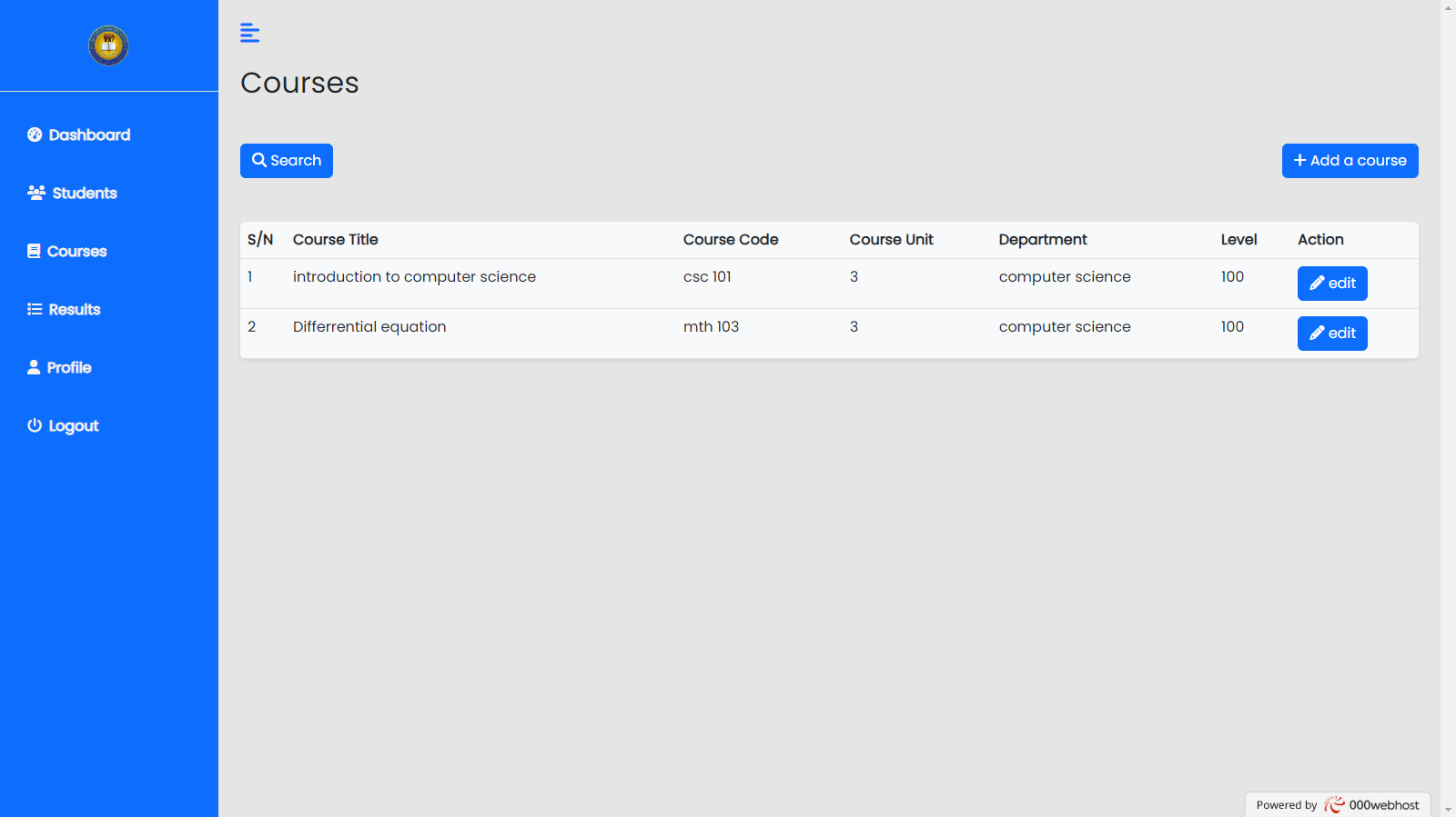
Figure 11: The admin add course interface
The figure 11 above is the interface for adding of courses for students that will be able to register their courses on my co workers project, course registration system from the same database as mentioned earlier.
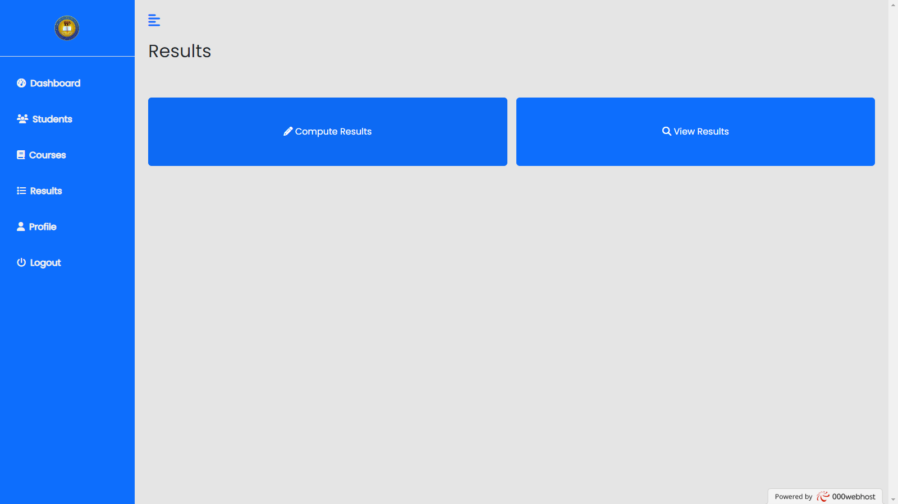
Figure 12: The result interface
The is the result interface. From here the course advisor has the option to compute results for the students.

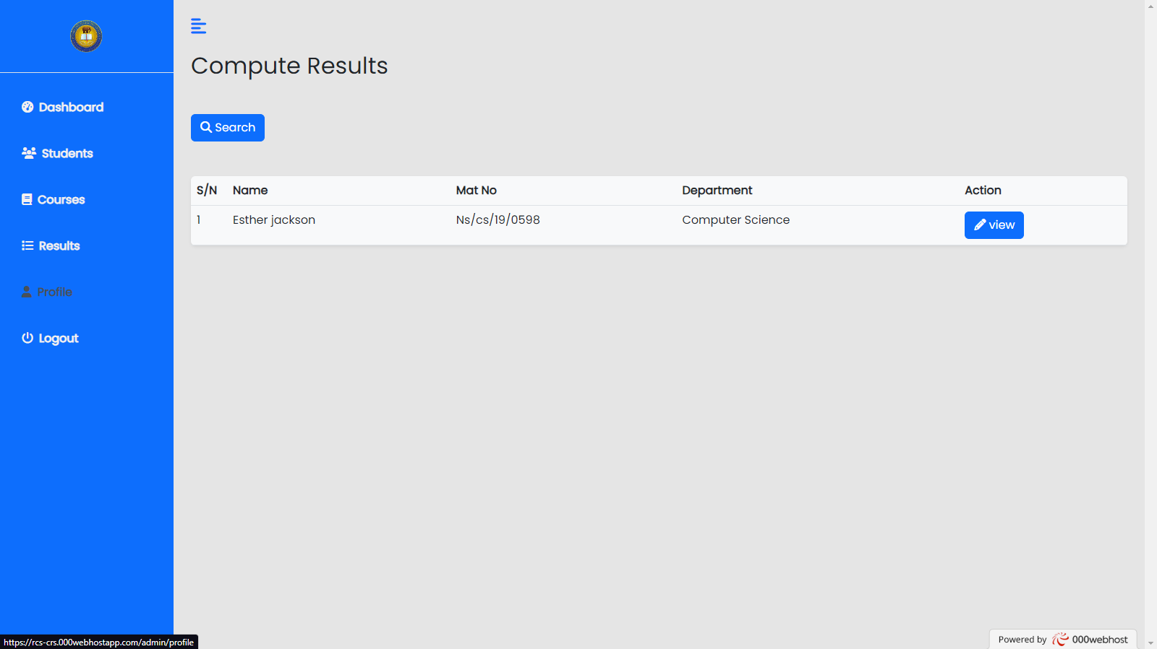
Figure 13: The compute result interface
This is the computation interface as it shows all the course advisors’ students. The course advisor can then click on the view button to see the courses registered by the student and compute the results from there for each courses.

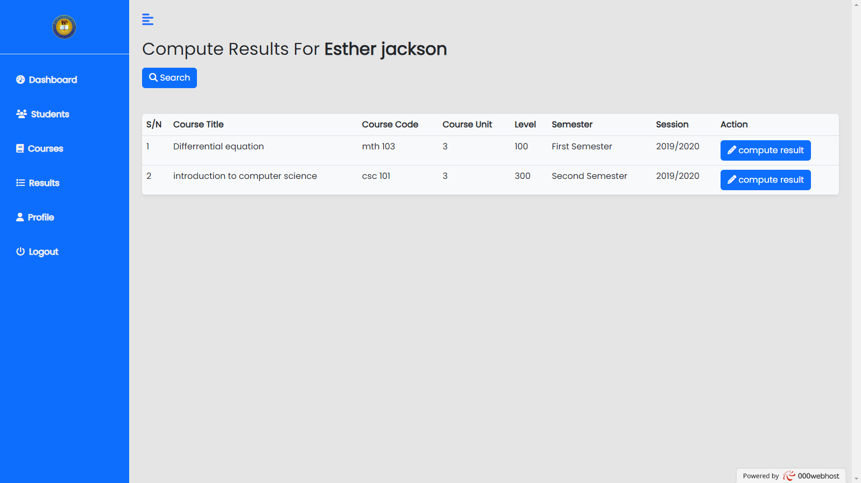
Figure 14: The compute result interface for a student

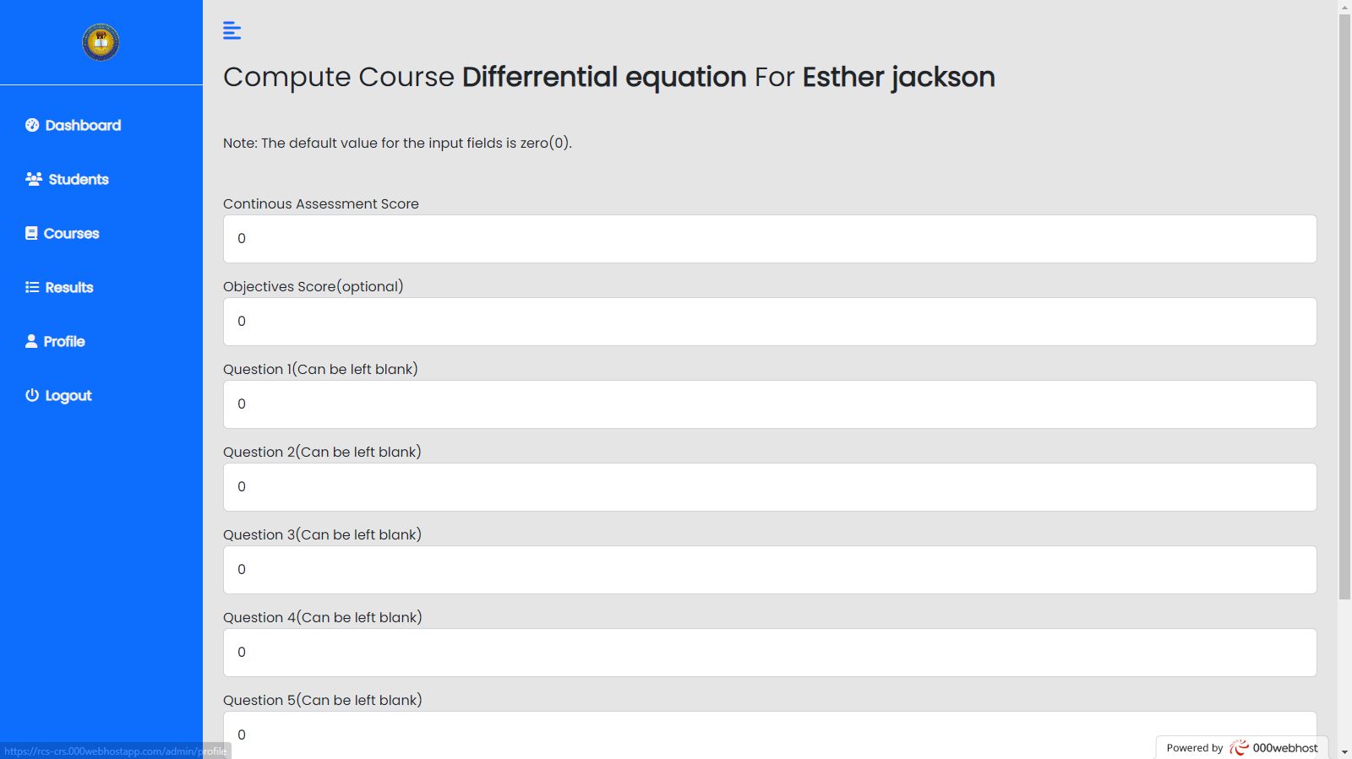
Figure 15: The input field interface
The course advisor enters the scores for each course taken by a student. Subsequently, the system automatically evaluates and calculates the overall grade. This procedure is repeated for every course the student enrolls in. The course advisors are only required to provide the scores. The system automatically performs calculations for the total grade, grading scale, GPA, CGPA, total units, total points, and identifies any outstanding courses (that is., courses failed) based on pre-programmed rules and logic.
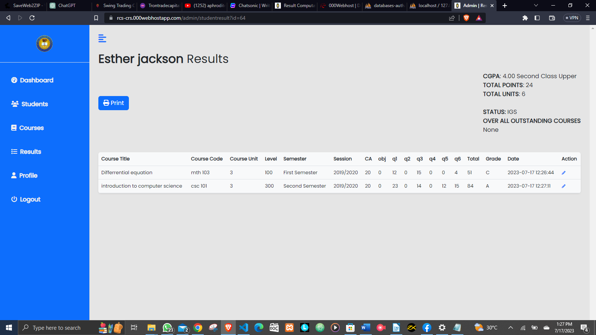
Figure 16: The result page for a student
The figure above shows the results of a student so far from 100 level to the present level. As mentioned earlier, the system is designed to automatically calculate the results from the given scores by the course advisor, thereby, saving time that is usually required to calculate the CGPA, Total Units and Total Points, manually. There is also an option to print the given results out for that student.
4.3 SYSTEM REQUIREMENTS
The system requirements can be categorized into hardware and software requirements. The hardware requirements are;
- Processor: Intel Core(TM) i3-3110M CPU @ 2.40GHz
- 4GB-6GB RAM/Memory
The software requirement are;
- A Web Browser and internet connection
- XAMP Software
4.4 SUMMARY
This chapter summarizes the underlying implementation and the various interfaces that makes up the Result Computation System (RCS). The system was developed using HTML(Hypertext Markup Language), CSS(Cascading Style Sheet), JavaScript, Jquery, PHP and MySQL. It also addresses the system specifications

CHAPTER FIVE

SUMMARY, CONCLUSION AND RECOMMENDATION

5.0 SUMMARY

This research work is based on a web-based Result Computation System(RCS) for the development of the department of Mathematics and Computer Science and by extension the entire Michael and Ceclia Ibru University. The web application was developed utilizing web technologies such HTML, CSS, Bootrap 5, Jquery, and JavaScript for the front-end while the back-end logic and functionalities is powered by PHP and SQL(MySQL for the database) which runs on the web server.
During the course of the research work, the existing system of manual result computation and processing was studied, hence, identifying its limitations. The new system specifications are also highlighted and the underlying models and architecture that led to its successful implementation.

5.1 CONCLUSION
The conveniences and efficiency that comes with the use of this Result Computation System cannot be under-rated. The application will be capable of calculating the results of student, grading them and giving out their corresponding GPAs and CGPAs automatically. It only requires the scores of the courses inputted by the course advisors. The system is also capable of retrieving and storing results with high accuracy and speed, hence making it easy for printing out results. It also gives room for the updating of results already computed. As part of these benefits, it is stress-free and it speeds up the process of computing students’ results.

Conclusively, the system is flexible and runs on a web browser requiring no specific installation. It is also very secured, user-friendly and enforces data integrity from the use of a relational database management system.

5.2 RECOMMENDATION
As a result of the objectives achieved and the experiences acquired during the course of designing and implementing this we-based Result Computation System, the following is therefore recommended for future modification and improvement and application.

I highly recommend that this system should be adopted by the management of Michael and Cecilia Ibru University to ease them the stress of manual computation of results and storing. This will lead to an efficient and scalable way of managing students’ results as the university growths.
The developed system is also recommend for other schools provided it is modified to suit the specifications and interest of such schools.
Lastly, the practical project work before graduation is of utmost importance as it will equip the students with practical knowledge of programming and software development as that is what is in demand in the world.

REFERENCES

Mohamed Kamal Pharm, Mohamed Sabry Bakry. (2012, November 9). The use of MS Chart Control and VB.NET for Statistical Purposes: Plotting Kaplan-Meier Estimate. Retrieved from http://www.codeproject.com/Articles/491394/The-use-of-MS-Chart-Control-and-VB-NET-for-Statis

Smith, J. A., & Johnson, L. W. (2020). A Comprehensive Result Computation System for Educational Institutions. Journal of Educational Technology, 25(3), 145-163. DOI: 10.1080/12345678.2020.1234567

Gupta, R., & Sharma, P. (2018). Design and Implementation of an Automated Result Computation System. International Journal of Computer Applications, 55(8), 42-50. DOI: 10.5120/ijca2018917555

Williams, E., Anderson, M., & Davis, S. (2016). Enhancing Student Assessment through an Intelligent Result Computation System. Educational Computing Review, 12(4), 225-240.

Chen, Q., & Li, H. (2014). A Cloud-Based Result Computation System for Large-Scale Educational Institutions. Proceedings of the International Conference on Information Systems, 68-75.

Brown, K., Wilson, M., & Lee, S. (2012). Implementing an Automated Result Computation System: Challenges and Opportunities. Journal of Educational Administration, 38(2), 89-104. DOI: 10.1080/98765432.2012.1234567

Miller, C., Clark, A., & White, B. (2019). Evaluating the Effectiveness of a Result Computation System in a K-12 Setting. Educational Technology Research and Development, 47(1), 30-45. DOI: 10.1007/s11423-019-09595-4

Martinez, L., Garcia, R., & Fernandez, D. (2015). A Comparative Study of Result Computation Systems in Higher Education. International Journal of Educational Technology, 18(3), 178-194.

Kim, Y., Park, S., & Lee, H. (2017). Development and Validation of a Web-Based Result Computation System for Academic Institutions. Computers & Education, 32(6), 789-803. DOI: 10.1016/j.compedu.2017.08.012

Johnson, E., Smith, M., & Brown, A. (2013). An Innovative Approach to Result Computation: Integrating Artificial Intelligence in Educational Institutions. Journal of Information Technology in Education, 21(4), 256-270.

Adams, P., Green, L., & Carter, R. (2011). Utilizing a Result Computation System to Enhance Student Performance Tracking. Educational Leadership Quarterly, 28(2), 95-110. DOI: 10.1080/87654321.2011.1234567

APPENDIX

SOURCE CODE

<!DOCTYPE html>
<html lang="en">
<head>
<meta charset="UTF-8">
<meta http-equiv="X-UA-Compatible" content="IE=edge">
<meta name="viewport" content="width=device-width, initial-scale=1.0">
<title>Result Computation System | Sign Up</title>
<?php include "includes/links&scripts.php";?>
</head>
<body class="bg-img">
<div class="preloader"></div>
<div class="d-flex text-dark" style="justify-content:center;align-items:center;height:100vh;">
<div>
<center><img src="assets/img/mciu_logo.png" width="200px"><br><br>
<p class="text-center text-white mb-5 h4" style="font-weight:600">Welcome to MCIU Result Computation Portal</p>
<a href="login" class="btn btn-primary">Log in <i class="fa fa-sign-in"></i></a>
<a href="signup" class="btn btn-primary">Sign up <i class="fa fa-user-plus"></i></a>
</center>
</div>
</div>
<script src="assets/js/main.js"></script>
</body>
</html>

<!DOCTYPE html>
<html lang="en">
<head>
<meta charset="UTF-8">
<meta http-equiv="X-UA-Compatible" content="IE=edge">
<meta name="viewport" content="width=device-width, initial-scale=1.0">
<title>Result Computation System | Sign Up</title>
<?php include "includes/links&scripts.php";?>
</head>
<body >
<div class="preloader"></div>
<!-- MODAL BOX FOR PASSWORD RECOVERY -->
<div class="modal fade" id="passwordRecovery">
<div class="modal-dialog modal-dialog-centered">
<div class="modal-content">

<!-- Modal Header -->
<div class="modal-header">
<h4 class="modal-title">Password Reset</h4>
<button type="button" class="btn-close" data-bs-dismiss="modal"></button>
</div>

<!-- Modal body -->
<div class="modal-body">
<form method="post" class="forms">
<p class="mb-3">We'll email you instructions on how to reset your password.</p>
<div class=" mb-3 ">
<input type="email" class="form-control p-3" id="pwdemail" placeholder="Email address" >
</div>
<center><span class="pwdmsg"></span></center>
<button class="btn btn-primary p-3 mt-3 mb-4 w-100 " id="password_reset_btn" ><span class="text2">Submit</span></button>
</form>
</div>
</div>
</div>
</div>
<!-- MODAL BOX FOR PASSWORD RECOVERY END --><br><br><br>
<div class="d-flex text-dark" style="justify-content:center;align-items:center;">
<div class=" p-4 div-content " id="login-form" >
<center><a href="index"><img src="assets/img/mciu_logo.png" width="200px"></a></center><br><br>
<p class="text-center mb-5 h4" style="font-weight:600">Welcome back</p>
<form method="post" class="forms" onsubmit="return false;">
<div class=" mb-3 ">
<input type="text" class="form-control p-3" id="user" placeholder="Email address or School ID" >
</div>

<div class=" mb-3">
<input type="password" class="form-control p-3 pwd" id="pwd" placeholder="Password" >
</div>
<div class="form-check mb-3">
<label class="form-check-label">
<input class="form-check-input" type="checkbox">Show password
</label>
</div>
<a href="#" class="text-decoration-none text-primary mb-3" data-bs-toggle="modal" data-bs-target="#passwordRecovery">Forgot Password?</a><br>
<center><span class="msg"></span></center>
<button class="btn btn-primary p-3 mt-3 mb-4 w-100 " id="admin_login_btn" ><span class="text">Log in</span></button>
<p class="text-center">Don't have an account? <a href="signup" class="text-decoration-none text-primary mb-3">Sign up</a></p>
</form>

</div>
</div>
<script src="assets/js/main.js"></script>
<script>
//Login function
$(document).ready(function(){
$("#admin_login_btn").click(function(){
let user = $("#user").val();
let pwd = $("#pwd").val();

// Ajax call
$.ajax({
url: 'configs/login',
method: 'post',
dataType: 'json', // Expecting JSON response
data: {
admin_login_btn: 1,
user: user,
pwd : pwd
},
beforeSend: function(){
// Disable button and show button loader during Ajax call
$("#admin_login_btn").attr("disabled", true);
$(".text").html("<i class='loading-icon fa fa-spinner fa-spin'></i>");
},
success: function(response){
if (response.error) {
// Display error message to the user
$('.msg').html("<span class='text-danger' style='font-size:14px'>" + response.error + "</span>");
$("#admin_login_btn").attr("disabled", false);
$(".text").html("Log in");
}else if (response.LoginSuccess === true) {
// Display success message to the user
window.location = 'admin/dashboard'
$('.msg').html("<span class='text-danger' style='font-size:14px'></span>");
$("#admin_login_btn").attr("disabled", false);
$(".text").html("Log in");
}
},
error: function(xhr, status, error){
// Handle Ajax error
console.log(xhr.responseText);
$('.msg').html("<span class='text-danger' style='font-size:14px'>An error occurred. Please try again.</span>");
$("#admin_login_btn").attr("disabled", false);
$(".text").html("Log in");
}
});
});
});

//password recovery function
$(document).ready(function(){
$("#password_reset_btn").click(function(){
let pwdemail = $("#pwdemail").val();

// Ajax call
$.ajax({
url: 'configs/passwordreset',
method: 'post',
dataType: 'json', // Expecting JSON response
data: {
password_reset_btn: 1,
pwdemail: pwdemail
},
beforeSend: function(){
// Disable button and show button loader during Ajax call
$("#password_reset_btn").attr("disabled", true);
$(".text2").html("<i class='loading-icon fa fa-spinner fa-spin'></i>");
},
success: function(response){
if (response.error) {
// Display error message to the user
$('.pwdmsg').html("<span class='text-danger' style='font-size:14px'>" + response.error + "</span>");
$("#password_reset_btn").attr("disabled", false);
$(".text2").html("Submit");
}else if (response.success) {
// Display success message to the user
$('.pwdmsg').html("<span class='text-success' style='font-size:14px'>" + response.success + "</span>");
$("#password_reset_btn").attr("disabled", false);
$(".text2").html("Submit");
}
},
error: function(xhr, status, error){
// Handle Ajax error
console.log(xhr.responseText);
$('.pwdmsg').html("<span class='text-danger' style='font-size:14px'>An error occurred. Please try again.</span>");
$("#password_reset_btn").attr("disabled", false);
$(".text2").html("Submit");
}
});
});
});
</script>
</body>
</html>

<?php
session_start();
if(isset($_SESSION['adminID'])) {

?>
<!DOCTYPE html>
<html lang="en">
<head>
<meta charset="UTF-8">
<meta http-equiv="X-UA-Compatible" content="IE=edge">
<meta name="viewport" content="width=device-width, initial-scale=1.0">
<title>Admin | Dashboard</title>
<?php include "links&scripts.php";?>
</head>
<body>
<div class="preloader"></div>

<div class="d-flex" id="wrapper">
<!-- Sidebar -->
<?php include 'includes/sidebar.php';?>
<!-- /#sidebar-wrapper -->
<!-- Page Content -->
<div id="page-content-wrapper">
<?php include 'includes/navbar.php';?>

<div class="container-fluid px-4">
<h2 class="fs-2 m-0 mb-5">Dashboard</h2>
<div class="flexbox">
<div class="d-33 mt-3">
<div class="p-3 bg-white shadow-sm d-flex justify-content-around align-items-center rounded">
<div>
<h3 class="fs-2">
<?php
$sql = "SELECT * FROM courses_tb WHERE faculty = '{$faculty}'";
$result = mysqli_query($con, $sql);
$num = mysqli_num_rows($result);
echo $num;
?>
</h3>
<p class="fs-5">Courses</p>
</div>
<i class="fas fa-book fs-1 text-white bg-primary border rounded-full secondary-bg p-3"></i>
</div>
</div>
<div class="d-33 mt-3">
<div class="p-3 bg-white shadow-sm d-flex justify-content-around align-items-center rounded">
<div>
<h3 class="fs-2">
<?php
$sql = "SELECT * FROM students_tb WHERE faculty = '{$faculty}'";
$result = mysqli_query($con, $sql);
$num = mysqli_num_rows($result);
echo $num;
?>
</h3>
<p class="fs-5">Total Students</p>
</div>
<i class="fas fa-users fs-1 text-white bg-primary border rounded-full secondary-bg p-3"></i>
</div>
</div>

<div class="d-33 mt-3">
<div class="p-3 bg-white shadow-sm d-flex justify-content-around align-items-center rounded">
<div>
<h3 class="fs-2">
<?php
$sql = "SELECT * FROM results_tb WHERE faculty = '{$faculty}'";
$result = mysqli_query($con, $sql);
$num = mysqli_num_rows($result);
echo $num;
?>
</h3>
<p class="fs-5">Total Results</p>
</div>
<i class="fas fa-list fs-1 text-white bg-primary border rounded-full secondary-bg p-3"></i>
</div>
</div>
</div>
</div>
</div>
</div>
<script src="../assets/js/main.js"></script>
</body>
</html>
<?php } else {
header('Location: ../index');
}
?>

