* Suggestions –
* Trgroup.co.nz –

|  |  |
| --- | --- |
| Improvement ID: | 1 |
| Name: | Should insert a map, not just write it in text |
| Environment: | URL: <https://www.trgroup.co.nz/>  Web browser: Google chrome (Version 95.0.4638.54 (Official Build) (64-bit))  OS: windows 10 Pro  Device: computer  Screen resolution: 1366x768 |
| Severity: | Cosmetic |
| Priority: | Low |
| Description: | A map should be inserted, not just written in text, so that the user can navigate more easily |
| Steps to reproduce: | 1:Click on the link <https://www.trgroup.co.nz/>  2. Scroll down  3. Find in footer where write “TR GROUP”  4. Where the old map is written, change to the new one which will be like a picture and when the map is clicked, it will take it to the map application. |
| Expected result: | New one which will be like a picture and when the map is clicked, it will take it to the map application. |
| Actual result: | The old map is written |
| Additional notes: | / |

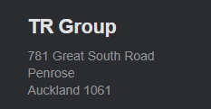

Picture 1: old map

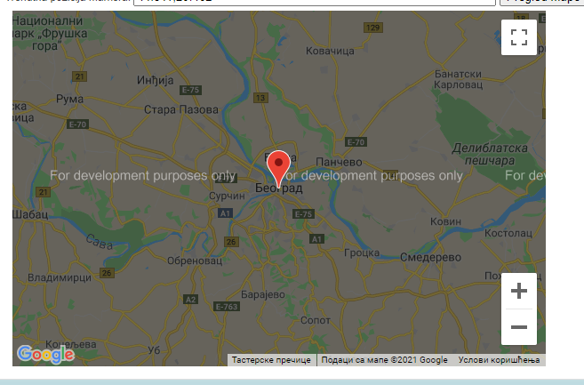

Picture 1: Set up a new map

|  |  |
| --- | --- |
| Improvement ID: | 2 |
| Name: | The images of the video should be a little smaller |
| Environment: | URL: <https://www.trgroup.co.nz/>  Web browser: Google chrome (Version 95.0.4638.54 (Official Build) (64-bit))  OS: windows 10 Pro  Device: computer  Screen resolution: 1366x768 |
| Severity: | Cosmetic |
| Priority: | Low |
| Description: | the images of the video should be a little smaller, to make it look more useful and pleasing to the human eye |
| Steps to reproduce: | 1:Click on the link <https://www.trgroup.co.nz/>  2. Scroll down  3. find all the videos  4. reduce the dimensions of the photo |
| Expected result: | The photo from the video will be a little smaller |
| Actual result: | A big photo from the video |
| Additional notes: | / |

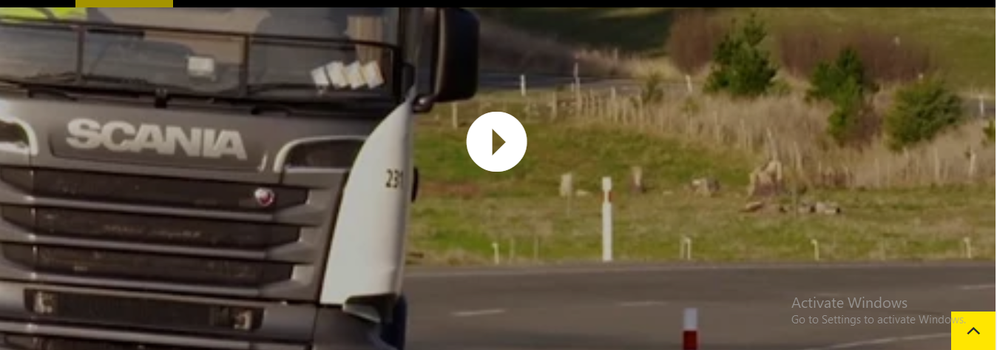

Picture 3: current photo from video

|  |  |
| --- | --- |
| Improvement ID: | 3 |
| Name: | The "read more" buttons should be tidy up |
| Environment: | URL: <https://www.trgroup.co.nz/>  Web browser: Google chrome (Version 95.0.4638.54 (Official Build) (64-bit))  OS: windows 10 Pro  Device: computer  Screen resolution: 1366x768 |
| Severity: | Cosmetic |
| Priority: | Low |
| Description: | The "read more" buttons should be arranged to make them more pleasing to the user |
| Steps to reproduce: | 1:Click on the link <https://www.trgroup.co.nz/>  2. scroll down  3. arrange the buttons to be in one line |
| Expected result: | The buttons in one line |
| Actual result: | Buttons aren’t arranged |
| Additional notes: | / |

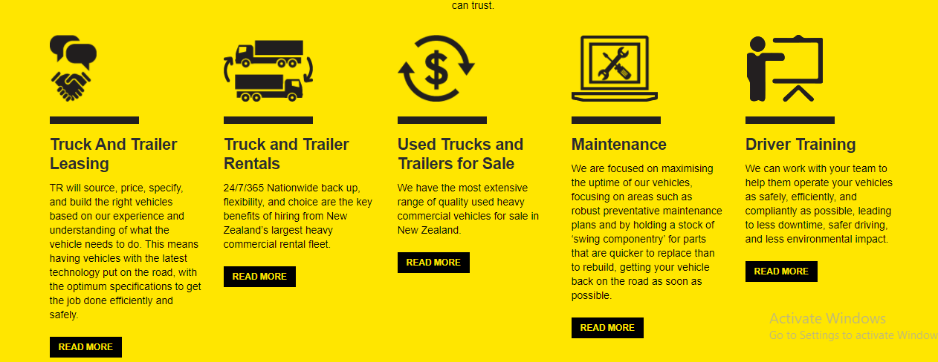

Picture 4: The "read more" buttons should be tidy up

|  |  |
| --- | --- |
| Improvement ID: | 4 |
| Name: | Employee profiles should be in color |
| Environment: | URL: <https://www.trgroup.co.nz/>  Web browser: Google chrome (Version 95.0.4638.54 (Official Build) (64-bit))  OS: windows 10 Pro  Device: computer  Screen resolution: 1366x768 |
| Severity: | Cosmetic |
| Priority: | Low |
| Description: | Employee profiles should be in color |
| Steps to reproduce: | 1: Click on the link <https://www.trgroup.co.nz/>  2. scroll down  3. find employee profiles and add color on picture |
| Expected result: | Employee profiles have a color |
| Actual result: | Employee profiles doesn’t have a color |
| Additional notes: | / |

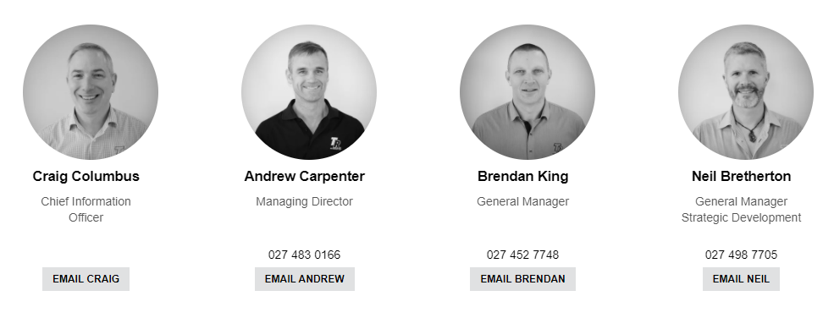

Picture 5: Employee profiles should be in color

|  |  |
| --- | --- |
| Improvement ID: | 5 |
| Name: | News cards should look interactive and launch |
| Environment: | URL: <https://www.trgroup.co.nz/>  Web browser: Google chrome (Version 95.0.4638.54 (Official Build) (64-bit))  OS: windows 10 Pro  Device: computer  Screen resolution: 1366x768 |
| Severity: | Cosmetic |
| Priority: | Low |
| Description: | News cards should look interactive and launch (so that one follows the other and the user can better see one particular news) |
| Steps to reproduce: | 1: Click on the link <https://www.trgroup.co.nz/>  2. scroll down  3. find the **"latest news"** section and change the list one card after another |
| Expected result: | The cards look interactive and quite design-enhanced with movements |
| Actual result: | Cards look ordinary |
| Additional notes: | Cards look ordinary, but cards need to be upgraded to attract users with their design |

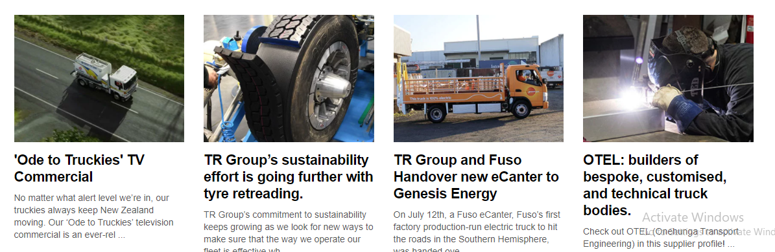

Picture 6: Cards look ordinary

|  |  |
| --- | --- |
| Improvement ID: | 6 |
| Name: | Contrasting colors and accessibility should be better |
| Environment: | URL: <https://www.trgroup.co.nz/>  Web browser: Google chrome (Version 95.0.4638.54 (Official Build) (64-bit))  OS: windows 10 Pro  Device: computer  Screen resolution: 1366x768 |
| Severity: | Minor |
| Priority: | Medium |
| Description: | contrasting colors should be otherwise much better suited to the user |
| Steps to reproduce: | 1: click on the link : <https://www.trgroup.co.nz/> 2. click on your keyboard button “F12” 3. Click in menu: “lighthouse” 4. Click on button: “generate report”  5. got a 80% of generate report |
| Expected result: | More than 90% |
| Actual result: | 80%, should be more than 90 % |
| Additional notes: | To pass the contact color test they must have over 90 percent and currently have only 80 percent ( reference by [WCAG 2.1 Standard](http://www.w3.org/TR/WCAG21/)) |



Picture 7: Accessibility should be better

|  |  |
| --- | --- |
| Improvement ID: | 7 |
| Name: | Need to insert the ReCaptcha in the login form |
| Environment: | URL: <https://www.trgroup.co.nz/>  Web browser: Google chrome (Version 95.0.4638.54 (Official Build) (64-bit))  OS: windows 10 Pro  Device: computer  Screen resolution: 1366x768 |
| Severity: | Cosmetic |
| Priority: | Low |
| Description: | Need to insert the ReCaptcha in the login form, in order to raise the level of security |
| Steps to reproduce: | 1: Click on the link <https://www.trgroup.co.nz/>  2. scroll down  3. where is login form insert ReCaptcha |
| Expected result: | Login form has ReCaptcha |
| Actual result: | Login form has no ReCaptcha |
| Additional notes: | / |



Picture 8: Need to insert the ReCaptcha in the login form