* Libertyvan.com –
* Exploratory testing –

|  |  |
| --- | --- |
| bug ID: | 001 |
| Name: | Accessibility (Contrast – ratio) should be better |
| Environment: | URL: <http://www.libertyvan.com/>  Web browser: Google chrome (Version 95.0.4638.54 (Official Build) (64-bit))  OS: windows 10 Pro  Device: computer  Screen resolution: 1366x768 |
| Severity: | minor |
| Priority: | Medium |
| Description: | contrasting colors should be otherwise much better suited to the user |
| Steps to reproduce: | 1: click on the link :” http://www.libertyvan.com/” 2. click on your keyboard button “F12” 3. Click in menu: “lighthouse” 4. Click on button: “generate report”  5. got a 76% of generate report |
| Expected result: | More than 90% |
| Actual result: | 76%, should be more than 90 % |
| Additional notes: | * to pass the contact color test they must have over 90 percent and currently have only 76 percent ( reference by [WCAG 2.1 Standard](http://www.w3.org/TR/WCAG21/)) |

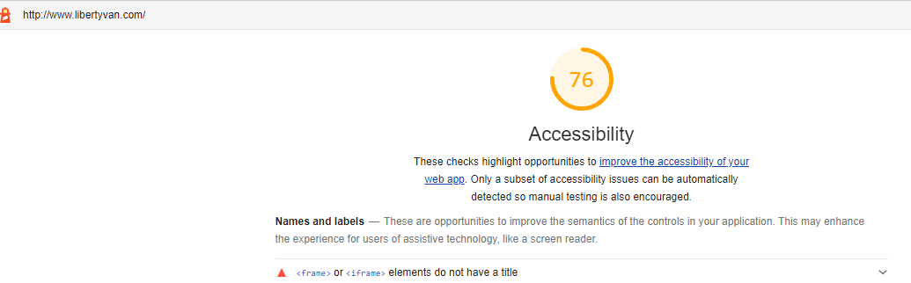

Picture 1: accessibility ( contrast-ratio)

|  |  |
| --- | --- |
| bug ID: | 002 |
| Name: | Elements don’t have a title Screen reader users rely on frame titles to describe the contents of frames |
| Environment: | URL: <http://www.libertyvan.com/>  Web browser: Google chrome (Version 95.0.4638.54 (Official Build) (64-bit))  OS: windows 10 Pro  Device: computer  Screen resolution: 1366x768 |
| Severity: | minor |
| Priority: | medium |
| Description: | Elements don’t have a title, should add title that the user knows what the element is |
| Steps to reproduce: | 1: click on the link: <http://www.libertyvan.com/>  2. Scroll down  3. find element like in attachment |
| Expected result: | Elements have a title |
| Actual result: | Elements don’t have a title |
| Additional notes: | / |

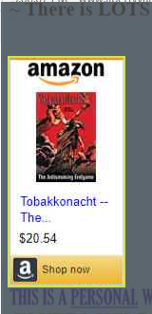 Picture 2: element don’t have a title

|  |  |
| --- | --- |
| improvement ID: | 003 |
| Name: | The image looks like a bug but isn’t a bug |
| Environment: | URL: <http://www.libertyvan.com/>  Web browser: Google chrome (Version 95.0.4638.54 (Official Build) (64-bit))  OS: windows 10 Pro  Device: computer  Screen resolution: 1366x768 |
| Severity: | minor |
| Priority: | low |
| Description: | the image looks like a bug but it isn’t a bug, the photo should be changed so as not to confuse the users |
| Steps to reproduce: | 1: click on the link: <http://www.libertyvan.com/>  2. Scroll down  3. find image like in attachment |
| Expected result: | an image that doesn’t look like a bag |
| Actual result: | The image looks like a bug |
| Additional notes: | / |

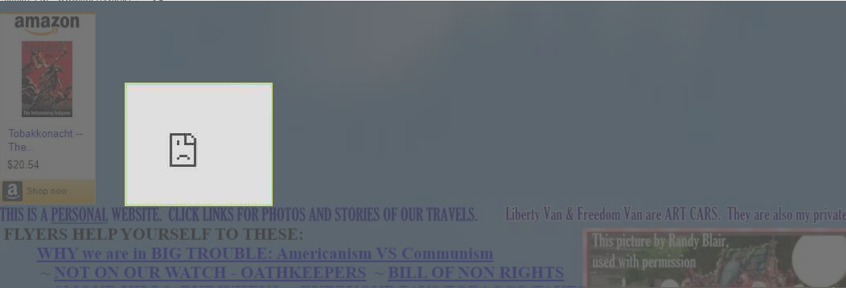

Picture 3: the image looks like a bug but isn’t a bug

|  |  |
| --- | --- |
| improvement ID: | 004 |
| Name: | Website should be safe and secure |
| Environment: | URL: <http://www.libertyvan.com/>  Web browser: Google chrome (Version 95.0.4638.54 (Official Build) (64-bit))  OS: windows 10 Pro  Device: computer  Screen resolution: 1366x768 |
| Severity: | normal |
| Priority: | high |
| Description: | Website should be safe, secure and contain a green certificate |
| Steps to reproduce: | 1: click on the link :” http://www.libertyvan.com/” 2. click on your keyboard button “F12” 3. Click in menu: “Security” 4. Write : Security overview- This page is not secure. |
| Expected result: | The website is secure and safe |
| Actual result: | The website isn’t secure and safe |
| Additional notes: | / |

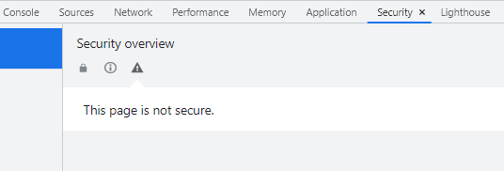

Picture 4: Website should be safe and secure

|  |  |
| --- | --- |
| bug ID: | 005 |
| Name: | Blocked a frame with origin "https://ws-na.assoc-amazon.com" from accessing a cross-origin frame. |
| Environment: | URL: <http://www.libertyvan.com/>  Web browser: Google chrome (Version 95.0.4638.54 (Official Build) (64-bit))  OS: windows 10 Pro  Device: computer  Screen resolution: 1366x768 |
| Severity: | Major |
| Priority: | High |
| Description: | Blocked a frame with origin "https://ws-na.assoc-amazon.com" from accessing a cross-origin frame, but it shouldn’t block. |
| Steps to reproduce: | 1: click on the link :” http://www.libertyvan.com/” 2. click on your keyboard button “F12” 3. Click in menu: “Console” 4. look at the errors, it is written in red color |
| Expected result: | That there are no errors in the console |
| Actual result: | There are bugs in the console |
| Additional notes: | / |

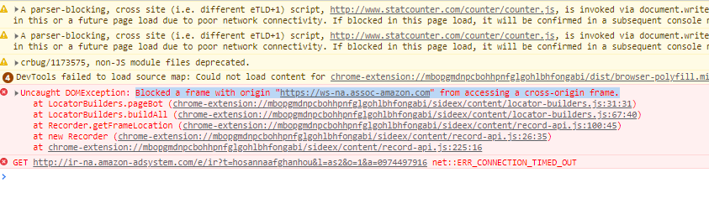

Picture 5: There are bugs in the console

|  |  |
| --- | --- |
| bug ID: | 006 |
| Name: | The video link doesn’t work, the link breaks |
| Environment: | URL: <http://www.libertyvan.com/>  Web browser: Google chrome (Version 95.0.4638.54 (Official Build) (64-bit))  OS: windows 10 Pro  Device: computer  Screen resolution: 1366x768 |
| Severity: | Major |
| Priority: | High |
| Description: | The video link doesn’t work, the link breaks (status: 404- page not found) |
| Steps to reproduce: | 1: click on the link: <http://www.libertyvan.com/>  2. Scroll down  3. find the part **Posted 5/29/14** and after that you have video link.  4. the link is [**http://www.clipsyndicate.com/video/play/5137433**](http://www.clipsyndicate.com/video/play/5137433) |
| Expected result: | The link of video works |
| Actual result: | The link of video doesn’t work |
| Additional notes: | / |

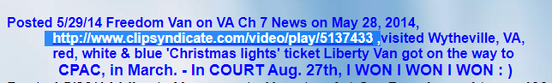



Picture 6: The link of video doesn’t work

|  |  |
| --- | --- |
| bug ID: | 007 |
| Name: | The website isn’t responsive |
| Environment: | URL: <http://www.libertyvan.com/>  Web browser: Google chrome (Version 95.0.4638.54 (Official Build) (64-bit))  OS: windows 10 Pro  Device: computer  Screen resolution: 1366x768 |
| Severity: | minor |
| Priority: | high |
| Description: | When viewed from other devices such as various mobile phone models, the responsiveness isn’t as it should be and the content overlaps |
| Steps to reproduce: | 1: click on the link :” http://www.libertyvan.com/” 2. click on your keyboard button “F12” 3. Click in menu: Toogle device toolbar( ctrl+shift+m) 4. Where is options: “dimension” choose which model you want ( for example: Iphone x) |
| Expected result: | The website is responsive |
| Actual result: | The website isn’t responsive |
| Additional notes: | / |

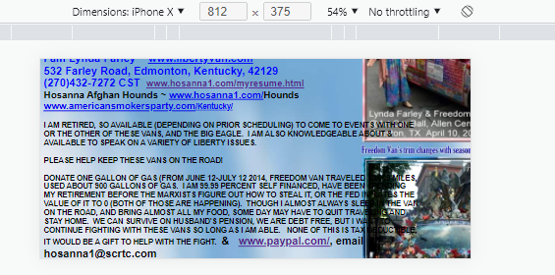  
 Picture 7: The website isn’t responsive

|  |  |
| --- | --- |
| bug ID: | 008 |
| Name: | There is no account on the social network |
| Environment: | URL: <http://www.libertyvan.com/>  Web browser: Google chrome (Version 95.0.4638.54 (Official Build) (64-bit))  OS: windows 10 Pro  Device: computer  Screen resolution: 1366x768 |
| Severity: | normal |
| Priority: | high |
| Description: | When you enter a link from twitter, the link works, but there is no account on the social network |
| Steps to reproduce: | 1: click on the link: <http://www.libertyvan.com/>  2. find the link: [**twitter.com/SmokinKYgranny**](https://twitter.com/SmokinKYgranny)  3. click on the link |
| Expected result: | A social network exists |
| Actual result: | A social network doesn’t exists |
| Additional notes: | / |

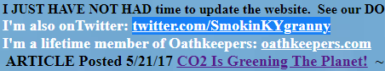

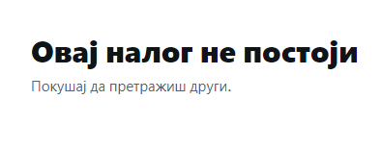

Picture 8: A social network doesn’t exists

|  |  |
| --- | --- |
| bug ID: | 009 |
| Name: | The email should have a link |
| Environment: | URL: <http://www.libertyvan.com/>  Web browser: Google chrome (Version 95.0.4638.54 (Official Build) (64-bit))  OS: windows 10 Pro  Device: computer  Screen resolution: 1366x768 |
| Severity: | Minor |
| Priority: | Medium |
| Description: | The email should have a link through which the mail application is opened and through which it can send the message immediately |
| Steps to reproduce: | 1: click on the link: <http://www.libertyvan.com/>  2. scroll down 3. find the text where is **email hosanna1@scrtc.com** |
| Expected result: | The email have a link |
| Actual result: | The email doesn’t have a link |
| Additional notes: | Add (mailto: **hosanna1@scrtc.com)** |

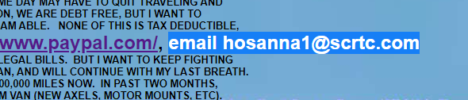

Picture 9: email should have a link

|  |  |
| --- | --- |
| bug ID: | 010 |
| Name: | The link doesn’t work |
| Environment: | URL: <http://www.libertyvan.com/>  Web browser: Google chrome (Version 95.0.4638.54 (Official Build) (64-bit))  OS: windows 10 Pro  Device: computer  Screen resolution: 1366x768 |
| Severity: | Major |
| Priority: | High |
| Description: | When the user wants to enter the link, link breaks |
| Steps to reproduce: | 1: click on the link: <http://www.libertyvan.com/>  2. scroll down 3. find the link: [Liberty Van #108, 109  ~  Freedom Van 110  OF 200](http://www.facebook.com/photo.php?fbid=10150305457167802&set=a.10150305454952802.405589.43766522801&type=1&ref=nf#!/photo.php?fbid=10150305470887802&set=a.10150305454952802.405589.43766522801&type=1&pid=9466509&id=43766522801)  4. click on the link |
| Expected result: | Link is open in the new page |
| Actual result: | The link doesn’t work, page isn’t open |
| Additional notes: | / |

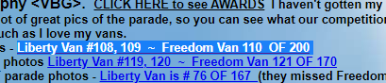

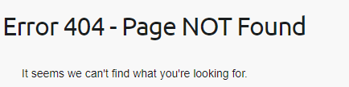

Picture 10: The link doesn’t work, page isn’t open

These are some of the main bugs, but there are a lot of things that need to be improved like: styling, design, lowercase and uppercase letters, justify, that the text doesn’t overlap with the content, there are too many fonts, font colors...