* Bug report -

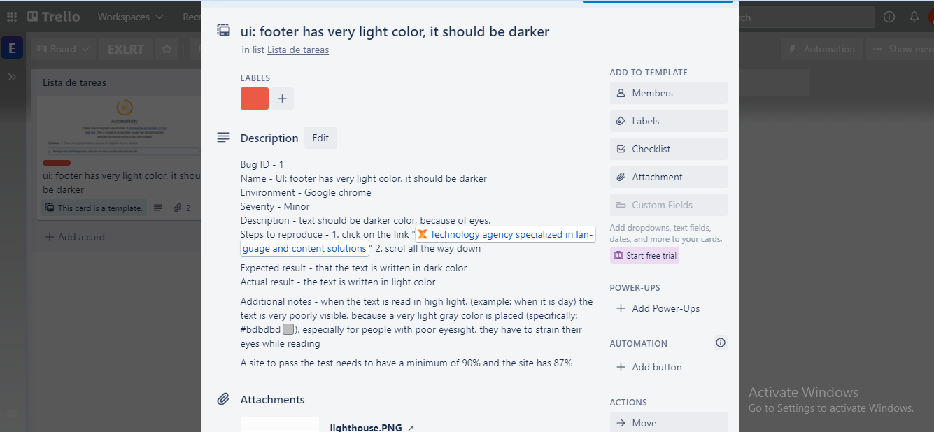

Image 1: used „Trello“ application for bug report

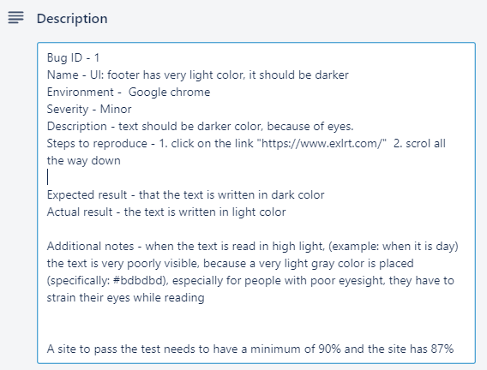

Image 2: Bug report (description)

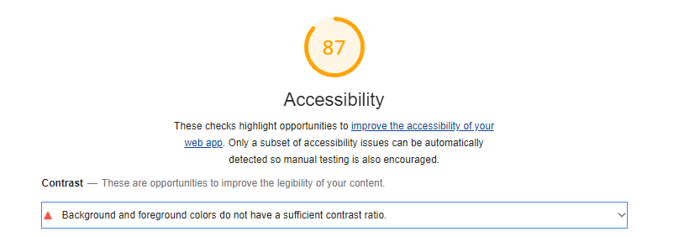

Image 3: lighthouse - accessibility

C:\Users\user\AppData\Local\Microsoft\Windows\INetCache\Content.Word\too light gray.png

Image 4: additional notes