PROJECT REVISION LIST

Legend:

|  |  |
| --- | --- |
|  | Done |
|  | Need rework |
|  | Not yet done |

|  |  |  |  |  |  |  |  |
| --- | --- | --- | --- | --- | --- | --- | --- |
| **No.** | **RECOMMENDATION/**  **FEEDBACK** | **Action Taken by the Team Member/s** | **Comment by Panel Member** | | | | |
| **PM1** | **PM2** | **PM3** | **PM4** | **PM5** |
| 1. 1 | Combined Login Page for Admin & Adviser | Created a separate login page for Advisers |  |  |  |  |  |
|  | Student’s Project | Created a Project page where students can create and view their project. |  |  |  |  |  |
|  | Student’s Project Limitation | Modified the ‘Add Project’ button to disable after the student create their project |  |  |  |  |  |
|  | Tasks can be assigned to students. | Added Task assignment feature for Admin/Dean |  |  |  |  |  |
|  | Tasks should be organized by prerequisites | Tasks are organized in accordion-style per prerequisites |  |  |  |  |  |
|  | Assigning of Project Advisers | Added List of Advisers students can choose from |  |  |  |  |  |
|  | Students’ application to Adviser | Advisers are notified whenever students choose their advisory;  Adviser can either Accept or Dismiss this application. |  |  |  |  |  |
|  | Add team/slots counter | Added team/slots counter for number of advisees per advisers |  |  |  |  |  |
|  | Identify the team | Added a Team Name label for each student’s team |  |  |  |  |  |
|  | Admin can see the task submitted by the students | Added a ‘Submission Page’ for Admin to view student’s submission |  |  |  |  |  |
|  | Advisers can see the task submitted by their advisee | Added a ‘Submission Page’ for Advisers to view their advisee’s submission |  |  |  |  |  |
|  | Status for tasks (ex: Reviewed etc.) | Added Status feature where Advisers can ‘Review’ and ‘Approve’ advisee’s submissions;  Admin can also see the status of the tasks if it was ‘reviewed’ by the Adviser |  |  |  |  |  |
|  | Project Page for Advisers | Added a ‘Project Page’ for Advisers to view the projects of their advisees |  |  |  |  |  |
|  | Project Advisers | Admin can add/delete Advisers |  |  |  |  |  |
|  | Slots available per Project Adviser | Added a counter per Adviser that will show the available slots of advisees still available |  |  |  |  |  |
|  | Project Adviser’s List of Advisees | Admin can see the students under each Project Adviser |  |  |  |  |  |
|  | Uploading of files is not working (including Profile Photo, Project Logo and Attachments of Tasks) | Debugged and fix this issue |  |  |  |  |  |
|  | Adviser should see the Project of each student | Added a Advisee profile page in Adviser side |  |  |  |  |  |
|  | Student should see the number of slots available advisee per adviser upon choosing them | Added a slot counter in each Adviser Card |  |  |  |  |  |
|  | Files submission bug | Added a warning prompt whenever users try to submit without files attached. |  |  |  |  |  |
|  | Status of tasks on the Task Page is not indicated | Added a status of Pending, Submitted and Reviewed to indicate the status of each task |  |  |  |  |  |
|  | Submission Table error | Fixed this error |  |  |  |  |  |
|  | Adviser choosing should have status | Added a status to indicate if the Advisee’s application is Pending, Accepted and Rejected. |  |  |  |  |  |
|  | Actions in Submissions | Review button for Advisers are added |  |  |  |  |  |
|  | Submission classifications | Submissions can now be classified as ‘Complete’ once Advisers reviewed it. |  |  |  |  |  |
|  | Adviser can remove the student from their advisee | Advisees can now be removed by Advisers |  |  |  |  |  |
|  | Task Submission Duplicate bug | Fixed this bug, Submissions per task is now different from each other. |  |  |  |  |  |
|  | Task Name in Submission page | Added the Task Name on top of the Submission page. |  |  |  |  |  |
|  | Task Status Bug | Fixed this bug, Students can now see the status per Activity. |  |  |  |  |  |
|  | Submissions can either be Accepted or Rejected | Advisers can now Accept or Reject the submission of their advisee. |  |  |  |  |  |
|  | Student can Resubmit if their submission is rejected |  |  |  |  |  |  |
|  | Adviser can provide feedback to the submission of Student |  |  |  |  |  |  |
|  | Status of Submission is not easily recognized | Added a color coding for the submission’s status |  |  |  |  |  |
|  | Viewing of Attachments instead of Downloading. |  |  |  |  |  |  |
|  | Include Team Name in table. | Added a column for the student’s team name. |  |  |  |  |  |
|  | “Group Name” not showing up on Completed table. | Group Name can now be seen in the Completed Table. |  |  |  |  |  |
|  | Admin should see the student’s Profile. | Admin can now see the Profile of student with their respective project and Adviser. |  |  |  |  |  |
|  | Allcaps website icon is not showing | Fixed this, AllCaps logo can now be seen as website icon. |  |  |  |  |  |
|  | Number list the Student submissions | Student submissions are now listed by number |  |  |  |  |  |
|  | Student can’t submit task unless they have a project. |  |  |  |  |  |  |
|  | Group Name not showing on the tables |  |  |  |  |  |  |
|  | Missing Group Name |  |  |  |  |  |  |

31. Tama na naiindicate na “Already Submitted” na si student pero paano pag ni reject ni Adviser yung Submission niya? Kaya dapat need ng Resubmit button.

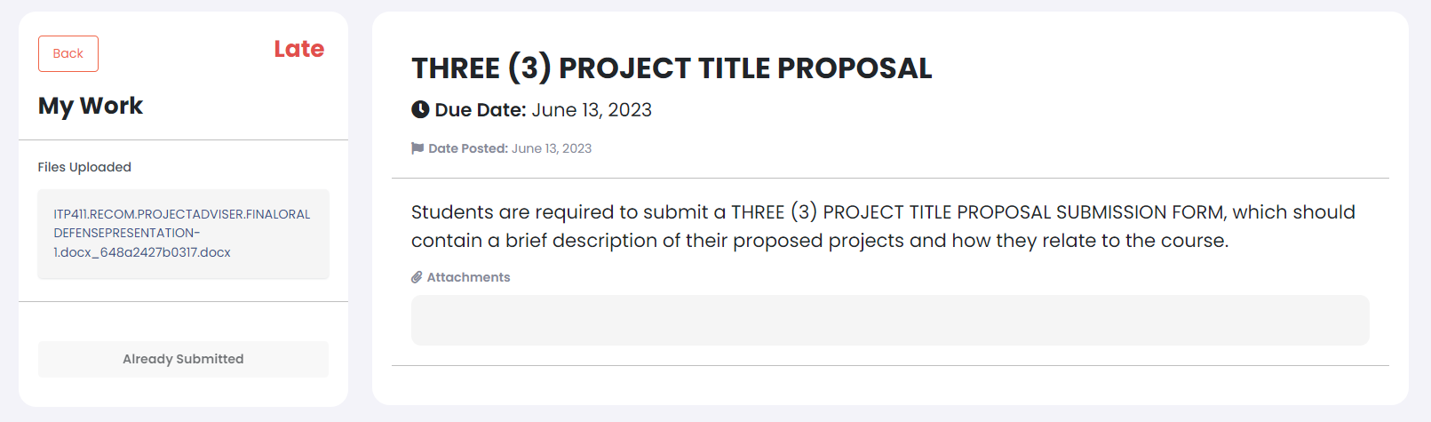

1. Dito sa submission, Meron sanang kakayanan na mag give ng feedback si Adviser sa pinasa ni student. Yung feedback, hihingin lang siguro once **Rejected** yung submission. May magpapop up siguro na form for confirmation if irereject ba talaga ni Adviser yung submission, and kasama din doon na need magprovide ng Info/dahilan bakit rejected yung submission.

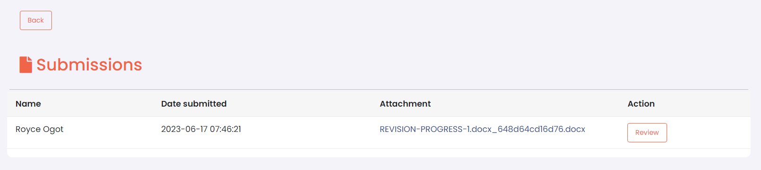

Ito yung Task page ni student. If rejected yung pinasa nila, makokonnect to sa #31 na kung saan need nila magresubmit. Yung feedback na prinovide ni Adviser, lalabas dapat siya dito sa page na to.



40. (If this is feasible) Hanggat walang Project na nagagawa si Student, Hindi dapat siya makakapag pasa sa Task or basically hindi makakaaccess sa Task Page.

- Di ata possible kasi bago mag karoon ng project dapat approve muna yung proposal ni student eh. So if the student walang project di sya makakapag submit ng task para sa proposal ng project sa task

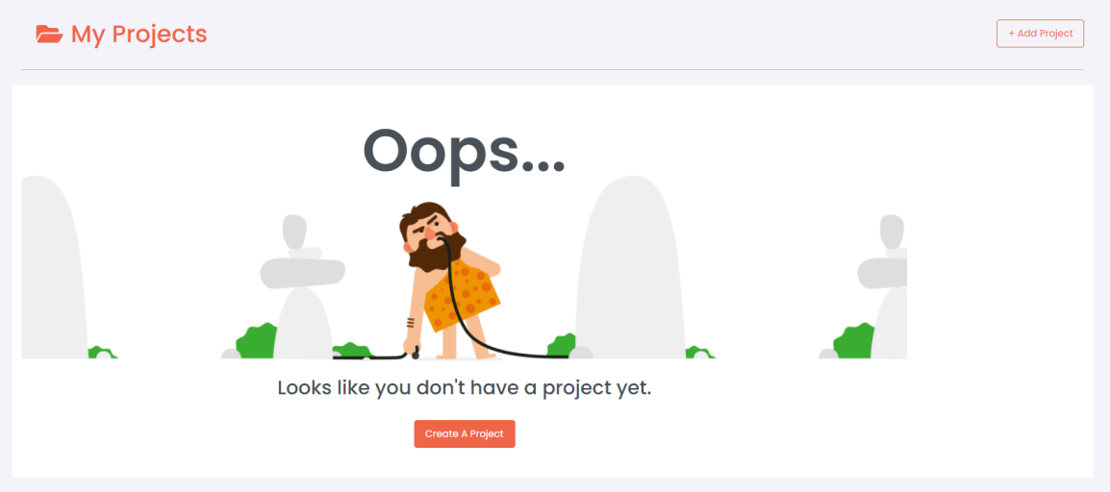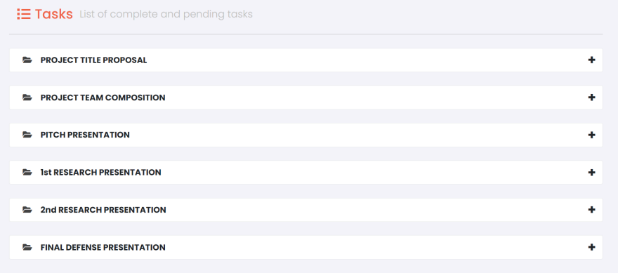

Gusto ko mangyari to para maiwasan yung descripancy sa Submissions. Kagaya dito sa baba, Blank yung Group Name dahil yung Group Name is nanggagaling sa Project, and since wala pang project na crineate si Student (Jerome), walang lumalabas na Group Name. (Refer to the image below)

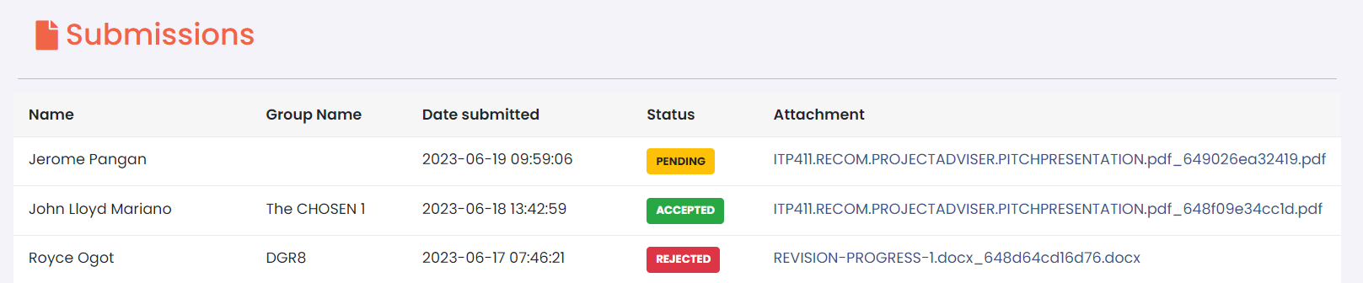

41. Di lumalabas yung group name ditto - Done 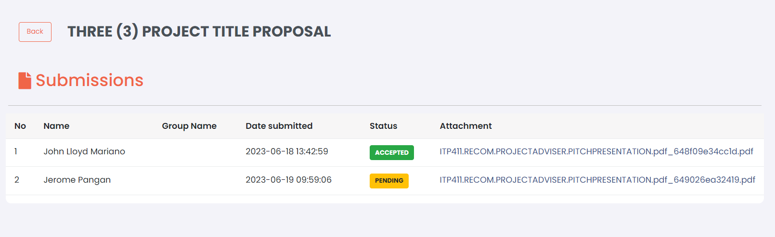

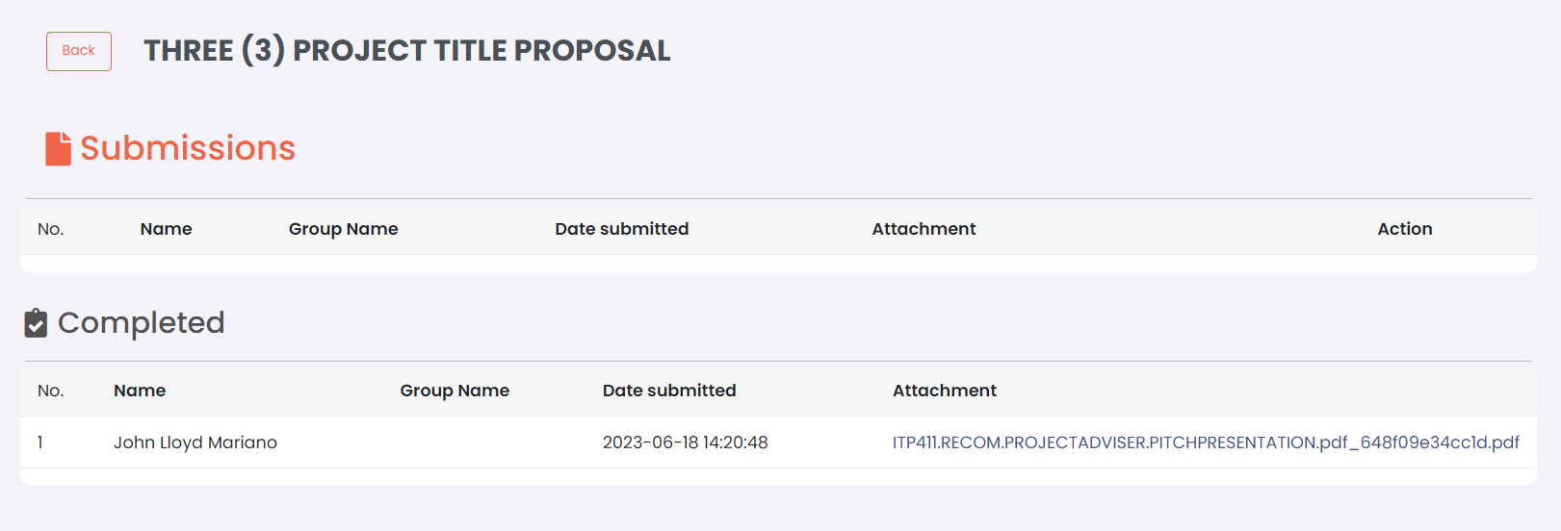

42. Nawala yung Group Name din dito. - Done

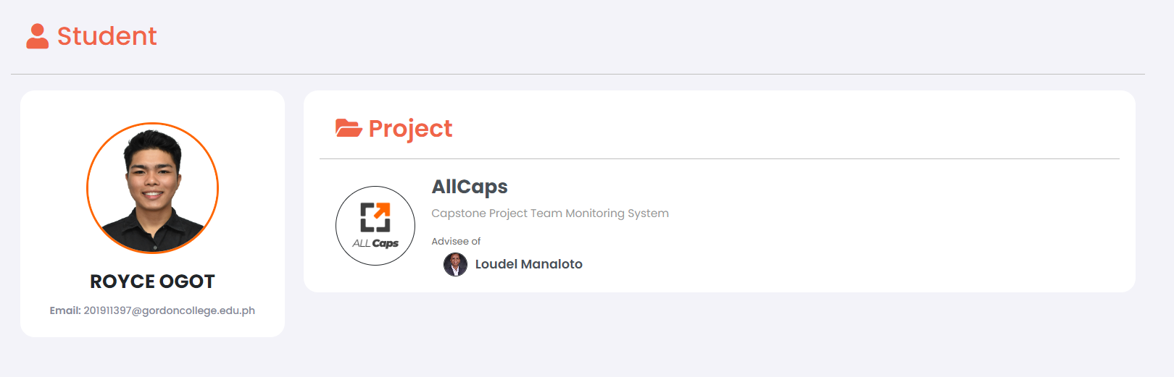

Group Name Here

Email Here

Group Name Here