PROJECT REVISION LIST

Legend:

|  |  |
| --- | --- |
|  | Done |
|  | Need rework |
|  | Not yet done |

|  |  |  |  |  |  |  |  |
| --- | --- | --- | --- | --- | --- | --- | --- |
| **No.** | **RECOMMENDATION/**  **FEEDBACK** | **Action Taken by the Team Member/s** | **Comment by Panel Member** | | | | |
| **PM1** | **PM2** | **PM3** | **PM4** | **PM5** |
| 1. 1 | Combined Login Page for Admin & Adviser | Created a separate login page for Advisers |  |  |  |  |  |
|  | Student’s Project | Created a Project page where students can create and view their project. |  |  |  |  |  |
|  | Student’s Project Limitation | Modified the ‘Add Project’ button to disable after the student create their project |  |  |  |  |  |
|  | Tasks can be assigned to students. | Added Task assignment feature for Admin/Dean |  |  |  |  |  |
|  | Tasks should be organized by prerequisites | Tasks are organized in accordion-style per prerequisites |  |  |  |  |  |
|  | Assigning of Project Advisers | Added List of Advisers students can choose from |  |  |  |  |  |
|  | Students’ application to Adviser | Advisers are notified whenever students choose their advisory;  Adviser can either Accept or Dismiss this application. |  |  |  |  |  |
|  | Add team/slots counter | Added team/slots counter for number of advisees per advisers |  |  |  |  |  |
|  | Identify the team | Added a Team Name label for each student’s team |  |  |  |  |  |
|  | Admin can see the task submitted by the students | Added a ‘Submission Page’ for Admin to view student’s submission |  |  |  |  |  |
|  | Advisers can see the task submitted by their advisee | Added a ‘Submission Page’ for Advisers to view their advisee’s submission |  |  |  |  |  |
|  | Status for tasks (ex: Reviewed etc.) | Added Status feature where Advisers can ‘Review’ and ‘Approve’ advisee’s submissions;  Admin can also see the status of the tasks if it was ‘reviewed’ by the Adviser |  |  |  |  |  |
|  | Project Page for Advisers | Added a ‘Project Page’ for Advisers to view the projects of their advisees |  |  |  |  |  |
|  | Project Advisers | Admin can add/delete Advisers |  |  |  |  |  |
|  | Slots available per Project Adviser | Added a counter per Adviser that will show the available slots of advisees still available |  |  |  |  |  |
|  | Project Adviser’s List of Advisees | Admin can see the students under each Project Adviser |  |  |  |  |  |
|  | Uploading of files is not working (including Profile Photo, Project Logo and Attachments of Tasks) | Debugged and fix this issue |  |  |  |  |  |
|  | Adviser should see the Project of each student | Added a Advisee profile page in Adviser side |  |  |  |  |  |
|  | Student should see the number of slots available advisee per adviser upon choosing them | Added a slot counter in each Adviser Card |  |  |  |  |  |
|  | Files submitted bug |  |  |  |  |  |  |
|  | Status of tasks on the Task Page is not indicated | Added a status of Pending, Submitted and Reviewed to indicate the status of each task |  |  |  |  |  |
|  | Submission Table error |  |  |  |  |  |  |

18. Adviser Side, Advisee page to. Pag pinindot yung card ni student,nagreredirect siya dito. Static lang yung data dun.

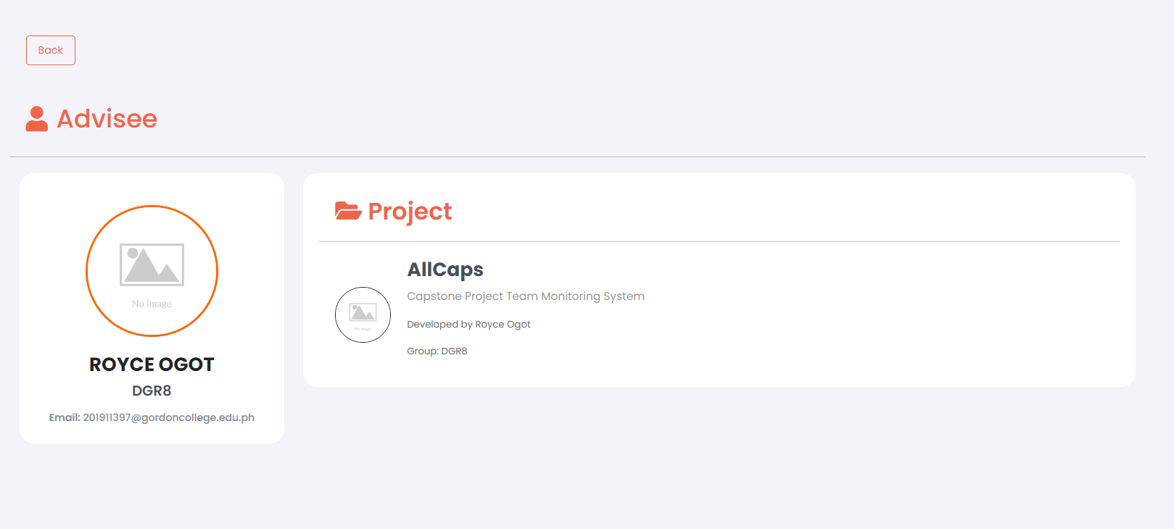

1. Student Side to. Nilagyan ko ng counter dito para makikita kaagad yung slots na available. Tinanggal ko din yung choose button instead yung info na yung pipindutin. Gumagana parin naman to kahit iniba ko. Need dito gumana yung counter at kung posible, madidisable yung card ng adviser na puno na yung advisory.

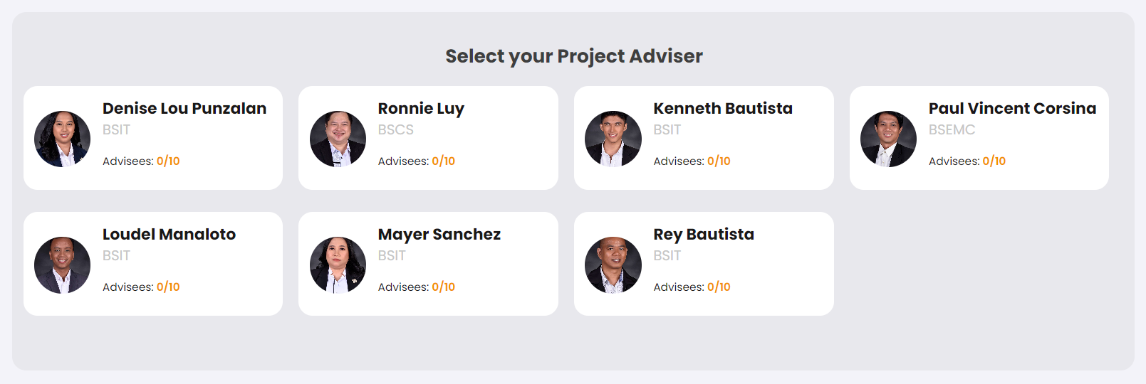

1. May Problema dito yob. Ang nangyayari pag nag submit ka ng task mo sa Task 1, submitted nadin yung file na yon sa Task 2.

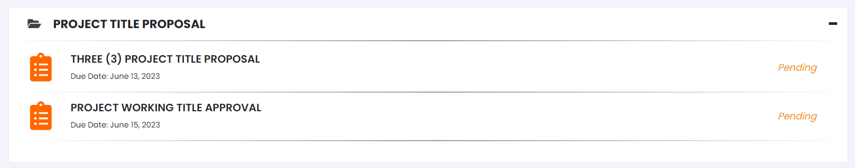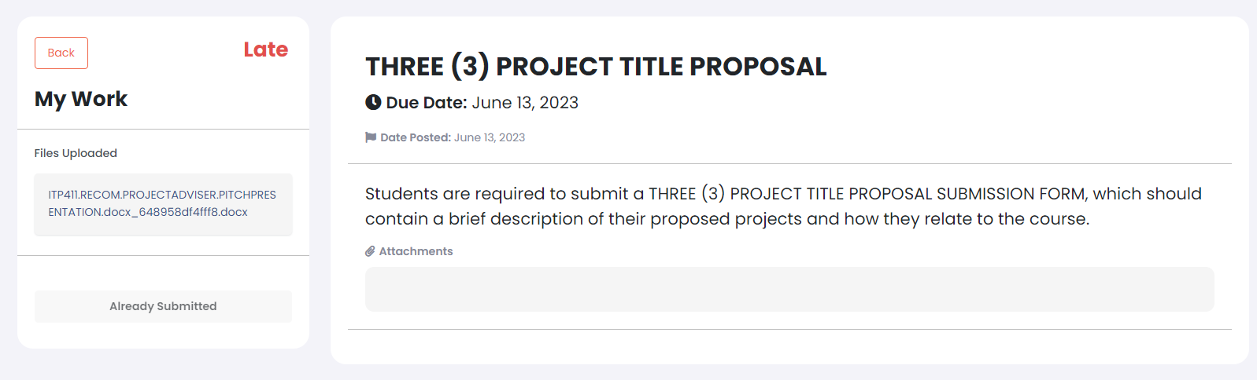

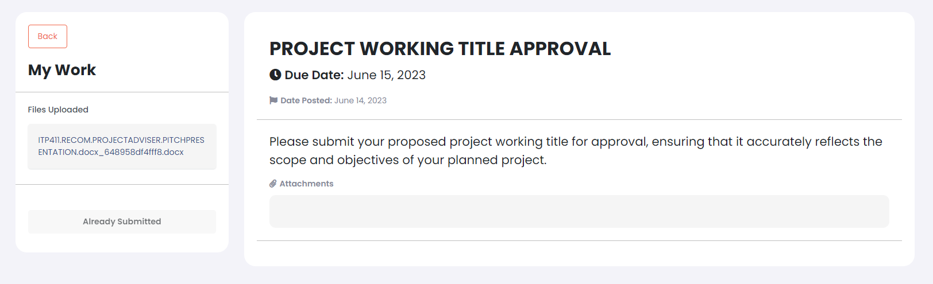

1. Kung possible to, na Magkaroon ng status dito. **Pending** pag di pa nakakapagpasa si student, **Submitted** pag nakapagpasa na siya then **Reviewed** pag na review na ni adviser.



1. Naging ganito yung kinalabasan ng table after ko magtry na magsubmit. Admin side and Adviser side to.

