Olivia Reed

Design Document foR: Tyrrell County Website Redesign

Olivia Reed

Professor Nicolas D’Agata

WEB 125.0001

2 December 2022

Design Document For: Tyrrell County Website Redesign

# Name and Description of the Website

This project is a redesign of the Tyrrell County website. It employs a mobile first design and a clear, fully functional navigation. This will allow the target market to quickly and easily be able to find the information that they are looking for on any device.

# Type of Website

This is a website redesign for Tyrrell County. This would be a professional government type of website where those living in, or near Tyrrell County, or interesting in moving to the area of Tyrrell County would go to find out more about the area, what it offered, or to get in contact with official Tyrrell County bord members.

# Target Market

Men and Women Between the ages of 17-60. Either living in or near Tyrrell County or considering a move to the area.

# What it Does/How it Works

This Website offers clear navigation for users to find out more information about Tyrrell County.

Navbar: This website contains seven main header links, Home, About Us, Contact Us, Events, Forms & Documents, Water/Sewer, and Jobs. Four of these navigation links are drop down button links containing navigation links to the following site pages: About Us – History, Boards, County Departments. Events – Upcoming Events, Annual Scuppernong River Festival. Water/Sewer – Pay My Water/Sewer Bill, Solid Waste Management, Annual Drinking Water Quality Report.

Total number of pages: 19 potential 6 functional coded

The 6 functional coded pages are as follows and can be accessed as detailed: Home page, accessed by nav bar or logo. History page, accessed by About us drop down nav bar link. Contact Us accessed by nav bar. Upcoming Events page, accessed by events drop down nav bar link. Annual Scuppernong River Festival, accessed by events drop down nav bar link. Covid-19 page, accessed by the link provided on the Home page under the Covid-19 header.

The pages will offer information about Tyrrell County catered to the Target Market.

# Major Features

* Slightly animated navigation with drop down boxes organizing content.
* Consistent design choices throughout the site
* Web-friendly and accessible images
* Organized layout on all viewport sizes

# Information Architecture/Site Map

Link to site map: [www.gloomaps.com/MrxkefHgkG](http://www.gloomaps.com/MrxkefHgkG)

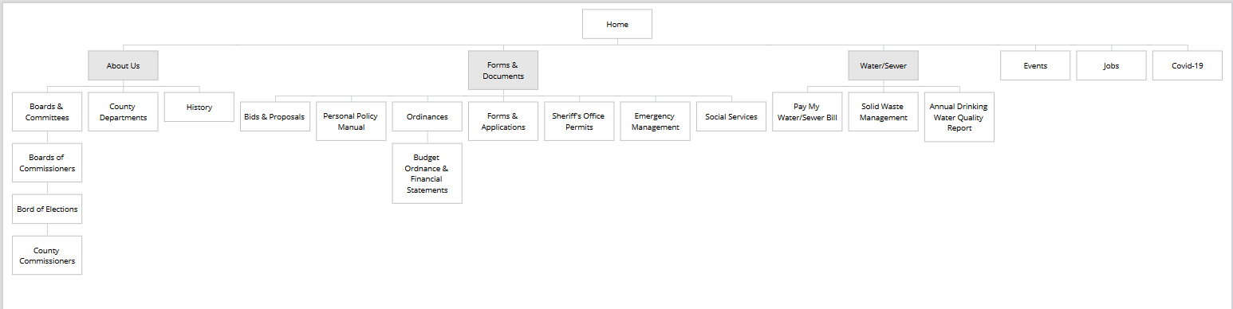

# Description/Justification of Design Choices

I chose to have a more simplistic aesthetic design for this project for two reasons. Firstly, I wanted all the content on the page to be fully readable and clear and by having a white background, and not much visual distraction the content would stand for itself. Secondly, due to the type of website that this is I felt that it was more professional in appearance to have the design be more simplistic and structured.

# Competitive Analysis

Competitors:

<https://currituckcountync.gov/>

<https://washconc.org/>

<https://www.granvillecounty.org/>

<https://www.wakegov.com/>

All of these are county websites of similar design. They have a target market of individuals seeking to know more about said counties. They have a professional simplistic design keeping the information clear and accessible, and the navigation of all these sites is very strong. All these sites are responsive on smaller viewports. We differ from these sites in that our clear website layout offers unique content specifically catered to our target market. (Men and Women Between the ages of 17-60. Either living in or near Tyrrell County or considering a move to the area.)