OGSERC·CERTIFICATE·OF·REGISTRATION·CERT-01·2026.1·OGSERC·CERTIFICATE·OF·REGISTRATION·CERT-01·2026.1·OGSERC·CERTIFICATE·OF·REGISTRATION·CERT-01·2026.1·OGSERC·CERTIFICATE·OF·REGISTRATION·CERT-01·2026.1·OGSERC·CERTIFICATE·OF·REGISTRATION·CERT-01·2026.1·OGSERC·CERTIFICATE·OF·REGISTRATION·CERT-01·2026.1·OGSERC·CERTIFICATE·OF·REGISTRATION·CERT-01·2026.1·OGSERC·CERTIFICATE·OF·REGISTRATION·CERT-01·2026.1·OGSERC·CERTIFICATE·OF·REGISTRATION·CERT-01·2026.1·OGSERC·CERTIFICATE·OF·REGISTRATION·CERT-01·2026.1·OGSERC·CERTIFICATE·OF·REGISTRATION·CERT-01·2026.1·
Certificate Serial No.: {{SERIAL}} | Form OGSERC/CERT-01 · Version 2026.1
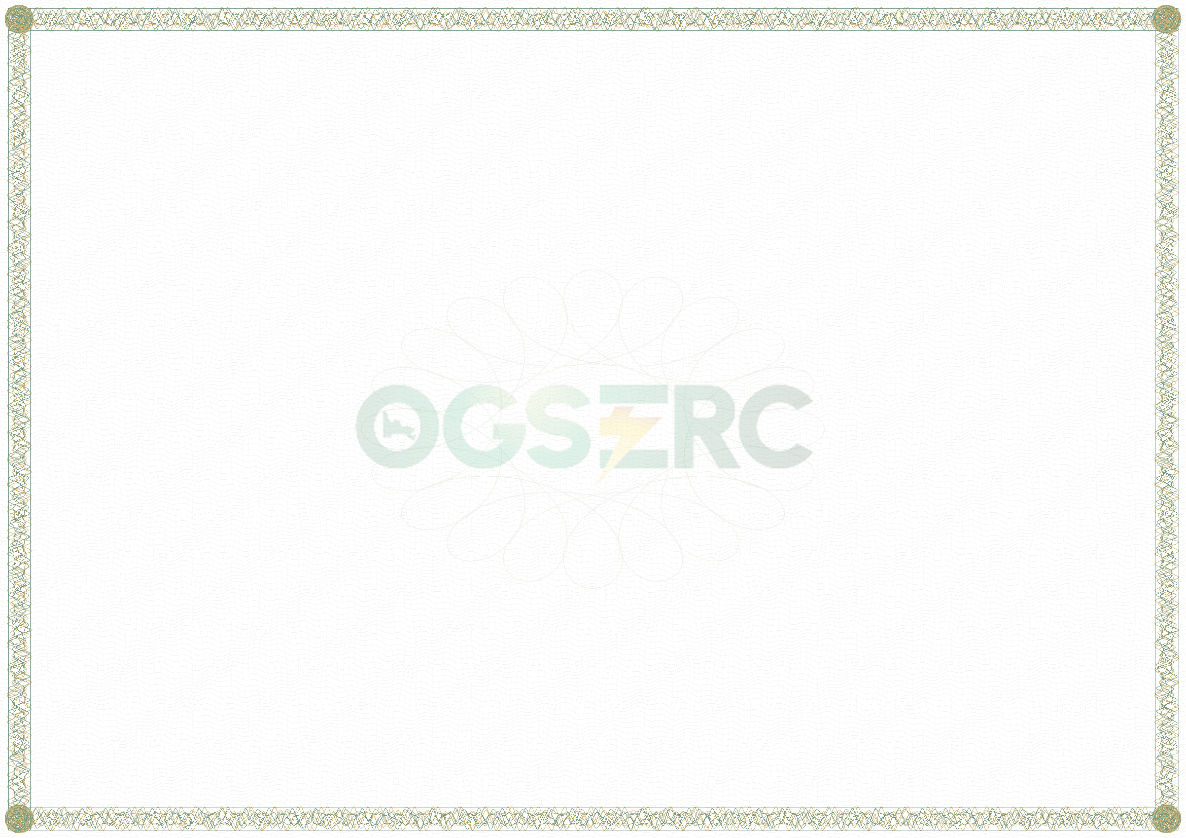

OGUN STATE ELECTRICITY REGULATORY COMMISSION
Established under the Ogun State Power Law, 2024
CERTIFICATE OF REGISTRATION
Register of Licensees and Electricity Operators in Ogun State
Registration No. {{REG_NO}}
This is to certify that
{{NAME}}
RC / Registration No. {{CAC}} of {{ADDRESS}}
has been entered in the Register of Licensees and Electricity Operators maintained by the Commission under paragraph 15 of the OGSERC Order on Commencement of Operations and Registration of Licensees and Electricity Operators, 2026, with the following particulars:
Registration category (Schedule 3) | {{CATEGORY}}
Primary activity | {{ACTIVITY}}
Other activities | {{OTHER}}
Principal LGA and service area | {{AREA}}
Licence / permit held | {{LICENCE}}
Issued at Abeokuta this {{DAY}} day of {{MONTH}}, {{YEAR}}
______________________________  {{CHAIR_NAME}}  Chairman / Chief Executive Officer  Ogun State Electricity Regulatory Commission |  | ______________________________  {{COMM_NAME}}  Commissioner  Ogun State Electricity Regulatory Commission
  COMMISSION
  SEAL
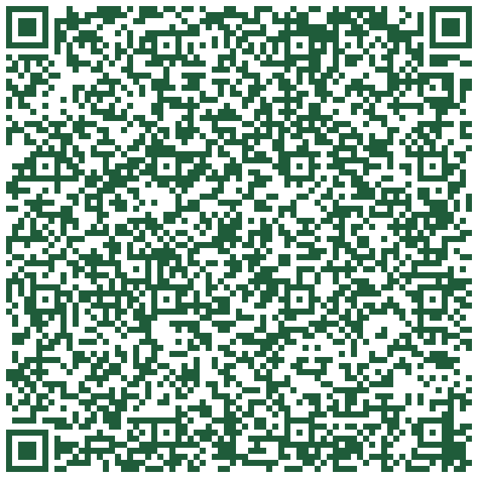 | This certificate is evidence of registration only. It is not a licence or permit and does not authorize any activity that requires one (para 13(5)). It remains valid until cancelled under paragraph 14, subject to annual confirmation by 31 January each year (para 16(2)). The registration number must be quoted on all correspondence and filings with the Commission and on customer bills issued in Ogun State (para 13(6)). Any material change must be notified to the Commission within fourteen (14) days (para 16(1)). Genuine certificates carry a security border, microtext, the Commission's seal and two signatures; verify the registration number against the Commission's public Register.
OGSERC·CERTIFICATE·OF·REGISTRATION·CERT-01·2026.1·OGSERC·CERTIFICATE·OF·REGISTRATION·CERT-01·2026.1·OGSERC·CERTIFICATE·OF·REGISTRATION·CERT-01·2026.1·OGSERC·CERTIFICATE·OF·REGISTRATION·CERT-01·2026.1·OGSERC·CERTIFICATE·OF·REGISTRATION·CERT-01·2026.1·OGSERC·CERTIFICATE·OF·REGISTRATION·CERT-01·2026.1·OGSERC·CERTIFICATE·OF·REGISTRATION·CERT-01·2026.1·OGSERC·CERTIFICATE·OF·REGISTRATION·CERT-01·2026.1·OGSERC·CERTIFICATE·OF·REGISTRATION·CERT-01·2026.1·OGSERC·CERTIFICATE·OF·REGISTRATION·CERT-01·2026.1·OGSERC·CERTIFICATE·OF·REGISTRATION·CERT-01·2026.1·

