

MIDDLE EAST TECHNICAL UNIVERSITY

ELECTRICAL AND ELECTRONICS ENGINEERING

**EE 568**

**Project 1**

Ogün Altun - 2165785

April 17, 2022

**Introduction**

In this project an inductor modelling is performed using different methods. The modeled inductor is used in a DC-DC boost converter. Hence, ripple and average direct current passes through it. Firstly, analytical inductor design is conducted. Analytical design is performed for linear and nonlinear material properties. The specifications of the modelled inductor are given below.

|  |  |
| --- | --- |
| L | 250 µH |
| IL,avg | 24 A |
| IL,max | 26 A |
| IL,min | 22 A |

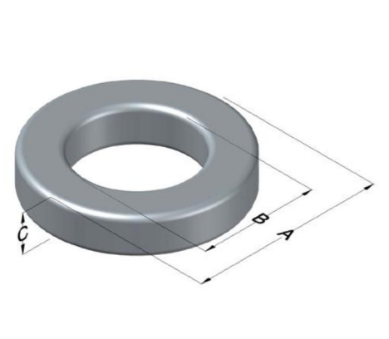The modelled core is given below with dimensions. It is a distributed air-gap toroidal core manufactured by Magnetics.

|  |  |
| --- | --- |
| A | 101.6 mm |
| B | 57.15 mm |
| C | 16.5 mm |
| Le | 243 mm |
| Ae | 358 mm2 |

**Q1) Analytical modelling**

In the first part of the project, inductor is modelled analytically. Firstly, constant permeability is assumed and reluctance, required number of turns are calculated. Then, the distinctive feature of Kool Mu cores which is soft saturation is adopted and calculations are repeated.

1. Calculation of reluctance:

First assume that there is no DC biasing effect in the core and permeability is constant. Relative permeability of the core is 40 in this case. Reluctance can be calculated as,

1. Calculation of inductance:

For 250µH inductance the required number of turns is calculated as below. In the calculation constant permeability is assumed as in Q1-a. Also, all flux is assumed to travel in the core and there is no fringing flux.

1. Calculation of inductance with nonlinear core material:

Now assume permeability changes with DC bias. Core manufacturer provides below formula for change of relative permeability.

The and constants are provided by the manufacturer and given in the Appendix. To find resultant DC bias and relative permeability iteratively, a MATLAB script is written and included in the Appendix. Iterations resulted in relative permeability of 27.8 and final reluctance and required number of turns are as follows,

1. Effects of nonlinearities:

In the above calculations, homogeneous flux distribution is assumed in the core which is non-realistic. Flux tries to flow in the shortest path, so flux density is higher in the inner path. FEA modelling improves the inductance calculation. Moreover, fringing flux should also be included for better improved modelling. Fringing flux introduces additional parallel flux path. Then effective reluctance decreases which increases the inductance.

**Q2) FEA Modelling (2D-Linear Materials)**

In this part, inductor is modelled using COMSOL software. First, the model is constructed using analytical design results and inductance is found for constant permeability. Then, number of turns are found for 250 µH inductance requirement. Finally, 2D steady state analysis performed for three different current values which are minimum, maximum and average inductor currents.  
The model geometry is shown in Figure 1.

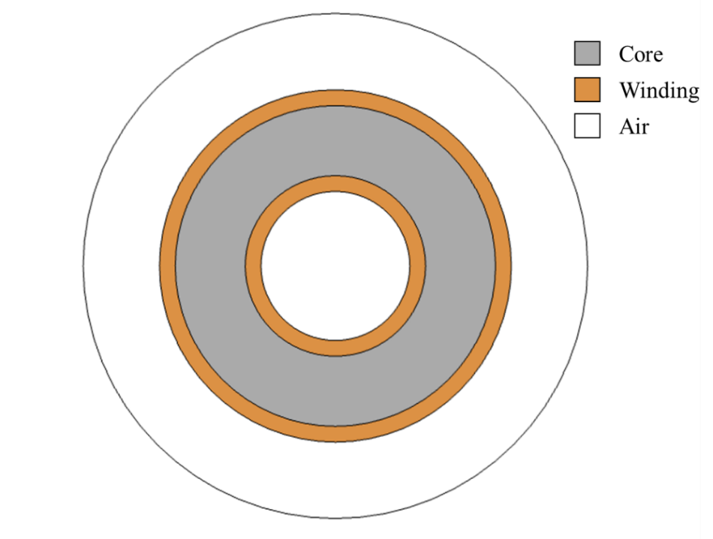

Figure 1. 2D geometry of modelled inductor

1. Calculation of inductance:

In the analytical modelling part, number of turns were found as 59 for constant relative permeability of 40. Hence initial analysis is performed with 59 turns. Resulting flux distribution is shown in Figure 2. 264 µH is obtained with this design. As stated in the previous parts, nonhomogeneous flux distribution is observed in the core which causes higher inductance.

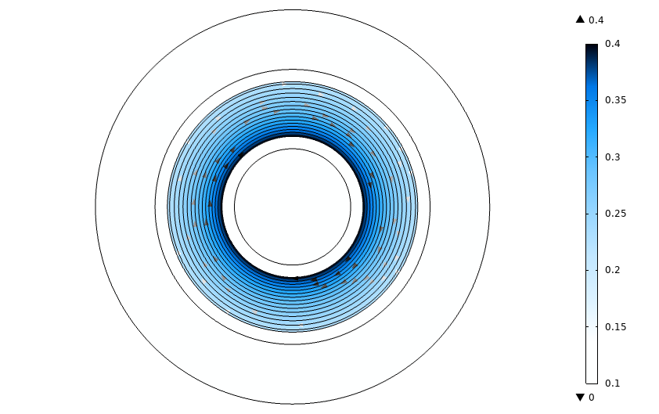

Figure 2. Flux distribution of inductor with linear material, N=59

Then, new turns number to achieve 250 µH inductance is found as 58. Resulting flux distribution is shown in Figure 3. Compared with the previous result, less flux density is obtained, and it is observed especially in the inner parts of the core where flux density is higher.

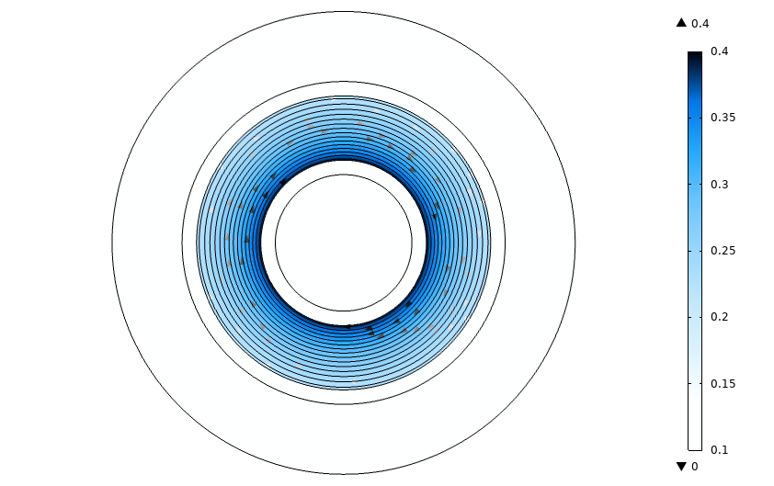

Figure 3. Flux distribution of inductor with linear material, N=58

1. Flux density for different currents:

As discussed in the project specifications, inductor has a current ripple in addition to direct current. In this part, three analysis results are given for minimum, average and maximum currents. 58 turn number is used. As shown in the Figure 4, flux density increases with increased current as expected. Since linear material is assumed, inductance is constant and 255 µH. Stored energies in the core are 61.8mJ, 73.5mJ and 86.3mJ respectively.

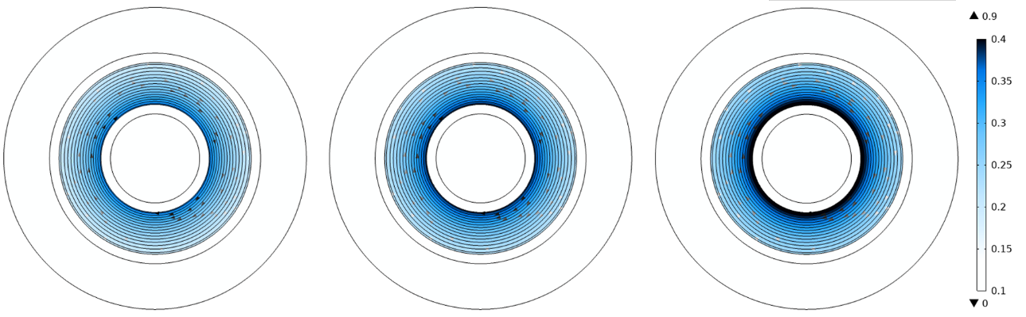

Figure 4. Flux distribution of inductor with minimum, average and maximum current from left to right

**Q3) FEA Modelling (2D-Nonlinear Materials)**

In this part, saturation behavior of the core is modelled in COMSOL software. Same geometry is used with previous part. B-H curve of the material, which is imported to COMSOL, is given in Figure 5.



Figure 5. B-H characteristics of modelled core

1. Calculation of inductance:

The previously created model with same turn number is analyzed in this part. Same turns number (N=59) resulted in 217 µH inductance. This is expected since core is saturated with DC bias and relative permeability is not 40 anymore. Resulting flux density is shown in Figure.

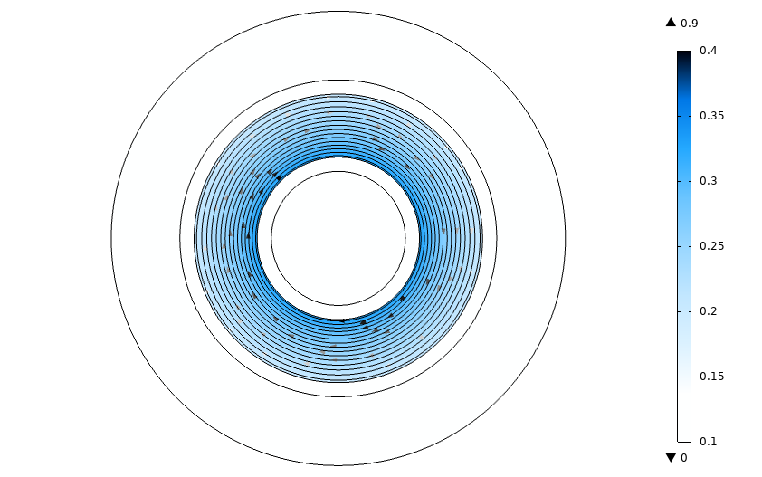

Figure 6. Flux distribution of inductor with nonlinear material, N=59

Then required number of turns is found and analysis is repeated. With N=64, 257.7 µH inductance is achieved. Flux density is shown in Figure 7.

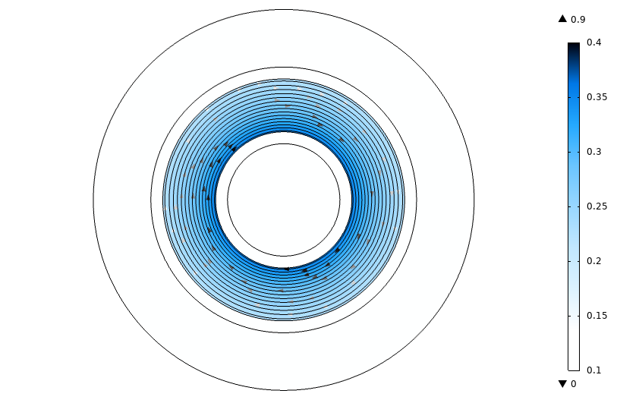

Figure 7. Flux distribution of inductor with nonlinear material, N=64

1. Flux density for different currents:

Now three different current levels are analyzed with non-linear core material and shown in Figure 8. For this analysis, turn number is 64 as found in the first part of the non-linear core part. Since core is now saturated with DC bias, each condition results in different inductances. Inductances are 263.5 µH, 257.7 µH and 251.8 µH for increasing current level. Respectively, stored energy in the core is 63.8mJ, 74.2mJ and 85.1mJ.

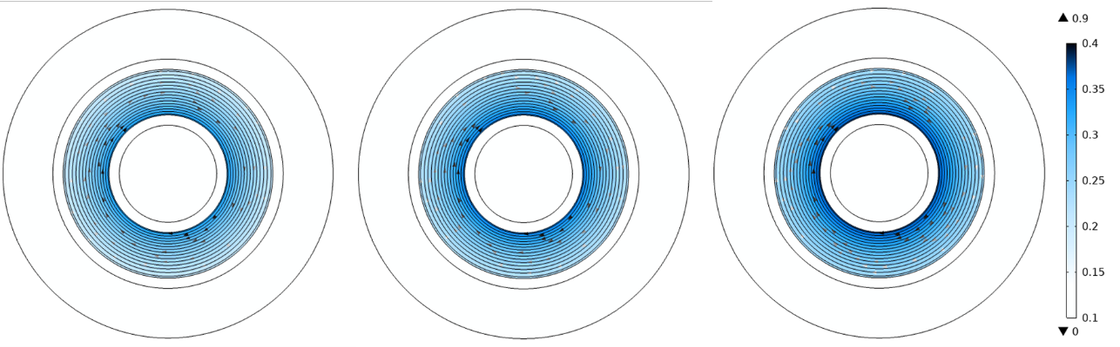

Figure 8. Flux distribution of nonlinear inductor with minimum, average and maximum current

1. When linear and non-linear material properties are compared, the first conclusion is reduction of inductance for non-linear solution. Apart from that, flux distribution changes for linear and non-linear material. For linear material, flux always tries to travel from shortest path since reluctance is smaller. However, for non-linear material, shortest path does not directly result in smaller reluctance. As core saturates, reluctance increases, and some flux tries to flow from outside. This behavior is clearly shown from Figure 7 and Figure 8. Non-linear material has more homogenous flux distribution.

Since solid copper region is used for these analyzes and there is no direct airgap in the core, fringing effects cannot be observed.

**Q4) FEA Modelling (2D-Nonlinear Material and Coil Modelling)**

In this part each conductor turn is modelled separately to improve the solution. The model geometry is given in Figure 9. There are 65 turns as calculated in the third part of the project.

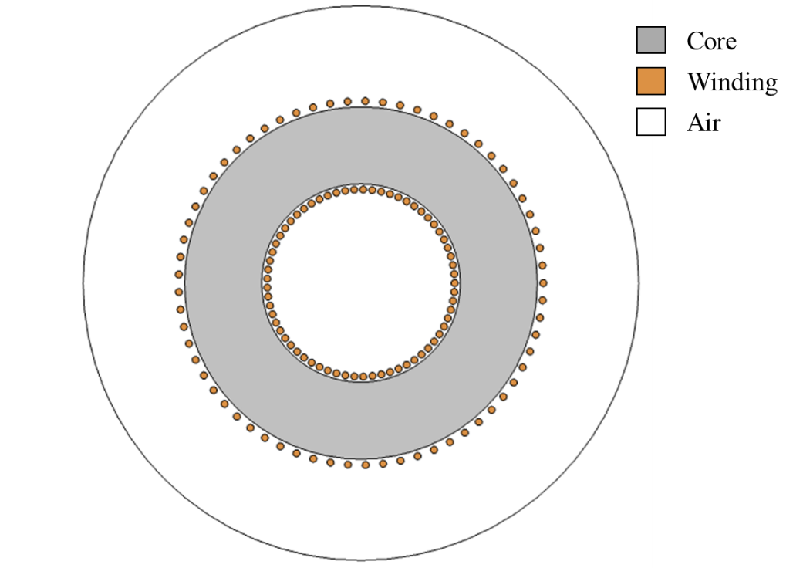

Figure 9. 2D geometry of modelled inductor with separate coil modelling

The coils are excited with three different current levels. Resultant flux density graphs are given in Figure 10. The inductances are 271 µH, 265.5 µH and 259 µH whereas stored energies are 65.6 mJ, 76.4 mJ and 87.5 mJ. Compared to solid coper coil, inductances are higher. This is due to the fringing fluxes flowing in the air. Since distributed airgap material is used, core permeability is lower, and the effect of fringing flux is distinguishable.

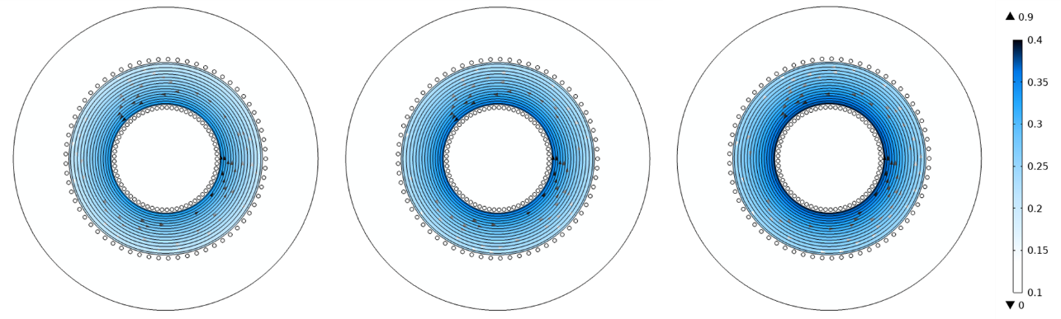

Figure 10. Flux distribution of inductor with different currents

**Q5-Animation**

The inductor current is a triangle waveform with average of 24A and 4A peak to peak value. The frequency of ripple is 160 kHz. The coils in the COMSOL software are excited with this current and resultant flux distribution is observed. The GIF file obtained for this part is given in [GitHub page](https://github.com/OgunAltun/EE568-Project1) of the project.

**Conclusion**

In this project, inductor modelling was performed. Firstly, analytical design is performed. It was shown that nonlinear B-H characteristic significantly affects the performance of the inductor. Due to low permeability of distributed airgap core, DC bias clearly decreases the inductance. Then, finite element analysis is performed for the same core. Nonhomogeneous flux distribution was observed. Flux density on the inner parts of the core is higher since reluctance is lower in these parts. However, distribution becomes more homogenous when nonlinear characteristics adopted in FEA. Finally effect of fringing flux is observed with coil modelling. When coils are modelled separately, higher inductance was obtained thanks to effect of flux which does not passes through core but linked by other coils.

**APPENDIX**

***MATLAB script for iterative inductance calculation***

aa=0.01;

bb=2.177e-6;

cc=1.704;

L=250e-6;

I=24;

le=243e-3;

Ae=358e-6;

mu0=4*pi*1e-7;

mu_r0=40;

R=le/(mu_r0*mu0*Ae);

N=ceil(sqrt(L*R));

H=N*I/(le*100)*1.26;

while 1

mu_r=mu_r0./(aa+bb*H.^cc)/100;

R=le/(mu_r*mu0*Ae);

Nold=N;

N=ceil(sqrt(L*R));

H=N*I/(le*100)*1.26;

if(Nold==N)

break

end

end