Q1)

In this part, 72 slot, 6-pole, 3 phase machine with double layer winding configuration is investigated. For this machine, slots per pole per phase is found as,

The electrical angle between coils is found by following formula.

1. Firstly, winding diagram of the full pith winding is obtained and shown in Figure.



Winding diagram of the other option which is 11/12 short-pitched winding is shown in Figure.



b) The distribution factor shows how the distribution of coils affect the total induced emf. The electrical angle between windings results in different phases for different winding of the same coil. Hence the resulting voltage is obtained by vectoral summation. Distribution factor is the ratio of vectoral sum over algebraic sum.

For this machine distribution factor is found as,

The pitch factor is the representation of the coil span. If the return path of the coil is not at the opposite of the positive path, resultant back emf becomes smaller. Pitch factor is found by following formula where is the coil span in electrical angels.

For full pitch winding diagram, pitch factor is unity.

For 11/12 short-pitched winding, pitch factor is found as,

Winding factor is the multiplication of distribution and the pitch factor. For full pitch winding,

Winding factor of 11/12 short-pitched winding is calculated as,

c)

Distribution and pitch factor of 3rd and 5th harmonics are given below for full and 11/12 short-pitched winding designs.

The resulting winding factors are calculated accordingly.

d) Distribution factor reduces the voltage of the fundamental harmonic just by 4.3%. However, it significantly helps to reduce the 3rd and 5th harmonic voltages, which are not desired. For short pitch configuration, fundamental harmonic voltage decreases about 1% which is not negligibly small, whereas, 3rd and 5th harmonic voltages decrease about 8% and 20% respectively.   
In short, adjusting the distribution and span of coils, unwanted harmonics can be eliminated considerably.

Q2)

A three-phase permanent magnet synchronous machine which has 20 poles is investigated in this part. Firstly, slot number is chosen as 24. For this configuration, phase angles of induced voltage in each slot are given in Table below.

|  |  |  |  |  |  |  |  |
| --- | --- | --- | --- | --- | --- | --- | --- |
| 1st | 0° | 7th | 180° | 13th | 0° | 19th | 180° |
| 2nd | 150° | 8th | 330° | 14th | 150° | 20th | 330° |
| 3rd | 300° | 9th | 120° | 15th | 300° | 21st | 120° |
| 4th | 90° | 10th | 270° | 16th | 90° | 22nd | 270° |
| 5th | 240° | 11th | 60° | 17th | 240° | 23rd | 60° |
| 6th | 30° | 12th | 210° | 18th | 30° | 24th | 210° |

The phasor diagram of Phase-A is given in below Figure.





The distribution factor is found by vectoral sum over algebraic sum. Due to symmetry, sum of two vectors with angle between 30° can be used.

The coil span is 180° as shown in the Figure. Hence pitch factor is unity. Thus, winding factor is equal to distribution factor.

For third and fifth harmonics, winding factor calculation is as follows.





Now the same machine is analyzed for 21 slots. The phase angles of induced voltage in each slot are given in Table below.

|  |  |  |  |  |  |
| --- | --- | --- | --- | --- | --- |
| 1st | 0° | 8th | 120° | 15th | 240° |
| 2nd | 171.43° | 9th | 291.43° | 16th | 51.43° |
| 3rd | 342.86° | 10th | 102.86° | 17th | 222.86° |
| 4th | 154.28° | 11th | 274.28° | 18th | 34.28° |
| 5th | 325.71° | 12th | 85.71° | 19th | 205.71° |
| 6th | 137.14° | 13th | 257.14° | 20th | 17.14° |
| 7th | 308.57° | 14th | 68.57° | 21st | 188.57° |



For maximum winding factor winding 1 3 5 and 7 should be positive current and 2,4,6 are negative current. For distribution factor calculation, all vector is summed in MATLAB and divided by algebraic sum which is formulated in the following equation.

Coil pitch is 171.43° so pitch factor is calculated in the following equation.

Hence fundamental winding factor is,

The third and fourth harmonic winding factors are calculated in a similar manner.





Q3)

In this part of the project, finite element analysis is performed in Ansys Maxwell for a 20 pole 24 slot motor. The motor parameters are selected from Hanselman’s Example Designs. The stator outer diameter is 100mm whereas inner diameter is 60mm. Airgap is chosen as 1mm and length of the motor is 100mm.

The winding diagram of the motor is shown in Figure. 2D drawing of the design is shown in Figure where half-symmetry is applied.

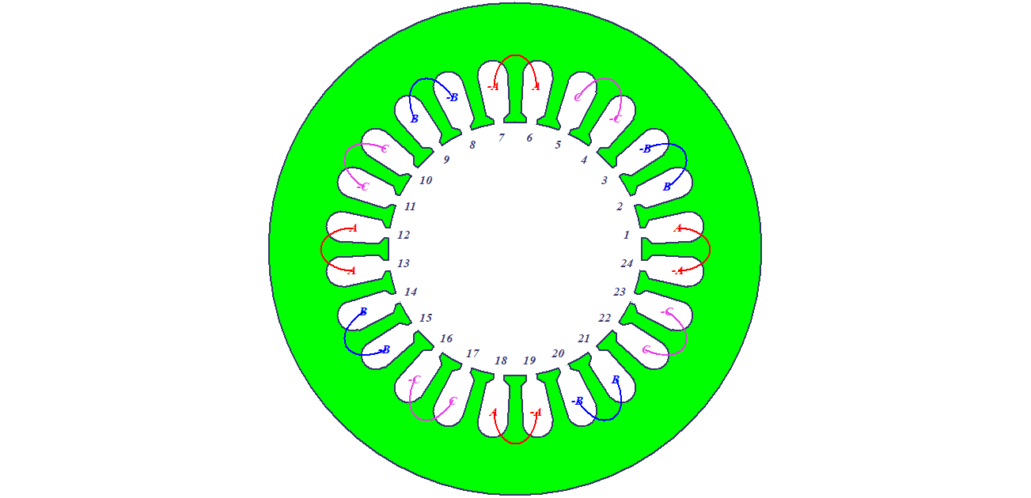

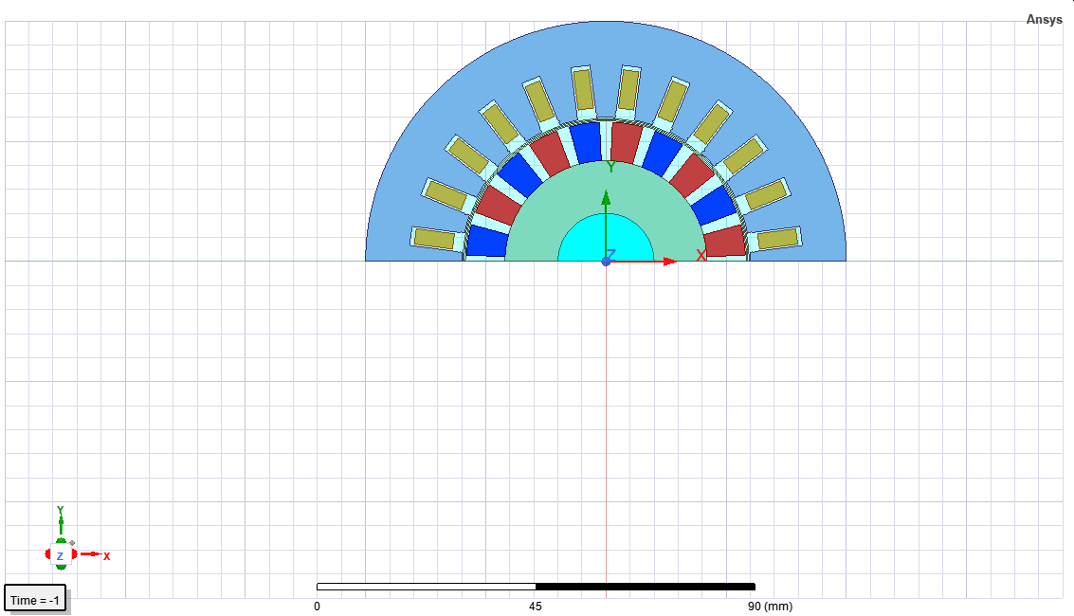

The airgap flux density is shown in Figure.



Induced EMF is shown in Figure.



