

**Middle East Technical University**

**Faculty of Engineering**

**Department of Electrical and Electronics Engineering**

**EE464 Hardware Project Simulation Report**

**Kutay Delibaş**

**Mehmet Gürtekin 2166593**

**Ogün Altun 2165785**

**Introduction**

This report presents the preliminary simulations, their results and our inferences from those results to construct our hardware project for EE464 course. In this hardware project, we are required to design an isolated DC-DC converter that includes magnetic design. We selected our topology from the given list on the hardware project page which is FOR#2. The features of this converter are given below:

* Minimum Input Voltage = 24 V
* Maximum Input Voltage = 48 V
* Output Voltage = 10 V
* Output Power = 48 W
* Output Volt. Peak-to-Peak Ripple = 2%
* Line Regulation = 2%
* Load Regulation = 2%

The reason behind this selection lies under the advantages of the Forward converter over the Flyback converter which is the other option for this project. The transformer in the Forward converter transfers energy instantly unlike Flyback converter which stores energy in the transformer’s air gaps. The instant energy transfer allows us to construct a more ideal transformer with high magnetizing inductance and without an air gap. This transformer type provides much lower peak currents on both sides which lowers the copper losses. Another advantage of Forward converter is having the output inductor and freewheeling diode. These two components stabilize the output current, so the ripple of the secondary side current is smaller in Forward converter. Furthermore, since the output inductor is also the main energy storage element, output capacitor can be selected smaller and with a lower ESR value which results in lower output voltage ripples. In order to benefit from these advantages in our design, we chose to make a Forward converter in our hardware project. The overall block diagram of the project is given in Figure 1.

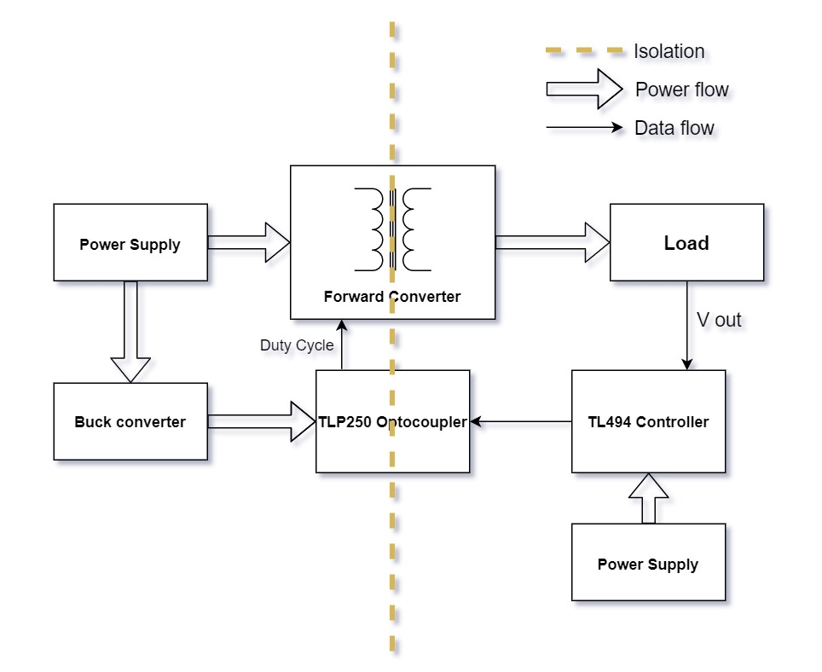

**Figure 1.** Overall converter diagram

**Transformer Design**

To design a proper transformer for our application, we firstly determined the wire size for safe operation. As we have seen in the lectures, we have limited current density to 4-5 A/mm2. In the input side of the converter, 48W/24V= 2A is carried by the wires and a 0.5mm2 cross sectional area is required if the converter is 100% efficient. Since the efficiency will be lower, the input power will be higher. By checking the AWG wire sizes, we decided that AWG#19 (0.653 mm2) is suitable for the primary windings of the transformer. For this wire, the recommended maximum frequency is 21kHz [1]. Output current of the converter is 48W/10V=4.8A. Hence, the cross-section area of the secondary winding must be 1.2 mm2 for 4 A/mm2 current density. However, increasing the wire area decreases the recommended maximum frequency. To overcome this problem, we decided to use 2 parallel AWG#19 (0.653 mm2) wires for secondary winding, and we have selected 20kHz switching frequency which is appropriate for selected wire type.

For a forward converter, the input-output relationship is given by equation (1). By choosing N1=N3(reset), we limited the maximum duty ratio to 50% in order to reset the reset the transformer.

(1)

Vi=24V is the limiting input voltage since increases in Vi can be overcome by lowering the duty ratio. We need Vo=10V at the output of the converter. However, since equation (1) is derived for ideal components, we set Vo=11-12V by considering the voltage drops on output inductor and diode. Therefore, we chose . If the voltage drops on the output components become lower than expected, decreasing D solves the problem.

We used formula (2) to find the minimum number of primary winding not to saturate the core.

(2)

In equation (2), ,, and , , for our core selection which is 0P44022EC. For given parameters 16, and we decided that . As we mentioned in the previous parts, and selected wire has 0.653 mm2 cross-sectional area. The total area of conductors is 52.24 mm2. Then, we have calculated the fill-factor of the transformer by equation (3) to check if the conductors fit in the window area of the selected core.

(3)

Although the resulting fill-factor is lower than limits, we decided that it would be the best choice from available cores.

To find magnetizing the inductance of the transformer, we used inductance factor (AL) given in the datasheet of the core. From equation (4), calculated that Lm=2.4mH.

(4)

[1] https://www.powerstream.com/Wire_Size.htm

**Simulation of Forward Converter**

After designing the transformer, we have constructed a forward converter model in MATLAB/Simulink to verify our calculations and to find out the stresses on the components. Since we couldn’t realize our transformer design, we couldn’t measure the transformer parameters such as leakage inductance. Therefore, we firstly simulated the converter with an ideal transformer and ideal components. Simulink model of the converter is seen in Figure 2.

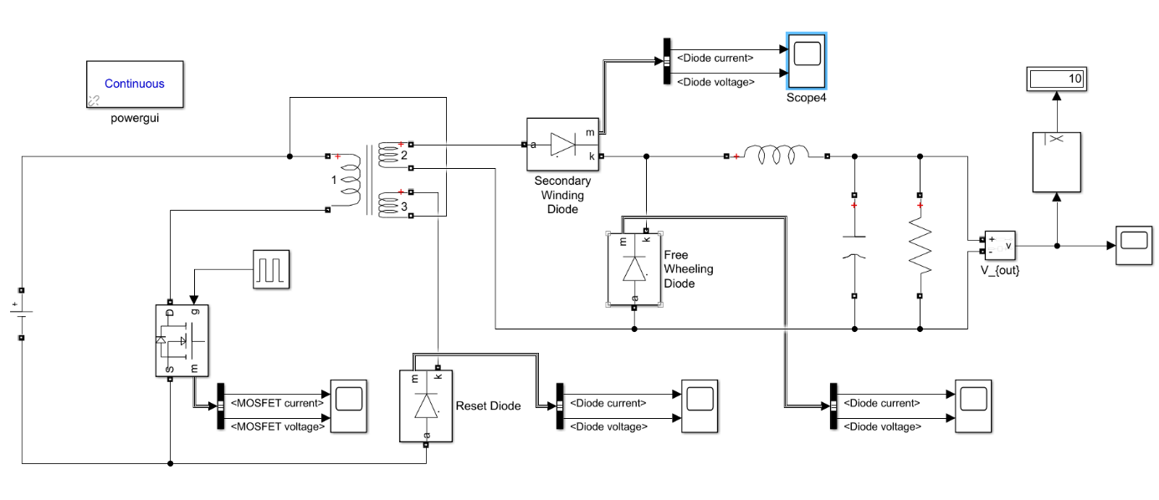

Figure 2. Simulink model of the forward converter

Output voltage characteristics are given in Figures 3 and 4 for 24V and 48V input voltage respectively. When the input voltage is 24V, 43.8% duty cycle results in the 10V output voltage with 0.9V voltage ripple. When the input voltage increases to 48 V, the required duty ratio decreases to 21.4% and output voltage ripple becomes 1.2V which fulfills the ripple requirement.

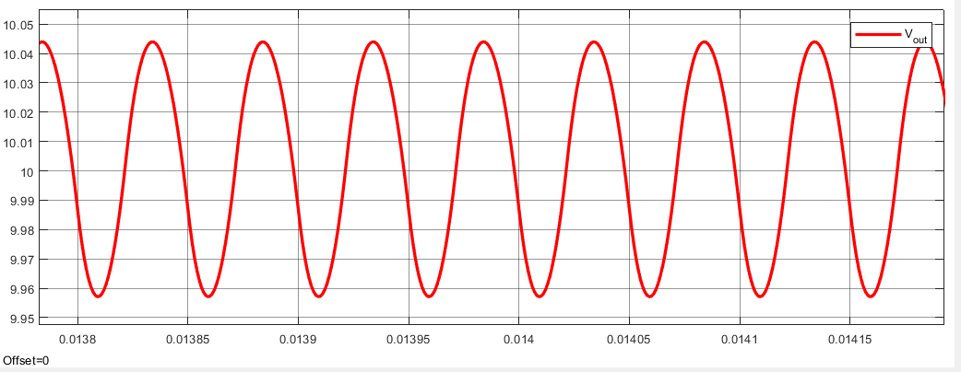

Figure 3. Output voltage of the converter, Vi=24V

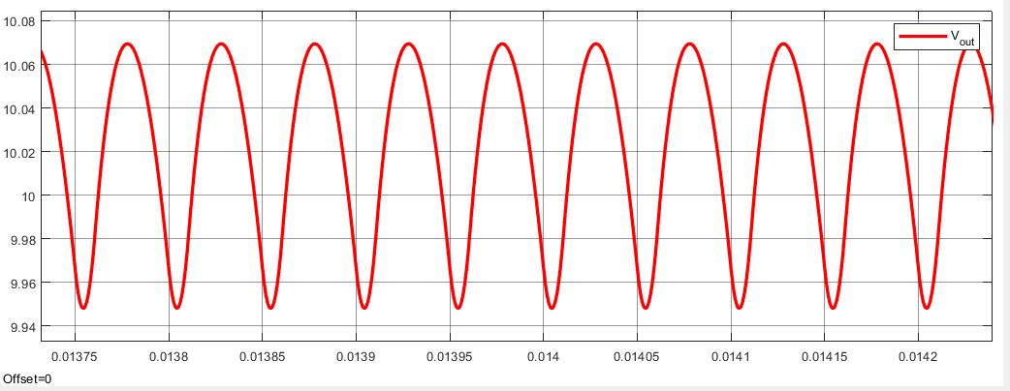

Figure 4. Output voltage of the converter, Vi=48V

In Figure 5 and 6, the voltage and current waveforms of the MOSFET is given for two different input voltage level. Since we could not consider the leakage inductance of the transformer, we don’t see spikes in the MOSFET. In fact, spikes due to inductances will require a snubber circuit, and we are planning to solve this problem after starting the implementation of the converter.

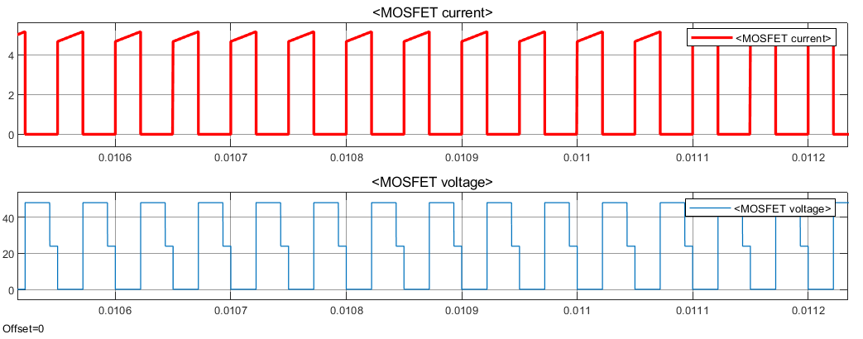

Figure 5. Voltage and current waveforms of MOSFET, Vi=24V

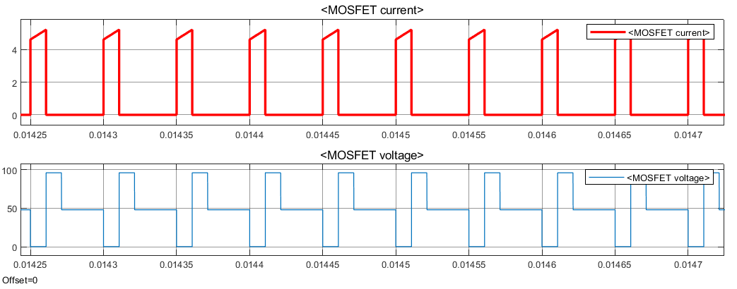

Figure 6. Voltage and current waveforms of MOSFET, Vi=48V

Voltage and current waveforms of the diode which is series to reset winding is given in Figure 7 and 8.

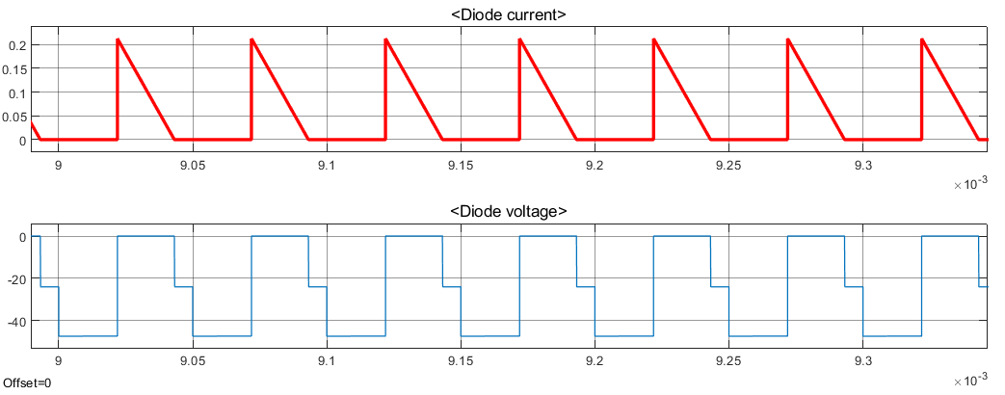

Figure 7. Voltage and current waveforms of reset diode, Vi=24V

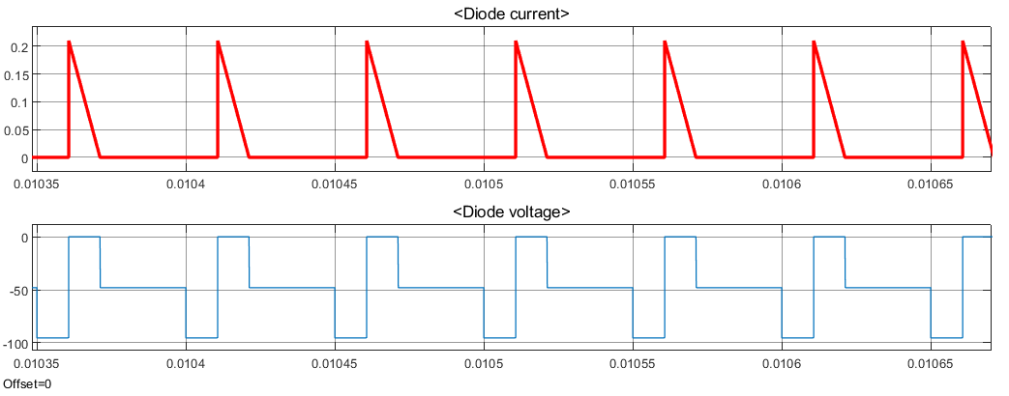

Figure 8. Voltage and current waveforms of reset diode, Vi=48V

Below Figures 9 and 10 shows the waveforms of the diode which is placed at the secondary winding of the transformer.

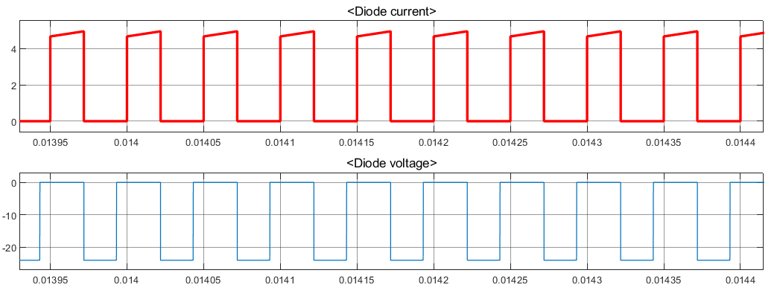

Figure 9. Voltage and current waveforms of secondary diode, Vi=24V

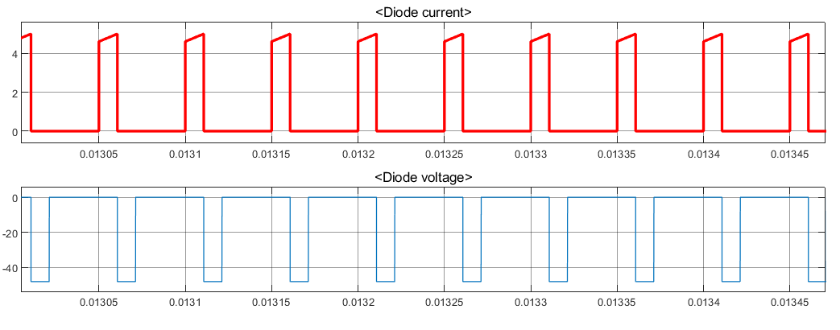

Figure 10. Voltage and current waveforms of secondary diode, Vi=48V

Lastly, freewheeling diode current and voltage waveforms are given in Figure 11 and 12.

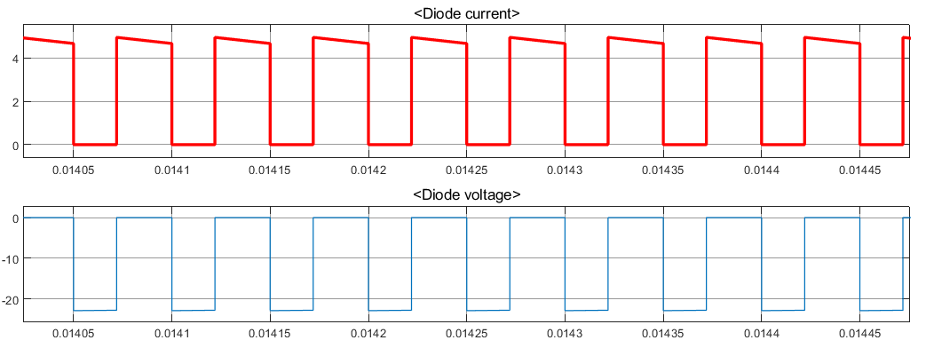

Figure 11. Voltage and current waveforms of freewheeling diode, Vi=24V

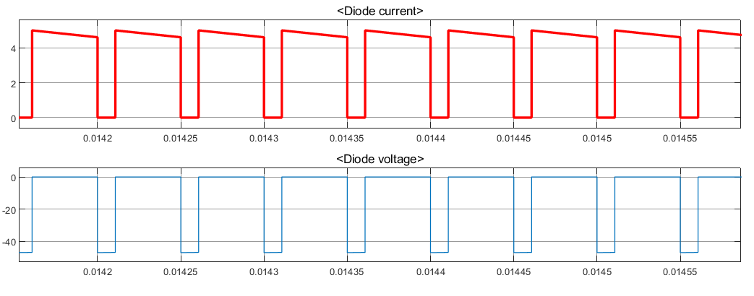

Figure 12. Voltage and current waveforms of freewheeling diode, Vi=48V

**Output Filter Design**

According to our simulations, the inductance value of the filter is 100µH. To design filter inductor, we have checked the available cores in the laboratory. To decrease the number of turns, we decided to use the core which has the maximum inductance factor (AL). We also want to design an inductor as small as possible. By considering these, we selected 55928A2 toroid core for our design. Important parameters of the selected core are given below:

Inductance Factor (AL) = 201nH/Turns2

Window Area (AW) = 156mm2

Volume = 4150 mm3

Then we have calculated the required number of turns for 100µH using equation (5). We found the minimum number of turns as 23.

(5)

Since the output current is 4.8A in average, we decided to use 1.31 mm2 cross-sectional area AWG#16 wire for inductor winding and current density is 3.66 which is in the acceptable range. The total area of the conductors becomes 30.13mm2 which results in k=0.193 fill-factor. Since we selected the smallest available core, low fill-factor is not a problem for our design.

In order to have a 2% output ripple, we have selected the output capacitance of the converter as 200µF. The cut-off frequency of the designed LC filter is found by equation (6). fc= 1137 Hz which is much lower than switching frequency.

(6)

**Controller Design**

As a PWM generator and a closed loop feedback control, the analog controller TL494 is chosen because of its useful properties, which are listed in this part. The design is done using the datasheet of Texas Instruments as a guide. The simplified block diagram and pin layout for this controller can be seen in Figure 13-14.

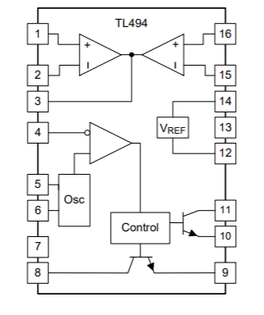

Figure 13. Simplified block diagram of TL494

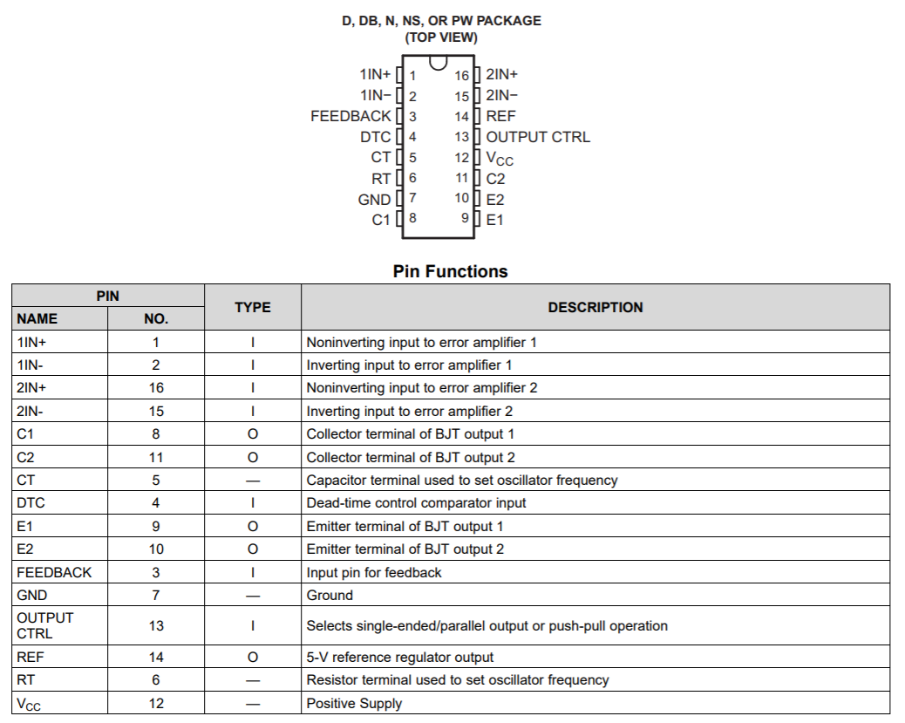

Figure 14. Pin layout of TL494 and their functions

1. Oscillator

TL494 allows up to 300kHz oscillation frequency. We have decided to use 20kHz, which will be set with connecting a resistor and a capacitor at RT and CT pins. Values of these components will be selected using the following formula:

‬RT=500Ω

CT=100nF

1. Closed loop feedback control

TL494 have 2 error amplifiers. One of them will be used for voltage feedback while the other one can be used for current feedback. Current control will be decided later in the project depending on whether current feedback bonus is aimed or not. Typical design of this part can be seen in Figure 15. R7/R5 ratio determines the gain, and higher gain makes the response faster and the error smaller. However, it also decreases stability. Therefore, a gain of 10 will be chosen.

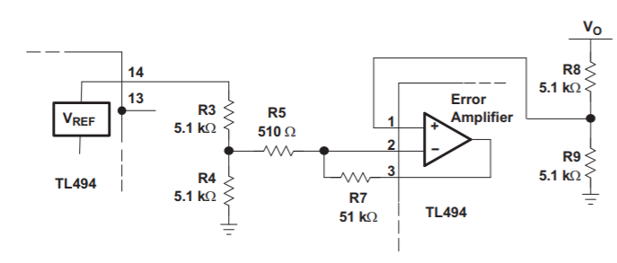

Figure 15. Error amplifier of TL494

R3=1kΩ

R4=1kΩ

R5=500Ω

R7=5kΩ

R8= 20kΩ Potentiometer (to get exactly 10 V)

R9=5kΩ

1. Dead Time Control and Soft Start

TL494 allows setting a minimum dead time control, which can be used to limit the duty cycle. DTC pin can be adjusted from 0 V to 3.3 V to achieve such limit. This is very helpful for the forward converter, since the duty cycle should be limited such that there is enough time to reset the transformer. In our case, N1/N3 is 1 and the maximum duty cycle of 0.5 is allowed.

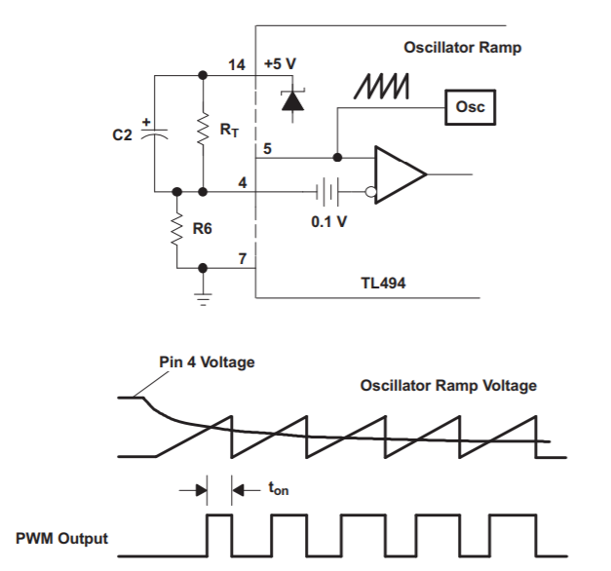

Figure 16. Soft start circuit

The controller also allows for a simple soft starting circuit using the DTC pin. A typical circuit is given in Figure 16. Here, R6 and RT will act as a voltage divider and determine the dead time limit. In our case, they will be selected such that Pin 4 voltage is 1.6 V. From voltage division, R6/(RT+R6) should be equal to 1.6/5 and we have a 0.5 duty cycle limit.

For a soft starting of 50 clock cycles at 20 kHz, C2=2.5uF will be selected.

RT=2.2kΩ

R6=1kΩ

C2=2.5uF

Since the input and output sides of the converter need to be fully isolated from each other, the TL494 output cannot be directly used to drive MOSFET. Hence, we need to use an optocoupler to drive MOSFET by maintaining the isolation. For this purpose, we will use TLP250 optocoupler which has own gate driver inside.

TLP250 operates with a supply voltage of 15-30V. Since we have 24-48V on the input side of the converter, we need to use a DC-DC converter. For this converter operation, we are planning to use D36V6F15 converter which converts 15.2-50V to 15V.

**Component Selections**

In our simulations, we tried to observe the critical limits of our components. For the primary side diode, the voltage on it is twice the input voltage which has a maximum value of 96 Volts. For the current limitations, the need is really small as indicated in Figure 8. Furthermore, since our working frequency is 20kHz, we searched for Schottky diodes that can switch fast. Our selection for the primary side diode is ***MUR415RL*** which is a Schottky diode with a reverse voltage rating of 150 volts and current rating of 4 Amperes.

For the secondary side diodes (both secondary and freewheeling diodes), the needed voltage level is the same with maximum input voltage which is 48 volts and the current level is around 5 Amperes as indicated in Figures 10 and 12. Our selection for the secondary side diodes is ***MBRF1060 C0G*** which is also a Schottky diode with a reverse voltage rating of 60 volts and a current rating of 10 Amperes.

For the switching device, we are going to use a MOSFET which provides the needed fast switching action for our application. For the rating of the MOSFET, the maximum voltage on it is 96 Volts and the maximum current is around 5 Amperes as indicated in Figure 6. Our selection for switching device is ***HUF75925D3ST*** which has a voltage rating of 200 Volts and a current rating of 11 Amperes.

In the simulations, we observed a ripple less than 2% with a DC link capacitor of 200uF. The voltage on the capacitor is 10 Volts which is our output voltage. We searched for capacitors with low ESR value to keep the voltage ripple low and the selected capacitor is ***B41888C6227M008*** which has a capacitance of 220uF (which reduces the ripple more) and voltage rating of 50 Volts.

**Conclusion**

In this simulation report, we have represented our converter design for the given specifications. For our Forward converter selection, we have designed a transformer. Then we have simulated the converter topology in MATLAB/Simulink and observed the voltage and current waveforms of the components. Based on the simulation results, we have designed an LC filter to satisfy the output voltage ripple requirement. Moreover, we have designed an analog controller and isolated gate driver to adjust output voltage at a constant level. Finally, we have selected commercial products for our converter depending on the simulations.