差分方程的收敛点计算
——差分方差关于b取不同值时的收敛点
一、程序源代码
function x_next = f(x, b1)
x_next = b1 * x * (1 - x);
end

function converge_points = converge(b)
converge_points = zeros(1, 1);
x = 0.2;
count = 0;
cover = zeros(1, 100);
converge_points(1) = b;
for i = 1:100
x = f(x, b);
cover(i) = x;
end
for i = 98:-1:1
if round(cover(100), 2) == round(cover(i), 2)
count = 100 - i;
break;
end
end
for i = 1:count
converge_points(end + 1) = round(cover(100 - i), 4);
plot(b, round(cover(100 - i), 4), 'b.');
hold on;
end
disp(converge_points);
end

b_range = 2.5:0.01:3.5;
for i = b_range
converge(round(i, 2));
end

xticks(2.5:0.15:3.5);
yticks(0:0.1:1);
title('收敛点 —— b');
xlabel('b');
ylabel('收敛点');

二、b不同取值时收敛点的情况
1. 结果表
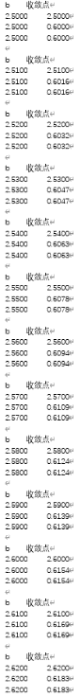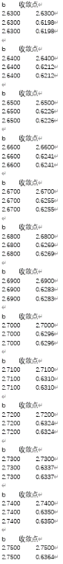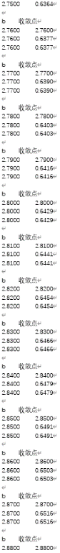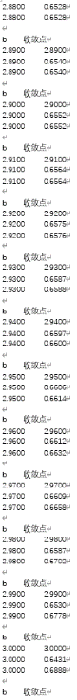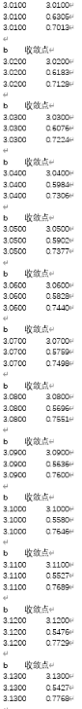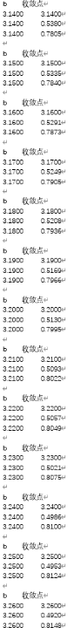
2. 结果图
