PRINCE MOHAMMAD BIN FAHD UNIVERSITY
College of Computer Engineering and Sciences
Programming Languages_101
Project Report: Fraction Expression Interpreter
Fall 2025/2026
Dr. Marius Nagy
Submission Date: May 16, 2026
Group Members:
1. Abdulhadi Al-Sultan 202201246 Software Engineer
2. Ahmad Al-Dawood 202201115 Software Engineer

Table of Contents
1. Introduction 3
2. Language Specification 3
Grammar 3
3. Implementation 4
Architecture Overview 4
Main Components 5
Execution Flow 5
4. Key Design Decisions 5
Recursive Descent Parsing 5
Direct Evaluation Instead of an AST 5
Fraction Simplification 5
Negative Fraction Handling 5
Numeric Representation Review 5
5. Testing Strategy and Results 6
Sample Output 7
Visualizer Website 7
6. Challenges Encountered 8
7. AI and Third-Party Code Disclosure 8
Third-Party Code 9
8. Conclusion and Future Work 9
Appendix A. Source Code 10
Appendix B. Supporting Files 18
Appendix C. AI Session Log and References 18

Fraction Expression Interpreter Report
This report describes the design, implementation, testing, and AI usage disclosure for a Java interpreter that evaluates arithmetic expressions involving fractions only.
Project topic | Construct an interpreter for a simple fraction-expression language
Programming language | Java
Implementation style | Single Java file with inner classes for tokens, lexer, parser, fraction arithmetic, and syntax errors
Tools used | Java standard library; OpenAI Codex/AI assistance for concept review, visualizer support, testing, code review, and report drafting
Submission method | Blackboard submission

1. Introduction
The project implements an interpreter for a small expression language where fractions are the only valid numerical constants. The language supports the four basic arithmetic operations, parentheses, operator precedence, and syntax errors for invalid input.
A valid expression is one where every numeric value is written as a fraction, such as 1/5 * (2/11 - 5/3). An expression such as 1/5 * (2 - 5/3) must be rejected because 2 is an integer constant, not a fraction. This restriction is the main difference between the project language and normal arithmetic expressions.
The implementation was written in Java. It adapts the ad-hoc scanner and recursive descent parser ideas from Chapter 2 of the course material, while keeping the scope focused on expression evaluation only.

2. Language Specification
The interpreter accepts expressions made from fraction constants, arithmetic operators, and parentheses. It ignores whitespace between tokens. The output is either a simplified fraction result or an informed syntax error.
Valid constants | Fractions in numerator/denominator form, for example 1/5, 2/11, 0/3, and -3/4.
Invalid constants | Integers and decimals such as 2, -2, 0.5, and 1.5/2.
Operators | +, -, *, and /.
Grouping | Parentheses are supported and may be nested.
Result format | Results are reduced to simplest terms and printed as numerator/denominator.
Error behavior | The interpreter reports syntax errors with position information and a description of the expected or invalid input.

Grammar
The parser follows this grammar. The separation between expr, term, and factor gives multiplication and division higher precedence than addition and subtraction.
program -> expr EOF
expr -> term term_tail
term_tail -> + term term_tail
| - term term_tail
| epsilon
term -> factor factor_tail
factor_tail -> * factor factor_tail
| / factor factor_tail
| epsilon
factor -> FRACTION
| ( expr )

3. Implementation

Architecture Overview
The interpreter is implemented as a single source file, FractionInterpreter.java. Although it is contained in one file, the code is still divided into clear inner classes: TokenType, Token, Lexer, Parser, Fraction, and SyntaxException. This organization kept the submission simple while preserving separation of responsibilities.
AI was also used to help explain the architecture at a high level. That discussion helped separate the roles of the scanner, parser, interpreter, and main driver before writing the report and before reviewing the code structure.
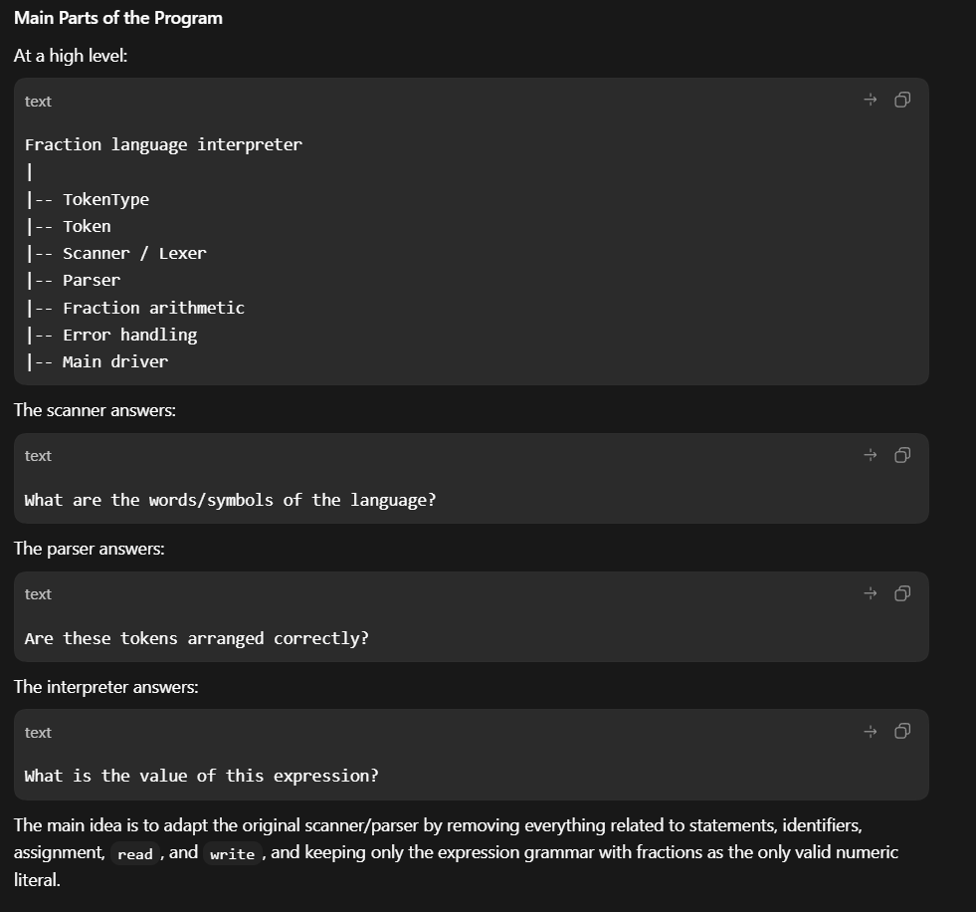
Figure 1. AI-assisted architecture discussion showing the main program parts and the responsibilities of the scanner, parser, and interpreter.
The architecture follows a direct interpreter pipeline. The main method reads a line of input, the lexer converts characters into tokens, the parser checks the grammar using recursive descent functions, and Fraction objects are evaluated immediately as parsing succeeds. Since the language has no variables, declarations, or later semantic checks, a separate abstract syntax tree was not required.
Input expression
|
v
Lexer: characters -> tokens
|
v
Parser: recursive descent grammar checks
|
v
Fraction evaluation during parsing
|
v
Simplified result or syntax error

Main Components
The lexer scans the input string, skips whitespace, recognizes operators and parentheses, and validates fraction constants. Invalid constants such as integers and decimals are rejected early.
The parser enforces the grammar using methods such as parseProgram, expr, term, factor, termTail, factorTail, and match. These methods correspond to the grammar rules and make the parser close to the recursive descent style studied in class.
The Fraction class represents runtime values. It validates denominators, prevents zero denominators, normalizes signs, reduces values using the greatest common divisor algorithm, and implements the four arithmetic operations.
Error handling is centralized through SyntaxException and helper error methods. Messages include the position of the problem and an explanation of what was expected or why a token was invalid.

Execution Flow
- The main method reads one input expression from the console.
- The parser creates a lexer and requests the first token.
- The lexer scans tokens for fractions, operators, parentheses, and end of input.
- The parser begins with parseProgram, then calls expr, term, and factor according to the grammar.
- When a fraction token is matched, Fraction.parse creates a normalized Fraction object.
- Parser tail methods immediately combine Fraction values when operators are encountered.
- At the end, parseProgram requires EOF to ensure there is no unexpected extra input.
- The program prints either the final simplified fraction or the syntax error message.

4. Key Design Decisions

Recursive Descent Parsing
The parser was designed around recursive descent because it matches the course material and works well for this small language. The grammar was structured so that expr handles addition and subtraction, term handles multiplication and division, and factor handles fractions and parenthesized expressions.

Direct Evaluation Instead of an AST
The interpreter evaluates expressions during parsing instead of building an abstract syntax tree. This was reasonable because the language is small and has no semantic analysis phase. Each parser method returns a Fraction, so the result is built as the recursive calls return.

Fraction Simplification
Every Fraction object reduces itself using Euclid's greatest common divisor algorithm. Results are therefore printed in normalized form.

Negative Fraction Handling
While reviewing the codebase with AI, we noticed an important shortcoming: negative fractions needed special handling. A minus sign can mean binary subtraction, but it can also begin a negative fraction such as -1/2. The lexer therefore tracks the previous token type and allows a negative fraction at the beginning of an expression, after another operator, or after a left parenthesis.

Numeric Representation Review
AI-assisted code review also raised a discussion about using BigInteger to avoid integer overflow in large fraction arithmetic. For this course project, the final implementation stayed with int because it is simpler and closer to the slide-based implementation style. This review was still useful because it identified BigInteger as a possible future improvement and reinforced the division-by-zero check for fractions such as 0/3.
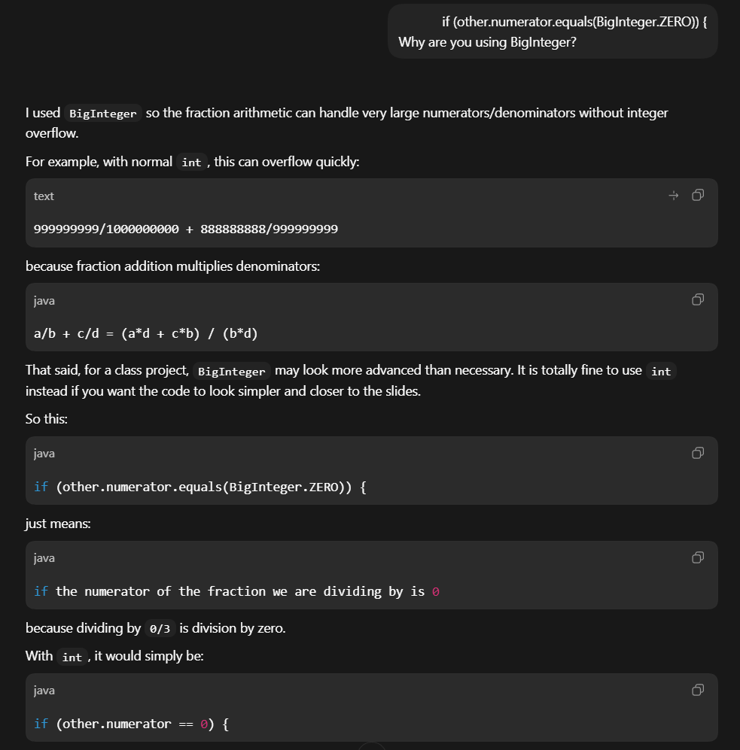
Figure 2. AI-assisted code review discussion about integer overflow, BigInteger, and division by a zero fraction.

5. Testing Strategy and Results
The testing strategy used a set of valid and invalid expressions. AI was used to help create both the test-case file and the batch script used to run many cases quickly. This made it easier to cover normal cases and edge cases rather than relying only on a few manual examples.
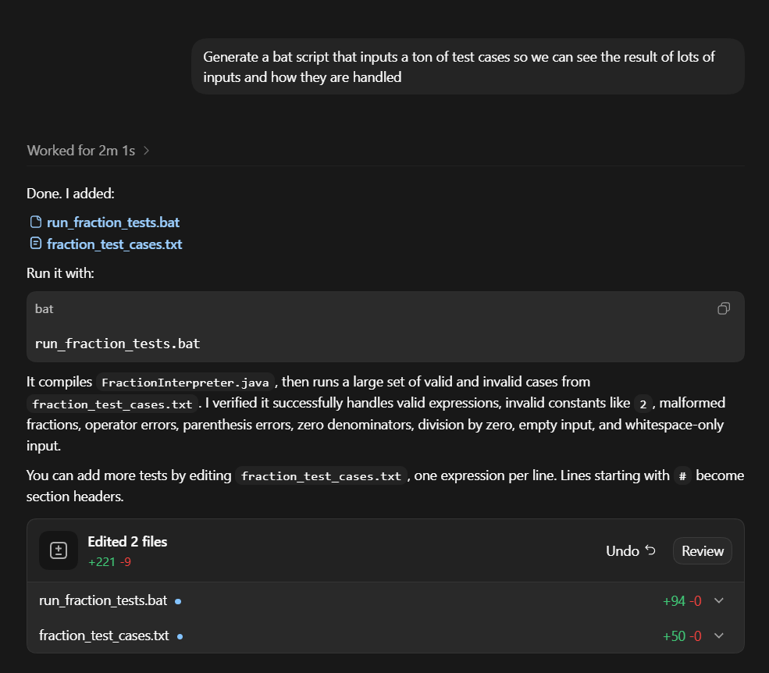
Figure 3. AI-assisted creation of the batch test runner and fraction test-case file.
Case | Input | Expected behavior | Result
T1 | 1/5 * (2/11 - 5/3) | Valid expression; result -49/165 | Passed
T2 | 1/5 * (2 - 5/3) | Reject integer constant 2 | Passed
T3 | (1/2 + 1/3) * 3/4 | Valid parentheses and precedence; result 5/8 | Passed
T4 | 1/2 / 0/3 | Reject division by zero fraction | Passed
The broader test suite included basic arithmetic, precedence, nested parentheses, whitespace, simplification, negative fractions, malformed fractions, invalid constants, misplaced operators, missing parentheses, zero denominators, division by zero, empty input, and whitespace-only input.

Sample Output
Input: 1/5 * (2/11 - 5/3)
Output: Result: -49/165
Input: 1/5 * (2 - 5/3)
Output: Syntax error at position 8: Invalid number '2'. Only fractions like 2/3 or -2/3 are valid constants.

Visualizer Website
AI was also used to create a small HTML, CSS, and JavaScript visualizer. The visualizer was not required for the interpreter itself, but it helped us understand and demonstrate how tokens move through the lexer and parser. It shows states visually and highlights accepted tokens or error states.
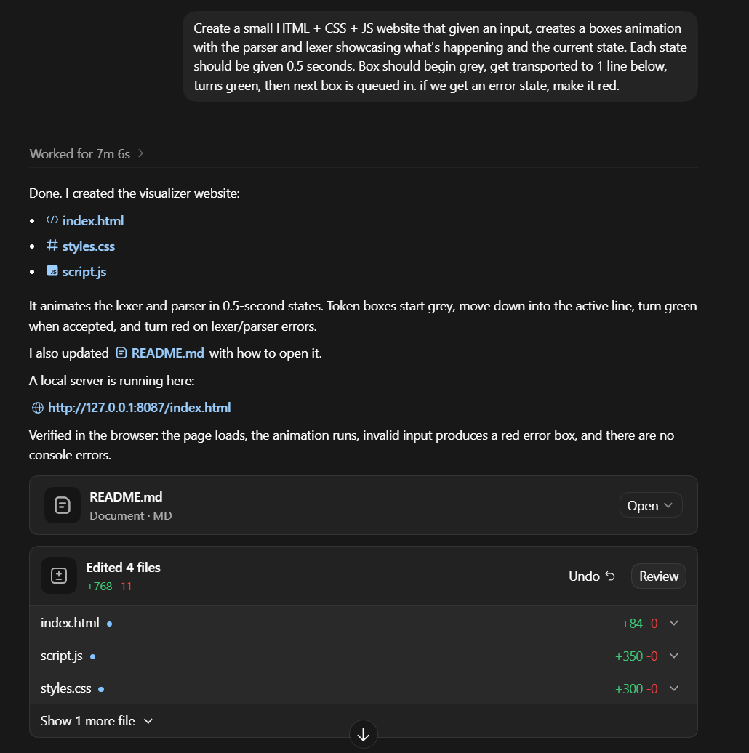
Figure 4. AI-assisted creation of a visualizer website for demonstrating lexer and parser states.

6. Challenges Encountered
One main challenge was the lack of initial understanding. The topics used in the project came from the beginning of the course, so some scanner and parser details had been forgotten. Using AI helped us rebuild the mental model, especially by simulating how recursive descent calls move through an expression.
Another challenge was enforcing the fraction-only rule. In normal arithmetic, inputs such as 2 or 0.5 would be acceptable, but in this language they must be syntax errors. This influenced the lexer design because invalid numeric constants should be caught before the parser treats them as valid factors.
The negative fraction issue was also important. The first way of thinking about the grammar made it easy to treat every minus sign as subtraction. During review, we identified that expressions such as -1/2 + 3/4 and 1/2 + -3/4 require the scanner to recognize a negative fraction in certain positions.

7. AI and Third-Party Code Disclosure
AI was used as a learning and support tool, not as an unchecked replacement for implementation work. It helped clarify the assignment, understand grammar design, simulate recursion, review the code, generate tests, create a visualizer website, and draft report text. The team reviewed the outputs and checked that they matched the final implementation.
Project part | How AI was used | Human verification
Concept understanding | Reviewed ad-hoc scanning, recursive descent parsing, and grammar structure. | Team connected explanations to the course material.
Architecture planning | Produced a high-level breakdown of scanner, parser, interpreter, error handling, and main driver responsibilities. | Team compared it with the actual Java inner-class structure.
Implementation review | Discussed negative fractions, division by zero, and the possibility of BigInteger for overflow protection. | Team kept int for simplicity and listed BigInteger as future work.
Testing | Helped generate valid and invalid test cases and a batch runner. | Team used the tests to iterate and verify results.
Visualizer website | Helped create HTML/CSS/JS files to animate lexer and parser states for understanding and demonstration. | Team treated the visualizer as supporting material, not as part of the interpreter core.
Report writing | Helped organize and draft the final report from the actual code and screenshots. | Team checked accuracy before submission.

Third-Party Code
No external third-party code libraries were copied into the interpreter. The implementation uses the Java standard library, mainly Scanner for console input and normal Java string/integer operations. The course slides were used as the conceptual reference for the scanner and recursive descent parser patterns.

8. Conclusion and Future Work
The project successfully produced a working Java interpreter for a fraction-expression language. It supports the required arithmetic operators, parentheses, precedence, fraction simplification, and informed error reporting. The final design shows how a lexer and recursive descent parser cooperate to turn a source expression into an evaluated result.
The project also helped reinforce early course concepts that had become less familiar. AI assistance was useful for rebuilding understanding, creating tests, reviewing the design, and producing supporting visual materials. The final decisions were checked against the assignment requirements and the actual implementation.
Future improvements could include a clearer automated test runner, an optional abstract syntax tree for demonstration, support for larger numbers using BigInteger, or an expanded language with variables and assignment.

Appendix A. Source Code
The main implementation file is FractionInterpreter.java. The source code is included in the project submission. The important source-level responsibilities are summarized below.
Element | Responsibility
FractionInterpreter.main | Reads the input expression and prints either the evaluated result or a syntax error.
TokenType / Token | Defines and stores token categories, lexemes, and source positions.
Lexer | Scans fractions, operators, parentheses, whitespace, invalid characters, and EOF.
Parser | Implements recursive descent parsing and direct evaluation.
Fraction | Validates denominators, simplifies values, and performs arithmetic.
SyntaxException | Represents syntax and runtime-style expression errors reported to the user.

import java.util.Scanner;

public class FractionInterpreter {
public static void main(String[] args) {
Scanner keyboard = new Scanner(System.in);
System.out.print("Enter a fraction expression: ");
String input = keyboard.hasNextLine() ? keyboard.nextLine() : "";

try {
Parser parser = new Parser(input);
Fraction result = parser.parseProgram();
System.out.println("Result: " + result);
} catch (SyntaxException ex) {
System.out.println(ex.getMessage());
}
}

private enum TokenType {
FRACTION,
PLUS,
MINUS,
TIMES,
DIVIDE,
LEFT_PAREN,
RIGHT_PAREN,
EOF
}

private static final class Token {
private final TokenType type;
private final String lexeme;
private final int position;

private Token(TokenType type, String lexeme, int position) {
this.type = type;
this.lexeme = lexeme;
this.position = position;
}
}

private static final class Lexer {
private final String input;
private int index;
private TokenType previousTokenType;

private Lexer(String input) {
this.input = input == null ? "" : input;
this.index = 0;
}

private Token nextToken() {
skipWhiteSpace();

if (isAtEnd()) {
return new Token(TokenType.EOF, "$$", index);
}

int start = index;
char current = input.charAt(index);

switch (current) {
case '+':
index++;
return remember(new Token(TokenType.PLUS, "+", start));
case '-':
if (canStartNegativeFraction()) {
return remember(scanFraction());
}
index++;
return remember(new Token(TokenType.MINUS, "-", start));
case '*':
index++;
return remember(new Token(TokenType.TIMES, "*", start));
case '/':
index++;
return remember(new Token(TokenType.DIVIDE, "/", start));
case '(':
index++;
return remember(new Token(TokenType.LEFT_PAREN, "(", start));
case ')':
index++;
return remember(new Token(TokenType.RIGHT_PAREN, ")", start));
default:
if (Character.isDigit(current)) {
return remember(scanFraction());
}
throw error(start, "Invalid character '" + current + "'. Expected a fraction, operator, or parenthesis.");
}
}

private Token scanFraction() {
int start = index;

if (!isAtEnd() && input.charAt(index) == '-') {
index++;
}

readDigits();

if (isAtEnd() || input.charAt(index) != '/') {
throw error(start, "Invalid number '" + input.substring(start, index) + "'. Only fractions like 2/3 or -2/3 are valid constants.");
}

index++;

if (isAtEnd() || !Character.isDigit(input.charAt(index))) {
throw error(index, "Missing denominator after '/'. A fraction must look like numerator/denominator.");
}

readDigits();
return new Token(TokenType.FRACTION, input.substring(start, index), start);
}

private boolean canStartNegativeFraction() {
if (index + 1 >= input.length() || !Character.isDigit(input.charAt(index + 1))) {
return false;
}

return previousTokenType == null
|| previousTokenType == TokenType.PLUS
|| previousTokenType == TokenType.MINUS
|| previousTokenType == TokenType.TIMES
|| previousTokenType == TokenType.DIVIDE
|| previousTokenType == TokenType.LEFT_PAREN;
}

private Token remember(Token token) {
if (token.type != TokenType.EOF) {
previousTokenType = token.type;
}
return token;
}

private void readDigits() {
while (!isAtEnd() && Character.isDigit(input.charAt(index))) {
index++;
}
}

private void skipWhiteSpace() {
while (!isAtEnd() && Character.isWhitespace(input.charAt(index))) {
index++;
}
}

private boolean isAtEnd() {
return index >= input.length();
}
}

private static final class Parser {
private final Lexer lexer;
private Token inputToken;

private Parser(String input) {
this.lexer = new Lexer(input);
this.inputToken = lexer.nextToken();
}

private Fraction parseProgram() {
Fraction value = expr();
match(TokenType.EOF);
return value;
}

private void match(TokenType expected) {
if (inputToken.type == expected) {
inputToken = lexer.nextToken();
return;
}

throw parseError("Expected " + describe(expected) + " but found " + describe(inputToken) + ".");
}

private Fraction expr() {
switch (inputToken.type) {
case FRACTION:
case LEFT_PAREN:
Fraction value = term();
return termTail(value);
default:
throw parseError("Expected a fraction or '(' to start an expression, but found " + describe(inputToken) + ".");
}
}

private Fraction termTail(Fraction left) {
switch (inputToken.type) {
case PLUS:
match(TokenType.PLUS);
return termTail(left.add(term()));
case MINUS:
match(TokenType.MINUS);
return termTail(left.subtract(term()));
case RIGHT_PAREN:
case EOF:
return left;
default:
throw parseError("Expected '+', '-', ')', or end of input, but found " + describe(inputToken) + ".");
}
}

private Fraction term() {
switch (inputToken.type) {
case FRACTION:
case LEFT_PAREN:
Fraction value = factor();
return factorTail(value);
default:
throw parseError("Expected a fraction or '(' to start a term, but found " + describe(inputToken) + ".");
}
}

private Fraction factorTail(Fraction left) {
switch (inputToken.type) {
case TIMES:
match(TokenType.TIMES);
return factorTail(left.multiply(factor()));
case DIVIDE:
match(TokenType.DIVIDE);
return factorTail(left.divide(factor()));
case PLUS:
case MINUS:
case RIGHT_PAREN:
case EOF:
return left;
default:
throw parseError("Expected '*', '/', '+', '-', ')', or end of input, but found " + describe(inputToken) + ".");
}
}

private Fraction factor() {
switch (inputToken.type) {
case FRACTION:
Fraction value = Fraction.parse(inputToken.lexeme, inputToken.position);
match(TokenType.FRACTION);
return value;
case LEFT_PAREN:
match(TokenType.LEFT_PAREN);
Fraction inner = expr();
match(TokenType.RIGHT_PAREN);
return inner;
default:
throw parseError("Expected a fraction or parenthesized expression, but found " + describe(inputToken) + ".");
}
}

private SyntaxException parseError(String message) {
return error(inputToken.position, message);
}

private String describe(TokenType type) {
switch (type) {
case FRACTION:
return "a fraction";
case PLUS:
return "'+'";
case MINUS:
return "'-'";
case TIMES:
return "'*'";
case DIVIDE:
return "'/'";
case LEFT_PAREN:
return "'('";
case RIGHT_PAREN:
return "')'";
case EOF:
return "end of input";
default:
return type.name();
}
}

private String describe(Token token) {
if (token.type == TokenType.EOF) {
return "end of input";
}
return "'" + token.lexeme + "'";
}
}

private static final class Fraction {
private final int numerator;
private final int denominator;

private Fraction(int numerator, int denominator) {
if (denominator == 0) {
throw new SyntaxException("Syntax error at position 1: Denominator cannot be zero.");
}

if (denominator < 0) {
numerator = -numerator;
denominator = -denominator;
}

int gcd = gcd(Math.abs(numerator), Math.abs(denominator));
this.numerator = numerator / gcd;
this.denominator = denominator / gcd;
}

private static Fraction parse(String lexeme, int position) {
String[] parts = lexeme.split("/");
int numerator = Integer.parseInt(parts[0]);
int denominator = Integer.parseInt(parts[1]);

if (denominator == 0) {
throw error(position, "Denominator cannot be zero in fraction '" + lexeme + "'.");
}

return new Fraction(numerator, denominator);
}

private Fraction add(Fraction other) {
int newNumerator = numerator * other.denominator + other.numerator * denominator;
int newDenominator = denominator * other.denominator;
return new Fraction(newNumerator, newDenominator);
}

private Fraction subtract(Fraction other) {
int newNumerator = numerator * other.denominator - other.numerator * denominator;
int newDenominator = denominator * other.denominator;
return new Fraction(newNumerator, newDenominator);
}

private Fraction multiply(Fraction other) {
return new Fraction(numerator * other.numerator, denominator * other.denominator);
}

private Fraction divide(Fraction other) {
if (other.numerator == 0) {
throw new SyntaxException("Syntax error: Division by zero fraction is not allowed.");
}
return new Fraction(numerator * other.denominator, denominator * other.numerator);
}

@Override
public String toString() {
if (denominator == 1) {
return numerator + "/1";
}
return numerator + "/" + denominator;
}

private static int gcd(int a, int b) {
while (b != 0) {
int remainder = a % b;
a = b;
b = remainder;
}
return a;
}
}

private static SyntaxException error(int position, String message) {
return new SyntaxException("Syntax error at position " + (position + 1) + ": " + message);
}

private static final class SyntaxException extends RuntimeException {
private SyntaxException(String message) {
super(message);
}
}
}

Appendix B. Supporting Files
The project folder also includes a test file, a batch runner, and a visualizer website used as supporting material during development and demonstration.
fraction_test_cases.txt
run_fraction_tests.bat
index.html
styles.css
script.js

Appendix C. AI Session Log and References
Prompt # | User prompt | AI response summary | Used?
1 | Explain scanner/parser architecture. | Summarized scanner, parser, interpreter, error handling, and main driver roles. | Yes
2 | Generate tests and a batch runner. | Created test cases and script workflow for many valid and invalid expressions. | Yes
3 | Create a visualizer website. | Produced HTML/CSS/JS support files for visualizing lexer/parser states. | Yes
4 | Review implementation and report. | Discussed negative fractions, division by zero, numeric representation, and report organization. | Yes
Reference | Source | Access date | Relevant part
1 | Course Chapter 2 slides, slide 20 and slide 41 | May 16, 2026 | Ad-hoc scanner and recursive descent parser patterns.
2 | OpenAI Codex / AI assistant session screenshots | May 16, 2026 | Concept review, architecture planning, tests, visualizer creation, implementation review, and report drafting support.

