ICS4U
Java Level 4 Final Project

Golf Solitaire by Leo Tan
Screen layout
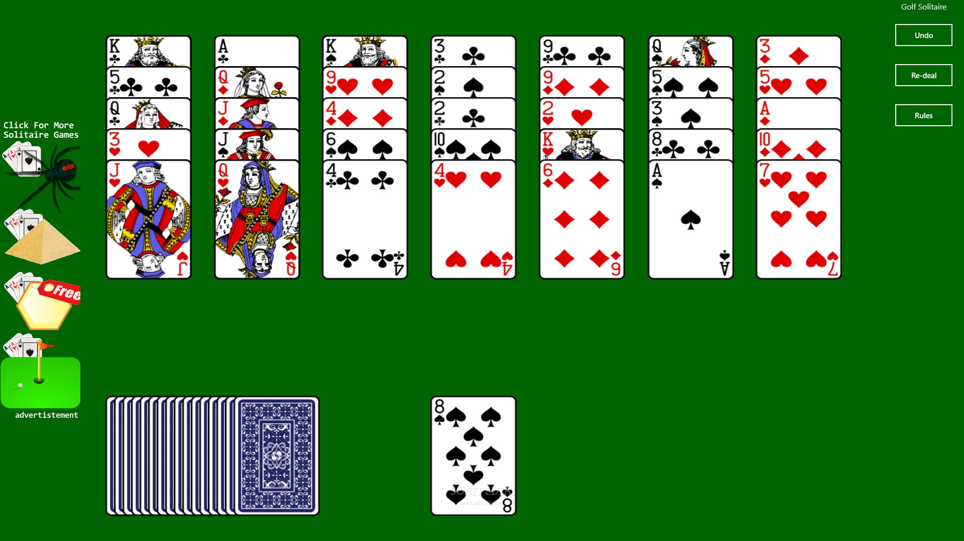

Golf (patience)
Golf is a Patience card game where players try to earn the lowest number of points (as in golf, the sport) over the course of nine deals (or "holes," also borrowing from golf terminology). It has a tableau of 35 face-up cards and a higher ratio of skill to luck than most other solitaire card games.

Setup[edit]
From a standard 52-card deck, 7 columns of 5 cards each are dealt, all face up. This is the tableau. One additional card is dealt as the base of the foundation. The remaining 16 cards are turned face down to form the stock.

Play[edit]
Rules are as follows:
- Only the topmost card in each column (closest to the player) may be removed from the tableau. When it is removed, the card beneath becomes available for play.
- Cards may be moved from the tableau to the foundation if they are either one rank higher or one rank lower than the top card of the foundation, regardless of suit, but nothing may be played on top of a King.
- Cards rank A 2 3 4 5 6 7 8 9 10 J Q K. There is no "wrapping" (Ace on a King, or King on an Ace) in golf.
- Whenever there are no possible plays, turn cards up one at a time from the stock to the foundation and resume playing cards from the tableau when possible.
- There is no redeal. The game is over when the stock is exhausted and no more moves are available.

Scoring[edit]
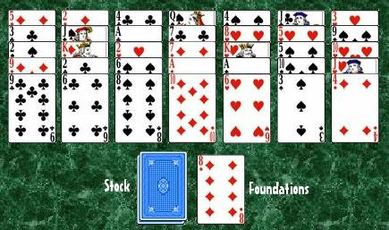
Player scores one point for each card remaining in the tableau after the stock has run out. If the tableau is cleared, player scores a negative point for every card left in the stock. Game is nine "holes" (deals) and a score of 45 or lower is considered par, with a score of zero or lower being perfect.

Impossible Win[edit]
If a tableau is dealt that would make it impossible for the player to clear all of the cards (if all queens are covered by kings for example), then the cards may be reshuffled and redealt.

Variations[edit]
Common variations on these rules include:
- Queens may be played on top of Kings.
- Turning the corner is permitted so that a King can be played on top of an Ace, and vice versa.
- Multiple decks may be used to create larger tableaus.
- One or both of the Jokers may be added to the deck and used as wild cards that represent any value.

Solvability[edit]
When played with the standard rules only about 26% of Golf deals are possible to win. This increases to 45% if queens may be played on kings, and to 93% if turning the corner is permitted.^{[1]}

https://en.wikipedia.org/wiki/Golf_(patience)
http://www.icardgames.com/CardsGolf.php

