ICS4U Level Java Summative Project (15% of Semester)

Contents

Summative Project Notes 2
ICS4U Java Level 4 Final Project Proposal 3
ICS4U Java Level 4 Final Project Exemplar 4
ICS4U Final Project LEVEL 4 Rubric 5
UML Diagram 6
Daily Log Form 7

Read the notes on page 2.

ICS4 Level Java Summative Project (15% of Semester)

Summative Project Notes and Requirements.

NOTE: You are required on a daily basis to keep you final project folder on H drive current. It is your responsibility to keep your files and code secure and backed up. Name all files as specified. Only use AWT. No Swing, SWT etc. KEEP YOUR FOLDER FREE OF ALL REDUNDANT FILES.

- Create a folder named 20XX_ICS4_FPROJ on your H drive (NOT in the class folder). Create another folder in your GAPPS account and share it.

- Due and deadline dates and times will be set in class. These dates and times will be strictly adhered to. All files must be uploaded to locations as specified by the set times and dates.
- Use a USB, your H drive and GAPPS to keep your files current and backed up. Update all files immediately at the start of each class to your H drive and GAPPS 20XX_ICS4_FPROJ folder.
- Back up your folder at the end of class. ALL updated files should be updated and located in your GAPPS 20XX_ICS4_FPROJ folder.
- Create a daily log file as 20XX_ICS4_Log_YourLastNameYourFirstName in your GAPPS 20XX_ICS4_FPROJ folder and share it with me (today). At the end (or start) of each class take time to update your daily log on GAPPS. (See 4Project_Daily_Log.doc)
- Complete a proposal document located in your final project folder. Save it in your folder as 2014ICS4U101_Proposal. Upload it to GAPPS and share it with me by the due date. (See exemplar)
- After your proposal is approved. You must create a UML diagram. This diagram will help you plan the class hierarchy for your program.
- You will be asked to conference with me on several occasions without prior notification. You must be prepared to answer questions and demonstrate knowledge of your code and algorithms with updated daily logs and project files.
The following and the like are not acceptable at a conference:

- I have my files at home.
- I work on it at home.
- One, some or all of my files are corrupt, lost or missing.
- My USB was corrupted (when it was accidently put in the wash)
- Etc.

This is the course summative and counts for 15% of your course mark. The teacher must verify that you are working on your project and that all files and all code is yours. The teacher must see you working in class and witness your progression. Failure to prove that you are progressing via conference(s) will result in a mark of 0 (zero) for the project.

ICS4 Java Level 4 Final Project Proposal

Create a Java applet called AppletFinal.java that will allow the user to play a solitaire card game. Use the card deck that you created in Assignment 4 and include as many applet features as you can. Begin by laying out the game screen in the area below. Indicate all of the panels, layouts and components that you intend to use. Given the limited time that is available, you may want to choose a simple game having only a few decks and simple rules. [Blank form] [Exemplar]

Screen layout

Game Play Description

ICS4 Java Level 4 Final Project Proposal Exemplar

Follow the link to see exemplar
.

ICS4 Final Project LEVEL 4 Rubric
Name |  |  |  | Project Name
 | Mark | Level 4 | Level 3 | Level 2 | Level 1 | Level 0
Design | /5 | Thoroughly describes game layout, rules and game play. | Mostly describes game layout, rules and game play. | Somewhat describes game layout, rules and game play. | Poorly describes game layout, rules and game play. | Does not describe game layout, rules and game play.
Java program & Applet features: mouse,  buttons, combo boxes, text boxes | /10 | Implements all program features covered in assignments; Uses several Panels and different layout managers | Implements most program features covered in assignments; Uses some Panels and few layout managers | Implements few program features covered in assignments; Uses one Panel and simple layout manager | Implements few program features covered in assignments Does not use Panel but uses border layout manager | Implements very few program features covered in assignments; Uses default layout manager
Program completion | /50 | Program has no errors and works to completion | Program has few errors and works to completion | Program has some errors and works to completion | Program has many errors and works to completion | Program does not work to completion
Work Logs | /10 | Includes dates and time spent every day; gives thorough description of accomplishments, concerns & expectations | Includes dates and time spent every day; gives good description of accomplishments, concerns & expectations | Includes dates and time spent for most days; gives good description of accomplishments, concerns & expectations | Omits dates and time spent for most days; gives poor description of accomplishments, concerns & expectations | No accounting of accomplishments, concerns & expectations
Program Level of difficulty | /10 | Program has several new or difficult programming features  Algorithm is complex | Program has one new or difficult programming feature  Algorithm is difficult | Program has no new or difficult programming features  Algorithm is moderate | Program has no new or difficult programming features  Algorithm is easy | Program has no new/difficult pro-gramming features  Algorithm is very easy
Total | /85
Comments:

UML Diagram
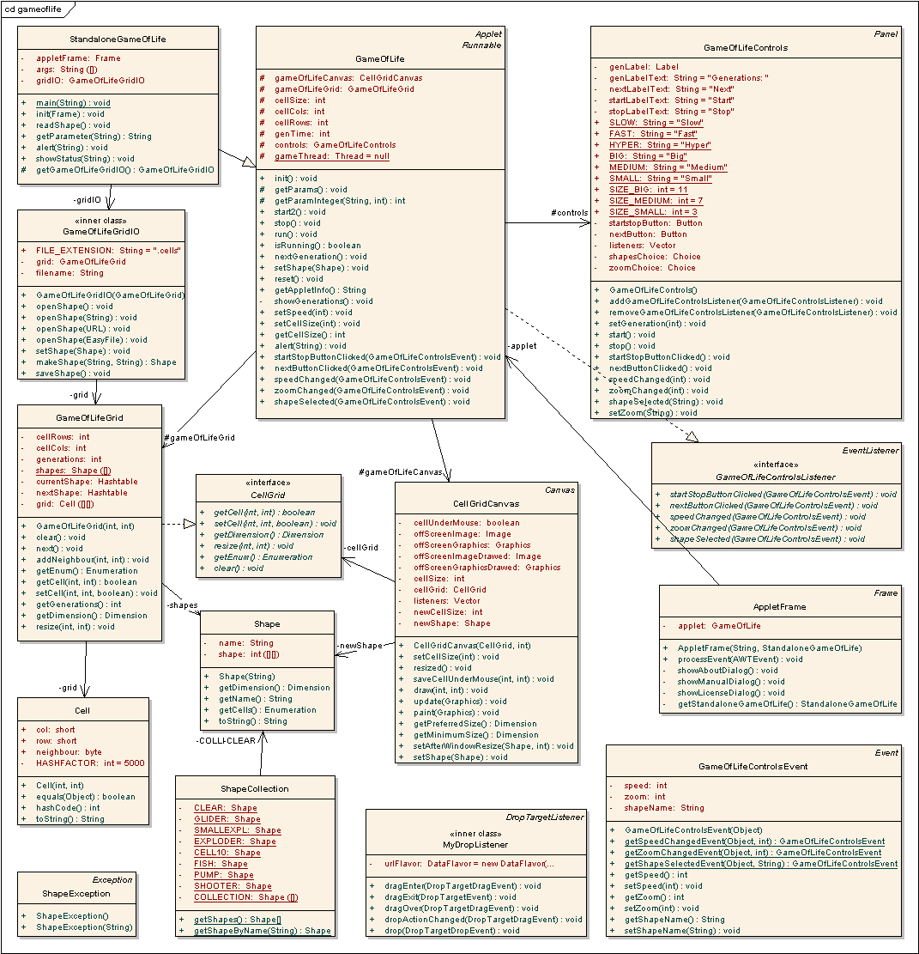

Daily Log Form
Name |  |  |  |  | Week of Mon: |  | to Sun:
Mon |  | hrs | A:
Mon |  | hrs | C:
Mon |  | hrs | E:
Tue |  | hrs | A:
Tue |  | hrs | C:
Tue |  | hrs | E:
Wed |  | hrs | A:
Wed |  | hrs | C:
Wed |  | hrs | E:
Thu |  | hrs | A:
Thu |  | hrs | C:
Thu |  | hrs | E:
Fri |  | hrs | A:
Fri |  | hrs | C:
Fri |  | hrs | E:
Sat |  | hrs | A:
Sat |  | hrs | C:
Sat |  | hrs | E:
Sun |  | hrs | A:
Sun |  | hrs | C:
Sun |  | hrs | E:
Use the ACE method to record a daily log of your Accomplishments, Concerns, and Expectations in your efforts to the final project. You may wish to use this method in future projects, research papers and the like. [blank forms]

Name |  |  |  |  | Week of Mon: |  | to Sun:
Mon |  | hrs | A:
Mon |  | hrs | C:
Mon |  | hrs | E:
Tue |  | hrs | A:
Tue |  | hrs | C:
Tue |  | hrs | E:
Wed |  | hrs | A:
Wed |  | hrs | C:
Wed |  | hrs | E:
Thu |  | hrs | A:
Thu |  | hrs | C:
Thu |  | hrs | E:
Fri |  | hrs | A:
Fri |  | hrs | C:
Fri |  | hrs | E:
Sat |  | hrs | A:
Sat |  | hrs | C:
Sat |  | hrs | E:
Sun |  | hrs | A:
Sun |  | hrs | C:
Sun |  | hrs | E:
Use the ACE method to record a daily log of your Accomplishments, Concerns, Expectations in your efforts to the final project. You may wish to use this method in future projects, research papers and the like.

Name |  |  |  |  | Week of Mon: |  | to Sun:
Mon |  | hrs | A:
Mon |  | hrs | C:
Mon |  | hrs | E:
Tue |  | hrs | A:
Tue |  | hrs | C:
Tue |  | hrs | E:
Wed |  | hrs | A:
Wed |  | hrs | C:
Wed |  | hrs | E:
Thu |  | hrs | A:
Thu |  | hrs | C:
Thu |  | hrs | E:
Fri |  | hrs | A:
Fri |  | hrs | C:
Fri |  | hrs | E:
Sat |  | hrs | A:
Sat |  | hrs | C:
Sat |  | hrs | E:
Sun |  | hrs | A:
Sun |  | hrs | C:
Sun |  | hrs | E:
Use the ACE method to record a daily log of your Accomplishments, Concerns, Expectations in your efforts to the final project. You may wish to use this method in future projects, research papers and the like.

Name |  |  |  |  | Week of Mon: |  | to Sun:
Mon |  | hrs | A:
Mon |  | hrs | C:
Mon |  | hrs | E:
Tue |  | hrs | A:
Tue |  | hrs | C:
Tue |  | hrs | E:
Wed |  | hrs | A:
Wed |  | hrs | C:
Wed |  | hrs | E:
Thu |  | hrs | A:
Thu |  | hrs | C:
Thu |  | hrs | E:
Fri |  | hrs | A:
Fri |  | hrs | C:
Fri |  | hrs | E:
Sat |  | hrs | A:
Sat |  | hrs | C:
Sat |  | hrs | E:
Sun |  | hrs | A:
Sun |  | hrs | C:
Sun |  | hrs | E:
Use the ACE method to record a daily log of your Accomplishments, Concerns, Expectations in your efforts to the final project. You may wish to use this method in future projects, research papers and the like.

