

Yoshi Moshi - Manual

# Controls with Xbox 360 Controller:

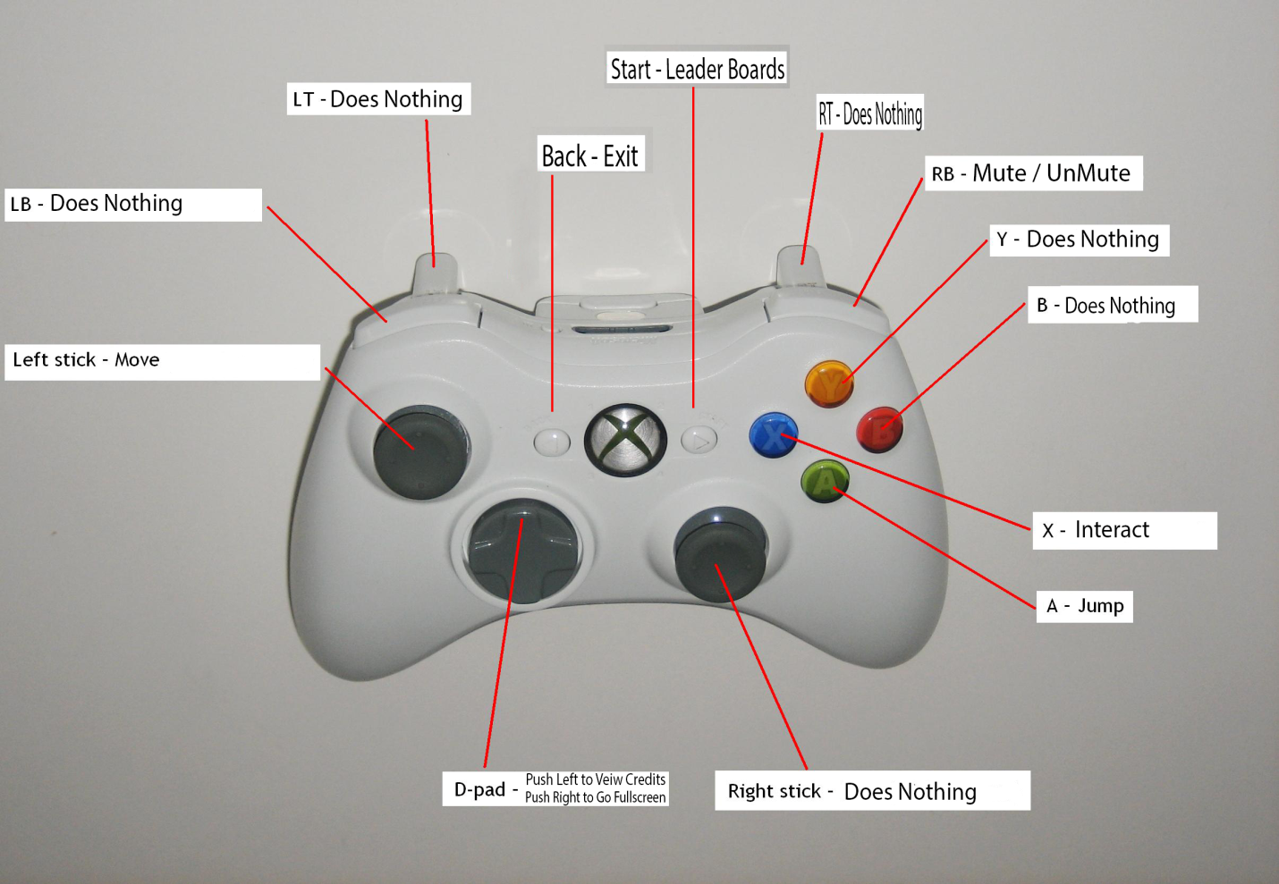

Left Stick to move, A to jump, X to interact, RB to mute and un-mute, Start for Leader Boards,

D-Pad Left for Credits, D-Pad Right for Full screen.

Cheats: Maybe, maybe not.

# Controls with PC:

To Move: Use WASD (Use W to jump with regular gravity, and S to jump with flipped gravity).

To Interact: Press E to eat, or take.

To Mute: Press M to mute.

Leader Boards: Press L to view leader boards.

To Exit: Hit Esc To Exit.

Full Screen: Press F to view Full Screen

Credits: Press C to view Credits

Cheats: Got to find them yourself!

# How To Play:

finish.pngfinish.pngfinish.pngThe Purpose of this game is to reach the finish line and solve the puzzle as soon as possible without dying and losing all your lives.

Throughout the game Yoshi has options. He can move crates: wood.png He can eat apples: apple.png He can pick up stars: star.png and he can create bridges. But Yoshi gets hungry, Fast! So feeding him is important. Although, yoshi eats slowly, so a 5 second time penalty will be added for eating. If Yoshi gets a star, then his star bonus goes up and increases his overall score. If the player goes on a blue lever: leverBlue.pngthen the blue bridges activate, and the orange bridges go down. If the player goes on an orange lever: leverOrange.pngthen the orange bridges activate and the blue bridges go down. While doing all of this, Yoshi must solve the level and be careful for red blocks like this: red.png cause they hurt! A lot!

# Some Gameplay Pictures:

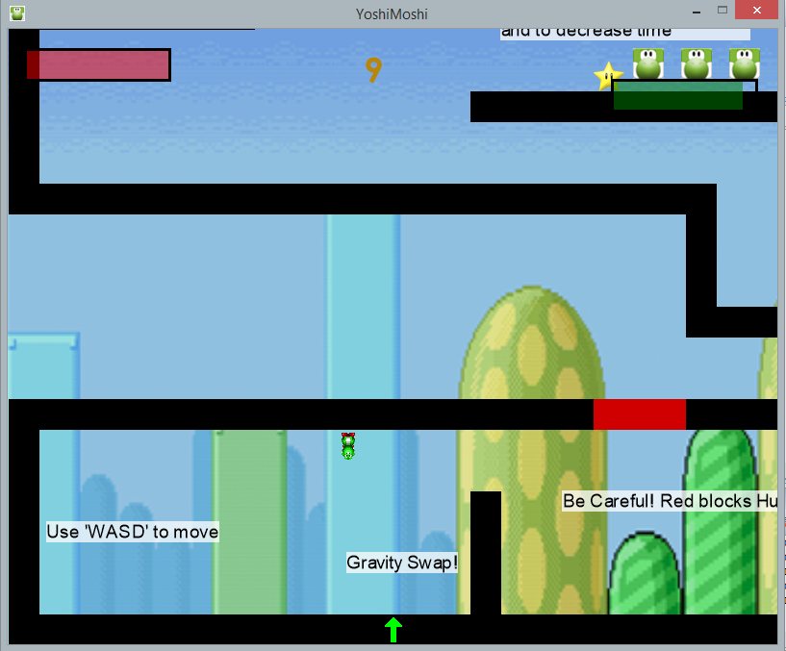

Yoshi right in the beginning after hitting the gravity swap. You can see his health and hunger are almost completely full.

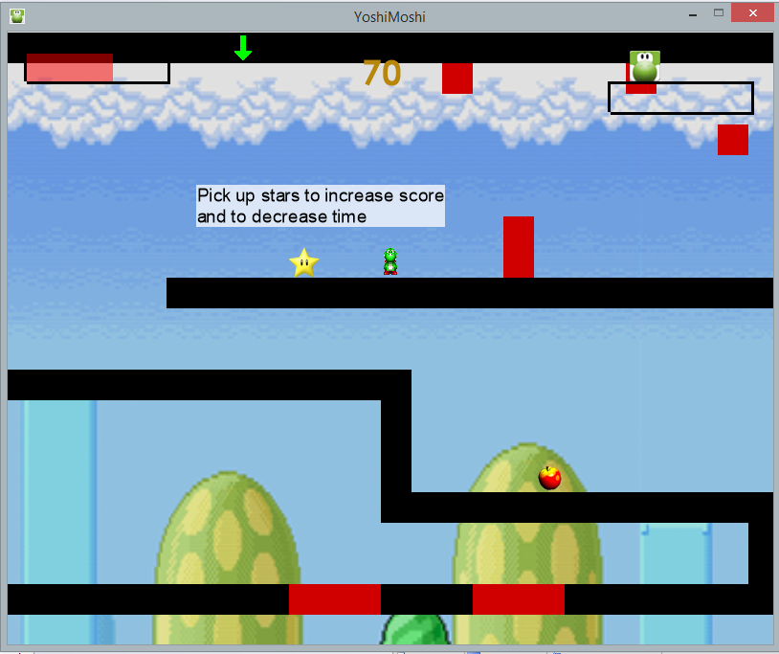

Here you can see that Yoshi is maneuvering through all those red dangerous blocks, going for those stars, but starving and losing health. But Yoshi can see an apple in his future, so he seems fine.

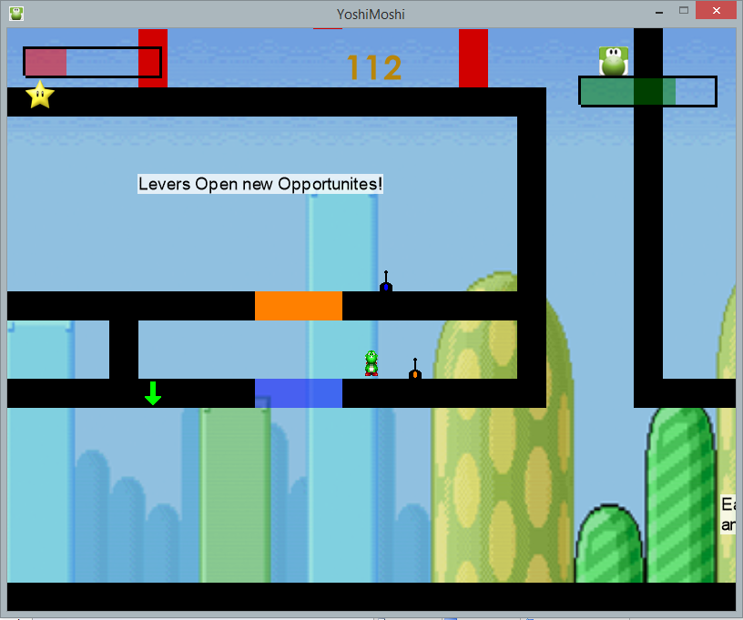

Here you can see Yoshi has ate, as his hunger went up, but he's still very hurt. Might not ever recover. He only has one Life Left! Oh no! You can also see that he's been using his levers and bridges wisely.

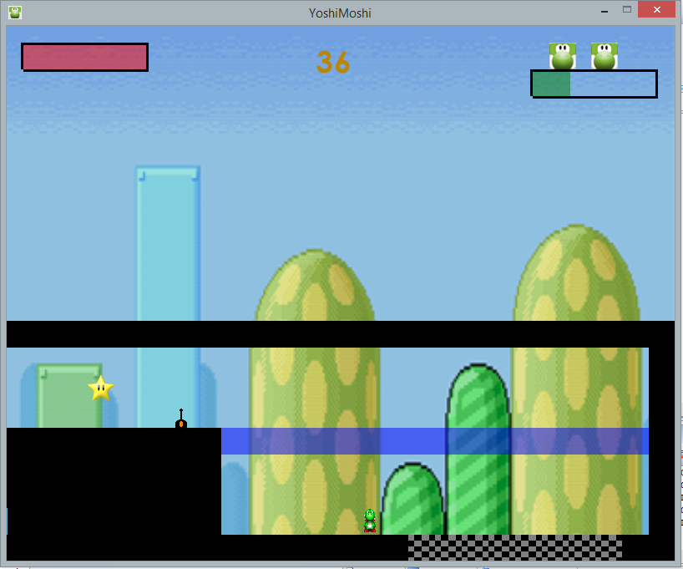

Crossing the finish line! Only 3 more to go!