Information Retreival Project

Software Manual

By:
Ohad Redlich
Gal Reider
Shalom Yaakov

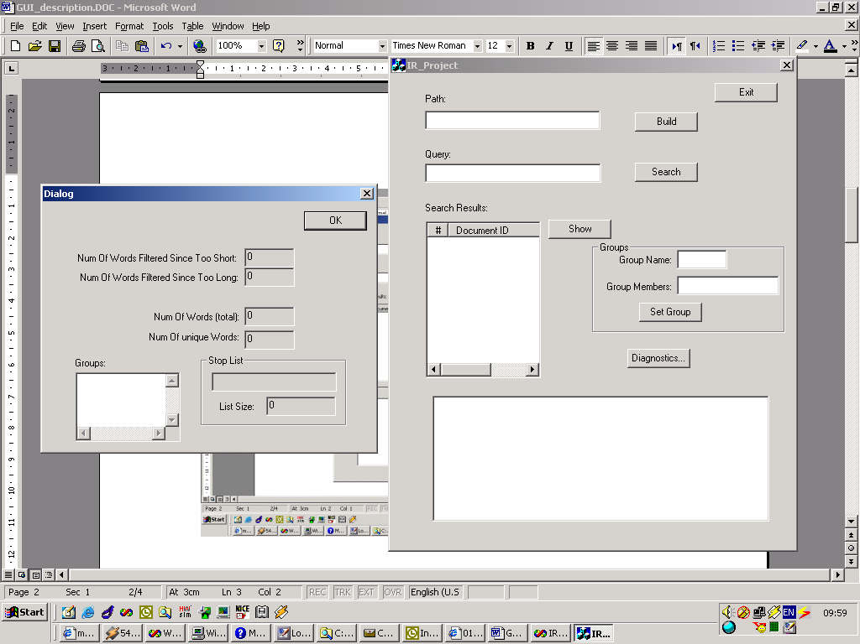

1. Build- Makes the “build” process that includes processing the Reuter’s documents and building the hash table. The system searches for the files in the path that was entered in the “Path” edit box. If it is empty, then the default path is <../../Files>
2. Search- The user enters his query in the search box and clicking the Search button will execute the query and return the relevant docs. The results of the query is a list of documents, which will appear in the “Search Results” list box. When the user want to view one of these documents, he will click and mark the document, and press “show” (see “Show”)
3. Groups Handling
a.. Group name- The user can enter the name of a new group in this box. Numbers are allowed to be used in the group name.
b. Group members - The user should enter the members of the group that was written above, separated by blanks.
c. Set group- After entering the group’s name and members, by clicking this button the group enters the system so it can be used for querying
4. Diagnostics- opens diagnostics dialog, which represents statistics about the whole documents like:
- the number of long/short words that were deleted in the process
- the stop list: its members and length
- the groups that the user has entered.
- The number of total words in all the Reuter’s documents
- The number of unique words that were detected.
5. Show- clicking on the doc that display in the "Show" box+clicking the "show " button give us the full doc in the "Search Result" .
6. Search Result - display one of the docs that was retrived from the query and was chosen in the "Show" option. The words that were requested in the query will be highlighted!

