GitHub: <http://github.com/Ohar>

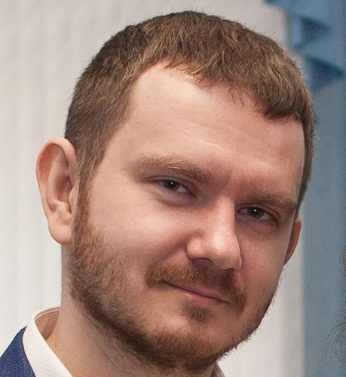

**Lysenko Pavel**

Male, 32 years

+7 (985) 268-53-23

job@ohar.name

— preferred for communication

Skype: commodus.voke

LinkedIn: [https://www.linkedin.com/in/oharr/](https://www.linkedin.com/in/oharr/?locale=en_US)

Reside in: Moscow, Russia.

Citizenship: Russia

Not ready to relocate, ready for rare business trips.

Desired position and salary

# Senior Frontend Developer

IT, Internet, Telecom

* Software Development
* Internet

Employment: full time

Work schedule: full day, flexible schedule, remote working

## Work experience — 8 years 9 month

January 2019 — **Sfera**

August 2019 Russia, [Sfera.ru](https://sfera.ru/)

8 months

## Frontend Developer

Leaving reason: relocation.

I developed finance info module (income, outcome, debts, etc).

I created basics of the trade system (3rd party API integration).

Tools: WebStorm, Git, Gitlab.

Technologies: JavaScript, React.js, LESS, Webpack.

June 2018 — **Skillmill**

October 2018 Remotely, skillmill.io (not public yet)

5 months

## Frontend Developer

Leaving reason: development was frozen.

I developed internal chat system (Websockets) with file sending and user's profile page.

I automatized release and deploy processes with shell scripts.

Tools: WebStorm, Git, Github.

Technologies: JavaScript, Vue.js, LESS, HTML, Webpack, Bash.

Novermber 2017 — **Carrus Mobile**

May 2018 Remotely, breakerlog.com (closed)

6 months

## Frontend Developer

Leaving reason: company was closed :-(

I created management panel (React.js). All frontend stuff was on my responsibility.

I planned site architecture and create pages, automatized release and deploy processes with shell scripts and configured Nginx server for frontend part.

I split site for independent bundles and configured different Webpack builds for different environments.

Tools: WebStorm, Git, Github.

Technologies: JavaScript, SCSS, HTML, React.js, Redux, Webpack, Bash, Lodash.

January 2017 — **YouDo**

September 2017 Russia, [youdo.com](https://youdo.com/)

9 months

## Programmer

Maintaining YouDo.com frontend.

Migration to ES2015 (Babel). React (Redux) integration.

Tools: WebStorm, Git, YouTrack.

Technologies: JavaScript, LESS, HTML, Angular.js, React.js, Lodash, Jest, Backbone.

# July 2015 — KamaGames Studio

January 2017 Moscow, [kamagames.com](https://www.kamagames.com/)

1 year 7 months

## Senior Frontend Developer

I had full responsibility for internal report and data visualization service.

I gathered requirements from internal consumers, develop frontend (Angular 1), backend (Node.js), integrate third party services.

I coordinated data gathering from all company departments.

I interviewed the frontend developers and fullstack developers.

Developed service features, fix bugs, create UI.

Developed API on Node.js.

Unit tests (Mocha + Chai). Added OAuth with LDAP.

Maintaining of internal React.js project: creating new components, bugfixing (a lot).

Tools: WebStorm, Git, Redmine, Postman.

Technologies: JavaScript, SCSS, HTML, Angular.js, React.js, Lodash, Node.js, Mocha, Chai, Websockets, a little MySQL and Redis.

|  |  |
| --- | --- |
| December 2014 —  July 2015  8 months | **Localway**  Moscow, [localway.ru](https://localway.ru)  Frontend developer  Maintaining and supporting localway.ru with Angular.js: bugfixing, layouts, developing new pages, modules, directives for main site, also for mobile site and admin panel.  Tools: WebStorm, Git, JIRA, Slack, Kato.  Technologies: JavaScript, jQuery, CSS, HTML, Angular.js, Underscore.js, a little bit Python. |
| June 2014 —  November 2014  6 months | **Workle**  Moscow, [workle.ru](https://www.workle.ru/)  Frontend developer  Features, bugfixing, layouts, again bugfixing. Change some pages, e. g. special offer page and tours search. Maintain some admin panel pages.  Tools: Git, JIRA, Visual Studio.  Technologies: JavaScript, jQuery, CSS, БЭМ, a little bit Backbone.js & Require.js. |
| November 2013 — May 2014  7 months | **NullPointer**  Moscow, [null-pointer.ru](http://null-pointer.ru/)  JavaScript developer  Modules for AngularJS: DB search, sorting, pseudopage pagination.  Tools: Git, Ubuntu, Netbeans.  Technologies: JavaScript, CSS, HTML, Angular.js, Require.js, Underscore.js. |
| July 2012 — November 2013  1 year 5 months | **Oversun**  Moscow, [oversun.ru](https://web.archive.org/web/20120921004723/http:/www.oversun.ru/)  UI developer  Develop company own service panel UI. Improve UX and UI for company sites and projects. Develop some child projects’s sites.  Tools: Notepad++, Visual Studio.  Technologies: CSS, HTML, JavaScript, jQuery, Razor. |
| April 2012 —  July 2012  4 months | **Oversun**  Moscow, [oversun.ru](https://web.archive.org/web/20120921004723/http:/www.oversun.ru/)  Web coder  Maintain new company site (a present one). Layouts, templates, scripting. Polish some third-party libs for project needs.  Tools: Notepad++.  Technologies: CSS, HTML, JavaScript, jQuery. |
| June 2010 — December 2011  1 year 7 months | **ARTUS Internet Agency**  Moscow, [artus.ru](http://www.artus.ru/) |

## Content manager

I filled pages with content, proofreaded and typographed for tens of sites . I maked and configured a lot of forms, banners, and pages.

I upgraded job descriptions and performance standards, also I updated content manager technical standards.

Tools: Notepad++.

Technologies: CSS, HTML.

Education

Incomplete higher

### 2012 National Research University 'Higher School of Economics', Moscow

Computing systems, machines and networks, quit after 2nd year

#### Professional development, courses

2011 **JavaScript. Fundamentals of Web programming**

Training Center “Specialist” at the MSTU. Bauman

### 2011 HTML, CSS, cross-browser layout, UI basics

Training Center “Specialist” at the MSTU. Bauman

#### Key skills

Languages Russian — native

English — I can attend an interview

Skills AngularJS JavaScript jQuery Git CSS HTML UX UI

Typographic Web Programming Usability Node.js SQL ES2015

React.js Redux Phaser Webpack Vue.js

#### Further information

About me Looking for relocation or remote positions.

I want to make web a little bit better: more comfortable for users and much comprehensible for crawlers.

Flexible schedule is preferable.

I am diligent, meticulous and scrupulous person.

I am very glad to see good solutions and try to no let bad solutions to go to the production.

I have perfect Russian and upper intermediate English.

I can create cross-browser layouts (possible IE6+, preferable IE11+).

In the workplace I need to have two displays (office only).