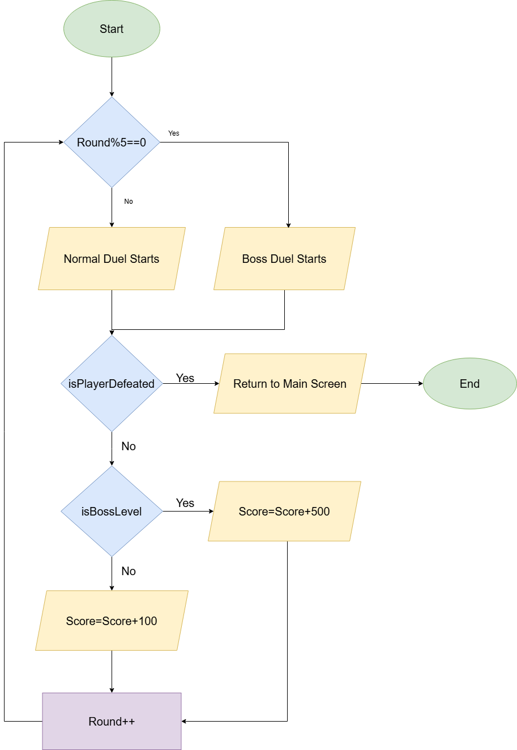***Core loop diagram:***

***Monetisation Ideas:***

**1. Rewarded Ads**

**2. Cosmetic Gacha (Stretch Goal)**

**3. IAP – Remove Ads / Currency Packs**

**4. Daily Quests + Login Rewards**

**5. Limited-Time Events**

**6. Progression-Driven Unlocks**

**7. Weapon Upgrade Meta**

***Next Steps:***

**1. Add Health System**

**2. Improve Core Loop Depth**

**3. Meta Progression Layer**

**4. Cosmetics (Stretch Feature)**

**5. Session Restart with Difficulty Scaling**

**6. UI Feedback Enhancements**

**7. Monetisation Placeholder**

**8. Polish for Demo**

**Monetisation Strategy**

***8-Bit Bang* adopts a player-friendly monetisation model focused on optional engagement. The initial strategy includes rewarded ads for non-intrusive bonuses and a Remove Ads IAP for a premium experience. Additional monetisation options include currency packs and, as a stretch goal, a cosmetic gacha system offering purely visual rewards. Features such as daily quests, login bonuses, and limited-time events will support retention, while progression-based unlocks and a weapon upgrade system provide meaningful long-term goals.**

**Development Roadmap**

**Upcoming development will focus on expanding core gameplay and preparing for public release. Key tasks include adding a health system, deepening the duel loop, and introducing a meta-progression layer. Stretch objectives include cosmetic customization and difficulty scaling tied to session restarts. Improvements to UI feedback, along with a monetisation framework for testing, will support polish and readiness for a public demo.**