Complaints Dashboard Performance Report Standard Operating Procedure (SOP)

Contents

1. Description 1

2. Before You Start 2

3. Repository Structure 3

4. Install Packages (first time only) 3

5. Prepare the Data 5

6. Run Dashboard 6

7. Important Notes 8

8. Quick Checklist 9

# Description

This guide explains how to set up and install repository to run the **Complaints** dashboard which is used for generating necessary figures for the **CSAC Performance**.

It covers setting up the initial repository, preparing data, and running the dashboard

***⚠️ Note: This SOP requires manually extracting data from the complaints Team which can be accessed via there sharepoint page. This SOP does not cover this and the repository does not contain any data for information Governance purposes***

# Before You Start

1. Request installation of the following from the Service Now portal:

* **R**
* **RStudio**
* **Git (x64)**

1. Download the repository from **GitHub**:
   1. Open **RStudio**. (**image 2.1 and 2.2**)
   2. Go to **File → New Project → Version Control**. (**image 2.3**)
   3. Select **Git**.
   4. Enter the following: (**image 2.4**)
      1. **Repository URL:** https://github.com/OhinUKHSA/Complaints_dashboard.git
      2. **Project directory name:** Complaints_dashboard (or a name of your choice)
      3. **Location:** [Choose where you want the project stored]
   5. Click **Create Project**.

***✅ This will create a local copy of the repository with all necessary scripts (excluding data files, which must be downloaded separately for information governance reasons).***

|  |  |
| --- | --- |
|  |  |
| * 1. Open R studio | * 1. Example of Rstudio |
|  |  |
| * 1. After opening **RStudio** click **file**, **new project** and then select **Version Control** | * 1. Fill in window as shown |

# Repository Structure

You should now have a repository similar to what is shown below

***⚠️ Note you will not have any data files (Raw data will need to be requested from data controller).***

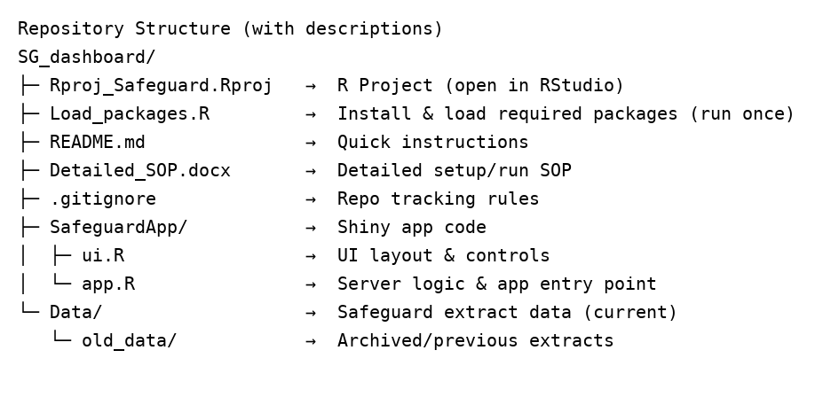

# Install Packages (first time only)

1. In **RStudio** project (**Rproject_Complaints.Rproj**), open the script **Load_Packages.R** (File → Open File → **Load_Packages.R**).
   * You should now see a screen similar to that shown in **image 4.1.**
2. Select all code (**Ctrl + A**) and run (**Ctrl + Enter**) (see **image 4.2**)
   * This can take **A WHILE** to complete
   * When complete, you will see the message:  
     ‘*All required packages are installed. You can run report*.’ (see **image 4.2)**

**✅ *Once you have done this step you will not need to do it again***

|  |
| --- |
|  |
| 4.1. Typical screen after opening **Load_package.R** file. Highlighted in red is a new window top left including **Load_package.R** script (yellow tab). |
|  |
| 4.2. Screenshot showing when all packages are installed. Highlighted in yellow indicates this is complete (**note this process can take a while to download**) |

# Prepare the Data

1. Navigate to the folder: **…/Complaints_dashboard/data/**
2. If a data file already exists, move it to the **…/Complaints_dashboard/data/old_data/** folder (see **Image 5.1**).
   * **It is recommended** to create a dated subfolder within **old_data/** (see **Image 5.2**) to support version control.
3. **Go to Complaints share point site and copy latest data into your data.xlsx file**

* ⚠️ The filename may vary — the name is not important.

|  |
| --- |
|  |
| * 1. Move or copy the previous month’s **files** into ***Complaints_dashboard /data/*old_data**/ before updating |
|  |
| * 1. **Recommended** to save data in separate folder for version control |

# Run Dashboard

1. Locate and open **Rproject_Complaints.Rproj** in your directory (**image 6.1** - highlighted in yellow)

|  |
| --- |
|  |
| * 1. Image highlighting **Rproject_Complaints.Rproj** project and folder (**ComplaintsDashboard**) containing files to run dashboard (highlighted in yellow). |

1. When the R project opens, check the *top left pane* for **server** or **ui** in top left pane (see **image 6.2** -highlighted in yellow),

If you don’t see either file **Click**:

* + File 🡪 Open File 🡪 **ComplaintsDashboard/server.R**. or (**ui.R**)

*You should now see this script open in top left pane*. (**image 6.2 –** highlighted with red circle)

⚠️ **IMPORTANT:** *Make sure you are in the* **server.R** *or* ***ui.R*** *script as you can have several scripts on at once. Click on the tab if required* (**image 6.2** – highlighted yellow circle**)**

|  |
| --- |
|  |
| * 1. Image showing **server.R** script (highlighted in red) in the **Rproject_Complaints.Rproj** R project |

1. Once the correct script is open, you should see the **Run App** button (**Image 6.2**, **blue** circle).

* Click **Run App** (or use the shortcut **Ctrl + Shift + Enter**).
* The dashboard will launch and appear as shown in **Image 6.3**.

|  |
| --- |
|  |
| * 1. Typical view of dashboard. Click in the Browse button (highlighted in yellow) to select file to run in dashboard. |

1. **Add Complaints Data File**

* In the dashboard, click the **Browse** button (**Image 6.3**, yellow highlight).
* Navigate to the file created in **Section 5**. This will be in: **Complaints_dashboard/data/**
* Select the file to load it into the dashboard.

1. **View the Output**

* A plot should now render at the bottom of the dashboard

1. **Customise the Plot**

* Use the dashboard controls to adjust (see **image 6.3**):
  + **Figure title, subheading, and caption text**
  + **Filters**: choose Groups, Departments, Units, or Teams
  + **Aggregation**: by Month, Financial Quarter, or Financial Year
  + **Figure size**: adjust height and width

# Important Notes

* Always save last month’s data in  ***Complaints_dashboard/*data/old_data/** before replacing with new files
* Do not edit any of the scripts

# Quick Checklist

✅ Ensure you have installed all necessary packages by running **Load_package.R** script

✅ Create copy of old files (if they exist) to **data/old_data/**

✅ Get latest data from data controller and copy its contents into new excel file

✅ Save new file in data/

✅ Open Rstudio project (**Rproject_Complaints.Rproj**) and run dashboard by opening **ComplaintsDashboard/server.R**

✅ Click **Run App** or pressing **ctrl** + **shift** + **enter**

✅ Add data file into dashboard by clicking ‘**browse**’

✅ Customize plot accordingly