Making Reasoning Visible — One Child, Two Ways
TCE 318P FA26 (Edwards)
Week 2 · Listener → Questioner · Number & Base-Ten
In class · with your partner · no AI.
The task the child was given
Find 1003 − 999. Solve it more than one way, and show your thinking so someone else could follow it.
What one third grader turned in
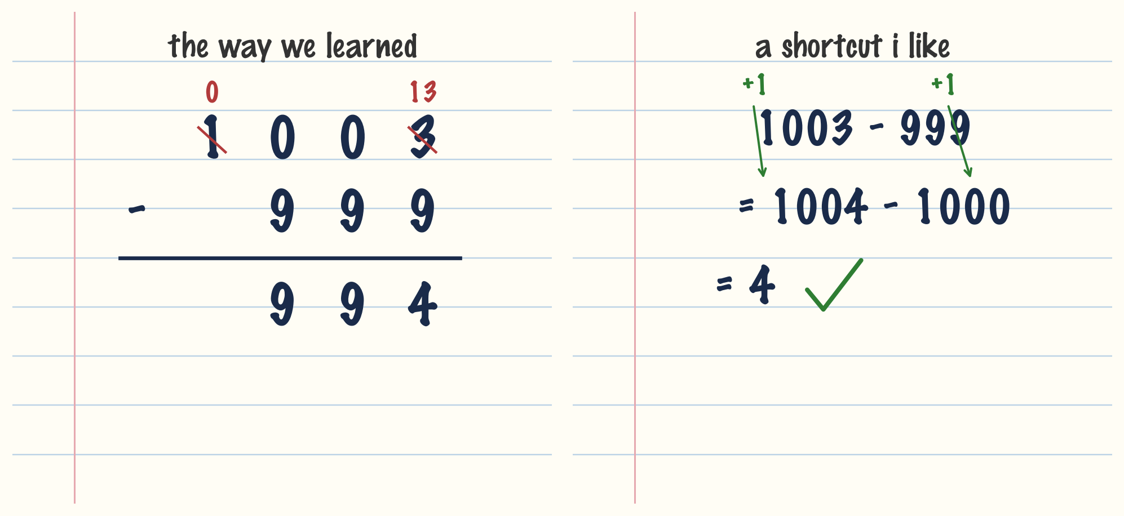
The child solved the same problem two ways and got two different answers.

1. Diagnose this student solution. What does the student seem to understand (or not) about the mathematics of the task? Justify your response with details from the student's work.
____________________________________________________________________________________________
____________________________________________________________________________________________
____________________________________________________________________________________________
____________________________________________________________________________________________

2. Brainstorm 5 open, non-leading questions you might ask this student to help them build a stronger mathematical understanding of the task. For each question, provide a brief justification why it's a good question.

1) Question: ________________________________________________________________
Why it's a good question: ________________________________________________

2) Question: ________________________________________________________________
Why it's a good question: ________________________________________________

3) Question: ________________________________________________________________
Why it's a good question: ________________________________________________

4) Question: ________________________________________________________________
Why it's a good question: ________________________________________________

5) Question: ________________________________________________________________
Why it's a good question: ________________________________________________

