Thinker-Doer — Two Rich Tasks
TCE 318P FA26 (Edwards)
Week 2 · Listener → Questioner · Number & Base-Ten
Two roles. The Doer works the problem out loud. The Thinker asks questions that draw out the Doer's reasoning — and never tells. Swap roles between tasks. Solve it, then be ready to make your thinking public.
Warm-Up — Four 4s
Using exactly four 4s and any operations (+ − × ÷ and parentheses), write an expression for as many of the whole numbers 0–20 as you can. For example, 4 + 4 − 4 − 4 = 0 and 4 ÷ 4 = 1.
Then pool your group's expressions: how many of 0–20 can the group make together? Which numbers were hardest, and why?

Thinker-Doer · Blue Task · TCE 318P FA26 · Week 2
Blue Task — Patio Tiles
A square patio is surrounded by a single ring of square border tiles. A 5 × 5 patio needs 24 border tiles to enclose it, as shown below.
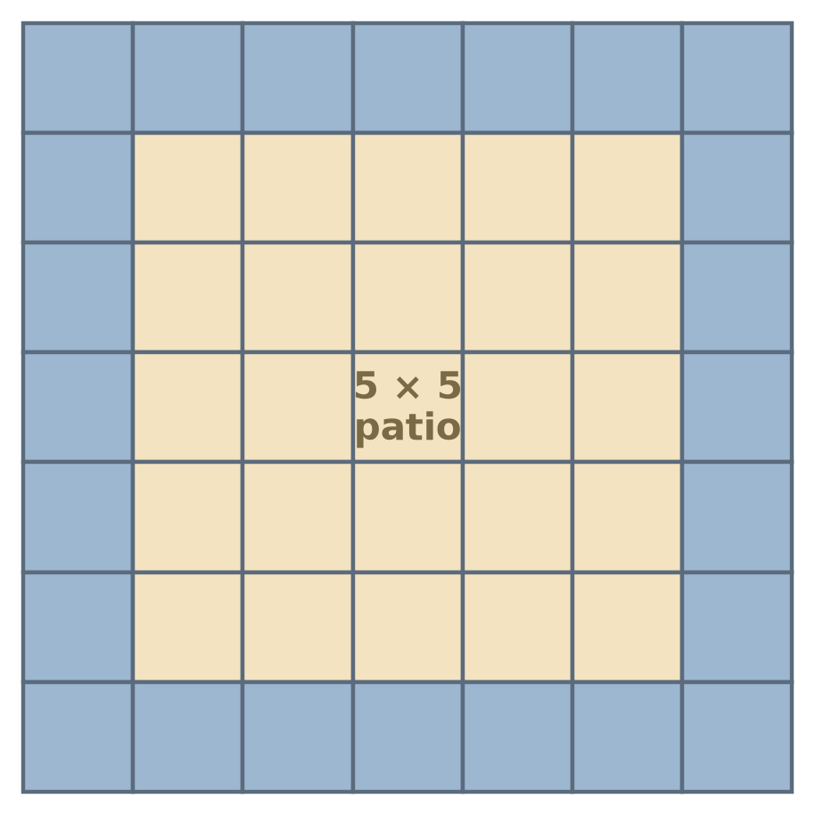

1. How many border tiles are needed to enclose a 32 × 32 patio? A 100 × 100 patio?
2. Solve the task two completely different ways to check your work.
3. Be ready to convince your group your count is right — and to explain why your two different ways agree.
Justify your answer with significant supporting work — drawings, numerical computations, and written explanations so others can follow your thinking.

Thinker-Doer · Green Task · TCE 318P FA26 · Week 2
Green Task — Greatest Product
Your teacher rolls digits one at a time (a ten-sided die, digits 0–9) and drops each into a box to build [ _ _ ] × [ _ _ ] . The goal is the greatest possible product.
(a) This round she rolled 3, 7, 8, and 9.
Arrange all four digits into [ _ _ ] × [ _ _ ] to make the greatest product you can. What is the greatest product, and how do you know no arrangement beats it? Is there more than one way to obtain the greatest product? If so, describe it and explain why it works. If not, explain why there is only one way.
(b) Now suppose she has rolled only 3, 8, and 7 so far — and each digit must be placed before the next is rolled.
The fourth digit is still unknown. Is there a way to place 3, 8, and 7 that guarantees the greatest product no matter what the fourth roll turns out to be? If not, where would you place them to give yourself the best chance — and what makes that the smart bet?
Justify your answer with significant supporting work — drawings, numerical computations, and written explanations so others can follow your thinking.

Resource Sheet
Students have found these tools helpful on the Blue and Green tasks. Use them, or not, as you like.
Greatest-Product board (fill digits into the boxes):
☐ ☐ × ☐ ☐ ☐ ☐ × ☐ ☐ ☐ ☐ × ☐ ☐
Hundred chart:
1 | 2 | 3 | 4 | 5 | 6 | 7 | 8 | 9 | 10
11 | 12 | 13 | 14 | 15 | 16 | 17 | 18 | 19 | 20
21 | 22 | 23 | 24 | 25 | 26 | 27 | 28 | 29 | 30
31 | 32 | 33 | 34 | 35 | 36 | 37 | 38 | 39 | 40
41 | 42 | 43 | 44 | 45 | 46 | 47 | 48 | 49 | 50
51 | 52 | 53 | 54 | 55 | 56 | 57 | 58 | 59 | 60
61 | 62 | 63 | 64 | 65 | 66 | 67 | 68 | 69 | 70
71 | 72 | 73 | 74 | 75 | 76 | 77 | 78 | 79 | 80
81 | 82 | 83 | 84 | 85 | 86 | 87 | 88 | 89 | 90
91 | 92 | 93 | 94 | 95 | 96 | 97 | 98 | 99 | 100

