Pedagogical Excursion #2 — Diagnosing a Subtraction Error
TCE 318P FA26 (Edwards)
20 points possible
In class · on your own or with a partner (no more than two). Collected at the end of the clinic.
The task the child was given
What number is 18 less than 83? (That is, find 83 − 18.) Show your thinking so someone else could follow it.
What one third grader turned in
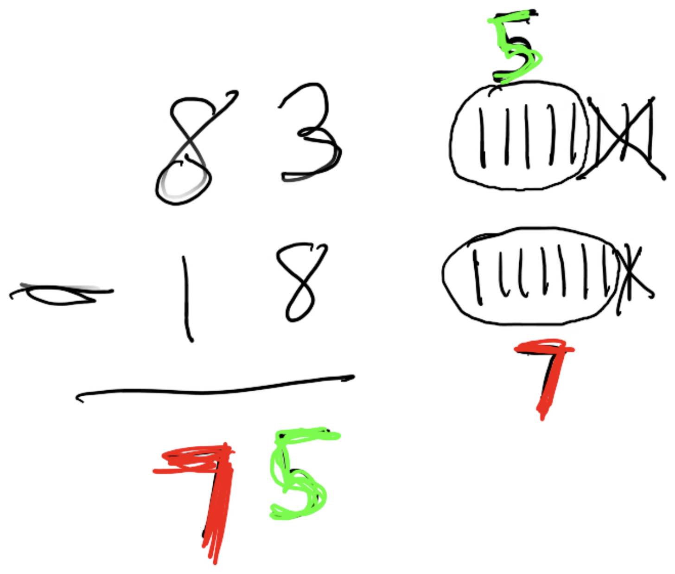

1. Diagnose this student solution. What does the student seem to understand (or not) about the mathematics of the task? Justify your response with details from the student's work.
2. Write five open, non-leading questions you might ask this student to help them build a stronger understanding of the task and their solution.

3. Choose the one question above that best addresses this student's learning needs. Write it here, then explain why it fits THIS child and this misconception.

Chosen question:

Why it fits this child (3–5 sentences):
How is my work assessed?
Criteria | Expectations
Diagnosis (5) | Names what the child understands and the misconception, at the place-value root — grounded in specific details from the work.
Questions (5 — 1 pt each) | Five open, non-leading questions — not telling, hinting, or funneling the answer.
Rationale for your chosen question (10) | Why this question fits THIS child and THIS misconception — specific to the context, not a general prompt. ("What are you thinking?" is too vague.) Cite details from this week's readings in your response.

