Pedagogical Excursion #5 — Reading a Learner with a Rubric
TCE 318P FA26 (Edwards)
20 points possible
In class · on your own · no genAI. Collected at the end of class Thursday. This is your second Misconception Quick Response.
The task the child was given
The child was shown these two figures and asked: In what ways are the figures alike? In what ways are they different? List as many ways as you can.
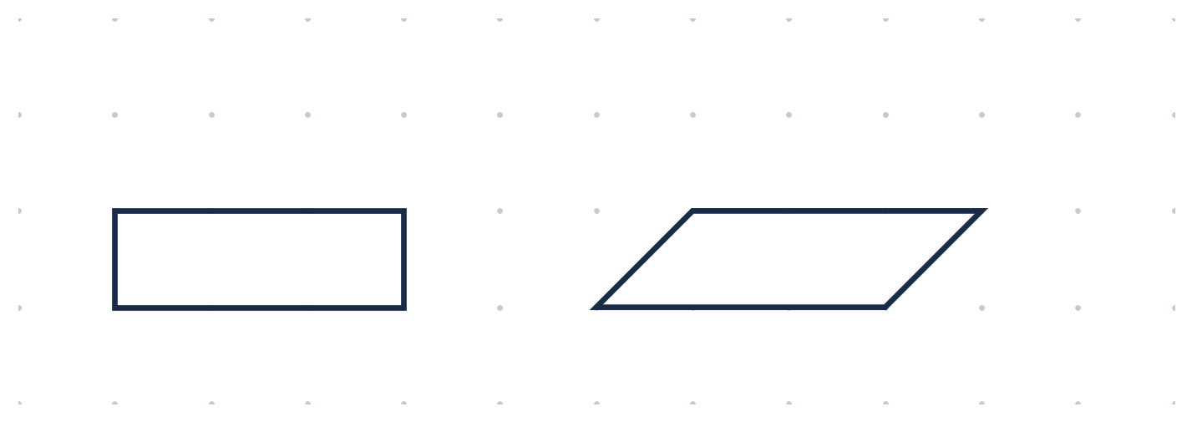
(NAEP grade-4 released item, 1996-4M9. The two figures have the same base, the same height, and so the same area.)
Assessing Student Understanding
Consider the following student work sample:
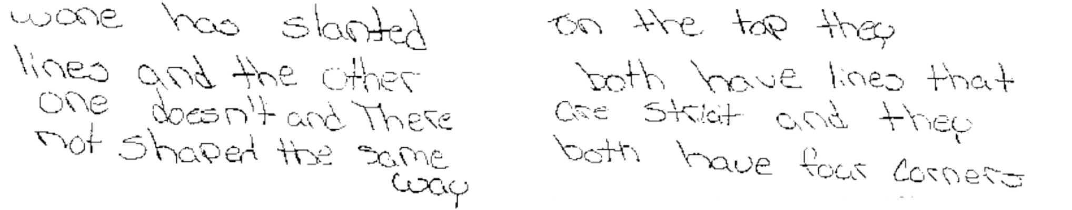
1. (5 pts) Name the Depth of Knowledge. What DOK does this task ask for? Justify your response with details from the task and the DOK levels. (Recall Week 4: DOK 1 recall · 2 apply · 3 reason · 4 extend.)

2. (5 pts) Identify the student's understanding. Did the student reach the targeted DOK level? Discuss what they seem to know — and where they may struggle — with this task. How do you know?

3. (10 pts) Construct a question to deepen understanding. Write an open, non-leading question you would ask THIS student to help them deepen their understanding of the task and their mathematical thinking. Pitch your question at a DOK level appropriate for the student. Share your question and your rationale for it, grounded in the student's work.
My question:

My rationale (why this question, at this DOK, for this student):

How is my work assessed?
Criteria | Expectations
Name the DOK of the task (5) | Correctly names the DOK the task demands, justified with details from the task and the DOK levels — not guessed.
Identify the student's understanding (5) | Judges whether the student reached that DOK and describes what they do and do not yet understand — grounded in the child's own work, with a clear “how do you know.”
A DOK-appropriate question to deepen (10) | One open, non-leading question pitched at a DOK level right for THIS student, with a rationale tied to the student's work — not telling or funneling, not vague. (“Can you explain more?” is too vague.)

