Reading Homework — McFeetors & Palfy (2017)
TCE 318P FA26 (Edwards)
Week 1 · Learner
Read McFeetors after Tuesday, then write one dated journal entry in Marginalia with both parts below. Don't just give answers — explain your reasoning; that's what counts.
1 · Rank the opening moves
Below are three possible first moves in the same Metadoku board (shown in no particular order). Rank each move great, okay, or poor, and explain your ranking: what makes a strong first move here? There is no single right order — just explain your reasoning.
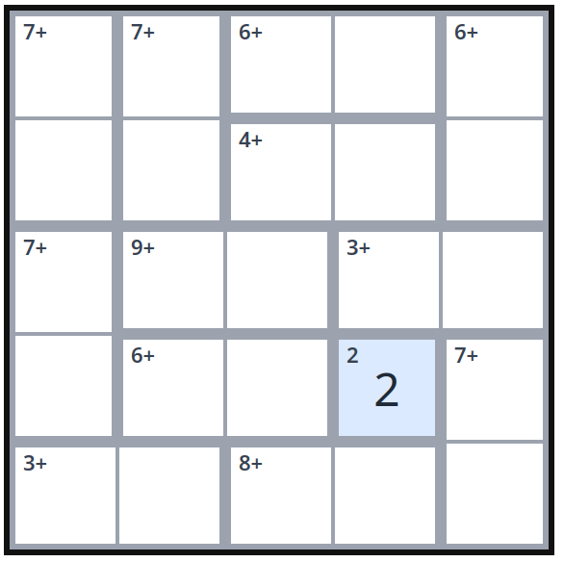 | 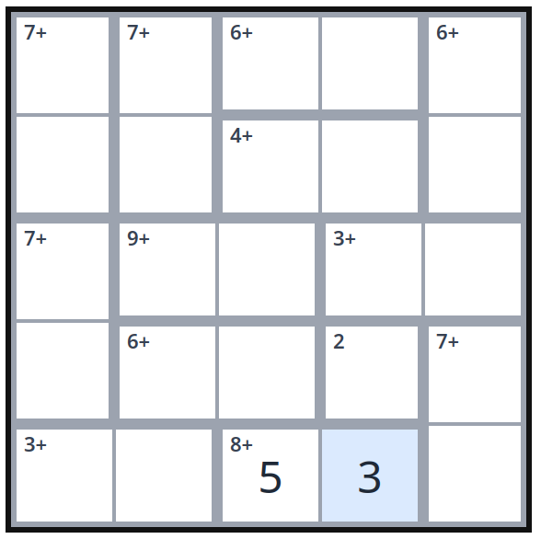 | 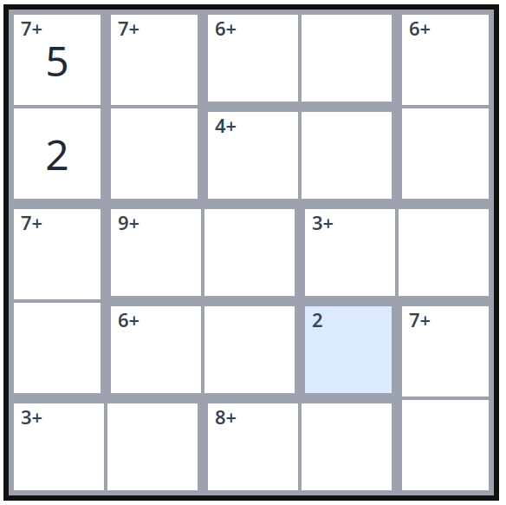
The single-cell 2 | The 8+ cage | The 7+ cage

2 · Then think about structure
McFeetors studied two-player competitive games; Metadoku is solitaire — you play it alone. Could Metadoku (or Metaplete or Metagons) be played competitively, against an opponent? What would be gained, and what would be lost?
This is a dated entry in your Reading Journal. Because it's about your own Tuesday and your own reasoning, you can't write it all at once at the end of the term — write it this week.

