Tuesday Studio — Three Reasoning Puzzles
TCE 318P FA26 (Edwards)
Week 1 · Low-Tech Tuesday
No one is going to tell you the rules. For each puzzle below you get one that's already solved — study it, figure out the goal and the rules for yourself, then solve the fresh one. On paper there is no “Check” button, so every puzzle comes down to a single question: how do you know you're right?

Puzzle 1
Here is one that is already solved:
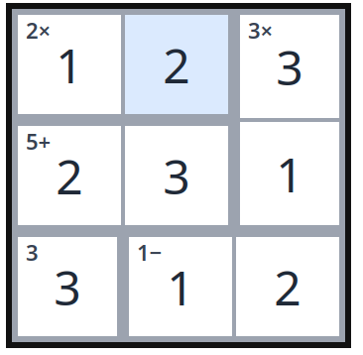
What is the goal? What are the rules? Write down what you notice from the solved example before you go on.
Now solve this one:
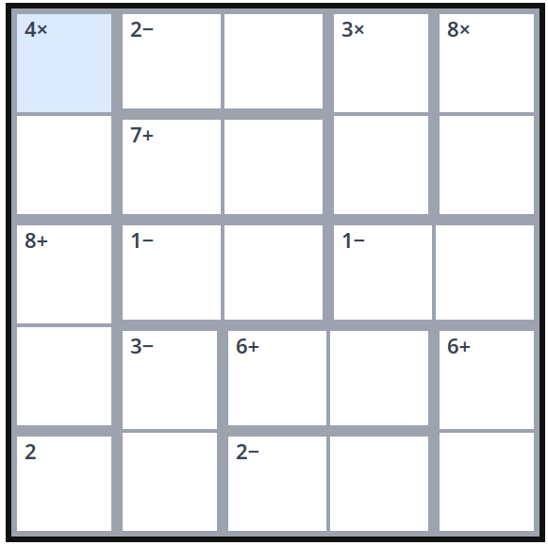
When you finish: how do you know this is the only solution it could be?

Puzzle 2
Here is one that is already solved:
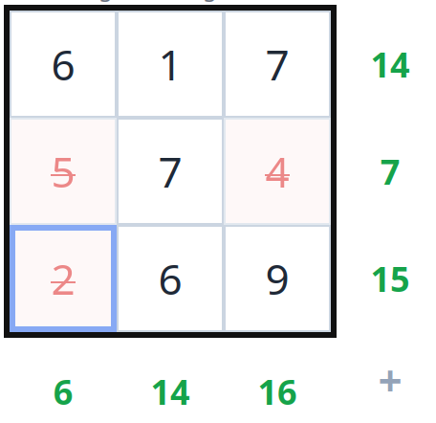
What is the goal? What are the rules? Write down what you notice from the solved example before you go on.
Now solve this one:
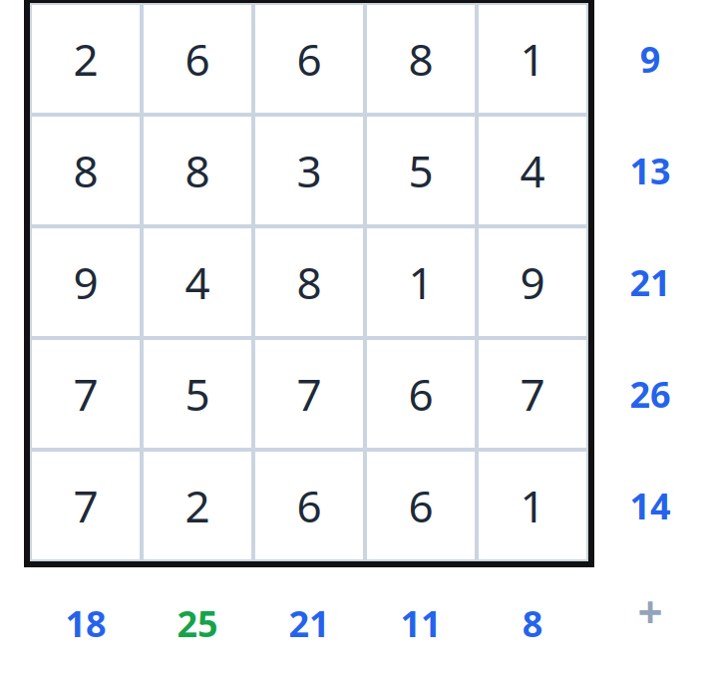
When you finish: how do you know this is the only solution it could be?

Puzzle 3
Here is one that is already solved:
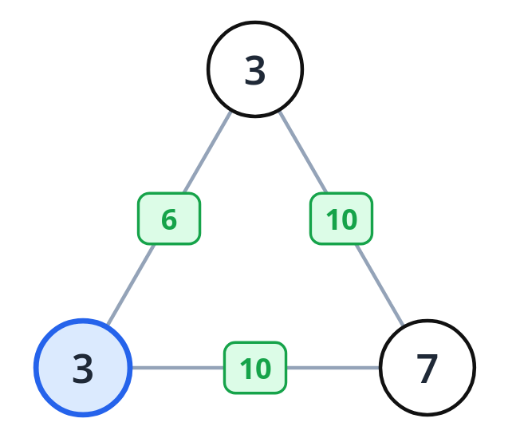
What is the goal? What are the rules? Write down what you notice from the solved example before you go on.
Now solve this one:
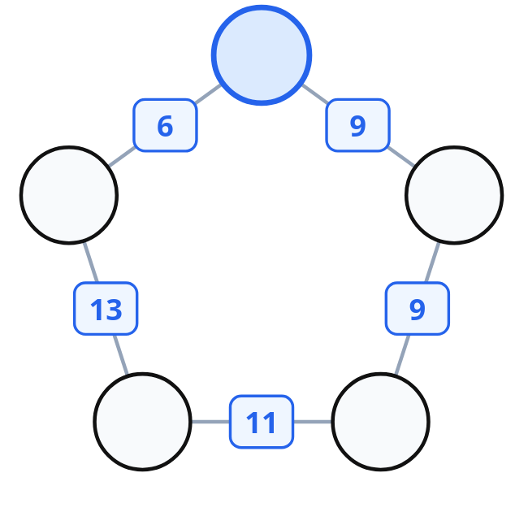
When you finish: how do you know this is the only solution it could be?

Before You Leave — Paper vs. Screen
You solved on screen this morning and on paper just now. What did the app do for you that you had to do for yourself on paper? When you are the teacher, when would you want a child working with the app — and when with the paper?

