Solution Report #3 — Classifying Figures
TCE 318P FA26 (Edwards)
Week 3 · Poser · Geometry (attributes)
In class · on your own · no AI.
Before you can hear a child mis-sort a shape, you have to be airtight yourself. Classify each figure below and — this is the whole point — say precisely WHY. Answers alone earn little here; the justification is the work.
The figures
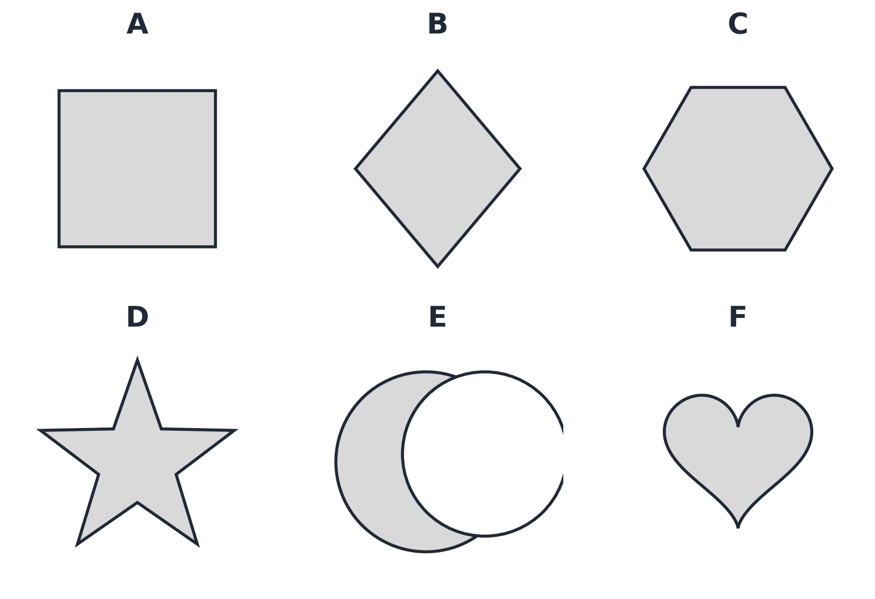

1 · Classify each figure
Use the three tests a figure must pass to be a polygon — its sides are all straight, it is simple (the boundary never crosses itself), and it is closed. Fill in every cell.
Figure | Polygon? (yes / no) | The property that decides it | If a polygon: convex or concave?
A
B
C
D
E
F

2. Two of these figures are polygons that many learners would refuse to call polygons, or would group with the non-polygons. Which figure is most often mis-sorted, and what is a learner attending to when they put it with the heart? Answer as a mathematician first: state exactly why it IS a polygon.
________________________________________________________________________________________________
________________________________________________________________________________________________
________________________________________________________________________________________________
________________________________________________________________________________________________

3. Among the figures that ARE polygons, sort them into convex and concave, and state the test you used. Then finish this sentence precisely: “A polygon is convex when …”
________________________________________________________________________________________________
________________________________________________________________________________________________
________________________________________________________________________________________________
________________________________________________________________________________________________

4. Write one careful sentence defining “polygon” — precise enough to let the star IN and keep the heart and the crescent OUT. Then name one figure your definition would wrongly include or exclude if you dropped any single word from it.
________________________________________________________________________________________________
________________________________________________________________________________________________
________________________________________________________________________________________________
________________________________________________________________________________________________

