Taylor Series with Verbatim-app

Purpose
We've created a one-stop application that collects a student's conversation with a prompt that the instructor provides and generates a transcript formatted specifically for further analysis. The app is a single html file that can be loaded locally or hosted on a school server. A companion app, verbatim-setup, enables teachers to modify activity directions and items from an optional exit survey.

Features
The app includes a number of useful features including: (a) the ability to use various genAI, including local, free, and paid options; (b) a built-in profiler that determines student learning preferences; (c) built in math symbol template; (d) built-in after-activity survey; and (e) report exporting tools. Each of these are discussed in more detail below.

Various API KEY options. The application connects to the student's genAI of choice using an API Key. All discussions are funneled through the app for consistent formatting across models.

Students can choose models at different price levels. The app quietly checks which AI services answer on the room's network and hides the ones that don't. Verbatim-app records which services answered, never anything about the student or their location.

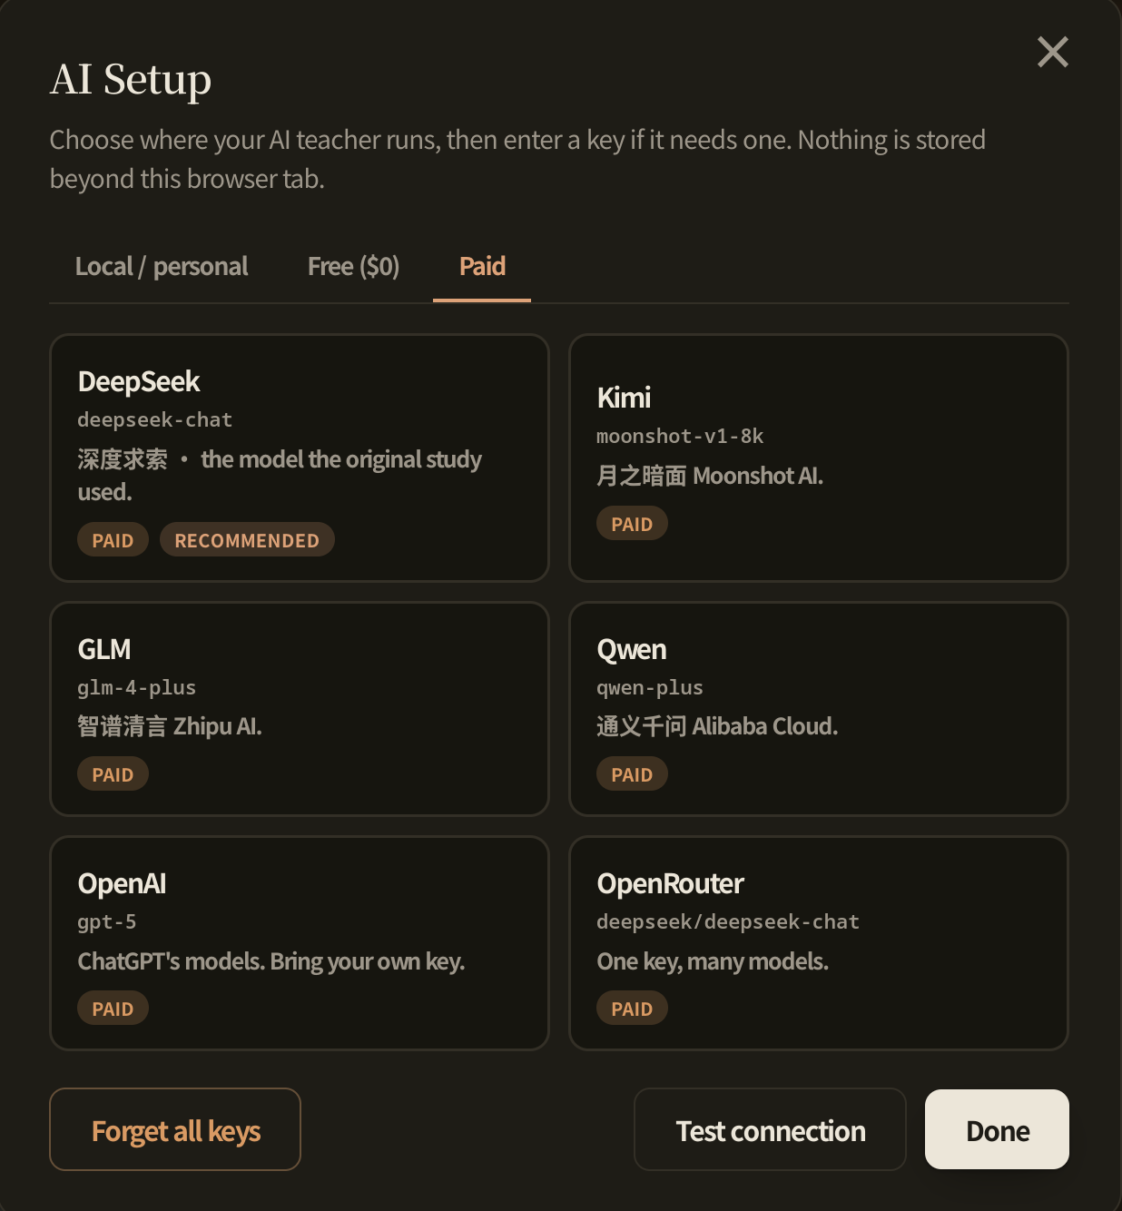

For instance, to connect to a free ($0) option, click on the Free ($0) tab. I clicked that tab and then selected Groq from the options (note: Options depend upon what network options you have available. For instance, Groq may not be available in China).

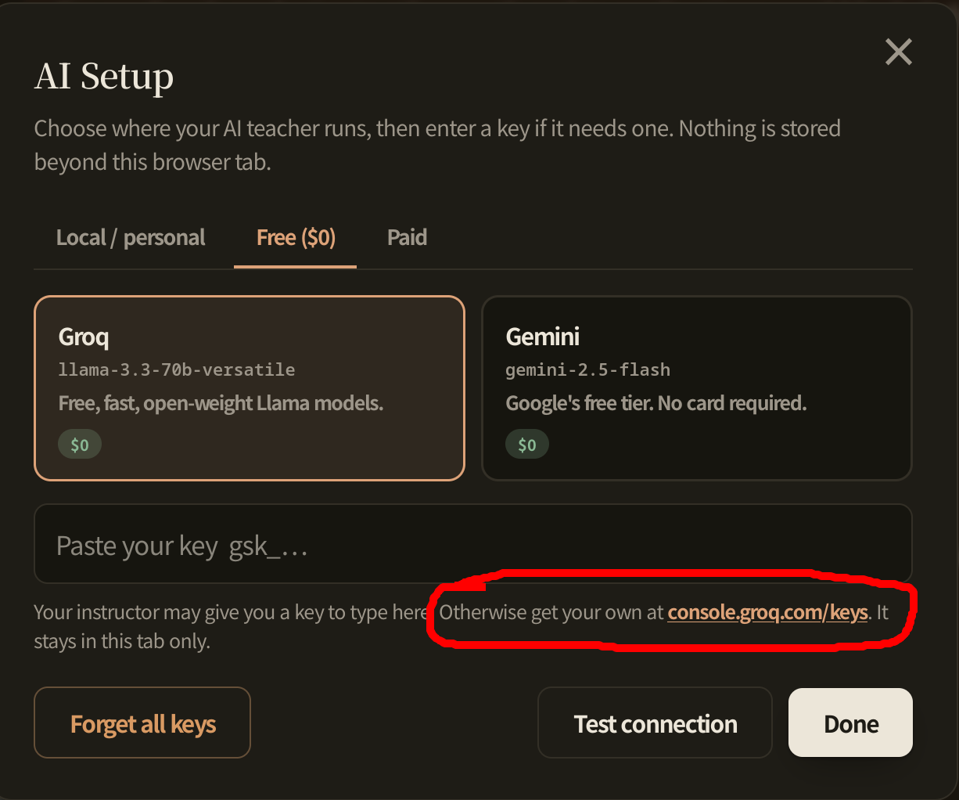

Note that the dialog provides a link for obtaining an API-KEY for each option. For instance, here's a screenshot of the recommended Groq page (console.groq.com/keys).
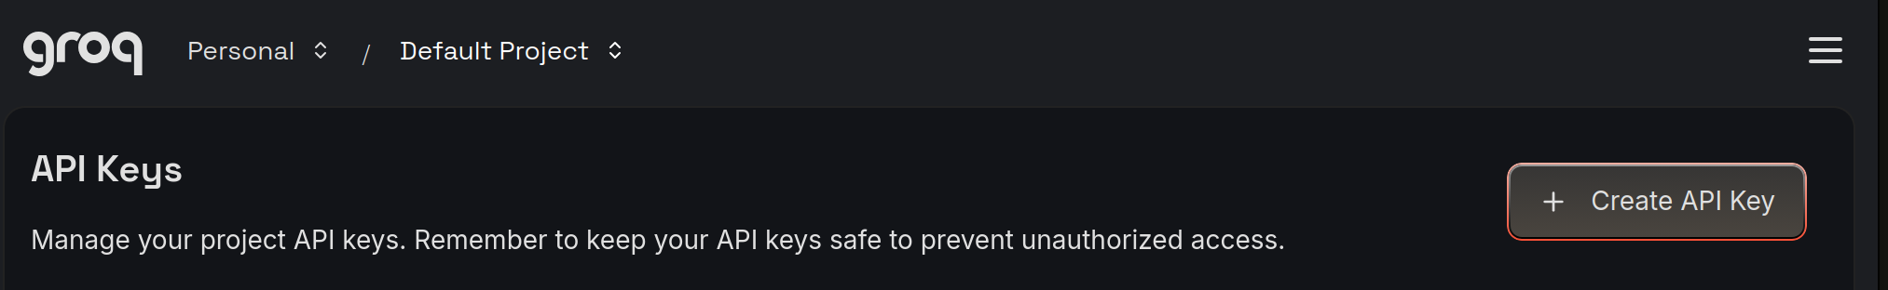

Click on the "Create API Key" button, type in a Display Name and set an expiration date. Then click SUBMIT to get a new key,

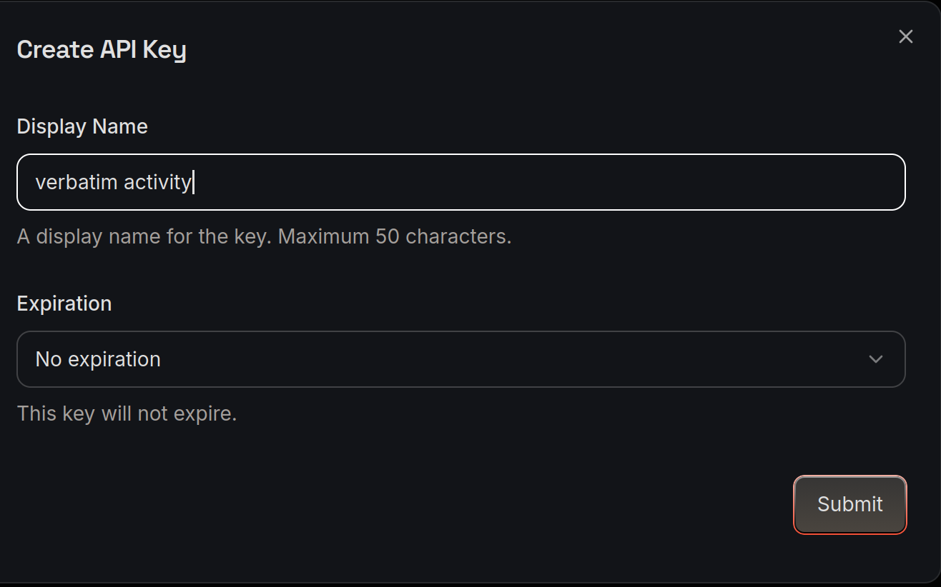

A window with your API KEY will appear. You'll only see the code once, so copy it carefully then paste into the space provided in Verbatim-app.
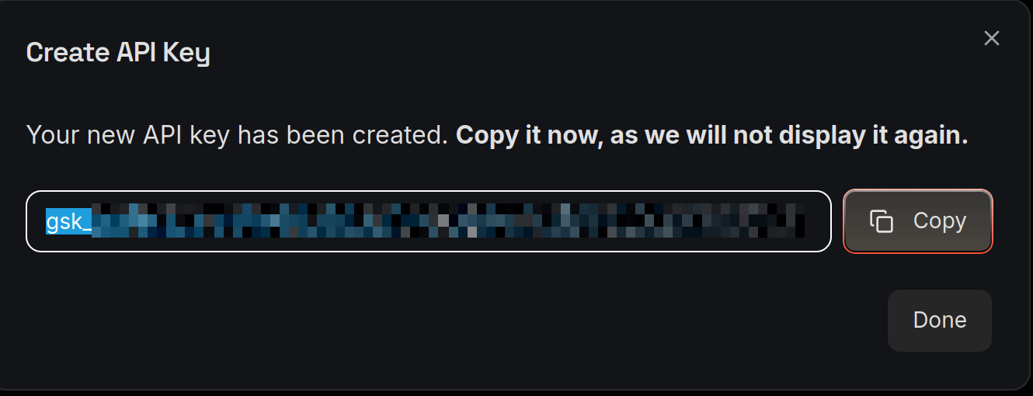
Your key is a long string of letters and numbers. When you paste into Verbatim, the key is replaced with dots and saved in your local computer until you delete it by clicking "Forget all keys" (see previous page). The key is like a password. Don't share it with others. Don't paste it into chat.

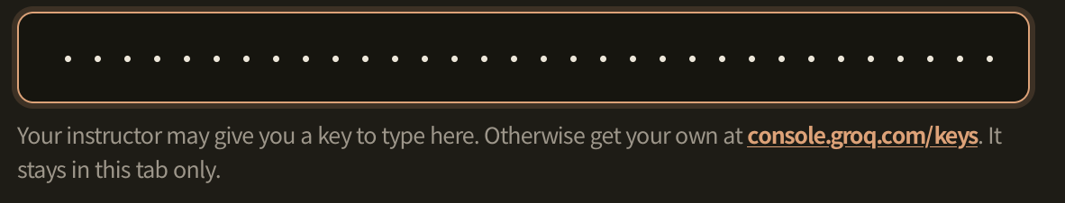

Note: The app also provides support for loading personal genAI models (from the Local/Personal tab), but that may take time and should be explored well in advance of data collection (e.g., a previous class meeting).

Profiler. Verbatim-app also supports the use of learning profiles. Our default instructions ask the AI to ask the student learning-profile questions. Student preferences are recorded in the chat and influence the AI's behavior during the chat.
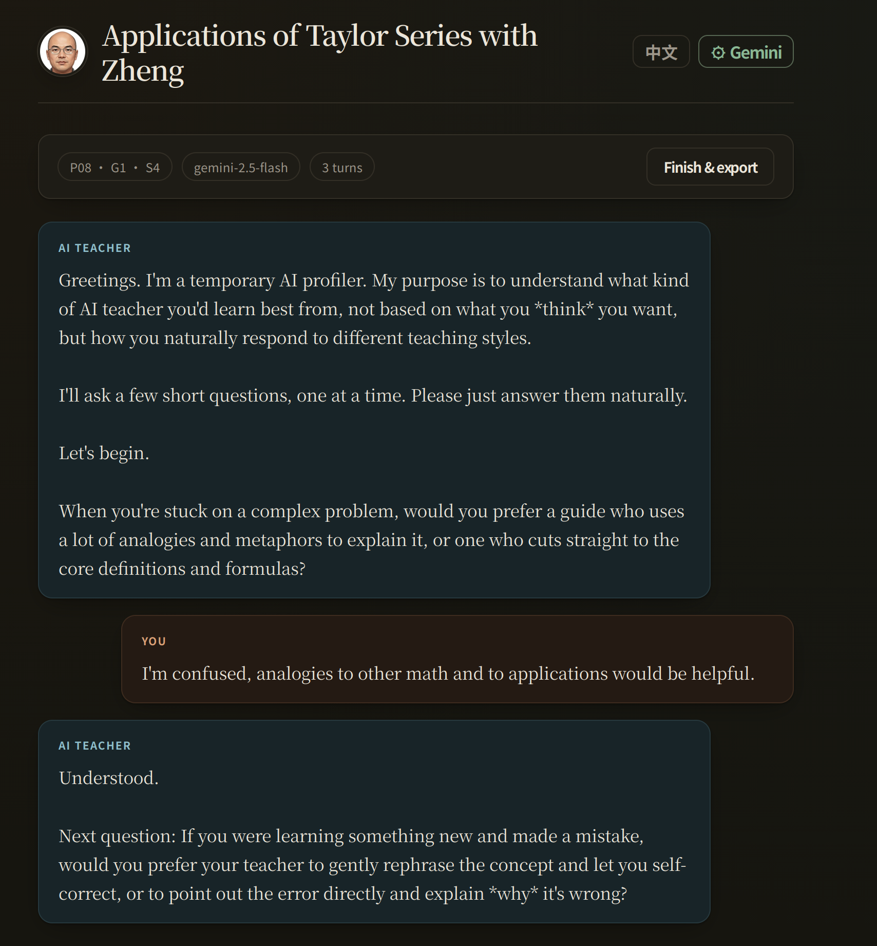

After the profile questions are completed, our default instructions direct the AI to facilitate a conversation about Taylor Series. (Note: Instructors can load different instructions using Verbatim-setup.)
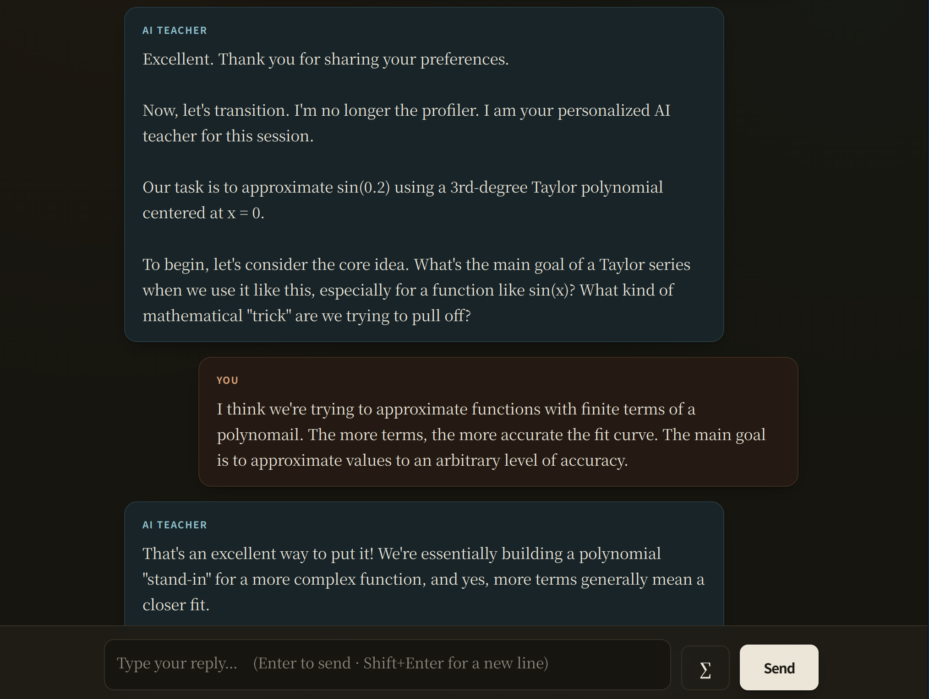
The input bar comes with a palette of commonly-used mathematics symbols.
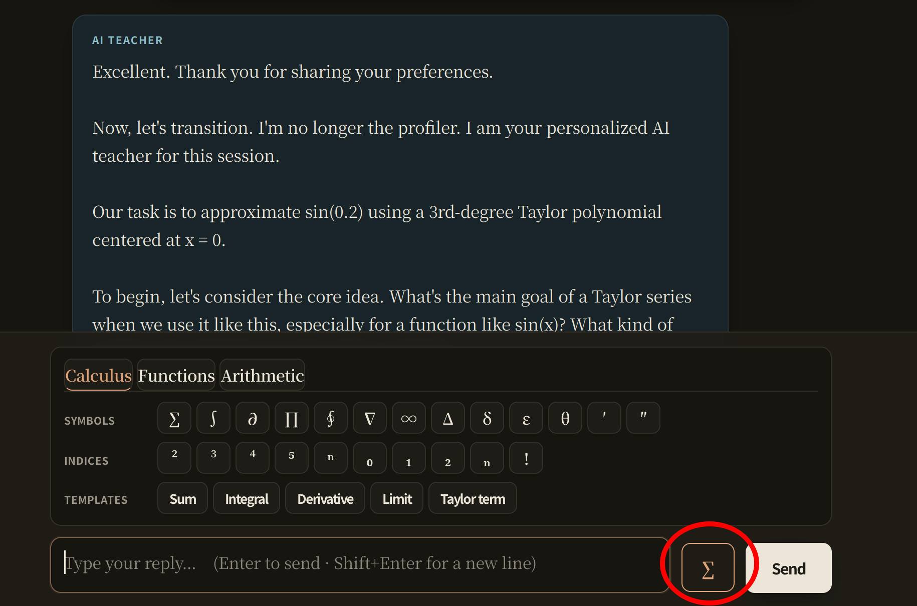

Built-In Survey. Once students complete the activity, they answer a survey about their experience within the app. Students are asked whatever questions are loaded into the app. The current questions match those that we used in the initial implementation of this study.
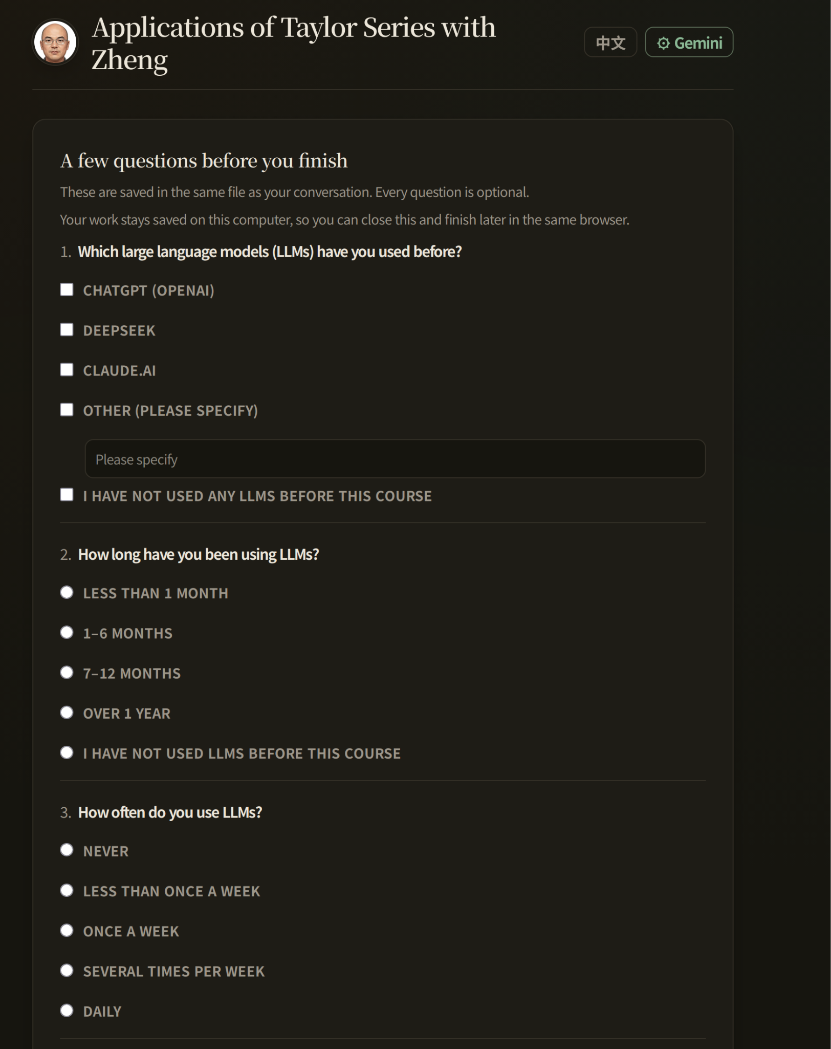
Questions may be changed by the instructor using Verbatim-setup.
Reporting. Once students complete the survey, they are provided with an option to download a report of the session. Reports are formatted specifically to ease data analysis. The reports include initial profiler information, a complete transcript of the student/AI conversation (with student and AI clearly tagged), and the final survey questions. The default filename of the report includes student number and section to help keep data organized.

Here is a screenshot of the window students see when they download their work.
