Contents

Purpose of this document 1

REST resources (services) 1

REST requests and responses 2

1 Get all products 2

2 Insert new product 4

3 Edit product 6

4 Delete product 6

HTTP methods 8

# Purpose of this document

This document describes what REST services the Pet Shop application provides. It contains all needed information so that client can be implemented.

# REST resources (services)

1. Get all products -> <http://localhost:8080/api/products/>

2. Insert new product-> <http://localhost:8080/api/products/>

3. Edit product -> [http://localhost:8080/api/products/{id}/](http://localhost:8080/api/products/%7bid%7d/) (ID parameter needed)

4. Delete product -> [http://localhost:8080/rest/products/{id}](http://localhost:8080/rest/products/%7bid%7d)

5. Get all manufacturers -> <http://localhost:8080/api/manufacturers/>

6. Insert new manufacturer -> <http://localhost:8080/api/manufacturers/>

7. Delete manufacturer -> [http://localhost:8080/api/manufacturers/{id}/](http://localhost:8080/api/manufacturers/%7bid%7d/)

# REST requests and responses

## 1 Get all products

HTTP method: GET

API call: <http://localhost:8080/api/products/>

Request body: -

Response example below:

{

    "_embedded": {

        "products": [

            {

                "name": "Dog Booties",

                "color": "Green",

                "price": 12.12,

                "_links": {

                    "self": {

                        "href": "http://localhost:8080/api/products/1"

                    },

                    "product": {

                        "href": "http://localhost:8080/api/products/1"

                    },

                    "manufacturer": {

                        "href": "http://localhost:8080/api/products/1/manufacturer"

                    },

                    "productType": {

                        "href": "http://localhost:8080/api/products/1/productType"

                    },

                    "size": {

                        "href": "http://localhost:8080/api/products/1/size"

                    }

                }

            },

            {

                "name": "Cat Collar",

                "color": "Red",

                "price": 12.99,

                "_links": {

                    "self": {

                        "href": "http://localhost:8080/api/products/2"

                    },

                    "product": {

                        "href": "http://localhost:8080/api/products/2"

                    },

                    "manufacturer": {

                        "href": "http://localhost:8080/api/products/2/manufacturer"

                    },

                    "productType": {

                        "href": "http://localhost:8080/api/products/2/productType"

                    },

                    "size": {

                        "href": "http://localhost:8080/api/products/2/size"

                    }

                }

            },

            {

                "name": "Squeaky Toy, Generic",

                "color": "Orange",

                "price": 3.50,

                "_links": {

                    "self": {

                        "href": "http://localhost:8080/api/products/3"

                    },

                    "product": {

                        "href": "http://localhost:8080/api/products/3"

                    },

                    "manufacturer": {

                        "href": "http://localhost:8080/api/products/3/manufacturer"

                    },

                    "productType": {

                        "href": "http://localhost:8080/api/products/3/productType"

                    },

                    "size": {

                        "href": "http://localhost:8080/api/products/3/size"

                    }

                }

            }

        ]

    },

    "_links": {

        "self": {

            "href": "http://localhost:8080/api/products"

        },

        "profile": {

            "href": "http://localhost:8080/api/profile/products"

        }

    }

}

## 2 Insert new product

HTTP method: POST

API call: <http://localhost:8080/api/products/>

Request body:

{

"name": "Cat ears",

"color": "Cat colored",

"price": 420.69,

"manufacturer": "http://localhost:8080/api/manufacturers/2",

"productType": "http://localhost:8080/api/productTypes/1",

"size": "http://localhost:8080/api/sizes/2"

}

Response example below (Status 201 Created):

{

    "name": "Cat ears",

    "color": "Cat colored",

    "price": 420.69,

    "_links": {

        "self": {

            "href": "http://localhost:8080/api/products/4"

        },

        "product": {

            "href": "http://localhost:8080/api/products/4"

        },

        "manufacturer": {

            "href": "http://localhost:8080/api/products/4/manufacturer"

        },

        "productType": {

            "href": "http://localhost:8080/api/products/4/productType"

        },

        "size": {

            "href": "http://localhost:8080/api/products/4/size"

        }

    }

}

## 3 Edit product

HTTP method: PUT

API call: <http://localhost:8080/api/products/1>

Request body:

{

"name": "Cat booties",

"color": "Blue",

"price": 420.69,

"manufacturer": "http://localhost:8080/api/manufacturers/2",

"productType": "http://localhost:8080/api/productTypes/1",

"size": "http://localhost:8080/api/sizes/2"

}

Response example below (Status 200 OK):

{

    "name": "Cat booties",

    "color": "Blue",

    "price": 420.69,

    "_links": {

        "self": {

            "href": "http://localhost:8080/api/products/1"

        },

        "product": {

            "href": "http://localhost:8080/api/products/1"

        },

        "manufacturer": {

            "href": "http://localhost:8080/api/products/1/manufacturer"

        },

        "productType": {

            "href": "http://localhost:8080/api/products/1/productType"

        },

        "size": {

            "href": "http://localhost:8080/api/products/1/size"

        }

    }

}

## 

## 4 Delete product

HTTP method: DELETE

API call: <http://localhost:8080/api/products/4>

Request body: -

Response: Status 200 OK

## 5 Get all manufacturers

HTTP method: GET

API call: <http://localhost:8080/api/manufacturers>

Request body: -

Response: Status 200 OK

Response example below:

{

    "_embedded": {

        "manufacturers": [

            {

                "name": "Doggy Stuff",

                "_links": {

                    "self": {

                        "href": "http://localhost:8080/api/manufacturers/1"

                    },

                    "manufacturer": {

                        "href": "http://localhost:8080/api/manufacturers/1"

                    },

                    "products": {

                        "href": "http://localhost:8080/api/manufacturers/1/products"

                    }

                }

            },

            {

                "name": "Catty Stuff",

                "_links": {

                    "self": {

                        "href": "http://localhost:8080/api/manufacturers/2"

                    },

                    "manufacturer": {

                        "href": "http://localhost:8080/api/manufacturers/2"

                    },

                    "products": {

                        "href": "http://localhost:8080/api/manufacturers/2/products"

                    }

                }

            },

            {

                "name": "Squeaky Stuff",

                "_links": {

                    "self": {

                        "href": "http://localhost:8080/api/manufacturers/3"

                    },

                    "manufacturer": {

                        "href": "http://localhost:8080/api/manufacturers/3"

                    },

                    "products": {

                        "href": "http://localhost:8080/api/manufacturers/3/products"

                    }

                }

            }

        ]

    },

    "_links": {

        "self": {

            "href": "http://localhost:8080/api/manufacturers"

        },

        "profile": {

            "href": "http://localhost:8080/api/profile/manufacturers"

        }

    }

}

## 2 Insert new manufacturer

HTTP method: POST

API call: <http://localhost:8080/api/manufacturers>

Request body:

{

    "name": "E-Corp"

}

Response: Status 201 Created

Response example below:

{

    "name": "E-Corp",

    "_links": {

        "self": {

            "href": "http://localhost:8080/api/manufacturers/4"

        },

        "manufacturer": {

            "href": "http://localhost:8080/api/manufacturers/4"

        },

        "products": {

            "href": "http://localhost:8080/api/manufacturers/4/products"

        }

    }

}

# HTTP methods

|  |  |  |  |  |  |
| --- | --- | --- | --- | --- | --- |
| **Http**  **Method** | **Resource EndPoint** | **Input** | **Success Response** | **Error**  **Response** | **Description** |
| GET | /api/products | Body: empty | Status: 200  List of products | Status 500 | Retrieves all products |
| POST | /api/products | Body: new product data | Status: 201  New product | Status: 500 | Creates new product |
| DELETE | /api/products/{Id} | Body: empty | Status: 200  Product deleted | Status: 500 | Deletes selected product |
| PUT | /api/products/{Id} | Body: updated product data | Status: 200  Product with new info | Status: 500 | Edits selected product |
| GET | /api/manufacturers | Body: empty | Status: 200  List of manufacturers | Status: 500 | Retrieves all manufacturers |
| POST | /api/manufacturers/{Id} | Body: new manufacturer data | Status: 201  New manufacturer | Status: 500 | Creates new manufacturer |

Uusi Reservation esim:

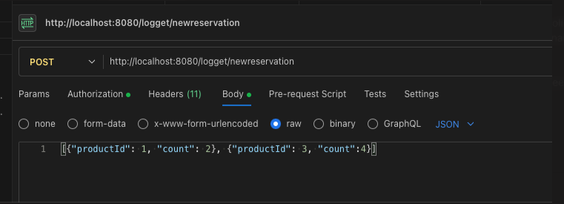

Reservationin peruminen esim:

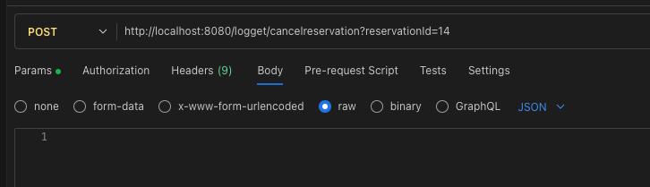

Reservationin tuotteet

