Ryan Collins  
Candidate Number: 0289  
Centre Number: 16437

TimeLord: User Manual

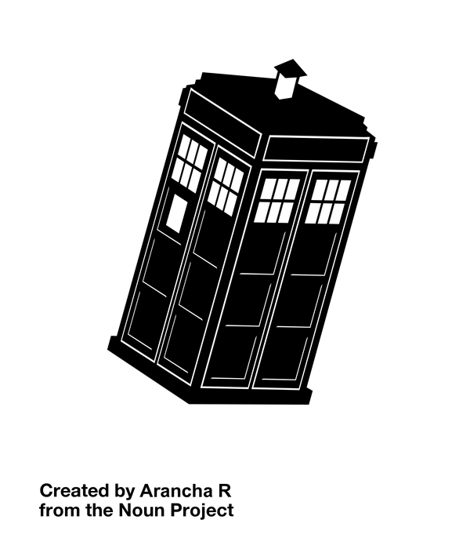

Table of Contents

Introduction 4

Installation Guide 4

Using The System 7

First Use 7

Description of the GUI: 8

Main View 8

Adding/Editing Day and Period Information 9

Viewing Periods for a particular day 9

Adding a Day 10

Renaming a day 11

Deleting a day 12

Adding a Period 12

Editing Period Details 13

Deleting a Period 13

Add/Edit/Remove Year Groups and Forms 13

Adding a Year Group 14

Editing a Year Group 14

Deleting a Year Group 15

Viewing corresponding Form groups 15

Adding a Form Group 15

Editing a Form Group 15

Deleting a Form Group 15

Modifying Staff Members 16

Adding a Staff Member 16

Editing Staff Member Details 17

Deleting a Staff Member 18

Adding/Removing/Editing Rooms 18

Adding Rooms 18

Editing rooms 18

Deleting Rooms 19

Modifying Subjects 19

Adding Subjects 19

Editing Subjects 20

Deleting Subjects 20

Creating and Saving a Timetable Template 20

Managing Lessons 22

Adding a new lesson for the first time 22

Adding a Lesson Using The Edit ToolBar 23

Using the edit bar to edit lesson attributes: 23

Moving Lessons by Dragging and Dropping 24

Deleting a lesson using the Edit Toolbar 25

The Data Cloud 25

Adding a Lesson to the Data Cloud 26

Editing a Lesson 26

Moving a Lesson from the Data cLoud To the Main Timetable 26

Deleting a lesson from the Data Cloud 26

Troubleshooting 26

Clashes 27

Staff Clashes 27

Room Clashes 27

Class Clash 28

# Introduction

Thank you for purchasing ‘TimeLord’. This user manual will explain the method needed to install the software, in addition to explaining how the program works. Furthermore, troubleshooting information is found in this guide, allowing the user to easily recover from any errors that might occur.

# Installation Guide

In order to install the program, open the installation wizard called “Setup.exe”.

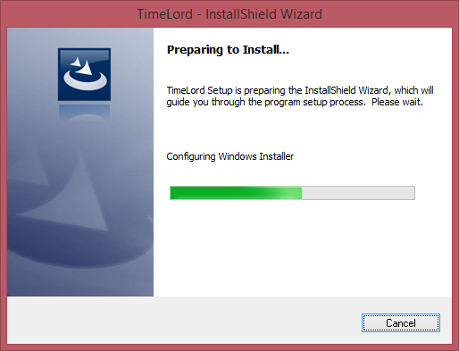

The screen above should be seen when running the wizard.

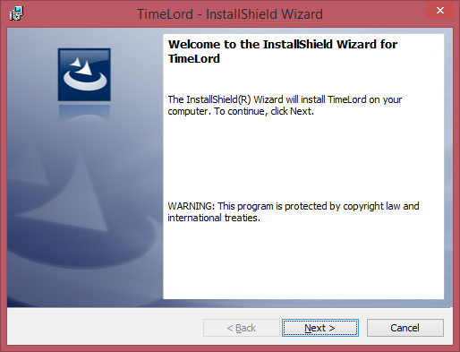

Now that the wizard has started up, press next to continue.

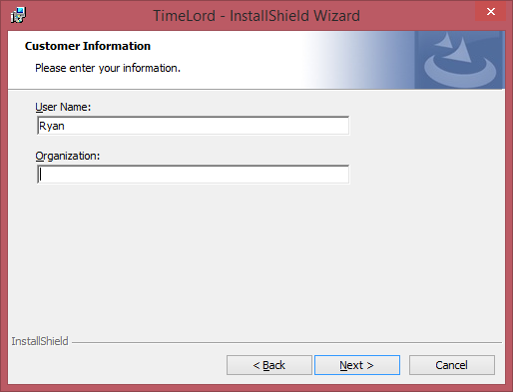

Insert the user information into the following form, including the ‘User Name’ of the account that you are currently using, in addition to the Organization that you are involved in. This could be a school name.

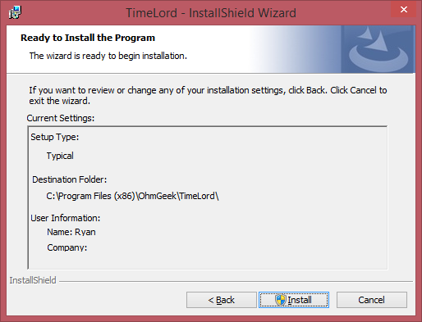

Pressing the next button will bring you to this screen, allowing you to see all the information that you have entered. To install the program, press the ‘Install’ button. Please note that you might require to enter your Administrator’s password here, in order to install the program.

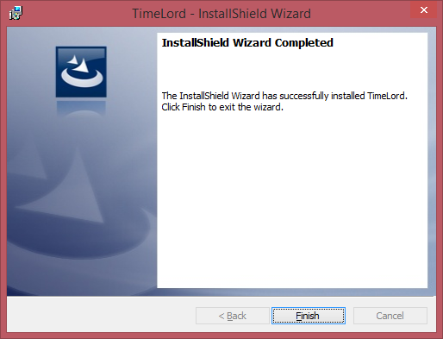

If you see this screen, the program has been successfully installed and pressing the finish button will exit the installer. You can then find the application under OhmGeek > TimeLord in the Program Files directory on the main drive.

# Using The System

Now that the system is installed, it is time to learn more about how the system operates. This section of the manual will explain what the user needs to do on first use, in addition to explain how the system works in general.

## First Use

When executing the program for the first time, be sure to right click and click “Run as Administrator”, as the program needs the privileges to write the template file to a folder in the Program Files directory.

On first use, the following error message will be displayed:

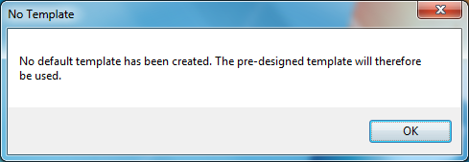

As the program has been executed for the first time, no default template will exist because the program hasn’t created one yet. This message is simply telling you that it is saving the pre-designed default one, which can be modified later on. Simply click OK to continue executing the program.

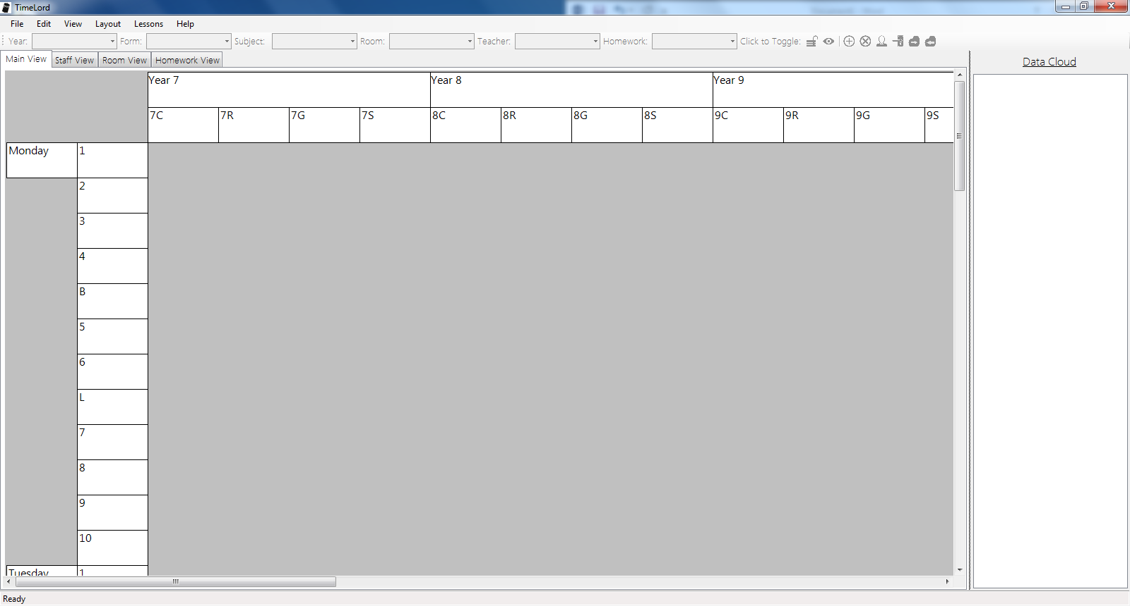

A screen that looks similar to the one above will be seen. This is the pre-designed template, containing all of the information for timetable CRGS lessons, including staff members, a list of years and corresponding forms, list of rooms, list of subjects, in addition to information about days and their corresponding periods. This hopefully will be suitable, but if it isn’t then a new template can be created. Creating a new template will be outlined in a later section.

## Description of the GUI:

### Main View

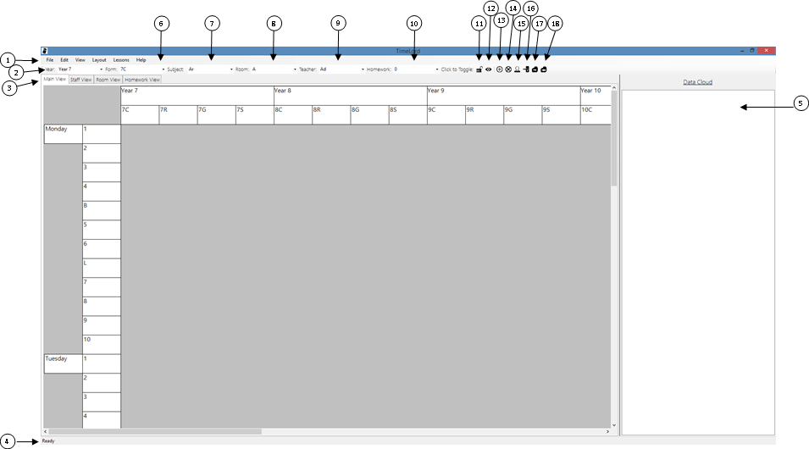

## Adding/Editing Day and Period Information

Once TimeLord has been loaded, go to the menu strip along the top of the program and select Layout > Modify Week.

The week manager should then be displayed, as shown above. This allows one to add, remove or edit information about the days, and the corresponding period information too.

In order to close out of the week manager, one can either press the button marked ‘OK’, or click the red ‘X’ button in the form header.

Please note that this can only be edited when the timetable hasn’t had any lessons set. After lessons are added to the timetable, you are unable to make changes.

### Viewing Periods for a particular day

In order to see the periods for a given day, simply select the day that you want to see the periods for. This will automatically update the periods, which are shown on the right hand side of the view.

### Adding a Day

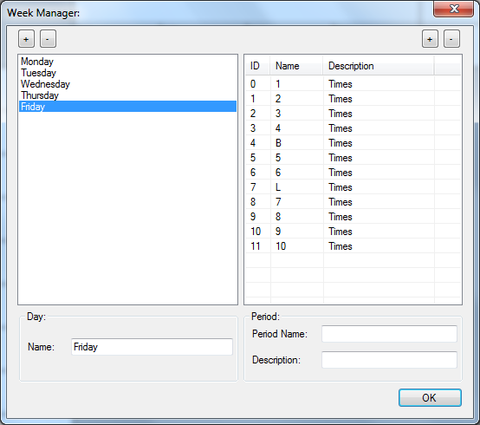

To add a new day to the week, click on the ‘Add Day’ button, which is the leftmost button marked with a ‘+’ symbol [ANNOTATE THIS].

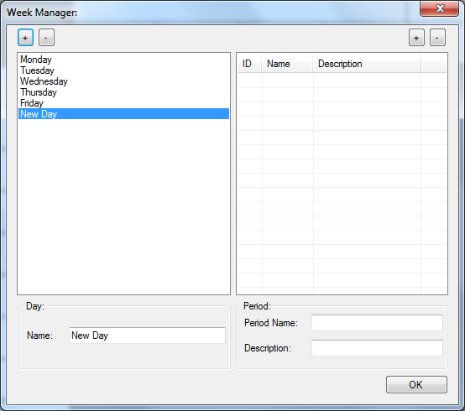

A brand new day, given the arbitrary name of “New Day” has now been created.

### Renaming a day

In order to change the name of the selected day, simply enter the textbox below the list of days, and change the name to what you would like it to be. For example, I’m going to rename this day to “Saturday”. After entering the name, press the return key which will update the day name.

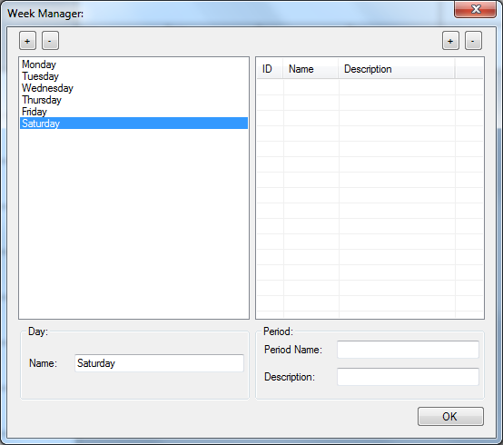

### Deleting a day

In order to delete a day, ensure that the day to be deleted is selected, and then click the ‘Delete Day’ button, which is denoted by the leftmost ‘-‘button. Clicking this will delete the day, and all the associated periods.

### Adding a Period

In order to add a period, select the day that you wish to add a period to. From here, press the ‘Add Period’ button, which is denoted by the right most button that is marked with a ‘+’ symbol. Doing this will create a new generic period, which is given a name and description that probably won’t be correct. From here, the user might want to change the details of the newly created period.

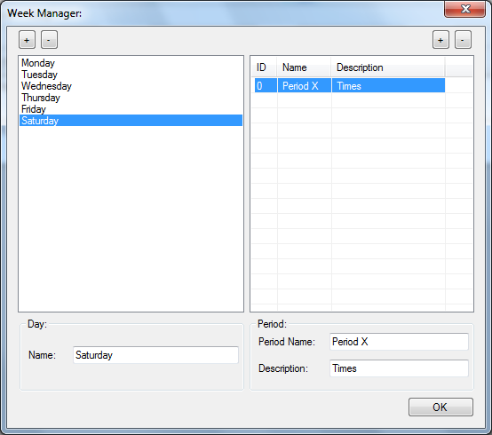

### Editing Period Details

While a period with a generic name has been created, it is probably more useful if the name and description is customized, so that timetabling can be made easier.

To change period details, simply select the period that you wish to modify. Then, change the values of the textboxes situated below, so that the values for ‘Period Name’ and ‘Description’ match what you want them to be. This is all you need to do, as the details will automatically update.

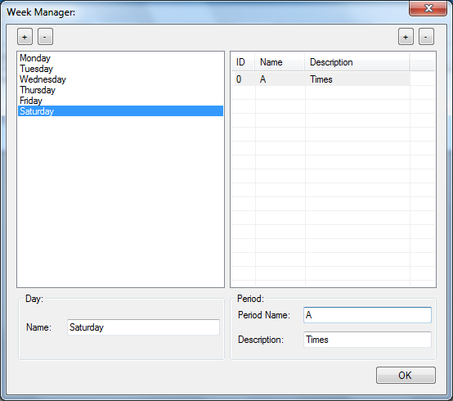

### Deleting a Period

Deleting a period is as easy as adding one! Simply select the period that you wish to delete, and then press the ‘Delete Period’ button, which is the rightmost button denoted by ‘-‘. Clicking this will automatically delete the selected period.

## Add/Edit/Remove Year Groups and Forms

In order to modify the year groups, firstly ensure that you are on the main form. By going to Layout > Modify Year Groups, the ‘Year Manager’ will be displayed, which allows you to edit the year groups and their corresponding form groups.

The following form should be visible when the ‘Modify Year Groups’ choice is selected on the menu:

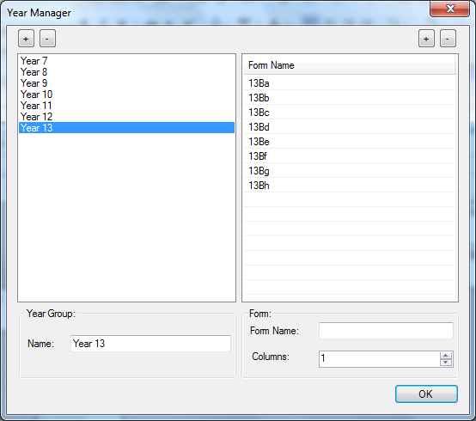

In order to exit the ‘Year Manager’, simply press the button marked “OK”.

Please note that this can only be edited when the timetable hasn’t had any lessons set. After lessons are added to the timetable, you are unable to make changes.

### Adding a Year Group

In order to add a year group, click on the leftmost button that is marked with a ‘+’ symbol. This will create a new generic year. The year name can be changed by following the instructions shown in the next section.

### Editing a Year Group

In order to edit the name of a year group, select the year group that you want to modify. From here, change the value in the textbox to the value that you would like to rename the year to. Pressing the return key will update the year group name accordingly.

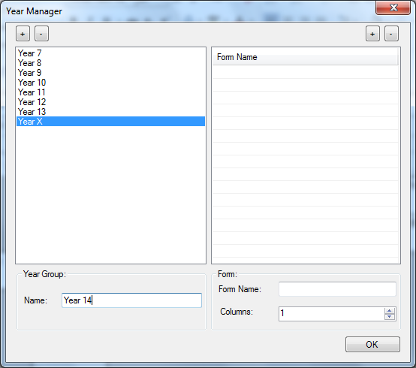

### Deleting a Year Group

Select the year group that you want to delete. From here, click the leftmost button that is marked with a ‘-‘. This will delete the select year group, and its corresponding forms.

### Viewing corresponding Form groups

By selecting the year group, the forms for the selected year group will automatically be displayed.

### Adding a Form Group

In order to add a form group to a particular year, ensure that a year is selected and then click the rightmost button that is marked with a ‘+’ symbol. This will then create a generic form group under the selected year.

### Editing a Form Group

Editing a form group can be done by selecting the year group that the form falls under, and then selecting the form group itself. From here, edit the ‘Form Name’ textbox contents, so that the value in here matches the value that you want to set the ‘Form Name’ to. When typing, the name of the corresponding form will automatically update.

### Deleting a Form Group

By selecting the form group that you wish to delete, and pressing the rightmost button marked with a ‘-‘ symbol, the form group will be deleted.

## Modifying Staff Members

Inputting the staff information into the system is very important for timetabling teachers. To input the information necessary, go to Layout > Modify Staff on the main menu. This will display the ‘Staff Manager’ window, which is shown below:

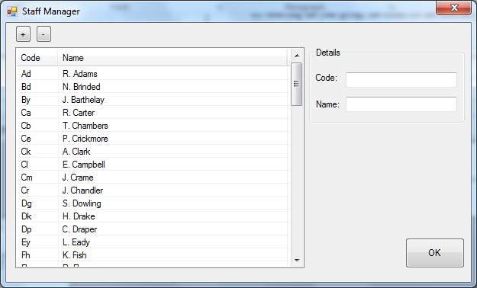

This allows you to add, remove and edit members of staff, by using the tools built into the window.

To close out of the window, simply click the button marked ‘OK’.

Please note that this can only be edited when the timetable hasn’t had any lessons set. After lessons are added to the timetable, you are unable to make changes.

### Adding a Staff Member

Adding a staff member is quite simple. Clicking the button marked with a ‘+’ symbol will automatically add a new generic staff member, with a preset code and name. From here, you will need to select this new lesson and then edit the details to the ones that you wish to enter.

### Editing Staff Member Details

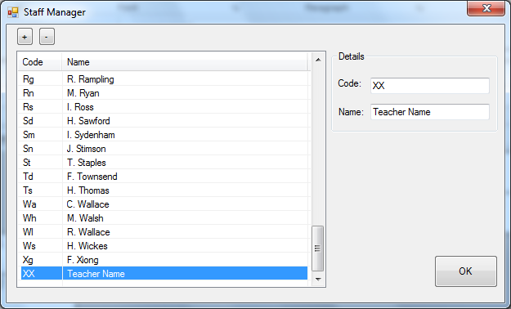

Firstly, ensure that the staff member that needs modifying is selected. The values for the ‘Code’ and ‘Name’ will automatically be displayed in this text box. Editing from this point is easy, as you simply need to change the values in the text boxes to the values that you would like to assign to the individual fields. The details will automatically update as you type as well.

Please note that the ‘Code’ entered should be unique, meaning that it isn’t already in use by another staff member. The code should also be a maximum of 3 characters in length.

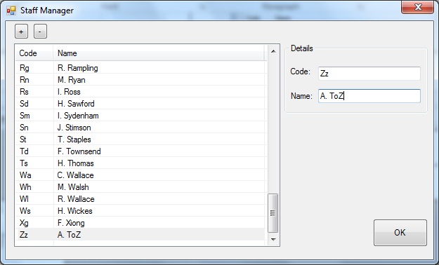

### Deleting a Staff Member

When a staff member has left the school, it might be necessary to delete their name and code from the system. In order to do this, select the staff member that you wish to delete, and press the button marked with a ‘-‘symbol. This will now have deleted the selected teacher.

## Adding/Removing/Editing Rooms

In order to edit rooms, the ‘Room Manager’ needs to be used. In order to get to this function, go to Layout > Modify Rooms, on the main menu strip. This should open the room manager, leading you to see the view as shown below:

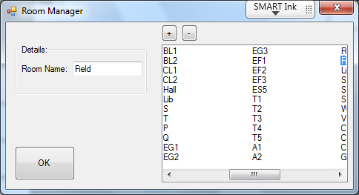

This window allows you to add/remove rooms, in addition to view and modify existing rooms. Once you have finished doing all the necessary modification, pressing the OK button will close the room manager.

Please note that this can only be edited when the timetable hasn’t had any lessons set. After lessons are added to the timetable, you are unable to make changes.

### Adding Rooms

Adding rooms is as easy as 1, 2 3! By pressing the button marked with a ‘+’ symbol, a generic room will be added. From here, one will now need to modify the room name, by using the instructions shown in the edit room section.

### Editing rooms

Editing rooms is relatively easy, as one needs to select the room that one wishes to modify, and then set the value of the text box to the new value. Pressing the return key will update the value. Please note that the room name should follow the room guidelines, and therefore have a maximum of 4 characters in the name. (e.g. AAAA is allowed, but BBBBB isn’t). These characters should only be alphanumeric, so that means that one cannot have punctuation in the room names.

### Deleting Rooms

In order to delete a specific room, just select the room that you wish to delete, and then click the button marked with a ‘-‘symbol. The selected room will now have been deleted from the system.

## Modifying Subjects

It is important to store information about subjects, as it will make the act of determining whether a balanced education is being given, to be made far easier. Managing the subjects can be done using the ‘Subject Manager’, which can be opened by going to Layout > Modify Subjects in the main menu bar. This should then open the following window:

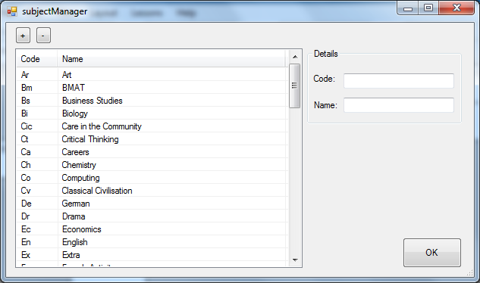

As you can see here, the subject codes and their corresponding names are visible.

When you have finished editing subjects, pressing the OK button will return you to the main window.

Please note that this can only be edited when the timetable hasn’t had any lessons set. After lessons are added to the timetable, you are unable to make changes.

### Adding Subjects

In order to add a subject, click the ‘+’ button, which will create a new generic subject. This generic subject will need to have its code and name edited, so follow the instructions under the next section in order to do this.

### Editing Subjects

In order to edit a subject, select the subject that you wish to edit by clicking on it in the list. This will display the details in the appropriate textboxes. From here, changing the contents of the textboxes to the new values will automatically update the subjects as you type, so there is no need to press the return key!

### Deleting Subjects

In order to delete a subject, select the subject that you wish to delete and then press the ‘-‘ button, which will delete it from the list and also from the timetable.

## Creating and Saving a Timetable Template

The template that comes built in does work, but you might want to create your own template that stores all the information about the timetable layout. In order to create a template, set the attributes of the layout accordingly (by using the layout menu buttons on the main tool strip). After these are set, go to File > Save and save the file and select the file extension as “All Files” with the name “normal.TTT”. From here, find the location of the exe file of ‘TimeLord’ by right clicking and finding the source URL. The folder that this EXE file is contain in is the location where the file that you just created should be copied to. Be sure to delete the file ‘normal.TTT’ that is found in the program folder before copying, as you want to replace this file.

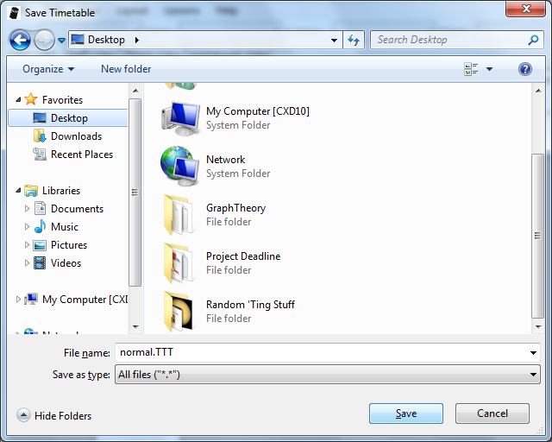

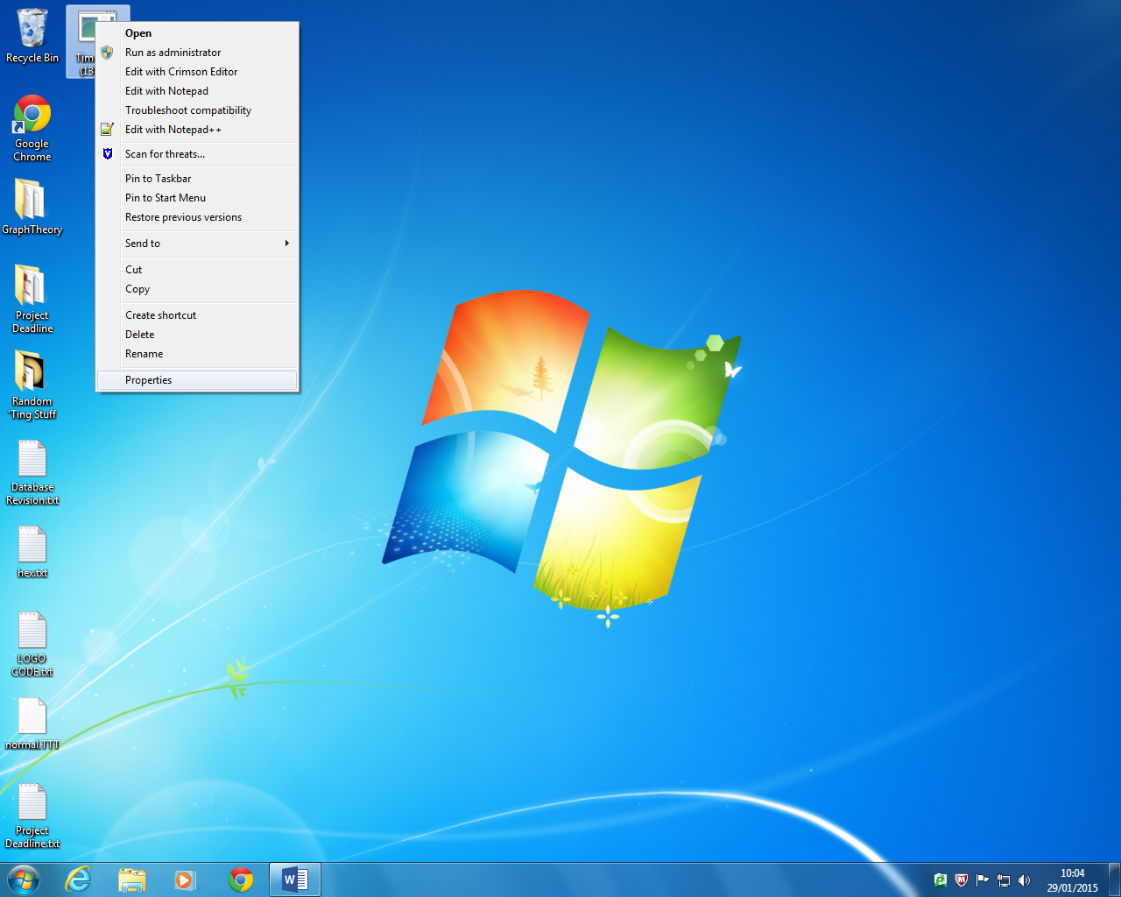

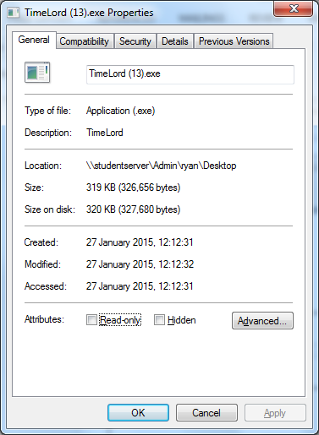

Congratulations, you have now created and saved a custom template.

In the event that you want to return to the default template, simply delete the file, and then run TimeLord, as the program will automatically create a new template file based upon the one built in.

## Managing Lessons

One of the main features of TimeLord is its ability to manipulate lessons, which is an essential part of a timetabling application. This section will explain how to create, edit and delete lessons using various different methods.

### Adding a new lesson for the first time

When you have created a timetable, and have the final layout that you require, go to Lessons > Add Lesson on the main menu. This should make the ‘Add Lesson’ window appear, which looks like this:

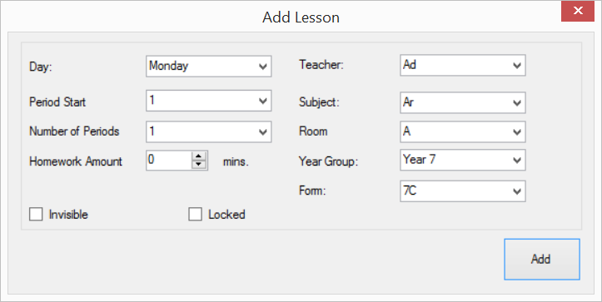

From here, you can set the attributes associated with this new lesson:

|  |  |
| --- | --- |
| Field | Description |
| Day | This is the day that the lesson will be contained in. |
| Period Start | This is the first period that the lesson will occur. |
| Number of Periods | This is the number of total periods that the lesson will take up. This allows you to have the same lesson 2 periods, instead of just one. |
| Homework Amount | This is the amount of homework, in minutes, that the staff member is expected to set the students. |
| Invisible | This sets whether the lesson is invisible on the timetable printouts. When it is deselected, the lesson isn’t invisible. |
| Locked | This sets whether the lesson is locked in place, and therefore is unable to be moved. When the check box displays a tick, this means that the lesson will be locked. |
| Teacher | This is the teacher code of the teacher that will be teaching this given lesson. You might want to consult your list of teachers for more information about the teacher codes. |
| Subject | This is the subject code associated with the lesson. Once again, consulting the subject list might be useful to remember the codes. |
| Room | This is the room that the lesson will be held in. The room name is given in the combo box. |
| Year Group | This is the year group of the class that is being taught. |
| Form | This is the form within the year group that is currently being taught. |

In order to select an item, simply click the arrow next to the text box, and the drop down list will appear, allowing you to select correct value. Once you have finished creating this lesson, clicking the ‘Add’ button will add the lesson to the specified location on the timetable view. This will also finalise the timetable, meaning that you can no longer make changes to the overall timetable layout. However, adding lessons becomes easier after adding this first lesson, as you can now use the shortcut below for adding lessons:

### Adding a Lesson Using The Edit ToolBar

Once the timetable has been finalized, you are able to use the edit toolbar shortcut. In order to do this, click the button marked with the ‘+’ symbol on the menu bar, as shown below.

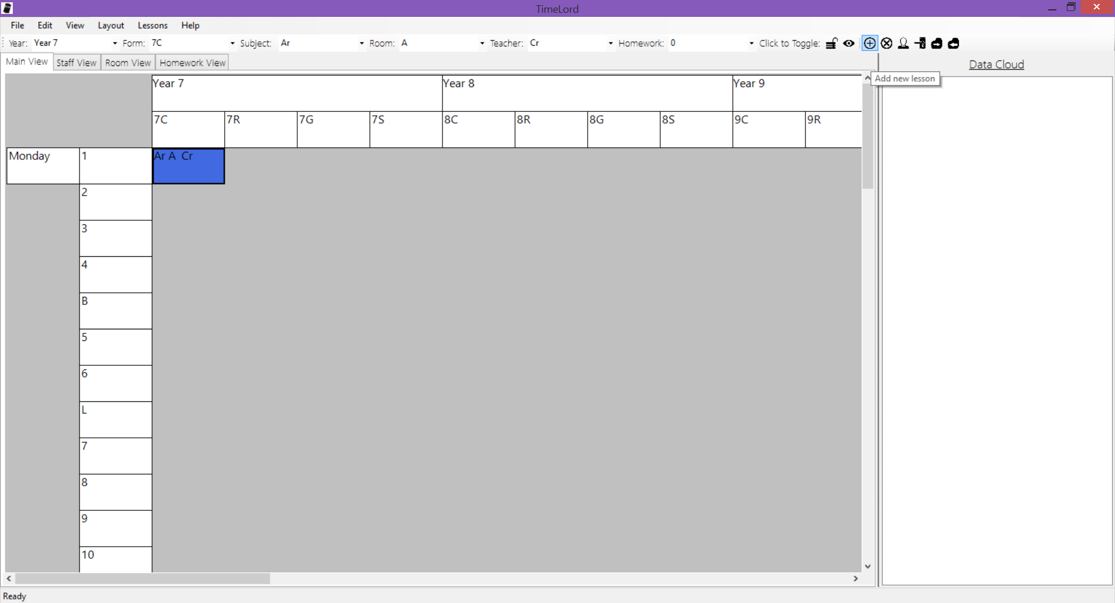

Once clicked, a prompt will appear in the status bar asking you to select the location on the main view that you would like to add the lesson to. Once you select the Year/Form/Day/Period by clicking on the timetable and marking where you want to add it, the ‘Add Lesson’ window will once again appear, with values for ‘Year Group’, ‘Form’, ‘Day’ and ‘Period Start’ automatically being filled in. All you need to do now is to enter the remaining information, and then click the add button to create the new lesson as normal. This will save you a little bit of time, as finding the period number that you require can be a tedious task.

### Using the edit bar to edit lesson attributes:

In order to edit a lesson’s attributes using the edit bar, the lesson that wants to be edited must be selected using the GUI (by clicking on the lesson). From here, the main attributes for the lesson will be displayed in the edit toolbar. An example is shown below:

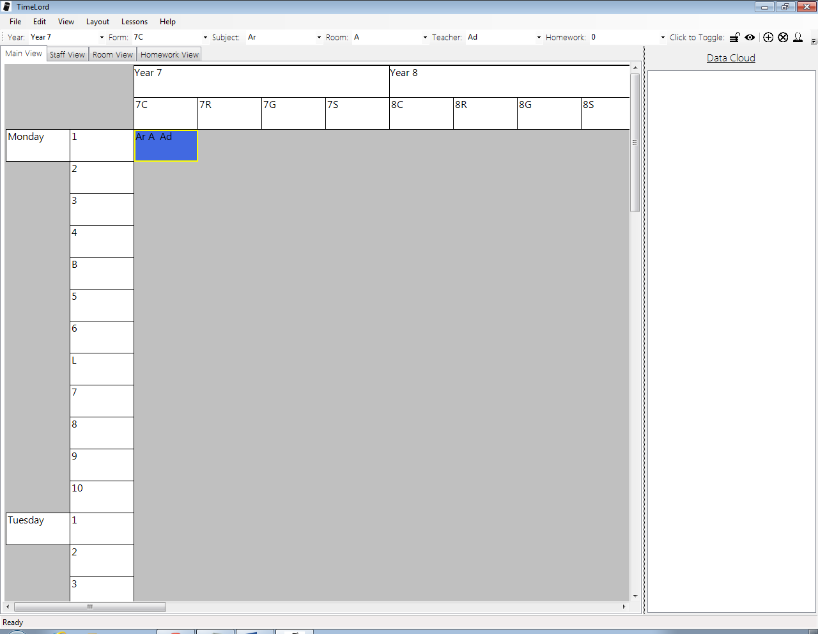

To change the Year, Form, Subject, Room or Teacher attributes, just select the new value in the drop down list, and this will automatically update the lesson. In order to change the homework amount, you can either select an amount from the dropdown list, or enter a value by using the keyboard. The value will be automatically updated when the text is changed. In order to lock/unlock a lesson, clicking the padlock button on the main form will toggle the value of this property. The same is true for the invisible property, as pressing the eye icon will toggle whether the selected lesson is invisible or not.

It is important to note that changing an attribute in the edit bar automatically updates the value of the lesson’s attribute, so there is no need to check whether it has been edited. Furthermore, please be sure that you haven’t accidentally changed attributes by mistake.

As you can see below, clicking on the arrow of one of the combo boxes will display a drop down list, which can be used to select the appropriate value.

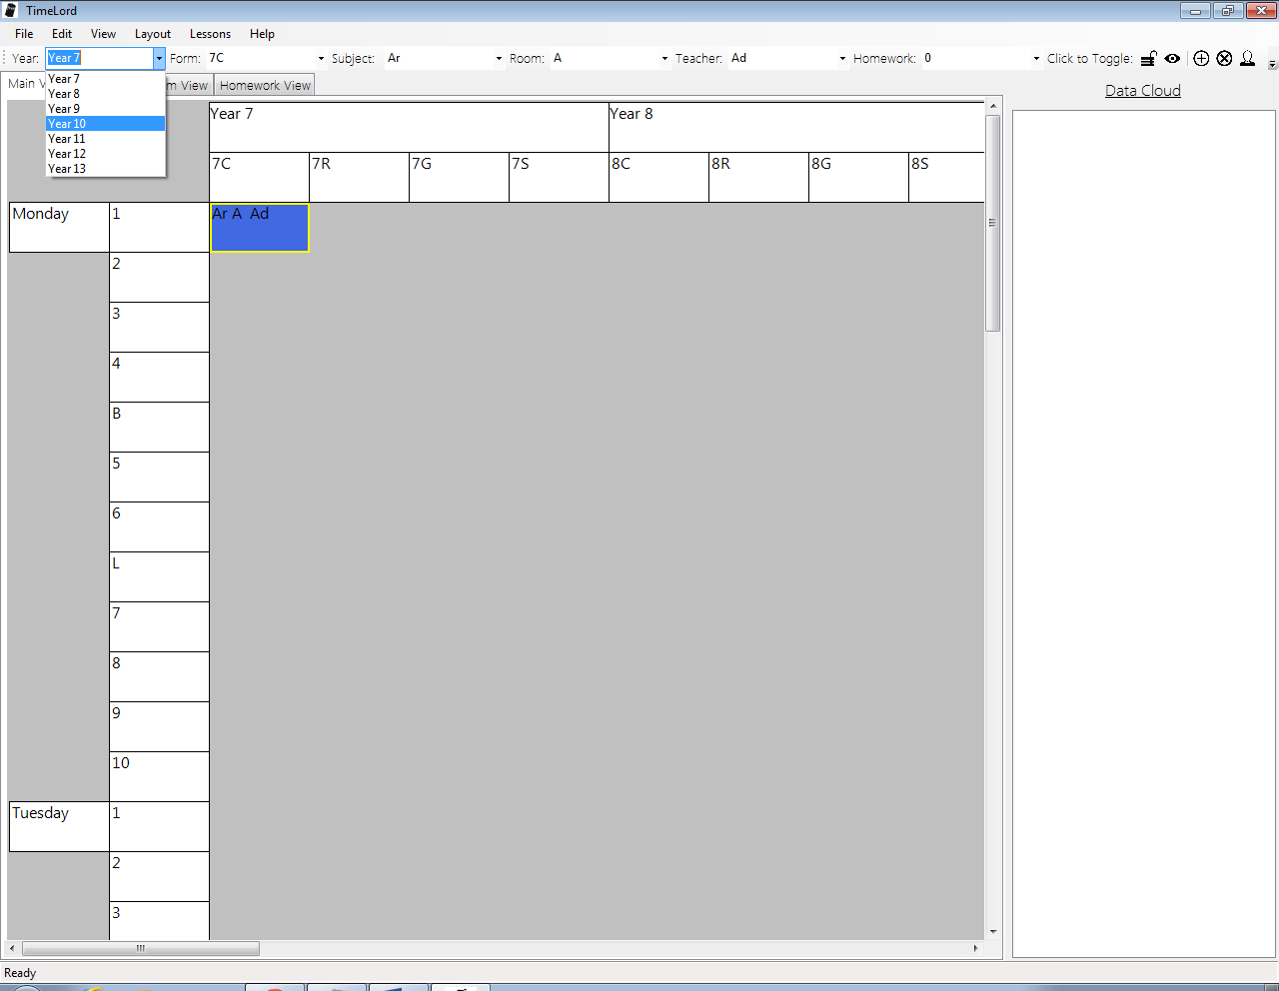

### Moving Lessons by Dragging and Dropping

One feature of TimeLord is the ability to move lessons around with ease. On the main view, dragging a lesson from one form to another, one year to another, or one period to another will automatically move the lesson for you. There is no need to use the edit toolbar to do this.

In order to move a lesson, hold down the mouse button over it and then drag to the location that you want to move the lesson to. Please be sure to hold the cursor down for more than a second in order to ensure that the lesson is actually moved, as sometimes the lesson might remain in its old location.

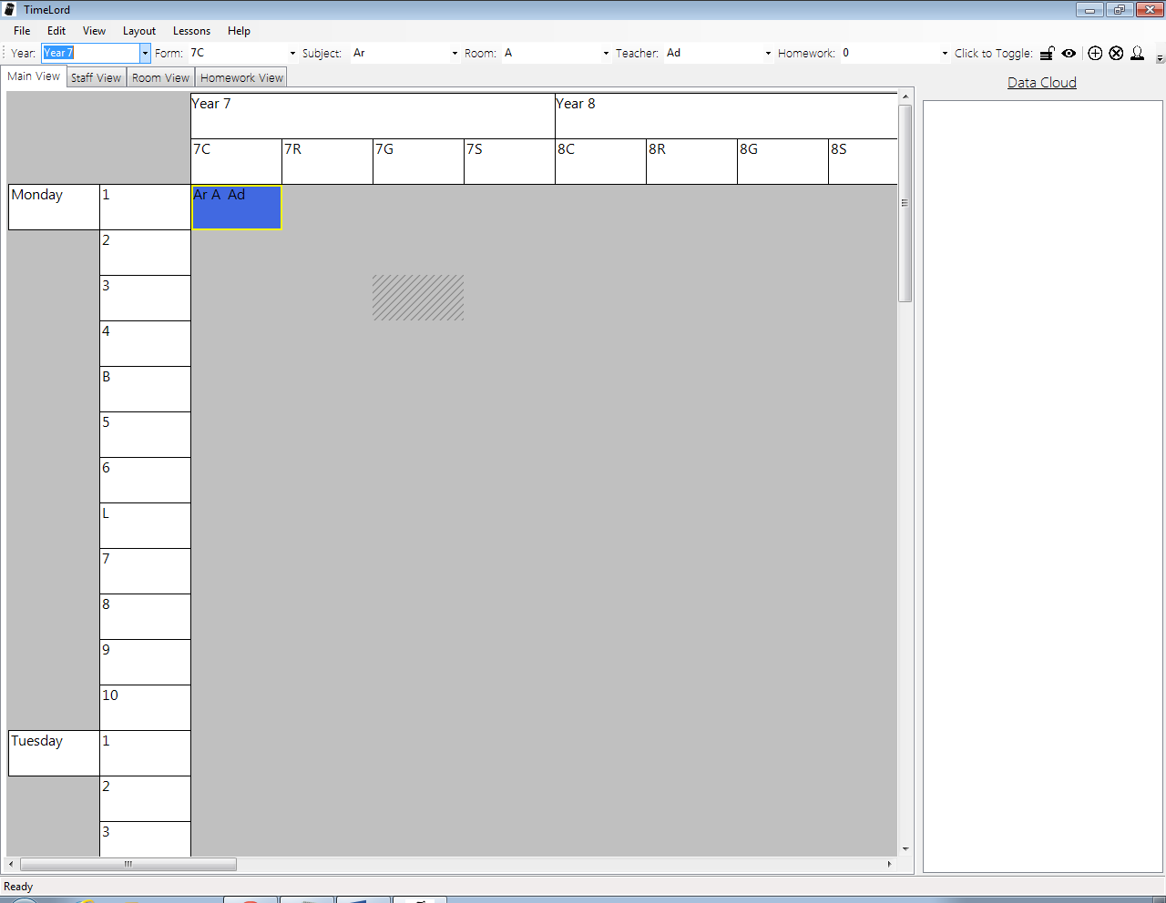

This even works when you have more than one lesson. When more than one lesson is found on the timetable, clashes might occur. This problem is solved by a red grid being drawn on the screen, which indicates which areas of the timetable that the current selected lesson cannot be moved to.

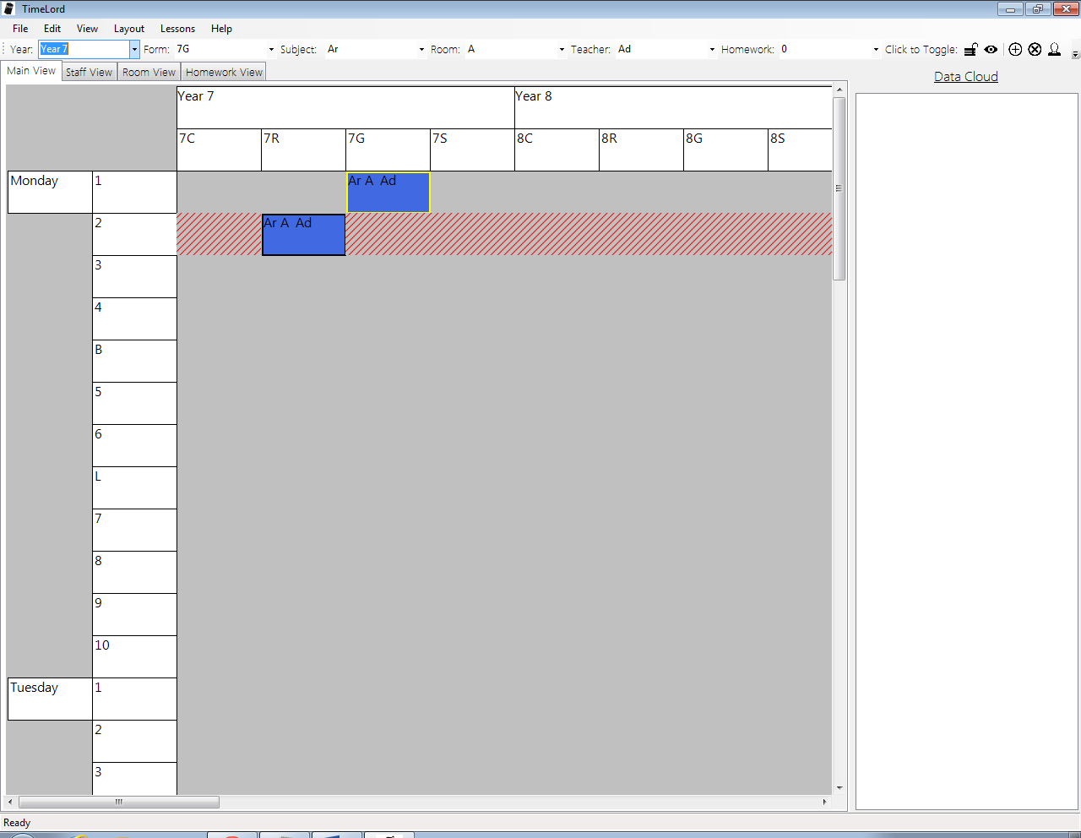

The selected lesson here cannot be moved from period 1 to period 2 because a staff and room clash could both occur. Therefore, the system flags this by displaying the region where the lesson cannot be added to.

Please note that lessons are unable to be moved between days of the week using this method. In order to carry out this action, you will need to use the tray, which is explained in a future section.

### Deleting a lesson using the Edit Toolbar

In order to delete a lesson, simply select the lesson that you wish to delete, by clicking on it in the GUI. From here, press the delete button on the edit toolbar, which is indicated by a circle with an ‘X’ inside it. This will now have deleted the selected lesson.

## The Data Cloud

The Data Cloud is a feature of TimeLord that allows lessons to be temporary stored while lessons are being moved about. This is particularly useful when timetabling as it allows you to keep hold of lessons while you are trying to prevent any clashes from occurring. Please remember that lessons on the main timetable views themselves are not able to have any clashes, so one can temporarily store lessons while clashes are being prevented.

It is also useful for moving lessons between days, as this isn’t able to be done using the edit toolbar or the drag and drop method.

### Adding a Lesson to the Data Cloud

Adding a currently existing lesson to the cloud is easy! Simply select the lesson that you wish to add, and then click on the button that has a picture of a cloud with an arrow pointing right (towards the data cloud). Clicking on this will automatically move the lesson to the tray.

There is no set limit to the number of items that are allowed in the tray, therefore you can add as many lessons as you need to the tray (providing you have enough memory space available in your computer).

### Editing a Lesson

In order to edit a lesson in the tray, simply click on the lesson that you wish to edit, and then adjust the values in the edit toolbar. Editing the attributes for tray lessons are the same as for normal lessons, although values for Year and Form cannot be specified.

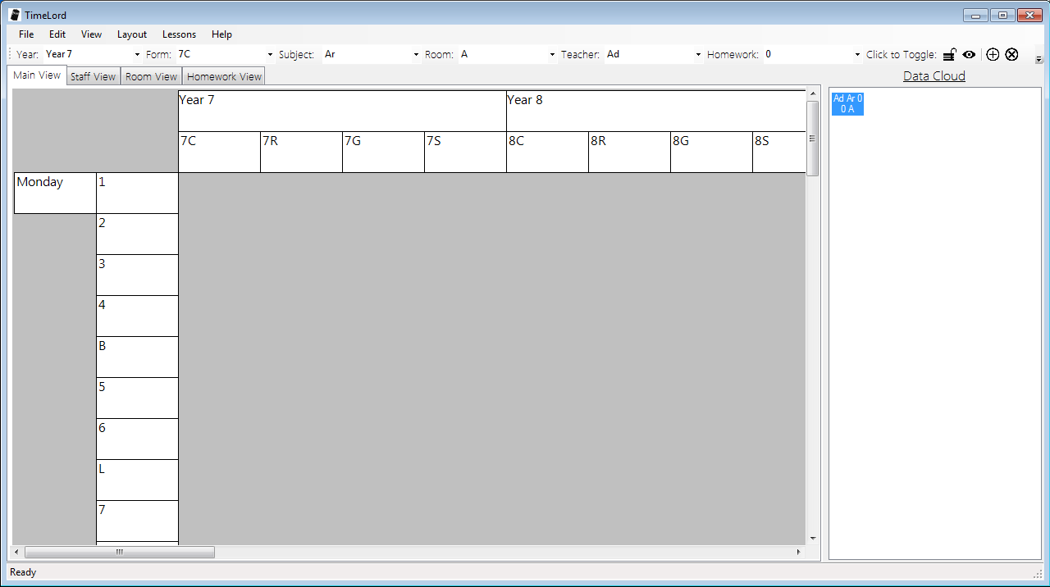

### Moving a Lesson from the Data cLoud To the Main Timetable

In order to move a lesson back to the main timetable, first select the lesson that you wish to move. From here, click the cloud icon with an arrow pointing left in the main edit toolbar. This will allow you to move the lesson. You will then be prompted to select the location on the main timetable where the lesson will be added to. This will set the attributes for Year, Form, Day and Period.

### Deleting a lesson from the Data Cloud

In order to delete a lesson from the data cloud, you will need to move the lesson to somewhere on the timetable, as shown above. From here, delete the lesson as you would do for a timetable object.

## Properties Window

The properties window is useful to allow customization of the system. For example, it allows you to change the overall colour scheme. In addition, it allows the width and height of the timetable displays and printouts to be modified. On the main menu bar, go to Edit > Properties open the properties window. The window, as shown below, will be seen:

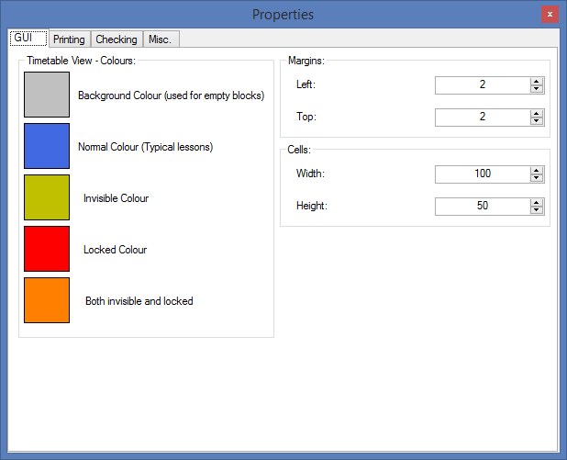

### GUI

This allows modification of several different GUI properties, such as the cell width and height, left and top margins, in addition to the colours that are used.

In order to change one of the colours, click on the coloured box itself, which will display a colour picker window, allowing you to select the replacement colour.

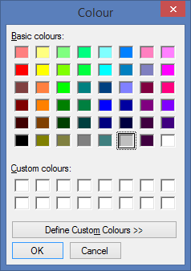

Pressing OK on the colour picker window will change the colour.

In order to change the values for the margins or cell properties, one can either click the up/down buttons to modify the values, or enter values into the text boxes. Changing the values automatically saves them.

### Printing

The printing tab allows the properties for each distinct type of timetable to be edited.

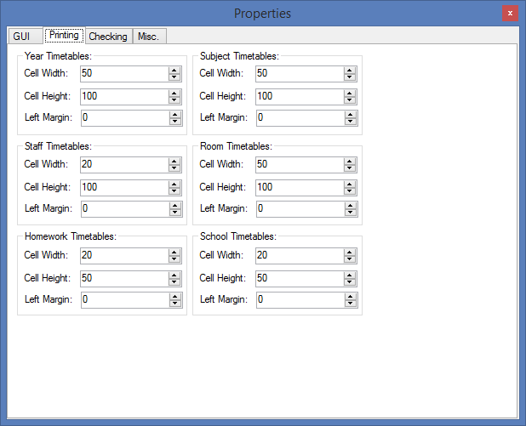

Much like on the GUI window, entering values into the text boxes will automatically change the value of the property in the program. Clicking the up/down buttons is another way of adjusting the values.

## About Page

This window contains information about the creator of the program, in addition to all the attributes for the images/icons used in the program.

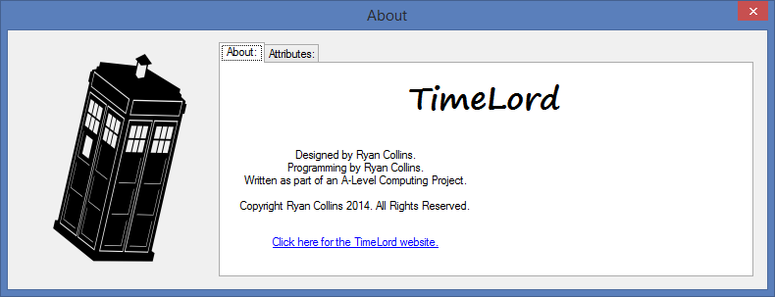

# Troubleshooting

Hopefully this section won’t need to be utilized, as we hope that the software provided always works seamlessly. However, moments will occur when you might receive some errors. This section will explain the most common errors that will appear, and how to recover from them.

## Clashes

When adding lessons to the timetable, clashes will occur when lessons in the same row share values for the Room or Staff attributes, or when they occur at the same time. Error messages will be displayed when a clash occurs, in order to prevent these clashes from occurring in the finished timetable.

### Staff Clashes

These occur when staff members are teaching multiple lessons at the same time. The following error will be seen:

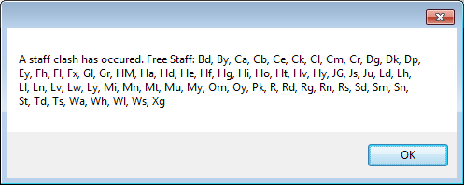

This indicates that a staff clash has occurred. Do not fear! In order to recover from this error, just set the value for the teacher to one of the free members of staff that are available. The staff codes for free staff will be displayed in the error message, so just select one of these. Once this is done, the error will be recovered from.

If there are no free staff listed, then you will need to adjust the timetable in order to allow more staff to be free, as this cannot be done automatically.

### Room Clashes

A room clash will occur when one room is meant to house multiple classes at once. The following error will be displayed:

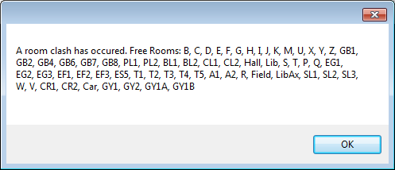

In order to recover from this error, a free room will need to be selected. These free rooms will be displayed in the error message to allow you to resolve this error with ease. If no free rooms are free, then the timetable might need to be manually reorganized in order to allow free rooms to occur. Alternatively, more rooms might be needed.

### Class Clash

A class clash is an error that occurs when one form has multiple lessons at the same time. In order to resolve this problem, you will need to change the form who has the lesson or the time that the lesson occurs. This could be caused by a mistake in entering details (in the Add Lesson window).

## Locked Lessons

By attempting to change attributes for a locked lesson, such as by moving a locked lesson to a different period or a different form class, the following error will appear:

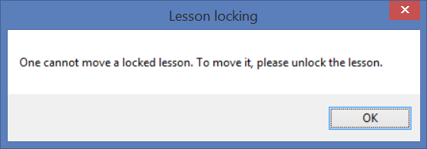

This error lets you know that the lesson you have attempted to move is locked. In order to resolve this issue, simply select the lesson and edit it so that the lesson is no longer locked. This should fix the problem.

## No homework information is displayed

When navigating to the homework view, it is possible to have no lessons displayed on the screen. The screen below might be seen, with no homework information displayed, for example:

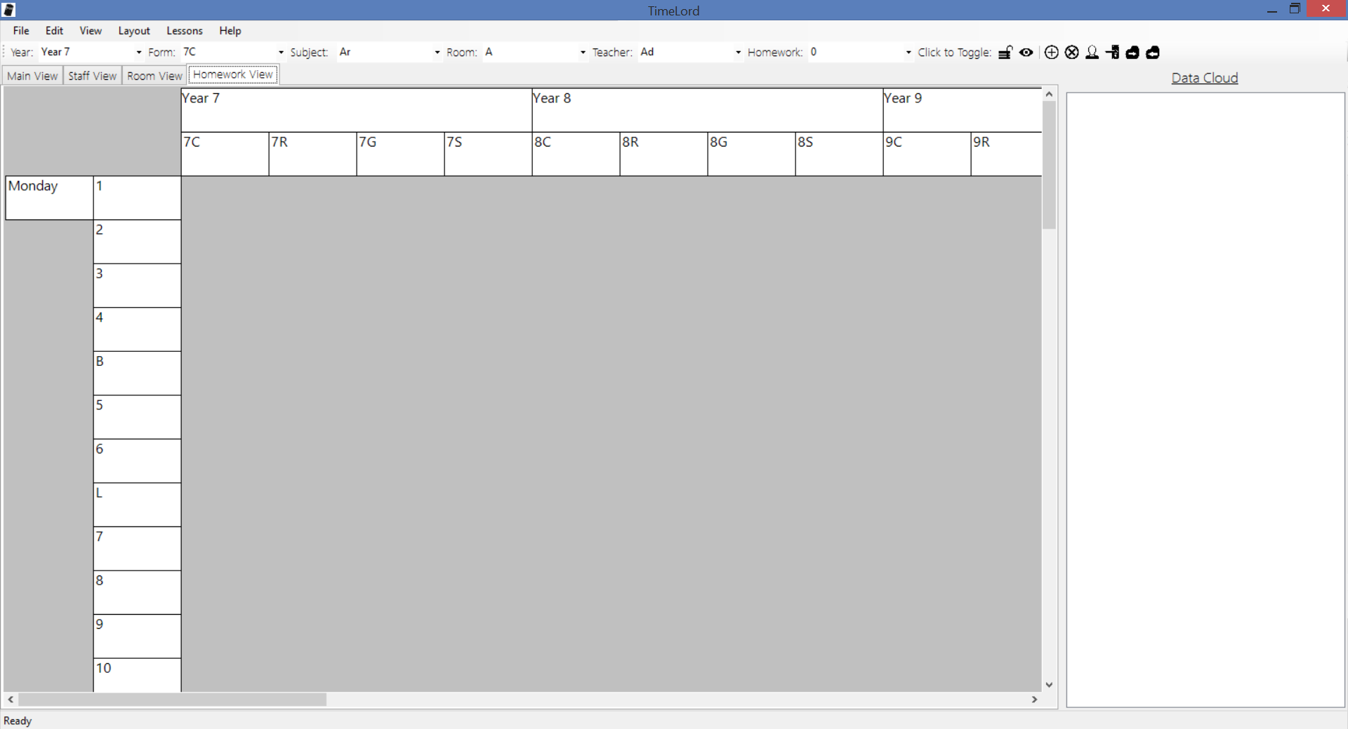

In order to rectify this issue, ensure that lessons are included on the timetable, by going to the main view. Nothing will be displayed on the homework view if there are no lessons to display.

Furthermore, ensure that at least one lesson has a non-zero homework time. This is important because only lessons that have homework assigned will be displayed in the homework view.