Bulacan State University
College of Science

DentDocs San Nicolas Dental Clinic Document Management System
System Documentation for a Web Application

Submitted in partial fulfillment of the requirements for
Software Engineering MCS 305

Submitted by
[TO BE FILLED: Student names and student identification numbers]

Submitted to
Mr. Jewel Jimenez

November 6, 2026

Certificate and Approval Sheet
This document presents DentDocs, the San Nicolas Dental Clinic Document Management System, for academic evaluation under Software Engineering MCS 305 at Bulacan State University, College of Science. Approval is recorded only upon completion of the signatures and dates below.
Project adviser: [TO BE FILLED]
Signature: ____________________ Date: ____________________

Panel member 1: [TO BE FILLED]
Signature: ____________________ Date: ____________________

Panel member 2: [TO BE FILLED]
Signature: ____________________ Date: ____________________

Department head: [TO BE FILLED]
Signature: ____________________ Date: ____________________

Academic approval does not constitute clinic deployment authorization, clinical validation, or an independent security certification.

Abstract
DentDocs was developed to organize dental documents and support assisted transcription with explicit staff review. It retains encrypted originals, associates documents with patients, and supports metadata, versions, archiving, search, completeness and validity workflows. Printed-text extraction uses an isolated local OCR worker. An optional experimental handwriting reader produces editable suggestions for selected image lines. Administrative summaries retain source excerpts and require named approval.
The implementation uses a React and TypeScript browser interface, FastAPI, SQLAlchemy, PostgreSQL with pgvector, and Docker Compose. Native PDF processing is separated from the data-store API. Optional model inference runs locally through PyTorch and Transformers. Named accounts, server-enforced permissions, protected histories, and encrypted recovery tools were implemented.
Recorded engineering verification included 99 API tests, seven worker tests, and 25 operator/recovery tests, together with frontend checks, selected browser workflows and a fresh-volume recovery drill. These establish specific engineering behaviors rather than clinical accuracy. A small handwriting feasibility experiment reduced test character error rate from 23.5% to 18.8% on 11 research crops; exact agreement remained one line. User-supplied dental transcriptions remain unconfirmed and were not used for training. The current installation uses fictional data and loopback access. Independent security assessment, physical off-device recovery, clinic policies and release approval remain outstanding.

Acknowledgments
The authors express their appreciation to Mr. Jewel Jimenez for academic instruction and guidance and to Bulacan State University, College of Science, for the educational context in which this project was developed.
The authors also acknowledge San Nicolas Dental Clinic as the institutional context represented by the project. The names of participating collaborators and testers, together with their confirmed contributions, remain [TO BE FILLED]. This acknowledgment does not imply that clinic personnel independently validated the system or its transcription results.
The contributions of the researchers, dataset creators, model developers, and open-source software maintainers whose work informed the project are recognized through the references in Appendix B.

Table of Contents
Certificate and Approval Sheet 2
Abstract 3
Acknowledgments 4
Table of Contents 5
List of Figures 8
List of Tables 8
Abbreviations 9
Documentation Scope 10
Chapter 1 Introduction 11
Project Background 11
Problem Statement 11
Objectives 11
Scope and Limitations 12
Chapter 2 Literature Review and Existing Systems 14
Existing Systems 14
Manual paper records and scanned folders 14
Open Dental Imaging Module 14
Dentrix Document Center 14
Recognition and training data 14
Comparison Matrix 15
Technology Background 16
Chapter 3 Requirements Analysis and Specification 18
Functional Requirements 18
Non-Functional Requirements 20
User Personas and User Stories 21
Hardware and Software Requirements 22
Chapter 4 System Design and Architecture 24
System Architecture 24
Data Flow Diagrams (DFD) 25
ER Diagram and Database Schema 26
UML Diagrams 34
Use Case Diagram 34
Class Diagram 35
Sequence Diagrams 37
User Interface and User Experience Wireframes 39
Chapter 5 Implementation and Development 42
Development Environment Setup 42
Project Folder Structure 42
Core Code Implementation 44
Server-side authorization 44
Bounded isolated OCR transport 45
Source-bound administrative summaries 45
Retrieval and model integration 46
Recovery implementation 46
Database Implementation 48
Chapter 6 Testing and Validation 50
Testing Strategy 50
Test Cases and Results 51
Handwriting feasibility 55
Bug Tracking and Troubleshooting 56
Chapter 7 Conclusion and Future Work 58
Conclusion 58
Future Enhancements 58
Appendices and References 60
Appendix A User Manual and User Guide 60
A.1 Installation and System Access 60
A.2 Signing In and Navigating the Dashboard 61
A.3 Locating a Patient and Opening a Document 62
A.4 Uploading and Transcribing Documents 65
A.5 Extraction Review Completeness and Validity 68
A.6 Searching Records and Reviewing Summaries 72
A.7 Versions Archives Staff Accounts and Audit History 74
A.8 Backup and Recovery Procedures 78
A.9 Troubleshooting and Escalation 80
Appendix B References 80
Appendix C Source Code and Repository Link 81
C.1 Repository and Implementation Baseline 81
C.2 Source Organization 81
C.3 Building Running and Checking the Source 82
C.4 Licensing and Reproducibility 82
Final Checklist 83
Placeholder Register 83

List of Figures
Figure 4.1. Deployment and layered architecture 24
Figure 4.2. Context DFD 25
Figure 4.3. Level 0 DFD 25
Figure 4.4. Level 1 DFD for assisted transcription 26
Figure 4.5. Physical entity relationships 27
Figure 4.6. Use case diagram 34
Figure 4.7. Persistence class diagram 35
Figure 4.8. Login sequence 37
Figure 4.9. Upload and transcription sequence 38
Figure 4.10. Screen navigation map 39
Figure 4.11. Main-screen wireframes 40
Figure A1. DentDocs Sign In Screen 61
Figure A2. Dashboard and Document Workflow Alerts 62
Figure A3. Patient Directory and Search Controls 63
Figure A4. Selected Patient Record and Alerts 64
Figure A5. Document Metadata and Completeness Controls 65
Figure A6. Upload Workflow and Patient Assignment 66
Figure A7. Editable Printed Text Extraction and Metadata 67
Figure A8. Experimental Handwriting Region and Rotation Controls 68
Figure A9. Pending Extraction Review and Named Decision Controls 69
Figure A10. Completeness Checklist and Missing Fields 70
Figure A11. Separate Extraction Review and Document Validity 71
Figure A12. Validity Policy Versions and Approval States 72
Figure A13. Search Method and Faceted Filters 73
Figure A14. Administrative Summary and Current Acceptance State 74
Figure A15. Active and Superseded Document Versions 75
Figure A16. Administrator Archived Records Vault 76
Figure A17. Staff Account Management Controls 77
Figure A18. Audit Activity Stream and Filters 78

List of Tables
Table 2.1. Existing-system comparison 15
Table 2.2. Implemented technology stack 16
Table 3.1. Functional requirements and source evidence 18
Table 3.2. Non-functional requirements and verification limits 20
Table 3.3. Role personas and user stories 21
Table 3.4. Hardware and software requirements 22
Table 4.1. Complete physical data dictionary 28
Table 4.2. Screen inventory and wireframe descriptions 41
Table 5.1. API surface by workflow 47
Table 6.1. Recorded test cases and results 51
Table 6.2. Handwriting feasibility measurements 55
Table 6.3. Bugs, causes and dispositions 56

Abbreviations
API — Application programming interface
CER — Character error rate
CRUD — Create, read, update, and delete
CSRF — Cross-site request forgery
DFD — Data flow diagram
EHR — Electronic health record
ER — Entity relationship
FDI — Fédération Dentaire Internationale tooth notation
FK — Foreign key
HTTPS — Hypertext Transfer Protocol Secure
IDE — Integrated development environment
JSON — JavaScript Object Notation
LAN — Local area network
OCR — Optical character recognition
PDF — Portable Document Format
PK — Primary key
PWA — Progressive web application
SDK — Software development kit
SLA — Service-level agreement
UAT — User acceptance testing
UI — User interface
UML — Unified Modeling Language
UX — User experience

Documentation Scope
This report formalizes the supplied system documentation at implementation baseline c50295eb4b0394becb6f214f00de7a028f8dbb4a on branch codex/phase4-review-validity. Recorded test outcomes are retained as source-reported evidence; this editorial preparation did not rerun the application tests. The chapter structure follows the supplied documentation instructions and Word reference, adapted to the implemented web application. The requested 1.5 line spacing is used throughout. Diagram definitions are retained as reproducible Mermaid source listings. Missing approvals, screenshots, and evaluations remain explicitly identified.

Chapter 1 Introduction

Project Background
Dental records contain scanned forms, handwritten treatment entries, consent documents, prescriptions, receipts and appointment records. A scan preserves appearance but does not itself make the content searchable or prove transcription correctness. Supplied sample records contain cursive writing, abbreviations, overlapping strokes, table lines and mixed numeric entries. These characteristics motivated a workflow that keeps the original accessible during correction.
DentDocs began as a frontend prototype and was extended with persistent storage, authentication, OCR, source-bound review, local retrieval, administrative summaries and recovery tools. The interface identifies San Nicolas Dental Clinic; the current installation contains fictional demonstration data. Document management and assistance are implemented, while diagnosis and radiograph interpretation are outside scope.

Problem Statement
The general problem is how to make dental documents retrievable and easier to transcribe while retaining source evidence and accountable human decisions.
1. Scans need organized patient association, original retention and recoverable change history.
2. Recognition errors must remain distinguishable from verified information.
3. Staff need separate transcription-review, completeness and validity decisions.
4. Retrieval must respect permissions and expose supporting passages.
5. Local records need controlled access, attributable actions and tested recovery.
These define the project problem; they are not findings from a quantified clinic study. Baseline retrieval times and measured clinic workload are [TO BE FILLED].

Objectives
The general objective is to develop a dental document management system with source-preserving, staff-reviewed transcription and accountable retrieval.
The specific objectives use the documented implementation milestone of November 3, 2026 as their assessment boundary. An independently approved academic schedule is [TO BE FILLED]. They are to:
1. Implement and demonstrate patient-linked persistence, encrypted originals, versions and reversible archiving by the assessment milestone.
2. Integrate printed OCR for PDF/PNG/JPEG files of at most 20 MiB and ten PDF pages, including an explicit manual-entry path when processing fails.
3. Implement editable image-line handwriting drafts with retained source/model evidence and required human review, without assigning an unsupported accuracy target.
4. Implement four staff roles and distinct review/completeness/validity decisions, demonstrated through permission and stale-update tests.
5. Demonstrate source-linked keyword and optional semantic/hybrid retrieval and named administrative-summary decisions, including source-change invalidation.
6. Implement encrypted snapshots and demonstrate isolated restoration without replacing live data, while documenting remaining release conditions.

Scope and Limitations
Implemented scope includes patient directories; eight document categories; permanent FDI tooth tags; uploads, preview and original downloads; editable text/metadata; versions; archive/restore; printed OCR; optional line-level handwriting; review assignment/decisions; completeness resolution; approved validity rules; keyword/semantic/hybrid search; administrative summaries; staff accounts; notice acknowledgment; audit history; and operator-run recovery.
Categories are Patient Record, X-ray, Treatment Plan, Prescription, Consent Form, Laboratory Report, Billing/Receipt and Appointment Record. These do not constitute a complete dental charting system, appointment scheduler, pharmacy system, payment ledger or diagnostic product. Patient display and association exist; separate patient registration and editing operations is outside the current API.
DentDocs is a web application, not an Android application package (APK) or a disconnected progressive web application (PWA). It requires the local server. Optional inference requires separately provisioned weights; initial package/image/model preparation requires downloads. Runtime inference is local after preparation. Handwriting assistance reads selected image lines, not guaranteed whole-page table reconstruction. Current Fédération Dentaire Internationale (FDI) tooth-notation validation covers permanent teeth in quadrants 1–4, positions 1–8; pediatric and universal numbering need separate implementation.
OCR scores are heuristic, not calibrated probabilities. OCR does not authenticate signatures. Completeness is separate from validity, and unknown expiry remains unknown without a confirmed basis. Small handwriting experiments do not establish dental accuracy. No clinic-confirmed labels have been trained. No clinic usability study, broad device qualification, or throughput service-level agreement (SLA) or production acceptance is claimed.
Release for real patient data or local area network (LAN) access remains outstanding pending security assessment, physical off-device recovery, approved policies, HTTPS configuration and sign-off. Protected histories do not remove host/database-owner privileges.

Chapter 2 Literature Review and Existing Systems

Existing Systems

Manual paper records and scanned folders
Paper preserves original marks; a simple scanned folder preserves a digital image. Neither necessarily provides structured metadata, accountable transcription, permission enforcement or passage-linked search. This describes the workflow represented by supplied samples, not an independently observed clinic deployment.

Open Dental Imaging Module
Open Dental documents an Imaging Module for scanning and storing images, forms, letters and other files, including PDF import/viewing and patient-associated categories. It demonstrates established dental document organization. The cited module guide does not establish equivalent selected-line handwriting review or source-bound summary decisions (Open Dental Software, n.d.). Official manual (https://www.opendental.com/manual/images.html).

Dentrix Document Center
Dentrix documents a Document Center for patient letters, explanation-of-benefits documents, referral letters and scanned, captured or imported images. This supplies another established example of dental document organization. The cited window guide does not establish equivalent handwriting adaptation or source-change invalidation (Henry Schein One, n.d.). Official help (https://hsps.pro/Dentrix/Help/mergedProjects/Document%20Center/desktop/Using_Document_Center/The_Document_Center_window.htm).

Recognition and training data
TrOCR combines pretrained image and text Transformers and supports adaptation with paired images/transcriptions. Its research motivates transfer learning but does not prove performance on the supplied dental notes (Li et al., 2021). Research paper (https://arxiv.org/abs/2109.10282).
African Medical Records provides paired handwritten clinical records, transcriptions and contributor metadata. Its card reports 62 paired records and 15 contributors under CC BY 4.0. Paired handwriting is relevant supervision; structured EHR tables without corresponding images are not equivalent. Nigerian clinical records nevertheless differ from the supplied Philippine dental notes and cannot substitute for dental validation (AMR Contributors, 2026). Dataset card (https://huggingface.co/datasets/Nigeria-Health-data-OCR-pipeline/African-Medical-Records).

Comparison Matrix
Table 2.1
Existing-system comparison
Feature | Paper / simple scanned folder | Open Dental Imaging Module | Dentrix Document Center | DentDocs
Retains original appearance | Yes | Yes | Yes | Yes
Patient-associated digital documents | No | Yes | Yes | Yes
Digital scan/import workflow | No | Yes | Yes | Yes
Selected-line experimental handwriting suggestions | No | ? | ? | Yes
Source-bound transcription review | No | ? | ? | Yes
Source-passaged semantic retrieval | No | ? | ? | Yes, optional
Named summary approval with source invalidation | No | ? | ? | Yes
Established commercial dental product | No | Yes | Yes | No

Yes indicates evidenced capability; No indicates absence in the narrowly defined workflow; ? means the cited source does not establish the capability. A simple scanned folder is not a configured document-management product. Unknown competitor features are not represented as absent. The matrix does not claim replacement of competitors' wider practice-management scope. Sources were consulted November 3, 2026.

Technology Background
Table 2.2
Implemented technology stack
Area | Actual technology | Role / repository evidence
Browser UI | React 19, TypeScript, React Router 7 | Typed components and navigation; package.json, src/App.tsx
Styling/build | Tailwind CSS 4, Vite 8, Lucide, Motion | Styling, assets, icons and transitions; package lock records exact packages
API | Python 3.12, FastAPI 0.162.0, Pydantic 2.14.2, Uvicorn 0.54.0 | HTTP validation and serving; backend/requirements.lock
Persistence | SQLAlchemy 2.1.6, psycopg 3.3.6, PostgreSQL 17 | Transactions and relational persistence; SQLite in isolated tests
Retrieval | pgvector 0.8.7, all-MiniLM-L6-v2 | 384-dimensional source-text embeddings
Printed optical character recognition (OCR) | Tesseract and Poppler | Printed extraction and PDF rasterization in separate worker
Model reader | Torch CPU 2.13.0, Transformers 5.10.0, Pillow 13.0.0 | Local TrOCR and embeddings
Account protection | Argon2id, opaque cookie sessions | Password hashes, hashed stored session tokens and CSRF
Encryption | cryptography 50.0.2 | Fernet originals and AES-256-GCM recovery components
Deployment | Docker Compose, Nginx | Service boundaries and loopback proxy
Verification | pytest, unittest, TypeScript checker, Vite build | API, worker, operator and frontend checks

MiniLM's model card describes 384-dimensional sentence/paragraph embeddings and masked mean pooling with normalization. DentDocs loads pinned files through Transformers locally rather than a cloud embedding endpoint (Sentence Transformers, n.d.). Model card (https://huggingface.co/sentence-transformers/all-MiniLM-L6-v2). Similarity is a retrieval signal, not clinical confidence.

Chapter 3 Requirements Analysis and Specification

Functional Requirements
Table 3.1
Functional requirements and source evidence
ID | Implemented acceptance behavior | Primary source
FR-01 | Authenticate named users; require temporary-password replacement and current notice acknowledgment | backend/app/security.py, src/views/SecurityViews.tsx
FR-02 | Enforce admin/dentist/assistant/front-desk permissions on server | security.py, main.py
FR-03 | List patients and associate documents with selected patient | main.py, PatientsView.tsx
FR-04 | Validate uploads, encrypt originals, retain MIME/size/hash and enforce attachment ownership | main.py, database.py
FR-05 | Provide bounded printed OCR with warnings and manual correction/failure path | ocr.py, ocr/server.py, UploadView.tsx
FR-06 | Provide optional image-line handwriting drafts with source/model evidence | handwriting.py, UploadView.tsx
FR-07 | Save typed metadata, FDI tags and corrected text with revision checks | main.py, src/types/dental.ts
FR-08 | Retrieve originals, retain versions and restore prior state as current state with history | main.py, DocumentViewerView.tsx
FR-09 | Reversibly archive records with restricted archived access | main.py, security.py
FR-10 | Maintain review reasons, assignment, decisions and source-change reopening | workflows.py, ReviewQueueView.tsx
FR-11 | Record completeness resolution separately from extraction review | main.py, workflows.py
FR-12 | Manage draft/approved/retired validity rules; preserve unknown default without confirmed basis | workflows.py, ValidityRulesView.tsx
FR-13 | Return authorized source-linked keyword/semantic/hybrid matches with explicit fallback/error | semantic.py, SearchView.tsx
FR-14 | Generate extractive administrative drafts; retain named decisions and invalidate stale acceptance | summaries.py, DocumentViewerView.tsx
FR-15 | Allow administrators to manage accounts and inspect audit | security.py, AuditLogView.tsx
FR-16 | Produce encrypted bundles and verify isolated fresh-volume recovery | scripts/recovery.py, scripts/verify-recovery.py

Paths are repository-relative. Abbreviated backend filenames refer to backend/app/; view filenames refer to src/views/.

Non-Functional Requirements
Table 3.2
Non-functional requirements and verification limits
ID | Requirement / implemented control | Evidence and limit
NFR-01 | Server authorization, origin/CSRF checks, Argon2id and session revocation | Security tests; no independent penetration-test certificate
NFR-02 | Encrypt originals and recovery; protect credentials | File/recovery tests; JSON database fields are not application-level encrypted
NFR-03 | Revision checks, original hashes, protected histories, source fingerprints | Stale-write/history tests; privileged owners remain trusted
NFR-04 | Bound upload size/pages, parser time and service resources | Worker/transport/deployment checks; no throughput SLA
NFR-05 | Explicit OCR failure/manual entry and search fallback | Recorded outage check; no availability percentage measured
NFR-06 | Authenticate full backup before use and verify restoration | Same-host 19-table/38-original comparison; physical drill pending
NFR-07 | Source preview, editable drafts and visible uncertainty | Selected browser checks; clinic usability study [TO BE FILLED]
NFR-08 | Browser client and containerized local server | Current environment; approved browser/OS matrix [TO BE FILLED]
NFR-09 | Modular source, locked dependencies and repeatable checks | Repository suites; no automated release pipeline claimed
NFR-10 | Fictional-data guard and versioned notice gate | Draft notice; approved privacy/retention policy [TO BE FILLED]

Sessions expire after ten idle minutes or eight hours overall. Failed logins are throttled. Current loopback HTTP uses local non-secure cookies; approved HTTPS and secure-cookie configuration are required before broader deployment.

User Personas and User Stories
Table 3.3
Role personas and user stories
Persona | Goal / pain point | User story
Administrator | Accountable access; shared accounts obscure responsibility | As an administrator, I want named accounts and audit records, so that access and actions are attributable.
Dentist | Verify source without silently trusting OCR | As a dentist, I want to compare text with the original and decide review, so that uncertainty remains explicit.
Assistant | Prepare records within role restrictions | As an assistant, I want editable extraction suggestions, so that I can prepare records for authorized verification.
Front desk | Handle administrative records within scope | As a front-desk user, I want billing/appointment documents, so that I can handle paperwork without clinical access.
Backup operator | Recover without damaging live data | As an authorized operator, I want encrypted snapshots and isolated drills, so that recovery can be demonstrated safely.

Backup operator is a designated responsibility using operator tools, not a fifth application role. Personas are design descriptions, not completed interviews. Front-desk access is limited to Billing/Receipt and Appointment Record; unclassified OCR/handwriting is restricted. Assistants cannot edit treatment plans or verify completeness. Summary decisions require dentist/admin authority. Validity-rule permissions are more specific and enforced in workflows.py.

Hardware and Software Requirements
Table 3.4
Hardware and software requirements
Item | Requirement / status
minSdk / targetSdk / compileSdk | Not applicable; no Android project
JDK / Java / Kotlin / Gradle / Android Gradle Plugin | Not applicable to the implemented stack
Development | Git, Python 3.12, virtual environment, Docker Desktop Linux containers and Compose
Host frontend checks | Node.js 22.12+ in documented 22.x line and npm; Docker supplies its own build environment
Database | PostgreSQL 17, pgvector 0.8.7, schema version 7
IDE/version/plugins | [TO BE FILLED]; not enforced by source
Developer CPU/RAM/storage/OS build | [TO BE FILLED]; historical research used RTX 4050, not an end-user minimum
End-user browser/device | Reachable prepared server; approved browser versions [TO BE FILLED]
Minimum host CPU/RAM/free storage | [TO BE FILLED] after measured deployment sizing
Optional models | Prepared TrOCR checkpoint and pinned MiniLM artifacts, absent from Git
Network | Downloads for preparation; server connection for use; local inference thereafter

API, optional reader and OCR container memory ceilings are respectively 2 GiB, 3 GiB and 1 GiB. Database/web/Docker overhead and snapshot/model storage are additional. These ceilings do not establish a tested minimum workstation specification.

Chapter 4 System Design and Architecture

System Architecture
DentDocs uses a layered browser-client and service architecture, not Android MVVM. React components and clinic context handle presentation/authenticated state. FastAPI modules enforce validation, permissions and workflows. SQLAlchemy persists state in PostgreSQL; encrypted originals reside in a separate volume.
Figure 4.1
Deployment and layered architecture
Mermaid diagram definition
flowchart TB
Staff[Staff browser] -->|Loopback HTTP 8080| Web[web: Nginx and React]
Web -->|Proxied requests| API[api: FastAPI]
API -->|Restricted SQL role| DB[(db: PostgreSQL and pgvector)]
API --> Files[(Encrypted originals volume)]
API -->|Private token and one scan| OCR[ocr: isolated native worker]
API -->|Separate private token| Reader[handwriting: optional CPU reader]
Models[(Read-only local models)] --> Reader
Migration[migrate: one-shot owner initialization] --> DB
Operator[Authorized operator] --> Recovery[Recovery CLI]
Recovery --> Bundle[(Encrypted six-component snapshot)]
Recovery -. Maintenance capture .-> DB
Recovery -. Maintenance capture .-> Files
Only web publishes a host port. OCR belongs to private ocr_link, shared only with API, and has no database credentials, originals/model mounts or published port. The reader uses the internal backend network and separate credential. Native modules/tools are excluded from the API image. API performs patient matching, provenance retention and persistence. Migration uses owner privileges; API uses restricted dentdocs_app. API/reader/OCR run nonroot with read-only roots, dropped capabilities and bounded resources. Isolation reduces exposure; it does not eliminate upstream library vulnerabilities.

Data Flow Diagrams (DFD)
DFDs describe logical data movement. Staff and the recovery operator are external entities; native/model services are internal processors. Stores include relational state, encrypted originals and protected snapshots.
Figure 4.2
Context DFD
Mermaid diagram definition
flowchart LR
S[Staff] -->|Credentials, scans, metadata and decisions| P((DentDocs))
P -->|Authorized records, drafts and outcomes| S
O[Recovery operator] -->|Snapshot or drill request and key| P
P -->|Encrypted bundle and verification report| O
Figure 4.3
Level 0 DFD
Mermaid diagram definition
flowchart TB
S[Staff] -->|Credentials and acknowledgment| A((1. Access control))
A <--> U[(D1 Accounts and sessions)]
A -->|Authorized identity| B((2. Capture and review))
S -->|Scan, correction and decision| B
B <--> F[(D2 Encrypted originals)]
B <--> D[(D3 Documents and workflows)]
B --> H[(D4 Protected histories)]
B -->|Saved state and outcomes| S
S -->|Search or summary request| C((3. Retrieve and summarize))
A -->|Authorized identity| C
D --> C
C <--> I[(D5 Search chunks and summary drafts)]
C --> H
C -->|Records, passages and drafts| S
O[Recovery operator] -->|Request and key| R((4. Snapshot and recovery))
U --> R
F --> R
D --> R
H --> R
I --> R
R -->|Encrypted bundle and report| O
Recovery also captures configuration, tracked/staged source, models and runtime images. It is an operator-triggered maintenance process, not a scheduled browser feature.
Figure 4.4
Level 1 DFD for assisted transcription
Mermaid diagram definition
flowchart TB
S[Authorized staff] -->|Patient and file| V((2.1 Validate upload))
V -->|Encrypted bytes and metadata| F[(D2 Originals)]
V -->|Authorized source| E((2.2 Extract text or selected handwriting line))
E -->|Draft, warnings and source evidence| S
E -->|Extraction evidence| H[(D4 Protected histories)]
S -->|Corrected text and metadata| C((2.3 Validate and save))
C --> D[(D3 Documents and versions)]
C -->|Source-bound reasons| Q((2.4 Review and completeness))
S -->|Named decision| Q
D --> Q
Q --> D
Q --> H
Q -->|State or stale-source rejection| S
OCR outage returns an explicit error. Staff can manually enter text against the retained original; failed processing is not recorded as successful OCR. Review acceptance does not automatically resolve completeness or validity.

ER Diagram and Database Schema
backend/app/database.py declares 21 physical tables. PostgreSQL is deployed; SQLite supports tests. String has no fixed declared length. String timestamps are not SQL timestamp columns. JSON holds structured application payloads. Encrypted original bytes are outside the database.
Figure 4.5
Physical entity relationships
Mermaid diagram definition
erDiagram
patients ||--o{ documents : patient_id
documents ||--o{ document_versions : document_id
document_files o|--o{ document_versions : file_id
users ||--o{ sessions : user_id
users ||--o{ privacy_acknowledgements : user_id
document_files ||--o| file_uploads : file_id
users ||--o{ file_uploads : user_id
document_files ||--o| file_extractions : file_id
patients ||--o{ file_extractions : patient_id
document_files ||--o{ handwriting_drafts : file_id
patients ||--o{ handwriting_drafts : patient_id
users ||--o{ handwriting_drafts : user_id
documents ||--o{ search_chunks : document_id
documents ||--o{ summary_drafts : document_id
document_files o|--o{ summary_drafts : file_id
users ||--o{ summary_drafts : created_by
summary_drafts ||--o| summary_decisions : draft_id
users ||--o{ summary_decisions : decided_by
documents ||--o{ review_queue : document_id
users o|--o{ review_queue : assignee_id
users o|--o{ review_queue : decided_by
review_queue ||--o{ review_events : review_id
users ||--o{ validity_rules : created_by
users o|--o{ validity_rules : approved_by
documents ||--o{ document_validity : document_id
documents o|--o{ document_validity : appointment_id
validity_rules o|--o{ document_validity : rule_id
users ||--o{ document_validity : confirmed_by
documents ||--o{ validity_events : document_id
audit_logs {
string id PK
}
schema_versions {
int version PK
}
login_throttles {
string key PK
}
Optional parent ends represent nullable foreign keys. JSON references are not physical foreign keys. Audit, schema version and throttle tables have no physical relationships. The dictionary supplies every mapped column, including fields omitted from the compact diagram.
Table 4.1
Complete physical data dictionary
Table | Column | Type | Constraints / reference
patients | id | String | PK; not null
patients | record_no | String | not null; unique
patients | data | JSON | not null
documents | id | String | PK; not null
documents | patient_id | String (inferred) | not null; FK patients.id
documents | revision | Integer | not null; default 1
documents | data | JSON | not null
document_files | id | String | PK; not null
document_files | mime | String | not null
document_files | size | Integer | not null
document_files | sha256 | String | not null
document_files | created_at | String | not null
document_versions | id | String | PK; not null
document_versions | document_id | String (inferred) | not null; FK documents.id
document_versions | number | Integer | not null
document_versions | file_id | String (inferred) | nullable; FK document_files.id
document_versions | snapshot | JSON | not null
audit_logs | id | String | PK; not null
audit_logs | data | JSON | not null
schema_versions | version | Integer | PK; not null
users | id | String | PK; not null
users | email | String | not null; unique
users | name | String | not null
users | role | String | not null
users | title | String | not null
users | password_hash | String | not null
users | enabled | Boolean | not null; default True
users | must_change | Boolean | not null; default True
users | revision | Integer | not null; default 1
sessions | token_hash | String | PK; not null
sessions | user_id | String (inferred) | not null; FK users.id
sessions | csrf | String | not null
sessions | last_seen | Float | not null
sessions | created_at | Float | not null
sessions | revoked | Boolean | not null; default False
privacy_acknowledgements | id | String | PK; not null
privacy_acknowledgements | user_id | String (inferred) | not null; FK users.id
privacy_acknowledgements | notice_version | String | not null
privacy_acknowledgements | timestamp | String | not null
login_throttles | key | String | PK; not null
login_throttles | failures | Integer | not null; default 0
login_throttles | locked_until | Float | not null; default 0
file_uploads | file_id | String (inferred) | PK; not null; FK document_files.id
file_uploads | user_id | String (inferred) | not null; FK users.id
file_uploads | consumed | Boolean | not null; default False
file_extractions | file_id | String (inferred) | PK; not null; FK document_files.id
file_extractions | patient_id | String (inferred) | not null; FK patients.id
file_extractions | result | JSON | not null
handwriting_drafts | id | String | PK; not null
handwriting_drafts | file_id | String (inferred) | not null; FK document_files.id
handwriting_drafts | patient_id | String (inferred) | not null; FK patients.id
handwriting_drafts | user_id | String (inferred) | not null; FK users.id
handwriting_drafts | data | JSON | not null
search_chunks | id | String | PK; not null
search_chunks | document_id | String (inferred) | not null; FK documents.id
search_chunks | revision | Integer | not null
search_chunks | number | Integer | not null
search_chunks | field | String | not null
search_chunks | start | Integer | not null
search_chunks | end | Integer | not null
search_chunks | snippet | String | not null
search_chunks | fingerprint | String | not null
search_chunks | model_id | String | not null
search_chunks | embedding | JSON in SQLite / vector(384) in PostgreSQL | not null
summary_drafts | id | String | PK; not null
summary_drafts | document_id | String (inferred) | not null; FK documents.id
summary_drafts | source_revision | Integer | not null
summary_drafts | source_version | Integer | not null
summary_drafts | source_fingerprint | String | not null
summary_drafts | source_type | String | not null
summary_drafts | file_id | String (inferred) | nullable; FK document_files.id
summary_drafts | created_by | String (inferred) | not null; FK users.id
summary_drafts | data | JSON | not null
summary_decisions | id | String | PK; not null
summary_decisions | draft_id | String (inferred) | not null; FK summary_drafts.id
summary_decisions | action | String | not null
summary_decisions | decided_by | String (inferred) | not null; FK users.id
summary_decisions | data | JSON | not null
review_queue | id | String | PK; not null
review_queue | document_id | String (inferred) | not null; FK documents.id
review_queue | version | Integer | not null
review_queue | source_fingerprint | String | not null
review_queue | status | String | not null; default 'pending'
review_queue | reasons | JSON | not null
review_queue | assignee_id | String (inferred) | nullable; FK users.id
review_queue | decided_by | String (inferred) | nullable; FK users.id
review_queue | decided_at | String | nullable
review_queue | decision_note | String | nullable
review_queue | updated_at | String | not null
review_queue | revision | Integer | not null; default 1
review_events | id | String | PK; not null
review_events | review_id | String (inferred) | not null; FK review_queue.id
review_events | data | JSON | not null
validity_rules | id | String | PK; not null
validity_rules | document_type | String | not null
validity_rules | category | String | not null
validity_rules | version | Integer | not null
validity_rules | valid_for_days | Integer | not null
validity_rules | warning_days | Integer | not null
validity_rules | reference | String | not null
validity_rules | status | String | not null; default 'draft'
validity_rules | created_by | String (inferred) | not null; FK users.id
validity_rules | approved_by | String (inferred) | nullable; FK users.id
validity_rules | approved_at | String | nullable
validity_rules | approval_note | String | nullable
validity_rules | revision | Integer | not null; default 1
document_validity | id | String | PK; not null
document_validity | document_id | String (inferred) | not null; FK documents.id
document_validity | version | Integer | not null
document_validity | source_fingerprint | String | not null
document_validity | basis | String | not null
document_validity | category | String | not null
document_validity | issued_on | Date | nullable
document_validity | expires_on | Date | nullable
document_validity | warning_days | Integer | not null; default 0
document_validity | rule_id | String (inferred) | nullable; FK validity_rules.id
document_validity | appointment_id | String (inferred) | nullable; FK documents.id
document_validity | appointment_revision | Integer | nullable
document_validity | confirmed_by | String (inferred) | not null; FK users.id
document_validity | confirmed_at | String | not null
document_validity | note | String | not null
document_validity | revision | Integer | not null; default 1
validity_events | id | String | PK; not null
validity_events | document_id | String (inferred) | not null; FK documents.id
validity_events | data | JSON | not null

Additional constraints: versions are unique on (document_id, number) with number > 0; acknowledgments on (user_id, notice_version); chunks on (document_id, number); summary decisions on draft_id, restricted to approve/reject; review/validity on (document_id, version); rules on (document_type, category, version).
Logical JSON types are in src/types/dental.ts and src/types/workflows.ts. Patient payloads contain identity/contact information, birth date, alerts, guardian details, visit dates and tooth arrays. Document payloads contain classification/date, patient display references, teeth/category/tags, confidence, completeness/missing fields, text, file linkage, upload/review metadata, versions, optional prescription/radiograph fields and archive state. These are not separate normalized treatment, prescription, payment or appointment tables.

UML Diagrams

Use Case Diagram
Mermaid flowchart notation represents actors and use cases within the system boundary.
Figure 4.6
Use case diagram
Mermaid diagram definition
flowchart LR
A[Administrator] --> L([Sign in and acknowledge notice])
D[Dentist] --> L
X[Assistant] --> L
F[Front desk] --> L
subgraph System[DentDocs]
L
U([Upload and correct permitted records])
S([Search and inspect permitted sources])
R([Review and verify completeness])
V([Confirm validity and manage permitted rules])
M([Generate draft and decide summary])
N([Manage accounts and inspect audit])
end
A --> U
D --> U
X --> U
F -->|Administrative scope| U
A --> S
D --> S
X --> S
F -->|Administrative scope| S
A --> R
D --> R
A --> V
D -->|Clinical policy scope| V
A --> M
D --> M
A --> N
Use-case access is subject to finer action checks. Upload access does not imply treatment-plan edit or verification authority. Other authorized users may generate drafts; summary decisions remain dentist/admin actions.

Class Diagram
Persistent classes inherit SQLAlchemy's declarative base. Workflow logic primarily consists of functions installed on FastAPI, not invented controller/ViewModel classes.
Figure 4.7
Persistence class diagram
Mermaid diagram definition
classDiagram
class Base
class Patient {
string id
string record_no
dict data
}
class Document {
string id
string patient_id
int revision
dict data
}
class Version {
string id
string document_id
int number
string file_id
dict snapshot
}
class User {
string id
string role
string password_hash
bool enabled
}
class SummaryDraft {
string id
string document_id
int source_revision
string source_fingerprint
}
class SummaryDecision {
string id
string draft_id
string action
string decided_by
}
Base <|-- Patient
Base <|-- Document
Base <|-- Version
Base <|-- User
Base <|-- SummaryDraft
Base <|-- SummaryDecision
Patient "1" --> "0..*" Document : patient_id
Document "1" --> "0..*" Version : document_id
Document "1" --> "0..*" SummaryDraft : document_id
SummaryDraft "1" --> "0..1" SummaryDecision : draft_id

Sequence Diagrams
Figure 4.8
Login sequence
Mermaid diagram definition
sequenceDiagram
actor Staff
participant UI as Browser
participant API as FastAPI security
participant DB as PostgreSQL
Staff->>UI: Enter email and password
UI->>API: POST /api/auth/login
API->>DB: Check throttle and enabled account
API->>API: Verify Argon2 hash
alt Invalid or throttled
API-->>UI: Failure or temporary lock
else Valid
API->>DB: Persist hashed opaque token and CSRF
API-->>UI: HttpOnly cookie and account state
UI->>API: GET /api/auth/me
API-->>UI: Password and notice gates
opt Temporary password
Staff->>UI: Choose new password
UI->>API: POST /api/auth/change-password
API->>DB: Replace hash and revoke prior sessions
end
opt Notice not acknowledged
Staff->>UI: Acknowledge current notice
UI->>API: POST /api/privacy-acknowledgements
API->>DB: Record named acknowledgment
end
UI->>API: GET /api/bootstrap
API-->>UI: Authorized clinic data
end
Figure 4.9
Upload and transcription sequence
Mermaid diagram definition
sequenceDiagram
actor Staff
participant UI as Upload view
participant API as FastAPI
participant FS as Encrypted originals
participant OCR as Private worker
participant DB as PostgreSQL
Staff->>UI: Select patient and scan
UI->>API: POST /api/files
API->>API: Authenticate and validate bounds
API->>FS: Retain encrypted original
API->>DB: Save hash, metadata and ownership
API-->>UI: File identifier
UI->>API: POST /api/files/{id}/extract
API->>FS: Read and verify original
API->>OCR: Token-authenticated scan
OCR-->>API: Bounded result or safe error
alt Usable result
API->>DB: Retain extraction evidence
API-->>UI: Suggested text, fields and warnings
else Failed processing
API-->>UI: Explicit manual-entry option
end
Staff->>UI: Compare original and correct
UI->>API: POST /api/documents
API->>DB: Save document, version, review and audit
API-->>UI: Saved state requiring applicable decisions
Handwriting uses /api/files/{id}/handwriting with an image box/rotation and a separate retained draft source. It does not silently replace printed extraction provenance.

User Interface and User Experience Wireframes
Figure 4.10
Screen navigation map
Mermaid diagram definition
flowchart TD
Login[Login] --> Gates[Password and notice gates when required]
Gates --> Dashboard[Dashboard]
Dashboard --> Patients[Patient directory and folder]
Dashboard --> Upload[Upload]
Dashboard --> Search[Search]
Dashboard --> Review[Review queue and item]
Dashboard --> Incomplete[Incomplete documents]
Dashboard --> Rules[Validity rules]
Dashboard --> Users[Staff: admin]
Dashboard --> Audit[Audit: admin]
Patients --> Viewer[Document viewer]
Upload --> Viewer
Search --> Viewer
Review --> Viewer
Incomplete --> Viewer
Eligible users pass gates without repeated acknowledgment. All record actions remain subject to server authorization.
Figure 4.11
Main-screen wireframes
LOGIN / PASSWORD / NOTICE
+----------------------------------------------------------+
| DentDocs |
| Email [____________] Password [____________] [Sign in] |
| Conditional password replacement / notice acknowledgment |
+----------------------------------------------------------+

AUTHENTICATED SHELL
+----------------------------------------------------------+
| DentDocs | Navigation | Named staff / role | Sign out |
| Page title and status / errors |
| Page-specific panels described in Table 4.2 |
| Fictional prototype data / clinic footer |
+----------------------------------------------------------+

UPLOAD
+----------------------------+-----------------------------+
| Patient / file selection | Original preview |
| Extraction status | Image crop / rotation |
| Editable text and metadata | Handwriting draft evidence |
| Warnings / save | Request suggestion |
+----------------------------+-----------------------------+

DOCUMENT VIEWER
+----------------------------+-----------------------------+
| Title / patient / version | Original preview |
| Text / tags / metadata | Version/source selection |
| Review / completeness | Download / print request |
| Validity / summary history | |
+----------------------------+-----------------------------+
These are low-fidelity descriptions of implemented screens. Appendix A registers the screenshots needed for an illustrated submission.
Table 4.2
Screen inventory and wireframe descriptions
Main screen / route | Existing component and layout
Login/password | SecurityViews.tsx: credentials/error state and forced replacement form
Notice gate | PrivacyNoticeModal.tsx: versioned notice and acknowledgment
/dashboard | DashboardView.tsx: overview/status cards and workflow navigation
/patients, /patients/:patientId | PatientsView.tsx: directory/search, patient details, tooth context and document list
/upload | UploadView.tsx: selection, preview, extraction/crop, editable fields/text, warnings/save
/documents/:documentId | DocumentViewerView.tsx: original/text, metadata, versions, review/completeness/validity and summaries
/search | SearchView.tsx: query/filter/mode controls, source-linked results and fallback/errors
/review, /review/:reviewId | ReviewQueueView.tsx: queue, reasons, assignment, source-linked item and decision form
/validity-rules | ValidityRulesView.tsx: rules, type/category, reference, draft/approve/retire controls
/incomplete | IncompleteDocumentsView.tsx: incomplete records and corrective links
/admin/audit | AuditLogView.tsx: administrator event list and filtering
/admin/users | UsersView in SecurityViews.tsx: list/create/edit/reset/disable named accounts

Chapter 5 Implementation and Development

Development Environment Setup
The documented environment uses Windows PowerShell, Python 3.12, Git and Docker Desktop Linux containers. Node.js 22.12+ in the documented 22.x line supports host frontend checks; Docker supplies its own build environment. IDE/version/plugins and exact OS build are [TO BE FILLED]. Android Studio, Gradle, emulators and Android devices are not implementation requirements.
For a new fictional-data installation only, with no existing .env:
git clone --branch codex/phase4-review-validity https://github.com/OhsirIIII/DentDocs.git
cd DentDocs
python -m venv .venv
.venv/Scripts/python.exe -m pip install -r backend/requirements.lock
.venv/Scripts/python.exe scripts/create-env.py
.venv/Scripts/python.exe scripts/bootstrap-admin.py
docker compose up --build -d
Open http://127.0.0.1:8080. The generated administrator uses admin@dentdocs.local; read its temporary password privately from ignored work/initial-admin.txt, replace it, and acknowledge the notice. Never publish passwords or configuration. Preserve existing encryption keys and volumes; regenerating keys does not recover old originals.
For an existing prepared installation:
docker compose --profile semantic up --build -d
docker compose --profile semantic ps
Optional inference requires work/handwriting/amr-base-run-001/trained/. After provisioning those weights, use scripts/configure-semantic.py and scripts/configure-handwriting.py. Source-only clones lack weights. Semantic/handwriting profiles enable the same reader. Without it, printed OCR/manual entry work; hybrid reports keyword fallback and semantic-only requests report unavailability.
The frontend-only server uses port 3000 and expects a separate API on port 8000. Compose does not publish API port 8000. Thus npm run dev alone is not the documented full-stack startup.

Project Folder Structure
Relevant actual paths are shown below; generated/private directories are omitted.
DentDocs/
src/
App.tsx
components/
context/ClinicContext.tsx
types/dental.ts
types/workflows.ts
views/ # Screens listed in Table 4.2
backend/
app/
main.py
asgi.py
database.py
initialize.py
security.py
workflows.py
summaries.py
semantic.py
handwriting.py
ocr.py
ocr_protocol.py
ocr_native.py
ocr_worker.py
tests/
requirements.lock
Dockerfile
ocr/
server.py
test_server.py
test_native.py
Dockerfile
handwriting/
deployment/database/
scripts/
create-env.py
bootstrap-admin.py
configure-ocr.py
configure-semantic.py
configure-handwriting.py
recovery.py
verify-deployment.py
verify-security.py
verify-recovery.py
tests/
training/
prepare_amr.py
prepare_amr_lines.py
train_names.py
transcribe_line.py
import_dental_review.py
README.md
compose.yaml
Dockerfile
README.md
SESSION_RECAP.md
Clinic context coordinates authenticated API state; views implement screens; types describe payloads. Backend modules separate persistence/security/workflows/retrieval. Native modules remain in source for the separate worker build but are removed from the API image. Scripts are operator tools; training contains research workflows. Ignored work/ is private local material, not distributable source.

Core Code Implementation

Server-side authorization
Source: backend/app/security.py.
def can_read(user, doc):
return (user['role'] == 'admin' or not doc.get('archived')) and (user['role'] != 'front_desk' or doc['type'] in ADMINISTRATIVE)

def authorize(user, doc, write=False, verify=False):
if not can_read(user, doc):
raise HTTPException(403, 'Your account cannot access this document')
if write and user['role'] == 'assistant' and doc['type'] == 'Treatment Plan':
raise HTTPException(403, 'Treatment plans can be changed only by a dentist or administrator')
if verify and user['role'] not in {'admin', 'dentist'}:
raise HTTPException(403, 'A dentist or administrator must verify completeness')
The server restricts archived and front-desk clinical access, assistant treatment-plan edits and completeness verification. Hidden UI controls do not replace these checks.

Bounded isolated OCR transport
Source: backend/app/ocr.py (initial validation/concurrency gate).
def run_local(payload, mime):
url,token=os.getenv('OCR_URL',''),os.getenv('OCR_TOKEN','')
if not url or len(token)<32:
raise OcrError('Local OCR service is unavailable. Retry or enter text manually.')
if mime not in {'application/pdf','image/png','image/jpeg'} or not 0<len(payload)<=MAX_FILE:
raise OcrError('Use a PDF, PNG or JPEG of at most 20 MB.')
if not SLOTS.acquire(blocking=False):raise OcrError('Local OCR is busy. Please retry shortly.')
The API requires a configured private credential, validates MIME/size and limits transport concurrency. The remaining function disables redirects/environment proxies, bounds response reads, validates output and handles timeouts safely. It never falls back to native parsing inside API. The worker processes one bounded native job at a time and cleans temporary files.

Source-bound administrative summaries
Source: backend/app/summaries.py.
def fingerprint(row):
return hashlib.sha256(json.dumps({'revision': row.revision, 'source': row.data}, sort_keys=True).encode()).hexdigest()
The fingerprint includes revision and full source JSON. Generation selects up to three short administrative-cue lines with exact quotes/offsets; it is not a generative clinical narrative. A dentist/admin provides a named decision, note and explicit confirmation. Current revision/review checks prevent stale acceptance.

Retrieval and model integration
backend/app/semantic.py binds text chunks to document revision/fingerprint, field and offsets. The local reader uses pinned MiniLM weights. Filters/permissions and freshness checks govern matches. Similarity is heuristic; accepted summaries are not separately indexed as source evidence.
backend/app/handwriting.py validates image boxes/rotation and retains draft source/model hashes and staff identity. Handwriting confidence is null and verification remains required. training/import_dental_review.py admits only explicitly verified accepted crops with corrected text, reviewer/writer information and matching hashes; it does not automatically train or split candidates.

Recovery implementation
scripts/recovery.py encrypts six components: database, originals, private configuration, source, models and runtime images. AES-256-GCM uses fresh nonces and authenticated component identity; an encrypted manifest records sizes/hashes. A separate recovery key protects the bundle; original-file keys are retained inside encrypted configuration.
The tool stops web/API writers briefly during capture and restarts them in a finally block. This is maintenance, not an unrestricted multi-writer backup guarantee. Source capture selects tracked/staged files. All components authenticate before extraction/execution; archives reject traversal/links. Drills restore exact images into new isolated projects/volumes and revoke restored sessions. No recurring backup scheduler is installed.
Table 5.1
API surface by workflow
Workflow | Routes relative to /api | Contract
Health/bootstrap | GET /health, GET /bootstrap | Health public; clinic data authorized/scoped
Authentication | POST /auth/login, GET /auth/me, POST /auth/logout, /auth/activity, /auth/change-password | Cookie sessions, gates, CSRF/origin and revocation
Notice | POST /privacy-acknowledgements | User/current notice version
Staff | GET/POST /admin/users, PATCH /admin/users/{id}, POST /admin/users/{id}/reset-password | Admin-only, revision and account safeguards
Files | POST /files, /files/{id}/extract, /files/{id}/handwriting | Ownership, bounds and restricted processing
Documents | GET /documents/{id}, POST /documents, PATCH /documents/{id} | Permission and expected-revision checks
Original/version | GET /documents/{id}/file, POST /documents/{id}/versions, /documents/{id}/versions/{number}/restore | Authorized retrieval and retained snapshots
Document actions | POST /documents/{id}/archive, /restore-archive, /completeness-resolution, /print | Action-specific authority; print logs a request, not printer completion
Search | POST /documents/search, POST /search | Legacy keyword and mode-aware retrieval
Review | GET /reviews, GET /reviews/{id}, POST /reviews/referrals, PATCH /reviews/{id}, POST /reviews/{id}/decision | Source-bound assignment/decisions
Validity | GET/POST /validity-rules, POST /validity-rules/{id}/approve, /retire, GET/PUT /documents/{id}/validity | Versioned approved rules or explicit confirmed basis
Summaries | GET/POST /documents/{id}/summaries, POST /documents/{id}/summaries/{draft}/decision | Draft history, named decision and invalidation

Abbreviated action suffixes retain their preceding resource path and method. Pydantic schemas in the source are authoritative for fields. Failures distinguish validation, missing authentication, forbidden action, stale state and service unavailability. Worker routes are not public staff APIs.

Database Implementation
Source: backend/app/database.py.
class Version(Base):
__tablename__ = 'document_versions'
__table_args__ = (UniqueConstraint('document_id', 'number'), CheckConstraint('number > 0'))
id: Mapped[str] = mapped_column(String, primary_key=True)
document_id: Mapped[str] = mapped_column(ForeignKey('documents.id'))
number: Mapped[int] = mapped_column(Integer)
file_id: Mapped[str | None] = mapped_column(ForeignKey('document_files.id'), nullable=True)
snapshot: Mapped[dict] = mapped_column(JSON)
Versions require a positive per-document unique number and retain structured snapshots and optional original linkage. SQLite explicitly enables foreign keys; PostgreSQL is the deployed database.
Custom migration creates the vector extension before tables and records schema versions 1–7. Additive create_all does not migrate arbitrary column changes; future changes require numbered migrations. No Alembic history is claimed.
Triggers protect audit_logs, review_events, validity_events, file_extractions, handwriting_drafts, summary_drafts and summary_decisions: update/delete are rejected on SQLite and update/delete/truncate on PostgreSQL. initialize.py separately restricts runtime grants and schema-version mutation. Protected histories remain subject to privileged-owner trust. Revision checks and transactions guard document/workflow changes; derived search evidence must match current sources.

Chapter 6 Testing and Validation

Testing Strategy
Verification used pytest API/integration tests, Python unittest for workers, operator/recovery tests, TypeScript checking, production builds and selected real browser workflows. JUnit, Espresso and androidTest are not applicable. Application suites were not rerun solely for this report; the following are recorded implementation results, not new clinic acceptance.
The latest evidence recorded 99 backend tests, seven worker/native tests and 25 operator/recovery tests: 131 total. Suites include backend/tests/test_api.py, test_security.py, test_additional_security.py, test_ocr.py, test_ocr_transport.py, test_handwriting.py, test_semantic.py, test_workflows.py, test_summaries.py, ocr/test_server.py, ocr/test_native.py and scripts/tests/.
Browser checks covered upload, printed OCR, PDF preview, summary acceptance/history/reload/source invalidation and actual worker outage with manual save. Deployment checks inspected networks, effective restrictions, absent native tools in API and denied worker-to-database connection. Recovery compared restored content before user interactions.
Evidence summaries: PARSER_ISOLATION.md (PARSER_ISOLATION.md), PHASE8.md (PHASE8.md), SECURITY_FOLLOWUP.md (SECURITY_FOLLOWUP.md), SESSION_RECAP.md (SESSION_RECAP.md). Detailed ignored work/parser-isolation/ artifacts are private operational material. Clinic UAT participants, protocol and signed results are [TO BE FILLED].

Test Cases and Results
Table 6.1
Recorded test cases and results
Test Case ID | Description | Test Steps | Expected Output | Actual Output | Status (Pass/Fail)
TC-01 | Authentication/gates | Sign in; exercise temporary-password/notice state | Access blocked until required gates pass | Recorded security suite passed | Pass
TC-02 | Role restrictions | Request clinical/archived records and restricted actions under each role | Unauthorized access rejected | Permission tests passed | Pass
TC-03 | Patient-linked persistence | Create/retrieve document for patient | Correct saved association | API tests passed | Pass
TC-04 | Original/version integrity | Upload/download, add version, restore | Original hash/history preserved | API and recovery checks passed | Pass
TC-05 | Printed OCR | Extract readable PDF/image and inspect | Real text, warnings and provenance | Browser OCR/PDF and suites passed | Pass
TC-06 | Parser boundary | Invalid inputs/responses and unauthorized worker request | Bounded rejection, no false extraction | Transport/worker tests passed | Pass
TC-07 | OCR outage | Stop worker, manually enter/save | Retained original; zero confidence; pending review; no false OCR source | Actual browser check matched | Pass
TC-08 | Handwriting | Select crop/rotation; request and retain draft | Editable draft with source/model evidence and no calibrated confidence | Integration tests/inference smoke check passed | Pass
TC-09 | Stale revision | Submit outdated change/decision | Conflict rejected | API/workflow tests passed | Pass
TC-10 | Archive/restore | Archive, test visibility, restore | Reversible authorized state | API/security tests passed | Pass
TC-11 | Review freshness | Assign/decide; edit source; retry stale decision | Required checks and reopening | Workflow tests passed | Pass
TC-12 | Separate completeness | Refer/review and inspect completeness | No silent completeness promotion | Workflow tests passed | Pass
TC-13 | Validity policy | Query no basis; attempt draft rule; approve/apply/retire | Unknown default and approved-rule constraints | Validity boundary tests passed | Pass
TC-14 | Retrieval | Query roles/filters; edit source; simulate reader failure | Authorized fresh matches and explicit fallback/error | Semantic tests passed | Pass
TC-15 | Summaries | Generate/approve/reload; edit source | Immutable decision and stale acceptance invalidation | Suite and browser check passed | Pass
TC-16 | Staff/audit | Create/reset/disable account; test forbidden access | Admin controls and attributable actions | Security/API suites passed | Pass
TC-17 | Protected history | Attempt prohibited history mutations | Mutation rejected | Database/security checks passed | Pass
TC-18 | Worker isolation | Inspect runtime; try database TCP from worker | No DB access/credentials/mounts | Live/recovered checks passed | Pass
TC-19 | Full recovery | Backup, fresh-volume drill, compare before interaction | Authenticated exact content recovery | 19 table hashes and 38 decrypt/SHA checks matched; sessions revoked | Pass
TC-20 | Unsafe recovery inputs | Alter components; test traversal/unsafe targets | Refusal before unsafe execution | Operator/recovery suite passed | Pass
TC-21 | Frontend | Type-check and production build | Successful checks | Passed with known advisories | Pass
TC-22 | Clinic/device acceptance | Run approved staff/device protocol | Signed acceptance and usability results | [TO BE FILLED] | [TO BE FILLED]
TC-23 | Physical off-device recovery | Second machine/operator/key custody | Independently demonstrated recovery | [TO BE FILLED] | [TO BE FILLED]

TC-08 validates software behavior, not correctness of every dental word. TC-19 excludes operational sessions and login_throttles from content equivalence; 21 physical tables exist and restored sessions are intentionally revoked.

Handwriting feasibility
The pipeline prepared 47 clinical-line crops from three writers: 21 train, 15 validation and 11 test, separated by writer. Labels were assistant-checked and not independently clinician-confirmed. Base TrOCR adaptation used 64 optimizer steps with a frozen image encoder. The test split was examined during feasibility work; it is not an untouched release benchmark.
Table 6.2
Handwriting feasibility measurements
Measure | Pretrained base | Adapted base | Scope
Validation CER | 28.0% | 24.1% | 15 crops
Test CER | 23.5% | 18.8% | 11 crops
Validation exact lines | 1/15 | 2/15 | Limited exact agreement
Test exact lines | 1/11 | 1/11 | No exact-line improvement

CER is character edit distance divided by reference length after uppercase/whitespace normalization, retaining punctuation. It can exceed 100%; it is not confidence or clinical field accuracy. Historical training used Torch 2.7.1+cu128 and Transformers 4.57.1. Current CPU upgrades smoke-tested inference but did not rerun CER. Details: training/README.md (training/README.md).
The private dental packet contains 24 procedure-line crops from five unique photos. Supplied transcriptions were explicitly identified as draft/unconfirmed. Zero verified candidates passed the initial import gate; photos/labels were not trained or imported into the app. Meaningful dental evaluation requires confirmed labels, multiple writers, a fresh held-out split and field-error analysis. Synthea EHR CSVs alone do not supply handwriting supervision.

Bug Tracking and Troubleshooting
Table 6.3
Bugs, causes and dispositions
Bug ID | Description | Cause / evidence | Resolution | Status
BUG-01 | Cold restore readiness race | Temporary database startup satisfied weaker readiness; drill record | Wait for final TCP listener; transactional import | Fixed; final drill passed at c50295e
BUG-02 | Native parser shared datastore runtime | Earlier parser placement; PARSER_ISOLATION.md | Separate bounded worker/network/token; remove native tools from API | Isolation verified in c50295e; upstream findings remain
BUG-03 | Invalid earlier handwriting evaluation | Decoder start-token configuration; training notes | Correct generation config; exclude invalid run scores | Corrected for cited experiment
BUG-04 | Accepted summaries require freshness | Source-dependent acceptance; e47aec0, summary tests | Full source/revision fingerprint and outdated state | Implemented/tested
BUG-05 | Dependency/privilege exposures | Security review; 60eed2d | Updates, restricted runtimes, pip removal, applicability review | Partially remediated; native/OS review open
BUG-06 | Large build chunk and test-library deprecation | Recorded frontend/test advisories | Retained as known work; no warning-free claim | Open advisory; no demonstrated functional failure

Vulnerability findings remain tracked with vendor-backport context. Isolation is not a blanket waiver or clean-scan certificate. Independent assessment/remediation remains a real-data release condition.

Chapter 7 Conclusion and Future Work

Conclusion
DentDocs achieved source-preserving documents, encrypted originals, patient association, versions, reversible archiving, named accounts and controlled decisions. Printed OCR and experimental line-level handwriting assistance support correction rather than automatic clinical acceptance. Review, completeness and validity remain separate. Retrieval exposes source passages; summaries retain decisions and become outdated after source edits.
Recorded verification supports specific engineering behaviors through 131 tests, frontend checks, selected browser workflows and a same-host recovery drill matching 19 persisted tables and 38 originals. It does not establish clinic acceptance, physical off-device recovery, production security approval or dental accuracy. These remain explicit outstanding objectives.
The work showed that relevant paired images and verified labels are essential to handwriting adaptation. Modest exact-line results support continued human review. Runtime boundaries and practical recovery verification also proved necessary beyond application validation.

Future Enhancements
1. Obtain confirmed, de-identified dental labels from multiple writers with crop hashes/reviewer decisions. Create a fresh writer-disjoint evaluation set and measure CER, words, exact lines and critical date/tooth/dose/amount errors before further training.
2. Complete independent native/OS advisory assessment and remediation or documented applicability/risk decisions; rescan changed images.
3. Perform physical second-machine recovery with another operator and separate key custody. Approve schedule, retention, recovery targets and failure monitoring before adding automation.
4. Finalize privacy, retention, roles, checklists and validity policies, then approve HTTPS deployment and real-data release.
5. Complete staff usability/accessibility and browser/device qualification; derive performance targets from measured use.
6. Investigate line/table segmentation and additional tooth-numbering systems with representative tests, preserving uncertainty/source linkage.
7. Evaluate retrieval scaling and incremental migrations when corpus size warrants them. Scheduling, billing, mobile packaging and cloud synchronization require separate requirements and privacy review.

Appendices and References

Appendix A User Manual and User Guide
This appendix provides operating procedures for the implemented DentDocs web application. Screen captures were taken on November 3, 2026, from the local fictional-data installation. The interface may vary with the signed-in role and viewport. Demonstration names, contact details, and record contents are fictional. Screenshots illustrate controls and states; they do not establish clinical accuracy or regulatory compliance.

A.1 Installation and System Access
The installation requires Docker Desktop with Linux containers, Docker Compose, Git, and Python 3.12. Host Node.js 22.12 or later in the documented 22.x line is required for frontend development checks. The server must remain running while staff use the browser application. First installation is described in Chapter 5; the following procedure resumes an existing configured installation.
1. Start Docker Desktop and confirm that the Linux container engine is available.
2. Open the existing DentDocs project folder in PowerShell. Preserve its configuration, encryption keys, databases, original-file volumes, and prepared model folders.
3. Run docker compose --profile semantic up --build -d for the prepared installation. Run docker compose --profile semantic ps to inspect service status. The optional reader requires previously provisioned model artifacts.
4. Open http://127.0.0.1:8080 in the browser. The loopback address is accessible on the host computer. Network deployment requires separately approved configuration.
5. If the sign-in screen does not load, follow Section A.9 before attempting to recreate configuration or reset the installation.
Figure A1
DentDocs Sign In Screen
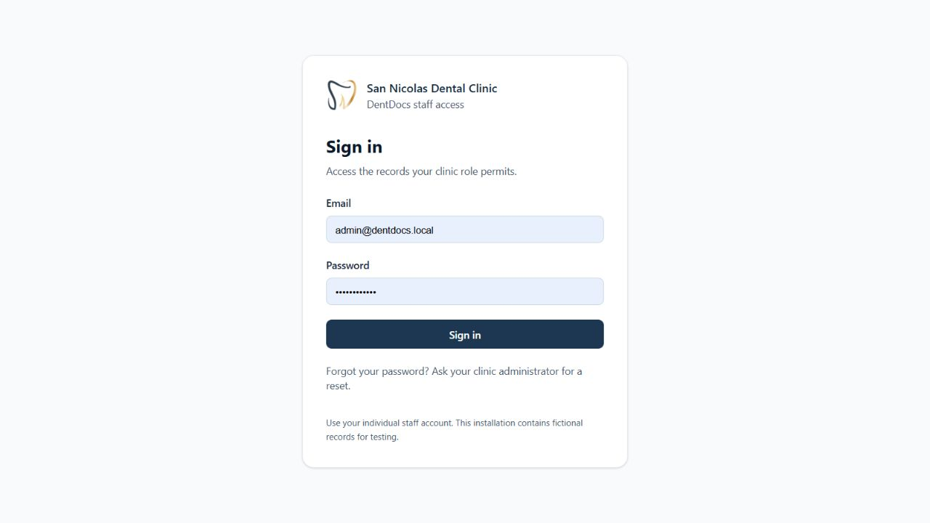

A.2 Signing In and Navigating the Dashboard
1. Enter the email address and existing password assigned to the individual staff member, then select Sign in. Shared accounts should not be used for attributable review decisions.
2. When the application requires a temporary password replacement, the account owner completes the password change. Read and acknowledge the current confidentiality notice before accessing records.
3. Confirm the displayed name and role in the account menu. Available screens and actions depend on server-enforced permissions.
4. Use Home, Patients, Upload, Incomplete, Search, Review, Audit, and Staff as permitted. Dashboard alerts link to records requiring attention.
5. At the end of a session, open the account menu and select Sign out. Session expiry requires signing in again. Request an authorized administrator reset for forgotten credentials.
Figure A2
Dashboard and Document Workflow Alerts
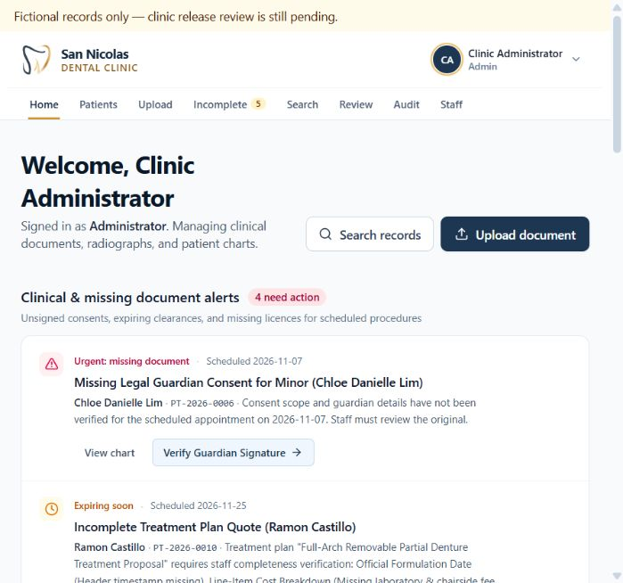
The password-replacement and notice gates are conditional first-use screens. They were not replayed solely for documentation, and no credentials are reproduced in this guide.

A.3 Locating a Patient and Opening a Document
1. Select Patients. Enter the patient name, record number, or mobile number in the directory search field.
2. Compare the record number with the intended patient before selecting Open Record. Similar names alone are insufficient for patient association.
3. Inspect the patient header, alerts, and contact background. Select a tooth in the FDI chart to filter linked documents when appropriate.
4. Select a linked document to open its viewer. Verify its title, patient record number, version, and current status.
5. Compare the extracted text and metadata with the retained original. A fictional fixture may explicitly state that no original was supplied; its preview is not a scanned source.
Figure A3
Patient Directory and Search Controls
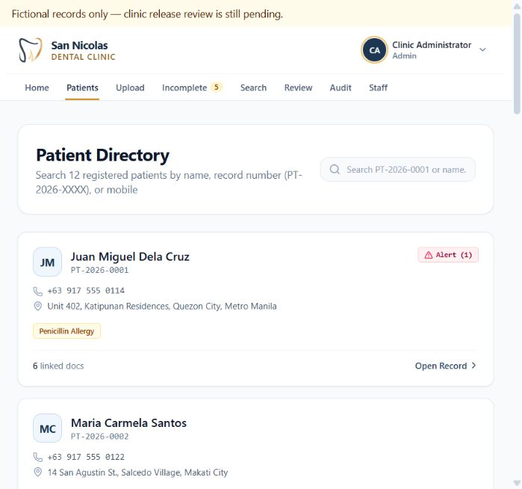
Figure A4
Selected Patient Record and Alerts
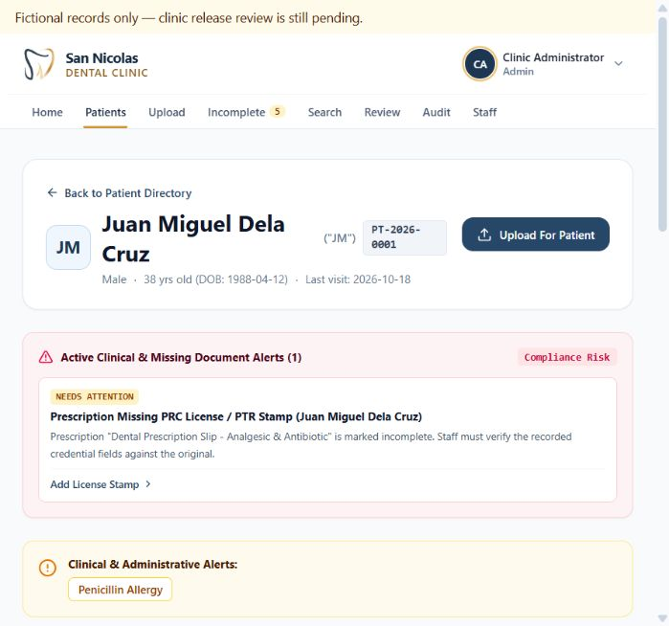
Figure A5
Document Metadata and Completeness Controls
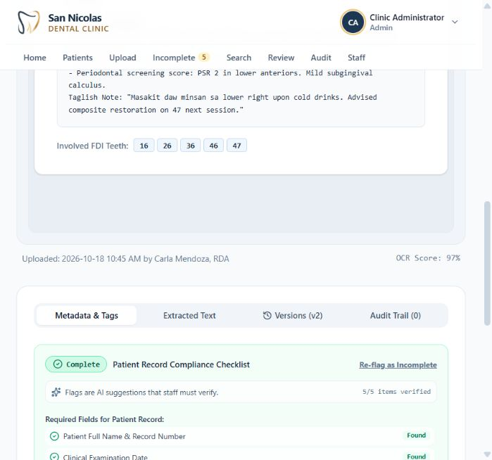
Note. This fixture displays demonstration content. Its label indicates that an original file was not supplied.
The current implementation displays existing patients and associates documents with those records. It does not expose separate patient registration and editing operations.

A.4 Uploading and Transcribing Documents
1. Select Upload or Upload For Patient. Confirm the selected patient record before choosing a file.
2. Choose a PDF, PNG, or JPEG original. Uploads are limited to 20 MiB. Printed PDF extraction supports up to ten pages and rejects encrypted PDFs. Use a readable scan with all relevant margins and pages.
3. Select Read Document Locally for printed-text extraction. Wait for processing to finish and inspect any warnings.
4. Compare the editable transcription with the original. Check every name, number, date, tooth reference, and document classification. Review the complete original separately when necessary.
5. Correct Document Type, Document Title, Date, Procedure Category, FDI tooth numbers, and tags. A displayed confidence estimate is not a verified clinical probability.
6. Verify the completeness checklist against the source. Select Send to Review Queue for unresolved extraction issues, or Confirm & Save to Record when the authorized checks are complete. Confirm the saved patient association and document status afterward.
7. If extraction fails, retain the original and use Enter metadata manually and send for review. Record uncertainty and do not describe manual entry as successful OCR.
Figure A6
Upload Workflow and Patient Assignment
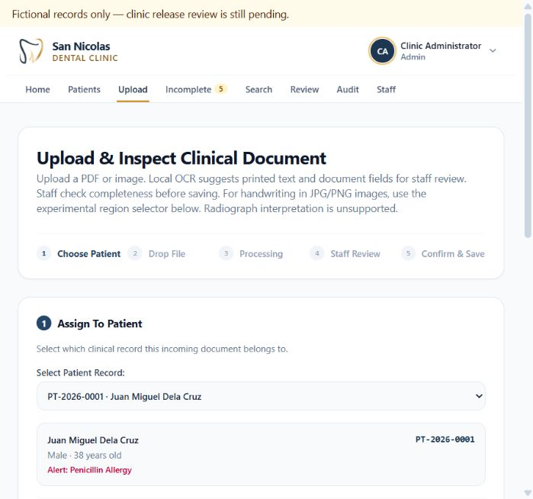
Figure A7
Editable Printed Text Extraction and Metadata
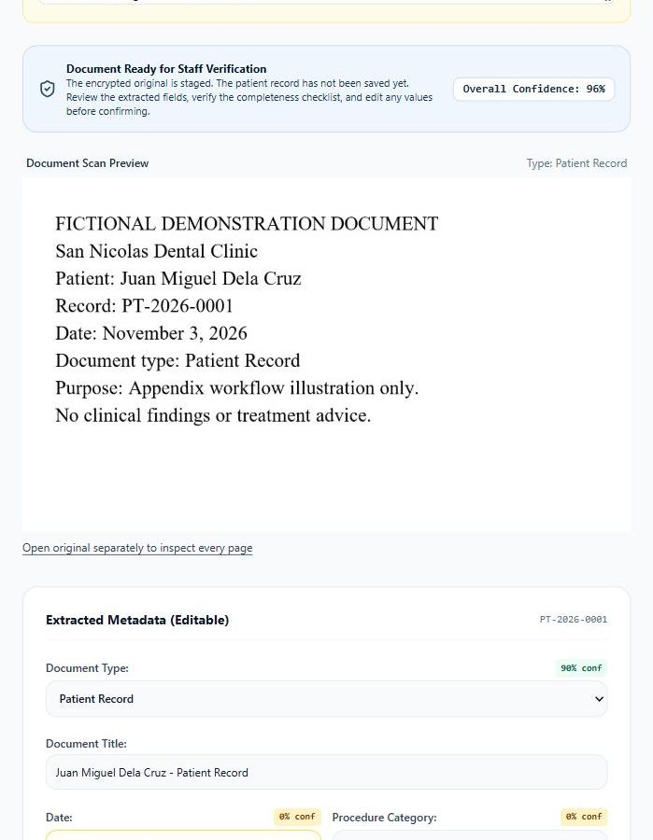
Note. This illustration used a purpose-made fictional sample. The original was staged for extraction; no patient document was saved during this documentation walkthrough.
For experimental handwriting assistance, select a JPG or PNG, expand Handwriting assistance, rotate the image if needed, and select one complete line using the region boundaries or drag selection. Select Suggest transcription when the reader is available. Compare the draft with the source, correct every character, and use Continue to metadata review. Unreadable content requires writer or reviewer confirmation. The reader does not guarantee whole-page or table reconstruction.
Figure A8
Experimental Handwriting Region and Rotation Controls
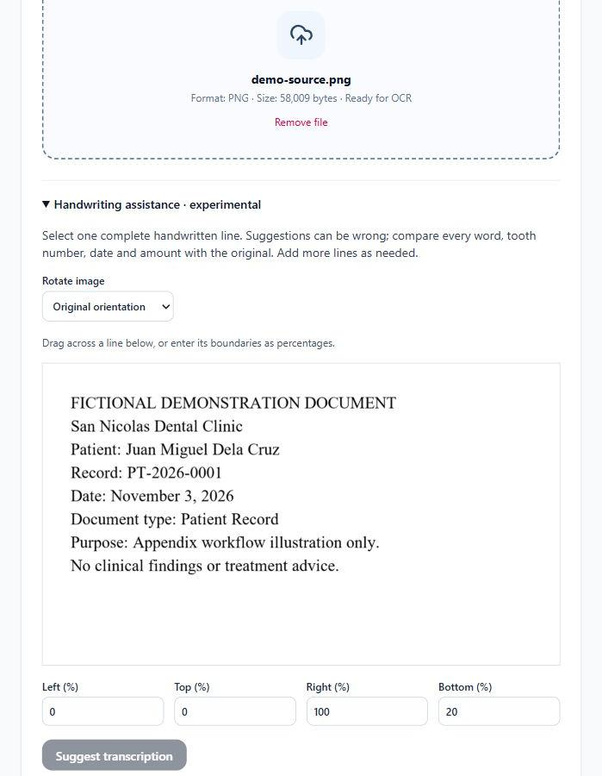
Note. The displayed image is a printed demonstration sample used to expose the controls. This figure does not report handwriting recognition performance or an accepted handwriting draft.

A.5 Extraction Review Completeness and Validity
1. Select Review and filter the queue by Review status or Assigned to me. Open a record and confirm its patient, document version, review reasons, and source availability.
2. Inspect Extracted text and field confidence and compare the text with the original. Assign a reviewer within the authority of the signed-in role when needed.
3. Select Approve extraction or Request corrections or replacement, supply the required staff review note and confirmations, and select Save review decision only after completing the checks.
4. If a source changes or the application reports a stale decision, reload the latest version, compare it again, and submit a new decision.
5. Use Incomplete to inspect missing checklist items. Use Inspect to return to the document, and Mark as Resolved only after the missing requirement has been verified and the required note is supplied.
6. Open Review and validity in the document viewer to inspect document validity. Record validity only from a supported source basis or eligible approved policy. Retain unknown validity when a basis is unavailable.
Figure A9
Pending Extraction Review and Named Decision Controls
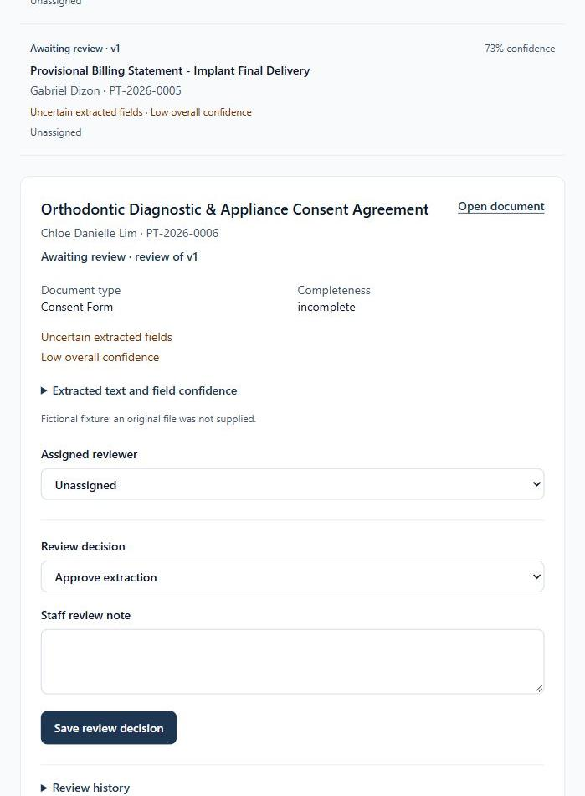
Note. The screenshot shows an awaiting-review state. No approval or correction decision was submitted for this illustration.
Figure A10
Completeness Checklist and Missing Fields
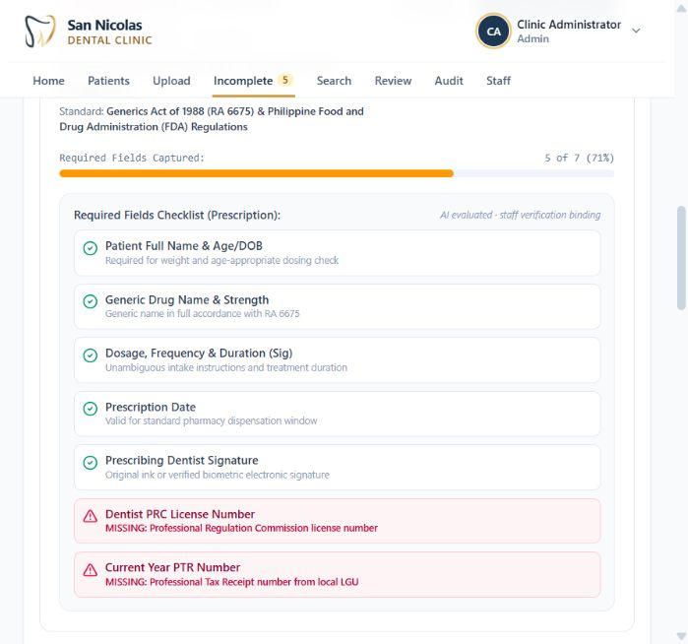
Note. Checklist wording is part of the prototype and remains subject to clinic policy approval. Its display is not a legal compliance determination.
Figure A11
Separate Extraction Review and Document Validity
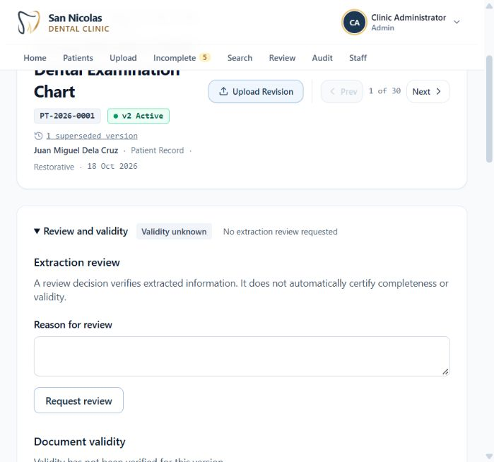
An approved extraction does not automatically make a record complete or valid. These decisions address different questions and remain separately recorded. To inspect validity policies, open the account menu and select Validity policies. A policy draft requires a documented clinic reference and approval by the appropriate role. Clinical policies require a dentist; administrative policies require an administrator. Existing fictional verification policies must not be adopted as clinic policy.
Figure A12
Validity Policy Versions and Approval States
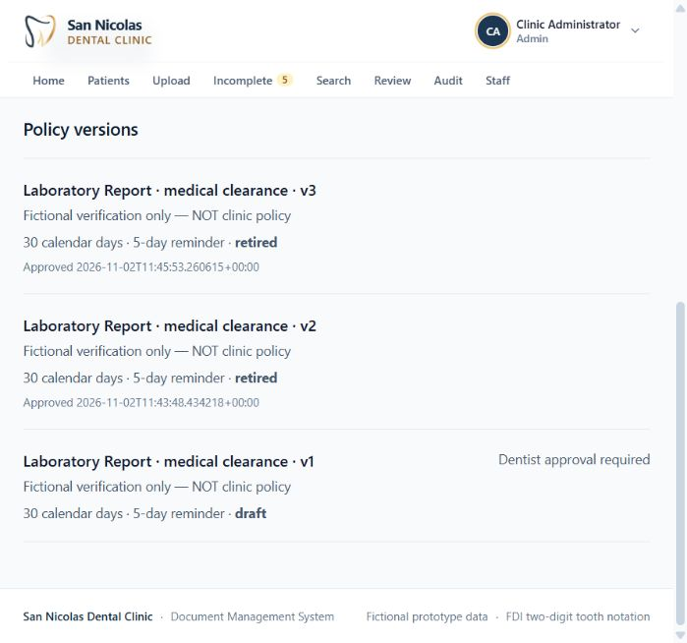

A.6 Searching Records and Reviewing Summaries
1. Select Search, enter a query, and choose Hybrid, Semantic, or Keyword under Search method. Keyword search is appropriate for exact names, record numbers, and wording.
2. Apply document type, status, patient, date, and tooth filters. Select Search again when needed.
3. Inspect the returned passage and its source version or revision, then open the record to verify the full context. Similarity alone does not establish a clinical fact.
4. If the optional reader is unavailable, inspect the displayed fallback or error. Hybrid can fall back to keyword retrieval; semantic-only requests report unavailability.
5. Open Administrative summary in the document viewer. Select Generate local draft when a summary is needed. Compare its quotations and proposed wording with the current source.
6. An authorized dentist or administrator may approve or reject the draft after supplying the required confirmation and note. A draft is not accepted merely because it was generated. Source edits can make a previous acceptance outdated and require fresh review.
Figure A13
Search Method and Faceted Filters
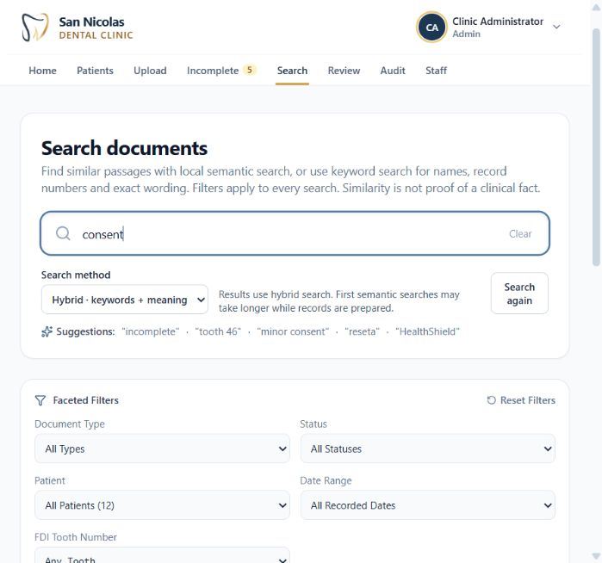
Figure A14
Administrative Summary and Current Acceptance State
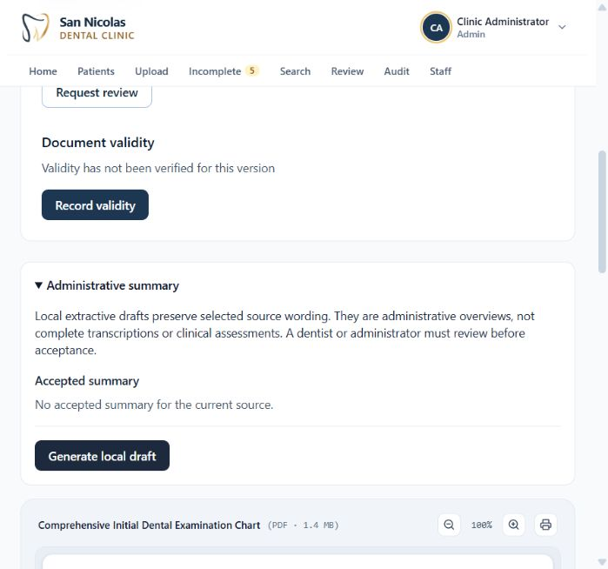
Note. No accepted summary exists for the displayed current source. The screenshot does not imply that a summary decision was made.
Administrative summaries are source-linked overviews. They are not complete transcriptions, diagnoses, treatment recommendations, or substitutes for the retained original.

A.7 Versions Archives Staff Accounts and Audit History
1. Open Versions in the document viewer to inspect the active and superseded revisions. Use Compare to inspect differences before choosing a revision.
2. Use Upload Revision for a replacement scan or revised source. Where authorized, Restore creates a new active state from a retained version; the historical record remains available.
3. Download or print only originals accessible to the signed-in role. A logged print request records the request and does not prove physical printer output.
4. An administrator can inspect archived records under Audit and use Restore Record when restoration is justified. Archiving hides a record from normal workflows and is reversible.
5. Select Staff to view named accounts. Create, reset, enable, disable, or change roles only under the clinic access policy. Account or credential changes can end existing sessions. Communicate temporary credentials privately.
6. Use Audit to inspect recorded actions, selecting staff and event-type filters as needed. Distinguish historical prototype events from authenticated operational events where their labels identify the difference.
Figure A15
Active and Superseded Document Versions
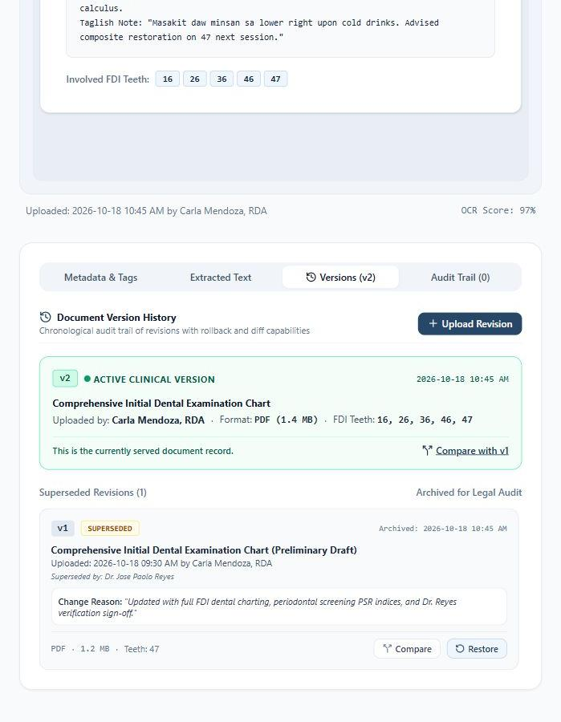
Figure A16
Administrator Archived Records Vault
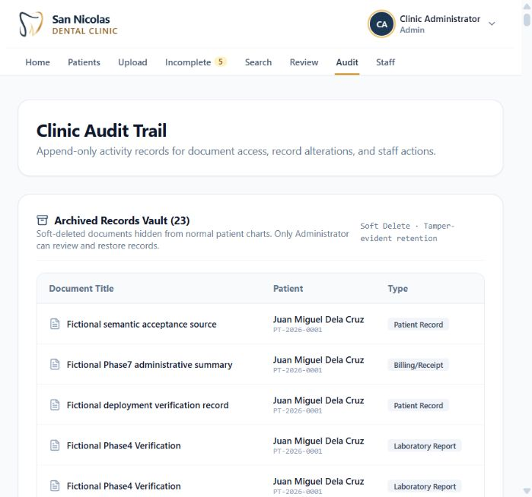
Figure A17
Staff Account Management Controls
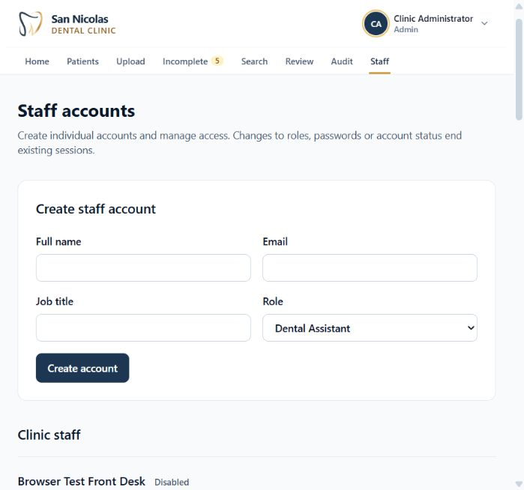
Figure A18
Audit Activity Stream and Filters
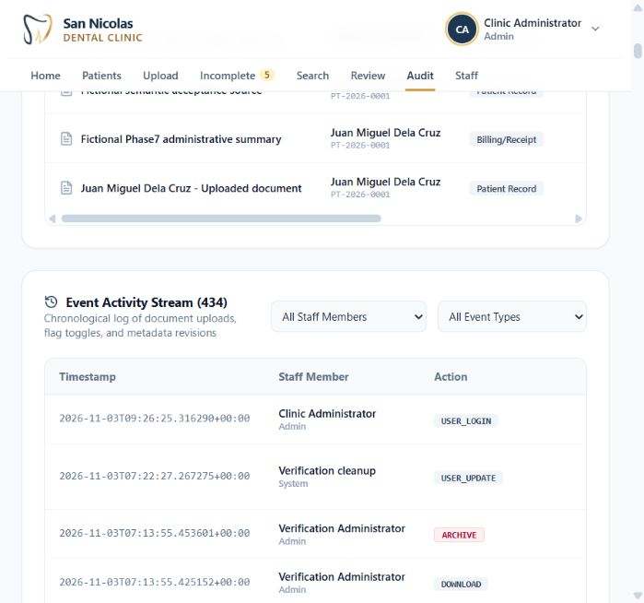

A.8 Backup and Recovery Procedures
Backup and recovery are operator tasks documented in PHASE8.md and PARSER_ISOLATION.md. An encrypted bundle includes the database dump, encrypted originals, required private configuration, source snapshot, model artifacts, and exact runtime images. The recovery key is held separately from the bundle. Losing the correct key makes its bundle unrecoverable.
1. Arrange a maintenance window with no other database writers or source, model, or configuration changes. Confirm sufficient storage and a complete prepared installation.
2. Use the existing separately held recovery key. Provision a new key only when establishing a new custody arrangement; never overwrite a retained key.
3. Run the backup command with a new snapshot destination. The tool temporarily stops web and API writers and restarts them afterward. Preserve the final encrypted bundle and record its creation and verification.
4. Copy the encrypted bundle off the host computer and hold the key separately. A same-disk copy does not demonstrate disaster recovery custody.
5. For a drill, choose a new isolated target and a loopback port other than the live port 8080. Authenticate all components before staging or starting restored services.
6. Run verification before interacting with the restored records and while the live source remains unchanged. Compare table hashes and original-file contents; confirm revoked restored sessions and protected histories.
7. Retain the nonsensitive verification report. Clean up only the named completed isolated drill using the supported cleanup command. Do not restore over live volumes or run blanket volume deletion.
# New key only when establishing separate key custody
.venv/Scripts/python.exe scripts/recovery.py keygen --key work/recovery-keys/recovery.key
# New backup destination
.venv/Scripts/python.exe scripts/recovery.py backup --key work/recovery-keys/recovery.key --bundle work/backups/snapshot-NEW
# New isolated recovery target
.venv/Scripts/python.exe scripts/recovery.py drill --key work/recovery-keys/recovery.key --bundle work/backups/snapshot-NEW --target work/recovery-drills/drill-NEW --port 18080
.venv/Scripts/python.exe scripts/verify-recovery.py --target work/recovery-drills/drill-NEW
The NEW suffixes identify example destinations that must be replaced by unique approved paths. These commands are operating examples and were not executed as part of preparing this appendix.
The retained parser-isolation recovery report records status passed, comparison of 19 persisted tables, and verification of 38 originals. It also records revoked restored sessions and protected history privileges. This is evidence from an earlier same-host isolated drill, not a newly performed drill or an independently demonstrated second-machine recovery. Source: work/parser-isolation/recovery-verification.json.
Backup frequency, retention period, off-device storage destination, responsible operator, alternate key custodian, recovery objectives, and physical second-machine drill approval remain [TO BE FILLED: clinic-approved operating policy].

A.9 Troubleshooting and Escalation
Application does not open. Confirm Docker Desktop and Compose service status, then use the loopback address http://127.0.0.1:8080. A frontend-only development server does not start the complete API stack.
Sign-in fails. Check the assigned account identifier and contact the administrator for an authorized reset. Do not delete configuration or recreate encryption keys.
Printed extraction is unavailable. Keep the original, inspect the error, retry when service is restored, or enter text manually with review required.
Handwriting or semantic reader is unavailable. Ask the operator to check prepared weights and reader configuration. Source-only clones do not include the trained artifacts. Use supported manual or keyword workflows.
A save or review decision is stale. Reload the current source and repeat verification before resubmitting. Avoid copying an obsolete decision onto a changed version.
Validity is unknown. Obtain an explicit source basis or eligible approved rule. Do not infer expiry from an upload date.
Original download or decryption fails. Preserve all configuration, volumes, keys, and evidence. Contact the operator; a newly generated key cannot decrypt originals protected by an earlier key.
An unexpected access restriction appears. Confirm the signed-in role and request review through the administrator. Do not change roles merely to bypass a restriction.
When reporting a fault, provide the screen, document identifier, approximate time, displayed error, and steps that preceded it. Exclude passwords, encryption keys, private configuration, and real patient content from general messages or academic evidence.

Appendix B References
The references below are retained from the supplied documentation and formatted using APA 7 conventions. The source report records November 3, 2026, as its consultation date. Repository paths identify implementation evidence.
AMR Contributors. (2026). African Medical Records (AMR): Nigerian handwritten clinical records dataset [Data set]. Hugging Face. https://huggingface.co/datasets/Nigeria-Health-data-OCR-pipeline/African-Medical-Records
DentDocs project contributors. (2026). DentDocs (commit c50295eb4b0394becb6f214f00de7a028f8dbb4a) [Source code]. GitHub. https://github.com/OhsirIIII/DentDocs/tree/codex/phase4-review-validity
Henry Schein One. (n.d.). The Document Center window. Dentrix Help. Retrieved November 3, 2026, from https://hsps.pro/Dentrix/Help/mergedProjects/Document%20Center/desktop/Using_Document_Center/The_Document_Center_window.htm
Li, M., Lv, T., Chen, J., Cui, L., Lu, Y., Florencio, D., Zhang, C., Li, Z., & Wei, F. (2021). TrOCR: Transformer-based optical character recognition with pre-trained models [Preprint]. arXiv. https://arxiv.org/abs/2109.10282
Open Dental Software. (n.d.). Imaging module. Retrieved November 3, 2026, from https://www.opendental.com/manual/images.html
Sentence Transformers. (n.d.). all-MiniLM-L6-v2 [Model card]. Hugging Face. Retrieved November 3, 2026, from https://huggingface.co/sentence-transformers/all-MiniLM-L6-v2
The research dataset snapshot was pinned at fa27d29dae4128ac45f035fd580928c84bec4e98. Dataset attribution/license notices must accompany permitted redistribution. This report does not redistribute private photos, annotations, weights, credentials, recovery keys or configuration.

Appendix C Source Code and Repository Link

C.1 Repository and Implementation Baseline
Repository: https://github.com/OhsirIIII/DentDocs. Implementation branch: codex/phase4-review-validity. The implementation baseline described by this report is commit c50295eb4b0394becb6f214f00de7a028f8dbb4a. Subsequent local documentation and screenshot changes do not establish that this branch has been merged into the production branch.

C.2 Source Organization
src/ contains the React and TypeScript browser application. src/views/ defines the dashboard, patients, uploads, document viewer, search, review, completeness, validity policies, staff, and audit screens. src/components/ supplies shared controls such as handwriting selection and source-linked summaries.
backend/ contains the FastAPI application, SQLAlchemy persistence, authorization, and API tests. ocr/ contains the separately isolated printed-text processing service and its tests.
handwriting/ and training/ contain reader integration and experimental training support. Model weights, private source images, and independently confirmed dental labels are not supplied by a source-only checkout.
scripts/ contains configuration, bootstrap, recovery, verification, and operator test tools. compose.yaml defines deployment services. PARSER_ISOLATION.md explains the processing boundary; SECURITY_FOLLOWUP.md records outstanding security work.

C.3 Building Running and Checking the Source
For a fresh fictional-data checkout, use the first-install procedure in Chapter 5 and README.md. For an existing prepared installation, use the resume procedure in Section A.1. Keep the full stack and optional model preparation distinct from frontend development checks.
npm ci
npm run lint
npm run build
These commands install the locked frontend dependencies, run the configured TypeScript check, and create the production frontend build. API tests use isolated fixtures; native worker and recovery tests require the dependencies and procedures identified in README.md, PARSER_ISOLATION.md, and scripts/tests. Recorded test results in Chapter 6 were not rerun during this editorial update.

C.4 Licensing and Reproducibility
No root LICENSE file was identified in the supplied implementation evidence. Repository-wide ownership and license confirmation remain [TO BE FILLED: project owner confirmation]. An individual source comment does not establish a repository-wide license. Third-party software, datasets, and model licenses remain separate obligations.
A source checkout alone cannot reproduce private databases, retained originals, local model weights, or an authenticated recovery bundle. Reproduction requires the appropriate dependencies and approved artifacts. Private configuration, credentials, recovery keys, patient records, and unconfirmed annotations must not be included in the academic submission or public repository.

Final Checklist
Verified in supplied documentation: Required chapters/sections are present in order.
Verified in supplied documentation: Android-only requirements are marked not applicable.
Verified in supplied documentation: Features/API/schema/snippets are grounded in repository evidence.
Chapter figures and tables and the new appendix screenshots are numbered, captioned, and listed.
Verified in supplied documentation: Architecture, DFD, ER, use case, class and sequences use Mermaid; wireframes use text.
Verified in supplied documentation: Real snippets identify source paths.
Verified in supplied documentation: References use consistent APA-style attribution and primary links.
Verified in supplied documentation: Recorded results are distinguished from unperformed evaluations.
Human-input requirements and the actual status of appendix illustrations are registered below.

Placeholder Register
All [TO BE FILLED] categories:
1. Title page: student names and identification numbers. The course, instructor, and submission date were supplied.
2. Approval: adviser, panel members, and department head; signatures and dates remain blank.
3. Acknowledgments: confirmed names/contributions.
4. Contents: the Word table of contents is generated from document headings; figure and table lists identify all numbered items.
5. Chapter 1: measured clinic baseline/workload and approved academic schedule.
6. Chapter 3: usability study, browser/OS matrix, privacy/retention policy, IDE/plugins, developer specifications, approved browser versions and measured host sizing.
7. Chapter 5: IDE/version/plugins and exact OS build.
8. Chapter 6: UAT participants/protocol/sign-off; actual results/status for TC-22 and TC-23.
9. Appendix A: clinic-approved backup schedule, retention, off-device storage, operator, key custodian, recovery objectives, and physical-drill approval.
10. Appendix C: repository-wide ownership/license confirmation.
Appendix illustrations now include actual local application captures for sign-in, dashboard, patients, upload, printed extraction, handwriting controls, review, completeness, validity, search, summaries, versions, archives, staff, and audit. Recovery results are reported from the retained verification file rather than represented as a newly captured execution.
Conditional first-use password and notice screens, an accepted handwriting draft, a newly submitted review decision, and an outdated accepted-summary state were not recreated solely for illustration. The user guide explains these workflows without presenting fabricated outcome screenshots.
Outstanding human input remains limited to the named academic details and approvals, unperformed evaluations, clinic operating policies, and repository licensing confirmation identified above.

