Adaptive Obstacle Avoidance: Methods, Code, and Dynamical-Systems Account
Peter Ohue, Gunnar Blohm
This document explains the task and controller, the code pipeline that produces every figure and table in the manuscript, and the dynamical-systems framework used in the closed-loop fixed-point analysis (Figure 7). It is intended as a standalone reference for collaborators and reviewers who want to run or extend the analysis without reading the full manuscript source.

1. Task and controller
We implemented the obstacle-avoidance environment using the Gymnasium interface, a standard open-source framework for defining physics-based reinforcement learning environments. The agent is a two-dimensional point mass that receives continuous force commands at each timestep and evolves under Newtonian dynamics within a bounded rectangular workspace. We deliberately kept the dynamics minimal (a single point mass with no rotational degrees of freedom and no joint limits) so that any representational structure found in the trained network is attributable to learning rather than to the complexity of the physical system.
The main perturbation experiment used a corridor formed by two static circular obstacles positioned symmetrically about the midline of the workspace. To probe the controller's capacity for online correction, we applied transient lateral force impulses mid-movement during evaluation. The impulse magnitude was held constant for six consecutive timesteps beginning at timestep 50, giving seven evaluation conditions: an unperturbed control (P0) and three increasing leftward perturbations (L1, L2, L3) and three increasing rightward perturbations (R1, R2, R3).
All training and evaluation used Stable-Baselines3, an open-source Python library built on PyTorch. We used Proximal Policy Optimization (PPO). The policy and value networks are separate feedforward multilayer perceptrons (MLPs), each with two hidden layers of 256 units and rectified linear (ReLU) activations. A feedforward MLP processes each timestep independently, without recurrence or explicit memory of previous states. Training ran for 3x10^6 environment timesteps.

2. Code pipeline
The repository is organised so that each stage of the pipeline, training, evaluation, neural-population analysis, and figure generation, has its own entry point. Collaborators can run any stage independently provided the previous stage's outputs exist on disk.

2.1 Training and evaluation
- src/training/trainer.py - PPO training loop (Stable-Baselines3).
- src/environment/ - the Gymnasium obstacle-avoidance environment and observation builder.
- src/evaluation/evaluator_v2.py - runs the trained policy across all seven perturbation conditions and saves per-episode trajectory, kinematics, and summary CSVs to experiments/version_1_0/results/evaluation_<condition>/.

2.2 Neural population analysis
- src/neural_analysis/activation_extractor.py - extracts the 256-unit hidden-layer activation vector at every evaluation timestep into latent_dataset.npz (activations, condition, episode, timestep).
- src/neural_analysis/latent_pca.py, latent_clustering.py, latent_correlation.py, latent_trajectory.py - PCA, hierarchical clustering, correlation, and trajectory analyses of the latent dataset.
- src/neural_analysis/attractor_analysis.py - closed-loop (policy + physics) fixed-point and vector-field analysis in the agent's physical state space, described in Section 3 below.

2.3 Figure generation (independent, standalone scripts)
Every main-text figure script is self-contained: it reads directly from experiments/version_1_0/results/ and writes both a PNG and an editable SVG (Arial 10pt, COSYNE convention) without depending on any other figure script.
- scripts/build_fig2_trajectories.py -> paper/fig2_trajectories.png + paper/figures/fig2_trajectories.svg
- scripts/build_fig3_velocity.py -> paper/fig3_velocity.png + paper/figures/fig3_velocity.svg
- scripts/build_fig4_pca.py -> paper/fig4_pca.png + paper/figures/fig4_pca.svg
- scripts/attractor_analysis.py -> experiments/version_1_0/results/neural_analysis/attractor/*.png (source panels for Figure 7)
- scripts/build_manuscript_attractor_figure.py -> paper/fig7_attractor.png + paper/figures/fig7_attractor.svg
Figures 1, 5, and 6 are produced by earlier hand-finished or script-generated assets already in paper/figures/; Figure 1 in particular is a hand-drawn biological schematic with no data-generating script.
python scripts/build_fig2_trajectories.py
python scripts/build_fig3_velocity.py
python scripts/build_fig4_pca.py
python scripts/attractor_analysis.py
python scripts/build_manuscript_attractor_figure.py

3. Dynamical-systems framework for the closed loop
PCA, clustering, and decoding describe where the population activity sits. They do not say why it sits there. To answer that, we treat the trained policy and the physics engine together as a single closed-loop dynamical system and analyse it with the standard vocabulary of dynamical-systems theory.

State, trajectory, vector field
A dynamical system is a rule for how a state changes over time. Here the state is the agent's physical situation: lateral position x, forward position y, lateral velocity vx, forward velocity vy. At every timestep the policy reads the state (plus the fixed goal and obstacle geometry) and outputs an acceleration; the physics engine integrates that acceleration into a new velocity and position. Chaining this over many steps produces a trajectory, exactly the (x, y) paths plotted in Figure 2. The vector field is the same rule evaluated everywhere at once: at every point in the state space, it specifies which direction and how fast the state moves next. A trajectory is one path through the vector field; the vector field is the full set of paths the system could take from anywhere.

Fixed points, stability, attractors
A fixed point is a state where the vector field is zero: nothing changes if the system starts exactly there. In this task, that means zero lateral velocity and zero commanded lateral acceleration; the controller has stopped correcting sideways and is content to keep going straight up the corridor. Whether a fixed point matters behaviourally depends on its stability. Perturbing the state slightly and linearising the vector field around the fixed point yields a matrix, the Jacobian, whose eigenvalues describe what happens next. In discrete time (the simulation advances in fixed steps of dt = 0.05 s), an eigenvalue with magnitude below 1 means that direction decays back to the fixed point, an attractor along that direction; magnitude above 1 means it grows away, a repeller; a nonzero imaginary part means the decay oscillates on the way back in rather than returning in a straight line. A fixed point's basin of attraction is the set of starting states that eventually settle there, and two different attractors can coexist in the same system (multistability) provided their basins do not overlap.

Why a feedforward policy still has a closed loop
The classic version of this analysis (Sussillo and Barak, 2013) finds fixed points of a recurrent network's own hidden state, because a recurrent unit's activity at time t+1 is a function of its activity at time t. Our policy is feedforward: the 256-unit hidden layer analysed in Figure 4 is a static function of the instantaneous observation, with no memory of its own previous value, so “the fixed points of the hidden layer” is not a well-posed question here. What is well posed, and what we compute instead, is the fixed points of the closed loop formed by the policy and the environment's physics, in the agent's physical state space. This is a legitimate substitute for the recurrent-network case, and is arguably more interpretable here, since the state space (x, y, vx, vy) already carries physical units and meaning, unlike an RNN's abstract hidden units.

What the closed-loop analysis found
Every one of the 140 saved evaluation episodes took the same, left, detour, so we solved for the fixed point of the reduced lateral subsystem (x, vx) separately for the left route (matching the sampled data) and, as a prediction, for the right route. Both fixed points are locally stable, with two real eigenvalues below 1 in magnitude and no imaginary component, meaning the lateral state relaxes back to it smoothly rather than oscillating. The left-route fixed point sits at x* = 3.32 m with a relaxation time constant of 1.42 s; the right-route fixed point sits at x* = 6.70 m with a time constant of 1.35 s, close to a mirror image of the left about the corridor midline at x = 5.0 m. The obstacles sit at x = 4.25 m and x = 5.75 m with 0.5 m radius, so the left-route fixed point leaves about 0.43 m of clearance from the near obstacle edge; a rightward perturbation pushes the agent toward that same near obstacle it is already closest to, which is the geometric explanation for the direction-dependent robustness asymmetry reported in the manuscript.

4. Results figures
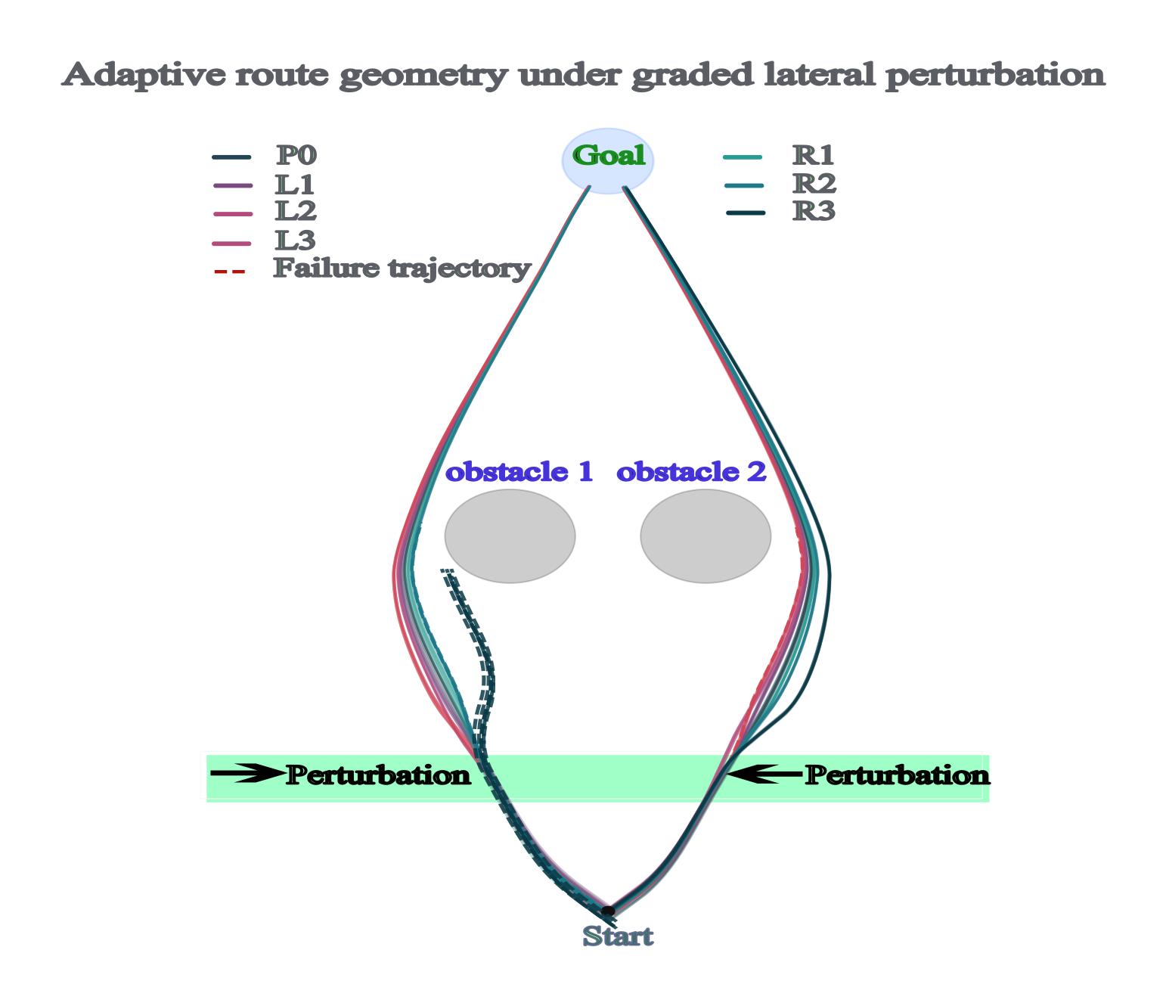
Figure 2. Cumulative reach trajectories across all seven perturbation conditions.
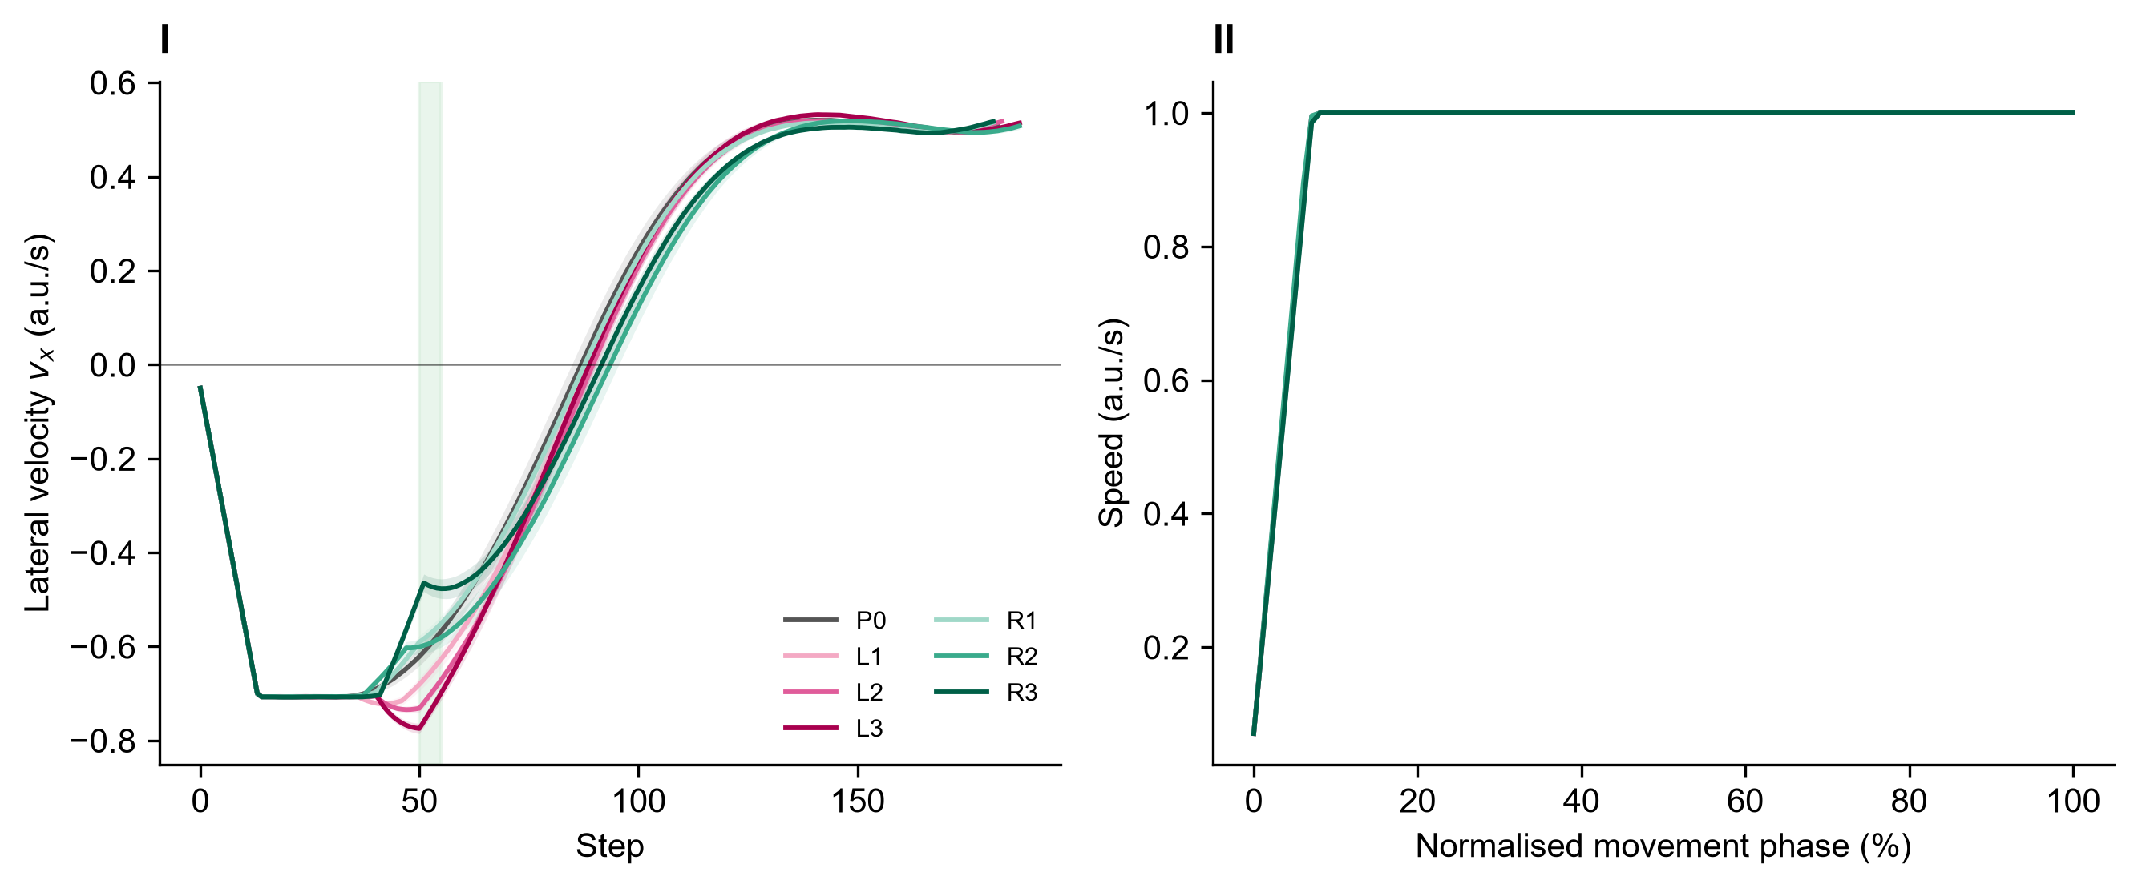
Figure 3. (I) Mean lateral velocity and (II) mean speed vs. normalised movement phase, by condition.
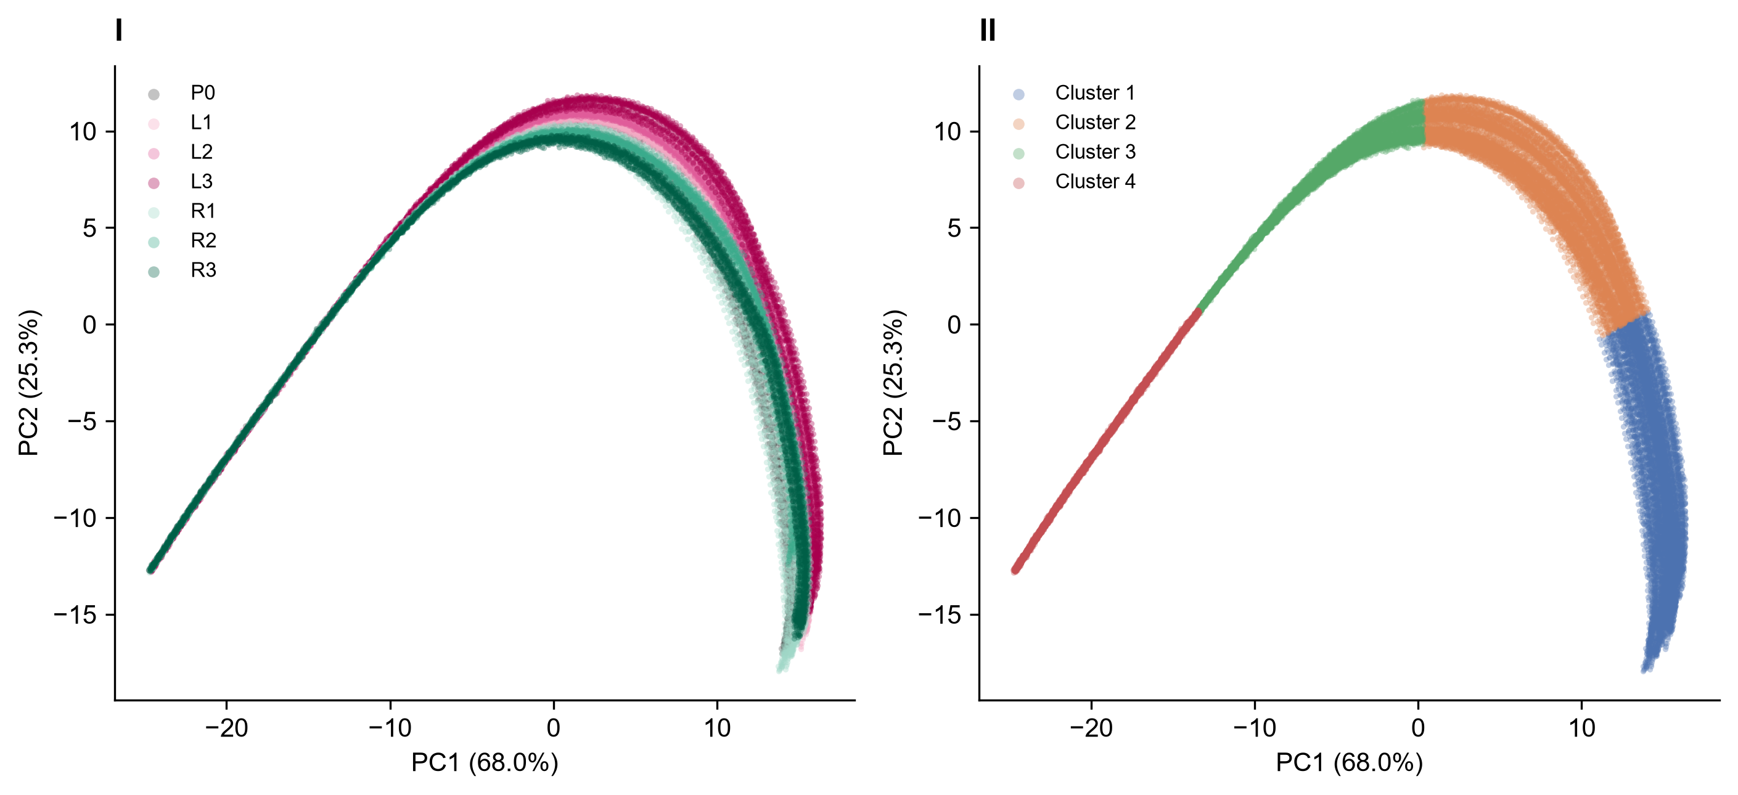
Figure 4. (I) PC1-PC2 projection of hidden-layer activity coloured by condition. (II) The same projection coloured by K-means cluster label (K=4).
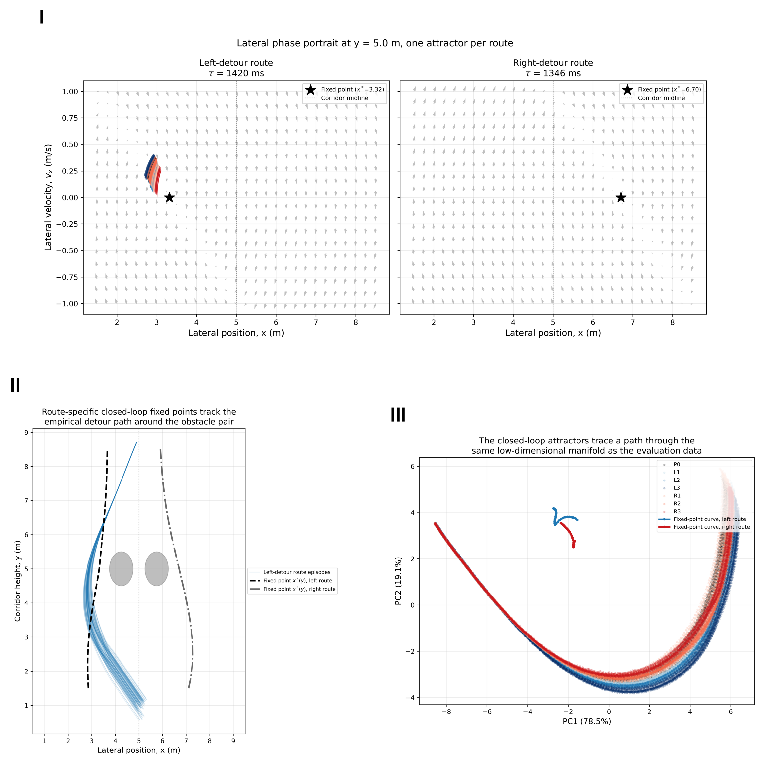
Figure 7. (I) Closed-loop lateral phase portrait and fixed points per detour route. (II) Fixed-point location across corridor height vs. empirical detour path. (III) Fixed-point curves projected into the PC1-PC2 manifold.

5. Reproducibility notes
- Run commands as `python -m pytest ...` or `python scripts/...` from the repository root with the project .venv active.
- Figures 2, 3, 4, and 7 read from experiments/version_1_0/results/ (not version_2_0, which only retains final neural-analysis manuscript PDFs, not raw per-episode recordings).
- The PCA variance reported for Figure 4 (PC1=68.0%, PC2=25.3%, total=93.3%) is computed directly from experiments/version_1_0/results/latent_dataset.npz with unit-wise standardisation before PCA, and is reproducible by running scripts/build_fig4_pca.py. It differs from the 74.8% figure quoted in the COSYNE abstract and grant proposal, which was computed by an earlier version_2_0 pipeline whose raw per-episode recordings are no longer present in this repository; that number is kept as-is in already-submitted documents and is not retroactively changed here.

