The dynamics live in the loop: route-specific lateral equilibria of a memoryless controller
Summary
Unexpected forces can push an ongoing reach toward an obstacle, requiring the motor system to correct while preserving progress to the target. We asked whether reward-based learning can produce interpretable population structure and local stability in a memoryless controller, and whether the stabilizing dynamics reside in the policy or in its interaction with physics. We trained a feedforward proximal policy optimization (PPO) actor-critic for 3 × 10^6 steps to steer a point mass through two obstacles. Its two 256-unit hidden layers received a 13-dimensional observation that included kinematics, task geometry, heading, and an explicit route cue. We analysed one hidden layer across 280 episodes (40 per condition, balanced across left and right routes) in seven conditions: baseline and three lateral-force magnitudes per direction. Fourteen-step impulses began at step 40. PCA showed that PC1 and PC2 accounted for 39.6% and 31.1% of activity variance (70.6% total); trajectories were ordered by movement step and separated by route, which was explicitly cued. At y = 5 m, with forward speed fixed and force removed, the reduced lateral policy-physics loop had stable, non-oscillatory fixed points at x* = 3.321 m (left route) and 6.705 m (right), with relaxation times of 1.42 s and 1.34 s. Mean successful crossing positions were 0.11 m and 0.09 m away. Only the strongest rightward impulse (1.80) collided: 20/20 left-route episodes; all other route-by-condition groups succeeded. Because force magnitudes differed across directions, this does not establish directional vulnerability. Episode-held-out decoding was 0.11 before and 0.81 after the impulse (chance 0.143), showing decodability rather than policy use. Thus, local stabilization resides in the closed policy-environment loop, not recurrent hidden-state dynamics. This one-seed point-mass model is a testable computational reference for studying feedback and population activity in perturbed reaching, not a neural equivalent.
Additional details
Motor-cortex reaching activity has structured population trajectories [1]. Here, “population” means 256 artificial hidden units, not recorded neurons. The feedforward actor maps current observation to activity; its hidden layer has no recurrent dynamics. Fixed points belong to the policy-physics loop, not hidden activity [2].
The actor-critic was trained for 3 million steps; the analysed best-evaluation checkpoint was saved at 800,000. Its 13-dimensional observation includes kinematics, target- and obstacle-relative coordinates, heading, target distance, and route cue. We evaluated 280 episodes, balanced across route and condition. Fourteen-step impulses began at step 40; leftward magnitudes were 0.40, 0.60, 0.85 and rightward 0.40, 0.65, 1.80, with Gaussian jitter (SD 0.05). Directions were not magnitude-matched.
At y = 5 m, with forward speed fixed and the force removed, local linearization of the reduced lateral map gave stable, non-oscillatory fixed points. They were within 0.11 m and 0.09 m of mean successful crossings. The equilibrium curve did not track the full path; relaxation times varied across checkpoints and are model times, not human response latencies.
The held-out decoder identified condition after, but not before, the impulse. Since the policy has no memory and receives current kinematics, decoding may reflect state change rather than stored perturbation history. A human comparison should test whether cortical decoding persists after accounting for hand state during matched perturbations across route plans [3,4].
References
[1] Churchland et al. (2012)
[2] Sussillo & Barak (2013)
[3] Pruszynski & Scott (2012)
[4] Nashed et al. (2014)
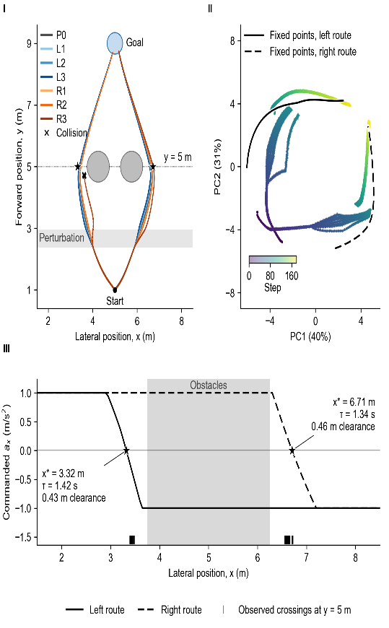 | 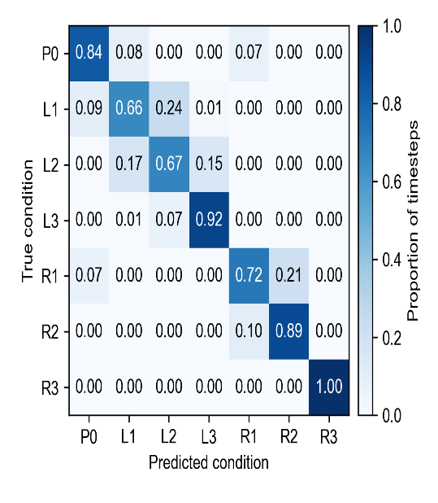
Figure 1. Behaviour, activity structure, and local stability. (A) Both routes; only the strongest rightward impulse collided on the left route (20/20). (B) PC1-PC2 activity (70.6% variance). (C) Negative-slope zero crossings show local stability at y = 5 m. | Figure 2. Episode-held-out perturbation decoding. Accuracy after the impulse was 0.81 (chance 0.143); errors were mainly between neighboring magnitudes on the same side.

