Obstacle avoidance under perturbation: a closed-loop attractor account
Abstract
Obstacle avoidance requires the rapid, graded correction of an ongoing reach after an unexpected force, without derailing an otherwise successful approach to the goal. We asked whether reward training alone produces this kind of correction, and whether the resulting population dynamics resemble biological reaching. A proximal policy optimization (PPO) controller learned to move a point mass through a two-obstacle corridor to a target. Six-timestep lateral force impulses were applied at three magnitudes in each of left and right directions. We analyzed the 256-unit hidden layer with PCA, clustering, kinematic tuning, linear decoding, and a closed-loop dynamical-systems analysis that treats the policy and the physics engine as one system. Moderate perturbations were compensated by graded path changes with almost no change in speed. Strong perturbations exposed a directional asymmetry: rightward impulses caused more failures than equal leftward impulses. The first two principal components captured 74.8% of hidden-activity variance, and four clusters aligned with movement phase across conditions. The main contribution here is mechanistic, not only descriptive: the closed loop has two stable fixed points, one per detour route, at x*=3.32 m and x*=6.70 m, with similar relaxation times (1.42 s, 1.35 s); the linearization has no oscillatory component, though the empirical correction itself briefly overshoots before settling. The asymmetry is explained geometrically, by obstacle clearance, not by one route being a weaker attractor, and both fixed-point curves fall on the same PC1-PC2 manifold region as the four phase-aligned clusters. Reward-driven optimization produces a compact, phase-structured, mechanistically interpretable solution to obstacle avoidance, without biological supervision. With one training seed and a feedforward policy, the correspondence to biology is organizational, not anatomical. A planned validation dataset will compare these signatures directly with wrist kinematics and six-muscle surface electromyography in healthy adults and stroke survivors.

Additional details
Task success alone does not show how a controller corrects an unexpected force, or why the same force fails in one direction. Sensory feedback must be converted into rapid, graded corrections while the limb keeps moving toward the goal, and this correction has to respect a hard physical constraint, the obstacle boundary. Population recordings in motor cortex show these corrections are distributed across neural activity and evolve through movement phases [1], which is why a population-level account, not a single-unit one, is the right level of description.
What is new here. We do not stop at describing the population geometry, but we go further to treat the trained policy and the physics engine together as one closed-loop dynamical system and find its fixed points in physical state space. These fixed points match the empirical detour trajectory within a few centimetres, explain the perturbation-direction asymmetry through obstacle clearance rather than unequal attractor strength, and map onto the same region of the PC1-PC2 manifold as the four phase-aligned clusters. This gives a testable, quantitative account of how the network solves obstacle avoidance, not only that it does.
A PPO actor-critic was trained for 3 million environment steps. The actor is a feedforward MLP with two 256-unit hidden layers, processing each timestep independently with no recurrence or memory. Because the policy has no memory of its own, the fixed points reported here are not fixed points of the hidden layer; there is nothing for a memoryless map to be a fixed point of. What is well posed, and what we compute instead, is the fixed points of the closed loop formed by the policy and the environment's physics. This is a direct substitute for the recurrent-network fixed-point analysis [2].
PC1 explained 46.8% and PC2 explained 28.0% of hidden-activity variance (74.8% combined). The closed-loop fixed points are stable under linearization (real eigenvalues, magnitude below 1, for both routes), so the local dynamics do not oscillate; the empirical lateral-velocity trace nonetheless briefly overshoots the baseline before settling, reflecting the policy's finite-amplitude nonlinear correction rather than the local linear dynamics themselves. The two routes are close to mirror images of each other (x*=3.32 m and 6.70 m), with similar relaxation times, so the asymmetry is not explained by one route being an intrinsically weaker attractor. It is explained by clearance: the obstacle pair sits at x=4.25 m and x=5.75 m with 0.5 m radius, so the left-route fixed point leaves about 0.43 m of clearance from the near obstacle edge, and a rightward perturbation pushes the agent toward the obstacle it is already closest to.
The relaxation time constant we recover, 1.3 to 1.4 s, is the same quantity used to characterize feedback-controller recovery in human perturbation experiments. The present result comes from one training seed and a simplified two-dimensional controller. Multi-seed training and a planned comparison with wrist kinematics and six-muscle surface EMG in healthy adults and stroke survivors are the direct next tests of robustness and biological scope.

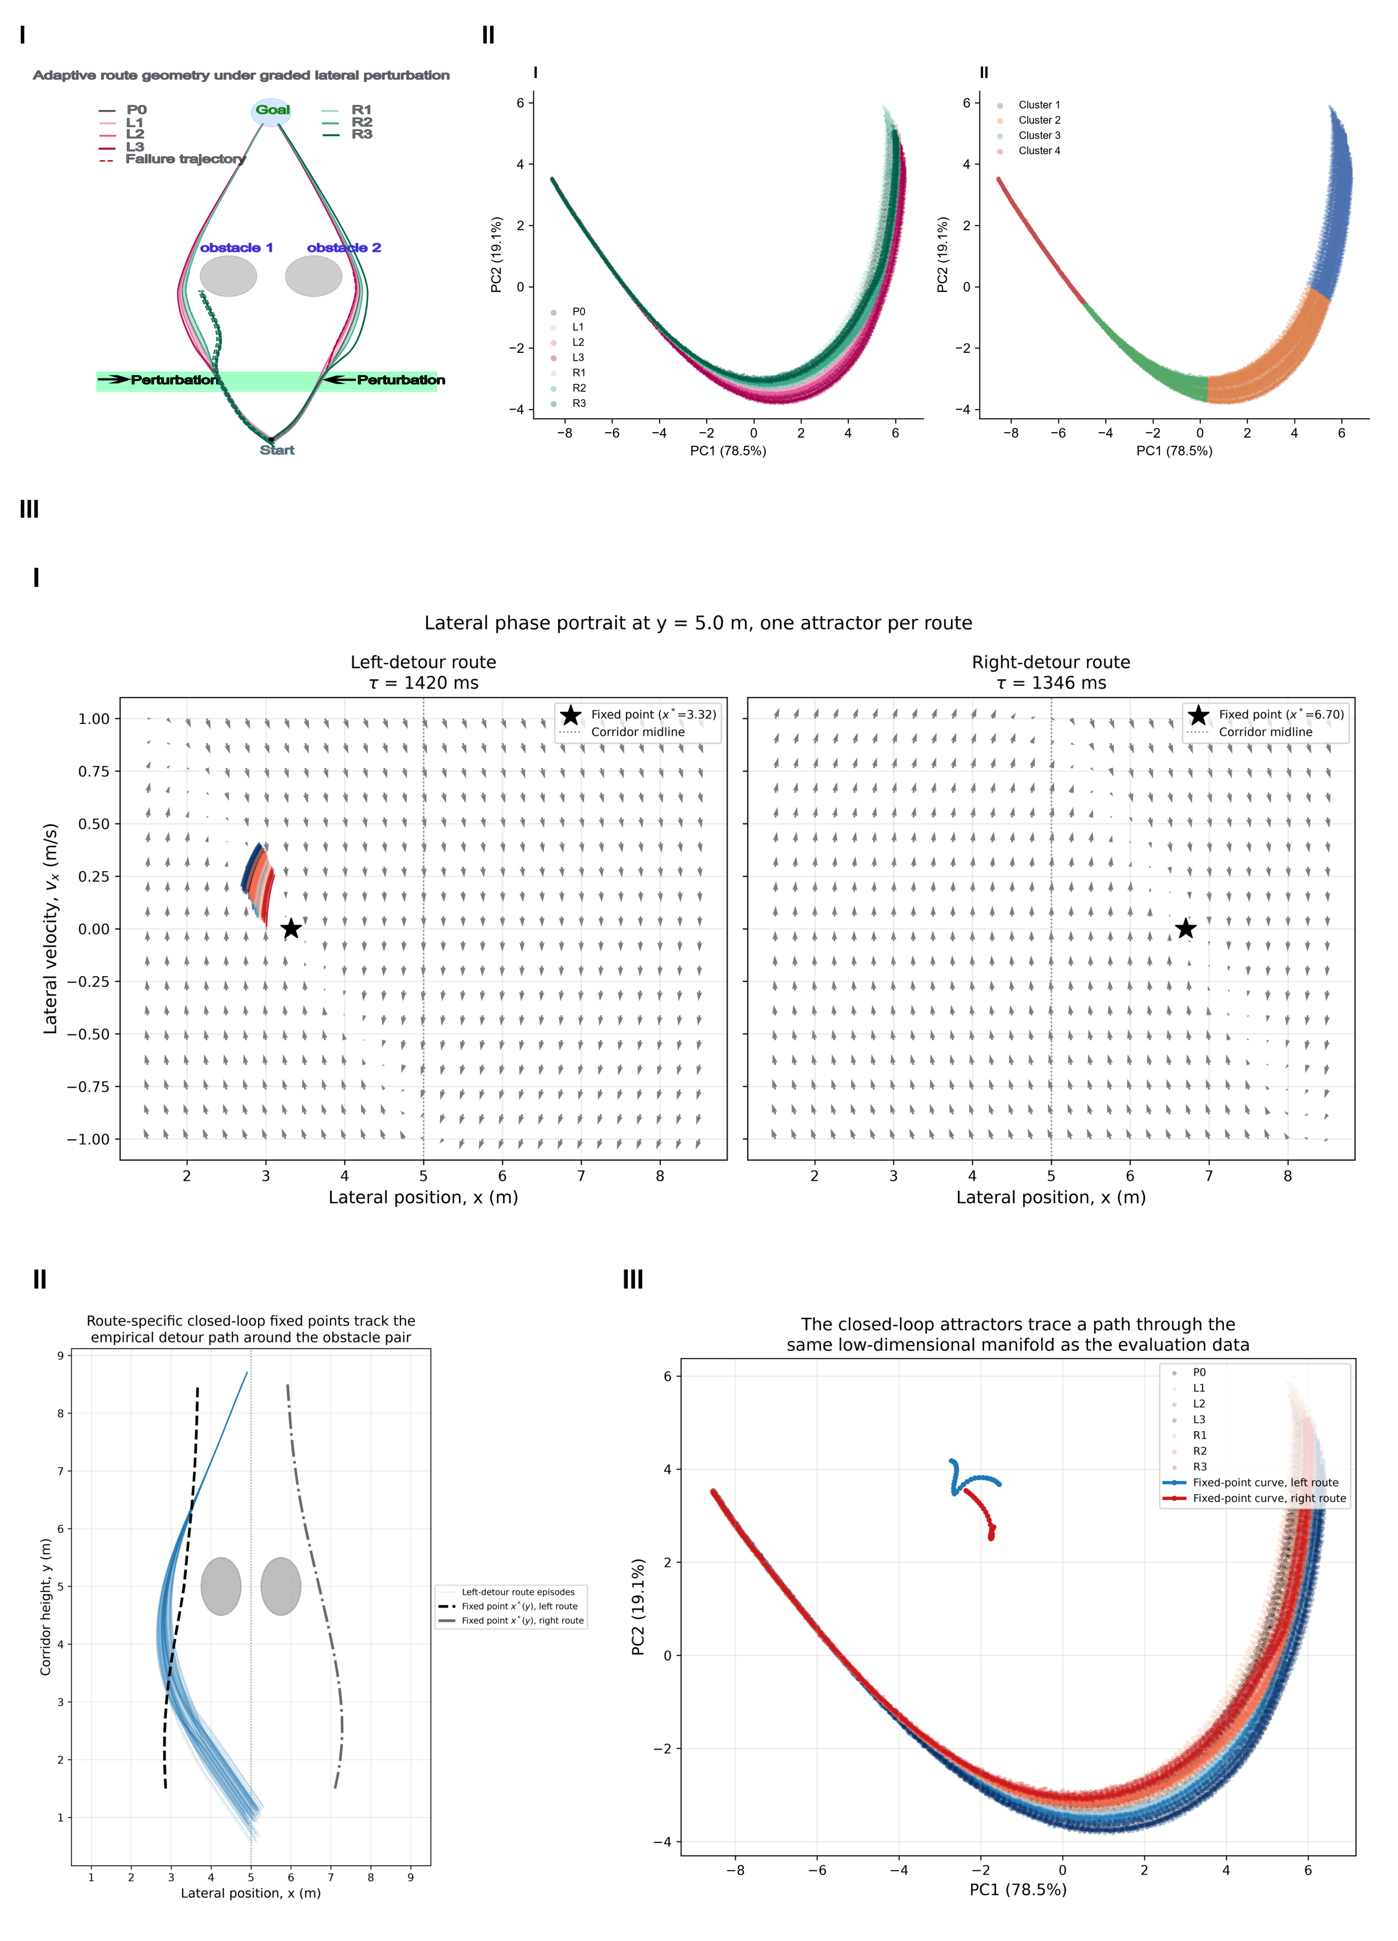
Figure. Obstacle avoidance and its mechanism. (I) Trajectories bend with perturbation strength; dashed lines mark failures, which occur at the strongest rightward impulses. (II) Hidden layer activity forms a compact PC1-PC2 manifold with four phase-aligned clusters. (III) Closed-loop analysis identifies one stable fixed point per detour route. The fixed-point curves track the empirical paths and occupy the same manifold region as the evaluation activity. Reduced obstacle clearance on the left route is consistent with the higher failure rate under rightward perturbations.
References
Churchland MM, Cunningham JP, Kaufman MT, Foster JD, Nuyujukian P, Ryu SI, Shenoy KV. Neural population dynamics during reaching. Nature. 2012;487(7405):51-56.
Sussillo D, Barak O. Opening the black box: low-dimensional dynamics in high-dimensional recurrent neural networks. Neural Comput. 2013;25(3):626-649.

Michaels JA, Dann B, Scherberger H. Neural population dynamics during reaching are better explained by a dynamical system than representational tuning. PLoS Comput Biol. 2016;12(11):e1005175.

