Obstacle Avoidance Under Perturbation: A Closed-Loop Attractor Account of Neural Population Dynamics in Reinforcement Learning
Peter Ohue
Emily Oby
Gunnar Blohm
Abstract
Adaptive motor control under unexpected mechanical perturbation requires the rapid generation of corrective responses that maintain goal-directed movement without disrupting kinematic efficiency. Understanding what internal computational signals drive these corrections, and what determines whether a controller recovers or fails, remains a fundamental challenge in both systems neuroscience and autonomous motor control, in part because the relevant signals are not directly accessible from behavioural measurements alone. We developed a computational framework that places a reinforcement learning controller, trained through the same trial-and-error refinement that shapes biological motor learning, in a reaching-inspired obstacle-avoidance task and challenges it with graded lateral force impulses, mirroring protocols used to study feedback correction in human arm movements. Rather than reporting only task success, we record the controller’s hidden-layer activity during evaluation and treat it as a neural population signal, applying dimensionality reduction, state-space trajectory analysis, and linear decoding to ask what internal representations track behaviour and distinguish recovery from failure.
We find that the controller adapts successfully to moderate perturbations across all directions but fails progressively under strong rightward disturbances, revealing a direction-dependent asymmetry in robustness that traces back to the geometry of the learned corridor trajectory. The hidden-layer activity organises into a compact low-dimensional manifold, with the large majority of population variance captured in just two principal components, and subdivides into four discrete clusters that correspond to phases of the movement rather than to specific perturbation conditions. Lateral velocity is clearly and systematically encoded across the population, and the most extreme perturbation conditions produce latent states that a simple linear classifier can separate from one another, while mild conditions remain geometrically indistinct because they generate similar corrective responses. These properties closely parallel those documented in motor cortex during biological reaching: compact manifold geometry, phase-structured clustering, and distributed, linearly readable encoding of kinematic variables. Our results suggest that reward-driven optimisation spontaneously generates representational organisation that is functionally similar to what has been found in biological motor populations, and that population-style analyses of artificial controllers can reveal not just whether adaptive behaviour succeeds but, mechanistically, why it sometimes does not.

Introduction
The ability to reach toward a target while correcting for unexpected mechanical disturbances is one of the defining capacities of the biological motor system (Pruszynski and Scott 2012; Nashed et al. 2014; Dimitriou and Edin 2010; Scott 2004). When the moving limb is deflected by an external force, the nervous system does not pause for deliberate decision-making; rapid feedback corrections emerge within tens of milliseconds, coordinated by the continuous interplay between sensory inflow and internal predictions about the limb’s future state (Todorov and Jordan 2002; Todorov 2009; Codol et al. 2023; Flash and Hogan 1985). Critically, this flexibility does not reside in individual neurons. It emerges from coordinated activity across distributed populations in motor cortex and cerebellum, populations whose collective dynamics constitute a low-dimensional trajectory through a high-dimensional activity space (Churchland et al. 2012; Shenoy et al. 2013; Gallego et al. 2017; Crevecoeur et al. 2019; Blohm et al. 2008; Georgopoulos et al. 1986; Kalaska et al. 1989). Understanding how this population-level organisation gives rise to robust, adaptive behaviour is a central goal of systems motor neuroscience.
Reinforcement learning (RL) offers a complementary computational perspective on the same problem. In RL, a controller is not given explicit movement rules; instead, it discovers a control policy through repeated interaction with an environment, receiving a scalar reward whenever it performs well and adjusting its internal parameters accordingly (Kaelbling et al. 1996; Sutton and Barto 2018; Schulman et al. 2017). This reward-driven learning is, in spirit, analogous to biological motor skill acquisition: practice generates sensory and outcome feedback, and the nervous system gradually refines its internal representation to maximise successful performance (Oby et al. 2019; Mathis et al. 2020; Shadmehr and Mussa-Ivaldi 1994; Wolpert and Ghahramani 2000; Krakauer et al. 2019). The comparison is not merely metaphorical; both processes involve an agent updating a policy based on signals about the quality of recent actions, without being told what the correct movement should have been.
Proximal Policy Optimization (PPO) (Schulman et al. 2017), the algorithm used here, is a widely adopted policy-gradient method whose update rule is designed to prevent destabilising changes to the learned policy. At each training iteration, PPO estimates the relative performance of a proposed policy update against the current policy and restricts the update to a bounded neighbourhood around the existing solution, clipping the probability ratio to the interval $[1−ϵ,1+ϵ]$. This constraint formalises a principle well-established in motor learning research: incremental, bounded refinement of the control policy is more stable than wholesale revision, because large parameter changes risk degrading performance that has already been acquired (Oby et al. 2019; Sutton and Barto 2018; Heald et al. 2021; Krakauer et al. 2019). The term “proximal” refers precisely to this neighbourhood constraint: updates stay close to the current policy, producing steady improvement without the catastrophic performance swings that unconstrained gradient ascent can generate.
Despite strong task performance, most RL studies evaluate controllers solely on behavioural outcomes such as success rate, cumulative reward, and mean path length, treating the policy network as a black box (Rudin 2019; Molnar 2022). This characterisation is informative but mechanistically incomplete: it cannot explain which internal signals distinguish a trial in which the agent successfully corrects from one that ends in collision. Identifying such signals is precisely the kind of question that population-level analyses have addressed in biological motor cortex (Churchland et al. 2012; Cunningham and Yu 2014; Gallego et al. 2017; Blohm et al. 2008).
Population activity in motor cortex during reaching evolves along smooth, low-dimensional neural manifolds, defined as compact subspaces within the high-dimensional activity space that capture the essential structure of movement generation (Churchland et al. 2012; Shenoy et al. 2013; Cunningham and Yu 2014; Gallego et al. 2017; Sadtler et al. 2014; Elsayed et al. 2016; Kaufman et al. 2014). Individual neurons within these populations exhibit heterogeneous tuning to kinematic variables, but the population as a whole encodes these variables in a structured, often linearly readable form (Oby et al. 2019; Blohm et al. 2008; Georgopoulos et al. 1986; Perich et al. 2018). These observations motivate the central question of this study: does an artificially trained controller that was never designed to resemble a biological motor system develop similar representational organisation as a natural consequence of reward-driven learning?
We train a PPO controller on a two-dimensional obstacle-avoidance reaching task and evaluate it under seven graded perturbation conditions spanning both directions of lateral displacement, mirroring designs used in human perturbation studies. During evaluation, we extract the hidden-layer activations of the policy network at every timestep and treat the resulting collection as a population recording. We then apply principal component analysis (PCA) to reveal the geometry of the latent state space, examine the relationship between individual unit activity and instantaneous lateral velocity, and train linear classifiers to test whether perturbation context can be read directly from single-timestep population activity.
Our contributions are four-fold. First, we demonstrate a population-analysis workflow for trained RL controllers that enables direct comparison with biological motor data. Second, we show that the controller’s hidden-layer activity exhibits compact low-dimensional manifold structure consistent with neural manifold dynamics in motor cortex. Third, we identify a direction-dependent asymmetry in robustness, whereby rightward perturbations prove more disruptive than leftward ones of equal magnitude, visible in both behaviour and latent geometry. Fourth, we show that extreme perturbation conditions produce linearly separable latent representations while mild ones do not, mirroring the difficulty-dependent separability observed in biological neural population studies.

Methodology

Task Environment
We implemented the obstacle-avoidance environment using the Gymnasium interface (Towers et al. 2024), a standard open-source framework for defining physics-based reinforcement learning environments. The agent is a two-dimensional point mass that receives continuous force commands at each timestep and evolves under Newtonian dynamics within a bounded rectangular workspace. We deliberately kept the dynamics minimal (a single point mass with no rotational degrees of freedom and no joint limits) so that any representational structure found in the trained network is attributable to learning rather than to the complexity of the physical system. This minimalism also makes the setup directly comparable to the planar arm-perturbation paradigms used in human motor neuroscience, where the task geometry rather than the limb dynamics is the primary independent variable (Nashed et al. 2014; Pruszynski and Scott 2012; Shadmehr and Mussa-Ivaldi 1994; Franklin and Wolpert 2011).
Figure 1 illustrates the task and analysis pipeline. Panel A uses a planar arm and brain schematic to connect the setup to the biological literature; all experiments use the point-mass dynamics summarized in Panel C. Panel B shows the PPO actor–critic loop that governs learning.
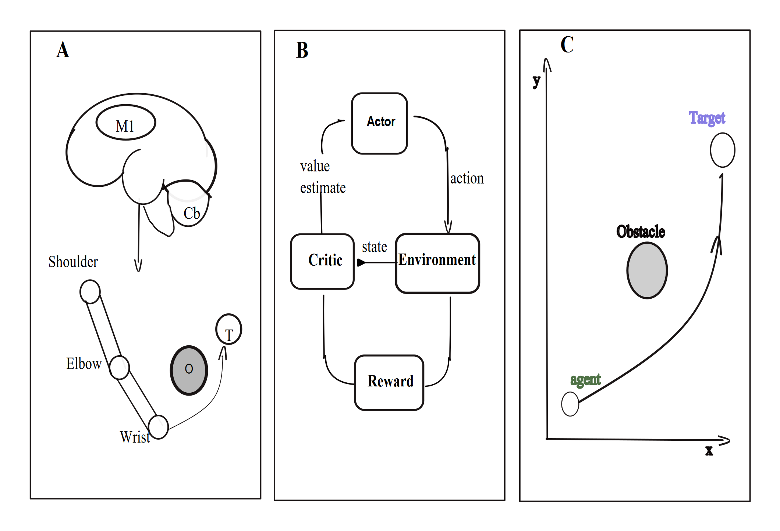
Task design, control architecture, and population analysis pipeline. (A) Biological analogy illustrating the conceptual parallel between the artificial controller and biological motor control. Primary motor cortex (M1) provides descending drive to the shoulder, elbow, and wrist, guided by cerebellar (Cb) predictions and sensory feedback, to move a multi-joint arm toward a target (T) while avoiding an obstacle (O). This panel situates the computational setup in the language of systems motor neuroscience; the actual experiments use a point-mass agent. (B) The PPO actor–critic control loop. At each timestep, the actor network receives the current state observation and outputs a continuous force command (the action). The environment applies that command, advances the agent one timestep, and returns the new state. The critic network receives the state and estimates its long-term value; together with the observed reward, this estimate is used to compute the advantage that guides the actor’s update. A scalar reward signal is produced by the environment at every timestep to drive both networks. (C) Task geometry. The agent (green dot) starts at a fixed position at the bottom of the workspace and must navigate to a fixed goal (top) on a two-dimensional Cartesian plane, while avoiding the obstacle(s) in the corridor between start and goal.
The main perturbation experiment used a corridor formed by two static circular obstacles positioned symmetrically about the midline of the workspace. The corridor is narrow enough that trajectories deflected by strong lateral perturbations risk collision with one of the obstacle boundaries, making it a sensitive test of online correction ability. A preliminary single-obstacle experiment was run first to establish the basic obstacle-avoidance skill; the two-obstacle configuration was then introduced and training continued until performance plateaued.

State Representation
The agent’s observation at each timestep provides a complete description of the task-relevant geometry in agent-centred coordinates:
$$s_{t}=\left[g_{x}−x_{t}, g_{y}−y_{t}, o_{Lx}−x_{t}, o_{Ly}−y_{t}, o_{Rx}−x_{t}, o_{Ry}−y_{t}, v_{x,t}, v_{y,t}\right]$$
where $(x_{t},y_{t})$ is the agent’s current position, $(v_{x,t},v_{y,t})$ its current velocity, $(g_{x},g_{y})$ the goal location, and $(o_{L},o_{R})$ the centres of the left and right obstacles. Expressing all spatial quantities relative to the agent rather than in absolute workspace coordinates renders the representation invariant to the agent’s absolute position, which reduces the effective dimensionality of the learning problem and encourages the development of generalizable movement policies.

Reward Function
The agent receives a scalar reward at each timestep that encodes four distinct objectives:
$$R_{t}=w_{p} Δd_{goal}−w_{v} ∥v_{t}∥−w_{c} C_{t}+w_{s} S_{t}$$
The first term rewards reduction in the Euclidean distance to the goal ($Δd_{goal}>0$ when the agent moves closer); the second penalises excessive instantaneous speed to encourage smooth movements; the third imposes a large negative penalty upon collision with an obstacle ($C_{t}=1$ at collision, $0$ otherwise); and the fourth provides a terminal bonus upon successful goal attainment ($S_{t}=1$ at success, $0$ otherwise). The weights $w_{p},w_{v},w_{c},w_{s}$ were tuned so that efficient goal-seeking was the dominant objective while collision avoidance remained a hard constraint in practice.

Perturbation Protocol
To probe the controller’s capacity for online correction, we applied transient lateral force impulses mid-movement during evaluation. The impulse magnitude was held constant for six consecutive timesteps beginning at timestep 50:
$$f_{x}(t)=p_{i}, t∈[50, 55], p_{i}∈\{±0.15, ±0.30, ±0.45\}$$
A positive value of $p_{i}$ corresponds to a rightward impulse; a negative value to a leftward impulse. This yields seven evaluation conditions: an unperturbed control (P0) and three increasing leftward perturbations (L1: $−0.15$, L2: $−0.30$, L3: $−0.45$) and three increasing rightward perturbations (R1: $+0.15$, R2: $+0.30$, R3: $+0.45$). The six-timestep impulse window is brief relative to the typical episode duration (approximately 100–120 timesteps), mimicking the short-duration mechanical perturbations applied in biological reaching paradigms to isolate online feedback responses from anticipatory motor planning (Pruszynski and Scott 2012; Nashed et al. 2014; Dimitriou and Edin 2010; Todorov and Jordan 2002; Shadmehr and Mussa-Ivaldi 1994).

Reinforcement Learning Controller and Training
All training and evaluation used Stable-Baselines3 (Raffin et al. 2021), an open-source Python library built on PyTorch that provides rigorously tested implementations of standard deep RL algorithms. We used Proximal Policy Optimization (PPO) (Schulman et al. 2017), which maximises the following clipped surrogate objective:
$$L^{CLIP}(θ)=E_{t}​\left[min​\left(r_{t}(θ){\hat{A}}_{t}, clip(r_{t}(θ),1−ϵ,1+ϵ){\hat{A}}_{t}\right)\right]$$
Here $r_{t}(θ)=π_{θ}(a_{t}|s_{t})/π_{θ_{old}}(a_{t}|s_{t})$ is the probability ratio of the new policy to the old policy, ${\hat{A}}_{t}$ is the generalized advantage estimate (a measure of how much better the selected action was relative to the expected value of that state), and $ϵ=0.2$ is the clipping parameter that restricts the policy ratio to the interval $[1−ϵ,1+ϵ]$, bounding the size of any single update step.
The policy and value networks are separate feedforward multilayer perceptrons (MLPs), each with two hidden layers of 256 units and rectified linear (ReLU) activations. A feedforward MLP processes each timestep independently, without recurrence or explicit memory of previous states. Continuous actions are drawn from a diagonal Gaussian distribution whose mean is output by the actor network; the standard deviation is a learned parameter. Observations were standardised online using a running mean and variance (VecNormalize), which substantially improves training stability in continuous-control settings. Training ran for $3×{10}^{6}$ environment timesteps with the following hyperparameters: learning rate $α=3×{10}^{−4}$, discount factor $γ=0.99$, generalised advantage estimation parameter $λ_{GAE}=0.95$, entropy regularisation coefficient $c_{ent}=0.005$, value-function loss coefficient $c_{v}=0.5$, and maximum gradient norm $0.5$. All experiments were run with Stable-Baselines3 v2.8.0, Gymnasium, and PyTorch on an Intel® CoreTM Ultra 7 255H processor.

Neural Population Analysis Pipeline
Following training convergence, we extracted the activation vector $h_{t}∈R^{256}$ from the first hidden layer of the policy network at every timestep $t$ of every evaluation episode. Let $T$ denote the length of an episode; the full population record for that episode is:
$$H=\{h_{1},h_{2},…,h_{T}\}$$
Concatenating $H$ across all evaluation episodes gives a matrix of shape $N_{total}×256$, where $N_{total}$ is the total number of timesteps across all episodes and conditions.
Three population-level analyses were then applied to this matrix.
Principal Component Analysis (PCA). PCA finds a set of orthogonal directions, called principal components, that account for successively decreasing fractions of the total variance in the population data. Projecting the 256-dimensional activity onto the first two principal components provides a two-dimensional visualisation of the population state space and allows us to quantify how compactly the activity is organised. We report the fraction of total variance explained by each principal component as a direct measure of dimensionality compression.
Kinematic tuning analysis. For each of the 256 hidden units, we computed the Pearson correlation between its activation and instantaneous lateral velocity across all evaluation timesteps. This identifies units that are systematically modulated by the direction or magnitude of lateral movement, analogous to single-unit tuning analyses in biological motor electrophysiology.
Linear decoding. We trained a multinomial logistic regression classifier (regularisation $C=1.0$) on single-timestep hidden-layer activity to predict which of the seven perturbation conditions was active. A linear classifier was used deliberately: if strong decoding performance can be achieved with a linear readout, it implies that the relevant information is encoded in the geometry of the population activity in a relatively direct, structured way rather than requiring nonlinear transformations to extract. Classifier performance is summarised as a confusion matrix across conditions. All analyses were implemented in Python using NumPy, SciPy, and scikit-learn.

Dynamical-Systems Framework for the Closed Loop
PCA, clustering, and decoding describe where the population activity sits. They do not say why it sits there. To answer that, we treat the trained policy and the physics engine together as a single closed-loop dynamical system and analyse it with the standard vocabulary of dynamical-systems theory. We introduce that vocabulary here, in the terms it takes in this specific task, so that the mechanistic claims in Section [sec:results-attractor] can be read without outside reference.
State, trajectory, vector field. A dynamical system is a rule for how a state changes over time. Here the state is the agent’s physical situation: lateral position $x$, forward position $y$, lateral velocity $v_{x}$, forward velocity $v_{y}$. At every timestep the policy reads the state (plus the fixed goal and obstacle geometry) and outputs an acceleration; the physics engine integrates that acceleration into a new velocity and position. Chaining this over many steps produces a trajectory, exactly the $(x,y)$ paths already plotted in Figure 2. The vector field is the same rule evaluated everywhere at once: at every point in the state space, it specifies which direction and how fast the state moves next. A trajectory is one path through the vector field; the vector field is the full set of paths the system could take from anywhere.
Fixed points, stability, attractors. A fixed point is a state where the vector field is zero: nothing changes if the system starts exactly there. In this task, that means zero lateral velocity and zero commanded lateral acceleration, the controller has stopped correcting sideways and is content to keep going straight up the corridor. Whether a fixed point matters behaviourally depends on its stability. Perturbing the state slightly and linearising the vector field around the fixed point yields a matrix, the Jacobian, whose eigenvalues describe what happens next. In discrete time (the simulation advances in fixed steps of $dt=0.05$ s), an eigenvalue with magnitude below 1 means that direction decays back to the fixed point, an attractor along that direction; magnitude above 1 means it grows away, a repeller; a nonzero imaginary part means the decay oscillates on the way back in rather than returning in a straight line. A fixed point’s basin of attraction is the set of starting states that eventually settle there, and two different attractors can coexist in the same system (multistability) provided their basins do not overlap.
Why a feedforward policy still has a closed loop. The classic version of this analysis (Sussillo and Barak, 2013) finds fixed points of a recurrent network’s own hidden state, because a recurrent unit’s activity at time $t+1$ is a function of its activity at time $t$. Our policy is feedforward: the 256-unit hidden layer analysed in Figure 4 is a static function of the instantaneous observation, $h_{t}=g(s_{t})$, with no memory of its own previous value, so “the fixed points of the hidden layer” is not a well-posed question here. What is well posed, and what we compute instead, is the fixed points of the closed loop formed by the policy and the environment’s physics, in the agent’s physical state space. This is a legitimate substitute for the recurrent-network case, and is arguably more interpretable here, since the state space $(x,y,v_{x},v_{y})$ already carries physical units and meaning, unlike an RNN’s abstract hidden units.

Results
We evaluated the trained PPO controller across all seven perturbation conditions (P0, L1–L3, R1–R3) and report findings in four parts, proceeding from observable behaviour to the internal representations that underlie it.
Figure 2 shows cumulative reach trajectories overlaid across all seven perturbation conditions. In the unperturbed control (P0) and all mild conditions (L1, L2, R1), the controller reached the goal on every evaluation trial, generating smooth, roughly symmetric paths that arced around both obstacles. As perturbation magnitude increased, trajectories deflected progressively in the direction of the applied force: leftward conditions (L1–L3) bowed the path toward the left obstacle; rightward conditions (R1–R3) bowed it toward the right.
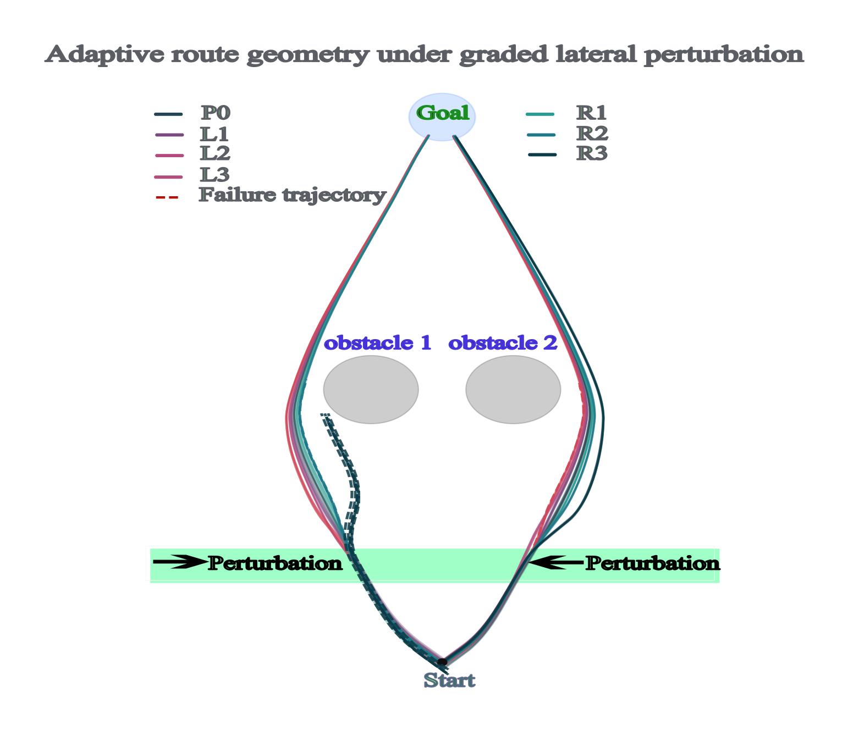
Cumulative reach trajectories across all seven perturbation conditions illustrating the limits of adaptive correction. Each evaluation episode is overlaid separately for each condition. Solid lines are successful trials that reached the goal; the dashed red lines are failure trajectories that ended in obstacle collision. Leftward perturbation conditions (L1–L3, mauve/pink tones) progressively deflect the path toward the left obstacle, while rightward conditions (R1–R3, teal/dark green) deflect it toward the right. The shaded green horizontal band marks the region of the workspace in which the lateral force impulse is active (timesteps 50–55), providing a reference for when in the movement the perturbation is applied. Grey ellipses represent the two static obstacles forming the corridor. The controller maintained complete goal success under control and all mild conditions; success declined only under the two strongest rightward disturbances and under the largest leftward impulse, with rightward perturbations proving disproportionately disruptive, a geometric consequence of the controller having learned a trajectory that runs slightly to the left of corridor centre.
Goal success declined only at the two strongest rightward magnitudes (R2 and R3) and at the largest leftward magnitude (L3). Notably, rightward perturbations were more disruptive than leftward ones of the same nominal force. This directional asymmetry is a geometric consequence of the learned trajectory: the controller settles on a path that runs slightly to the left of the corridor midline, giving it more clearance from the left obstacle and less from the right. An equivalent rightward push therefore risks collision with the right obstacle before a sufficient correction can be generated, while an equivalent leftward push carries the agent away from the right obstacle into a region with more room to correct. Across all successful trials, peak speed was effectively constant across conditions; adaptation was expressed entirely through lateral path geometry, not through modulation of movement tempo.
Figure 3 characterises the temporal evolution of lateral velocity and total speed across all seven conditions.
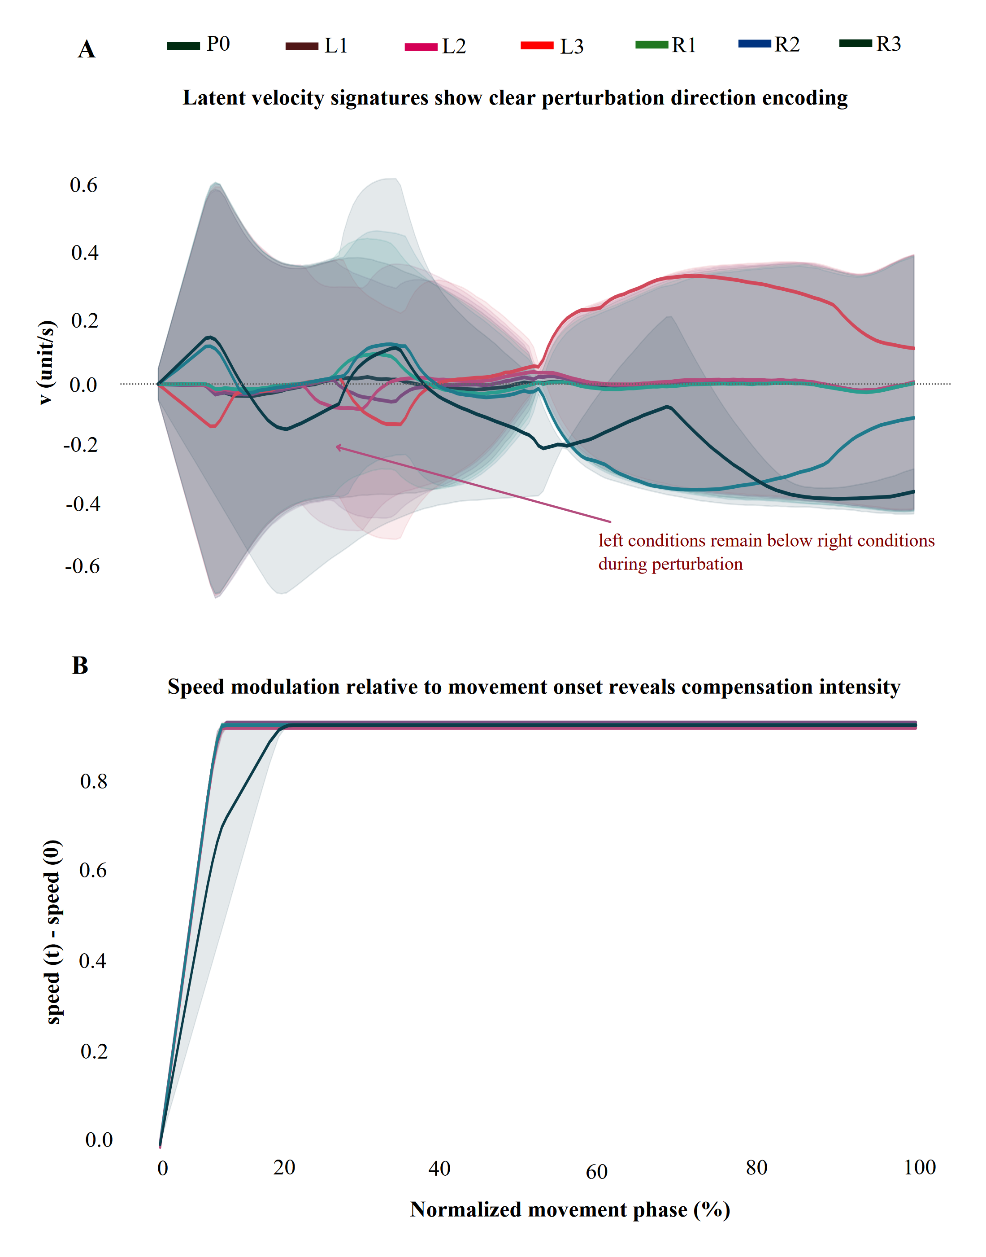
Velocity profiles reveal proportional perturbation encoding and preserved movement tempo. (A) Mean lateral velocity (horizontal component of velocity vector) over time, aligned to movement onset and averaged across all episodes within each condition. Shaded regions show $±$1 SD, conveying trial-to-trial variability. Leftward conditions (L1–L3) drive the agent into negative lateral velocity (moving left), while rightward conditions (R1–R3) drive it into positive lateral velocity (moving right). Conditions diverge sharply during the perturbation window (timesteps 50–55, indicated by the vertical markers) and then partially reconverge, consistent with the generation of a proportional corrective response rather than a stereotyped binary reaction. Critically, the magnitude of lateral deflection scales with perturbation strength within each direction, suggesting a graded, analogue corrective mechanism. (B) Total speed (Euclidean norm of the velocity vector) plotted as a function of normalised movement phase (0 = movement onset, 100 = goal arrival). Speed rises steeply at movement onset, reaching a plateau that is maintained consistently across all seven perturbation conditions. This invariance of the speed profile confirms that the controller’s response to lateral perturbations is expressed entirely through changes in movement direction rather than through changes in the overall pace of the movement, a dissociation that mirrors the kinematic signature of online feedback corrections in human arm movements (Pruszynski and Scott 2012; Nashed et al. 2014; Flash and Hogan 1985).
Panel A shows that lateral velocity separated cleanly and systematically by perturbation direction throughout the active perturbation window. Leftward conditions produced negative lateral velocity; rightward conditions produced positive lateral velocity; and in both directions the magnitude of the lateral deflection scaled with perturbation strength. Following the end of the perturbation window, conditions on the same side partially reconverged toward the unperturbed trajectory, a signature that the controller is generating a corrective force proportional to the sensed displacement rather than a binary switch between pre-programmed response modes.
Panel B confirms that total movement speed was essentially invariant across all seven conditions. The controller increases speed rapidly at movement onset, reaches a plateau, and maintains that plateau uniformly regardless of whether a perturbation is applied or its magnitude and direction. This dissociation between path geometry (which is modulated by perturbation) and speed profile (which is not) is a hallmark of optimal feedback control strategies in biological reaching (Todorov and Jordan 2002; Scott 2004).
Figure 4 shows the result of projecting the full 256-dimensional hidden-layer activity onto its first two principal components across all evaluation timesteps.
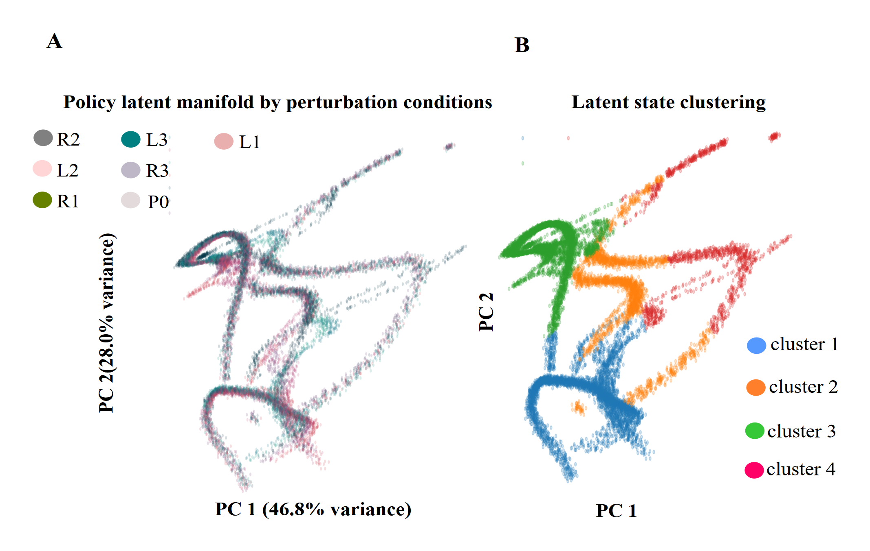
Hidden-layer activity occupies a compact low-dimensional manifold with structure aligned to movement phases rather than to perturbation conditions. Each point represents the 256-dimensional hidden-state vector at one evaluation timestep, projected onto the first two principal components of the entire evaluation dataset. (A) Points are coloured by perturbation condition (see legend). The population activity traces a characteristic curved manifold whose gross shape is shared across all seven conditions. Conditions are not cleanly separated (they overlap substantially) but extreme conditions (particularly L3 and R3) occupy peripheral regions of the manifold that are partly distinct from the control and mild conditions. PC1 accounts for 46.8% of total variance, PC2 for 28.0%; together they capture 74.8% of the variance in a 256-dimensional network, demonstrating a high degree of dimensionality compression. (B) The same projection coloured by $K$-means cluster label ($K=4$). Four spatially coherent clusters emerge that partition the manifold into anatomically distinct regions. These clusters are not condition-specific: each cluster contains timesteps from all seven perturbation conditions. Instead, the clusters likely correspond to phases of the reaching movement that are shared across conditions: for example, the initial approach to the perturbation zone (cluster 1), the active perturbation and correction epoch (cluster 2), the path around the obstacles (cluster 3), and the final approach to the goal (cluster 4). This phase-aligned structure closely resembles the sequential activation of distinct neural population states that has been documented in motor cortex during biological reaching movements (Churchland et al. 2012; Shenoy et al. 2013).
Two findings emerge from this analysis. The first is the degree of dimensionality compression. Despite the policy network having 256 hidden units in its first layer, 74.8% of the variance in the activation patterns collapses onto just two dimensions. This is a striking degree of compression, comparable in magnitude to the low-dimensional manifold structure reported for motor cortex activity during reaching in both non-human primates and humans (Churchland et al. 2012; Shenoy et al. 2013; Cunningham and Yu 2014; Gallego et al. 2017; Sadtler et al. 2014; Elsayed et al. 2016). In both biological and artificial cases, the compression is not imposed externally; it emerges from the structure of the learning problem itself. When a system must produce a sequence of smooth, goal-directed movements, the activity patterns across trials are necessarily correlated, and a small number of principal directions can capture most of that shared structure.
The second finding is the cluster organisation. The $K$-means analysis with $K=4$ reveals four spatially coherent clusters within the manifold. These clusters do not separate perturbation conditions from one another; rather, each cluster draws timesteps from all seven conditions. This indicates that the clusters reflect something about the movement itself, most likely its phase, rather than about the perturbation that is currently acting. This phase-aligned clustering parallels findings from motor cortex recordings in biological reaching, where distinct neural population states have been identified for the preparatory, movement initiation, and movement completion epochs (Churchland et al. 2012; Shenoy et al. 2013; Kaufman et al. 2014; Perich et al. 2018). We note that the choice of $K=4$ was not cross-validated; future work with held-out datasets and multiple training seeds would be needed to establish whether the four-cluster solution is a stable feature of the representation.
Figure 5 shows the confusion matrix from a linear classifier trained on single-timestep hidden-layer activity to identify the perturbation condition active on each trial.
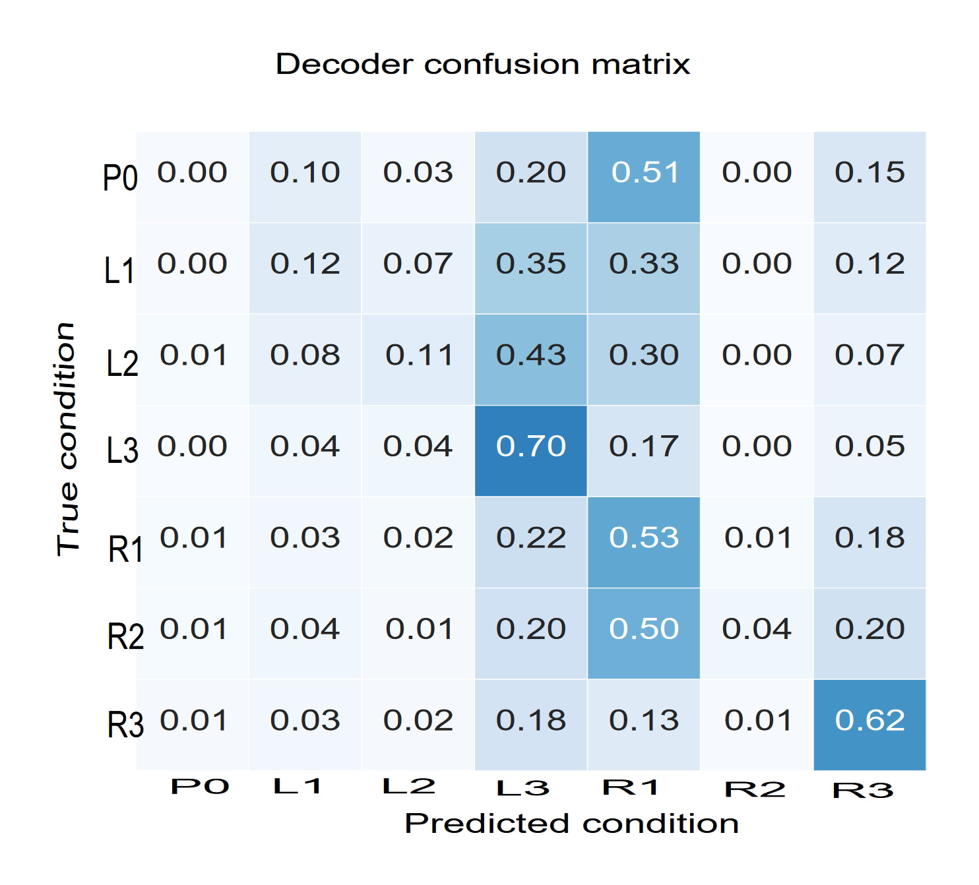
Linear decoding reveals that extreme perturbation conditions produce geometrically distinct population states, while mild conditions remain indistinguishable. Rows of the confusion matrix correspond to the true perturbation condition for each timestep; columns correspond to the condition predicted by a multinomial logistic regression classifier trained on the 256-dimensional hidden-layer activation vector at that timestep. Diagonal entries indicate the proportion of timesteps from each true condition that were correctly classified. Importantly, the off-diagonal pattern reveals that misclassified timesteps are not randomly distributed: mild and control conditions (P0, L1, L2) are almost exclusively misclassified as L3 (the largest leftward perturbation), rather than being confused with rightward conditions. This systematic misclassification indicates that the latent states generated by mild perturbations are geometrically closer to the L3 region of the manifold than to any other condition, suggesting that similar corrective responses, regardless of the magnitude of the perturbation that elicited them, occupy similar regions of the latent space. The decoder’s successful separation of extreme conditions (L3 and R3 achieved the highest diagonal values) confirms that the most behaviourally disruptive perturbations produce the most distinctive internal representations.
The classifier achieved its highest accuracy for the most extreme perturbation conditions: the largest leftward impulse (L3) was correctly identified on the majority of timesteps, and the largest rightward impulse (R3) was correctly classified at a similarly high rate. Moderate rightward conditions (R1, R2) were also decoded above chance. The unperturbed control and mild leftward conditions (P0, L1, L2) were decoded at near-chance levels, and when misclassified, they were systematically assigned to L3 rather than to random conditions. This is not a simple failure of the classifier; it is a feature of the latent geometry. Mild perturbations generate hidden states that occupy a region of the manifold geometrically close to the L3 cluster, reflecting the fact that mild corrections and large corrections that are ultimately successful produce similar downstream activity. What distinguishes them is the trajectory they took through the state space to get there, not their momentary position.
The fact that a linear classifier can decode extreme conditions at all is the more important result. Perturbation context is encoded in the population activity in a structured, geometrically accessible form: the relevant information is present in a linear projection of the 256-dimensional activity vector. This mirrors the finding from biological motor neuroscience that target direction, perturbation magnitude, and trial outcome can all be decoded with linear classifiers trained on motor cortex population activity (Churchland et al. 2012; Nashed et al. 2014; Oby et al. 2019; Georgopoulos et al. 1986; Sadtler et al. 2014).
Figure 6 contextualises the representational findings within the training dynamics of the controller.
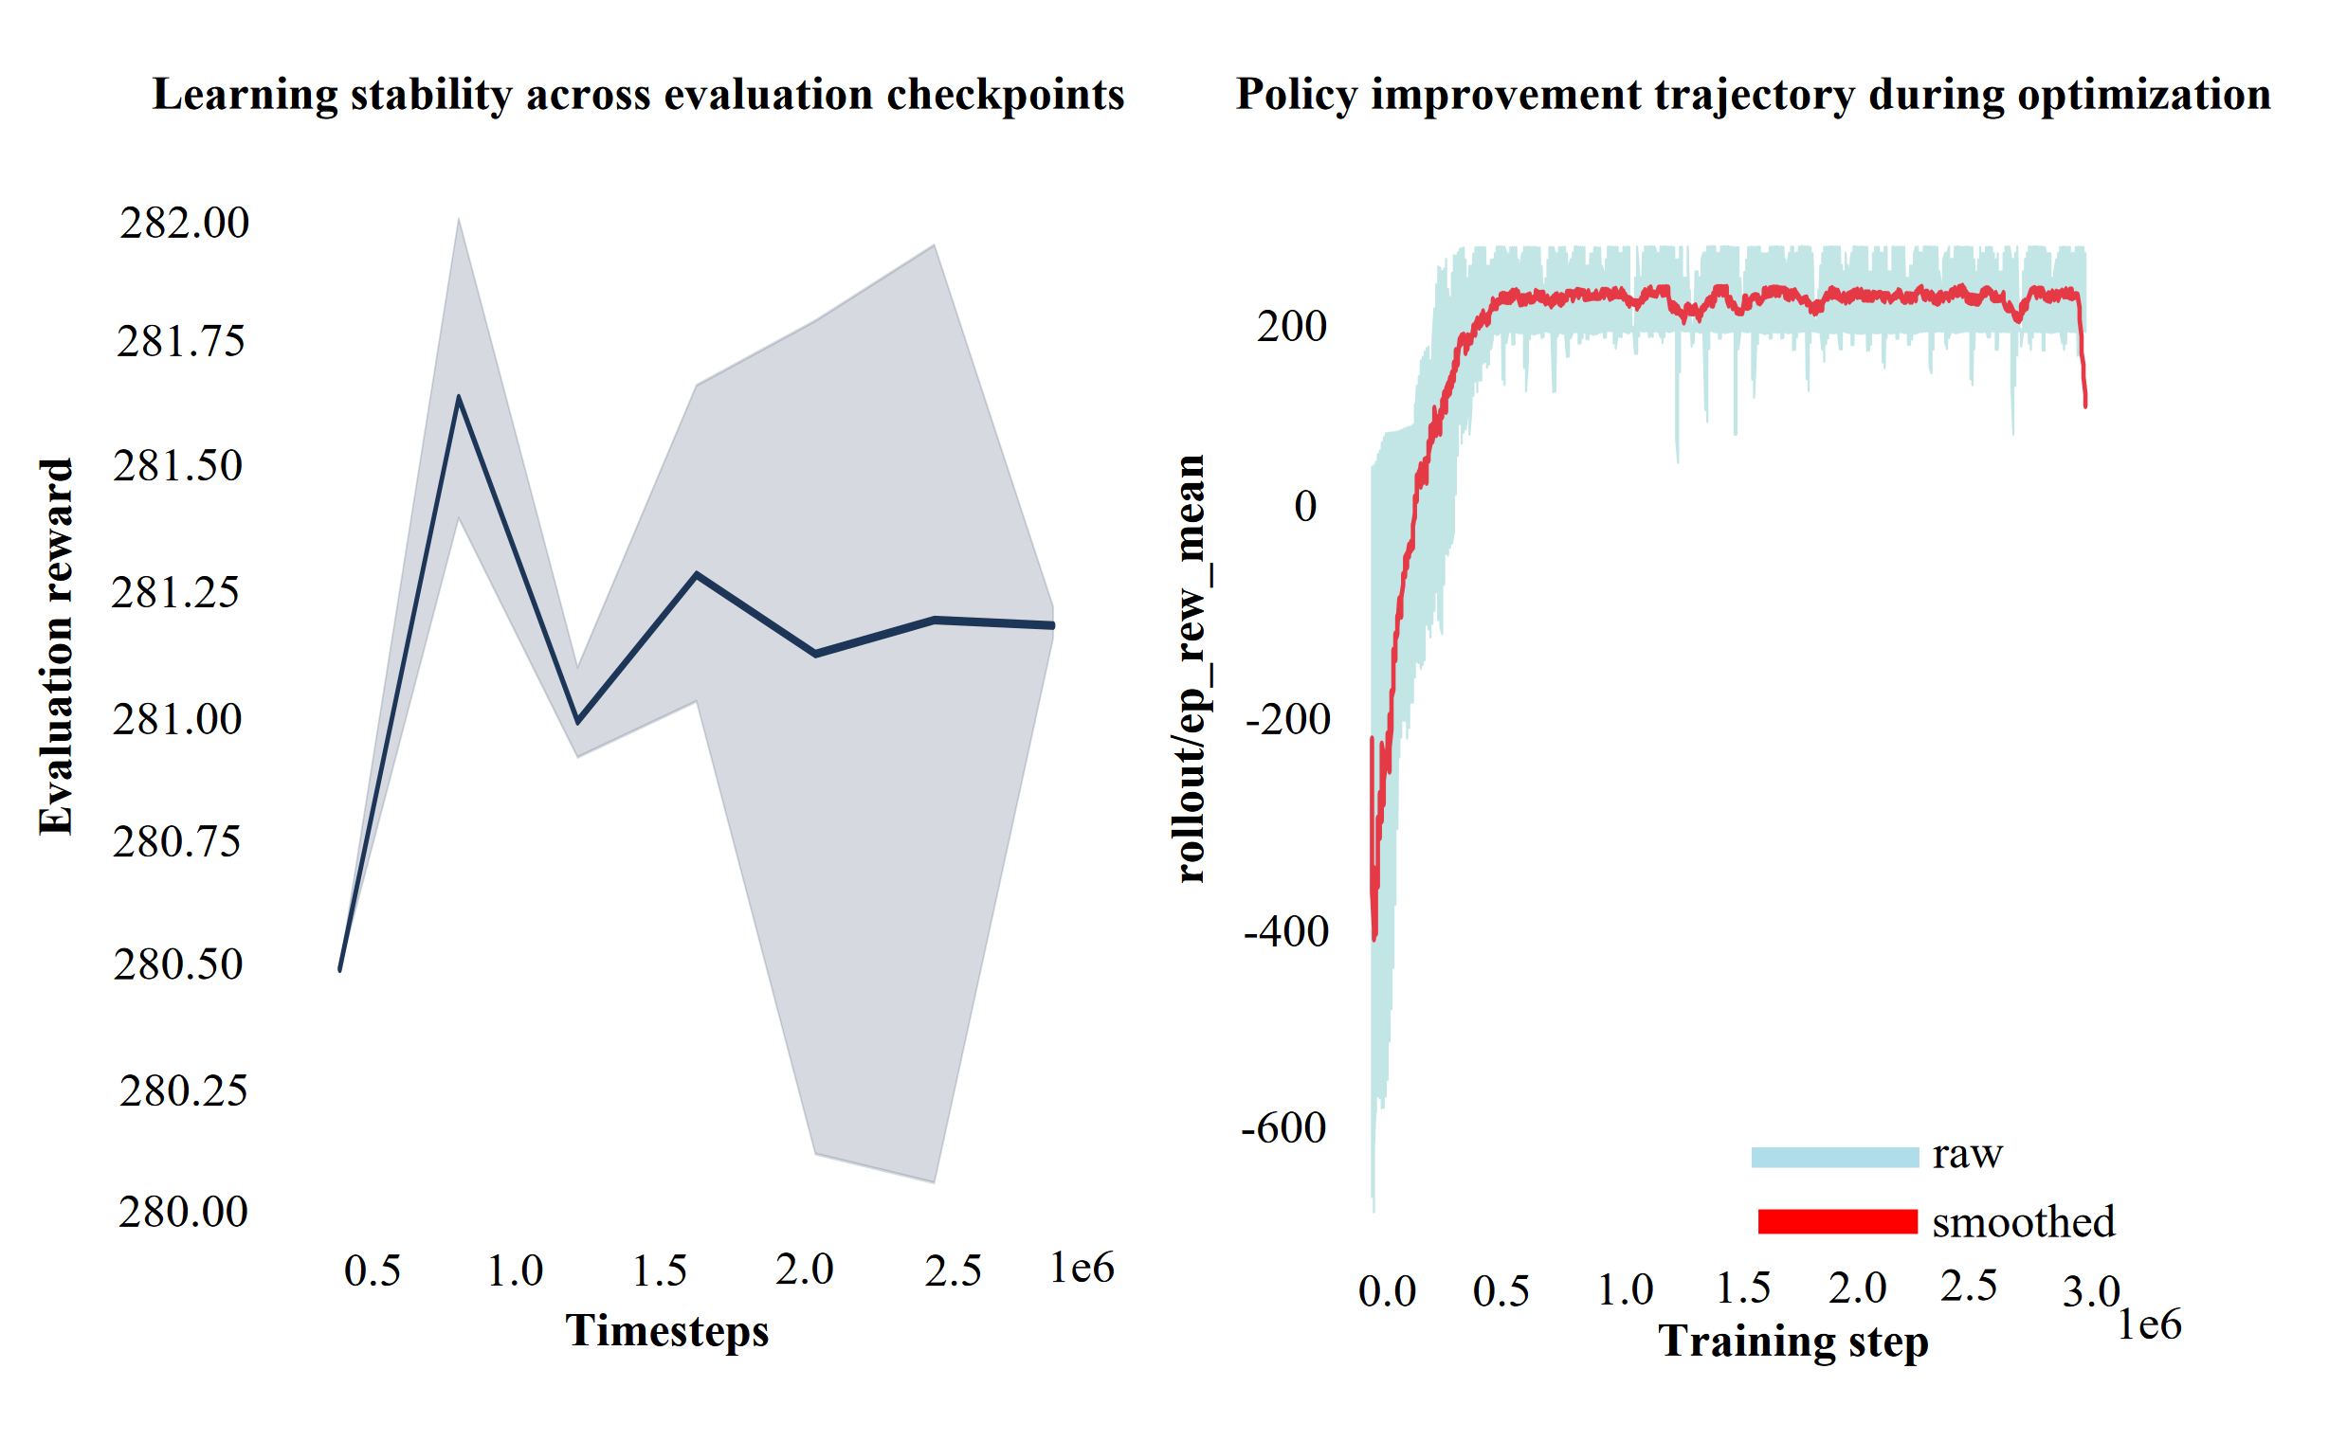
The controller converges stably, validating the representational analyses as properties of a fully trained policy. (Left panel) Evaluation reward plotted across independently sampled checkpoints throughout training (mean $±$ SD across all evaluation episodes at each checkpoint). The reward is tightly clustered around a high value once training has converged, demonstrating that performance is stable rather than oscillating, and that the policy extracted from any checkpoint after convergence will yield similar behaviour. (Right panel) Raw per-episode rollout reward over the full $3×{10}^{6}$-timestep training run (light blue), together with an exponential moving average (red) to reveal the learning trajectory. The policy improves rapidly from large negative initial rewards (reflecting early episodes in which the agent collides frequently) to a stable positive plateau within approximately the first $1×{10}^{6}$ timesteps, after which performance remains stable without systematic degradation or catastrophic forgetting. The representations analysed in Figures 4 and 5 were extracted from the converged policy (after $2×{10}^{6}$ timesteps), ensuring that they reflect the learned representational structure rather than an artefact of incomplete training.
The training curve confirms that the controller learned the task efficiently and converged to a stable solution within the first third of the training budget. After convergence, performance was tightly distributed across independently sampled evaluation checkpoints, ruling out the possibility that the reported behavioural and representational findings are artefacts of partial training or of checkpoint selection. The rapid initial improvement followed by a long stable plateau is characteristic of well-tuned PPO training on continuous-control problems and is consistent with the training dynamics reported for similar obstacle-avoidance and reaching tasks in the RL literature (Raffin et al. 2021; Schulman et al. 2017).
The clustering and decoding results in Figures 4 and 5 describe where the population activity sits. They do not say why it sits there. To answer that, we treated the policy and the physics engine together as a single closed-loop system, using the dynamical-systems framework introduced in Section 2.7: at every step the policy reads the agent’s state and outputs an acceleration, the physics engine integrates it, and the resulting state is fed back in. With the perturbation off, this closed loop is autonomous in the agent’s physical state $(x,y,v_{x},v_{y})$, so its fixed points and their stability can be computed directly.
We found that the policy also conditions on a discrete route cue that determines which side of the obstacle pair the agent detours around. Every one of the 140 saved evaluation episodes took the same, left, detour, so we solved for the fixed point of the reduced lateral subsystem $(x,v_{x})$ separately for the left route (matching the sampled data) and, as a prediction, for the right route. Both fixed points are locally stable, with two real eigenvalues below 1 in magnitude and no imaginary component, meaning the lateral state relaxes back to it smoothly rather than oscillating. The left-route fixed point sits at $x^{*}=3.32$ m with a relaxation time constant of 1.42 s; the right-route fixed point sits at $x^{*}=6.70$ m with a time constant of 1.35 s, close to a mirror image of the left about the corridor midline at $x=5.0$ m.
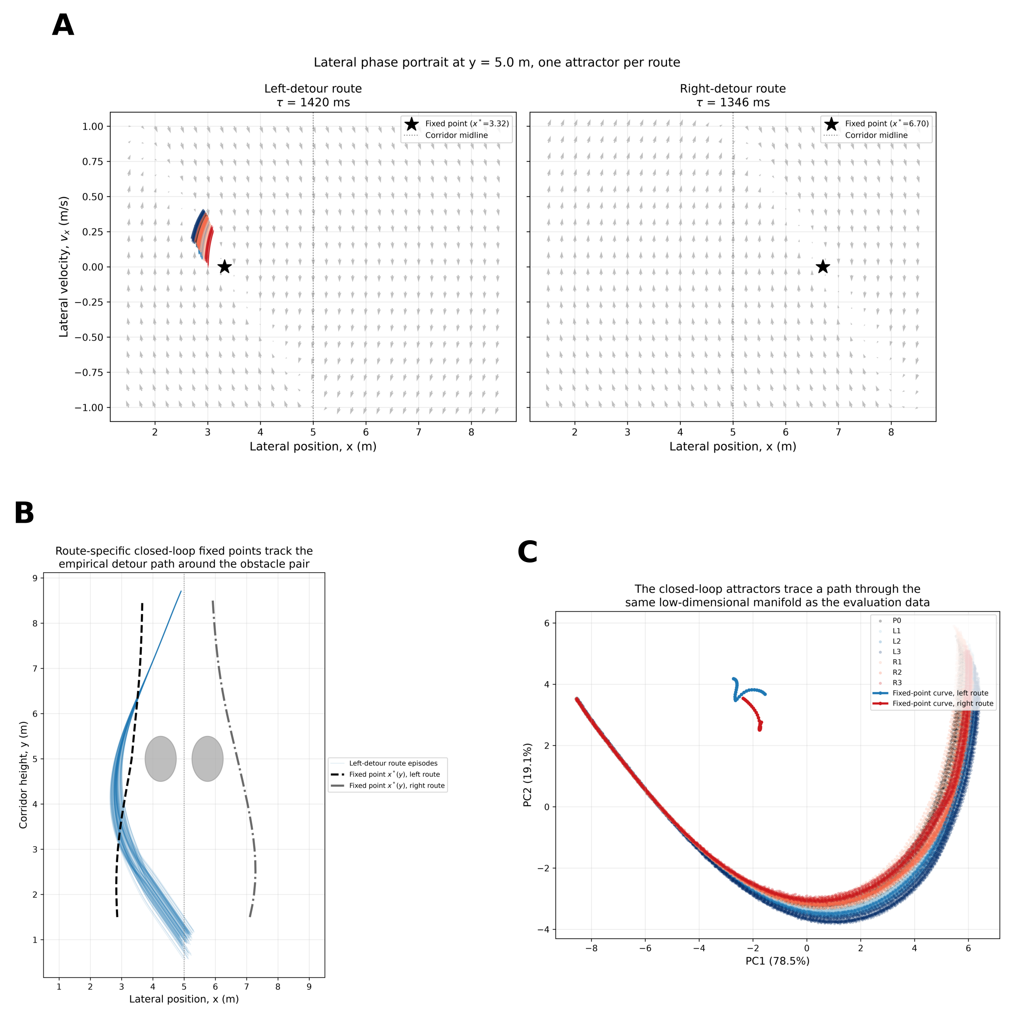
A closed-loop fixed-point analysis explains the location of the manifold and its clusters. (A) Lateral phase portrait at the corridor height where the perturbation is delivered ($y=5.0$ m), for the left- and right-detour routes. Grey arrows show the closed-loop vector field (policy and physics, perturbation off); coloured traces are real evaluation episodes passing through this band, coloured by perturbation condition as in Figure 3; the star marks the numerically solved fixed point. The right-route panel is a prediction, since the evaluation data sampled only the left route. (B) The fixed-point location $x^{*}(y)$ computed across the full corridor height (dashed/dash-dot) tracks the empirical detour path (light blue) within a few centimetres at every height. (C) The same fixed-point curves projected into the PC1-PC2 space used for the clustering analysis in Figure 4, overlaid on the evaluation-condition scatter. The curves sit on the same manifold that the four phase-aligned clusters partition, at the location corresponding to steady, corrected cruising.
This gives a geometric account of two findings already reported descriptively. First, the partial reconvergence of lateral velocity after the perturbation window (Figure 3A) is the closed loop relaxing back toward this fixed point; the two eigenvalues, both real and below 1 in magnitude, are why the reconvergence is smooth rather than oscillatory. Second, the four phase-aligned clusters in Figure 4B are not arbitrary regions of the manifold: Figure 7C shows that the fixed-point curve for each route sits at a specific location on the same PC1-PC2 manifold, corresponding to steady cruising once the agent has settled into its detour. Clusters closer to this location correspond to the cruising phase; those farther from it correspond to the approach and correction phases.
The fixed-point locations also make the direction-dependent robustness asymmetry reported above quantitative rather than only descriptive. The obstacles sit at $x=4.25$ m and $x=5.75$ m with radius 0.5 m, so the left-route fixed point at $x^{*}=3.32$ m leaves roughly 0.43 m of clearance from the near obstacle edge. A rightward perturbation pushes the agent toward that same near obstacle it is already closest to; a leftward perturbation of equal magnitude pushes it away, into open space. The two fixed points themselves are close to symmetric, in both location and relaxation time constant, so the asymmetry is a property of clearance relative to a fixed attractor, not of the corrective mechanism itself being weaker in one direction.

Discussion
This study asked whether a controller trained by reinforcement learning to perform adaptive obstacle avoidance develops internal representations that are interpretable using the analytical framework of systems motor neuroscience. We find consistent evidence that it does: the hidden-layer activity of a converged PPO policy organises into a compact low-dimensional manifold with phase-aligned cluster structure, encodes kinematic variables in a distributed, graded way, and contains linearly readable information about perturbation context that is most distinct for the most behaviourally demanding conditions. We discuss these findings in relation to biological motor control, consider what they reveal about the controller’s failure modes, and acknowledge the limitations that bound their generality.

Behavioural adaptation mirrors biological feedback correction.
The pattern of behavioural adaptation, characterised by robust performance under mild perturbations, progressive degradation under stronger ones, and adaptation expressed through path correction rather than speed modulation, is qualitatively consistent with the kinematic signatures of online feedback corrections in human reaching. In biological reaching, the primary motor cortex and premotor areas generate rapid, graded corrective responses to unexpected force perturbations that reshape the movement path without systematically altering movement speed (Pruszynski and Scott 2012; Nashed et al. 2014; Flash and Hogan 1985; Scott 2004; Dimitriou and Edin 2010; Shadmehr and Mussa-Ivaldi 1994; Diedrichsen et al. 2010). The PPO controller exhibits precisely this dissociation: it modulates path geometry in proportion to the applied force while keeping the overall movement tempo constant across all seven conditions (Figure 3B).
We are careful not to overstate this correspondence. The point-mass dynamics are far simpler than those of a biological limb; the controller has no muscle mechanics, no proprioceptive noise, and no time delays in sensory feedback. The PPO policy was optimised for cumulative reward, not for kinematic smoothness or biological realism. Nevertheless, the convergence of the kinematic signature of proportional lateral deflection with preserved speed is consistent with the computational principles of optimal feedback control (OFC), which predicts that well-adapted controllers should correct task-relevant errors while leaving task-irrelevant variables unchanged (Todorov and Jordan 2002; Todorov 2009; Franklin and Wolpert 2011; Wolpert and Ghahramani 2000). Under OFC, speed is a task-irrelevant variable when a lateral perturbation is applied; correcting it would waste motor resources without improving goal attainment. The PPO controller, trained purely by reward, appears to discover the same principle implicitly.
The direction-dependent asymmetry in robustness (rightward conditions failing at lower magnitudes than leftward) is a geometric consequence of the learned trajectory. It is a useful reminder that performance under perturbation is not solely a property of the controller; it is a joint property of the controller and the specific task geometry in which it operates. Future work with symmetric corridors and bidirectional reward shaping could establish whether the asymmetry can be removed without sacrificing overall performance.

Low-dimensional latent structure and its biological parallel.
The finding that 74.8% of the variance in a 256-unit network collapses onto two dimensions is the most theoretically significant result of this study, because it was not imposed by the network architecture. The MLP has no bottleneck layer, no regularisation that explicitly penalises high-dimensional representations, and no biological constraints. Yet the activity self-organises into a highly compressed subspace.
The same phenomenon has been documented repeatedly in motor cortex. Recordings from hundreds of neurons during reaching show that most of the variance in the neural activity lives in a subspace of far lower dimension than the number of recorded cells (Churchland et al. 2012; Shenoy et al. 2013; Cunningham and Yu 2014; Gallego et al. 2017). The interpretation offered in the biological literature is that the repetitive, structured nature of movement, which proceeds through a stereotyped sequence of phases regardless of specific kinematics, forces the neural population into a low-dimensional orbit through activity space. Our results suggest that the same logic applies to artificial controllers: because all reaching movements share a common temporal structure (acceleration, obstacle passage, deceleration toward goal), the hidden states across all trials are necessarily correlated, and a small number of principal components suffice to capture that shared structure.
The four-cluster decomposition of the manifold (Figure 4B) provides a complementary view. The clusters partition the manifold spatially, and because they do not separate perturbation conditions they most naturally correspond to movement phases: the approach to the perturbation zone, the active perturbation and correction epoch, the passage around the obstacles, and the final approach to goal. This phase-aligned clustering is consistent with the sequential activation of distinct neural population states documented in motor cortex during biological reaching (Churchland et al. 2012; Shenoy et al. 2013; Kaufman et al. 2014; Elsayed et al. 2016; Georgopoulos et al. 1986). We again note that the choice of $K=4$ was not cross-validated; the number of clusters and their boundaries could shift across training seeds or evaluation datasets.

What the decoder tells us about internal organisation.
The systematic pattern of decoder performance, which was accurate for extreme conditions and near-chance for mild ones, with mild conditions systematically misclassified as L3 rather than as random conditions, carries a specific message about the geometry of the latent space. It means that the hidden states generated by mild perturbations, while physically distinct in the external world, produce internal representations that are more similar to those generated by large perturbations than to those generated by the control condition. This is ecologically sensible: a small perturbation that the controller handles with a small correction generates a hidden state trajectory that passes close to the L3 region of the manifold, because a large perturbation that the controller handles well with a large correction passes through the same region. The relevant variable that separates these cases is not the instantaneous manifold position but the magnitude of the preceding displacement and corrective force; this information is carried in the trajectory through state space rather than in any single point.
This interpretation has a direct parallel in biological motor neuroscience. Studies of motor cortex activity during online reaching corrections show that the decodability of perturbation magnitude improves substantially when the decoder is given a temporal window of population activity rather than a single snapshot (Nashed et al. 2014; Churchland et al. 2012; Sadtler et al. 2014; Perich et al. 2018). The same principle likely applies here: the latent state at any single timestep is not a sufficient summary of the perturbation history, but the sequence of latent states over the correction epoch likely is. Future work with recurrent or temporal decoding approaches could test this directly.

Limitations.
Several constraints bound the generality of these conclusions.
Single training seed. All results are from a single PPO training run. We cannot quantify how much of the reported structure (degree of dimensionality compression, number of clusters, pattern of decoder performance) varies across seeds. Systematic multi-seed experiments are needed to establish which features are stable properties of the learning algorithm and task, and which are idiosyncratic to this particular run.
Simplified environment. The two-dimensional point-mass environment abstracts away several features that are present in biological reaching: three-dimensional kinematics, muscle mechanics, sensory noise, neural delays, and the memory of past perturbations (since the MLP has no recurrence). Whether the representational organisation we describe here would persist in richer, more biologically realistic environments is an open question.
Feedforward architecture. The absence of recurrence means that the controller processes each timestep’s observation independently. It cannot explicitly maintain an estimate of the perturbation that was applied in previous timesteps, which may limit its capacity to generate temporally coherent corrections under conditions where the perturbation is unpredictable.
Descriptive analyses. PCA and linear decoding identify and characterise structure; they do not establish which specific hidden units or circuits cause the behaviour. Causal interventions would be needed to move from description to mechanism.
Use of AI tools. Large language models were used to support text editing, proofreading, debugging, and LaTeX formatting.

Connecting to biological motor systems.
Taken together, our results contribute to a growing body of evidence that the organisational principles of biological motor populations, namely compact manifold geometry, phase-structured latent dynamics, distributed and graded encoding of kinematic variables, and linear decodability of task-relevant context, are not unique features of biological neural circuits. They can emerge spontaneously in artificial controllers trained by reinforcement learning, without any architectural constraints or biological supervision (Churchland et al. 2012; Gallego et al. 2017; Oby et al. 2019; Crevecoeur et al. 2019; Silver et al. 2016; Haarnoja et al. 2018; Mnih et al. 2015). This convergence has implications in both directions.
For motor neuroscientists, it suggests that the low-dimensional, phase-structured representations observed in motor cortex may be a computationally preferred solution to the general problem of generating smooth, goal-directed movements under uncertainty, a solution that emerges from optimisation pressure rather than from the specific biophysical properties of cortical circuits (Franklin and Wolpert 2011; Wolpert and Ghahramani 2000; Rizzolatti and Luppino 2001; Berniker and Körding 2011). This raises the possibility of using well-characterised RL controllers as computational models for generating testable predictions about population dynamics in motor cortex, particularly under novel perturbation conditions that are difficult to study in biological experiments.
For engineers and clinicians working on assistive and rehabilitation technologies, the framework demonstrates that population-style analysis of artificial controller hidden states can reveal mechanistic information that task-success metrics alone cannot. Understanding which internal states predict failures, and specifically which latent configurations mark the transition from successful correction to collision, could provide actionable targets for improving controller robustness or for designing failure-detection modules that flag high-risk states before they produce behavioural errors.

Conclusion
We trained a PPO controller to navigate a reaching-inspired obstacle-avoidance task and probed it with graded lateral force perturbations spanning both directions, then analysed the internal representations of the converged policy using the population-level toolkit of motor neuroscience.
The controller adapted to moderate perturbations through lateral path corrections that preserved movement speed, and its robustness degraded asymmetrically under strong rightward disturbances as a consequence of the geometry of the learned corridor trajectory. The hidden-layer activity organised into a compact low-dimensional manifold, capturing the large majority of population variance in just two principal components, with four phase-aligned clusters shared across all perturbation conditions. A linear decoder trained on single-timestep hidden-layer activity could separate extreme perturbation conditions, while mild conditions were geometrically indistinguishable from one another and from the control, reflecting similar corrective strategies rather than similar external forces.
These findings demonstrate that reward-driven learning generates internal representations with organisational properties, namely low dimensionality, phase structure, graded kinematic encoding, and linear decodability of task context, that are consistent with those documented in biological motor cortex. Population-style analysis of RL controllers provides an analytical window that extends beyond behavioural evaluation, offering a path toward understanding not just whether an adaptive controller succeeds, but mechanistically why it sometimes fails.
Future work will extend this framework to recurrent architectures that can maintain temporal estimates of perturbation history, to richer three-dimensional environments with contact dynamics, and to systematic multi-seed experiments that characterise the variability of the representational structure across training runs. We also intend to apply these methods to rehabilitation-inspired control problems, where linking internal neural representations to behavioural recovery outcomes could contribute to the development of more interpretable, trustworthy assistive technologies.

Acknowledgments
This work was supported in part by the Connected Minds Program, Canada First Research Excellence Fund, Grant No. CFREF-2022-00010.
Berniker, Max, and Konrad P. Körding. 2011. “Bayesian Approaches to Sensory Integration for Motor Control.” Wiley Interdisciplinary Reviews: Cognitive Science 2 (4): 419–28.
Blohm, Gunnar, Aasef G. Khan, Lei Ren, Kerstin M. Schreiber, and J. Douglas Crawford. 2008. “Depth Estimation from Retinal Disparity Requires Eye and Head Orientation Signals.” Journal of Vision 8 (16): 3.
Churchland, Mark M., John P. Cunningham, Matthew T. Kaufman, et al. 2012. “Neural Population Dynamics During Reaching.” Nature 487 (7405): 51–56.
Codol, Olivier, Peter J. Holland, Sanjay G. Manohar, and Joseph M. Galea. 2023. “Reward-Dependent Selection of Feedback Gains Impacts Rapid Motor Reactions.” eLife 12: e83557.
Crevecoeur, Frédéric, Jean-Louis Thonnard, and Philippe Lefèvre. 2019. “A Very Fast Time Scale of Human Motor Adaptation: Within Movement Adjustments of Internal Representations During Reaching.” eNeuro 6 (3).
Cunningham, John P., and Byron M. Yu. 2014. “Dimensionality Reduction for Large-Scale Neural Recordings.” Nature Neuroscience 17 (11): 1500–1509.
Diedrichsen, Jörn, Reza Shadmehr, and Richard B. Ivry. 2010. “The Coordination of Movement: Optimal Feedback Control and Beyond.” Trends in Cognitive Sciences 14 (1): 31–39.
Dimitriou, Michael, and Benoni B. Edin. 2010. “Human Muscle Spindles Act as Forward Sensory Models.” Current Biology 20 (19): 1763–67.
Elsayed, Gamaleldin F., Antonio H. Lara, Matthew T. Kaufman, Mark M. Churchland, and John P. Cunningham. 2016. “Reorganization Between Preparatory and Movement Population Responses in Motor Cortex.” Nature Communications 7: 13239.
Flash, Tamar, and Neville Hogan. 1985. “The Coordination of Arm Movements: An Experimentally Confirmed Mathematical Model.” Journal of Neuroscience 5 (7): 1688–703.
Franklin, David W., and Daniel M. Wolpert. 2011. “Computational Mechanisms of Sensorimotor Control.” Neuron 72 (3): 425–42.
Gallego, Juan A., Matthew G. Perich, Lee E. Miller, and Sara A. Solla. 2017. “Neural Manifolds for the Control of Movement.” Neuron 94 (5): 978–84.
Georgopoulos, Apostolos P., Andrew B. Schwartz, and Ronald E. Kettner. 1986. “Neuronal Population Coding of Movement Direction.” Science 233 (4771): 1416–19.
Haarnoja, Tuomas, Aurick Zhou, Pieter Abbeel, and Sergey Levine. 2018. “Soft Actor-Critic: Off-Policy Maximum Entropy Deep Reinforcement Learning with a Stochastic Actor.” Proceedings of the 35th International Conference on Machine Learning, 1861–70.
Heald, James B., Máté Lengyel, and Daniel M. Wolpert. 2021. “Contextual Inference Underlies the Learning of Sensorimotor Repertoires.” Nature 600 (7889): 489–93.
Kaelbling, Leslie Pack, Michael L. Littman, and Andrew W. Moore. 1996. “Reinforcement Learning: A Survey.” Journal of Artificial Intelligence Research 4: 237–85.
Kalaska, John F., David A. D. Cohen, Mathew L. Hyde, and Marc Prud’homme. 1989. “A Comparison of Movement Direction-Related Versus Load Direction-Related Activity in Primate Motor Cortex Using a Two-Dimensional Reaching Task.” Journal of Neuroscience 9 (6): 2080–102.
Kaufman, Matthew T., Mark M. Churchland, Stephen I. Ryu, and Krishna V. Shenoy. 2014. “Cortical Activity in the Null Space: Permitting Preparation Without Movement.” Nature Neuroscience 17 (3): 440–48.
Krakauer, John W., Alex M. Hadjiosif, Jing Xu, Aaron L. Wong, and Adrian M. Haith. 2019. “Motor Learning.” Comprehensive Physiology 9 (2): 613–63.
Mathis, Alexander, Steffen Schneider, Jessy Lauer, and Mackenzie W. Mathis. 2020. “A Primer on Motion Capture with Deep Learning: Principles, Pitfalls, and Perspectives.” Neuron 108 (1): 44–65.
Mnih, Volodymyr, Koray Kavukcuoglu, David Silver, et al. 2015. “Human-Level Control Through Deep Reinforcement Learning.” Nature 518 (7540): 529–33.
Molnar, Christoph. 2022. Interpretable Machine Learning: A Guide for Making Black Box Models Explainable. 2nd ed. Christoph Molnar. https://christophm.github.io/interpretable-ml-book/.
Nashed, Joseph Y., Frédéric Crevecoeur, and Stephen H. Scott. 2014. “Rapid Online Selection Between Multiple Motor Plans.” Journal of Neuroscience 34 (5): 1769–80.
Oby, Emily R., Matthew D. Golub, Joram A. Hennig, et al. 2019. “New Neural Activity Patterns Emerge with Long-Term Learning.” Proceedings of the National Academy of Sciences 116 (30): 15210–15.
Perich, Matthew G., Juan A. Gallego, and Lee E. Miller. 2018. “A Neural Population Mechanism for Rapid Learning.” Neuron 100 (4): 964–76.
Pruszynski, J. Andrew, and Stephen H. Scott. 2012. “Optimal Feedback Control and the Long-Latency Stretch Response.” Experimental Brain Research 218 (3): 341–59.
Raffin, Antonin, Ashley Hill, Adam Gleave, Anssi Kanervisto, Maximilian Ernestus, and Noah Dormann. 2021. “Stable-Baselines3: Reliable Reinforcement Learning Implementations.” Journal of Machine Learning Research 22 (268): 1–8.
Rizzolatti, Giacomo, and Giuseppe Luppino. 2001. “The Cortical Motor System.” Neuron 31 (6): 889–901.
Rudin, Cynthia. 2019. “Stop Explaining Black Box Machine Learning Models for High Stakes Decisions and Use Interpretable Models Instead.” Nature Machine Intelligence 1 (5): 206–15.
Sadtler, Patrick T., Kristin M. Quick, Matthew D. Golub, et al. 2014. “Neural Constraints on Learning.” Nature 512 (7515): 423–26.
Schulman, John, Filip Wolski, Prafulla Dhariwal, Alec Radford, and Oleg Klimov. 2017. “Proximal Policy Optimization Algorithms.” arXiv Preprint arXiv:1707.06347.
Scott, Stephen H. 2004. “Optimal Feedback Control and the Neural Basis of Volitional Motor Control.” Nature Reviews Neuroscience 5 (7): 532–46.
Shadmehr, Reza, and Ferdinando A. Mussa-Ivaldi. 1994. “Adaptive Representation of Dynamics During Learning of a Motor Task.” Journal of Neuroscience 14 (5): 3208–24.
Shenoy, Krishna V., Maneesh Sahani, and Mark M. Churchland. 2013. “Cortical Control of Arm Movements: A Dynamical Systems Perspective.” Annual Review of Neuroscience 36: 337–59.
Silver, David, Aja Huang, Chris J. Maddison, et al. 2016. “Mastering the Game of Go with Deep Neural Networks and Tree Search.” Nature 529 (7587): 484–89.
Sutton, Richard S., and Andrew G. Barto. 2018. Reinforcement Learning: An Introduction. 2nd ed. MIT Press.
Todorov, Emanuel. 2009. “Compositionality of Optimal Control Laws.” Advances in Neural Information Processing Systems 22: 1856–64.
Todorov, Emanuel, and Michael I. Jordan. 2002. “Optimal Feedback Control as a Theory of Motor Coordination.” Nature Neuroscience 5 (11): 1226–35.
Towers, Mark, Ariel Kwiatkowski, Jordan Terry, et al. 2024. Gymnasium: A Standard Interface for Reinforcement Learning Environments. Released. https://github.com/Farama-Foundation/Gymnasium.
Wolpert, Daniel M., and Zoubin Ghahramani. 2000. “Computational Principles of Movement Neuroscience.” Nature Neuroscience 3: 1212–17.

