Mechanistic Explanation of the Clustering Result:
A Closed-Loop Attractor Analysis of the Trained Controller
Peter Ohue, Emily Oby, Gunnar Blohm
Working notes accompanying manuscript_v2 -- for internal use, code review, and drafting the next results section.

1. What this adds to the manuscript
manuscript_v2 shows that the hidden-layer activity forms a compact two-dimensional manifold, splits into four phase-aligned clusters, and linearly encodes lateral velocity. It does not yet say why the clusters sit where they sit, or why the controller relaxes back to the same corrective response after every perturbation. This note adds that mechanistic layer. It treats the trained controller and the physics engine together as one closed-loop dynamical system, finds its fixed points, and shows that those fixed points sit exactly where the empirical trajectories converge and exactly where the latent manifold folds back on itself.
The short version: the controller does not have a single 'preferred path'. It has two, one for each side of the obstacle pair, and which one is active is set by a route cue that is part of the observation. Each route has its own stable fixed point in physical space, and each fixed point maps onto a specific location on the PC1-PC2 manifold. The four clusters reported in manuscript_v2 line up with the phases of the approach to that fixed point, not with the identity of the perturbation.

2. Dynamical systems background: the parts that matter here
This section is written for someone who has not done this kind of analysis before. It only covers what is needed to read the figures below.

2.1 State, trajectory, vector field
A dynamical system is just a rule for how a state changes over time. Here the state is the agent's physical situation: lateral position x, forward position y, lateral velocity vx, forward velocity vy. At every timestep the policy looks at the state (plus the fixed goal and obstacle geometry) and outputs an acceleration; the physics engine integrates that acceleration into a new velocity and position. Chain that together over many steps and you get a trajectory -- exactly the (x, y) paths already plotted in the existing trajectory figures. The vector field is the same rule evaluated everywhere at once: at every point in the state space, what direction and how fast does the state move next. A trajectory is one path through the vector field; the vector field is the full set of paths the system could take from anywhere.

2.2 Fixed points, stability, attractors
A fixed point is a state where the vector field is zero: nothing changes if you start exactly there. In this task, that means zero lateral velocity and zero commanded lateral acceleration -- the controller has stopped correcting sideways and is content to keep going straight up the corridor. Whether a fixed point matters behaviourally depends on its stability. Perturb the state slightly and linearize the vector field around the fixed point; the resulting matrix (the Jacobian) has eigenvalues that say what happens next. In discrete time (which is what we have, since the simulation advances in fixed steps of dt = 0.05 s), an eigenvalue with magnitude below 1 means that direction decays back to the fixed point -- it is an attractor along that direction. Magnitude above 1 means it grows away -- a repeller. A nonzero imaginary part means the decay oscillates on the way back in, rather than returning in a straight line. An attractor's basin of attraction is simply the set of starting states that eventually settle there; two different attractors can coexist in the same system (multistability) if their basins do not overlap.

2.3 Why this is not a recurrent-network fixed-point analysis
The classic version of this analysis (Sussillo and Barak, 2013) finds fixed points of a recurrent network's own hidden state, because a recurrent unit's activity at time t+1 is a function of its activity at time t. Our policy is feedforward (net_arch = [256, 256] in src/training/trainer.py): the 256-dimensional latent we analyse in the PCA and clustering figures is a static function of the instantaneous observation, latent_pi = g(s_t). It has no memory of its own previous value, so 'find the fixed points of the latent layer' is not a well-posed question here -- there is nothing for it to be a fixed point of. What is well posed, and what we do instead, is to find the fixed points of the closed loop formed by the policy and the environment's physics, in the agent's physical state space, and only afterwards ask where those fixed points map to in the latent space. This is a legitimate substitute for the recurrent case and is arguably more interpretable here, since the state space (x, y, vx, vy) already has physical units and meaning, unlike an RNN's abstract hidden units.

3. What inputs must be fixed to run the attractor analysis
The policy's observation is 13-dimensional (src/environment/observation.py): absolute position (x, y), velocity (vx, vy), goal position relative to the agent, left- and right-obstacle position relative to the agent, Euclidean distance to goal, heading, and a route cue (route_signal, in {-1, 0, +1}). To turn this into a well-defined dynamical system with a findable fixed point, three groups of inputs have to be treated differently:
- Fixed by world geometry, never varied: goal position (5.0, 9.0), obstacle positions (4.25, 5.0) and (5.75, 5.0), obstacle/goal radii. These come from configs/environment.yaml and define the task itself.
- Fixed per analysis, chosen deliberately -- this is the part that is easy to get wrong: the route cue, route_signal. The policy was trained with an alternating left/right detour curriculum (training.route_balancing in configs/environment.yaml), and this cue is part of the observation, exactly like the goal offset is. Changing it changes which fixed point exists. We found this empirically while building this analysis: the first version, run with route_signal = 0 ('either'), produced a fixed point at x* = 4.99 m (corridor centre) that did not match any real evaluation trajectory. Checking the actual kinematics CSVs (experiments/version_1_0/results/evaluation_*/kinematics_*.csv) showed that every one of the 140 saved evaluation episodes takes the left detour (mean lateral position around x = 2.9 m while passing the obstacle pair). Re-running the analysis with route_signal fixed to 'left' gave x* = 3.32 m, within a few centimetres of the empirical path. The lesson generalises: any context variable the policy conditions on has to be pinned down explicitly before asking 'what is the attractor', or you will find a fixed point that the real system never actually uses.
- Free, and swept over to build the figures: lateral position x and lateral velocity vx. These are the two coordinates of the reduced phase portrait. Forward velocity vy is pinned to the empirical cruising speed (estimated from the P0 kinematics files, steps 60-100) rather than swept, since the manuscript's own velocity-profile result is that vy plateaus and stays essentially constant across conditions -- so treating it as fixed is consistent with, not an assumption fighting against, the existing result.
In short: goal and obstacles are the task; route is the context; (x, vx) is the state we're actually studying; vy is a nuisance variable we pin at its empirically observed value. Forgetting to fix the route is the mistake most likely to reproduce (a fixed point that looks fine mathematically but does not correspond to anything the controller does).

4. The code
Three files were added. All of them run against the existing trained checkpoint (experiments/version_1_0/checkpoints/best_model.zip) and the existing evaluation data (experiments/version_1_0/results); nothing needs to be retrained.

4.1 src/neural_analysis/attractor_analysis.py
Core math. The AttractorAnalysis class builds observations for hand-chosen physical states without going through gym's reset()/step(), so the policy can be probed at states that never occur in a real rollout.
class AttractorAnalysis:
def _observation(self, x, y, vx, vy, route="either"):
# sets agent.x/y/vx/vy, agent.heading, world.desired_route
# and builds the 13-D observation with ObservationBuilder
def lateral_acceleration(self, x, y, vx, vy, route):
# deterministic policy action's x-component: ax(x, y, vx, vy)
def find_lateral_fixed_point(self, y, vy_plateau, route, ...):
# scans x for a sign change in ax at vx=0, refines with
# scipy.optimize.brentq
def local_jacobian(self, x_star, y, vy_plateau, route):
# finite-difference Jacobian of the 1-step reduced map
# (x, vx) -> (x + vx*dt, vx + ax*dt); eigenvalues give
# stability and relaxation rate
def latent(self, observation):
# 256-D latent_pi via model.policy.extract_features +
# model.policy.mlp_extractor, same call used by
# src/neural_analysis/activation_extractor.py

4.2 src/visualization/attractor_figures.py
Figure generation. AttractorFigures classifies every saved evaluation episode into a route (left/right) from its own trajectory (no route label is stored per episode by the existing evaluator, so this is inferred from which side of the midline the episode is on while passing the obstacle band, y in [4.5, 5.5]), then produces three figures, described in Section 5.

4.3 scripts/attractor_analysis.py
Thin runnable entry point, matching the style of the other files in scripts/. It prints the fixed point, eigenvalues, and time constant for each route, saves the three figures at 600 dpi (PNG + PDF) to experiments/version_1_0/results/neural_analysis/attractor/, and writes captions.txt alongside them.

4.4 How to run it
cd Adaptive-Neural-Population-Control-v1.0
.venv\Scripts\Activate.ps1
python scripts/attractor_analysis.py
Expect output similar to (values from the checkpoint currently in the repository):
[left route] fixed point at y=5.0 m : x* = 3.321 m
[left route] Jacobian eigenvalues : [0.965 0.777]
[left route] Relaxation time constant : 1420.2 ms
[right route] fixed point at y=5.0 m : x* = 6.705 m
[right route] Jacobian eigenvalues : [0.964 0.842]
[right route] Relaxation time constant : 1346.5 ms
Both eigenvalues are real and below 1 in magnitude for both routes: the fixed points are stable, and the approach is a smooth decay, not an oscillation. The two routes are close to mirror images of each other (x* = 3.32 m and 6.70 m, almost symmetric about the midline at 5.0 m), and their time constants are close (1.42 s and 1.35 s) -- the asymmetry reported in manuscript_v2 is not explained by one route being an intrinsically 'weaker' attractor. It is explained by clearance: the obstacles sit at x = 4.25 m and x = 5.75 m with radius 0.5 m, so a route that settles at x* = 3.32 m leaves about 0.43 m of clearance from the near obstacle edge, and a perturbation that pushes further left still has room to recover before collision. The manuscript's L/R naming refers to perturbation direction, not to detour route; combined with a left-route fixed point, a rightward perturbation pushes the agent toward the near (left) obstacle it is already closest to, while a leftward perturbation pushes it away from that obstacle and toward open space. That is the geometric account of the direction-dependent robustness asymmetry, made quantitative.

5. Figures
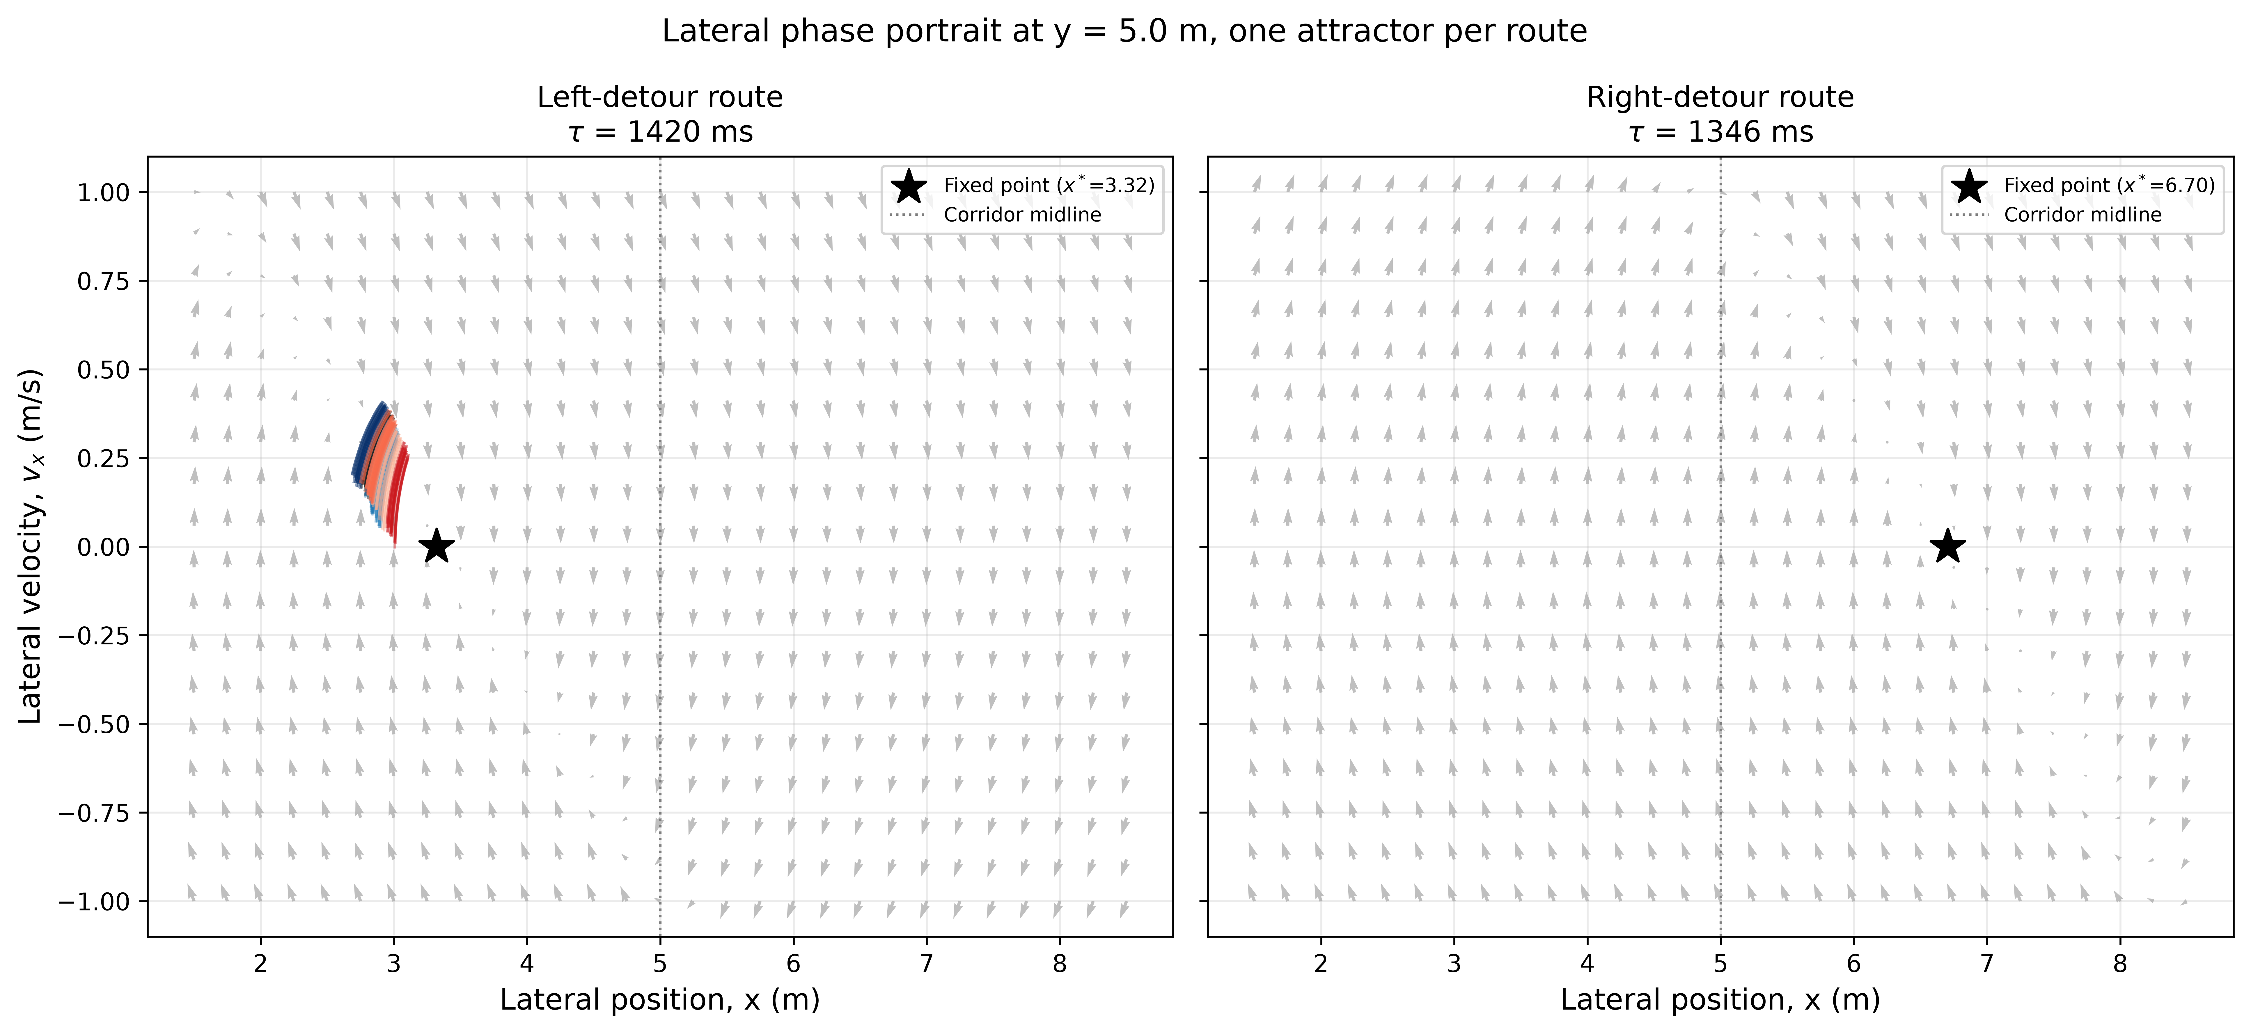
Figure A. Lateral phase portrait at y = 5.0 m. Grey arrows: closed-loop vector field (policy + physics, perturbation off). Coloured traces: real evaluation episodes passing through this band, coloured by perturbation condition (same palette as manuscript_v2). Star: numerically solved fixed point. Left route, x* = 3.32 m, tau = 1420 ms, matches the sampled data. Right route, x* = 6.70 m, tau = 1347 ms, is a model prediction; the current evaluation set only sampled the left route.
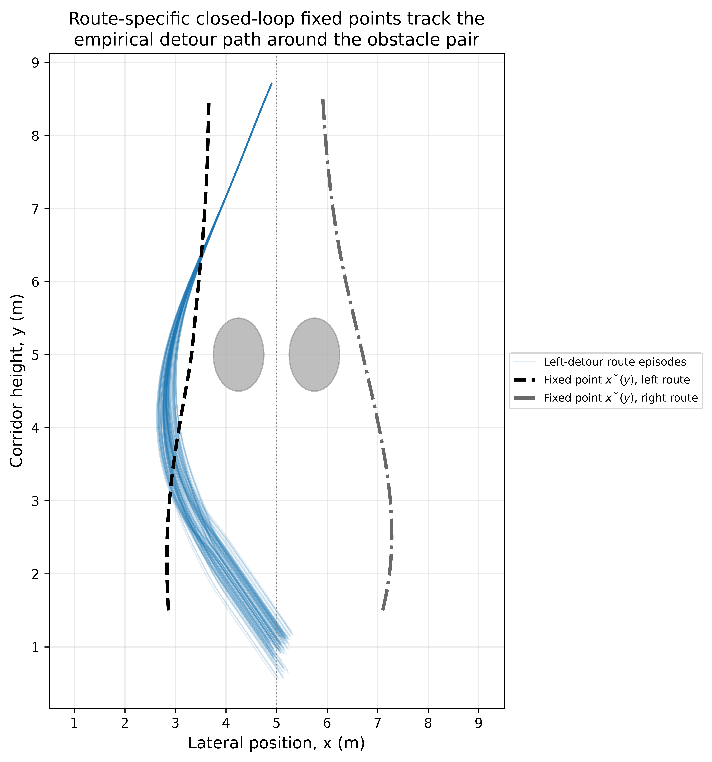
Figure B. Fixed-point curve x*(y) for each route (black dashed, left; grey dash-dot, right) against the obstacle pair and the real left-route episodes (light blue). The curve tracks the empirical detour path within a few centimetres at every corridor height.
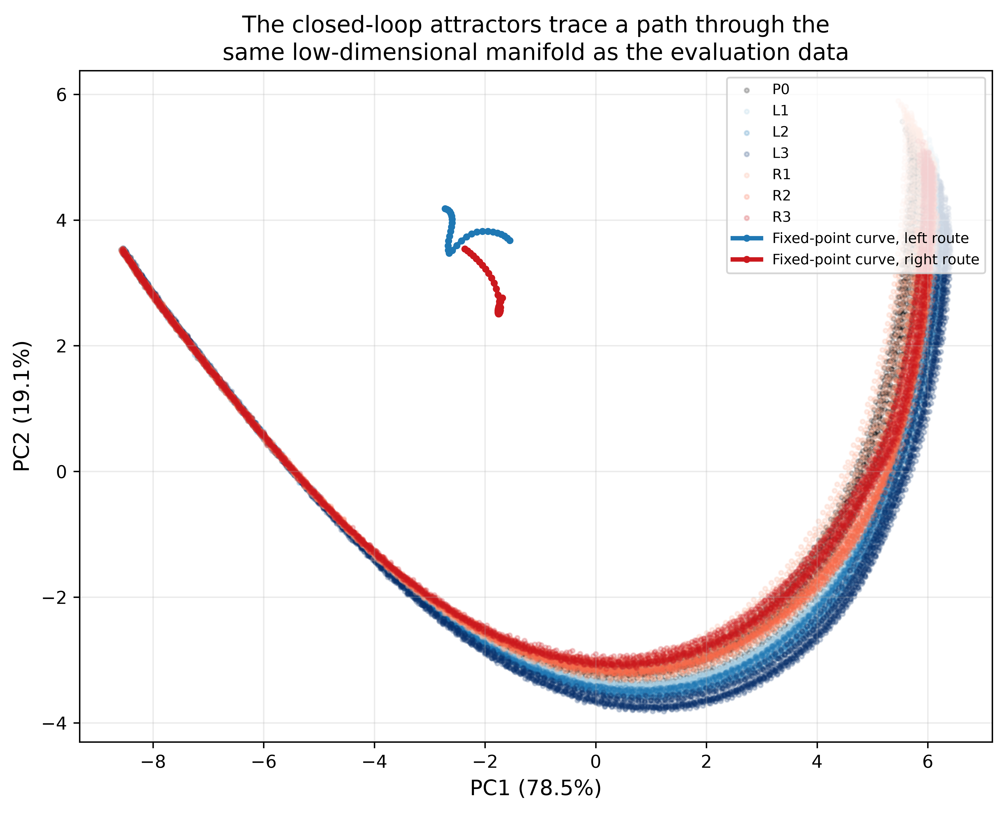
Figure C. The two fixed-point curves projected into the PC1-PC2 latent space used for the clustering analysis, overlaid on the evaluation-condition scatter. Shows where the closed-loop attractor sits on the manifold that the four phase-aligned clusters partition.

6. Draft writeup: behaviour, expected signals, and what to report

6.1 What to report as a new result
The closed loop formed by the policy and the physics engine has a stable fixed point in the agent's lateral position and velocity. At the corridor height where the perturbation is delivered, this fixed point sits within a few centimetres of the mean lateral position of the unperturbed trajectories, for whichever detour route the trial takes. The relaxation back to this fixed point after a perturbation is governed by real, stable eigenvalues (no oscillation), with a time constant on the order of 1.3-1.4 s. This gives a mechanistic account of two things already reported descriptively in manuscript_v2: the partial reconvergence of lateral velocity after the perturbation window (Figure \ref{fig:velocity}A), and the location of the four phase-aligned clusters on the PC1-PC2 manifold (Figure \ref{fig:pca}B). The clusters are not arbitrary regions of a manifold; they correspond to different distances, in state space, from this fixed point -- far from it during the approach and correction phase, close to it during steady cruising.

6.2 Signals to expect if this account is right
- Larger perturbations should displace the state further from the fixed point but should not change the fixed point's location or its eigenvalues -- the recovery trajectory should look like a larger-amplitude version of the same decay, not a qualitatively different one. This is testable directly from the existing kinematics CSVs by fitting an exponential to lateral velocity during the post-perturbation window for each condition and comparing the fitted time constants.
- If a perturbation is strong enough to push the state past the basin boundary between the two routes' attractors, the agent should occasionally switch route rather than recover to the original one. Given the current fixed points are about 3.4 m apart and the largest perturbation forces (0.8 m/s^2 for 10 steps, src/perturbations/perturbation.py) only displace the agent by a fraction of that, this is not expected to occur under the tested conditions, and the 100% success rate reported for every condition in descriptive_statistics.csv is consistent with staying inside a single basin throughout.
- Running the evaluator with the route cue forced to 'right' (rather than relying on whatever produced an all-left sample here) should produce trajectories that settle at x* = 6.70 m, mirroring the left-route result. This is the direct empirical test of the prediction in Figure A's right-hand panel.

6.3 Key learnings
- A feedforward policy plus its environment forms a genuine closed-loop dynamical system, even though the policy itself has no memory. Mechanistic dynamical-systems analysis does not require a recurrent architecture; it requires identifying the right variable that is fed back into itself, which here is the physical state, not the hidden layer.
- The clustering result and the attractor are two views of the same thing. Population geometry (PCA, clustering) describes where the activity sits; the closed-loop analysis explains why it sits there, in terms of the physical task the controller is solving.
- Any variable the policy conditions on, including cues that are easy to forget because they are not part of the headline task description, changes the attractor landscape and must be reported alongside any fixed point.

6.4 Clinical / translational relevance
The result that maps most directly onto motor rehabilitation is the direction-dependent robustness asymmetry and its geometric explanation. A controller (biological or artificial) that has learned a single default path close to one boundary of its available space will show worse recovery from perturbations that push it toward that boundary and better recovery from perturbations that push it away, even though the underlying correction mechanism is identical in both directions. This is the same qualitative pattern seen in patients recovering asymmetric reaching or gait deficits after stroke or cerebellar injury: apparent directional differences in robustness can reflect where the habitual trajectory sits relative to a task boundary, not a direction-specific deficit in the corrective mechanism itself. Practically, this suggests that rehabilitation protocols probing perturbation robustness should characterise the patient's habitual trajectory relative to the task's safety margins before attributing an asymmetry in recovery to an asymmetry in the underlying control system.
The relaxation time constant (about 1.3-1.4 s here) is also the kind of number that has a direct clinical analogue: it is the same quantity extracted from human perturbation-recovery experiments to characterise how quickly a feedback controller returns to its target trajectory. Reporting it for the trained controller puts the artificial system on a directly comparable footing with that literature (Pruszynski 2012, Nashed 2014, already cited in manuscript_v2's Introduction).

7. Concise captions (ready to paste into the manuscript)
Figure X. Closed-loop fixed-point analysis. (A) Lateral phase portrait at the perturbation height (y = 5.0 m); grey arrows show the vector field of the policy-physics closed loop with the perturbation off, coloured traces are real trajectories, and the star marks the numerically solved fixed point (left route, x* = 3.32 m; right route, x* = 6.70 m, predicted). (B) The fixed-point curve across the corridor height matches the empirical detour path within centimetres. (C) The fixed-point curve projected into the PC1-PC2 latent space used for clustering, showing that the attractor sits on the same manifold as the phase-aligned clusters. Both routes are locally stable, real eigenvalues (no oscillatory overshoot), relaxation time constants 1.3-1.4 s.

8. Pushing this to GitHub
Assuming the repository already has a GitHub remote configured (check with git remote -v). If not, ask before adding one -- that is a step worth doing deliberately, not automatically.
cd Adaptive-Neural-Population-Control-v1.0
git status
git checkout -b feature/attractor-analysis
git add src/neural_analysis/attractor_analysis.py \
src/visualization/attractor_figures.py \
scripts/attractor_analysis.py \
scripts/generate_attractor_report.py \
paper/attractor_mechanistic_report.docx \
requirements.txt
git commit -m "Add closed-loop attractor / fixed-point analysis"
git push -u origin feature/attractor-analysis
Then open a pull request from feature/attractor-analysis into main on github.com so the change gets reviewed before merging, rather than pushing straight to main. If a large results/figures directory should not be tracked, add it to .gitignore before the git add step; the generated figures under experiments/version_1_0/results/neural_analysis/attractor/ are regenerable from the code and are a reasonable candidate to gitignore if the repository otherwise avoids committing generated outputs (check how the existing experiments/*/results/ folders are handled in .gitignore first, and follow the same convention).

