AMRITA VISHWA VIDYAPEETHAM, AMRITAPURI
B. Tech – Computer Science Engineering (Artificial Intelligence)
22AIE401 – Reinforcement Learning
Inverse Reinforcement Learning for Route Preference Learning
Name | Roll No
Abhinav Nair | AM.SC.U4AIE23005
Advaith K | AM.SC.U4AIE23010
Akash A | AM.SC.U4AIE23011

1. Problem Background
Navigation applications such as Google Maps, Waze, and Apple Maps help users find suitable routes by considering factors such as travel distance, travel time, traffic, road conditions, and other route information. These systems use graph-based routing along with machine learning and other techniques to improve route recommendations.
However, people do not always choose the shortest or fastest route. A driver may choose a slightly longer route because it has better road conditions, fewer difficult turns, less traffic, or a more comfortable driving experience. These preferences can also vary from one driver to another.
With the availability of historical GPS trajectory data, we can study the routes that drivers choose instead of relying only on manually defined assumptions. This gives us an opportunity to learn the preferences behind human route choices.
Inverse Reinforcement Learning (IRL) is useful for this problem because it works in the opposite way of normal Reinforcement Learning. Instead of starting with a known reward and learning how to act, IRL observes human actions and tries to learn the hidden reward that explains those actions using historical GPS trajectories. The learned reward functions can then be used to generate routes that better align with human preferences.

2. Problem Statement
Develop an Inverse Reinforcement Learning-based route planning system that learns human driving preferences from historical GPS trajectories and generates realistic, human-aligned routes on OpenStreetMap road networks.

3. Dataset
The proposed system will use historical GPS trajectory datasets such as GeoLife GPS Trajectories or other publicly available trajectory datasets. OpenStreetMap (OSM) will be used to construct the road network for route planning experiments. GeoLife supplies the demonstration data — real recorded driving behaviour; OSM supplies the environment graph on which that behaviour is modelled. Commercial systems such as Google Maps are not a data source for this project: their routing models, reward functions, and historical trajectory data are proprietary and inaccessible, which is precisely the transparency gap this project addresses (see Gap Analysis, Section 7).

4. Why Reinforcement Learning?
Route planning is a sequential decision-making problem. During a journey, a driver reaches different intersections and repeatedly decides which road to take next. Each decision affects the future part of the journey.
This can naturally be represented using a Markov Decision Process (MDP), where the current road location is the state, the possible roads are the actions, and the reward represents how desirable a particular choice is.
Traditional Reinforcement Learning assumes that the reward function is already known. In our problem, the reward that represents human driving preferences is not directly available. We can observe which roads drivers choose, but we cannot directly observe the reasons or preferences behind those choices.
Therefore, Inverse Reinforcement Learning is used to learn the hidden reward or preferences from observed human driving behaviour.

5. Literature Review
S.No | Paper | Year | Relevance
1 | Maximum Entropy Inverse Reinforcement Learning — Ziebart et al. | 2008 | Foundational IRL method; developed and demonstrated for navigation and driving behaviour.
2 | Integrating Dijkstra's Algorithm into Deep Inverse Reinforcement Learning for Food Delivery Route Planning — Liu et al. | 2020 | Combines IRL with Dijkstra and learns delivery-driver preferences from GPS trajectories.
3 | A Deep Inverse Reinforcement Learning Approach to Route Choice Modeling with Context-Dependent Rewards — Zhao & Liang | 2023 | Studies driver route choice using deep IRL and taxi GPS data.
4 | Massively Scalable Inverse Reinforcement Learning in Google Maps — Barnes et al. | 2024 | Demonstrates IRL for route recommendation at Google Maps scale.
5 | Recursive Logit-Based Meta-Inverse Reinforcement Learning for Driver-Preferred Route Planning — Zhang et al. | 2024 | Addresses computational efficiency and sparse GPS coverage in driver-preference IRL.
6 | Trajectory Modeling via Random Utility Inverse Reinforcement Learning — Pitombeira-Neto et al. | 2024 | Models driver trajectories using IRL and accounts for observed/unobserved factors.
7 | Personalized Origin–Destination Travel Time Estimation with Active Adversarial Inverse Reinforcement Learning and Transformer — Liu et al. | 2025 | Relevant to personalized route preference learning using adversarial IRL.
8 | Modelling Route Choice in Public Transport with Deep Learning — Marra & Corman | 2025 | Shows how learned nonlinear utilities can model complex route preferences.

6. Existing System
Modern navigation systems such as Google Maps, Waze, and Apple Maps already use advanced routing methods along with information such as traffic, road conditions, travel time, and other signals.
Google has also published research on using Inverse Reinforcement Learning for Google Maps. Their work shows that IRL can be used to learn the hidden preferences of travellers from real-world travel patterns. The research also addresses the major challenge of scaling IRL to very large road networks. This shows that learning human route preferences using IRL is a practical research direction and not only a theoretical idea.
However, commercial navigation systems are proprietary. Their complete routing models, reward functions, and personalization methods are not publicly available. Therefore, it is difficult to directly study and reproduce their complete decision-making process. Our project focuses on creating a smaller and transparent research framework where the relationship between human trajectories, learned preferences, and route generation can be studied and evaluated.

7. Gap Analysis
Traditional routing algorithms like Dijkstra's and A* rely on static, manually engineered cost functions — typically minimizing distance or travel time — failing to capture the subjective, multi-criteria trade-offs that govern real-world driving behavior.
Supervised machine learning can predict trajectory patterns from historical data, but it acts primarily as an uninterpretable black box. It predicts which paths may be selected without recovering the underlying utility function that explains why drivers make specific decisions, limiting its generalizability across unseen origin–destination pairs.
While Inverse Reinforcement Learning (IRL) mathematically infers latent reward functions from demonstrations, existing implementations face significant hurdles: high computational overhead during forward-MDP solving on large road networks, high sensitivity to sparse or noisy GPS traces, and an ongoing trade-off between complex deep-IRL models and interpretable feature representations.
Despite recent advances, existing IRL-based route planning systems either rely on computationally intensive deep models, large-scale proprietary datasets, or black-box implementations that are difficult to reproduce and interpret. Therefore, a gap remains for a computationally efficient and transparent IRL framework that can learn explainable driver preferences from publicly available GPS trajectory data and OpenStreetMap road networks.

8. Proposed System
The proposed research will use historical GPS trajectories as examples of real human driving behaviour and an OpenStreetMap road network as the environment.
The road network will be represented as a Markov Decision Process, where drivers make a sequence of road-selection decisions while travelling from an origin to a destination. Maximum Entropy Inverse Reinforcement Learning (MaxEnt IRL) will be used to learn the underlying reward function that best explains the observed route choices.
The study will consider relevant route characteristics such as distance, travel time, road type, turns, and other available road or traffic information. The exact factors will depend on the data available for the selected study area.
Performance will be evaluated using route similarity measures, trajectory overlap, path deviation, and comparison against expert driver trajectories.
The main objective is to study whether a reward learned from real driving behaviour can produce routes that more closely reflect human route-selection patterns. The project is therefore focused not on replacing existing navigation applications, but on understanding and demonstrating how Inverse Reinforcement Learning can be used to learn human route preferences in a transparent and reproducible way.

9. Initial RL Formulation: State, Action, Reward, Policy, Objective
The route-choice problem is formulated as an MDP M = (S, A, T, R, γ) built directly on the OSM road graph.

State (S)
sₜ = (vₜ, eₜ₋₁) — the intersection currently reached (vₜ) together with the road segment just travelled (eₜ₋₁). Using the bare intersection alone would make the process non-Markovian with respect to turning behaviour (a left turn could not be distinguished from a U-turn without knowing the incoming direction), so the incoming edge is carried as part of the state. This mirrors the state representation used in Ziebart's driving-behaviour IRL and in recursive-logit route-choice models.

Action (A)
aₜ is the choice of one outgoing edge from vₜ — i.e. which road to take next. The action set is state-dependent: only the roads physically connected at that junction are available at each decision point.

Reward (R)
The reward is linear in features: R(sₜ, aₜ) = wᵀφ(sₜ, aₜ). The feature vector φ is built from segment length, estimated travel time, road class (motorway / primary / residential, one-hot from the OSM highway tag), a turn-angle penalty (straight vs. left / right / U-turn), and number of lanes. Keeping the reward linear in interpretable features means the learned weight vector w can itself be read afterward — e.g. "drivers penalize left turns three times more than added distance."

Policy (π)
The MaxEnt-optimal stochastic policy is π(aₜ|sₜ) ∝ exp(Q_soft(sₜ, aₜ)), where Q_soft is computed by soft value iteration run backward from the destination. This produces probabilistic route generation — a distribution over plausible routes — rather than a single deterministic shortest path, which is the point of modelling human choice instead of an optimizer.

Objective
Training maximizes the log-likelihood of the observed expert trajectories under the maximum-entropy trajectory distribution:
P(τ | w) = (1 / Z(w)) · exp( Σₜ R_w(sₜ, aₜ) )
Gradient ascent on w follows the classical MaxEnt IRL update: ∇L(w) = φ_expert − E_π[φ] — empirical feature counts from real GeoLife trajectories minus expected feature counts under the current soft policy. Training converges when the learned policy's feature usage matches what drivers actually did.

10. High-Level Solution Diagram
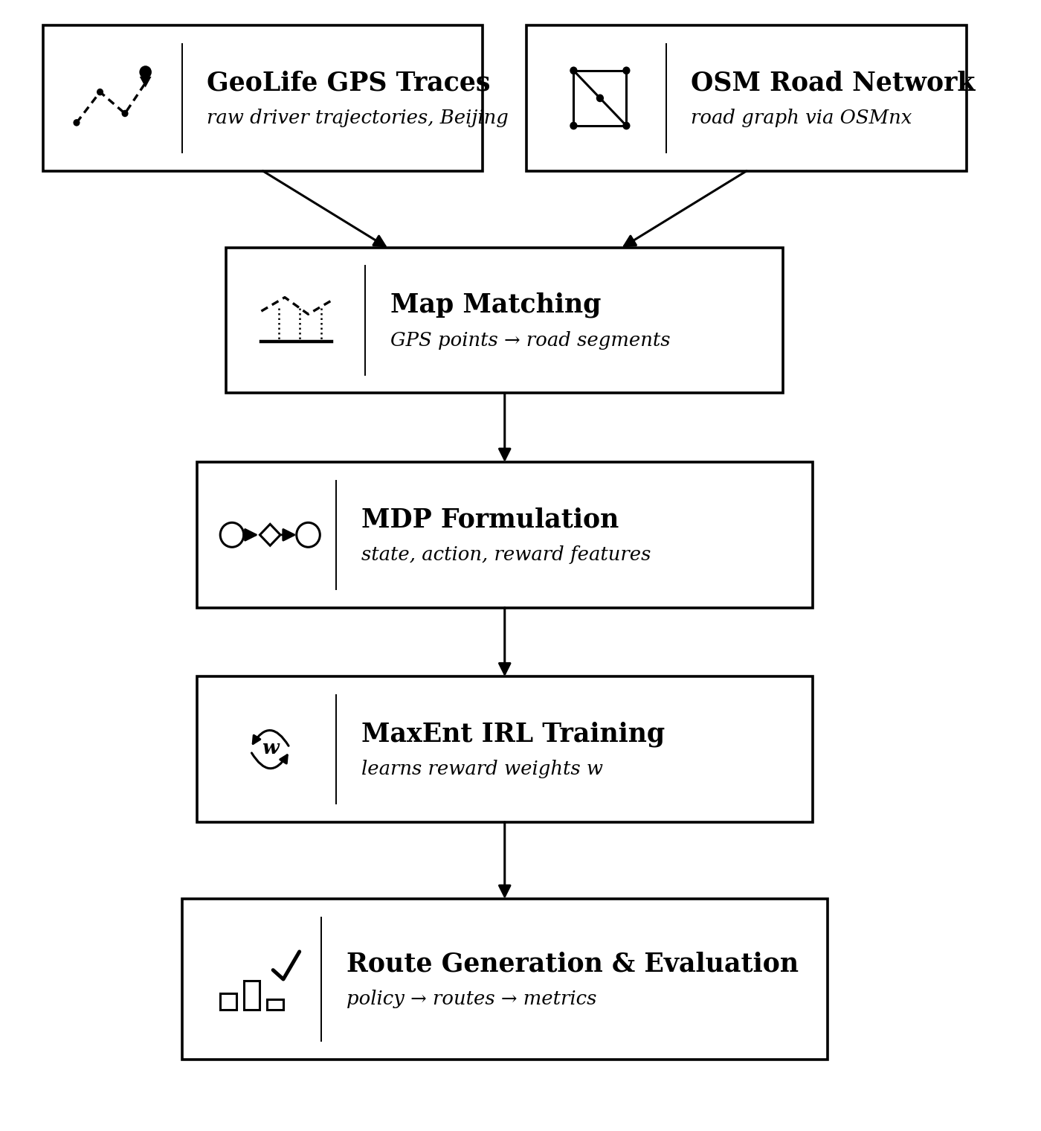
Figure 1. End-to-end pipeline from raw GPS and OSM data to a learned, evaluated routing policy.
For grounding, the diagram below sketches the same state / action / transition-probability / reward grammar as Section 9 on a small, real road cluster in Haidian District, Beijing — the area GeoLife trajectories are densest in, and home to Microsoft Research Asia, the dataset's own publisher. A driver at the Zhichun Road junction chooses between Zhongguancun Street and the North 4th Ring Road; each choice carries a probabilistic outcome and a reward, ending either at the destination or in a gridlocked trap. Every action's outgoing probabilities sum to exactly 1.0. This is still a hand-illustrated example, not an output of the pipeline: the real state space is the full OSM graph for the study area, and the real reward values come from MaxEnt IRL training rather than being authored by hand.
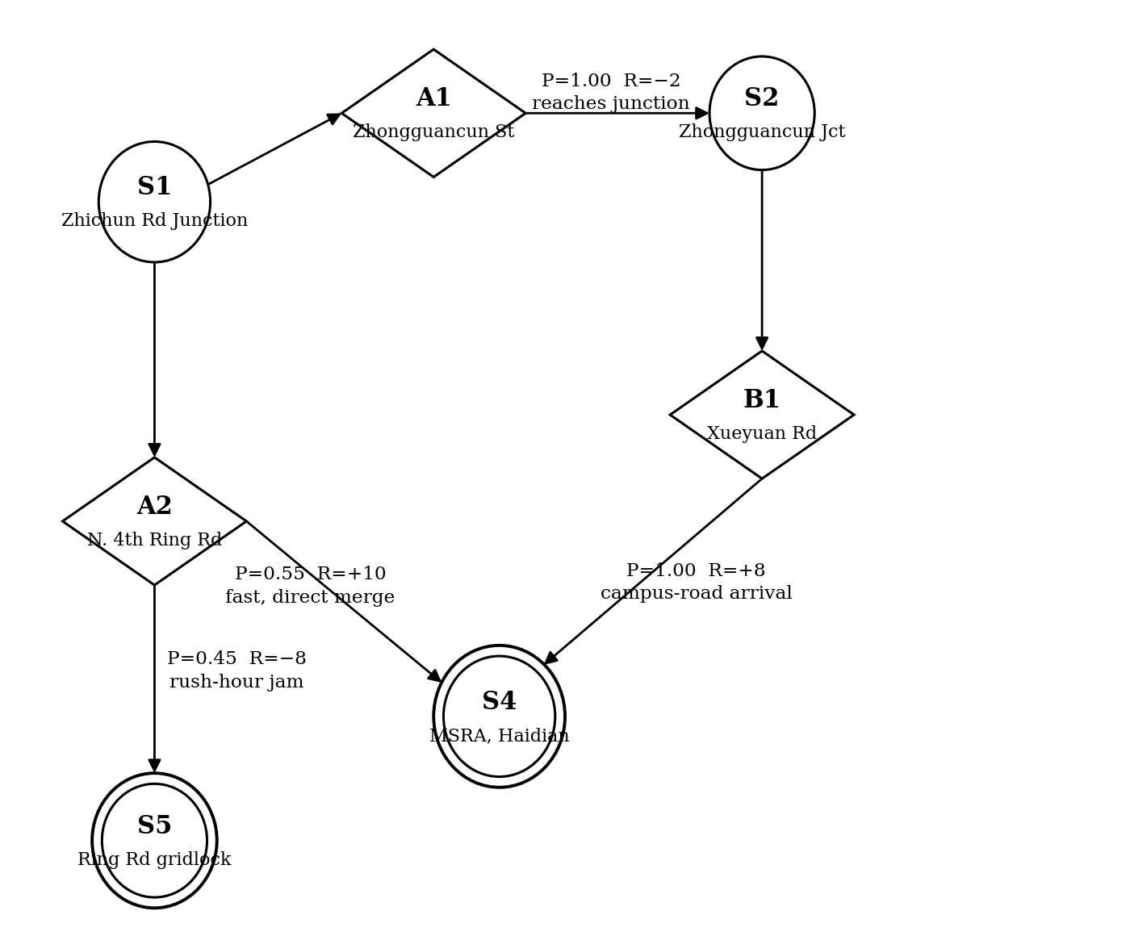
Figure 2. Illustrative MDP on a real Haidian District road cluster: states (circles), actions (diamonds), and transition probability / reward / outcome on each edge.

11. Dataset / Simulation Plan
- Trajectories: GeoLife (Microsoft Research Asia) — filtered to the subset of users with mode = car / taxi labels (about 69 of 182 users carry transportation-mode tags), restricted to the Beijing metro area for trajectory density.
- Road network: an OSMnx pull of the network_type='drive' graph for the same bounding box. Training starts on a bounded sub-region (e.g. inside the 5th Ring Road) rather than all of Beijing, to keep the state space tractable — directly addressing the compute concern raised in the Gap Analysis.
- Preprocessing: trajectories that are too short, sparse, or GPS-noisy are discarded; surviving traces are map-matched onto OSM edges (e.g. Leuven MapMatching or an HMM-based matcher) to convert raw lat/lon points into edge sequences.
- Split: trajectories are partitioned by origin–destination pair, roughly 80/20 train/test, so evaluation happens on OD pairs the model never trained feature-matching on.
- Simulation: w is trained on the training set; soft value iteration is then run per held-out OD pair to generate a route distribution, which is compared against the driver's actual recorded path.

12. Evaluation Metrics and Baseline

Metrics
Metric | What it measures
Edge-overlap F1 / Jaccard similarity | Precision and recall of edges shared between the generated route and the true route.
Path-length ratio | Generated route length divided by actual route length.
Frechet distance | Geometric closeness between the generated route polyline and the raw GPS polyline.
Held-out log-likelihood | Likelihood of expert trajectories under the learned policy; the direct IRL objective evaluated on unseen data.
Top-1 / top-3 next-edge accuracy | How often the model's highest-probability (or top-3) edge choice matches the driver's actual choice at each junction.

Baselines
Baselines are chosen in increasing sophistication, so that any gain from IRL is shown against progressively stronger and more relevant comparisons.
Baseline | Description
Dijkstra — shortest path | Minimizes distance only; the classical, preference-blind baseline.
Dijkstra — fastest path | Minimizes estimated travel time only; still ignores subjective preference.
Myopic supervised classifier | A local, junction-level classifier trained on the same features; a black-box ML baseline with no interpretable reward, directly contrasting with the learned linear w.

13. Expected Novelty
- A fully reproducible, public-data pipeline (GeoLife + OSM), in contrast to Google's Maps-scale IRL work (Barnes et al., 2024), which is proprietary end-to-end; this pipeline is small enough to run and audit on a single machine.
- Interpretability by construction: the linear reward means the learned weight vector w is itself a result — what drivers trade off (turns vs. distance vs. road class) can be reported directly, addressing the black-box gap identified in Section 7.
- A clean evaluation protocol bridging classical routing (Dijkstra) and modern IRL on a real OSM graph, producing a reusable benchmark harness rather than a one-off model.
- Stretch goal (future work): clustering learned reward weights across driver subgroups to characterize heterogeneity in route preference, beyond a single population-average reward.

14. References
[1] Ziebart, B. D., Maas, A., Bagnell, J. A., & Dey, A. K. (2008). Maximum Entropy Inverse Reinforcement Learning. AAAI.
[2] Liu, S., et al. (2020). Integrating Dijkstra's Algorithm into Deep Inverse Reinforcement Learning for Food Delivery Route Planning.
[3] Zhao, X., & Liang, Y. (2023). A Deep Inverse Reinforcement Learning Approach to Route Choice Modeling with Context-Dependent Rewards.
[4] Barnes, M., et al. (2024). Massively Scalable Inverse Reinforcement Learning in Google Maps. arXiv.
[5] Zhang, et al. (2024). Recursive Logit-Based Meta-Inverse Reinforcement Learning for Driver-Preferred Route Planning.
[6] Pitombeira-Neto, A., et al. (2024). Trajectory Modeling via Random Utility Inverse Reinforcement Learning.
[7] Liu, et al. (2025). Personalized Origin–Destination Travel Time Estimation with Active Adversarial Inverse Reinforcement Learning and Transformer.
[8] Marra, A., & Corman, F. (2025). Modelling Route Choice in Public Transport with Deep Learning.

