Executive Summary

The report presents the strategic deployment of Industry 4.0 based Smart Manufacturing System for addressing the key operational pain points like frequent machine breakdown, high defect ratio, inefficient production scheduling of all Indian manufacturing company. Through shifting from reactive legacy methods to proactive data-driven approach, this proposed architecture with Machine Learning, Computer Vision & Autonomous agents to achieve maximum throughout and assured product quality.

The operation system changeover rests on the three key-technological pillars:

- Predictive maintenance (Zero Downtime operation)
Through employing Edge AI and Industrial IOT based sensors to monitor continuously machine vitals like Vibration and Temperature and more. Unsupervised learning algorithm and probabilistic reasoning to spot small anomalies in real-time anticipate components failure to prior of events and moving from costly Run to failure to highly efficient Condition based Servicing.

- AI-Quality Control (Automatic Visual Inspection)
To remove the fatigue and subjective nature of human inspection. High speed Industrial camera in conjunction with Convolutional Neural Network (CNN). Supervised learning is used on augmented dataset defect vs. perfect products and through this visual cortex analyze complex surfaces features within milliseconds which automatically rejects anomalies. Resulting in assured almost 100% quality assurance in full speed of production.

- Smart Production Scheduling (Dynamic Resource Optimization)
An Agentic AI (using mathematical optimization methods like Simulated Annealing, A* Search goes through millions of variations and computations on scheduling and etc. Dynamically rerouting raw materials worker assignments Machine Loads shows in real time to reduce supply chain disruptions and Maintenance down time.
To replace static spreadsheets and system as independent digital twin of the factory.

Implementation of this AI systems brings a resilient and autonomous ecosystem for the factory floor. A direct connection between defect detection maintenance prediction and resource scheduling will dramatically reduce unexpected downtime. Eliminate defective products cost and bring about globally optimized production flow which is scalable to market demands

Problem

The company is an Indian manufacturing firm facing three major operational problems:

- Frequent machine breakdowns can make production stops unexpectedly.
- Quality issues that lead to defective products are being produced.
- Inefficient production planning can lead to machines, workers, and materials are not being scheduled optimally.

Predictive Maintenance

AI transforms maintenance from a reactive or scheduled process into a highly accurate data driven strategy. It monitors industrial equipment in real time using Internet of Things (IoT) sensors that track:

- Thermal and temperature signatures (detecting overheating before smoke appears)
- Acoustic emissions and micro-vibrations (detecting imperceptible grinding or friction)
- Fluid and pressure metrics (monitoring hydraulic integrity)
- Motor current signature analysis (detecting electrical irregularities)
- Historical operating hours and load cycles

The AI uses machine learning to establish a baseline "healthy" signature for each specific machine. It then continuously runs anomaly detection to spot microscopic deviations from this baseline, predicting exactly when and how a machine is likely to fail.

B. AI Quality Control by Computer Vision

Using high resolution cameras, infrared sensors, and edge computing. AI performs high speed micro inspections that far exceed human capabilities. Computer vision models are trained on millions of images to instantly examine products for defects such as:

- Micro scratches and hairline cracks invisible to the naked eye
- Dimensional inaccuracies down to the micron level
- Missing, inverted, or incorrect components
- Surface texture defects, colour variances, and faulty seals

Unlike human inspectors who suffer from eye fatigue and inconsistency over a shift, computer vision systems maintain 100% accuracy at speeds of hundreds of units per minute, 24/7.

C. Smart Production Scheduling

Manufacturing environments are chaotic with hundreds of moving variables. AI operates as a digital air traffic controller for the factory floor, creating agile, optimized production schedules by analysing massive datasets including:

- Live customer demand and priority rush orders
- Real-time machine availability and health (feeding in data from Predictive Maintenance)
- Supply chain logistics and raw material transit times
- Worker shift availability, skills, and labour costs
- Dynamic energy pricing that can scheduling heavy power usage during off-peak hours

Using digital twin technology and optimization algorithms, the AI runs thousands of hypothetical scenarios per minute to find the most cost-effective and efficient path forward.

The transition to Industry 4.0 leverages advanced artificial intelligence and interconnected systems to resolve a wide array of historically chronic manufacturing challenges. To combat frequent machine breakdowns unexpected downtime and prohibitively high maintenance costs modern factories are replacing reactive protocols with condition based and predictive maintenance utilizing continuous IoT machine sensors and AI predictions to foresee equipment failures long before they disrupt operations. Simultaneously the persistent issues of product defects and the inherent physical limitations of manual inspection are being eradicated through computer vision and automated visual inspection which guarantee high speed precision and round the clock consistency. On the operational side daily inefficiencies like poor scheduling unnecessary machine idle time and severe production bottlenecks are actively smoothed out by AI based production scheduling and continuous production optimization algorithms that dynamically adapt factory workflows to changing conditions. Furthermore the supply chain disadvantages such as material shortages are mitigated via precise demand and inventory forecasting while the historical lack of real time information and subsequent poor decision making are cured by deploying robust IoT dashboards powered by deep data analytics. Ultimately by tying all of these solutions together with intelligent automation and decision support systems smart factories drastically reduce the risk of human error and create a highly efficient resilient industrial environment.

How and what the AI will be Trained on:

Predictive Maintenance:

- Unsupervised Learning (Anomaly Detection): By analysing unlabelled continuous sensor data like temperature and vibration the AI finds hidden structures and identifies unusual patterns that deviate from normal machine behaviour flagging a potential breakdown before it happens.

- Edge AI and Industrial IoT Sensors: Running AI models directly on local factory floor sensors ensures real time and low latency monitoring. This allows immediate action when a motor vibration spikes without relying on cloud connectivity.

- Fuzzy Logic and Probabilistic Reasoning: Helps the AI handle vague sensor inputs (for e.g. assessing that a motor is somewhat hot rather than strictly hot or cold) and calculates the mathematical probability of an impending failure.

B. AI Quality Control (Solving Defective Product Issues)

- Supervised Learning (Classification): The AI learns from thousands of human labelled examples of both perfect and defective products. This creates a mapping rule that allows the AI to accurately classify and automatically reject new items with scratches or cracks.

- Deep Learning and Convolutional Neural Networks (CNNs): This specific neural network architecture acts as the AI visual cortex. Layer by layer CNNs analyse raw pixel patterns from the production line cameras and detecting simple edges and combining them into shapes and eventually identifying complex surface defects.

C. Smart Production Scheduling (Solving Inefficient Planning)

- Optimisation Techniques: Factory scheduling has millions of possible configurations. Algorithms search this space to find the most efficient setup.
- Hill Climbing optimizes daily machine schedules to maximize output step by step
- Simulated Annealing handles complex Job Shop Scheduling across multiple machines to ensure the entire factory flow is optimal.

- Agentic AI: Transforms the system from a passive advisory dashboard into a proactive autonomous agent. If a machine requires maintenance the Agentic AI can independently reason break the problem into steps and automatically reroute raw materials and workers to a backup machine without waiting for human input.

- State Space Search: Treats the factory floor and the schedule as a vast web of possibilities systematically exploring different paths to find the most efficient sequence of actions to fulfil customer orders.
For more detail as given in the [Table 1].

Implementation Strategy and Risk Governance

The implementation of this integrated smart manufacturing architecture provides an end-to-end operational upgrade for the Indian manufacturing firm. By systematically replacing run-to-failure approaches with Edge AI Predictive Maintenance, eliminating human inspection bottlenecks with high-speed Computer Vision, and transforming static planning spreadsheets into an autonomous Agentic AI scheduling engine, the facility addresses the root causes of its operational inefficiencies.

This technology stack links machine sensor telemetry, automated quality assurance, and dynamic factory scheduling into a single, closed-loop operational ecosystem. As raw operational data flows seamlessly between these systems, the plant transitions from reactive firefighting to proactive, mathematically optimized manufacturing. The resulting gains in Overall Equipment Effectiveness, First Pass Yield, and plant-wide throughput deliver rapid capital recovery, establishing an agile, high-precision manufacturing base built to thrive in competitive global markets.

To ensure successful deployment and avoid common AI failure modes the integration must follow a structured execution plan.

- Implementation Horizons:
The rollout should follow three phases: Quick wins (0-6 months) to build trust and Core transformation (6-18 months) to deploy ML systems at scale and Strategic differentiation (18-36 months) for full Agentic AI autonomy.

- Change Management:
Using Kotter's 8-step change model the firm must empower internal AI champions to prevent frontline employees from resisting the technology due to fears of job automation.

- Avoiding Failure Modes:
The firm must establish rigorous data pipelines to avoid Data poverty and assign clear project ownership to ensure the algorithms do not get stuck in Pilot purgatory.

In the [Figure 1] you can see:

Machine Uptime: Transition from Reactive to Predictive Maintenance

- Pre AI (65% Uptime): Represents a conventional run to failure or fixed calendar maintenance model where unexpected equipment breakdowns cause 35% of operational hours to be lost on to unplanned line stoppages.
- Post AI (95% Uptime): Driven by Unsupervised Learning and Edge IoT. By catching anomalous vibration, thermal, and current trends weeks before mechanical failure occurs repairs can be planned during scheduled shifts and it is eliminating sudden downtime and bringing machine to run smoothly and continuous at full capacity.

2. Defect Detection Rate: Transition from Manual Inspection to Deep Vision

- Pre AI (50% Detection): Reflects the limitations of human visual inspection or basic threshold sensors where fatigue line speed and microscopic flaws allow roughly half of defective parts (like surface cracks, misalignments, scratches) to pass through unnoticed.
- Post AI (98% Detection): Enabled by Supervised Deep Learning using Convolutional Neural Networks (CNNs) for automated visual perception. The system inspects parts at line speed with 24/7 consistency stopping defective components from reaching downstream assembly or escaping to external clients.

3. Schedule Optimization: Transition from Static Planning to Heuristic Search

- Pre AI (40% Efficiency): Highlights rigid manual production planning using spreadsheets or static rules. When a machine goes down or priority orders shift the floor suffers from idle bottlenecks misallocated labour and long changeover times.
- Post AI (85% Efficiency): Achieved by framing factory scheduling as a State Space Search and Optimization problem. Algorithms such as Simulated Annealing and Hill Climbing dynamically resolve job shop dependencies and material routing to ensuring production capacity should not fall or decrease and labour are utilized near theoretical optimums.

Strategic Business Implication

From an executive and financial standpoint the chart demonstrates a dual return on investment (ROI):

- Hard ROI: Direct cost reductions through minimized scrap waste reduced overtime pay for emergency repairs and increased daily factory throughput without needing to purchase new machinery.
- Risk and Contract Protection: A defect detection rate of 98% and uptime of 95% removes the operational risk of failing supplier or losing critical customer contract due to missed products deadlines or substandard quality.

To implement the smart manufacturing AI system the firm will utilise a portion of its allocated 50 crore rupee transformation budget. This investment covers the 5 essential components required for manufacturing AI and that are an Industrial IoT Sensor, Network Package, Edge AI Computing Devices, Predictive Maintenance AI Models and a Digital Twin of Critical Machines and a Maintenance Work Order Automation System. Additionally the firm can reduce its overall cash expenditure by taking advantage of government subsidies available under the Industry 4.0 PLI scheme (Production Linked Incentive).

The primary financial return is measured through Hard ROI which focuses direct on quantifiable cost savings. Currently unexpected machine downtime costs the company over 3 crore rupees every single month product defect rates sit at nearly five percent (5%) and energy expenses have risen sharply. By using predictive maintenance to eliminate unplanned downtime computer vision to push defect rates below the two percent (2%) target and smart scheduling to cut energy waste by that the company recovers massive operational losses. Because these savings are so substantial the payback period is incredibly short that allowing the investment to break even within a few months.

Beyond direct financial savings the investment provides critical Soft ROI and Strategic ROI. Soft benefits include empowering the factory two hundred floor supervisors with real time operational insights leading to faster and better decision making. Strategically eliminating breakdowns and keeping defect rates strictly below the critical five percent (5%) client threshold protects high value supplier contracts such as the Tata Motors agreement. This prevents catastrophic revenue loss and establishes a proprietary competitive advantage that other manufacturers cannot easily copy that is our company competitive advantage. [ Figure 2]

Appendix

Problem | AI/Industry 4.0 Solution | Underlying Algorithmic Engine | Operational Mechanism & Business Impact
Machine breakdowns | Predictive maintenance | Unsupervised Deep Autoencoders & Isolation Forests | Analyzes high-frequency vibration and temperature telemetry to detect microscopic mechanical wear before physical breakdown occurs.
Unexpected downtime | Machine sensors + AI predictions | Time-Series Anomaly Detection & Bayesian RUL | Computes a real-time Remaining Useful Life metric, converting catastrophic halts into controlled, scheduled shift-gap maintenance.
Product defects | Computer vision | Deep Convolutional Neural Networks (CNNs) & YOLOv8 | Analyzes structural pixel data layer-by-layer at 60+ FPS, reliably identifying hairline cracks, scratches, and dimensional errors.
Manual inspection | Automated visual inspection | Supervised Classification with Transfer Learning | Replaces fatigue-prone manual review with continuous, sub-millimeter optical inspection, eliminating human error on the line.
Poor scheduling | AI-based production scheduling | Simulated Annealing & Heuristic State Space Search | Solves the NP-hard Job Shop Scheduling Problem by stochastically escaping local minima to optimize factory-wide makespan.
Machine idle time | Production optimization | Combinatorial Optimization Algorithms | Eliminates starvation and blocking across machining cells by dynamically balancing upstream and downstream buffer queues.
Material shortages | Demand/inventory forecasting | Predictive Recurrent Networks (LSTM/GRU) | Forecasts stock consumption patterns in real time, synchronizing vendor delivery schedules directly with active production needs.
Lack of real-time info | IoT + dashboards | Industrial Edge Gateways & OPC-UA Fabrics | Aggregates disparate OT telemetry across legacy machinery, displaying a unified Digital Twin to plant supervisors.
Poor decision-making | Data analytics | Prescriptive Analytics Engines & Decision Trees | Replaces subjective intuition with data-driven operational intelligence, optimizing feeds, speeds, and tooling cycles.
High maintenance cost | Condition-based maintenance | Fuzzy Logic & Probabilistic Reasoning | Eliminates wasteful scheduled replacements of healthy parts, servicing machinery strictly when physical degradation is proven.
Production bottlenecks | AI scheduling and optimization | A∗ State Space Search on Factory Graphs | Dynamically routes production lots around degraded or overloaded machines to maintain steady factory-wide flow.
Human error | Automation and decision support | Reinforcement Learning & Autonomous Agentic AI | Transforms passive monitoring into closed-loop execution, automatically rerouting conveyor paths and issuing PLC overrides.
Table 1

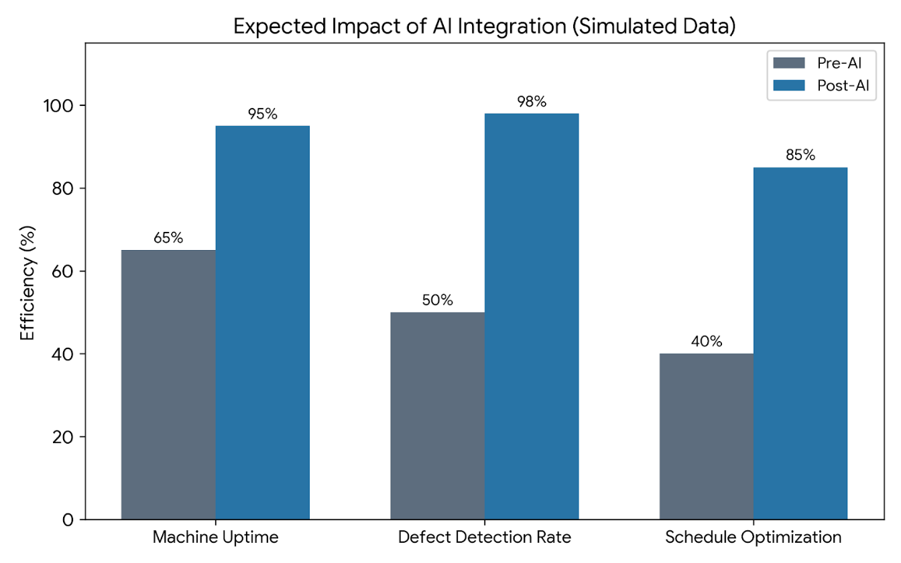
Figure 1

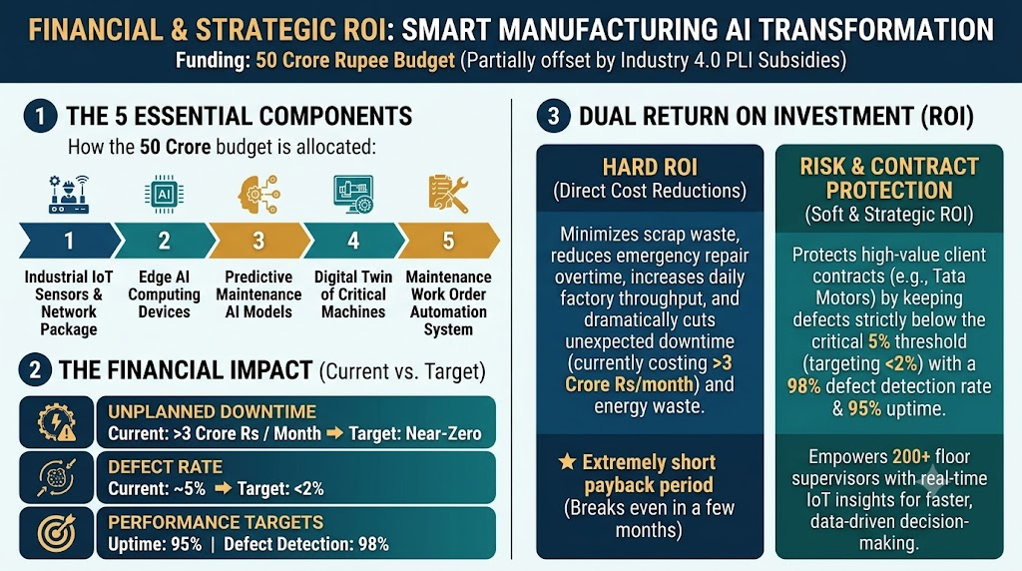
Figure 2

Reference
  - https://gemini.google.com
  - https://aima.cs.berkeley.edu
  - https://www.sciencedirect.com/science/article/abs/pii/S221384631400025X?via%3Dihub
  - https://drive.google.com/drive/folders/1GWXMvKkGgExHUF3MH6ZVmKdOgHV8puHe?usp=drive_link
  - https://www.ibm.com/think/insights/ai-in-predictive-maintenance
  - https://aistudio.google.com
  - https://notebook.google

