

Functional Safety Concept Lane Assistance

**Document Version: 1.0**

**Template Version 1.0, Released on 2017-06-21**



# Document history

|  |  |  |  |
| --- | --- | --- | --- |
| Date | Version | Editor | Description |
| 2019-01-23 | 1.0 |  | First draft |
|  |  |  |  |
|  |  |  |  |
|  |  |  |  |
|  |  |  |  |

# Table of Contents

Table of Contents

Document history 2

Table of Contents 2

Purpose of the Functional Safety Concept 3

Inputs to the Functional Safety Concept 3

Safety goals from the Hazard Analysis and Risk Assessment 3

Preliminary Architecture 3

Description of architecture elements 4

Functional Safety Concept 4

Functional Safety Analysis 4

Functional Safety Requirements 5

Refinement of the System Architecture 7

Allocation of Functional Safety Requirements to Architecture Elements 7

Warning and Degradation Concept 8

# Purpose of the Functional Safety Concept

The purpose of the functional safety concept is to identify new functional requirements at a high level and allocate these functional requirements to system diagrams/architecture.

# Inputs to the Functional Safety Concept

## Safety goals from the Hazard Analysis and Risk Assessment

|  |  |
| --- | --- |
| **ID** | **Safety Goal** |
| Safety_Goal_01 | The oscillating steering torque from the lane departure warning function shall be limited. |
| Safety_Goal_02 | The lane keeping assistance function shall be time limited and the additional steering torque shall end after a given time interval so that the driver cannot misuse the system for autonomous driving. |
| Safety_Goal_03 | The lane keeping assistance function shall be turned off on roads with tight curves so that the driver cannot misuse the system for autonomous driving. |

## Preliminary Architecture

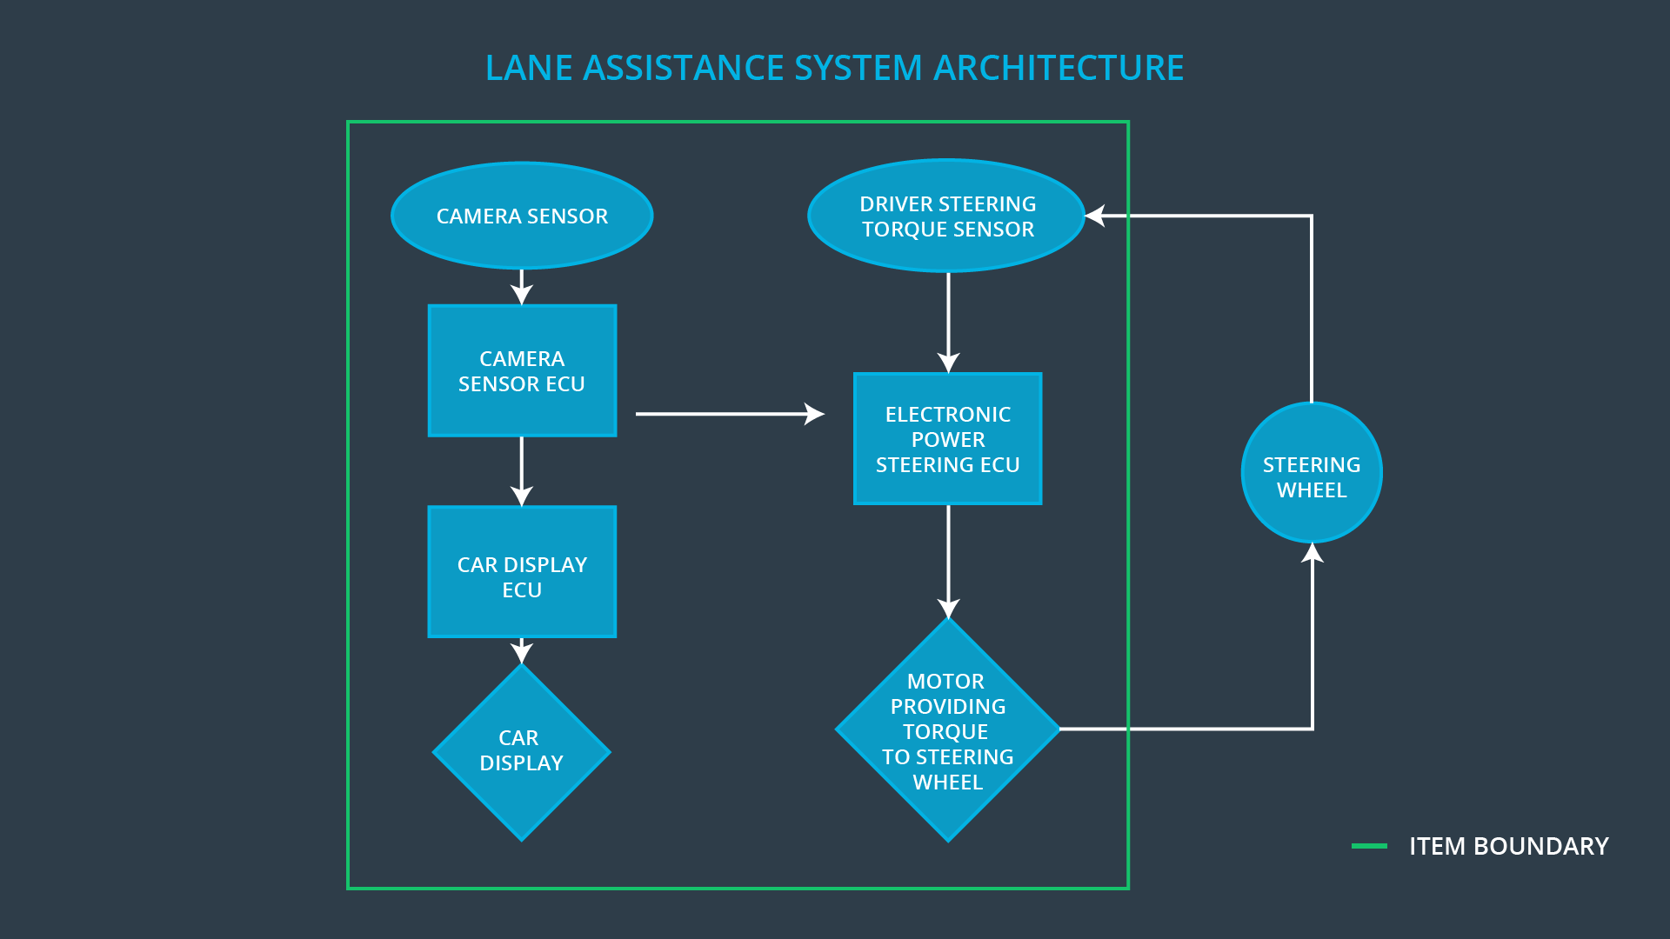

### Description of architecture elements

|  |  |
| --- | --- |
| **Element** | **Description** |
| Camera Sensor | Records an image of the current road |
| Camera Sensor ECU | Calculates the position and orientation of the car respectively to the lane lines |
| Car Display | Displays the status of the functions and the driver warnings |
| Car Display ECU | Controls the LED for the status and driver warnings |
| Driver Steering Torque Sensor | Senses the torque the driver applies to the steering wheel |
| Electronic Power Steering ECU | Controls the torque of the steering wheel motor |
| Motor | Applies the torque to the steering wheel |

# Functional Safety Concept

The functional safety concept consists of:

* Functional safety analysis
* Functional safety requirements
* Functional safety architecture
* Warning and degradation concept

## Functional Safety Analysis

|  |  |  |  |
| --- | --- | --- | --- |
| **Malfunction ID** | **Main Function of the Item Related to Safety Goal Violations** | **Guidewords (NO, WRONG, EARLY, LATE, MORE, LESS)** | **Resulting Malfunction** |
| Malfunction_01 | Lane Departure Warning (LDW) function shall apply an oscillating steering torque to provide the driver a haptic feedback | MORE | The lane departure warning function applies an oscillating torque with very high torque amplitude (above limit). |
| Malfunction_02 | Lane Departure Warning (LDW) function shall apply an oscillating steering torque to provide the driver a haptic feedback | MORE | The lane departure warning function applies an oscillating torque with very high torque frequency (above limit). |
| Malfunction_03 | Lane Keeping Assistance (LKA) function shall apply the steering torque when active in order to stay in ego lane | NO | The lane keeping assistance function is not limited in time duration which leads to misuse as an autonomous driving function. |

## Functional Safety Requirements

Lane Departure Warning (LDW) Requirements:

|  |  |  |  |  |
| --- | --- | --- | --- | --- |
| **ID** | **Functional Safety Requirement** | **ASIL** | **Fault Tolerant Time Interval** | **Safe State** |
| Functional  Safety  Requirement  01-01 | The lane keeping item shall ensure that the lane departure oscillating torque amplitude is below Max_Torque_Amplitude. | C | 50ms | OFF |
| Functional  Safety  Requirement  01-02 | The lane keeping item shall ensure that the lane departure oscillating torque frequency is below Max_Torque_Frequency. | C | 50ms | OFF |

Lane Departure Warning (LDW) Verification and Validation Acceptance Criteria:

|  |  |  |
| --- | --- | --- |
| **ID** | **Validation Acceptance**  **Criteria and Method** | **Verification Acceptance**  **Criteria and Method** |
| Functional  Safety  Requirement  01-01 | The test drivers can still control the car while it is trying to warn the driver, and they also can feel the warning. To validate this, several test drivers will receive different amplitudes and after each test they must document, how they could control the car and if they felt the warning. | A testing environment simulates different driver steering torque inputs and measures the amplitude of the LDW. The values measured should not be higher than the limit, with a tolerance of 3%. |
| Functional  Safety  Requirement  01-02 | The test drivers can still control the car while it is trying to warn the driver, and they also can feel the warning. To validate this, several test drivers will receive different frequencies and after each test they must document, how they could control the car and if they felt the warning. | A testing environment simulates different driver steering torque inputs and measures the frequency of the LDW. The values measured should not be higher than the limit, with a tolerance of 3%. |

Lane Keeping Assistance (LKA) Requirements:

|  |  |  |  |  |
| --- | --- | --- | --- | --- |
| **ID** | **Functional Safety Requirement** | **ASIL** | **Fault Tolerant Time Interval** | **Safe State** |
| Functional  Safety  Requirement  02-01 | The electronic power steering ECU shall ensure that the lane keeping assistance torque is applied for only Max_Duration. | B | 500ms | OFF |

Lane Keeping Assistance (LKA) Verification and Validation Acceptance Criteria:

|  |  |  |
| --- | --- | --- |
| **ID** | **Validation Acceptance**  **Criteria and Method** | **Verification Acceptance**  **Criteria and Method** |
| Functional  Safety  Requirement  02-01 | The test drivers do not treat the car as autonomous vehicle, because the LKA function turns off, if the driver does not have his hands on the steering wheel. To validate this, several test drivers will have different duration settings after which the LKA will be disabled and after each test they must document, how likely they would treat the car as autonomous vehicle. | A testing environment simulates steering action of a driver. After some random time, it will stop simulating driver steering torque. The time until the system will be disabled should have Max_Duration with a tolerance of 5%. |

## Refinement of the System Architecture

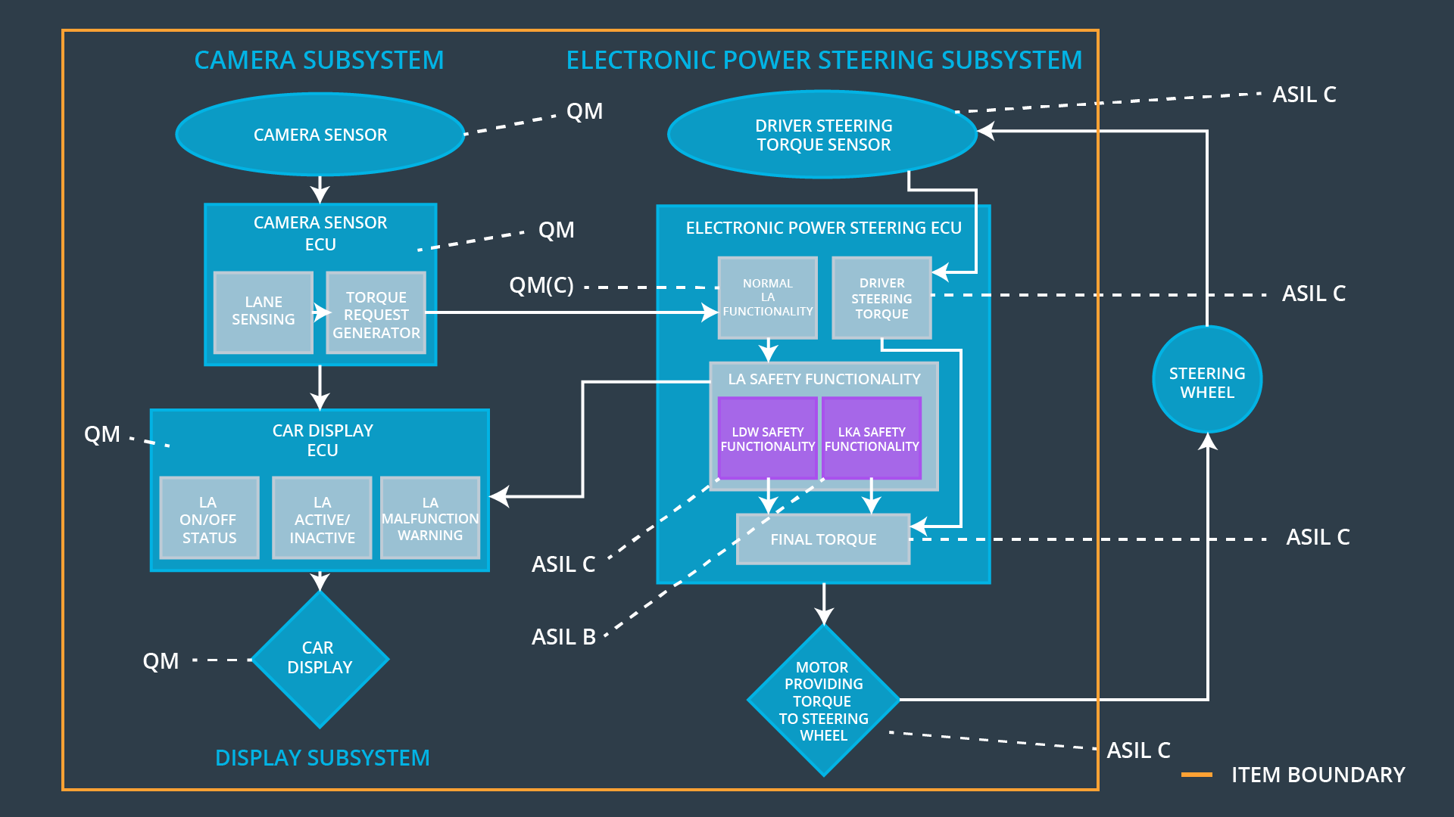

## Allocation of Functional Safety Requirements to Architecture Elements

|  |  |  |  |  |
| --- | --- | --- | --- | --- |
| **ID** | **Functional Safety Requirement** | **Electronic Power Steering ECU** | **Camera ECU** | **Car Display ECU** |
| Functional  Safety  Requirement  01-01 | The lane keeping item shall ensure that the lane departure oscillating torque amplitude is below Max_Torque_Amplitude. | **X** |  |  |
| Functional  Safety  Requirement  01-02 | The lane keeping item shall ensure that the lane departure oscillating torque frequency is below Max_Torque_Frequency. | **X** |  |  |
| Functional  Safety  Requirement  02-01 | The electronic power steering ECU shall ensure that the lane keeping assistance torque is applied for only Max_Duration. | **X** |  |  |

## Warning and Degradation Concept

|  |  |  |  |  |
| --- | --- | --- | --- | --- |
| **ID** | **Degradation Mode** | **Trigger for Degradation Mode** | **Safe State invoked?** | **Driver Warning** |
| WDC-01 | OFF | LDW torque or frequency limit exceeded | YES | Display message and turn on a warning light |
| WDC-02 | OFF | LKA driver hands not at steering wheel | YES | Display message and turn on a warning light |