

Technical Safety Concept Lane Assistance

**Document Version: 1.0**

**Template Version 1.0, Released on 2017-06-21**



# Document history

|  |  |  |  |
| --- | --- | --- | --- |
| Date | Version | Editor | Description |
| 2019-01-23 | 1.0 |  | First draft |
|  |  |  |  |
|  |  |  |  |
|  |  |  |  |
|  |  |  |  |

# Table of Contents

Table of Contents

Document history 2

Table of Contents 2

Purpose of the Technical Safety Concept 3

Inputs to the Technical Safety Concept 3

Functional Safety Requirements 3

Refined System Architecture from Functional Safety Concept 3

Functional overview of architecture elements 4

Technical Safety Concept 5

Technical Safety Requirements 5

Refinement of the System Architecture 9

Allocation of Technical Safety Requirements to Architecture Elements 9

Warning and Degradation Concept 9

# Purpose of the Technical Safety Concept

The purpose of the technical safety concept is, to add more technical details to the functional safety concept. Create new requirements and allocate them to the system architecture.

# Inputs to the Technical Safety Concept

## Functional Safety Requirements

|  |  |  |  |  |
| --- | --- | --- | --- | --- |
| **ID** | **Functional Safety Requirement** | **ASIL** | **Fault Tolerant Time Interval** | **Safe State** |
| Functional  Safety  Requirement  01-01 | The lane keeping item shall ensure that the lane departure oscillating torque amplitude is below Max_Torque_Amplitude. | C | 50ms | OFF |
| Functional  Safety  Requirement  01-02 | The lane keeping item shall ensure that the lane departure oscillating torque frequency is below Max_Torque_Frequency. | C | 50ms | OFF |
| Functional  Safety  Requirement  02-01 | The electronic power steering ECU shall ensure that the lane keeping assistance torque is applied for only Max_Duration. | B | 500ms | OFF |

## Refined System Architecture from Functional Safety Concept

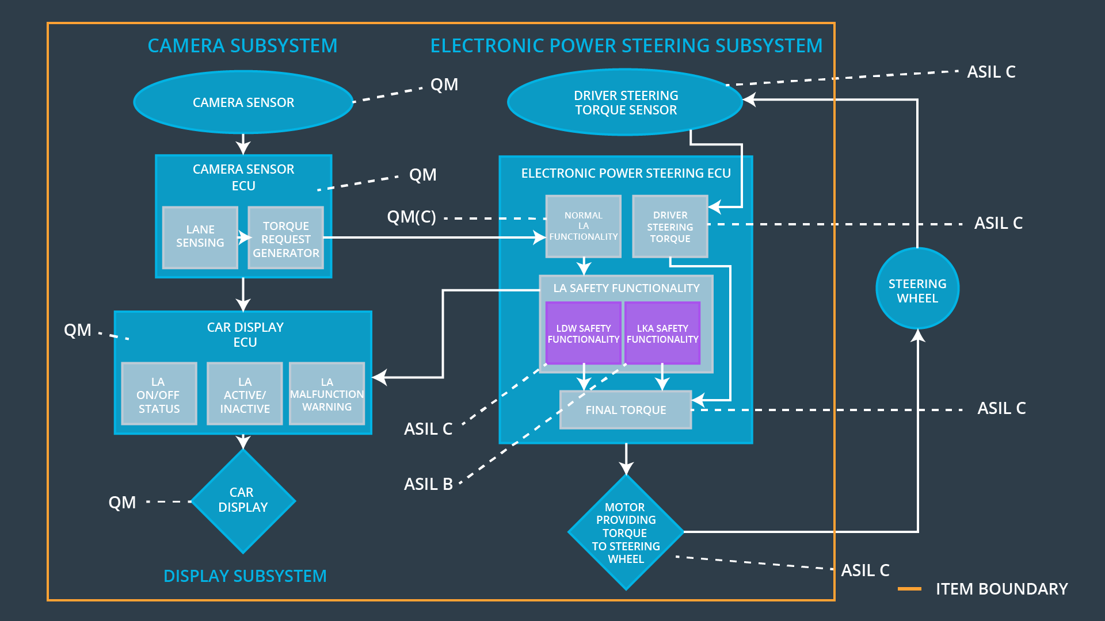

### Functional overview of architecture elements

|  |  |
| --- | --- |
| **Element** | **Description** |
| Camera Sensor | Records an image of the current road |
| Camera Sensor ECU - Lane Sensing | Calculates the position and orientation of the car respectively to the lane lines |
| Camera Sensor ECU - Torque request generator | Calculates the torque to be applied to the steering wheel in order to get back to the center of the lane |
| Car Display | Displays the status of the functions and the driver warnings |
| Car Display ECU - Lane Assistance On/Off Status | Controls the LED for the status |
| Car Display ECU - Lane Assistant Active/Inactive | Controls the LED for the status |
| Car Display ECU - Lane Assistance malfunction warning | Controls the LED for the warning |
| Driver Steering Torque Sensor | Senses the torque the driver applies to the steering wheel |
| Electronic Power Steering (EPS) ECU - Driver Steering Torque | Reads the Driver Steering Torque Sensor and passes the driver steering torque to the Final Torque unit |
| EPS ECU - Normal Lane Assistance Functionality | Receives the torque request from the Camera Sensor ECU and passes it to the LA Safety Functionality. It also limits the torque request in amplitude and frequency. |
| EPS ECU - Lane Departure Warning Safety Functionality | It deactivates the LDW if the torque request amplitude or frequency exceeds the limits |
| EPS ECU - Lane Keeping Assistant Safety Functionality | It deactivates the LKA if the driver does not steer the car anymore for the maximum amount of time |
| EPS ECU - Final Torque | Combines the LDW, LKA and the driver steering torque requests to the final torque, which will be used for the steering motor |
| Motor | Applies the torque to the steering wheel |

# Technical Safety Concept

## Technical Safety Requirements

**Lane Departure Warning (LDW) Requirements:**

Functional Safety Requirement 01-01 with its associated system elements

(derived in the functional safety concept)

|  |  |  |  |  |
| --- | --- | --- | --- | --- |
| **ID** | **Functional Safety Requirement** | **Electronic Power Steering ECU** | **Camera ECU** | **Car Display ECU** |
| Functional  Safety  Requirement  01-01 | The lane keeping item shall ensure that the lane departure oscillating torque amplitude is below Max_Torque_Amplitude | X |  |  |

Technical Safety Requirements related to Functional Safety Requirement 01-01 are:

|  |  |  |  |  |  |
| --- | --- | --- | --- | --- | --- |
| **ID** | **Technical Safety Requirement** | **ASIL** | **Fault Tolerant Time Interval** | **Architecture Allocation** | **Safe State** |
| Technical  Safety  Requirement  01 | The LDW safety component shall ensure that the amplitude of the 'LDW_Torque_Request' sent to the 'Final electronic power steering Torque' component is below 'Max_Torque_Amplitude'. | C | 50 ms | LDW Safety block | OFF |
| Technical  Safety  Requirement  02 | As soon as the LDW function deactivates the LDW feature, the 'LDW Safety' software block shall send a signal to the car display ECU to turn on a warning light. | C | 50 ms | LDW Safety block, LA malfunction warning block | OFF |
| Technical  Safety  Requirement  03 | As soon as a failure is detected by the LDW function, it shall deactivate the LDW feature and the 'LDW_Torque_Request' shall be set to zero. | C | 50 ms | LDW Safety block | OFF |
| Technical  Safety  Requirement  04 | The validity and integrity of the data transmission for 'LDW_Torque_Request' signal shall be ensured. | C | 50 ms | Data Transmission Integrity Check | OFF |
| Technical  Safety  Requirement  05 | Memory test shall be conducted at startup of the EPS ECU to check for any faults in memory. | A | ignition cylce | Safety startup | OFF |

Functional Safety Requirement 01-2 with its associated system elements

(derived in the functional safety concept)

|  |  |  |  |  |
| --- | --- | --- | --- | --- |
| **ID** | **Functional Safety Requirement** | **Electronic Power Steering ECU** | **Camera ECU** | **Car Display ECU** |
| Functional  Safety  Requirement  01-02 | The lane keeping item shall ensure that the lane departure oscillating torque frequency is below Max_Torque_Frequency | X |  |  |

Technical Safety Requirements related to Functional Safety Requirement 01-02 are:

|  |  |  |  |  |  |
| --- | --- | --- | --- | --- | --- |
| **ID** | **Technical Safety Requirement** | **ASIL** | **Fault Tolerant Time Interval** | **Architecture Allocation** | **Safe State** |
| Technical  Safety  Requirement  01 | The LDW safety component shall ensure that the frequency of the 'LDW_Torque_Request' sent to the 'Final electronic power steering Torque' component is below 'Max_Torque_Frequency'. | C | 50 ms | LDW Safety block | OFF |
| Technical  Safety  Requirement  02 | As soon as the LDW function deactivates the LDW feature, the 'LDW Safety' software block shall send a signal to the car display ECU to turn on a warning light. | C | 50 ms | LDW Safety block, LA malfunction warning block | OFF |
| Technical  Safety  Requirement  03 | As soon as a failure is detected by the LDW function, it shall deactivate the LDW feature and the 'LDW_Torque_Request' shall be set to zero. | C | 50 ms | LDW Safety block | OFF |
| Technical  Safety  Requirement  04 | The validity and integrity of the data transmission for 'LDW_Torque_Request' signal shall be ensured. | C | 50 ms | Data Transmission Integrity Check | OFF |
| Technical  Safety  Requirement  05 | Memory test shall be conducted at startup of the EPS ECU to check for any faults in memory. | A | ignition cylce | Safety startup | OFF |

**Lane Departure Warning (LDW) Verification and Validation Acceptance Criteria:**

**Lane Keeping Assistance (LKA) Requirements:**

Functional Safety Requirement 02-1 with its associated system elements

(derived in the functional safety concept)

|  |  |  |  |  |
| --- | --- | --- | --- | --- |
| **ID** | **Functional Safety Requirement** | **Electronic Power Steering ECU** | **Camera ECU** | **Car Display ECU** |
| Functional  Safety  Requirement  02-01 | The lane keeping item shall ensure that the lane keeping assistance torque is applied for only Max_Duration | X |  |  |

Technical Safety Requirements related to Functional Safety Requirement 02-01 are:

|  |  |  |  |  |  |
| --- | --- | --- | --- | --- | --- |
| **ID** | **Technical Safety Requirement** | **ASIL** | **Fault Tolerant Time Interval** | **Allocation to Architecture** | **Safe State** |
| Technical  Safety  Requirement  01 | The LKA safety component shall ensure that the lane keeping assistance torque is applied for only 'Max_Duration'. | B | 500 ms | LKA Safety block | OFF |
| Technical  Safety  Requirement  02 | As soon as the LKA function deactivates the LKA feature, the 'LKA Safety' software block shall send a signal to the car display ECU to turn on a warning light. | B | 500 ms | LKA Safety block, LA malfunction warning block | OFF |
| Technical  Safety  Requirement  03 | As soon as a failure is detected by the LKA function, it shall deactivate the LKA feature and the 'LKA_Torque_Request' shall be set to zero. | B | 500 ms | LKA Safety block | OFF |
| Technical  Safety  Requirement  04 | The validity and integrity of the data transmission for 'LKA_Torque_Request' signal shall be ensured. | B | 500 ms | Data Transmission Integrity Check | OFF |
| Technical  Safety  Requirement  05 | Memory test shall be conducted at startup of the EPS ECU to check for any faults in memory. | A | ignition cylce | Safety startup | OFF |

**Lane Keeping Assistance (LKA) Verification and Validation Acceptance Criteria:**

## Refinement of the System Architecture

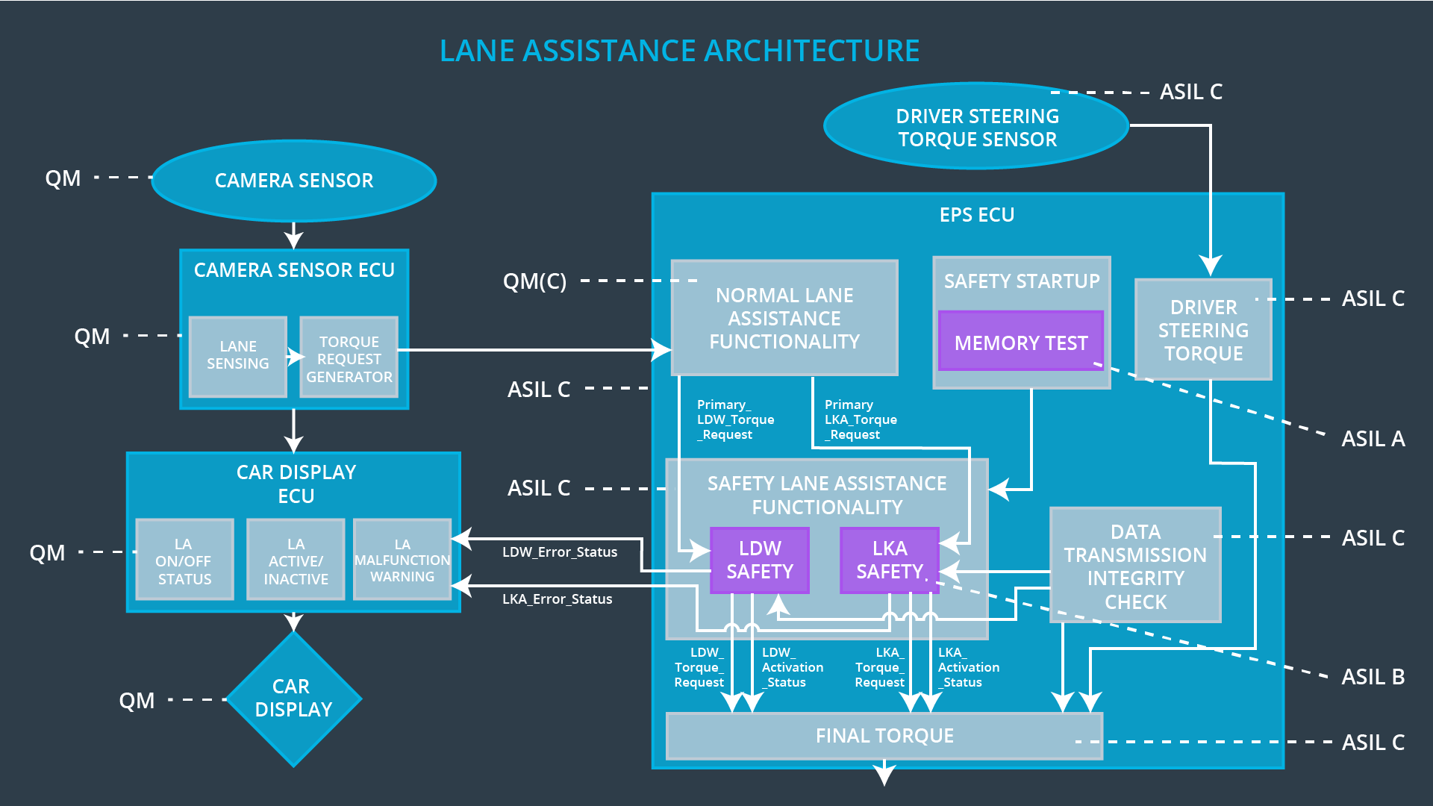

## Allocation of Technical Safety Requirements to Architecture Elements

For the lane keeping item all technical safety requirements are allocated to the Electronic Power Steering ECU.

## Warning and Degradation Concept

|  |  |  |  |  |
| --- | --- | --- | --- | --- |
| **ID** | **Degradation Mode** | **Trigger for Degradation Mode** | **Safe State invoked?** | **Driver Warning** |
| WDC-01 | OFF | LDW torque or frequency limit exceeded | YES | Display message and turn on a warning light |
| WDC-02 | OFF | LKA driver hands not at steering wheel | YES | Display message and turn on a warning light |