Data Structures and Graph Theory I
Chapter 1 Data Structure

1. Draw a diagram to describe the types of data structure.
Answer
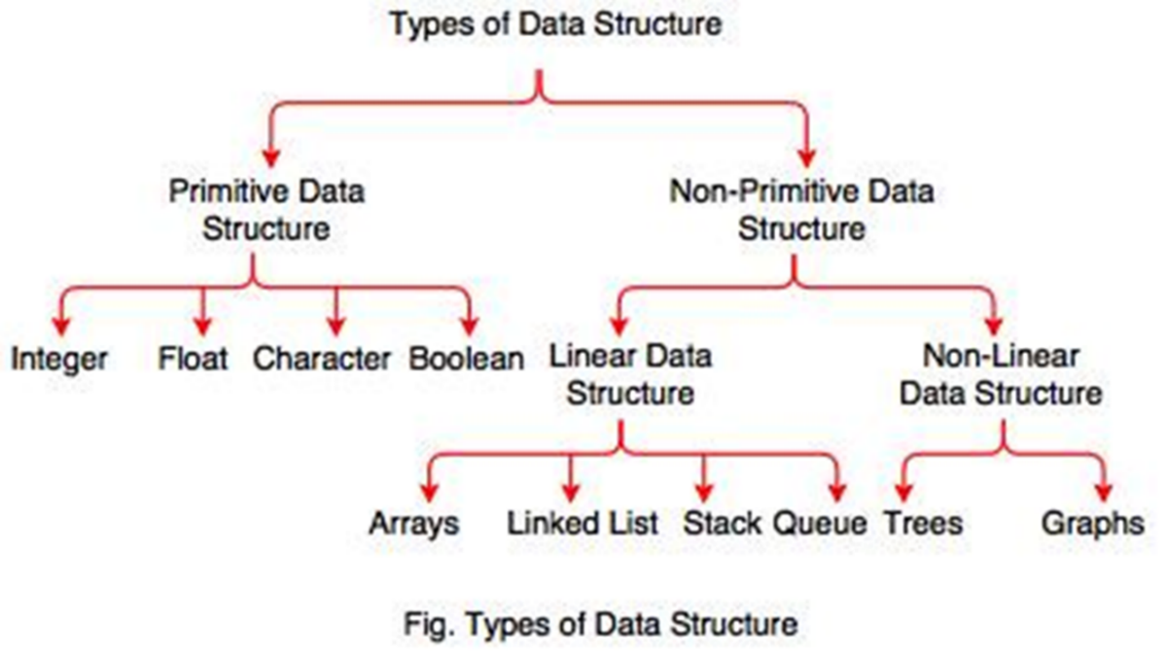

2. Describe the categories of data structure. Explain detail about simplest type of linear data structure with examples.
Answer
Linear Data Structure:
A data structure is said to be linear if its elements form any sequence.
e.g. Arrays, Queues, Stacks, Linked lists
Non-linear Data Structure:
This structure is mainly used to represent data containing a hierarchical relationship between elements. e.g. graphs, family trees
Arrays
The simplest type of data structure is a linear (or one dimensional) array. A list of a finite number n of similar data referenced respectively by a set of n consecutive numbers, usually 1, 2, 3 . . . . . . . n. a set of n consecutive numbers.
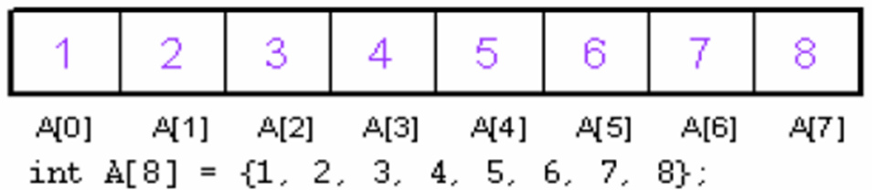
A finite collection of similar elements stored in adjacent memory locations. An array with n number of elements is referenced using an index that ranges 0 to n-1. The lowest index of an array is called its lower bound. The highest index is called upper bound. The number of elements in an array is called its range.
The elements of an array A[n] containing n elements are referenced as A[0], A[1], A[2],…, A[n-1], 0 is the lower bound and n-1 is the upper bound. A collection of data elements in which all elements are of the same data type.
For example:
int A[10] - {5,6,12,4,15,45,87,1,9,13};

base address
The operations of an Array are:
Traversing: means to visit all the elements of the array in an operation.
Insertion: means to put values into an array.
Deletion/ Remove: to delete a value from an array.
Sorting: Rearrangement of values in an array in a specific order (ascending/ descending) is called sorting.
Searching: the process of finding the location of a particular element in an array is called searching. There are two popular searching techniques/mechanisms: linear search and binary search.

3. What are the data structure operations?
Answer
Traversing: accessing each record/node exactly once so that certain items in the record may be processed. (This accessing and processing is sometimes called “visiting” the record.)
Searching: Finding the location of the desired node with a given key value, or finding the locations of all such nodes which satisfy one or more conditions.
Inserting: Adding a new node/record to the structure.
Deleting: Removing a node/record from the structure.

4. What is an algorithm?
Answer
An algorithm is a finite set of instructions or logic, written in order, to accomplish a certain predefined task. Algorithm is not the complete code or program, it is just the core logic(solution) of a problem, which can be expressed either as an informal high-level description as pseudocode or using a flowchart.
Every Algorithm must satisfy the following properties:
Input- There should be 1 or more inputs supplied externally to the algorithm.
Output- There should be at least 1 output obtained.
Definiteness- Every step of the algorithm should be clear and well defined.
Finiteness- The algorithm should have finite number of steps.
Correctness- Every step of the algorithm must generate a correct output.
An algorithm is said to be efficient and fast, if it takes less time to execute and consumes less memory space. The performance of an algorithm is measured on the basis of following properties:
i. Space Complexity
ii. Time Complexity

Space Complexity
It is the amount of memory space required by the algorithm, during the course of its execution. Space complexity must be taken seriously for multi-user systems and in situations where limited memory is available.
Instruction Space: It is the space required to store the executable version of the program. This space is fixed, but varies depending upon the number of lines of code in the program.
Data Space: It is the space required to store all the constants and variables (including temporary variables) value.
Environment Space: It is the space required to store the environment information needed to resume the suspended function.
Time Complexity
Time Complexity is a way to represent the amount of time required by the program to run till its completion. It's generally a good practice to try to keep the time required minimum, so that the algorithm completes its execution in the minimum time possible.

5. What is a program?
Answer
A program is the expression of an algorithm in a programming language. A set of instructions which the computer will follow to solve a problem.
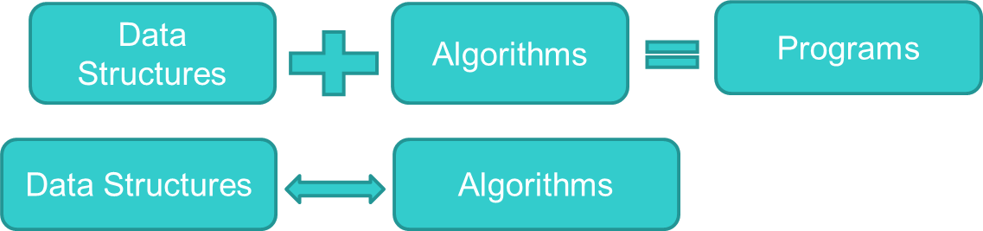

6. Described the difference between Algorithm, Pseudocode and Program.
Answer
Algorithm: Systematic logical approach which is a well-defined, step-by-step procedure that allows a computer to solve a problem.

Pseudocode: It is a simpler version of a programming code in plain English which uses short phrases to write code for a program before it is implemented in a specific programming language.
Program: It is exact code written for problem following all the rules of the programming language.

7. Describe about Abstract Data Types and Data Structures.
Answer
Abstract Data Type (ADT) is the realization of a data type as a software component. ADT, is a logical description of how we view the data and the operations that are allowed without regard to how they will be implemented. These implementation details are hidden from the user of the ADT and protected from outside access; a concept referred to as encapsulation.
Logical and Physical Form
Data items have both a logical and a physical form.
Logical form: definition of the data item within an ADT. Eg: Integers in mathematical sense: +, -
Physical form: implementation of the data item within a data structure. Eg: 16/32-bit integers, overflow.
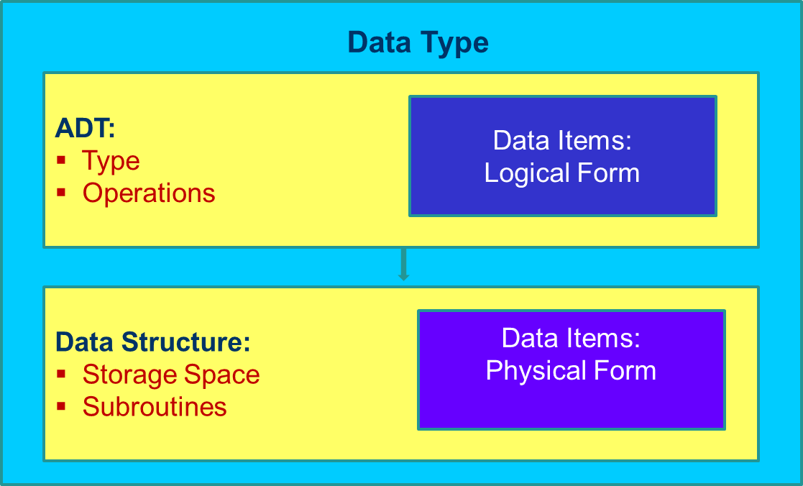

8. Describe about Problems, Algorithms, and Programs.
Answer
Each data structure requires:
Space to store each item, including overhead time to perform basic operations programming effort. Algorithms are closely related: poor data structure choice can make higher complexity algorithm and good data structure choice can make the algorithm trivial.
Problem is a task to be performed. One view: a set of inputs and matching outputs. Problem definition includes resource constraints. Problems are analogous to mathematical functions which are mapping of inputs (domain) to outputs (range). The input to a function can varies single number, multiple numbers and set of information. Parameters are the values making up an input. A given input must always map to the same output.
Algorithm: a method or process followed to solve a problem and transforms the input of a problem to its output. The properties of algorithm are:
1. It must be correct.
2. It must be composed of a series of concrete steps.
3. There can be no ambiguity about which step is next.
4. It must be finite in length.
5. It must terminate.
Program: an instance of an algorithm, written in some programming language. A problem is a function or a mapping of inputs to outputs. An algorithm is a recipe for solving a problem whose steps are concrete and unambiguous. Algorithms must be correct, of finite length, and must terminate for all inputs. A program is an instantiation of an algorithm in a programming language.

